
Year ${10}^{F}$: Autumn 1 Half Term Check-up (Calc) Name: ……………………
Score: …….…………… / 20
Section A: Knowledge
Sketch two similar rectangles.
Label the dimensions
What is Pythagoras’ Theorem?
What is the hypotenuse of a right-angled triangle?
Which trigonometric ratio is equivalent to $\frac{adjacent }{hypotenuse}$ ?

Section B: Common Mistakes
Round $78.55°$to the nearest degree
Circle your answer.

$78°$ $78.5°$ $78.6°$ $79°$

What is the value of $\sqrt{3^{2}+4^{2}}$
Circle your answer.

$5$ 5.1 $7$ $25$
A triangle has a height of 9cm. It is enlarged by a scale factor of 3.
What is the height of the enlarged triangle?
Circle your answer.

$3cm$ $12cm$ $18cm$ $729cm$
Round $98.36 cm$to 1 decimal place
Circle your answer.

$$98.0 98.3 98.4 99.0$$

Section C: Problems
Q1.
On the grid, enlarge shape B by scale factor
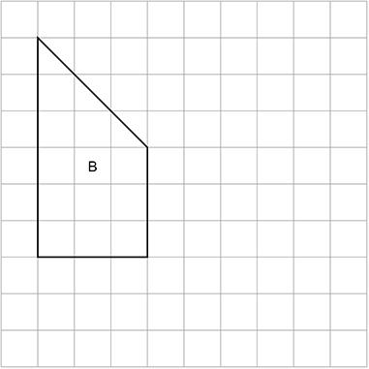
(Total 2 marks)
Q2.

These two shapes are similar.
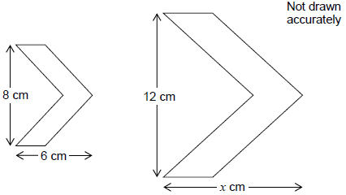
Work out the value of x.
_______________________________________________________________________
x = _________________________________________
(Total 2 marks)
Q3.
Use Pythagoras’ theorem to work out the value of x.

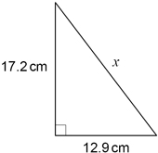 | Not drawn  accurately
_______________________________________________________________________
_______________________________________________________________________
_______________________________________________________________________
_______________________________________________________________________
_______________________________________________________________________
_______________________________________________________________________
x = ___________ cm
(Total 2 marks)
Q4.
Use trigonometry to work out the size of angle w.

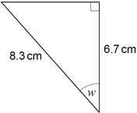 | Not drawn  accurately
_______________________________________________________________________
_______________________________________________________________________
_______________________________________________________________________
_______________________________________________________________________
_______________________________________________________________________
_______________________________________________________________________
w = _________________________°
(Total 3 marks)
Q5.
Use trigonometry to work out the value of x.

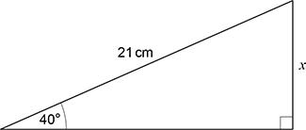 | Not drawn  accurately
_______________________________________________________________________
_______________________________________________________________________
_______________________________________________________________________
_______________________________________________________________________
_______________________________________________________________________
_______________________________________________________________________
Answer ____________________ cm
(Total3 marks)

END OF CHECK UP

