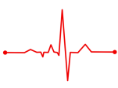
Year ${10}^{H}$: Autumn 1 Half Term Check-up (Calc) Name: ……………………
Score: …….…………… / 20
Section A: Knowledge
What is Pythagoras’ Theorem?
Which trigonometric ratio is equivalent to $\frac{adjacent }{hypotenuse}$ ?
What is a bearing?
Sketch two triangles that are similar. Ensure you label the dimensions

Section B: Common Mistakes
Round 702.908 to 3 significant figures
Circle your answer.

$700$ $702$ $703$ $702.9$
The bearing of A from B is 089. What is the bearing of B from A?
You may wish to draw a diagram below to help.
Circle your answer

$$089 091 269 271$$

Section C: Problems
Q1.
Describe fully the single transformation that maps triangle A to triangle B.
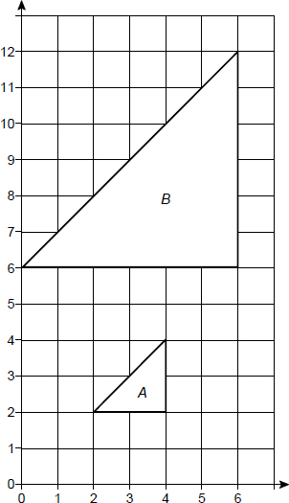
_______________________________________________________________________
_______________________________________________________________________
_______________________________________________________________________
_______________________________________________________________________
_______________________________________________________________________
(Total 3 marks)

Q2.
Enlarge triangle PQR by scale factor with centre (0, 0)
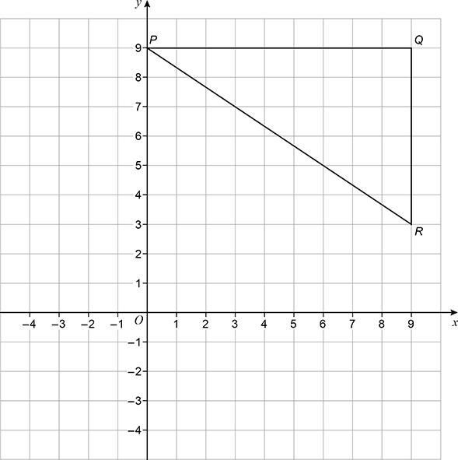
(Total 2 marks)
Q3.
The diagram shows a small triangle which is also part of a large triangle.
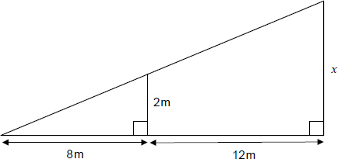
Work out the value of x.
_______________________________________________________________________
_______________________________________________________________________
Answer ______________________________
(Total 2 marks)
Q4.
Use trigonometry to work out the value of x.

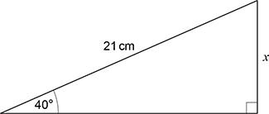 | Not drawn  accurately
_______________________________________________________________________
_______________________________________________________________________
_______________________________________________________________________
_______________________________________________________________________
_______________________________________________________________________
_______________________________________________________________________
Answer ____________________ cm
(Total 3 marks)
Q5.
Work out the area of triangle ABC.

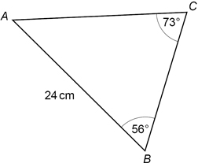 | Not drawn  accurately
_______________________________________________________________________
_______________________________________________________________________
______________________________________________________________________
Answer _________________________ cm²
(Total 4 marks)

END OF CHECK UP

