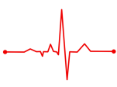
Year 9: Autumn 2 Half Term Check-up Name: ……………………
Calculator Allowed Score: …….…………… / 20
Section A: Knowledge
How do you calculate the volume of a cuboid?
Describe the difference between an edge and a vertex of a 3d shape
What does congruent mean?
How do we calculate the density of an object?
Section B: Common Mistakes
The plan of a solid is a rectangle. Circle the solid it could be.

$sphere$ $cone$ $hemisphere$ $cylinder$

Which one of the following is a unit for density?

$cm^{2}/g$ $cm^{3}/g$ $g/cm^{2}$ $g/cm^{3}$
Which unit is a measure of volume? Circle your answer.

${cm}^{2}$ $cubic centimetres$ $miles$ $kg$

Section C: Problems
Q1.

A tray for holding paper clips is an open cuboid.
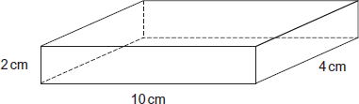
Complete a net for the tray on the grid.
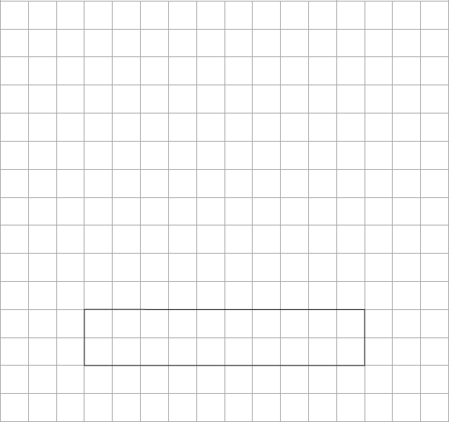
(Total 3 marks)

Q2.
A solid cuboid is made from centimetre cubes.
The plan view, front elevation and side elevation are shown.
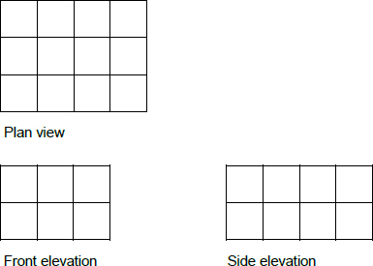
How many cubes were used to make the cuboid?
_______________________________________________________________________
_______________________________________________________________________
_______________________________________________________________________
Answer ______________________________
(Total 2 marks)

Q3.
A water tank is a cylinder with radius 30 cm and depth 160 cm.
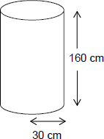
It is filled at the rate of 0.1 litres per second.
1 litre = 1000 cm³
Does it take longer than 1 hour to fill the tank?
You must show your working.
_______________________________________________________________________
_______________________________________________________________________
_______________________________________________________________________
_______________________________________________________________________
_______________________________________________________________________
_______________________________________________________________________
Answer ______________________________
(Total 4 marks)

Q4.
Volume of a sphere = πr³
A steel sphere, radius 3 cm, is shown.
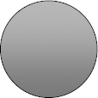
(a) Work out the volume of the sphere.
___________________________________________________________________
___________________________________________________________________
Answer ______________________ cm³
(2)
(b) The density of the steel is 5.2 grams/cm³
Work out the mass of the sphere.
___________________________________________________________________
___________________________________________________________________
Answer ____________________ grams
(2)
(Total 4 marks)

END OF CHECKPOINT

