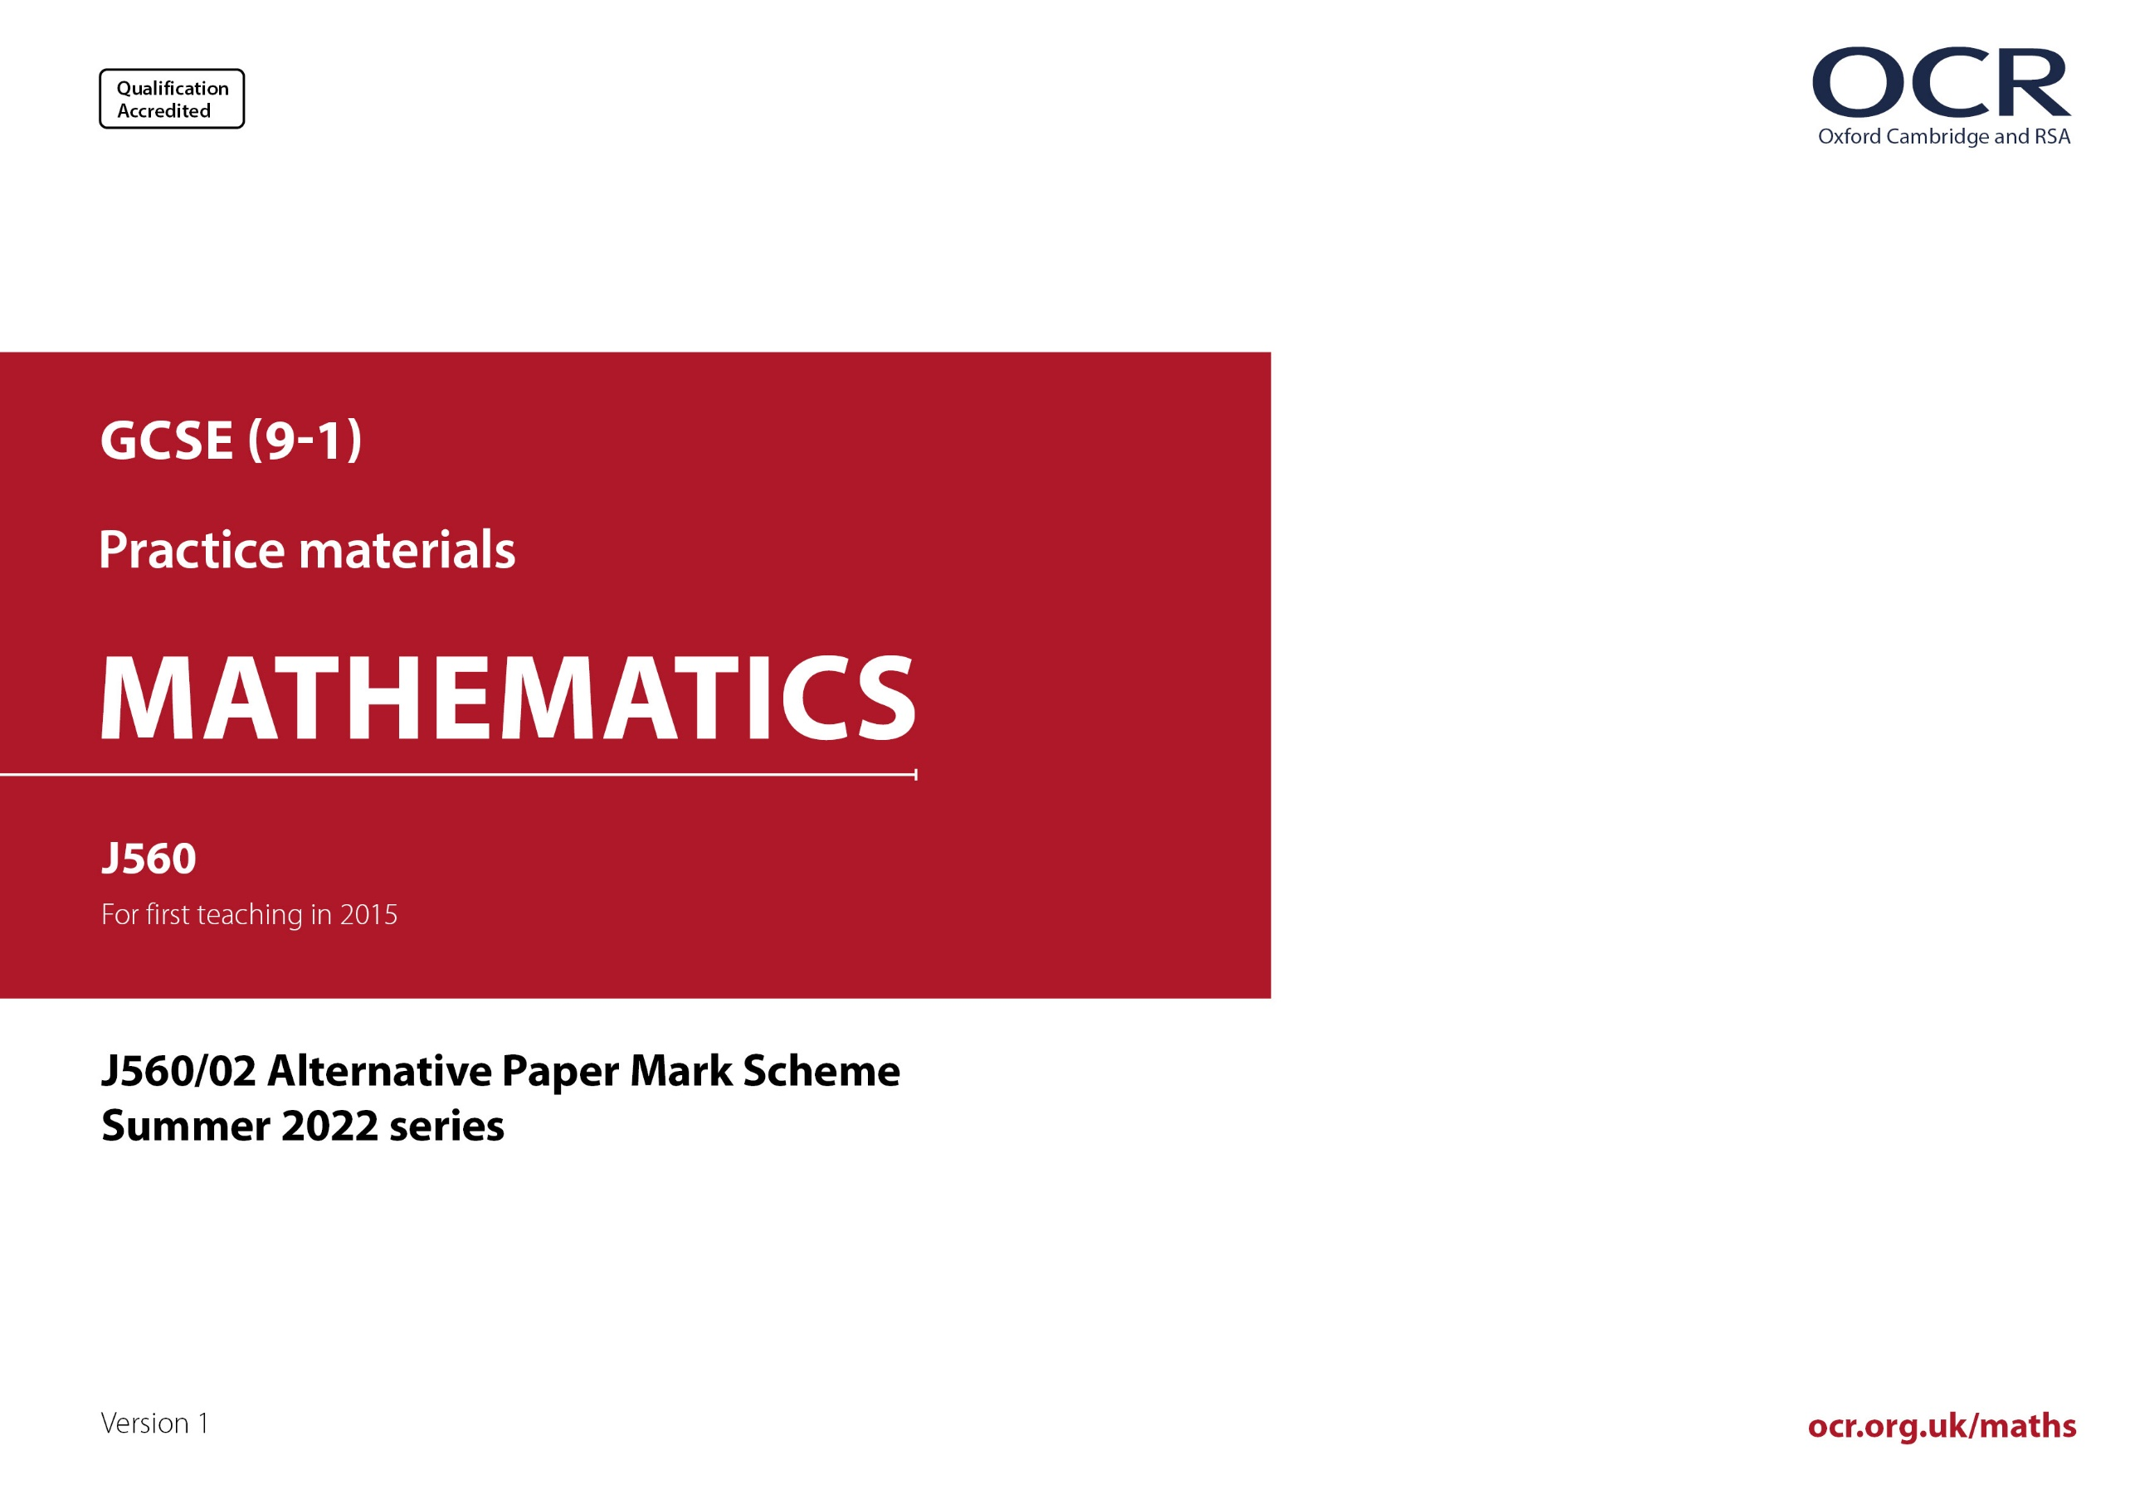
ocr.org.uk/maths

J560/02 Mark Scheme

- M marks are for using a correct method and are not lost for purely numerical errors.
A marks are for an accurate answer and depend on preceding M (method) marks. Therefore M0 A1 cannot be awarded.
B marks are independent of M (method) marks and are for a correct final answer, a partially correct answer, or a correct intermediate stage.
SC marks are for special cases that are worthy of some credit.

- The following abbreviations are commonly found in GCSE Mathematics mark schemes.

  - figs 237, for example, means any answer with only these digits. You should ignore leading or trailing zeros and any decimal point
e.g. 237000, 2.37, 2.370, 0.00237 would be acceptable but 23070 or 2374 would not.
  - isw means ignore subsequent working after correct answer obtained and applies as a default.
  - nfww means not from wrong working.
  - oe means or equivalent.
  - rot means rounded or truncated.
  - soi means seen or implied.
  - dep means that the marks are dependent on the marks indicated. You must check that the candidate has met all the criteria specified for the mark to be awarded.
  - with correct working means that full marks must not be awarded without some working. The required minimum amount of working will be defined in the guidance column and SC marks given for unsupported answers.
- Anything in the mark scheme which is in square brackets […] is not required for the mark to be earned, but if present it must be correct.

- Unless the command word requires that working is shown and the working required is stated in the mark scheme, then if the correct answer is clearly given and is not from wrong working full marks should be awarded.

Do not award the marks if the answer was obtained from an incorrect method, i.e. incorrect working is seen and the correct answer clearly follows from it.

- Where follow through (FT) is indicated in the mark scheme, marks can be awarded where the candidate’s work follows correctly from a previous answer whether or not it was correct. For questions with FT available you must ensure that you refer back to the relevant previous answer. You may find it easier to mark these questions candidate by candidate rather than question by question.

Figures or expressions that are being followed through are sometimes encompassed by single quotation marks after the word their for clarity, e.g. FT 180 × (their ‘37’ + 16), or FT 300 – √(their ‘52 + 72’). Answers to part questions which are being followed through are indicated by
e.g. FT 3 × their (a).

- In questions with no final answer line, make no deductions for wrong work after an acceptable answer (i.e. isw) unless the mark scheme says otherwise, indicated by the instruction ‘mark final answer’.

- In questions with a final answer line and incorrect answer given:

(i) If the correct answer is seen in the body of working and the answer given on the answer line is a clear transcription error allow full marks unless the mark scheme says ‘mark final answer’. Place the annotation next to the correct answer.

(ii) If the correct answer is seen in the body of working but the answer line is blank, allow full marks. Place the annotation next to the correct answer.

(iii) If the correct answer is seen in the body of working but a completely different answer is seen on the answer line, then accuracy marks for the answer are lost. Method marks could still be awarded if there is no other method leading to the incorrect answer. Use the M0, M1, M2 annotations as appropriate and place the annotation next to the wrong answer.

- In questions with a final answer line:

(i) If one answer is provided on the answer line, mark the method that leads to that answer. A correct step, value or statement that is not
part of the method that leads to the given answer should be awarded M0 and/or B0.

(ii) If more than one answer is provided on the answer line and there is a single method provided, award method marks only.

(iii) If more than one answer is provided on the answer line and there is more than one method provided, award marks for the poorer response unless the candidate has clearly indicated which method is to be marked.

- In questions with no final answer line:

(i) If a single response is provided, mark as usual.

(ii) If more than one response is provided, award marks for the poorer response unless the candidate has clearly indicated which response is to be marked.

- When the data of a question is consistently misread in such a way as not to alter the nature or difficulty of the question, please follow the candidate’s work and allow follow through for A and B marks. Deduct 1 mark from any A or B marks earned and record this by using the MR annotation. M marks are not deducted for misreads. If a candidate corrects the misread in a later part, do not continue to follow through, but award A and B marks for the correct answer only.

- Unless the question asks for an answer to a specific degree of accuracy, always mark at the greatest number of significant figures even if this is rounded or truncated on the answer line. For example, an answer in the mark scheme is 15.75, which is seen in the working. The candidate then rounds or truncates this to 15.8, 15 or 16 on the answer line. Allow full marks for the 15.75.

- Ranges of answers given in the mark scheme are always inclusive.

- For methods not provided for in the mark scheme give as far as possible equivalent marks for equivalent work. If in doubt, consult your Team Leader.

- If in any case the mark scheme operates with considerable unfairness consult your Team Leader.

Question |  |  | Answer | Marks | Part marks and guidance
1 | (a) | (i) | -1 | 1
 | (a) | (ii) | -8 | 1
 | (a) | (iii) | $\frac{\text{4}}{\text{5}}$ | 1
 | (a) | (iv) | 3$\frac{\text{3}}{\text{4}}$ | 1 |  | Accept 3.75  Accept an equivalent fraction but do not accept $\frac{\text{7.5}}{\text{2}}$
 | (b) |  | 7 | 2 | B1 for answer 2 or 5  or 7 with one or both other prime numbers. | e.g. B1 for 2 × 5 × 7
2 | (a) |  | $\frac{\text{2}}{\text{5}}$ | 1 |  | Condone $\frac{\text{2}\text{k}}{\text{5}\text{k}}$
 | (b) |  | 25 | 1
 | (c) |  | $\frac{\text{3}}{\text{5}}$final answer | 2 | M1 for $\frac{\text{6}}{\text{10}}$or an equivalent fraction  After 0 scored, SC1 for their fraction written in simplest form | SC1 dep on a fraction that simplifies
 | (d) |  | 24 | 2 | M1 for 0.6 × 40 or 4 × 6 oe  After 0 scored, SC1 for 24% | Allow M1 for complete attempt at ‘chunking’ e.g., 10% = 4 [repeated 6 times] oe
3 |  |  | 12 | 2 | M1 for any valid complete method  e.g. 100 ÷ 25 × 3 oe  soi by 4 × 3 or 300 ÷ 25 | For M1 accept  25, 50, 75,… [up to] 300  or 300, 275, 250,… [down to] 0  with one arithmetic slip condoned
4 | (a) |  | $\frac{\text{5}}{\text{8}}$ | 1 |  | In (a) and (b) accept equivalent fractions, decimals or %’s with the % sign  Isw attempts to convert after correct answer seen  Do not accept ratio or words
 | (b) |  | $\frac{\text{1}}{\text{4}}$ | 2 | M1 for 12 and 18 chosen | Accept $\frac{\text{2}}{\text{8}}$  For M1 12 and 18 may be circled or underlined – intention that only these 2 numbers selected must be clear
5 |  |  | 2 : 3 final answer | 2 | B1 for any ratio equivalent to 3 : $\text{4}\frac{\text{1}}{\text{2}}$ except 3 : 4.5 and 3 : $\frac{\text{9}}{\text{2}}$ | 2 marks for 1 : 1.5 or 1 : $\frac{\text{3}}{\text{2}}$ or $\frac{\text{2}}{\text{3}}$ : 1  For B1 isw
6 | (a) |  | Correct bar at 46 | 1 |  | Accept clear intention but do not accept a vertical line to 46
 | (b) |  | No, not true with valid supporting reason | 1 |  | e.g. 100% being the same as all students who cycled oe  e.g. percentage cannot be greater than 100% in this context oe  If values are used, they must be correct  Any incorrect statement invalidates the mark  See Appendix
 | (c) |  | 6 | 3 | M2 for $\frac{\text{42}}{\text{700}}$ × 100 oe  or  M1 for $\frac{\text{42}}{\text{700}}$ oe or $\frac{\text{n}}{\text{700}}$ × 100 oe | e.g. 42 ÷ 7  n < 60
7 | (a) |  | 3x + 15 final answer | 1
 | (b) |  | t = $\frac{\text{r} \text{+} \text{3}}{\text{5}}$ or t = $\frac{\text{r}}{\text{5}}$ + $\frac{\text{3}}{\text{5}}$ | 2 | M1 for r + 3 = 5t or for $\frac{\text{r}}{\text{5}}$ = t - $\frac{\text{3}}{\text{5}}$  or for answer $\frac{\text{r}\text{ + 3}}{\text{5}}$ or $\frac{\text{r}}{\text{5}}$ + $\frac{\text{3}}{\text{5}}$  or for correct step to answer after incorrect first step shown
8 | (a) | (i) | 4.6[0] | 1
 | (a) | (ii) | [0].8 | 1
 | (b) |  | 0.36 | 3 | B2 for figs 36 in final answer  or 1.8 oe nfww  or (2.6 – their $\frac{\text{4}}{\text{5}}$) × 0.2 evaluated accurately  or their (2.6 – 0.8) × 0.2 evaluated accurately  or  B1 for [ $\frac{\text{4}}{\text{5}}$ = ] 0.8  or (2.6 – their $\frac{\text{4}}{\text{5}}$) evaluated accurately  or the result of their (2.6 – their $\frac{\text{4}}{\text{5}}$) × 0.2 evaluated accurately | i.e. B2 for two accurate processes  or B1 for one accurate process
9 |  |  | 195 | 4 | B1 for 50 [adults]  and  M2 for 30 × 1.5 + (their 50) × 3 soi  or M1 for 30 × 1.5  or (their 50) × 3 | For M2 and M1 their 50 must be an integer  The addition may be implied by their answer  May be implied by 45  May be implied by their 150
10 |  |  | 35.91 with correct working | 6 | M1 for $\frac{\text{1}}{\text{2}}$ × 10 × 25 oe  A1 for 125  M1 for their area ÷ 15 soi by 8.3...  or repeated addition of 15 to at least 120  or to the multiple of 15 below their area oe  A1FT for [number of bags =] 9 or  their area ÷ 15 rounded up to an integer  M1 for k × 3.99  A1FT for 35.91 or k × 3.99 evaluated correctly  If 0 or M1 scored, instead award SC2 for answer 35.91 with no or insufficient working. | correct working requires evidence of at least M1M1  125 implies M1A1  From an area, not a perimeter or length  Allow 1 arithmetic slip in their list  May be implied by their final calculation of cost  Where k is an integer but not k = 1 or 10  Mark the calculation that leads to their final answer
11 | (a) |  | Correct, labelled pie chart with correct working | 6 | M2 for 360 – (140 + 80 +30) oe  or M1 for 140 + 80 + 30  AND  M1 for $\frac{\text{3}}{\text{5}}$× their 110 oe  A1 for 66  or  M1 for $\frac{\text{2}}{\text{5}}$ × their 110 oe  A1 for 44  AND  B1 for ruled line at 66˚  B1 for their larger sector labelled ‘bus’ and smaller sector labelled ‘car’ | “correct working” requires at least M1M1 and ruled line  If there are labelled angles, mark the method that leads to the angles  If angles are not shown mark worst method  May be implied by 110  May be implied by 250  Mark to the candidate’s advantage  Their 110 < 360  66 implies M1A1  44 implies M1A1  Tolerance ± 2˚ only if correct working seen.
 | (b) |  | Walk | 1
12 | (a) |  | Correct comment about large numbers or too many zeros oe | 1 |  | e.g.  Standard form is used for [very] large/long numbers [or very small numbers]  Writing out all the zeros may lead to errors  See Appendix
 | (b) |  | 1.8 × 10⁸ | 3 | M2 for figs 18 in final answer  or  B1 for 210 000 000 or 30 000 000  or 21 × 10⁷ or 0.3 × 10⁸  or M1 for 2.1 × 10⁸ – 3 × 10⁷ oe | Accept both converted to same power of 10 e.g. 210 × 10⁶ and 30 × 10⁶  For M1, if standard form subtraction written correctly, isw incorrect conversion to values
13 | (a) |  | 4 | 1
 | (b) |  | 24 | 2 | B1 for answer that is a multiple of 6 (not 6 or 12) but not a multiple of 36 and is less than 576  or n × 6 seen leading to the answer | 24 scores 2 marks from any method  Allow B1 for a correct equivalent to 24 of form a$\sqrt{\text{b}}$ (a ≠ 1) e.g. 6$\sqrt{\text{16}}$, 4$\sqrt{\text{36}},$2$\sqrt{\text{144}}$  n = 2^{k} where k is an integer > 1
14 |  |  | Translation  $\left({\text{-7} \atop \text{3}}\right)$  Rotation  180[°] [clockwise/anticlockwise]  [Centre] (0, 1) | 1  2  1  1  1 | or 7 left and 3 up  B1 for each component of the vector  or 7 left or 3 up  or SC1 for ( $\frac{\text{-7}}{\text{3}}$) or $\left({\text{3} \atop \text{-7}}\right)$ | For each statement marks spoilt if extra transformations  For each statement treat extra descriptors as choice  Mark statement 1 and 2 independently unless a single transformation is described across the entire answer space  Condone omission of brackets  Do not allow a coordinate  Condone omission of brackets  Allow  1 for [negative] enlargement  1 for scale factor -1  1 for [centre] (0, 1)
15 |  |  | 5 | 3 | B1 for y = $\frac{\text{k}}{\text{x}}$ oe soi by 10 = $\frac{\text{k}}{\text{8}}$ or k = 80  M1 for [y =] $\frac{\text{their k}}{\text{16}}$  OR  M2 for 10 × 8 = y × 16 or better  or  M1 for 10 × 8  Alternative method:  M2 for 10 ÷ (16 ÷ 8)  or M1 for 16 ÷ 8  If 0 scored SC1 for answer of 20 | e.g. for 2 marks $\frac{\text{80}}{\text{16}}$ oe  Implied by 80  May be seen in a table:  M2 for × 2 oe and ÷ 2 oe  or M1 for × 2 oe  × 2  ÷ 2
  x | 8 | 16
  y | 10
16 | (a) |  | x + 160 | 1
 | (b) |  | 200 nfww | 4 | B1 for 5x  M1 for 5x = their (x + 160)  A1FT for x = 40 | their (x + 160) cannot be numeric and must lead to an equation that can be solved when equated to 5x  e.g. if their (x + 160) is 5x then M0  FT correctly solving their linear equation in x
17 | (a) |  | [0].22 oe | 2 | M1 for 1 – (0.06 + 0.72) oe | Accept e.g. 22%, 22/100 oe  M1 implied by 1 – 0.78
 | (b) |  | 232 [points]  and  No/Darcy is not correct oe | 4FT | B3 for 232 or 144 + 4 × their 0.22 × 100 correctly evaluated  or  M2 for [0.06 × 0 × 100 + ](2 × 0.72 × 100) + (4 × their 0.22 × 100) or better  or  M1 for 2 × 0.72 and 4 × their 0.22  or for one of (2 × 0.72 × 100), (4 × their 0.22 × 100)  FT dep on B3 for correct conclusion from their 0.22 | M2 for full method implied by 144 + 88  or 2.32 × 100  M1 implied by 1.44 and [0].88 or 2.32 or one of 144, 88  For conclusion accept e.g.  232 and No,  232 > 230  If FT from e.g. 0.12 in (a) then 192 and yes gets 4FT
18 |  |  | 75 with correct working | 5 | M4 for 30 × $\frac{\text{5}}{\text{2}}$ oe or 6 × $\frac{\text{25}}{\text{2}}$ oe or 24 × $\frac{\text{25}}{\text{8}}$ oe or 45 × $\frac{\text{5}}{\text{3}}$ oe  or M3 for $\frac{\text{3}}{\text{5}}$ + $\frac{\text{6}}{\text{n}}$ +$\frac{\text{4} \text{×} \text{6}}{\text{n}}$ [= 1] oe or $\frac{\text{2}}{\text{5}}$ = $\frac{\text{6} \text{+} \text{4} \text{×} \text{6}}{\text{n}}$ oe  or $\frac{\text{1}}{\text{5}}$ of $\frac{\text{2}}{\text{5}}$ = $\frac{\text{6}}{\text{n}}$ oe or $\frac{\text{4}}{\text{5}}$ of $\frac{\text{2}}{\text{5}}$ = $\frac{\text{4} \text{×} \text{6}}{\text{n}}$ oe  or M2 for $\frac{\text{4} \text{×} \text{6}}{\text{n}}\text{+}\frac{\text{6}}{\text{n}}$ oe  or M1 for $\frac{\text{4} \text{×} \text{6}}{\text{n}}$ oe  OR  M2 for [no. of R + B =] 6 + 4 × 6 oe  or M1 for [no. of R =] 4 × 6 oe  B2 for no. of green = 45  or M1 for ratio of G : R + B = 3 : 2 oe  OR  M2 for [no. of R + B =] 6 + 4 × 6 oe  or M1 for [no. of R =] 4 × 6 oe  M1 $\frac{\text{2}}{\text{5}}\text{[}\text{n}\text{]}$ is 6 + 4 × 6 oe  A1 $\frac{\text{1}}{\text{5}}\text{[}\text{n}\text{]}$ is 15 oe  If 0 or M1 scored, instead award SC2 for answer 75 with no or insufficient working.  If 0 scored, SC1 for $\frac{\text{1}}{\text{5}}\text{[}\text{n}\text{]}$ oe is 15 with no working. | “correct working” requires at least M2  M4 for any fully correct method  e.g. For M3 accept e.g. $\frac{\text{2}}{\text{5}}$ = 30,  $\frac{\text{2}}{\text{25}}\text{=} \text{6, }\frac{\text{8}}{\text{25}}$ = 24 or $\frac{\text{3}}{\text{5}}\text{=45}$ oe,  x = $\frac{\text{2}}{\text{25}}$ oe (where x is probability of B)  M2 for 4x + x = $\frac{\text{2}}{\text{5}}$ oe (from x = P(B))  M2 implied by [no. R + B =] 6 + 24 or 30  M1 for e.g. G = $\frac{\text{3}}{\text{5}}$, R + B = $\frac{\text{2}}{\text{5}}$  M2 implied by [no. R + B =] 6 + 24 or 30  May work in equivalent decimals or percentages e.g. 40% is 30, 20% is 15
19 | (a) |  | $$\frac{\text{1}}{\text{2}}$$ | 1
 | (b) |  | 9 | 2FT | B2FT for final answer 6, 9$\sqrt{3}$, 6$\sqrt{3}$ or 4.5 or 4½ if consistent with their (a)  or  M1 for 18 × $\frac{\text{1}}{\text{2}}$ or 18 × their (a) | For 1 or 2 marks, isw attempts to simplify the surds  May be implied by their answer  Ignore units
20 |  |  | y = 3x – 21 with correct working | 5 | M1 for attempt at $\frac{\text{change in y}}{\text{change in x}}$  A1 for ‘m’ = 3  M1 for 0 = their ‘m’ × 7 + ‘c’  or -12 = their ‘m’ × 3 + ‘c’  or for $\frac{\text{7}}{\text{4}}$ × [±]12 oe  A1 for ‘c’ = -21  If 0 scored, SC1 for implying the y-intercept is -21 with no or insufficient working, may be seen on the diagram  or for D is (3, -12) | ‘correct working’ requires evidence of at least M1M1 or M1A1  may be implied on the diagram or may be implied by -3  M1A1 soi by [‘m’ =] 3  Allow FT from D or their D stated  may be implied on the diagram
21 | (a) |  | x² + 3x + 5x + 15 [= x² + 8x +15]  Taylor with a correct statement about definition of an identity or of an equation  or  Taylor with correct supporting work and statement | M1  B1 | Alternative Method  M1 for shows LHS = RHS for at least three values of x  B1 dep for Taylor with their correct statement e.g. a quadratic equation does not have three solutions [so by elimination it is an identity] | May be seen in the work space or within their statement and it might be seen in e.g. a table where the addition can be implied  e.g. an identity is true for all values of x  or  e.g. this cannot be solved to get a value of x  or  e.g. left-hand side is the same as the right-hand side  Accept “neither, because if it was an identity then it would have ≡”  See Appendix
 | (b) |  | (x + 9) (x – 2)  -9 and 2 final answer | M2  B1FT | M1 for (x + a)(x + b) where  a + b = 7 or ab = -18  or for x + 9 [= 0] and x – 2 [= 0]  strict FT for correct solutions from their quadratic factors  If 0 scored SC1 for answer ±2 and ±9 | For M2 or M1 condone omission of final bracket  e.g. (x + 5)(x + 2) as a + b = 7  or e.g. (x – 9)(x + 2) as ab = -18  e.g. FT x = -5 and x = -2 from  (x + 5)(x + 2)
22 |  |  | Accurate ruled angle bisector with two pairs of supporting arcs isw  Accurate ruled perpendicular bisector with two correct pairs of intersecting arcs isw  2 correct regions shaded/clearly indicated with no extras | B2  B2  B2 dep | B1 for accurate angle bisector at least  2 cm long with no/incorrect arcs isw  B1 for accurate perpendicular bisector at least 2 cm long with no/incorrect arcs isw  Dep on at least B1B1  B1dep for 1 correct region with no extras or 2 correct regions and one extra | For B2 allow use of the arc around B as one pair – at least 2 cm long for B2  Tolerance ±2˚  Tolerance ±2° and ±2 mm  At least 2 cm long for B2 but must remain in tolerance if extended within shape for B1 and B2  B1dep on B1 for angle bisector for region bounded by angle bisector  or dep on B1B1 for region bounded by both bisectors and arc  See Appendix for solution

Appendix

Exemplar responses for Question 6b

 | Response | Mark
1 | No because 100% means everyone | 1
2 | No that would be all of the students and more (this would also score if they hadn’t stated ‘and more’) | 1
3 | No There can only be 100% of the students | 1
4 | No it is over 100% meaning all of them would have cycled to school | 1
5 | No 125% means all students cycled to school (we can condone use of 125% as ‘all would have cycled’) | 1
6 | This could not be true as not everyone cycled to school (could not be true is fine to imply ‘no’) | 1
7 | This could not be true as 125% is 1.25 times more students which is impossible (BOD ‘more’) | BOD 1
8 | No it cannot because 125% is more than the total which isn’t possible (BOD ‘total’ implies students) | BOD 1
9 | No, that is more students than there is in the school (BOD a % rather than 125 as there are 700) | BOD 1
10 | No because how can more than 100% cycle (the word cycle is referring to the context) | BOD 1
11 | No because only 25 students cycled (needs reference to all or less than 100%) | 0
12 | No because 125% of all students would be over 70 and only 25 cycled on Wednesday (should be 700) | 0
13 | No because it’s less than the number of people in the school (interpreted as 125 rather than 125%) | 0
14 | No, 25/700 isn’t 125% (true but doesn’t answer the question with reference to 125% >100%) | 0
15 | No this could not be true as 100% is all the students. There were 55 students who didn’t cycle on Monday (The 1st sentence alone would score, but the additional incorrect statement loses the mark) | 0
 | All of the following score 0 as they do not refer to the context of the question
16 | No, it could only be out of 100% | 0
17 | No because the percent is out of 100 | 0
18 | No because 125% is impossible | 0
19 | No there should always be 100% | 0

Exemplar responses for Question 12a

 | Response | Mark
1 | Writing all the 0’s out is very long/difficult to read/may lead to errors | 1
2 | As they would contain a lot of 0s | 1
3 | Because there would be too many zeros | 1
4 | Because the numbers would be extremely long/high/large. | 1
5 | Because of how long/high/large the number would be | 1
6 | The numbers would be too long to write down e.g. 3 x 10⁷ = 30 000 000 | 1
7 | It shortens the numbers due to them having so many 0s | 1
8 | Because they’re too big (Given the wording of the demand – refers to numbers) | 1
9 | It takes too long to write it all out | 1
10 | Because the digits will be too long (BOD infers numbers are too long) | BOD 1
11 | Wastes time writing out the digits, standard form is simple shorthand (similar to above) | BOD 1
12 | To makes it easier to read (no reason given as to why) | 0
13 | To make the numbers more simpler (no reason given e.g. numbers too large, too many zeros) | 0
14 | It’s easier to understand (no reason given as to why) | 0
15 | Because otherwise you need to write 3 million so 3 x 10⁷ is easier to say in standard form  (Contains error in number, if 30 million this would be OK) | 0
16 | Because the numbers are billions so it’s easier to read them in standard form (as above) | 0
17 | It shortens the numbers (no reason given why e.g. too large, too many zeros) | 0

Exemplar responses for Question 21a

 | Response for the B marks | Mark
1 | Taylor – the expression before and after the equal sign are the same (‘same’ implies identical in form) | 1
2 | Taylor – (x + 3)(x + 5) is the same as x² + 8x + 15 | 1
3 | Taylor – the statement in the box doesn’t gives a value, an equation would be to find a specific number | 1
4 | Identity – (x + 3)(x + 5) has the same answer expanded as x² + 8x + 15 (condone identity instead of Taylor) | 1
5 | Taylor – they are written differently but are equal to the same (this is ok to score as they have clarified that the 2 sides are the same but in different forms) | 1 BOD
6 | Taylor – (x + 3)(x + 5) is equal x² + 8x + 15 when expanded | 0
7 | Taylor there is nothing to work out (not enough) | 0
8 | Taylor – it is identifying how each formula is equal to each other (equal to each other is not enough) | 0
9 | Taylor – you’re not asked to work anything out, it gives you the answer (they say you’re not asked to work it out rather than saying it cannot be solved) | 0

Correct answer for Question 22

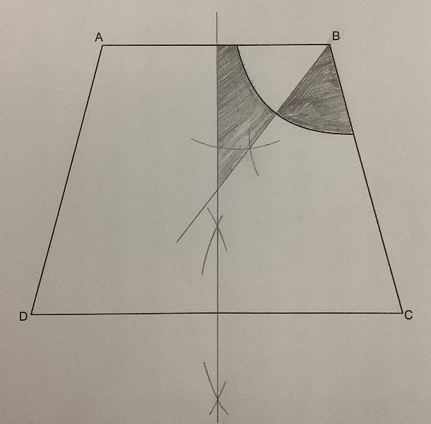



We’d like to know your view on the resources we produce. Click ‘Like’ or ‘Dislike’ to send us an auto generated email about this resource. Add comments if you want to. Let us know how we can improve this resource or what else you need. Your email will not be used or shared for any marketing purposes.
Looking for another resource? There is now a quick and easy search tool to help find free resources for your qualification.
OCR is part of Cambridge University Press & Assessment, which is itself a department of the University of Cambridge.
For staff training purposes and as part of our quality assurance programme your call may be recorded or monitored.
Oxford Cambridge and RSA Examinations is a Company Limited by Guarantee. Registered in England. Registered office The Triangle Building, Shaftesbury Road, Cambridge, CB2 8EA.
Registered company number 3484466. OCR is an exempt charity.
OCR operates academic and vocational qualifications regulated by Ofqual, Qualifications Wales and CCEA as listed in their qualifications registers including A Levels, GCSEs, Cambridge Technicals
and Cambridge Nationals.
OCR provides resources to help you deliver our qualifications. These resources do not represent any teaching method we expect you to use. We update our resources regularly and aim to make sure content is accurate but please check the OCR website so that you have the most up to date version. OCR cannot be held responsible for any errors or omissions in these resources.
Though we make every effort to check our resources, there may be contradictions between published support and the specification, so it is important that you always use information in the latest specification. We indicate any specification changes within the document itself, change the version number and provide a summary of the changes. If you do notice a discrepancy between the specification and a resource, please contact us.
© OCR 2023 - You can copy and distribute this resource freely if you keep the OCR logo and this small print intact and you acknowledge OCR as the originator of the resource.
OCR acknowledges the use of the following content: N/A
Whether you already offer OCR qualifications, are new to OCR or are thinking about switching, you can request more information using our Expression of Interest form.
Please get in touch if you want to discuss the accessibility of resources we offer to support you in delivering our qualifications.

