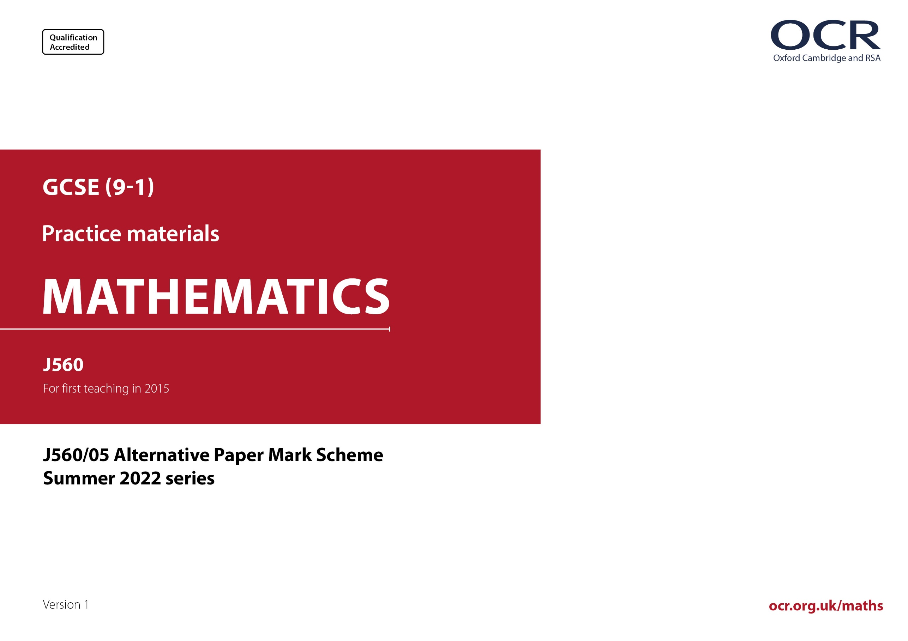
ocr.org.uk/maths

J560/05 Mark Scheme

- M marks are for using a correct method and are not lost for purely numerical errors.
A marks are for an accurate answer and depend on preceding M (method) marks. Therefore M0 A1 cannot be awarded.
B marks are independent of M (method) marks and are for a correct final answer, a partially correct answer, or a correct intermediate stage.
SC marks are for special cases that are worthy of some credit.

- The following abbreviations are commonly found in GCSE Mathematics mark schemes.

  - figs 237, for example, means any answer with only these digits. You should ignore leading or trailing zeros and any decimal point
e.g. 237000, 2.37, 2.370, 0.00237 would be acceptable but 23070 or 2374 would not.
  - isw means ignore subsequent working after correct answer obtained and applies as a default.
  - nfww means not from wrong working.
  - oe means or equivalent.
  - rot means rounded or truncated.
  - soi means seen or implied.
  - dep means that the marks are dependent on the marks indicated. You must check that the candidate has met all the criteria specified for the mark to be awarded.
  - with correct working means that full marks must not be awarded without some working. The required minimum amount of working will be defined in the guidance column and SC marks given for unsupported answers.
- Anything in the mark scheme which is in square brackets […] is not required for the mark to be earned, but if present it must be correct.

- Unless the command word requires that working is shown and the working required is stated in the mark scheme, then if the correct answer is clearly given and is not from wrong working full marks should be awarded.

Do not award the marks if the answer was obtained from an incorrect method, i.e. incorrect working is seen and the correct answer clearly follows from it.

- Where follow through (FT) is indicated in the mark scheme, marks can be awarded where the candidate’s work follows correctly from a previous answer whether or not it was correct. For questions with FT available you must ensure that you refer back to the relevant previous answer. You may find it easier to mark these questions candidate by candidate rather than question by question.

Figures or expressions that are being followed through are sometimes encompassed by single quotation marks after the word their for clarity, e.g. FT 180 × (their ‘37’ + 16), or FT 300 – √(their ‘52 + 72’). Answers to part questions which are being followed through are indicated by
e.g. FT 3 × their (a).

- In questions with no final answer line, make no deductions for wrong work after an acceptable answer (i.e. isw) unless the mark scheme says otherwise, indicated by the instruction ‘mark final answer’.

- In questions with a final answer line and incorrect answer given:

(i) If the correct answer is seen in the body of working and the answer given on the answer line is a clear transcription error allow full marks unless the mark scheme says ‘mark final answer’. Place the annotation next to the correct answer.

(ii) If the correct answer is seen in the body of working but the answer line is blank, allow full marks. Place the annotation next to the correct answer.

(iii) If the correct answer is seen in the body of working but a completely different answer is seen on the answer line, then accuracy marks for the answer are lost. Method marks could still be awarded if there is no other method leading to the incorrect answer. Use the M0, M1, M2 annotations as appropriate and place the annotation next to the wrong answer.

- In questions with a final answer line:

(i) If one answer is provided on the answer line, mark the method that leads to that answer. A correct step, value or statement that is not
part of the method that leads to the given answer should be awarded M0 and/or B0.

(ii) If more than one answer is provided on the answer line and there is a single method provided, award method marks only.

(iii) If more than one answer is provided on the answer line and there is more than one method provided, award marks for the poorer response unless the candidate has clearly indicated which method is to be marked.

- In questions with no final answer line:

(i) If a single response is provided, mark as usual.

(ii) If more than one response is provided, award marks for the poorer response unless the candidate has clearly indicated which response is to be marked.

- When the data of a question is consistently misread in such a way as not to alter the nature or difficulty of the question, please follow the candidate’s work and allow follow through for A and B marks. Deduct 1 mark from any A or B marks earned and record this by using the MR annotation. M marks are not deducted for misreads. If a candidate corrects the misread in a later part, do not continue to follow through, but award A and B marks for the correct answer only.

- Unless the question asks for an answer to a specific degree of accuracy, always mark at the greatest number of significant figures even if this is rounded or truncated on the answer line. For example, an answer in the mark scheme is 15.75, which is seen in the working. The candidate then rounds or truncates this to 15.8, 15 or 16 on the answer line. Allow full marks for the 15.75.

- Ranges of answers given in the mark scheme are always inclusive.

- For methods not provided for in the mark scheme give as far as possible equivalent marks for equivalent work. If in doubt, consult your Team Leader.

- If in any case the mark scheme operates with considerable unfairness consult your Team Leader.

Question |  |  | Answer | Marks | Part marks and guidance
1 | (a) |  | Two correct different observations from these three categories  No values shown  e.g. Pie chart only shows proportions not totals  3D aspect  e.g. 3D distorts perspective oe  Colours/key unclear  e.g. The colour/key are too similar oe | 2 | B1 for one correct observation | e.g. We have no total/numbers/figures/frequency  e.g. It’s tilted, slanted, seen from an angle, etc  Where more than two reasons are given, mark the best unless contradicted e.g. ignore all references to missing angles  Do not allow 2 marks for two reasons that refer to the same category  Two reasons may appear in the same statement  e.g. Its slanted and it does not show the total number [gets 2 marks]  See Appendix
1 | (b) |  | 60 | 4 | B1 for 0.5 and 0.8 or 3 [rows] and 5 [rows] oe  AND  M2 for $\frac{\text{their}\text{ 0.8} \text{-} \text{their}\text{ 0.5}}{\text{their}\text{ 0.5}}$ or $\frac{\text{their}\text{ 0.8 - }\text{their}\text{ 0.5}}{\text{their}\text{ 0.5}} \text{×} \text{100}$  or for $\frac{\text{their}\text{ 0.8}}{\text{their}\text{ 0.5}}$ × 100 [ –100] oe  or M1 for $\frac{\text{their}\text{ 0.8}}{\text{their}\text{ 0.5}}$ | Accept work in thousands for B and M marks  i.e. 500 000 and 800 000  M2 soi by 0.6[0] or 160  M1 soi by 1.6[0]
2 |  |  | Answer in range 36 to 42 | 4dep | Dep on B1B1  B1 for bearing of 078˚  B1 for bearing of 114˚  M1dep for 5 × their RL ±0.1cm soi | Bearings can be short lines. If no lines then L labelled can imply the bearings  Dep on L marked oe e.g. with cross etc or on 2 intersecting lines  Use ruler to measure RL  (Do not allow RS measured if no L)
3 | (a) |  | Correct comment about large numbers or too many zeros oe | 1 |  | e.g.  Standard form is used for [very] large/long numbers [or very small numbers]  Writing out all the zeros may lead to errors  See Appendix
3 | (b) |  | 1.8 × 10⁸ | 3 | M2 for figs 18 in final answer  or  B1 for 210 000 000 or 30 000 000  or 21 × 10⁷ or 0.3 × 10⁸  or M1 for 2.1 × 10⁸ – 3 × 10⁷ oe | Accept both converted to same power of 10 e.g. 210 × 10⁶ and 30 × 10⁶  For M1, if standard form subtraction written correctly, isw incorrect conversion to values
4 | (a) |  | 4 | 1
4 | (b) |  | 24 | 2 | B1 for answer that is a multiple of 6 (not 6 or 12) but not a multiple of 36 and is less than 576  or n × 6 seen leading to the answer | 24 scores 2 marks from any method  Allow B1 for a correct equivalent to 24 of form a$\sqrt{\text{b}}$ (a ≠ 1) e.g. 6$\sqrt{\text{16}}$, 4$\sqrt{\text{36}},$2$\sqrt{\text{144}}$  n = 2^{k} where k is an integer > 1
5 |  |  | 13.5 | 3 | M2 for 2 : 27 oe or for 9 ÷ $\frac{\text{2}}{\text{3}}$oe seen  or M1 for $\frac{\text{2}}{\text{3}}$ : 9 oe ratio seen  Alternative method in tablespoons:  M2 for $\frac{\text{2}}{\text{9}}$ : 3 oe seen  or M1 for $\frac{\text{2}}{\text{3}}$ × $\frac{\text{1}}{\text{3}}$ [: 3] oe seen | For M1 e.g. 0.67 : 9  M2 for e.g. 1 : $\frac{\text{27}}{\text{2}}$ oe  If in decimal form allow 0.33 for $\frac{\text{1}}{\text{3}}$ and 0.22 for $\frac{\text{2}}{\text{9}}$
6 | (a) |  | [0].22 oe | 2 | M1 for 1 – (0.06 + 0.72) oe | Accept e.g. 22%, 22/100 oe  M1 implied by 1 – 0.78
6 | (b) |  | 232 [points]  and  No/Darcy is not correct oe | 4FT | B3 for 232 or 144 + 4 × their 0.22 × 100 correctly evaluated  or  M2 for [0.06 × 0 × 100 + ](2 × 0.72 × 100) + (4 × their 0.22 × 100) or better  or  M1 for 2 × 0.72 and 4 × their 0.22  or for one of (2 × 0.72 × 100), (4 × their 0.22 × 100)  FT dep on B3 for correct conclusion from their 0.22 | M2 for full method implied by 144 + 88  or 2.32 × 100  M1 implied by 1.44 and [0].88 or 2.32 or one of 144, 88  For conclusion accept e.g.  232 and No,  232 > 230  If FT from e.g. 0.12 in (a) then 192 and yes gets 4FT
7 | (a) |  | s = 350 with 6, 5 and 10 or 100 seen | 4 | B2 for 6, 5 and 10 or 100  or B1 for two correct  AND  M1 for (5 × 10) + ½(6 × 10²) or correct substitution of unrounded or incorrectly rounded values  If 0 scored then SC1 for sight of 350 | For all marks condone e.g. 5.00, 6.0, 10.0 used  These values may be written in the stem of the question  For M1 e.g. allow a mixture  (4.92 × 10.3) + ½(6.1 × 10²)
7 | (b) |  | x = [±]$\sqrt{\frac{\text{2}\text{E}}{\text{k}}}$ oe final answer | 3 | M2 for first two steps correctly completed e.g. $\frac{\text{2}\text{E}}{\text{k}}$ $={\text{x}}^{\text{2}}$  or answer [±]$\sqrt{\frac{\text{2}\text{E}}{\text{k}}}$ (no x = )  or M1 for first step correctly completed e.g. 2E = kx² or $\frac{\text{E}}{\text{k}}\text{ =} \frac{\text{1}}{\text{2}}{\text{x}}^{\text{2}}$  If 0 scored, SC1 for final answer  x = [±]$\sqrt{\frac{\frac{\text{1}}{\text{2}}\text{E}}{\text{k}}}$ oe | Square root must dip below fraction line in final answer unless $\left(\frac{\text{2}\text{E}}{\text{k}}\right)$bracketed  For 3 marks oe e.g. x = [±]$\sqrt{\frac{\text{2} \text{×} \text{E}}{\text{k}}}$ , x = $\sqrt{\frac{\text{E}}{\frac{\text{1}}{\text{2}}\text{k}}}$  M2 for e.g. $\frac{\text{E}}{\frac{\text{k}}{\text{2}}}$ = x², $\frac{\text{E}}{\frac{\text{1}}{\text{2}}\text{k}}$= x², $\frac{\text{E}}{\text{0.5}\text{k}}$= x²  Allow M1 for $\frac{\text{E}}{\text{0.5}}\text{=} {\text{kx}}^{\text{2}}$ oe  oe for SC1 e.g. x = [±]$\sqrt{\frac{\text{E}}{\text{2}\text{k}}}$
8 |  |  | 75 with correct working | 5 | M4 for 30 × $\frac{\text{5}}{\text{2}}$ oe or 6 × $\frac{\text{25}}{\text{2}}$ oe or 24 × $\frac{\text{25}}{\text{8}}$ oe or 45 × $\frac{\text{5}}{\text{3}}$ oe  or M3 for $\frac{\text{3}}{\text{5}}$ + $\frac{\text{6}}{\text{n}}$ +$\frac{\text{4} \text{×} \text{6}}{\text{n}}$ [= 1] oe or $\frac{\text{2}}{\text{5}}$ = $\frac{\text{6} \text{+} \text{4} \text{×} \text{6}}{\text{n}}$ oe  or $\frac{\text{1}}{\text{5}}$ of $\frac{\text{2}}{\text{5}}$ = $\frac{\text{6}}{\text{n}}$ oe or $\frac{\text{4}}{\text{5}}$ of $\frac{\text{2}}{\text{5}}$ = $\frac{\text{4} \text{×} \text{6}}{\text{n}}$ oe  or M2 for $\frac{\text{4} \text{×} \text{6}}{\text{n}}\text{+}\frac{\text{6}}{\text{n}}$ oe  or M1 for $\frac{\text{4} \text{×} \text{6}}{\text{n}}$ oe  OR  M2 for [no. of R + B =] 6 + 4 × 6 oe  or M1 for [no. of R =] 4 × 6 oe  B2 for no. of green = 45  or M1 for ratio of G : R + B = 3 : 2 oe  OR  M2 for [no. of R + B =] 6 + 4 × 6 oe  or M1 for [no. of R =] 4 × 6 oe  M1 $\frac{\text{2}}{\text{5}}\text{[}\text{n}\text{]}$ is 6 + 4 × 6 oe  A1 $\frac{\text{1}}{\text{5}}\text{[}\text{n}\text{]}$ is 15 oe  If 0 or M1 scored, instead award SC2 for answer 75 with no or insufficient working.  If 0 scored, SC1 for $\frac{\text{1}}{\text{5}}\text{[}\text{n}\text{]}$ oe is 15 with no working. | “correct working” requires at least M2  M4 for any fully correct method  e.g. For M3 accept e.g. $\frac{\text{2}}{\text{5}}$ = 30,  $\frac{\text{2}}{\text{25}}\text{=} \text{6, }\frac{\text{8}}{\text{25}}$ = 24 or $\frac{\text{3}}{\text{5}}\text{=45}$ oe,  x = $\frac{\text{2}}{\text{25}}$ oe (where x is probability of B)  M2 for 4x + x = $\frac{\text{2}}{\text{5}}$ oe (from x = P(B))  M2 implied by [no. R + B =] 6 + 24 or 30  M1 for e.g. G = $\frac{\text{3}}{\text{5}}$, R + B = $\frac{\text{2}}{\text{5}}$  M2 implied by [no. R + B =] 6 + 24 or 30  May work in equivalent decimals or percentages e.g. 40% is 30, 20% is 15
9 |  |  | Accurate ruled angle bisector with two pairs of supporting arcs isw  Accurate ruled perpendicular bisector with two correct pairs of intersecting arcs isw  2 correct regions shaded/clearly indicated with no extras | B2  B2  B2 dep | B1 for accurate angle bisector at least  2 cm long with no/incorrect arcs isw  B1 for accurate perpendicular bisector at least 2 cm long with no/incorrect arcs isw  Dep on at least B1B1  B1dep for 1 correct region with no extras or 2 correct regions and one extra | For B2 allow use of the arc around B as one pair – at least 2 cm long for B2  Tolerance ±2˚  Tolerance ±2° and ±2 mm  At least 2 cm long for B2 but must remain in tolerance if extended within shape for B1 and B2  B1dep on B1 for angle bisector for region bounded by angle bisector  or dep on B1B1 for region bounded by both bisectors and arc  See Appendix for solution
10 | (a) |  | Triangle drawn with vertices at  (2, 6), (2, -4), (7, ⁻4) | 3 | B2 for scale factor 2.5 but wrong centre  or for correct centre but wrong scale factor  or for 3 correct plots but no triangle drawn  OR  B1 for 2 vertices correct | Condone freehand mark intention  e.g. B2 for a translation of the correct image  For B2 and B1 image must fit entirely on grid
10 | (b) |  | Rotation  180  (⁻3, 1) | 2  1  1 | or B1 for triangle or vertices at (⁻2, 2),  (⁻2, 6), (⁻4, 6) | Not turn, must be rotate or rotation  Accept:  Enlargement 2  [Scale factor =] -1 1  [Centre] (⁻3, 1) 1  Condone ⁻3, 1  Allow as answer [full and part marks]  Rotation, 180, (⁻3, 1)  followed by/and reflection in y-axis  (repeat of info in question)  but in other cases  If more than one other transformation given then B1 maximum if the triangle drawn on the grid  e.g. Rotation 180 then translate 6 down is two transformations  Extra properties treat as choice
11 |  |  | 0.5 oe final answer | 3 | B1 for y = $\frac{\text{k}}{{\text{x}}^{\text{2}}}$ oe soi by 8 = $\frac{\text{k}}{{\text{3}}^{\text{2}}}$ or k =72  M1 for y = $\frac{\text{their} \text{k}}{{\text{12}}^{\text{2}}}$  OR  M2 for 3² × 8 = 12² × y oe | oe e.g. for 3 marks $\frac{\text{72}}{\text{144}}$ oe
12 | (a) |  | 0 | 1
12 | (b) |  | 2 with correct working | 5 | M3 for method for three areas correct  or for 3000 or 900 and 1500 and 600  nfww  or M2 for method for two areas correct  (method towards two from 900, 1500, 600)  or M1 for method for one area correct (method towards 900 or 1500 or 600)  or for 1500 seen  AND  M1dep for their 3000 ÷ 1500, dep on at least M2  If 0 or 1 scored instead award SC2 for 2 with no or insufficient working but not from wrong working | “correct working” requires at least M3  Treat as three separate areas, so trapezium from 0 to 1500 is three areas, trapezium from 0 to 1100 is 2 areas, trapezium from 600 to 1500 is 2 areas.  For M marks, mark method not accuracy, so M1 for $\frac{\text{600 ×3}}{\text{2}}$ even if not evaluated as 900.
13 | (a) | (i) | 5 | 1
13 | (a) | (ii) | At x = 0 oe  and  y < 0 or y is negative or y = -4  or curve is below x-axis  and at x = 1 , y is positive or y > 0 or y = 5 or curve is above the x - axis  and  change of sign oe  [between x = 0 and x = 1]  or the curve crosses the x-axis between 0 and 1  or solution/q lies between 0 and 1 | 1  1dep | If y value evaluated then must be correct for 2 marks or 1 mark  Dep on first mark  If 0 scored, SC1 for change of sign oe  or the curve crosses the x-axis between 0 and 1 oe | For 2 marks needs to refer  x = 0 negative oe and x = 1 positive oe  and change of sign/graph crosses axis/solution between 0 and 1 oe  e.g.  For 2 marks  At x = 0 the curve is below the x–axis, at x = 1 the curve is above the x–axis so there is a change of sign  See Appendix
13 | (a) | (iii) | Correct response concerning accuracy/time taken/refer to specific more efficient methods  e.g.  Iteration gives an estimate oe  Iteration can be a lengthy process oe [to get an accurate result] | 1 |  | e.g. The quadratic formula/complete the square is quicker/more accurate/easier  Trial and improvement is less efficient/takes too long  You can always go to more decimal places  It will not give an exact/accurate answer  It will take many iterations  There are two solutions, iteration is used to find one at a time  Mark the best if more than one answer given  Do not accept incorrect statement  e.g. It would be quicker/easier to factorise the equation
13 | (b) |  | -4 + 2$\sqrt{\text{5}}$ final answer | 3 | B2 for answer p + 2$\sqrt{\text{5}}$  or M1 for [$\sqrt{\text{80}}$ =] 4$\sqrt{\text{5}}$ seen or $\frac{\sqrt{\text{80}}}{\sqrt{\text{4}}}$ seen  B1 for answer -4 + $\sqrt{\text{k}}$ or -4 + 2$\sqrt{\text{k}}$ | p ≠ 0  k > 0 but not 80
14 | (a) |  | 54 | 4 | B3 for x = 15  or  M2 for 3(x + 11) = 2(x + 24) oe or better  or for 39 : 26 seen  or  M1 (x + 11) and (x + 24) seen or better | For M2 accept [P =] 39 and [F =] 26  (An answer of 69 may indicate this but check working for 39 and 26)  For M1, could appear as 3 2  x + 24 x + 11  or e.g. 3y = 24 + x and 2y = x + 11
14 | (b) |  | $\frac{\text{8}}{\text{13}}$ oe | 2FT | B2FT for $\frac{\text{24}}{\text{their}\left(\text{a}\right) \text{-} \text{15}}$ dep on 0 < answer < 1  or B1 for numerator 8n  or for denominator 13n or their (a) – 15 | isw cancelling/conversion after correct answer seen  For FT - if fraction is simplified or given as a decimal check for equivalents for B2FT or B1  B1 must be part of a proper fraction  0 < P < 1
15 |  |  | Correctly shows cos 45˚ = $\frac{\text{1}}{\sqrt{\text{2}}}$ with supporting working  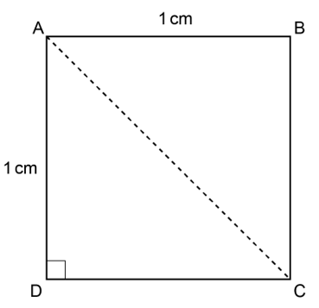 | 4 | Using triangle ACD (mark similarly for use of triangle ABC):  B1 for ACD = 45˚ or CAD = 45˚  M2 for [AC =] $\sqrt{{\text{1}}^{\text{[2]}} \text{+} {\text{1}}^{\text{[2]}}}$ [=$\sqrt{\text{2}}$]  or for [AC² =] ${\text{1}}^{\text{[2]}} \text{+} {\text{1}}^{\text{[2]}}$ oe and $\sqrt{\text{2}}$  or M1 for [AC² =] ${\text{1}}^{\text{[2]}} \text{+} {\text{1}}^{\text{[2]}}$  OR  B1 for ACD = 45˚ or CAD = 45˚ soi by use in cos rule  M2 for $\sqrt{{\text{1}}^{\text{[2]}} \text{+} {\text{1}}^{\text{[2]}} \text{-} \text{2} \text{×} \text{1} \text{×} \text{1 ×}\text{cos}{\text{90}}}$  and cos 90 = 0 soi [= $\sqrt{\text{2}} ]$  or M1 for ${\text{1}}^{\text{[2]}} \text{+} {\text{1}}^{\text{[2]}} \text{-} \text{2} \text{×} \text{2 } \text{×} \text{1} \text{×}\text{cos}{\text{90}}$  OR  B1 for ACD = 45˚ or CAD = 45˚ soi by use in sine ratio or sine rule  M2 for [x = ] $\frac{\text{1}}{\text{sin} \text{45}}$ oe and sin 45 = $\frac{\text{1}}{\sqrt{\text{2}}}$ soi  [= $\sqrt{\text{2}} ]$  or M1 for $\frac{\text{sin}{\text{90}}}{\text{x}}\text{= }\frac{\text{sin}{\text{45}}}{\text{1}}$ oe  AND  A1dep for ACD = 45˚ or CAD = 45˚ stated/on diagram and cos 45˚ = $\frac{\text{1}}{\sqrt{\text{2}}}$ and with no errors seen leading to the answer | May be on diagram  Dep on B1M2  A0 for cos = $\frac{\text{1}}{\sqrt{\text{2}}}$ (without the 45)
16 |  |  | $\frac{\text{3}}{\text{11}}$ final answer  with correct working | 5 | B4 for $\frac{\text{81}}{\text{297}}$ oe with correct working isw cancelling  or  B1 for [$\text{0.}\overset{\text{•}}{\text{3}}$ =] $\frac{\text{1}}{\text{3}}$ oe fraction  B2 for $\frac{\text{81}}{\text{99}}$ oe fraction  or M1 for [100n =] 81.81… oe or better  Alternative method:  B4 for $\frac{\text{81}}{\text{297}}$ oe with correct working  or  B1 for [0. $\overset{\text{•}}{\text{3}}$ =] $\frac{\text{1}}{\text{3}}$ oe fraction  B2 for [100n =] 27.27… or better  or M1 for [$\frac{\text{1}}{\text{3}}$ × 0.$\overset{\text{•}}{\text{8}}\overset{\text{•}}{\text{1}}$ =] 0. $\overset{\text{•}}{\text{2}}\overset{\text{•}}{\text{7}}$  If 0, 1 or 2 scored, instead award SC3 for $\frac{\text{3}}{\text{11}}$ with no or insufficient working  If 0 or 1 scored, instead award SC2 for answer $\frac{\text{81}}{\text{297}}$ oe with no or insufficient working | “Correct working” requires $\frac{\text{1}}{\text{3}}$ oe fraction seen and $\frac{\text{81}}{\text{99}}$ oe fraction seen  or B1 and B2 if alt method  e.g. $\frac{\text{27}}{\text{99}}$ with correct working gets B4  oe any correct method for conversion  e.g. $\frac{\text{27}}{\text{99}}$ with correct working gets B4
17 |  |  | 3 frames with correct working | 6 | Algebraic method:  B5 for [one frame =] 50 [cm] with x = 7  and 3x² – 12x – 63 [= 0] or better  or  M3 for 3x² – 12x – 63 [= 0] or better  A1 for [x =] 7  or  M2 for (3x – 3)(x – 3) [= 72] oe or better seen  or  B1 for 3x – 3 or x – 3 seen  OR  Trial and improvement:  B5 for [one frame =] 50 [cm] with x = 7 and 18 by 4 [= 72] shown  or  B4 for x = 7 and 18 by 4 [= 72] selected  or  B3 for selects 4 by 18 [= 72]  If 0, 1 or 2 scored, instead award SC3 for [one frame =] 50 [cm] with no or insufficient working  If 0 or 1 scored, instead award SC2 for  x = 7 with no or insufficient working | “Correct working” requires B5  For B5 and M3A1 isw for use of x = -3  For B5 or M3 allow equivalent 3 term quadratic e.g. 3x² – 12x = 63  Allow equivalents for M2  e.g. 2 × 1.5 × 3x + 2 × 1.5(x – 3) + 72 = 3x²  May be on diagram  B3 not just for seeing 4 by 18 it must be selected in some way e.g. ringed, underlined, used
18 |  |  | $\frac{\text{7}\text{π}\text{r}}{\text{12}}$ with correct working | 5 | B4 for correct unsimplified answer with correct working  OR  M1 for $\frac{\text{45}}{\text{360}}$ × [2 × ]πk oe  A1 for $\frac{\text{45}}{\text{360}}$ × 2πr oe or better isw incorrect cancelling/simplification  AND  M1 for $\frac{\text{45}}{\text{360}}$ × [2 × ] π$\frac{\text{4}\text{k}}{\text{3}}$  A1 for $\frac{\text{45}}{\text{360}}$ × π$\frac{\text{8}}{\text{3}}$r oe or better isw incorrect cancelling/simplification  If 0 or 1 scored, instead award SC2 for final answer $\frac{\text{7}\text{π}\text{r}}{\text{12}}$oe simplified answer with no or insufficient working | Condone ‘×’ sign oe in simplified answer if otherwise correct e.g. $\frac{\text{7}}{\text{12}}\text{×} \text{π}\text{r}$  “correct working” requires M1A1M1A1  Condone R for r throughout  For method marks, allow use of 3.14, 3.142, 22/7 for $π$  Where k is numeric or algebraic but does not come from squaring  Allow e.g. k = 3, r, d, $\frac{\text{3}}{\text{7}}$, $\frac{\text{3}}{\text{7}}$x  For A1 accept e.g. 0.25 πr  Correct expression implies M1A1  For M1 must use their previous k  e.g. uses k = 6 for first M1 then uses 8 here for $\frac{\text{4}\text{k}}{\text{3}}$ gets 2nd M1  unless the expression is correctly stated as $\frac{\text{45}}{\text{360}}$ × π$\frac{\text{8}}{\text{3}}$r oe which gets M1A1  Correct expression implies M1A1
19 | (a) |  | 8² + ([-]6)²  64 + 36 = 100  or $\sqrt{\text{64} \text{+} \text{36} }\text{=} \text{10}$ and $\sqrt{\text{100}} \text{=} \text{10}$ | 1  1 | Accept equivalent reasoning  e.g. For first mark 10² – 8²  e.g. For second mark 100 – 64 = 36  $\sqrt{\text{36}}$ = ±6 | If 8² + -6² do not allow first mark  If $\sqrt{\text{100}}$ evaluated then it must be 10  For 2 marks there must be no errors leading to the answer
19 | (b) |  | y = $\frac{\text{4}}{\text{3}}$ x −$\frac{\text{50}}{\text{3}}$ final answer | 5 | B4 for answer $\frac{\text{4}}{\text{3}}$ x −$\frac{\text{50}}{\text{3}}$ oe (no y = )  or correct 3-term answer in different form  e.g. 6y – 8x = 100  OR  M1 for $–\frac{\text{3}}{\text{4}}$ oe  and  M1 [tangent gradient = ] –1 ÷ their $–\frac{\text{3}}{\text{4}}$ oe  AND  M1dep for y + 6 = their $\frac{\text{4}}{\text{3}}$(x – 8) oe  or M1dep for y = their $\frac{\text{4}}{\text{3}}$ x + c | Accept e.g. y = 1.33[..]x – 16.6[..]  $\frac{\text{4}}{\text{3}}$ oe implies M1M1 unless contradicted  Dep on at least M1  oe e.g. −6 = their $\frac{\text{4}}{\text{3}}$ × 8 + c  Do not allow M1 for e.g. grad $–\frac{\text{3}}{\text{4}}$ used if the gradient is then changed subsequently to e.g. $\frac{\text{4}}{\text{3}}$  Dep on at least M1  Allow ‘c’ or any value including 0  Answer y = $\frac{\text{4}}{\text{3}}$ x [+ c] oe implies M1M1M1

Appendix
Additional Guidance Q1(a)

 | Comments about no numbers
1 | There are no numbers/figures/scale [to indicate total or numbers in sector] | 1
2 | You don’t know what it’s out of. You need to total [frequency] | 1
3 | It’s difficult to tell the size of each fraction of the pie chart and we need the total (we need the total gets the mark) | 1
4 | We need to know the angle sizes and what it’s out of (and what it’s out of gets the mark provided they don’t say it’s out of 360) | 1
5 | Pie charts show proportions/fractions/%’s but do not show quantities | 1
 | Comments about 3D aspect
6 | Morgan is viewing the chart from the side not the front | 1
7 | It’s 3D | 1
8 | It is hard to see the fractions/proportions | 1
9 | The sections at the front look larger than those at the back | 1
10 | It’s slanted so it’s hard to measure the angles (It’s slanted gets the mark) | 1
11 | Not able to measure angles owing to the positioning of the pie chart (gets it for the underlined part) | 1
 | Comments about key/colours
12 | Segments are not clearly labelled (ref to colour reason) | 1
13 | The colours look the same. Some of the years are the same colour. | 1
14 | The parts need to be clearly labelled BOD related to colour | 1
15 | The colours are confusing | 1
16 | It does not tell us the size of each sector (size does not imply number – could be angles) | 0
17 | Pie charts are for discrete data only | 0
18 | It might not be accurate | 0
19 | We need to know the angle sizes | 0
20 | There are better ways to present the data | 0
21 | It doesn’t have any labels (Not true – there are labels but not very clear) | 0
22 | It is an estimated number of users | 0
23 | The data is not in percentages. | 0
24 | The sectors have no angles/percentages/fractions | 0
25 | The sections are similar in size making it unclear | 0
26 | Not exact figures/data lost | 0

Additional guidance for Question 3(a)

 | Response | Mark
1 | Writing all the 0’s out is very long/difficult to read/may lead to errors | 1
2 | As they would contain a lot of 0s | 1
3 | Because there would be too many zeros | 1
4 | Because the numbers would be extremely long/high/large. | 1
5 | Because of how long/high/large the number would be | 1
6 | The numbers would be too long to write down e.g. 3 x 10⁷ = 30 000 000 | 1
7 | It shortens the numbers due to them having so many 0s | 1
8 | Because they’re too big (Given the wording of the demand – refers to numbers) | 1
9 | It takes too long to write it all out | 1
10 | Because the digits will be too long (BOD infers numbers are too long) | BOD 1
11 | Wastes time writing out the digits, standard form is simple shorthand (similar to above) | BOD 1
12 | To makes it easier to read (no reason given as to why) | 0
13 | To make the numbers more simpler (no reason given e.g. numbers too large, too many zeros) | 0
14 | It’s easier to understand (no reason given as to why) | 0
15 | Because otherwise you need to write 3 million so 3 x 10⁷ is easier to say in standard form  (Contains error in number, if 30 million this would be OK) | 0
16 | Because the numbers are billions so it’s easier to read them in standard form (as above) | 0
17 | It shortens the numbers (no reason given why e.g. too large, too many zeros) | 0

Correct answer for Question 9

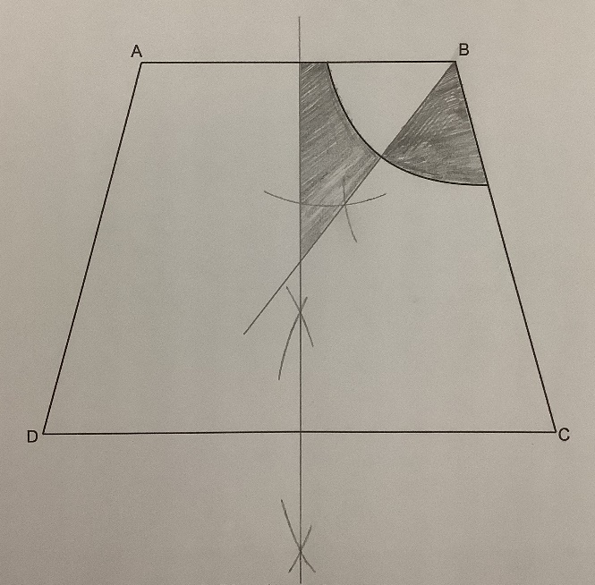

Additional guidance Question 13(a)(ii)

 | Response | Mark
1 | The graph is below the x-axis at x = 0 and above the x-axis at x = 1 so the solution lies between 0 and 1 | 2
2 | 0² + (8 × 0) – 4 = -4 and 1² + (8 × 1) – 4 = 5 so there is a sign change from -4 to 5  BOD x = 0 and x = 1 implied in reasoning and a correct statement regarding sign change | 2
3 | Because at q, y = 0, but at 1 y = 5 and at 0 y is negative. So the solution is in between 0 and 1  (BOD x = 0 and x = 1 implied in reasoning similar to above and correct conclusion stated) | 2
4 | When q = 0 graph is negative, when q = 1 graph is positive so there is a sign change  (BOD q is on the x-axis so take q as x here) | BOD2
5 | The graph is positive at 1 and negative at zero so the solution lies in between 0 and 1  [BOD first mark allow as 1 and 0 imply x = 1 and x = 0 and the conclusion is correct for 2nd mark) | BOD2
6 | When x = 1, y = 5 and the graph intersects the x-axis between 0 and 1 so that is where the solution lies  [Does not mention x = 0 and negative and second mark dep on first but gets SC1] | SC1
7 | The graph crosses the x-axis between 0 and 1 [ 2nd mark dep on 1st mark and does not specifically mention x = 0 and x = 1 being negative and positive so zero but gets SC1] | SC1
8 | There is a change of sign (2nd mark dep on first mark buts gets SC1) | SC1
9 | The root lies between 0 and 1 (not adding to question asked – no reasons given for this) | 0



We’d like to know your view on the resources we produce. Click ‘Like’ or ‘Dislike’ to send us an auto generated email about this resource. Add comments if you want to. Let us know how we can improve this resource or what else you need. Your email will not be used or shared for any marketing purposes.
Looking for another resource? There is now a quick and easy search tool to help find free resources for your qualification.
OCR is part of Cambridge University Press & Assessment, which is itself a department of the University of Cambridge.
For staff training purposes and as part of our quality assurance programme your call may be recorded or monitored.
Oxford Cambridge and RSA Examinations is a Company Limited by Guarantee. Registered in England. Registered office The Triangle Building, Shaftesbury Road, Cambridge, CB2 8EA.
Registered company number 3484466. OCR is an exempt charity.
OCR operates academic and vocational qualifications regulated by Ofqual, Qualifications Wales and CCEA as listed in their qualifications registers including A Levels, GCSEs, Cambridge Technicals
and Cambridge Nationals.
OCR provides resources to help you deliver our qualifications. These resources do not represent any teaching method we expect you to use. We update our resources regularly and aim to make sure content is accurate but please check the OCR website so that you have the most up to date version. OCR cannot be held responsible for any errors or omissions in these resources.
Though we make every effort to check our resources, there may be contradictions between published support and the specification, so it is important that you always use information in the latest specification. We indicate any specification changes within the document itself, change the version number and provide a summary of the changes. If you do notice a discrepancy between the specification and a resource, please contact us.
© OCR 2023 - You can copy and distribute this resource freely if you keep the OCR logo and this small print intact and you acknowledge OCR as the originator of the resource.
OCR acknowledges the use of the following content: N/A
Whether you already offer OCR qualifications, are new to OCR or are thinking about switching, you can request more information using our Expression of Interest form.
Please get in touch if you want to discuss the accessibility of resources we offer to support you in delivering our qualifications.

