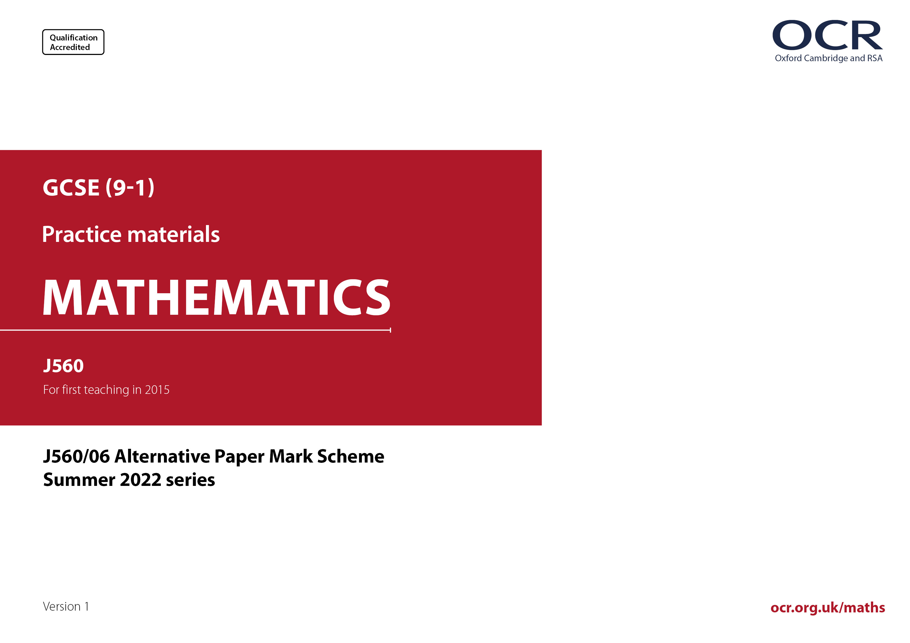
ocr.org.uk/maths
ocr.org.uk/maths

J560/06 Mark Scheme

- M marks are for using a correct method and are not lost for purely numerical errors.
A marks are for an accurate answer and depend on preceding M (method) marks. Therefore M0 A1 cannot be awarded.
B marks are independent of M (method) marks and are for a correct final answer, a partially correct answer, or a correct intermediate stage.
SC marks are for special cases that are worthy of some credit.

- The following abbreviations are commonly found in GCSE Mathematics mark schemes.

  - figs 237, for example, means any answer with only these digits. You should ignore leading or trailing zeros and any decimal point
e.g. 237000, 2.37, 2.370, 0.00237 would be acceptable but 23070 or 2374 would not.
  - isw means ignore subsequent working after correct answer obtained and applies as a default.
  - nfww means not from wrong working.
  - oe means or equivalent.
  - rot means rounded or truncated.
  - soi means seen or implied.
  - dep means that the marks are dependent on the marks indicated. You must check that the candidate has met all the criteria specified for the mark to be awarded.
  - with correct working means that full marks must not be awarded without some working. The required minimum amount of working will be defined in the guidance column and SC marks given for unsupported answers.
- Anything in the mark scheme which is in square brackets […] is not required for the mark to be earned, but if present it must be correct.

- Unless the command word requires that working is shown and the working required is stated in the mark scheme, then if the correct answer is clearly given and is not from wrong working full marks should be awarded.

Do not award the marks if the answer was obtained from an incorrect method, i.e. incorrect working is seen and the correct answer clearly follows from it.

- Where follow through (FT) is indicated in the mark scheme, marks can be awarded where the candidate’s work follows correctly from a previous answer whether or not it was correct. For questions with FT available you must ensure that you refer back to the relevant previous answer. You may find it easier to mark these questions candidate by candidate rather than question by question.

Figures or expressions that are being followed through are sometimes encompassed by single quotation marks after the word their for clarity, e.g. FT 180 × (their ‘37’ + 16), or FT 300 – √(their ‘52 + 72’). Answers to part questions which are being followed through are indicated by
e.g. FT 3 × their (a).

- In questions with no final answer line, make no deductions for wrong work after an acceptable answer (i.e. isw) unless the mark scheme says otherwise, indicated by the instruction ‘mark final answer’.

- In questions with a final answer line and incorrect answer given:

(i) If the correct answer is seen in the body of working and the answer given on the answer line is a clear transcription error allow full marks unless the mark scheme says ‘mark final answer’. Place the annotation next to the correct answer.

(ii) If the correct answer is seen in the body of working but the answer line is blank, allow full marks. Place the annotation next to the correct answer.

(iii) If the correct answer is seen in the body of working but a completely different answer is seen on the answer line, then accuracy marks for the answer are lost. Method marks could still be awarded if there is no other method leading to the incorrect answer. Use the M0, M1, M2 annotations as appropriate and place the annotation next to the wrong answer.

- In questions with a final answer line:

(i) If one answer is provided on the answer line, mark the method that leads to that answer. A correct step, value or statement that is not
part of the method that leads to the given answer should be awarded M0 and/or B0.

(ii) If more than one answer is provided on the answer line and there is a single method provided, award method marks only.

(iii) If more than one answer is provided on the answer line and there is more than one method provided, award marks for the poorer response unless the candidate has clearly indicated which method is to be marked.

- In questions with no final answer line:

(i) If a single response is provided, mark as usual.

(ii) If more than one response is provided, award marks for the poorer response unless the candidate has clearly indicated which response is to be marked.

- When the data of a question is consistently misread in such a way as not to alter the nature or difficulty of the question, please follow the candidate’s work and allow follow through for A and B marks. Deduct 1 mark from any A or B marks earned and record this by using the MR annotation. M marks are not deducted for misreads. If a candidate corrects the misread in a later part, do not continue to follow through, but award A and B marks for the correct answer only.

- Unless the question asks for an answer to a specific degree of accuracy, always mark at the greatest number of significant figures even if this is rounded or truncated on the answer line. For example, an answer in the mark scheme is 15.75, which is seen in the working. The candidate then rounds or truncates this to 15.8, 15 or 16 on the answer line. Allow full marks for the 15.75.

- Ranges of answers given in the mark scheme are always inclusive.

- For methods not provided for in the mark scheme give as far as possible equivalent marks for equivalent work. If in doubt, consult your Team Leader.

- If in any case the mark scheme operates with considerable unfairness consult your Team Leader.

Question |  |  | Answer | Marks | Part marks and guidance
1 |  | (a) |  | 2 | B1 for at least 7 correct values in the table
   | 2 | 3 | 4
  2 | 4 | 6 | 8
  3 | 6 | 9 | 12
  4 | 8 | 12
 |  | (b) | $\frac{\text{4}}{\text{16}}$ oe | 1FT |  | Isw if final answer comes from simplifying $\frac{\text{4}}{\text{16}}$  Accept decimal, percentage with % but not ratio or “in”.
 |  | (c) | $\frac{\text{12}}{\text{16}}$ oe | 1FT |  | Isw if final answer comes from simplifying $\frac{\text{12}}{\text{16}}$  Do not penalise ratio or “in” if already penalised in (b)
2 |  |  | 81.48[…] with correct working | 4 | M3 for $\text{π} \text{×}{\left(\frac{\text{32}}{\text{2}\text{π}}\right)}^{\text{2}}$  OR  M1 for 32 ÷ 2π or 32 = 2πr or 32 = πd  A1 for 5.09[…]  M1 for π × (their 5.09)²  If 0 or 1 scored, instead award  SC2 for 81.48[…] with no or insufficient working  If 0 scored, instead award  SC1 for 5.09[…], 81.39[…], 81.42[…], 81.52[…] or 325[…] or 326 with no or insufficient working | Correct working requires evidence of at least M1  Do not accept starting with 81.5 and working backwards  Candidates should use the π button or 3.142. Accept 3.14 and 22/7 for max of M3  M1 may be in two steps or seen as diameter here and diameter/2 in the area calculation  their 5.09 must come from a calculation involving π
3 |  |  | 82 min 30 sec | 4 | B3 for 82.5 or 82$\frac{\text{1}}{\text{2}}$ or 82$\frac{\text{30}}{\text{60}}$  or for answer 82m 5s or  82m 50s  OR  M1 for 3.3 × 10⁻⁶ × 1.5 × 10⁹ oe soi by figs 495  and  M1FT for (their 4950 ÷ 60) | e.g. $\frac{\text{1.5 ×}{\text{10}}^{\text{9}} }{\text{303030[.3…]}}$  their 4950 from attempt at a correct M1 expression
4 |  |  | 2 and 12 nfww | 4 | B3 $\frac{\text{9}{\text{a}}^{\text{2}} \text{×} {\text{a}}^{\text{5}}}{{\text{12}\text{a}}^{\text{3}}}\text{=}\frac{\text{3}{\text{a}}^{\text{4}}}{\text{4}}$  OR  B2 for k = 2  or  M1 any correct simplification of $\frac{{\text{a}}^{\text{k}} \text{×} {\text{a}}^{\text{5}}}{{\text{a}}^{\text{3}}}$ = a⁴  e.g.  [a^{k} ×] a² [= a⁴] or [a^{k} × a⁵ =] a⁷  a^{k} = a²  $\frac{{\text{a}}^{\text{k} \text{+} \text{5}}}{\text{[}{\text{a}}^{\text{3}}\text{]}} \text{[=}{ \text{a}}^{\text{4}}\text{]}$  k + 5 – 3 = 4 oe  and  B2 for m = 12  or  M1 for $\frac{\text{9}}{\text{m}}\text{=} \frac{\text{3}}{\text{4}}$ oe | Otherwise, condone embedded answers for M marks only  M1 applying correctly a law of indices  May be seen within an attempt to simplify with other coefficients.  Allow [m] = 9 × 4 ÷ 3
5 |  |  | Yes SAS  Yes RHS  No | 3 | B2 for two correct rows  or  B1 for one correct row | Accept ticks and crosses  For “No” ignore reason
6 | (a) |  | 375 | 2 | M1 for 675 ÷ 1.8[0] oe
 | (b) |  | 1800 or 1.8 × 10³ | 1
7 | (a) |  | x² + [1]x – 30 final answer | 2 | M1 for at least three of  x² , [+]6x , − 5x , – 30 | M1 may be seen in a table  e.g.  [1]x counts as two terms  M1 for x² + [1]x + – 30  Do not accept poor algebra e.g. x6 for 6x or x × x for x²
   | x | [+] 6
  x | x² | [+]6x
  − 5 | −5x | -30
 | (b) |  | (x – 6)(x + 6) final answer | 1 |  | Condone missing final bracket.
8 | (a) |  | 2315 2431 | 3 | B2 for 2315 or 2431  or 2315.25 with either 2430.7[5] or  2431.0[1]  or  M1 for 2205 ×+ 2205 oe soi 2315.25 | e.g. 2205 × 1.05  e.g. 2000 × 1.05³  NC% methods  M1 for e.g.2205 ÷ 10 = [x]. [x] ÷ 2 = [y]. [y] + 2205
 | (b) |  | Correct curved graph | 3 | B2 for 5 of their points plotted correctly  or  B1 for 4 of their points plotted correctly or  5 of their points plotted at correct  height but incorrect time | ½ square accuracy  Stick graph mark heights as points max B2  If stick graph and curve regard as choice and mark points/heights only  Bar chart  If points clearly marked, mark the points  If points not clear B0  Ruled line or line segments max B2
 | (c) |  | Increases [to 2500]  Flattens/levels off/plateaus/horizontal [at 2500] | 1  1 |  | See Appendix  2500/the maximum must be seen once for 2 marks  Accept approx/about 2500  Condone embellishments such as “slight fall” after correct statement or reference to line of best fit
9 |  |  | 20[%] with correct working | 5 | B2 for 18 000  or  M1 for 24 000 × oe or 24 000 × oe  AND  M2 for $\frac{\text{their}\text{ 18} \text{000} \text{-} \text{14} \text{400}}{\text{their}\text{ 18} \text{000}}$ [× 100] oe  or  M1 for $\frac{\text{14} \text{400}}{\text{their}\text{ 18} \text{000}}$ [× 100] oe  If 0 or M1 scored, instead award SC2 for answer 20[%] with no or insufficient working  If 0 scored, award SC1 for 0.2 or 0.8 or 80[%] with no or insufficient working | “correct working” requires at least M2 or M1M1 the first M1 implied by B2  M0 for e.g. 75% of 24 000  M0 for e.g. 75% × 24 000  Accept 3600 for numerator  M2 may be  $$\left(\text{1} \text{-} \text{their}\frac{\text{14} \text{400}}{\text{their} \text{18} \text{000}}\right) \text{[×} \text{100]}$$  M1 may be seen as  $\frac{\text{14} \text{400}}{\text{24} \text{000}}$= 0.6 and then  followed by  Trials for second M marks  M2 for 18 000 × 0.2 = 3600  or  M1 for 18 000 × 0.8 = 14 400  Equation method  B2M2 p/100 × 18 000 = 3600; leading to p = 20 (scores 5 marks)  B2M1 p/100 × 18 000 =  14 400; leading to p = 80  B2M1 24000 × 0.75 × m =  14 400 leading to m = 0.8, as 18 000 implied within this
10 |  |  | 1944 with correct working | 6 | M1 for $\frac{\text{18} \text{×} \text{24}}{\text{2}}$× 27 oe  A1 for 5832  or  M1 for $\frac{\text{18} \text{×} \text{24}}{\text{2}}$ oe  AND  M1 for  A1 for 18  AND  M1 for 6 × (their 18)²  If 0, 1 or 2 scored, instead award SC3 for 1944 as final answer with no working or insufficient working  If 0 or M1 scored, instead award SC2 for 18 seen as dimension of cube or × 6 soi 3085 to 3086 with no working or insufficient working  If 0 scored, award SC1 for 5832 or $\sqrt[\text{3}]{\text{11664}}$ soi 22.6[...]with no working or insufficient working | ”correct working” requires at least M1M1  Accept e.g. 18 × 12 × 27  or 216 × 27  Allow 18³ = 5832 for M1A1 5832 must be from correct method for volume of triangular prism  Their 18 must come from use of volume of triangular prism and cube root
11 |  |  | 133.5[0] with correct working | 6 | B1 for 3a or a + 4 or 5a + 4 or 25.5[0] + 4x seen  M1 for a + 3a + a + 4 = 89 or better  or for a trial correctly evaluated  A1 for [a =] 17 [hours]  AND  M2 for $\frac{\text{25.5[0]}}{\text{their}\text{ 17}} \text{×} \text{89}$ or 1.5 × 89 oe  or 25.5[0] + 76.5[0] +$\frac{\text{25.5[0]}}{\text{their}\text{ 17}} \text{×} \text{their} \text{21}$ oe  or 25.5[0] + 1.5 × 51 + 1.5 × 21 oe  or  M1 for $\frac{\text{25.5[0]}}{\text{their}\text{ 17}}$ implied by 1.5  or $\frac{\text{25.5[0]}}{\text{5}}$ implied by 5.1[0]  If 0 or 1 scored, instead award  SC2 for 133.5[0] with no or insufficient working  If 0 scored, instead award  SC1 for 17 [hours] with no or insufficient working | “correct working” requires at least M1ANDM1 or M2  If working in pence:  - Allow up to 5 part marks for consistent working  - Allow full marks if answer is clearly stated as 13350 p[ence]  M1 implied by sub into  a + 3a + a [+ 4] with evaluation  B1 max possible for using 4a instead of a + 4  e.g. M2 for $\frac{\text{3}}{\text{2}}\text{×} \text{89}$  Method marks may be earned in stages  May see equivalent algebraic methods. See Appendix.  Non-algebraic methods may earn up to full marks.
12 |  |  | 0.36 oe nfww | 4 | M3 for 0.5² + 0.3² + 0.1² + 0.1² oe  or  M2 for 0.5² oe and 0.3² oe and 0.1²  or  M1 for 0.5² oe or 0.3² oe or 0.1² oe | M2 for correct method spoilt e.g. $\frac{\left(\text{0.}{\text{5}}^{\text{2}}\text{ + 0.}{\text{3}}^{\text{2}}\text{ + 0.}{\text{1}}^{\text{2}}\text{ + 0.}{\text{1}}^{\text{2}}\right)}{\text{4}}$  Likely equivalents:  0.5² = 0.25 or $\frac{\text{1}}{\text{4}}$ or 25%  0.3² = 0.09 or $\frac{\text{9}}{\text{100}}$ or 9%  0.1² = 0.01 or $\frac{\text{1}}{\text{100}}$ or 1%
13 |  |  | 298 598 400 with correct working | 4 | B1 for 900 or 9 × 100 or 9 × 10 × 10  AND  M2 for 24 × their 900 × 24 × 24 × 24 oe  or  M1 for 24 [×…] × 24 or 24 × their 900 [×…]  or for 24,9,10,10,24,24,24 in any order  If 0 or 1 scored, instead award  SC2 for 298 598 400 with no working  If 0 scored, instead award  SC1 for 24 × their 900 × 24 × 24 × 24 | “correct working” requires at least M1  Allow 9 × 100 or 9 × 10 × 10 or 899 for their 900  e.g. M1 for 24 × 5 × their 900 or for 24 × 23 × their 900 × 22 × 21 × 20  Accept list, summed, or on diagram
14 |  |  | 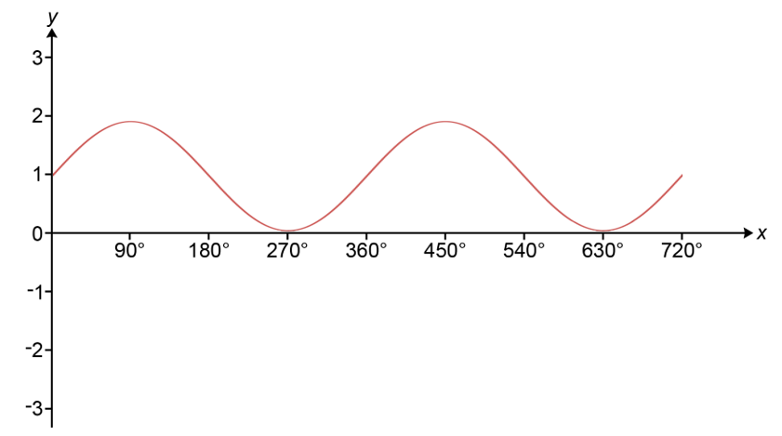 | 3 | B1 for general shape of sine curve  B1 for max at y = 2, minimum at y = 0  B1 for max at x = 90, 450 | Starting at [their] centre and completing at least one full cycle; condone incorrect period  For full marks, it must be a curve and have correct curvature  Only these two max between 0 < x ≤ 720
15 | (a) |  | 18, 38, 60, 72, 80 | 2 | M1 for cf calculated with one arithmetic error | Allow 80 or their 80 FT
 | (b) |  | Plots at right-hand end of intervals  Plots at correct heights  Join with smooth curve or straight line segments | 1  1  1 | Tol ½ square; FT if M1 in (a)  Tol ½ square; FT their ascending plots only  Condone curve or absence of curve below t = 25 | Plots of frequencies scores 0 across the whole of (b)  0 for bars at correct heights since must miss off one end; if cf graph as well as bars, ignore bars
 | (c) | (i) | For 2 marks must say right/correct/true not yes  Sight of 20 or 60  20/80 = ¼ or ¼ of 80 = 20  60/80 = ¾ or ¾ of 80 = 60 | 1  1 | Must be separate from the fraction comment. Do not accept more than/less than 60/20. | See Appendix  Accept equivalent in words
 |  | (ii) | wrong/incorrect/false and correct reason | 1 | e.g. cannot be sure as exact data not given; it could be anywhere between 45 and 50 etc | See Appendix
16 | (a) |  | E.g.  [y = ](x + 2)(x - 3)  AND  either  [y = x² - 3x + 2x] - 6  or  [Constant/y-intercept =] 2 × -3 = -6  Alternative method using simultaneous equations  y = x² + bx + c  0 = (-2)² + (-2)b + c and 0 = 3² + 3b + c  [b = -1] c = -6 | 3 | M2 for [y = ](x + 2)(x - 3)  or  M1 for k(x + 2)(x - 3)  M2 for  0 = (-2)² + (-2)b + c and  0 = 3² + 3b + c  or  M1 for y = x² + bx + c | For full marks, all shown parts of their expansion must be correct
 | (b) |  | The equation could be a multiple  e.g. [y = ]k(x + 2)(x - 3)  So the intercept could be a multiple of -6 | 2 | B1 for  giving an example in the form  k(x + 2)(x - 3) (where k > 0, k ≠ 1, k need not be an integer)  or  stating that the intercept could be a multiple of -6 | Allow full or part marks for a fully correct algebraic example  e.g.  [y = ]2(x + 2)(x - 3) would have a y-intercept of -12
17 | (a) |  | 10 is not a prime number oe | 1 |  | See Appendix
 | (b) |  | 2¹¹ × 3⁴ × 5⁵ | 2 | M1 for [10⁵ =] 2⁵ × 5⁵ seen, expanded or used or for answer including 2¹¹ | Correct answer in expanded form implies 2⁵ × 5⁵ used for M1
 | (c) |  | 16000 | 2 | B1 for 2⁷ × 5³
18 |  |  | E.g.  Correct inequalities shown on diagram, correct region R identified and correct area calculation ½ × 3 × 2 [= 3]  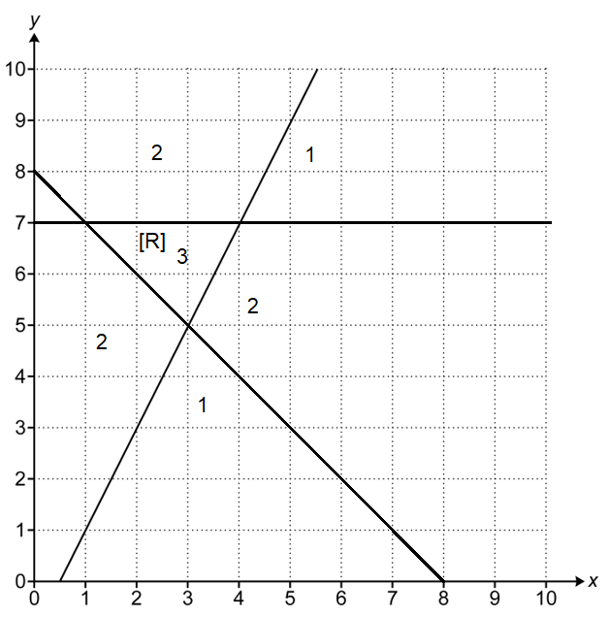 | 6 | B1 for line y = 7  B1 for line x + y = 8  AND  B1 for correct side of y = 2x − 1  B1 for correct side of y = 7  B1 for correct side of x + y = 8  AND  M1dep for ½ × 3 × 2 [= 3] oe | Condone good freehand lines, which can be dashed or solid.  Lines need only be one square long for line mark but they must be fit for purpose to define their region  Mark the region that is labelled, but if no labelling mark the single region that is shaded (or unshaded) or implied by area calculation of correct region R  Use diagram for these three marks  If extra lines, mark those bounding R. If no R, mark poorest two  Dep on region R being correct  Accept counting squares but check areas bounding  y = 2x −1  Accept split into two triangles 2 and 1 oe
19 | (a) |  | (x + 2)² – 3 final answer | 3 | B1 for (x + 2)²  AND  B2FT for – 3  or  M1 for 1 – (their 2)² oe shown  If 0 or 1 scored, allow  SC2 for final answer (x + 2) – 3 | No FT from (x + 1)²  FT can be implied, check  1 – (their 2)²
 | (b) |  | -2 + $\sqrt{\text{3}}$ -2 -$\sqrt{\text{3}}$ final answer with working from (a) | 2FT | M1 for their (x + 2)² = their 3  FT from their (a) for solutions in exact form if working shown | Answers only score 0  Do not FT where b = 0  e.g. (x + 2)²  If their b is a perfect square, allow FT for a + $\sqrt{\text{b}}$ and  a – $\sqrt{\text{b}}$ or simplified as two integers  If b < 0, a max of M1
20 |  |  | 64 with correct working | 4 | M3 for [8 ×] ${\left(\sqrt{\frac{\text{48}}{\text{12}}}\right)}^{\text{3}}$ or 2³ oe  or  M2 for $\sqrt{\frac{\text{48}}{\text{12}}}$ or $\sqrt{\text{4}}$ oe implied by 2  or  M1 for $\frac{\text{48}}{\text{12}}$ oe implied by 4  Alternative method:  M3 for [8 ÷] ${\left(\sqrt{\frac{\text{12}}{\text{48}}}\right)}^{\text{3}}$ or ${\left(\frac{\text{1}}{\text{2}}\right)}^{\text{3}}$ oe  or  M2 for $\sqrt{\frac{\text{12}}{\text{48}}}$ or $\sqrt{\frac{\text{1}}{\text{4}}}$ oe implied by $\frac{\text{1}}{\text{2}}$ or 0.5  or  M1 for $\frac{\text{12}}{\text{48}}$ oe implied by $\frac{\text{1}}{\text{4}}$ or 0.25  If 0 scored, instead award  SC1 for answer 64 with no or insufficient working | “correct working” requires evidence of at least M2  Accept ratios  M3 for 8 : 64 oe  or  M2 for 2 : 4 oe  or  M1 for 4 : 16 oe
21 |  |  | 2.91 to 2.93 with correct working | 6 | First M1 may be on diagram or within other M marks  M1 for BAC = 180 – (37 + 48) or 53 + 42 or 95  AND  M2 for AC = $\frac{\text{6.5 ×} \text{sin37}}{\text{sin(}\text{their}\text{ 95)}}$  or  M1 for $\frac{\text{AC}}{\text{sin37}}$ = $\frac{\text{6.5 }}{\text{sin(}\text{their}\text{ 95)}}$ oe  AND  A1 for AC = 3.92[6…] or 3.93  (M1A1 implies M2A1)  AND  M1 for $\frac{\text{AX}}{\text{their}\text{ 3.93}}$ = sin48  or their 3.92 × sin48 oe  If 0, 1 or 2 scored, instead award  SC3 for 2.91 to 2.93 with no or insufficient working.  If 0 or 1 scored, instead award  SC2 for 3.92[6...] or 3.93 with no or insufficient working.  Alternative Method splitting BC:  First M1 may be on diagram or within other M marks. Accept other terms for d. Do not accept numerical partition of BC.  M1 for BX = d and XC = 6.5 – d  AND  M2 for d = $\frac{\text{6.5tan48}}{\text{tan37} \text{+} \text{tan48}}$ oe  or  M1 for dtan37 = (6.5 – d)tan48 oe  AND  A1 for d =3.87 to 3.88  (M1A1 implies M2A1)  AND  M1 for $\frac{\text{AX}}{\text{their 3.87}}$ = tan37  or their 3.87 × tan37  or for $\frac{\text{AX}}{\text{(6.5 - }\text{their}\text{ 3.87)}}$ = tan48  or (6.5 – their 3.87) × tan48  If 0, 1 or 2 scored, instead award  SC3 for 2.91 to 2.93 with no or insufficient working.  If 0 or 1 scored, instead award  SC2 for 3.87 to 3.88 with no or insufficient working.  Alternative Method using Areas  The main scheme still applies. The first four marks will be identical and the area method eventually simplifies to the final M1 expression. This is just a much more complex method. | All methods: “correct working” requires at least M1ANDM1ANDM1  First M1 may be on diagram or within other M marks  M1 for BAC = 180 – (37 + 48) or 53 + 42 or 95  AND  M2 for AB = $\frac{\text{6.5 ×} \text{sin48}}{\text{sin(}\text{their}\text{ 95)}}$  or  M1 $\frac{\text{AB}}{\text{sin48}}$ = $\frac{\text{6.5 }}{\text{sin(}\text{their}\text{ 95)}}$ oe  AND  A1 for AB = 4.84[8…] or 4.85  (M1A1 implies M2A1)  AND  M1 for $\frac{\text{AX}}{\text{their} \text{4.85}}$ = sin37  or their 4.85 × sin37 oe  If 0, 1 or 2 scored, instead award SC3 for 2.91 to 2.93 with no or insufficient working.  If 0 or 1 scored, instead award SC2 for 4.84[8…] or 4.85 with no or insufficient working.  First M1 may be on diagram or within other M marks. Accept other terms for d. Do not accept numerical partition of BC.  M1 BX = 6.5 – d and XC = d  AND  M2 for d = $\frac{\text{6.5tan37}}{\text{tan48} \text{+} \text{tan37}}$ oe  or M1 for  dtan48 = (6.5 – d)tan37 oe  AND  A1 for d = 2.62 to 2.63  (M1A1 implies M2A1)  AND  M1 for $\frac{\text{AX}}{\text{their}\text{ 2.63}}$ = tan48  or their 2.63× tan48  or $\frac{\text{AX}}{\text{(6.5} \text{-} \text{their}\text{ 2.63)}}$ = tan37 or  (6.5 – their 2.63) × tan37  If 0, 1 or 2 scored, instead award  SC3 for 2.91 to 2.93 with no or insufficient working.  If 0 or 1 scored, instead award  SC2 for 2.62 to 2.63 with no or insufficient working.

Appendix

Non Calculator methods for percentages.

Labels only
This is when labels such as 10% = are used. If only labels are used the final answer scores full marks if it is correct.
Condone a numerical slip if the answer is correct.
If there is an error in the values and so the final answer is incorrect this cannot score method marks
e.g. Find 65% of 80
Method scoring M1A1
10% = 8 10% = 8
5% = 4 5% = 5 condone this slip as answer correct
50% = 40 50% = 40
65% = 52 M1A1 65% = 52 M1A1
Method scoring M0A0
10% = 8
5% = 6 Do not condone this slip as answer incorrect
50% = 40
65% = 54 M0

Build up method
This is where the candidate finds the percentages to build up to the required value but shows the operations used.
e.g. Find 65% of 80
10% = 80 ÷ 10 = x
5% = x ÷ 2 = y
50% = x × 5 = z
65% = x + z + y
Because the operations have been shown and they are correct, if there is an error in one of x, y or z, method marks can still be earned

8c

Reason | Judgement | Mark
It would increase to 2500  then stay at 2500 | Correct  correct | 1  1
Once it reaches 2500 it will plateau | Reaches 2500 implies increasing  It will plateau is fine | 1  1
It would increase to approx. 2500  and then remain more or less constant around this value. | approx. is okay. 2500 referenced at least once. | 1  1
Keep increasing as 2500 is a little way up the scale. | Increase is fine | 1  0
It will increase and continue past the maximum  Then it will fall as fish will die | Award for “It will increase”  Doesn’t say the line will level off | 1  0
After the 5th year the graph would be capped at 2500,  only allowing 69 more fish in the lake. | Implies increase in graph BOD  The description is for what is happening in the lake and not the shape of the graph | 1  0
The line continues up  and then falls | Continues up is enough but without the up, would not get the mark  Falls is incorrect | 1  0
It would cause it to slow down in the rate of increase  and would then cause it to plateau. | Describes increase  True. No mention of 2500. Max 1 mark | 1  0
The line of best fit would hit a peak. | Not awarded as the peak could be at the end of the line so “up” not implied. | 0  0
It would eventually plateau and level out with no increase. | No mention of increase (to 2500) | 0  1
The line will continue to 2500  Then it will go along the x-axis | Correct as “the line continues” and max/2500 imply going up  Incorrect as it is parallel to the x-axis, not along it | 1  0
It starts to decrease...then not go past 2500  Once at 2500 it will stay around the same place | Incorrect should be increase  Staying around the same place BOD for value | 0  1
After 4 years the shape would no longer increase.  It’ll stay at 2500 with a horizontal line on 2500. | Incorrect.  Correct | 0  1
It would plateau/level off at 2500 fish | No mention of graph increasing  2500 then staying there. | 0  1
It would become a horizontal straight line |  | 0  1
The graph would plateau as no fish are being added or taken away | No mention of increase  Correct for plateau | 0  1
4 years almost 2000 fish(1995) so the graph would plateau as no more fish can live in the pool | No increase  Plateau | 0  1
It would not increase.  The line of best fit would level off and perhaps sometimes slightly decrease. | Wrong (but It would not increase past 2000 implies curve increasing for 1 mark)  Level off okay, condone the rest as not contradicting | 0  1
It will exceed the maximum amount of fish | Describing what is going on in the lake not the shape of the graph | 0  0
Would start plateauing downward  becoming more and more flat as less fish were present year by year. | No mention of increase (or 2000)  Spoilt for second mark as suggests going down so is contradictory | 0  0
The graph curves as the max capacity is exceeded | Ruled out as a possible interpretation is that it has already reached maximum and it then curves in some direction | 0

Q11
There are possibly many algebraic methods for this question. Examiners should use the main scheme as a template, matching steps or positions in the solution as best as possible. If in doubt, contact your Team Leader. For example:

(tips) Ariel : Blake : Casey is 25.5 : 76.5 : 25.5 + 4x (where x is hourly rate of tips)  (total tips) 25.5 + 76.5 + 25.5 + 4x = 89x  (solving) x = 1.5  (substitution into either side of the equation) e.g. 89 × 1.5  (final answer) 133.5[0] | This is on the scheme at B1  There is an equation on the scheme, so M1 would be a good judgement  And then this would be the A1  This is on the scheme at M2  The answer is correct and the candidate has satisfied the “correct working” requirement and so is awarded full marks | B1  M1  A1  M2

Q15c(i)

Reason | Judgement | Mark
Correct, ¼ of 80 is 20 and 20 cyclists took more than 40 minutes. |  | 1  1
True, ¾ of 80 = 60 and 60 cyclists took 40 minutes or less, leaving ¼ to take more than 40 minutes. |  | 1  1
Right, 20 cyclists completed the race in over 40 minutes and 20/80 = ¼. |  | 1  1
Right, 60 cyclists took less than 40 minutes and ¾ of 80 = 60. |  | 1  1
Wrong, 60 cyclists took less than 40 minutes and ¾ of 80 = 60. | Despite “wrong”, mark the comments but do not award full marks | 1  0
Yes, 20 cyclists took more than 40 minutes and ¼ of 80 = 20. | Do not award 2 marks with “yes” | 1  0
Correct, if you add the amount of times after 40 you get 20 and there’s 80 cyclists. |  | 1  0
Right, 60 cyclists took less than 40 minutes. |  | 1  0
Wrong, 20 cyclists took more than 40 minutes. | Despite “wrong”, mark the comment | 1  0
True, the upper quartile is at 40 mins. | Implies 60 | 1  0
¼ of 80 = 20. |  | 0  1

Q15c(ii)

Reason | Judgement | Mark
Wrong, all we know is that it is between 45 and 50 | Condone 46 and 50 | 1
Wrong, there is a range of values for the time so not definitely 50 |  | 1
Wrong, as the time is given as a range |  | 1
Wrong, we are not given the accurate values |  | 1
Wrong, it might be but we need to know the exact values to find out |  | 1
Wrong, they may have all been less than 50 | all | 1
Wrong, some cyclists may have taken 49.5 minutes | some | 0
Wrong, we need more data | Ambiguous | 0
Right, 50 is the highest value |  | 0
Right [with any comment] |  | 0

Q17a

Reason | Judgement | Mark
10 is not a prime number |  | 1
10 is not a prime factor |  | 1
10 can be written as 2 × 5 |  | 1
10 is not allowed |  | 0

Please note – web links are correct at date of publication but other websites may change over time. If you have any problems with a link you may want to navigate to that organisation’s website for a direct search.



We’d like to know your view on the resources we produce. Click ‘Like’ or ‘Dislike’ to send us an auto generated email about this resource. Add comments if you want to. Let us know how we can improve this resource or what else you need. Your email will not be used or shared for any marketing purposes.
Looking for another resource? There is now a quick and easy search tool to help find free resources for your qualification.
OCR is part of Cambridge University Press & Assessment, which is itself a department of the University of Cambridge.
For staff training purposes and as part of our quality assurance programme your call may be recorded or monitored.
Oxford Cambridge and RSA Examinations is a Company Limited by Guarantee. Registered in England. Registered office
The Triangle Building, Shaftesbury Road, Cambridge, CB2 8EA. Registered company number 3484466. OCR is an exempt charity.
OCR operates academic and vocational qualifications regulated by Ofqual, Qualifications Wales and CCEA as listed
in their qualifications registers including A Levels, GCSEs, Cambridge Technicals and Cambridge Nationals.
OCR provides resources to help you deliver our qualifications. These resources do not represent any teaching method we expect you to use. We update our resources regularly and aim to make sure content is accurate but please check the OCR website so that you have the most up to date version. OCR cannot be held responsible for any errors or omissions in these resources.
Though we make every effort to check our resources, there may be contradictions between published support and the specification, so it is important that you always use information in the latest specification. We indicate any specification changes within the document itself, change the version number and provide a summary of the changes. If you do notice a discrepancy between the specification and a resource, please contact us.
© OCR 2022 - You can copy and distribute this resource freely if you keep the OCR logo and this small print intact and you acknowledge OCR as the originator of the resource.
OCR acknowledges the use of the following content: N/A
Whether you already offer OCR qualifications, are new to OCR or are thinking about switching, you can request more information using our Expression of Interest form.
Please get in touch if you want to discuss the accessibility of resources we offer to support you in delivering our qualifications.

