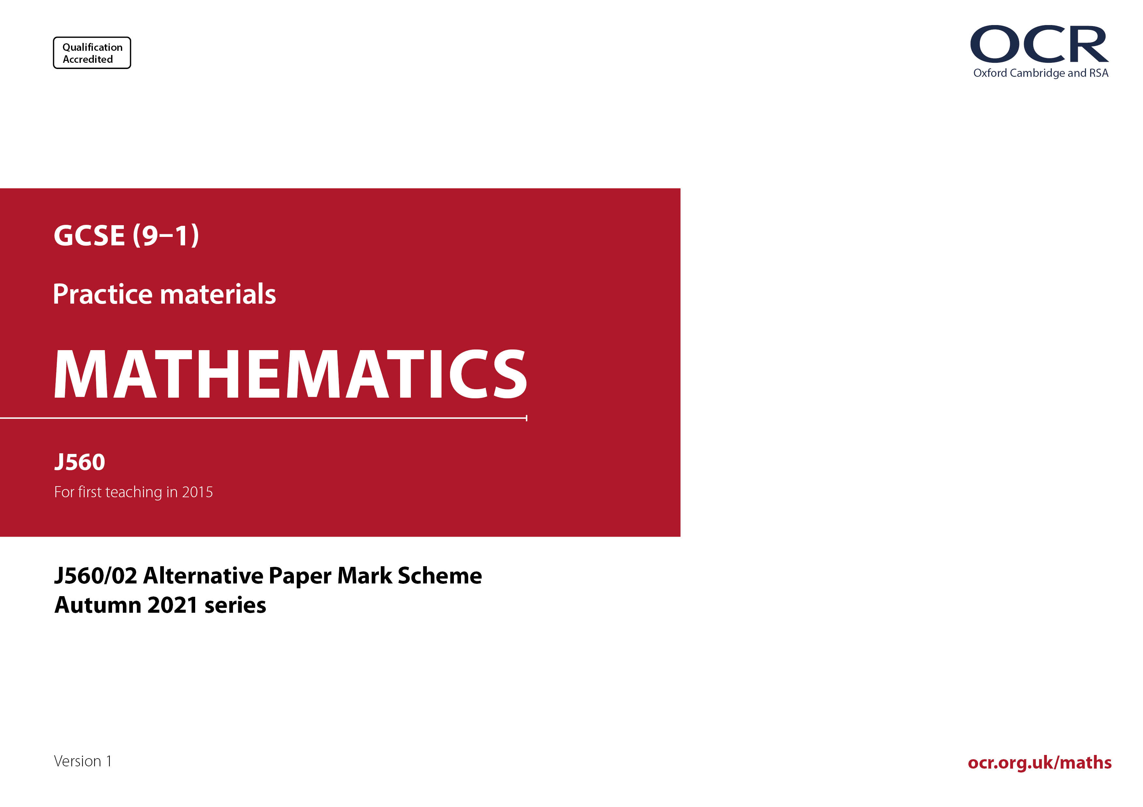
ocr.org.uk/maths

J560/02 Mark Scheme

- M marks are for using a correct method and are not lost for purely numerical errors.
A marks are for an accurate answer and depend on preceding M (method) marks. Therefore M0 A1 cannot be awarded.
B marks are independent of M (method) marks and are for a correct final answer, a partially correct answer, or a correct intermediate stage.
SC marks are for special cases that are worthy of some credit.

- The following abbreviations are commonly found in GCSE Mathematics mark schemes.

  - figs 237, for example, means any answer with only these digits. You should ignore leading or trailing zeros and any decimal point
e.g. 237000, 2.37, 2.370, 0.00237 would be acceptable but 23070 or 2374 would not.
  - isw means ignore subsequent working after correct answer obtained and applies as a default.
  - nfww means not from wrong working.
  - oe means or equivalent.
  - rot means rounded or truncated.
  - soi means seen or implied.
  - dep means that the marks are dependent on the marks indicated. You must check that the candidate has met all the criteria specified for the mark to be awarded.
  - with correct working means that full marks must not be awarded without some working. The required minimum amount of working will be defined in the guidance column and SC marks given for unsupported answers.

- Anything in the mark scheme which is in square brackets […] is not required for the mark to be earned, but if present it must be correct.

- Unless the command word requires that working is shown and the working required is stated in the mark scheme, then if the correct answer is clearly given and is not from wrong working full marks should be awarded.

Do not award the marks if the answer was obtained from an incorrect method, i.e. incorrect working is seen and the correct answer clearly follows from it.

- Where follow through (FT) is indicated in the mark scheme, marks can be awarded where the candidate’s work follows correctly from a previous answer whether or not it was correct. For questions with FT available you must ensure that you refer back to the relevant previous answer. You may find it easier to mark these questions candidate by candidate rather than question by question.

Figures or expressions that are being followed through are sometimes encompassed by single quotation marks after the word their for clarity, e.g. FT 180 × (their ‘37’ + 16), or FT 300 – √(their ‘52 + 72’). Answers to part questions which are being followed through are indicated by
e.g. FT 3 × their (a).
- In questions with no final answer line, make no deductions for wrong work after an acceptable answer (i.e. isw) unless the mark scheme says otherwise, indicated by the instruction ‘mark final answer’.

- In questions with a final answer line and incorrect answer given:

(i) If the correct answer is seen in the body of working and the answer given on the answer line is a clear transcription error allow full marks unless the mark scheme says ‘mark final answer’. Place the annotation next to the correct answer.

(ii) If the correct answer is seen in the body of working but the answer line is blank, allow full marks. Place the annotation next to the correct answer.

(iii) If the correct answer is seen in the body of working but a completely different answer is seen on the answer line, then accuracy marks for the answer are lost. Method marks could still be awarded if there is no other method leading to the incorrect answer. Use the M0, M1, M2 annotations as appropriate and place the annotation next to the wrong answer.

- In questions with a final answer line:

(i) If one answer is provided on the answer line, mark the method that leads to that answer. A correct step, value or statement that is not
part of the method that leads to the given answer should be awarded M0 and/or B0.

(ii) If more than one answer is provided on the answer line and there is a single method provided, award method marks only.

(iii) If more than one answer is provided on the answer line and there is more than one method provided, award marks for the poorer response unless the candidate has clearly indicated which method is to be marked.

- In questions with no final answer line:

(i) If a single response is provided, mark as usual.

(ii) If more than one response is provided, award marks for the poorer response unless the candidate has clearly indicated which response is to be marked.

- When the data of a question is consistently misread in such a way as not to alter the nature or difficulty of the question, please follow the candidate’s work and allow follow through for A and B marks. Deduct 1 mark from any A or B marks earned and record this by using the MR annotation. M marks are not deducted for misreads. If a candidate corrects the misread in a later part, do not continue to follow through, but award A and B marks for the correct answer only.

- Unless the question asks for an answer to a specific degree of accuracy, always mark at the greatest number of significant figures even if this is rounded or truncated on the answer line. For example, an answer in the mark scheme is 15.75, which is seen in the working. The candidate then rounds or truncates this to 15.8, 15 or 16 on the answer line. Allow full marks for the 15.75.

- Ranges of answers given in the mark scheme are always inclusive.

- For methods not provided for in the mark scheme give as far as possible equivalent marks for equivalent work. If in doubt, consult your Team Leader.

- If in any case the mark scheme operates with considerable unfairness consult your Team Leader.

Question |  |  | Answer | Marks | Part marks and guidance
1 | (a) |  | 6 | 1
 | (b) |  | Cylinder | 1
 | (c) |  | Isosceles [triangle] | 1 |  | Condone wrong spelling
2 | (a) |  | -2 | 1
 | (b) |  | 12 | 1
3 | (a) |  | 2.03 | 1
 | (b) |  | 12[.00..] | 2 | M1 for answer figs 12...
4 | (a) |  | = | 1
 | (b) |  | > | 1
5 | (a) |  | 13 | 1
 | (b) |  | (4 × 7 + 8) ÷ 4 = 9 | 1
6 | (a) |  | $$\frac{\text{3}}{\text{5}}$$ | 2 | B1 for $\frac{\text{6}}{\text{10}}$ or for correct answer seen
 | (b) |  | [0].6[00..] | 1
7 | (a) |  | $$\text{3}\frac{\text{2}}{\text{5}}$$ | 1
 | (b) | (i) | oe | 2 | M1 for or where k is a positive integer | For 2 marks oe equivalent fractions  For M1, may be seen as part of a single fraction e.g.
 | (b) | (ii) | 20 | 1 |  | Do not accept
8 | (a) |  | 15 | 1
 | (b) |  | 14 | 2 | M1 for $÷$ 5 and + 2 soi  or for $\text{60} \text{÷ 5 = 12}$ soi
9 |  |  | 52 with correct working | 5 | M3 for 500 – 6 × 55 – 14 oe  Or M2 for 500 – 6 × 55 oe  or for 6 × 55 + 14 oe  Or M1 for 6 × 55  or for 500 – 14 or 5[.00] –[0].14  M1 for their 156 ÷ 3  If 0 scored  SC2 for answer 52  Or SC1 for 156 with no working | ‘Correct working’ requires evidence of at least M2  [156]  [170]  [344]  [330]  [486] or [4.86]
10 | (a) |  | 5:12 | 2 | M1 for correct partial simplification  of 125 : 300 | e.g. 25 : 60, but not e.g. 2.5 : 6  1 : 2 oe scores M1
 | (b) |  | 240 | 2 | M1 for 30 ÷ 20 × 160 oe
 | (c) |  | Answer of 55 | 4 | M3 for 220 ÷ 80 × 20 oe  Or B2 for 60 or 11 [eggs] and 220  Or M1 for 220 ÷ 80 or 12 ÷ 4 soi | For M3 allow a table with just one error
11 | (a) |  | B K R S  B K S R  B R K S  B R S K  B S K R  B S R K | 2 | B1 for at least 3 additional correct arrangements | For 2 marks no repeats or extras  apart from B K R S
 | (b) |  | oe isw | 2 | FT their table  M1 for correct numerator or denominator FT their table | For 2 marks or M1 denominator < 11  Not ratio or words  isw cancelling/conversion to other forms
12 |  |  | 56 nfww | 4 | B2 for length of rectangle = 10  Or M1 for 6 ÷ 3 × 5  M1 for 6 × 6 + 2 × their length oe
13 | (a) |  | [No,] 1 is not a prime [factor] oe | 1 |  | Accept it should be 2 × 5², but do not isw if with an incorrect statement.
 | (b) |  | -4 | 1
 | (c) |  | 72 | 3 | B1 for [$\sqrt{\text{64} }$ =] 8  B1 for [3² oe =] 9 | For 3 marks condone ±72 or -72  For B1 condone ±8 or -8
14 |  |  | 4000 [ml] or 0.35 [L] soi  9 × 350 oe  Correct attempt to find 80% or 20% of 4000 oe  3150 and 3200  or 850 and 800  and  [They are] incorrect oe | B1  M1  M1  A2 | Or oe  or oe  Or 78[.75]% or 79% [and 80%] or 21[.25]% [and 20%]  If A0 scored  B1 for 3150 or 3200 or 850 or 800 | Correct conversion at any stage  Alternate approaches are possible  M1 may be implied by 3200 or 800 or 78[.75]% or 79% or 21[.21]% seen  For A2 accept in other correct consistent units for comparison  e.g. 3.15 [L] and 3.2 [L] and must have no incorrect statement  For B1 accept e.g. 3.15 [L] or 3.2 [L]
15 |  |  | x > 9 | 3 | M1 for 3x – 12 > 15 or x – 4 > 5  M1 for next correct productive step FT their first step | For method marks condone incorrect inequality sign or ‘equals’
16 | (a) |  | D | 1
 | (b) |  | C | 1
17 | (a) | (i) | Rectangle 7 by 6 with one internal line 2 cm from the longer edge | 3 | B1 for a rectangular side  B1 for 7 by 6 or for any rectangle with one line drawn inside parallel to longer edge | Accept in any orientation  e.g.  7 by 6 scores B1B1  7 by 6 with wrong line scores B1B1  7 by 5 scores B1B0  7 by 5 with one line scores B1B1
 |  | (ii) | 6 × 3 × 7 ÷ 2 [=63] | M2 | M1 for 6 × 3 ÷ 2 oe  or for their area or cross section × 7 | May be done in stages
 | (b) |  | 14 | 3 | M2 for $\text{56 ÷ }{\text{2}}^{\text{2}}$ oe  Or M1 for h × 2 × 2 = 56 oe  or for ${\text{2}}^{\text{2}}$ = 4 oe
18 | (a) |  | Four correct plots  (70, 89) (44, 63) (37, 51) (38, 53) | 2 | B1 for 2 or 3 correct plots
 | (b) |  | Positive | 1 |  | Ignore embellishments
18 | (c) | (i) | Circles (30, 69) only | 1 |  | Accept any clear indication
 |  | (ii) | 130 | 3 | M2 for oe  or for oe  Or M1 for oe or for 69 – 30 oe | For M2 and M1 FT their (c)(i), point must be chosen for FT (table or graph)  M2 implied by 1.3 or 230  M1 implied by 2.3 or 39
 | (d) |  | No and line of best fit should not extend beyond data provided oe | 1 |  | e.g.  Only have data up to 70 marks  No one scored that high [so the trend may not continue]  He would need to extrapolate beyond the line of best fit  Do not accept e.g. the graph only goes up to 90 for the second test
19 |  |  | Shows actual increase is 32[%]  with correct working | 5 | M3 for [k ×] 1.2 × 1.1 oe  A1 for answer 132[%] or for 1.32  OR  M1 for 1.2 oe soi  A1 for a correct evaluation of the first stage with their value  If 0 scored  SC2 for answer 32[%]  Or SC1 for 132% or 1.32 with no working | “Correct working” requires evidence of at least M3 or alternative convincing approach  Allow method marks if contained in  correct method involving any invented starting price  e.g. M3 for 100 × 1.2 × 1.1 oe  e.g. for M1A1 uses 80 as value then gives 96 in working
20 |  |  | 10 nfww | 4 | M1 for 6 × 5  M1 for 300 or 297 used  M1dep for their 300 ÷ their area, dep on first M1 | nfww for 4 marks no errors in calculating values and at least one of 6, 5, 300 or 297 used  Allow for 30 or for 5.9 × 5.1 [30.09] or with one unrounded value [29.5 or 30.6]  Allow for 297.3 ÷ (5.9 × 5.1)
21 | (a) |  | 11 and 2 | 2 | B1 for each
 | (b) |  | Correct curve | 3 | B2FT for 6 or 7 correct plots  B1FT for 4 or 5 correct plots | Tolerance ±1 small square for plotting and curve through correct points  Condone slight feathering – must not be ruled  If large blob for plot, check centre of blob
 | (c) |  | -2.5 to -2.4 and 2.4 to 2.5 | 2FT | Strict FT  B1 for either FT their graph | Tolerance ±½ a small square  Do not allow exact answers or answers with no graph  Do not FT from a straight line graph  If more than 2 intersections, B1 for each correct intersection on the answer line. If more than 2 answers, mark the worst
22 | (a) |  | Correct reason | 1 | e.g.  all could be over 50 oe  people over 50 are more likely to be in the park at that time  too small a sample  vary the time  various age groups | See appendix
 | (b) |  | Any three from:  Larger sample size  Vary the time of day/day  Ensure equal numbers [of older and younger adults are asked]  Vary the location | 3 | B1 for each | isw incorrect reasons  See appendix
23 |  |  | 55 with correct working | 6 | M1 for 3x – 10 = 2x + 35  M1dep for ±x = k or kx = ±45 (k ≠ 0)  A1 for x = 45  OR  M1 for at least two trials of 3x –10 or evaluated for x = 45  M1 for at least two trials of 2x + 35 or evaluated for x = 45  A1 for both expressions evaluated as 125 when x = 45  AND  M1 for 3 × their x – 10 or 2 × their x + 35  M1 for y = 180 – (2 × their x + 35) oe  If 0 scored  SC2 for answer 55 with no working or insufficient working  Or SC1 for x = 45 with no or insufficient working | ‘Correct working’ requires evidence of at least M1 AND M1  i.e. we expect to see a minimum of an equation or trials leading to x = 45 and the substitution

Appendix

Exemplar responses to Q22(a)

Response | Mark
Over 50s more likely to be in the park at that time | 1
There might be no one below 50 | 1
Because he could ask more people that are under 50 than over 50 | 1
The first 20 might all be the same age | 1BOD
People under 50 will be at work and more over 50 may be in the park | 1BOD
Not diverse enough | 0
Not everybody may be out at the time the survey is taken | 0
How do we know they all watched television | 0
Won’t know what age they will be | 0

Exemplar responses to Q22(b)

Response | Mark
Use statistics from other days | 1
Make the survey available online implies more people and different age groups | 1
Go to the park and ask individually every person, confirm ages, equal amounts of both under and over 50 | 0, 0, 1BOD
Make sure you ask their age | 0
It should be a closed question | 0
The journalist should be unbiased | 0
Go to the park and ask 20 adults | 0
Go to a TV stop/a place with TVs | 0
Have a wider time range as there is no time range/limit | 0
Do it on a Tuesday as just on a different day of the week would make no difference | 0
Asking people of all ages not the same as ensuring equal numbers | 0
Ask females and males not relevant to the data required | 0

Please note – web links are correct at date of publication but other websites may change over time. If you have any problems with a link you may want to navigate to that organisation’s website for a direct search.


We’d like to know your view on the resources we produce. Click ‘Like’ or ‘Dislike’ to send us an auto generated email about this resource. Add comments if you want to. Let us know how we can improve this resource or what else you need. Your email will not be used or shared for any marketing purposes.
Looking for another resource? There is now a quick and easy search tool to help find free resources for your qualification.
OCR is part of Cambridge University Press & Assessment, which is itself a department of the University of Cambridge.
For staff training purposes and as part of our quality assurance programme your call may be recorded or monitored. Oxford Cambridge and RSA Examinations is a Company Limited by Guarantee. Registered in England. Registered office The Triangle Building, Shaftesbury Road, Cambridge, CB2 8EA. Registered company number 3484466. OCR is an exempt charity.
OCR operates academic and vocational qualifications regulated by Ofqual, Qualifications Wales and CCEA as listed in their qualifications registers including A Levels, GCSEs, Cambridge Technicals and Cambridge Nationals.
OCR provides resources to help you deliver our qualifications. These resources do not represent any teaching method we expect you to use. We update our resources regularly and aim to make sure content is accurate but please check the OCR website so that you have the most up to date version. OCR cannot be held responsible for any errors or omissions in these resources.
Though we make every effort to check our resources, there may be contradictions between published support and the specification, so it is important that you always use information in the latest specification. We indicate any specification changes within the document itself, change the version number and provide a summary of the changes. If you do notice a discrepancy between the specification and a resource, please contact us.
© OCR 2022 - You can copy and distribute this resource freely if you keep the OCR logo and this small print intact and you acknowledge OCR as the originator of the resource.
OCR acknowledges the use of the following content: N/A
Whether you already offer OCR qualifications, are new to OCR or are thinking about switching, you can request more information using our Expression of Interest form.
Please get in touch if you want to discuss the accessibility of resources we offer to support you in delivering our qualifications.

