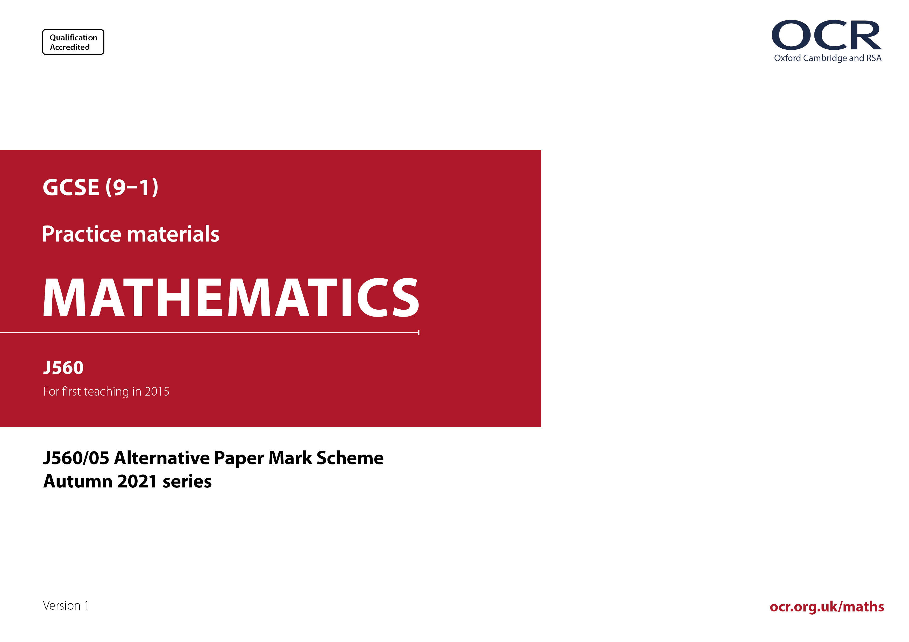

ocr.org.uk/maths

J560/02 Mark Scheme

- M marks are for using a correct method and are not lost for purely numerical errors.
A marks are for an accurate answer and depend on preceding M (method) marks. Therefore M0 A1 cannot be awarded.
B marks are independent of M (method) marks and are for a correct final answer, a partially correct answer, or a correct intermediate stage.
SC marks are for special cases that are worthy of some credit.

- The following abbreviations are commonly found in GCSE Mathematics mark schemes.

  - figs 237, for example, means any answer with only these digits. You should ignore leading or trailing zeros and any decimal point
e.g. 237000, 2.37, 2.370, 0.00237 would be acceptable but 23070 or 2374 would not.
  - isw means ignore subsequent working after correct answer obtained and applies as a default.
  - nfww means not from wrong working.
  - oe means or equivalent.
  - rot means rounded or truncated.
  - soi means seen or implied.
  - dep means that the marks are dependent on the marks indicated. You must check that the candidate has met all the criteria specified for the mark to be awarded.
  - with correct working means that full marks must not be awarded without some working. The required minimum amount of working will be defined in the guidance column and SC marks given for unsupported answers.

- Anything in the mark scheme which is in square brackets […] is not required for the mark to be earned, but if present it must be correct.

- Unless the command word requires that working is shown and the working required is stated in the mark scheme, then if the correct answer is clearly given and is not from wrong working full marks should be awarded.

Do not award the marks if the answer was obtained from an incorrect method, i.e. incorrect working is seen and the correct answer clearly follows from it.

- Where follow through (FT) is indicated in the mark scheme, marks can be awarded where the candidate’s work follows correctly from a previous answer whether or not it was correct. For questions with FT available you must ensure that you refer back to the relevant previous answer. You may find it easier to mark these questions candidate by candidate rather than question by question.

Figures or expressions that are being followed through are sometimes encompassed by single quotation marks after the word their for clarity, e.g. FT 180 × (their ‘37’ + 16), or FT 300 – √(their ‘52 + 72’). Answers to part questions which are being followed through are indicated by
e.g. FT 3 × their (a).

- In questions with no final answer line, make no deductions for wrong work after an acceptable answer (i.e. isw) unless the mark scheme says otherwise, indicated by the instruction ‘mark final answer’.

- In questions with a final answer line and incorrect answer given:

(i) If the correct answer is seen in the body of working and the answer given on the answer line is a clear transcription error allow full marks unless the mark scheme says ‘mark final answer’. Place the annotation next to the correct answer.

(ii) If the correct answer is seen in the body of working but the answer line is blank, allow full marks. Place the annotation next to the correct answer.

(iii) If the correct answer is seen in the body of working but a completely different answer is seen on the answer line, then accuracy marks for the answer are lost. Method marks could still be awarded if there is no other method leading to the incorrect answer. Use the M0, M1, M2 annotations as appropriate and place the annotation next to the wrong answer.

- In questions with a final answer line:

(i) If one answer is provided on the answer line, mark the method that leads to that answer. A correct step, value or statement that is not
part of the method that leads to the given answer should be awarded M0 and/or B0.

(ii) If more than one answer is provided on the answer line and there is a single method provided, award method marks only.

(iii) If more than one answer is provided on the answer line and there is more than one method provided, award marks for the poorer response unless the candidate has clearly indicated which method is to be marked.

- In questions with no final answer line:

(i) If a single response is provided, mark as usual.

(ii) If more than one response is provided, award marks for the poorer response unless the candidate has clearly indicated which response is to be marked.

- When the data of a question is consistently misread in such a way as not to alter the nature or difficulty of the question, please follow the candidate’s work and allow follow through for A and B marks. Deduct 1 mark from any A or B marks earned and record this by using the MR annotation. M marks are not deducted for misreads. If a candidate corrects the misread in a later part, do not continue to follow through, but award A and B marks for the correct answer only.

- Unless the question asks for an answer to a specific degree of accuracy, always mark at the greatest number of significant figures even if this is rounded or truncated on the answer line. For example, an answer in the mark scheme is 15.75, which is seen in the working. The candidate then rounds or truncates this to 15.8, 15 or 16 on the answer line. Allow full marks for the 15.75.

- Ranges of answers given in the mark scheme are always inclusive.

- For methods not provided for in the mark scheme give as far as possible equivalent marks for equivalent work. If in doubt, consult your Team Leader.

- If in any case the mark scheme operates with considerable unfairness consult your Team Leader.

Question |  |  | Answer | Marks | Part marks and guidance
1 |  |  | $$\text{1}\frac{\text{1}}{\text{5}}$$ | 3 | Mark final answer  B2 for $\frac{\text{210}}{\text{175}}$ oe  Or M1 for $\frac{\text{30}}{\text{7}}$ seen
2 | (a) |  | No oe and 1 is not a prime [factor] oe | 1 |  | e.g. it should be 2² × 3 × 5
 | (b) |  | -3 | 1
3 |  |  | 4000 [ml] or 0.35 [L] soi  9 × 350 oe  Correct attempt to find 80% or 20% of 4000 oe  3150 and 3200  or 850 and 800  and  [They are] incorrect oe | B1  M1  M1  A2 | Or oe  or oe  Or 78[.75]% or 79% [and 80%] or 21[.25]% [and 20%]  If A0 scored  B1 for 3150 or 3200 or 850 or 800 | Correct conversion at any stage  Alternate approaches are possible  M1 may be implied by 3200 or 800 or 78[.75]% or 79% or 21[.21]% seen  For A2 accept in other correct consistent units for comparison  e.g. 3.15 [L] and 3.2 [L] and must have no incorrect statement  For B1 accept e.g. 3.15 [L] or 3.2 [L]
4 | (a) |  | Four correct plots  (70, 89) (44, 63) (37, 51) (38, 53) | 2 | B1 for 2 or 3 correct plots
 | (b) |  | Positive | 1 |  | Ignore embellishments
 | (c) | (i) | Circles (30, 69) only | 1 |  | Accept any clear indication
 |  | (ii) | 130 | 3 | M2 for oe  or for oe  Or M1 for oe or for 69 – 30 oe | For M2 and M1 FT their (c)(i), point must be chosen for FT (table or graph)  M2 implied by 1.3 or 230  M1 implied by 2.3 or 39
 | (d) |  | No and line of best fit should not extend beyond data provided oe | 1 |  | e.g.  Only have data up to 70 marks  No one scored that high [so the trend may not continue]  He would need to extrapolate beyond the line of best fit  Do not accept e.g. the graph only goes up to 90 for the second test
5 |  |  | 50 | 4 | M2 for correct method to find area of L-shaped face e.g. 7 × 4 – 6 × 3  Or M1 for finding one of the relevant partial lengths of 3 or 6  M1 for their area × 5  OR  M1 for 4 × 5 × 1  M1 for 6 × 5 × 1  A1 for 20 or 30  OR  M1 for 7 × 4 × 5  M1 for 3 × 6 × 5  A1 for 140 or 90 | M1 could be on diagram  Treat extra volumes as choice  A1 Implies M1  Mark as oe for other correct products if split into two different cuboids that make the solid  Not 7 × 4 × 5 × 1 × 1  Treat extra volumes as choice  A1 implies M1 unless 140 comes from  7 × 4 × 5 × 1 × 1
6 | (a) |  | D | 1
 | (b) |  | C | 1
7 | (a) |  | x > 3 | 3 | Mark final answer  M1 for 3x – 6 > x or x – 2 > $\frac{\text{x}}{\text{3}}$  M1 for correct step[s] to ax > b FT their first step | For method marks, condone incorrect inequality sign or ‘equals’ sign  e.g. Answer x = 3, x > 3 implies M1M1
 | (b) |  | Correct representation of their (a) on number line | 2 | Strict FT their (a) dep on an inequality in (a)  B1FT for their correct hollow or solid circle  B1FT for their correct arrow direction | If e.g. 4 on answer line and x < 4 in working then allow FT from x < 4  If answer 4 in (a) then allow x < 3 here  Both B1’s must be with their value from part (a)  If no arrow then their line must stretch to end of line
8 | (a) |  | -1 | 1
 | (b) |  | Correct graph | 3 | Curves must not be joined or touch either axis  B2FT for 7 or 8 correct plots  Or B1FT for 5 or 6 correct plots | Condone slight feathering, no ruled segments  If curve incorrect, mark the plots  If large blob for plot, check centre of blob
9 |  |  | Shows actual increase is 32[%]  with correct working | 5 | M3 for [k ×] 1.2 × 1.1 oe  A1 for answer 132[%] or for 1.32  OR  M1 for 1.2 oe soi  A1 for a correct evaluation of the first stage with their value  If 0 scored  SC2 for answer 32[%]  Or SC1 for 132% or 1.32 with no working | ‘Correct working’ requires evidence of at least M3 or alternative convincing approach  Allow method marks if contained in  correct method involving any invented starting price  e.g. M3 for 100 × 1.2 × 1.1 oe  e.g. for M1A1 uses 80 as value then gives 96 in working
10 |  |  | 10 nfww | 4 | M1 for 6 × 5  M1 for 300 or 297 used  M1dep for their 300 ÷ their area, dep on first M1 | nfww for 4 marks no errors in calculating values and at least one of 6, 5, 300 or 297 used  Allow for 30 or for 5.9 × 5.1 [30.09] or with one unrounded value [29.5 or 30.6]  Allow for 297.3 ÷ (5.9 × 5.1)
11 |  |  | 10 with correct working | 7 | M1 for $\frac{\text{BD}}{\text{12}}$ = sin 30 oe  B1 for sin 30 = 0.5 soi  A1 for [BD =] 6  M1 for their BD × oe  A1 for CD = 8  M1 for (their BD)² + (their CD)² [= BC²] oe  If 0 scored  SC3 for answer 10 with no working  Or SC2 for CD = 8 with no working  Or SC1 for BD = 6 with no working | ‘Correct working’ requires evidence of at least M1 or B1 and M1M1 or alternate convincing approach  Answer 8 gets A0 unless CD = 8 shown in working or on diagram  SCs may be seen on the diagram
12 | (a) |  | 0.62 | 2 | M1 for 8.6 – 7.98 or 7.98 to 8.6
 | (b) |  | 15 | 2 | M1 for 0.25 × 60 oe
 | (c) | (i) | Azmi’s hamster/median is shorter than the box plot’s median oe | 1 |  | With no incorrect statement  Accept ‘middle’ for ‘median’  Accept 8.25 < 8.32  It is below the box plot median [8.32]
 |  | (ii) | Spread/range/IQR of Azmi’s lengths is not known oe  or sample is too small oe | 1 |  | With no incorrect statement  Accept ‘They only measured the middle hamster’ oe  Accept ‘Lengths of Azmi’s other hamsters are not known’ oe  Azmi only has 5 hamsters, which makes the data unreliable for comparison
13 | (a) |  | 0.$\dot{\text{3}}\dot{\text{6}}$ | 2 | M1 for attempt to divide 4 by 11 | For 2 marks accept 0.363636…  Implied by 0.36 to 0.37
 | (b) |  | $\frac{\text{29}}{\text{45}}$ final answer | 3 | B2 for $\frac{\text{58}}{\text{90}}$ oe  Or M1 for 6.44[4…] or 64.4[4...] seen  or for  If 0 scored, SC1 for answer $\frac{\text{64}}{\text{99}}$ | B2 for e.g. $\frac{\text{5.8}}{\text{9}}$  For M1 accept any other decimal value[s] that would eliminate the recurrence when subtracted  M1 implied by 58 and 90  (SC mark from 0.6464…)
14 |  |  | 540 | 2 | M1 for 3³ oe
15 |  |  | 3$\sqrt{\text{3}}$ final answer | 3 | M2 for 5$\sqrt{\text{3}}$ and 2$\sqrt{\text{3}}$  Or M1 for $\sqrt{\text{25} \text{×} \text{3}}$ or better or $\sqrt{\text{4} \text{×} \text{3}}$ or better
16 |  |  | $\frac{\text{6}}{\text{20}}$ oe with correct working | 5 | With x representing the number of laptop and tablet:  B3 for [laptop and tablet =] 6 may be on a Venn diagram oe  Or M2 for [x = ] 26 + 20 + 10 – 50 oe  Or M1 for 26 – x + x + 20 – x + 10 = 50 oe  or for Venn diagram with 26 – x, x and  20 – x correctly placed  AND  M1 for fraction $\frac{\text{n}}{\text{20}}$ or $\frac{\text{6}}{\text{n}}$ that leads to the answer  If 0 scored  SC2 for $\frac{\text{6}}{\text{20}}$ oe with no working | isw cancelling/conversion to other forms  For full marks ‘correct working’ requires B3 i.e. [laptop and tablet =] 6 with evidence of M1 or M2 or alternative convincing approach  M1 FT their 6 provided < 20  For Venn diagrams, condone omission of universal set, rectangle and 10 for M1, M2, B3 and full marks  For M1 must be a proper fraction
17 |  |  | $\frac{\text{3(}\text{x} \text{–} \text{2)}}{\text{x} \text{+} \text{6}}$ or $\frac{\text{3}\text{x} \text{–} \text{6}}{\text{x} \text{+} \text{6}}$ final answer | 5 | M2 for 3(x – 2)(x + 2) or (3x – 6)(x + 2)  Or M1 for 3(x² – 4)  M2 for (x + 2)(x + 6)  Or M1 for x(x + 2) + 6(x + 2)  or x(x + 6) + 2(x + 6)  or for (x + a)(x + b) where a + b = 8 or  ab = 12 | For method marks condone omission of final bracket
18 |  |  | 45 with correct working | 5 | B3 for angle BCD = 105 with correct working  Or M1 for angle BAD = 75  or for angle BDE = 180 – 75 or 105  M1 for angle BCD = 180 – their angle BAD  AND  M2 for their angle BCD ÷ 7 × 3 oe  Or M1 for their angle BCD ÷ 7 oe  If 0 scored  SC2 for answer 45  Or SC1 for angle BCD = 105 | For full marks ‘correct working’ requires evidence of at least M1 AND M1 i.e. at least a correct angle and some ratio work  Ignore geometric reasons if given  For B3 “correct working” requires at least M1 or alternate convincing approach  Angles may be indicated on diagram for part marks  May be seen on diagram
19 |  |  | x² + y² = 124 final answer | 4 | B2 for 124  Or B1 for 108  Or M1 for 4² + (6$\sqrt{3}$)² oe  B1 for x² + y² = k as final answer | Accept ‘= k’ or numeric value where  k > 0
20 |  |  | z = 2y ² – 6 final answer | 4 | B3 for answer 2y ² – 6  Or M3 for oe or 2y ² – z = 6 oe or or better  Or M2 for oe  or oe  or 6x = 14 – 2y ²  or (6x + 2y ²) – (6x + z) = 14 – 8 oe  Or M1 for 6x + 2y ² = 14 or 3x = 7 – y ²  or 6x = 8 – z or better | Correct unsimplified formula in y and z  M2 sets up for substitution with x explicit or for method for elimination by equating coefficients of x and correct method to eliminate x  M1 equates coefficients of x or first step in rearrangement to eliminate x
21 |  |  | 16 + 6 final answer  with correct working | 6 | B3 for [angle at centre] = 135 with correct working or $\frac{\text{3}}{\text{8}}$ [of circle] oe  Or M2 for $\frac{\left[\text{360} \text{×} \right]\text{24}\text{π}}{\text{π} \text{×} {\text{8}}^{\text{2}}}$ oe  Or M1 for $\frac{\text{θ}}{\text{360}}$ × π × 8² oe  AND  M2 for answer 16 + k where k = $\frac{\text{8} \text{×} \text{their} \text{θ}}{\text{180}}$  Or M1 for $\frac{\text{their} \text{θ}}{\text{360}}$ × 2 × π × 8 oe  or answer 16 + k  If 0 scored, SC2 for answer 16 + 6 | For full marks ‘correct working’ requires evidence of at least M1 AND M1 i.e. use of formulas for sector area and arc length or alternate convincing approach  For B3 ‘correct working’ requires at least M1 for use of formula for sector area  M2 method for finding fraction of circle  M1 Implied by 6  For M1 k ≠ 0  May be on diagram
22 |  |  | 2n³ + 8n² – 20n + 10  or 2(n³ + 4n² – 10n + 5)  2(n³ + 4n² – 10n + 5) | M5  A1 | M3 for  2n³ – 4n² + 10n² – n² – 5n + 2n – 20n + 10 oe or better  or condone one error in coefficients in simplified expression 2n³ + 8n² – 20n + 10  Or M2 for one correct expanded pair  Or M1 for 3 correct terms out of 4 in expanded pair (term in n counts as 2 terms)  AND  M1 for 3n² + 3n  Accept e.g. each term is divisible by 2  or (2n³ + 8n² – 20n + 10) ÷ 2 = n³ + 4n² – 10n + 5  Alternative method  Alternative method for 6 marks  Fully correct reasoning with even and odds for n and for each term when n is even and when n is odd (2n –1)(n + 5)(n – 2) and  3n(n + 1), e.g. if n is even, (2n – 1) is odd, etc.  Or M3 for fully correct reasoning with even and odds, but only considering n is even or n is odd not both | 2n³ + 5n² – 23n + 10 when simplified  i.e. 2n² – n + 10n – 5 or better  or 2n² – n – 4n + 2 or better  or n² + 5n – 2n – 10 or better  Must include e.g. if n is even, 2n – 1 is odd, n + 5 is odd, n – 2 is even, then even × odd × odd = even and 3n is even and n + 1 is odd, even × odd = even, then even + even = even  and repeat when n = odd

Please note – web links are correct at date of publication but other websites may change over time. If you have any problems with a link you may want to navigate to that organisation’s website for a direct search.


We’d like to know your view on the resources we produce. Click ‘Like’ or ‘Dislike’ to send us an auto generated email about this resource. Add comments if you want to. Let us know how we can improve this resource or what else you need. Your email will not be used or shared for any marketing purposes.
Looking for another resource? There is now a quick and easy search tool to help find free resources for your qualification.
OCR is part of Cambridge University Press & Assessment, which is itself a department of the University of Cambridge.
For staff training purposes and as part of our quality assurance programme your call may be recorded or monitored. Oxford Cambridge and RSA Examinations is a Company Limited by Guarantee. Registered in England. Registered office The Triangle Building, Shaftesbury Road, Cambridge, CB2 8EA. Registered company number 3484466. OCR is an exempt charity.
OCR operates academic and vocational qualifications regulated by Ofqual, Qualifications Wales and CCEA as listed in their qualifications registers including A Levels, GCSEs, Cambridge Technicals and Cambridge Nationals.
OCR provides resources to help you deliver our qualifications. These resources do not represent any teaching method we expect you to use. We update our resources regularly and aim to make sure content is accurate but please check the OCR website so that you have the most up to date version. OCR cannot be held responsible for any errors or omissions in these resources.
Though we make every effort to check our resources, there may be contradictions between published support and the specification, so it is important that you always use information in the latest specification. We indicate any specification changes within the document itself, change the version number and provide a summary of the changes. If you do notice a discrepancy between the specification and a resource, please contact us.
© OCR 2022 - You can copy and distribute this resource freely if you keep the OCR logo and this small print intact and you acknowledge OCR as the originator of the resource.
OCR acknowledges the use of the following content: N/A
Whether you already offer OCR qualifications, are new to OCR or are thinking about switching, you can request more information using our Expression of Interest form.
Please get in touch if you want to discuss the accessibility of resources we offer to support you in delivering our qualifications.

