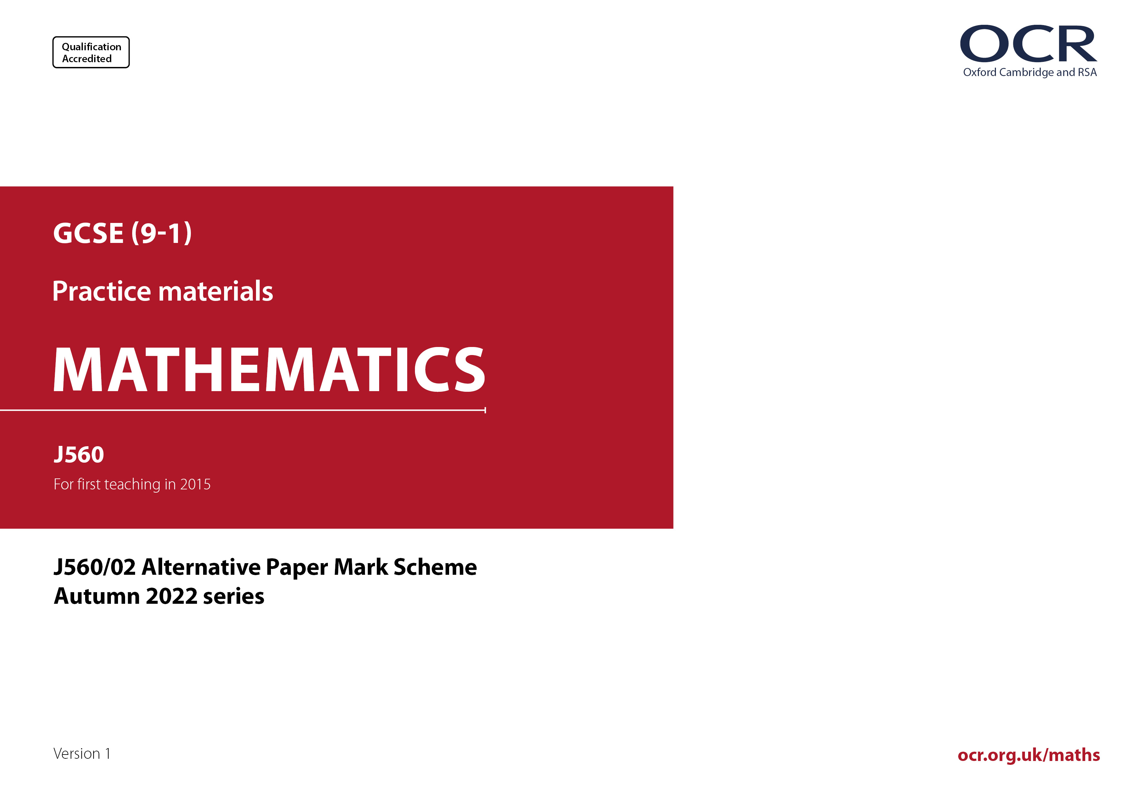
ocr.org.uk/maths

J560/02 Mark Scheme
- M marks are for using a correct method and are not lost for purely numerical errors.
A marks are for an accurate answer and depend on preceding M (method) marks. Therefore M0 A1 cannot be awarded.
B marks are independent of M (method) marks and are for a correct final answer, a partially correct answer, or a correct intermediate stage.
SC marks are for special cases that are worthy of some credit.

- The following abbreviations are commonly found in GCSE Mathematics mark schemes.

  - figs 237, for example, means any answer with only these digits. You should ignore leading or trailing zeros and any decimal point
e.g. 237000, 2.37, 2.370, 0.00237 would be acceptable but 23070 or 2374 would not.
  - isw means ignore subsequent working after correct answer obtained and applies as a default.
  - nfww means not from wrong working.
  - oe means or equivalent.
  - rot means rounded or truncated.
  - soi means seen or implied.
  - dep means that the marks are dependent on the marks indicated. You must check that the candidate has met all the criteria specified for the mark to be awarded.
  - with correct working means that full marks must not be awarded without some working. The required minimum amount of working will be defined in the guidance column and SC marks given for unsupported answers.
- Anything in the mark scheme which is in square brackets […] is not required for the mark to be earned, but if present it must be correct.

- Unless the command word requires that working is shown and the working required is stated in the mark scheme, then if the correct answer is clearly given and is not from wrong working full marks should be awarded.

Do not award the marks if the answer was obtained from an incorrect method, i.e. incorrect working is seen and the correct answer clearly follows from it.

- Where follow through (FT) is indicated in the mark scheme, marks can be awarded where the candidate’s work follows correctly from a previous answer whether or not it was correct. For questions with FT available you must ensure that you refer back to the relevant previous answer. You may find it easier to mark these questions candidate by candidate rather than question by question.

Figures or expressions that are being followed through are sometimes encompassed by single quotation marks after the word their for clarity, e.g. FT 180 × (their ‘37’ + 16), or FT 300 – √(their ‘52 + 72’). Answers to part questions which are being followed through are indicated by
e.g. FT 3 × their (a).

- In questions with no final answer line, make no deductions for wrong work after an acceptable answer (i.e. isw) unless the mark scheme says otherwise, indicated by the instruction ‘mark final answer’.

- In questions with a final answer line and incorrect answer given:

(i) If the correct answer is seen in the body of working and the answer given on the answer line is a clear transcription error allow full marks unless the mark scheme says ‘mark final answer’. Place the annotation next to the correct answer.

(ii) If the correct answer is seen in the body of working but the answer line is blank, allow full marks. Place the annotation next to the correct answer.

(iii) If the correct answer is seen in the body of working but a completely different answer is seen on the answer line, then accuracy marks for the answer are lost. Method marks could still be awarded if there is no other method leading to the incorrect answer. Use the M0, M1, M2 annotations as appropriate and place the annotation next to the wrong answer.

- In questions with a final answer line:

(i) If one answer is provided on the answer line, mark the method that leads to that answer. A correct step, value or statement that is not
part of the method that leads to the given answer should be awarded M0 and/or B0.

(ii) If more than one answer is provided on the answer line and there is a single method provided, award method marks only.

(iii) If more than one answer is provided on the answer line and there is more than one method provided, award marks for the poorer response unless the candidate has clearly indicated which method is to be marked.

- In questions with no final answer line:

(i) If a single response is provided, mark as usual.

(ii) If more than one response is provided, award marks for the poorer response unless the candidate has clearly indicated which response is to be marked.

- When the data of a question is consistently misread in such a way as not to alter the nature or difficulty of the question, please follow the candidate’s work and allow follow through for A and B marks. Deduct 1 mark from any A or B marks earned and record this by using the MR annotation. M marks are not deducted for misreads. If a candidate corrects the misread in a later part, do not continue to follow through, but award A and B marks for the correct answer only.

- Unless the question asks for an answer to a specific degree of accuracy, always mark at the greatest number of significant figures even if this is rounded or truncated on the answer line. For example, an answer in the mark scheme is 15.75, which is seen in the working. The candidate then rounds or truncates this to 15.8, 15 or 16 on the answer line. Allow full marks for the 15.75.

- Ranges of answers given in the mark scheme are always inclusive.

- For methods not provided for in the mark scheme give as far as possible equivalent marks for equivalent work. If in doubt, consult your Team Leader.

- If in any case the mark scheme operates with considerable unfairness consult your Team Leader.

Question |  |  | Answer | Marks | Part marks and guidance
1 | (a) |  | Not used the key oe  12 | 1  1 |  | e.g. Each circle is 4 students/not 1 student  Misinterpreted/Not interpreted the key  or reverse: ¾ of a circle should have been drawn  See AG
1 | (b) |  | 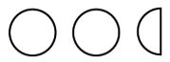 | 1
2 | (a) | (i) | 4 | 1
2 | (a) | (ii) | 3 | 1
2 | (b) |  | [±]45 | 3 | B1 for 9  B1 for [±]5 | Not embedded e.g. 5 × 5 = 25
3 | (a) |  | 7.54 | 1
 | (b) |  | [0].8 | 1
4 | (a) |  | $$\text{5}\frac{\text{2}}{\text{3}}$$ | 1
4 | (b) |  | $$\frac{\text{13}}{\text{7}}$$ | 1
4 | (c) |  | No and [0].625  or No and $\frac{\text{29}}{\text{50}}$  or No and 0.58 = $\frac{\text{580}}{\text{1000}}$ and $\frac{\text{5}}{\text{8}}$ = $\frac{\text{625}}{\text{1000}}$ | 2 | B1 for 0.62 to 0.63  or  M1 for $\frac{\text{58}}{\text{100}}$ oe | Allow equivalents for no e.g. incorrect  Allow for 2 marks $\frac{\text{62.5}}{\text{100}}$ with $\frac{\text{58}}{\text{100}}$  Also allow 62.5[%] with 58[%] seen  See AG
5 |  |  | 2 × 3 × 3 × 3  Or  2 × 3³ | 2 | B1 2, 3, 3, 3 as answer  Or  M1 for attempt at factor tree or ladder with 2 correct stages shown | B1 could be seen as a correct complete tree/ladder
6 | (a) |  | 130  and  [vertically] opposite angles | 2 | B1 for either | Accept  angles on a [straight] line [= 180]  if 50 is shown on the diagram/working
6 | (b) |  | 50  and  angles on a [straight] line [= 180] | 2 | B1 for either | Accept  angles at a point/full turn [= 360]  if 130, 130 and 50 shown on diagram/working
7 |  |  | -2 | 2 | M1 for 10 or -12  or 5 × 2 + 4 × -3 oe | Not 10x or -12y
8 | (a) |  | $$\frac{\text{11}}{\text{20}}$$ | 2 | M1 for $\frac{\text{55}}{\text{100}}$
8 | (b) |  | 15 | 2 | M1 for 0.15 [× 100] or $\frac{\text{3}}{\text{20}}$ [× 100] oe
8 | (c) |  | 195 | 3 | M2 for 150 × 1.3 oe  or M1 for 150 × 0.3 oe | M1 Implied by 45  Allow M1 for complete attempt at chunking  e.g. 10% = 15 [repeated three times] oe
9 | (a) |  | 240 with working | 2 | B1 for rounded value of 60 or 4  If 0 scored  SC1 for 60.0 and 4.0 and 240.0 as answer | For 2 marks 60 and 4 must be seen
9 | (b) |  | No oe  and  [because] the answer should be close to 240 oe | 1 |  | Eg  No his answer is ten times too big  No the decimal point is in the wrong place  See AG
10 |  |  | 800 with correct working | 6 | M1 for 3 × 1.30 + 2 × 0.85 oe or 3.9[0] + 1.7[0]  A1 for 5.6[0]  AND  M1 for (8 – their 5.6[0]) oe  A1 for 2.4[0]  AND  M1 for their 2.4[0] ÷ 1.2[0] [× 400]  A1FT for their 2.4[0] ÷ 1.2[0] rounded down × 400  If 0 or 1 scored, instead award  SC2 for answer 800 with no or insufficient working  If 0 scored, instead award  SC1 for 2.4[0] with no or insufficient working | “Correct working” requires evidence of at least two M marks and one A mark  Allow working in pence provided consistent units used  5.6[0] implies M1A1  Could be implied by  their 5.6[0] + their 2.4[0] + their ‘change’ [= 8.0[0]]  Implied by list 1.2[0], 2.4[0], [3.6[0], …] up to one less than their 2.4[0]  or Embedded 2 × 1.2[0] = 2.4[0]  Alternative Method: For first M1A1 M1A1  M1 for 8 - 3 × 1.30 or 8 - 2 × 0.85  A1 for 4.1[0] or 6.3[0]  AND  M1 for 8 - 3 × 1.30 - 2 × 0.85  or their 4.1[0] - 2 × 0.85  or their 6.3[0] - 3 × 1.30  A1 for 2.4[0]
11 | (a) |  | Correct sketch with -3 indicated as x-intercept  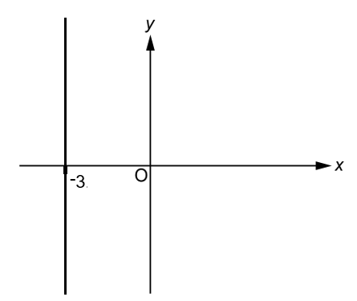 | 2 | B1 for a vertical line to the left of the y-axis | Condone good freehand  Line must be at least 10 mm
11 | (b) |  | Correct sketch with -2 indicated as  y-intercept and 2 indicated as  x-intercept  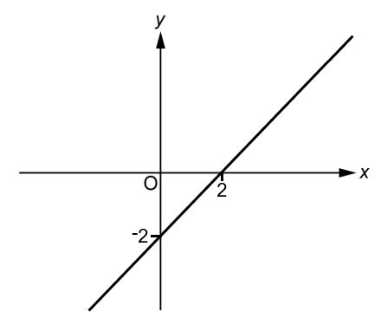 | 3 | B1 for line with positive gradient  and  B1 DEP  for a line with -2 indicated as y-intercept  or for a line with 2 indicated as x-intercept | Condone good freehand  Line must be at least 10 mm
11 | (c) |  | Correct sketch  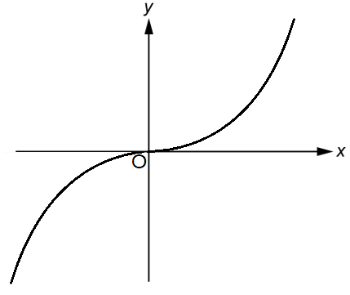 | 1 | Curve, correct shape | Condone intention to show turning point at (0,0) and length of curve.
12 | (a) |  | 5x + 10 | 1
12 | (b) |  | 4b² – 4b | 2 | B1 for 4b² or – 4b
13 | (a) |  | $\frac{\text{8}}{\text{9}}$ oe | 1
13 | (b) |  | $\frac{\text{5}}{\text{12}}$oe | 2 | M1 for $\frac{\text{9}\text{k}}{\text{12}\text{k}}$ or $\frac{\text{4}\text{k}}{\text{12}\text{k}}$ seen where k is a positive integer. | May be seen as part of a single fraction e.g. $\frac{\text{9} \text{-} \text{4}}{\text{12}}$
14 |  |  | 2.6 oe | 3 | M2 for 4x + 6x = 19 + 7 oe  OR  M1 for 10x – 7 = 19 or 10x = k  or 4x = 26 – 6x or kx = 26  AND  M1 for x = $\frac{\text{b}}{\text{a}}$ FT their ax = b seen | e.g. x = $\frac{\text{26}}{\text{10}}$ oe
15 |  |  | 5 | 4 | M3 for $\frac{\text{460} \text{–} \text{400}}{\text{3} \text{×} \text{400}}$ [× 100] oe  or M2 for $\frac{\text{460} \text{–} \text{400}}{\text{3}}$ oe or for $\frac{\text{460} \text{–} \text{400}}{\text{400}}$ oe  or M1 for 460 – 400 or $\frac{\text{460}}{\text{400}}$ or for $\frac{\text{400} \text{×} \text{r} \text{×} \text{3}}{\text{100}}$ oe | Eg $\frac{\text{20}}{\text{400}}$[× 100] or implied by [0].05  M2 implied by 20 or [0].15 or 15%  M1 implied by 60 or 1.15
16 |  |  | 8 : 1 with correct working | 5 | M1 for 360 ÷ 18 or $\frac{\text{(18} \text{-} \text{2)} \text{×} \text{180}}{\text{18}}$ oe  A1 for 20 or 160  AND  M1 for their interior + their exterior = 180  A1 for 20 and 160  If 0 or 1 scored, instead award  SC2 for answer 8 : 1 with no or insufficient working  If 0 scored, instead award  SC1 for 8k : k or for answer 1 : 8 or for 20 and 160 with no or insufficient working | “Correct working” requires evidence of at least one pair of M1A1  20 and/or 160 could be on the diagram  Where k > 1 and an integer
17 | (a) |  | 5 : 1 oe | 1 |  | Accept 1 : 0.2
 | (b) |  | $$\frac{\text{4}}{\text{7}}$$ | 2 | M1 for $\frac{\text{8}}{\text{14}}$ oe
18 |  |  | 3, 4, 5 | 3 | B2 for 2 correct and no extras or all 3 correct and one extra  OR  M2 for 2 < x ⩽ 5  or  M1 for 2 < x or x ⩽ 5
19 | (a) |  |  | 1
   | 2 | 3 | 5
  2 | 4 | 6 | 10
  3 | 6 | 9 | 15
  5 | 10 | 15 | 25
19 | (b) |  | $\frac{\text{4}}{\text{9}}$ oe | 2 | FT their completed table  M1 for 9, 15, 15 and 25 identified FT their table and no others | Do not accept ratio or words  isw conversion/cancelling  M1 implied by $\frac{\text{8}}{\text{15}}$
20 | (a) |  | $\frac{\text{1}}{\text{4}}$ | 1 | Accept any equivalent fraction | isw attempts to simplify
20 | (b) |  | 40[%] | 4 | M3 for 1 – $\left(\frac{\text{15}}{\text{100}} \text{÷} \text{their}\frac{\text{1}}{\text{4}}\right)$ oe  or for $\frac{\text{their} \text{25} \text{-} \text{15}}{\text{their}\text{ 25}}$ oe  or M2 for $\frac{\text{15}}{\text{100}}\text{÷} \text{their}\frac{\text{1}}{\text{4}}$ oe  or for their 25 – 15 oe  or M1 conversion of values to a common form e.g their 25% or $\frac{\text{15}}{\text{100}}$ or $\frac{\text{85}}{\text{100}}$ seen  or their 0.25 and 0.15 or their 0.25 and 0.85 seen  OR  Alternative method using a value for the number of biscuits  e.g. if using 20 biscuits…  M3 for fraction of Rowan’s share $\frac{\text{5} \text{-} \text{3}}{\text{5}}$  or M2 for Rowan eats 5 – 3  or M1 for Rowan receives 5 or is left with 3 | M3 implied by 0.4[0] oe  their 25 is their (a) converted to %, accept both 25 and 15 as decimals for M3 or M2  Accept FT conversion to 2 figs rot  M2 implied by 0.6[0] oe, 60[%] or 10[%]  M3 for any fraction leading to 0.4[0]  M2 for 25%FT for their (a) of their biscuits – 15% of their biscuits  M1 for 25%FT for their (a) of their biscuits or 15% of their biscuits
21 | (a) |  | Point correctly plotted | 1 |  | Accuracy ± ½ small square radially, use overlay as a guide
21 | (b) |  | 320 | 2 | B1 for answer figs 32  or for 3160 or 3480 | Don’t accept percentages
21 | (c) |  | Only part of vertical scale is shown oe | 1 |  | e.g. Because the population axis starts at 3000, 3.0 [thousand].  Vertical axis does not start at 0.  They may have just looked at the steepness of the graph and not the scale of the graph/numbers.  Accept it only goes up by 540.  See AG  Any incorrect statements/incorrect specific values scores zero
21 | (d) |  | Increasing trend continues oe | 1 |  | e.g. The number of births will continue to increase the same as in previous years.  If a number is given with the increase then it should be at least 60.  See AG  Any incorrect specific value(s) scores zero
22 | (a) |  | Circle radius 3 cm | 2 | B1 for circle any radius  or for 3 indicated as the radius  or for correct circle with internal lines | Allow freehand for 2 marks  or for B1 If vertical and horizontal diameters are consistent  6 indicated as the diameter implies B1  B1 could be implied on a diagram  but condone for 2 marks if correct circle and internal lines are diameter or radius
22 | (b) |  | Rectangle 6 cm (width) by 5 cm (height) | 2 | B1 for any rectangle with no internal lines  or for correct rectangle but good freehand | All lines must be ruled for 2 marks.  If both (a) and (b) are reversed but otherwise correct allow SC2 for both correct or SC1 for one correct
23 |  |  | $\text{[}{\left.\left(\frac{\text{1}}{\text{5}}\right.\right)}^{\text{2}}$=] $\frac{\text{1}}{\text{25}}$ oe or 0.04  [$\sqrt{\text{0.16}}$ =] 0.4 or $\frac{\text{4}}{\text{10}}$  [10⁻¹ =] $\frac{\text{1}}{\text{10}}$ or 0.1 | M3 | M1 for each | For all method marks accept oe %’s  If e.g. $\text{[}{\left.\left(\frac{\text{1}}{\text{5}}\right.\right)}^{\text{2}}\text{=] }\frac{\text{4}}{\text{100}}$ = 0.4 then M0  Accept -0.4 or ±0.4 oe for $\sqrt{\text{0.16}}$
 |  |  | No oe  and  ${\left(\frac{\text{1}}{\text{5}}\right)}^{\text{2}}$, 10⁻¹, $\sqrt{\text{0.16}}$ | A1 |  | Accept equivalents  Accept No oe and 10⁻¹ and $\sqrt{\text{0.16}}$ need to swap places oe  If -0.4 oe for $\sqrt{\text{0.16}}$, then accept order is $\sqrt{\text{0.16}}$, ${\left(\frac{\text{1}}{\text{5}}\right)}^{\text{2}}$, 10^{–1} oe
24 |  |  | No oe  and $\frac{\text{29}}{\text{49} }$ oe | 5 | M4 for $\frac{\text{5}}{\text{7}}$ × $\frac{\text{5}}{\text{7}}$ + $\frac{\text{2}}{\text{7}}$ ×$\frac{\text{2}}{\text{7}}$ oe  or  M3 for $\frac{\text{5}}{\text{7}}$ × $\frac{\text{5}}{\text{7}}$ or $\frac{\text{2}}{\text{7}}$ ×$\frac{\text{2}}{\text{7}}$ oe  or  B2 for $\frac{\text{5}}{\text{7}}$ and $\frac{\text{2}}{\text{7}}$ oe  or  B1 for $\frac{\text{5}}{\text{7}}$ oe or $\frac{\text{2}}{\text{7}}$ oe | M3, B2 or B1 may be seen on the diagram or in working. Diagram does not need to be labelled.  Accept equivalent decimals and percentages
25 |  |  | 10 with correct working | 6 | M1 for $\frac{\text{12} \text{×} \text{8}}{\text{2}}$  M1 for width of rectangle = their $\frac{\text{12} \text{×} \text{8}}{\text{2}}$ ÷ 6  A1 for [width of rectangle =] 8  AND  M2 for $\sqrt{{\text{6}}^{\text{2}} \text{+} \text{(}\text{their}{\text{ 8}}^{\text{2}}\text{)}}$ or better  or M1 for [d ² = ] 6² + (their 8)²  If 0, 1 or 2 scored, instead award  SC3 for answer 10 with no or insufficient working  If 0 or 1 instead award  SC2 for [width of rectangle =] 8 with no or insufficient working  If 0 scored, instead award  SC1 for [area of triangle =] 48  with no or insufficient working | “Correct working” requires evidence of at least M1A1 AND M1  M1 Allow embedded e.g. 6 × 8 = 48  Could be shown on the diagram  their 8 must be clearly identified as the width of the rectangle, e.g. written on the diagram.  Eg SC3 Insufficient working includes statement that 6, 8, 10 is a Pythagorean triple

Appendix Q1a
 | Response | Mark
 | Key not being used/Misinterpreted
1 | Not looked at the key | 1
2 | Counted circles as 1’s rather than 4’s | 1
3 | Counted the circles but hasn’t referred to the key | 1
4 | They didn’t understand what 1 circle represents (Misinterpretation of the key) | 1
5 | They didn’t understand what one circle 1 circle represents. They didn't add them. | 1
6 | Counted the circles only | 1
7 | Not counted the circles correctly. They added the three circles, they were supposed to count 4 + 4 + 4 = 12 | 1
8 | Mistaken each circles value | 1
9 | Misinterpreted the diagram and circle values | 1
10 | Not looked at the key and how many students each circle represents | 1
11 | Counted a circle per person instead of 12 people (First part of answer is correct, the second part references the correct answer) | 1BOD
12 | Counted 1 circle as 1 where it should be 12 (First part of answer is correct, the second part references the correct answer) | 1BOD
 | What the diagram should show | 1
13 | Put three circles instead of three quarters of a circle (diagram would have a three quarters of a circle if Monday was 3) | 1
14 | Put three full circles instead of ¾ | 1
15 | Done this wrong because a full circle means 4 students so he should have drawn ¾ of a circle | 1
16 | 12 students late (Not answering the question) | 0
17 | Done that wrong because the circle represents 4 students not 3 (contradiction) | 0
18 | Done full circles | 0
19 | Said that a whole circle represents 4 students, therefore it is misleading (to be correct the candidate would have had to say 1 student, as this is not stating what Alex has done incorrectly) | 0
20 | Wrote down that 12 students were late when 3 students were late (referencing the key being incorrect, not what Alex has done incorrectly) | 0

Appendix Q4c
 | Response | Mark
No
1 | 0.58 is 58% otherwise known as 58/100 (M1 for 58/100, but no comparison) | 1
2 | The answer would be 58/100 which isn’t equivalent to 5/8 (if we saw 29/50 this would score 2) | 1
3 | 0.58 is 58/100 which doesn’t simplify to 5/8 (if we saw 29/50 this would score 2) | 1
4 | you can't use the numerator and denominator together to equal a decimal | 0
5 | 5/8 is bigger than a half so it would be more than 58% | 0
6 | 58/10 is 0.58 | 0

Appendix Q9b
 | Response | Mark
No
1 | The answer should be 242.76 | 1
2 | The decimal point should be between the 2 and the 7 | 1
3 | The number is a lot higher than my estimate. I think they placed a decimal point wrong (the first part is not enough without seeing what their estimate is, ‘placed a decimal point wrong’ scores the mark) | 1
4 | Their answer should be in 200s not 2000s she must have placed decimal incorrectly | 1
5 | There should be 2 numbers behind the decimal place and not one | 1
6 | Because if you do 60 × 4 you’ll get 240 (implies the answer is 10 times too big) | 1
7 | It should be closer to 240 (this is the correct estimate, so no need for calculation to be shown here) | 1
8 | Their answer was in thousands which is too large (with ‘it should be in the hundreds’, this would have scored the mark) | 0
9 | Has not put decimals in | 0
10 | The answer is too high and shouldn’t have a decimal at the end (the first part of answer is not enough to score and ‘shouldn’t have a decimal at the end’ is incorrect) | 0
11 | The answer that Harper got is bigger than the estimate by 1 significant figure | 0
12 | There is only one two digit number so it cannot be above 1000 | 0
13 | It would be less than 2427.6 due to 60 × 4 (if the candidate had also written ‘= 240’, this would be enough) | 0
14 | The answer is significantly larger | 0
15 | There is no way it can be higher than 300 (not enough, as we need to see the calculation of their ‘estimate’ of 300) | 0
16 | The place value is not in the correct position (‘place value’ is not an equivalent for decimal point) | 0

Appendix Q21c
 | Response | Mark
1 | It/the graph/[y] axis/the number of births/the scale does not start at zero | 1
2 | Hasn’t realised the number of births is only going up by 100 each time, so it isn’t a huge increase (BOD implied axis and info on scale provided – huge increase implies steepness) | 1
3 | It has only gone up by 540 [births] (accept reference to the value of the increase if value is correct) | 1
4 | The graph has gone up by a lot, but it is only around 500 (accept reasonable approximation of increase with steepness implied) | 1
5 | The line on the graphs varied significantly but the value changed by only 600 (value is incorrect and no ref to steepness) | 0
6 | Each big tile is on the graph shows 100 births (not enough – need to refer to graph not starting as zero or steepness) | 0
7 | The steepness on the graph makes him think it has gone up a lot, but the graph is going up in 1000s (1000s is incorrect we would accept 100s or 0.1s) | 0
8 | The y axis is too small so it makes it look like there has been a huge increase (lacks detail about scale on y-axis) | 0
9 | The scale makes it look like it has gone up a lot when it really only a little (not enough – needs to refer to steepness and scale) | 0
10 | He used the steepness of the line to judge the increase (needs detail about scale) | 0
11 | The continuing rising of the graph number of births and not reading the numbers properly (not enough – steepness and scale needed) | 0
12 | Sam didn’t read the graph correct. 2015 = 3100, 2020 = 3630. Not a huge increase (error with one value (3630), otherwise we would accept with accurate values also) | 0
13 | May have been misled by not reading the graph properly as it only went up by 640 (specific value given that is incorrect) | 0
14 | By not looking at the figures and going by the plots rising (implies steepness, but too vague with vertical scale) | 0
15 | Because of how much the line is rising may seem there is a rapid increase (no ref to scale) | 0
16 | He may think it goes up by thousands, but there have been less than a thousand births | 0
17 | By just looking at the plots on the graph and not looking at the actual numbers (right idea but need to ref steepness and scale) | 0
18 | As the graph is only going up 100 between each box yet he sees it large by the depth (not enough - if ‘steepness’ rather than ‘depth’ then fine) | 0
19 | Just because the line gets higher doesn't mean it’s a huge increase (need to ref scale) | 0
20 | Because the line increased by a lot, but the numbers didn't (not enough – need more detail about the scale) | 0
21 | May have been misled by the sharp diagonal line on the graph (no detail on scale) | 0

Appendix Q21d
 | Response | Mark
1 | The number of births will increase at the same/constant rate | 1
2 | The number of births will continue to increase | 1
3 | The number of births will increase by [more than] a thousand/600/60 | 1
4 | The graph will follow the same trend | 1
5 | That the number of births will carry on rising like the past years | 1
6 | Ashley has estimated this through the constant increase in number of births (trend is implied, ignore constant) | 1
7 | The graph will continue growing in the same way and shape as it was this morning (fine, describes trend – ignore ref to morning) | 1
8 | Because of how the previous years were going, Ashley thinks it will stay in that pattern (BOD – ‘stay in that pattern’ for trend) | 1
9 | 2022 will be greater than 3800 if 2021 has 3740 births (not enough as repeats what is in the question) | 0
10 | Ashley may not be right as the number of births was increasing (does not describe the assumption) | 0

Please note – web links are correct at date of publication but other websites may change over time. If you have any problems with a link you may want to navigate to that organisation’s website for a direct search.



We’d like to know your view on the resources we produce. Click ‘Like’ or ‘Dislike’ to send us an auto generated email about this resource. Add comments if you want to. Let us know how we can improve this resource or what else you need. Your email will not be used or shared for any marketing purposes.
Looking for another resource? There is now a quick and easy search tool to help find free resources for your qualification.
OCR is part of Cambridge University Press & Assessment, which is itself a department of the University of Cambridge.
For staff training purposes and as part of our quality assurance programme your call may be recorded or monitored.
Oxford Cambridge and RSA Examinations is a Company Limited by Guarantee. Registered in England. Registered office
The Triangle Building, Shaftesbury Road, Cambridge, CB2 8EA. Registered company number 3484466. OCR is an exempt charity.
OCR operates academic and vocational qualifications regulated by Ofqual, Qualifications Wales and CCEA as listed in their qualifications registers including A Levels, GCSEs, Cambridge Technicals and Cambridge Nationals.
OCR provides resources to help you deliver our qualifications. These resources do not represent any particular teaching method we expect you to use. We update our resources regularly and aim to make sure content is accurate but please check the OCR website so that you have the most up to date version. OCR cannot be held responsible for any errors or omissions in these resources.
Though we make every effort to check our resources, there may be contradictions between published support and the specification, so it is important that you always use information in the latest specification. We indicate any specification changes within the document itself, change the version number and provide a summary of the changes. If you do notice a discrepancy between the specification and a resource, please contact us.
© OCR 2023 - You can copy and distribute this resource freely if you keep the OCR logo and this small print intact and you acknowledge OCR as the originator of the resource.
OCR acknowledges the use of the following content: N/A
Whether you already offer OCR qualifications, are new to OCR or are thinking about switching, you can request more information using our Expression of Interest form.
Please get in touch if you want to discuss the accessibility of resources we offer to support you in delivering our qualifications.

