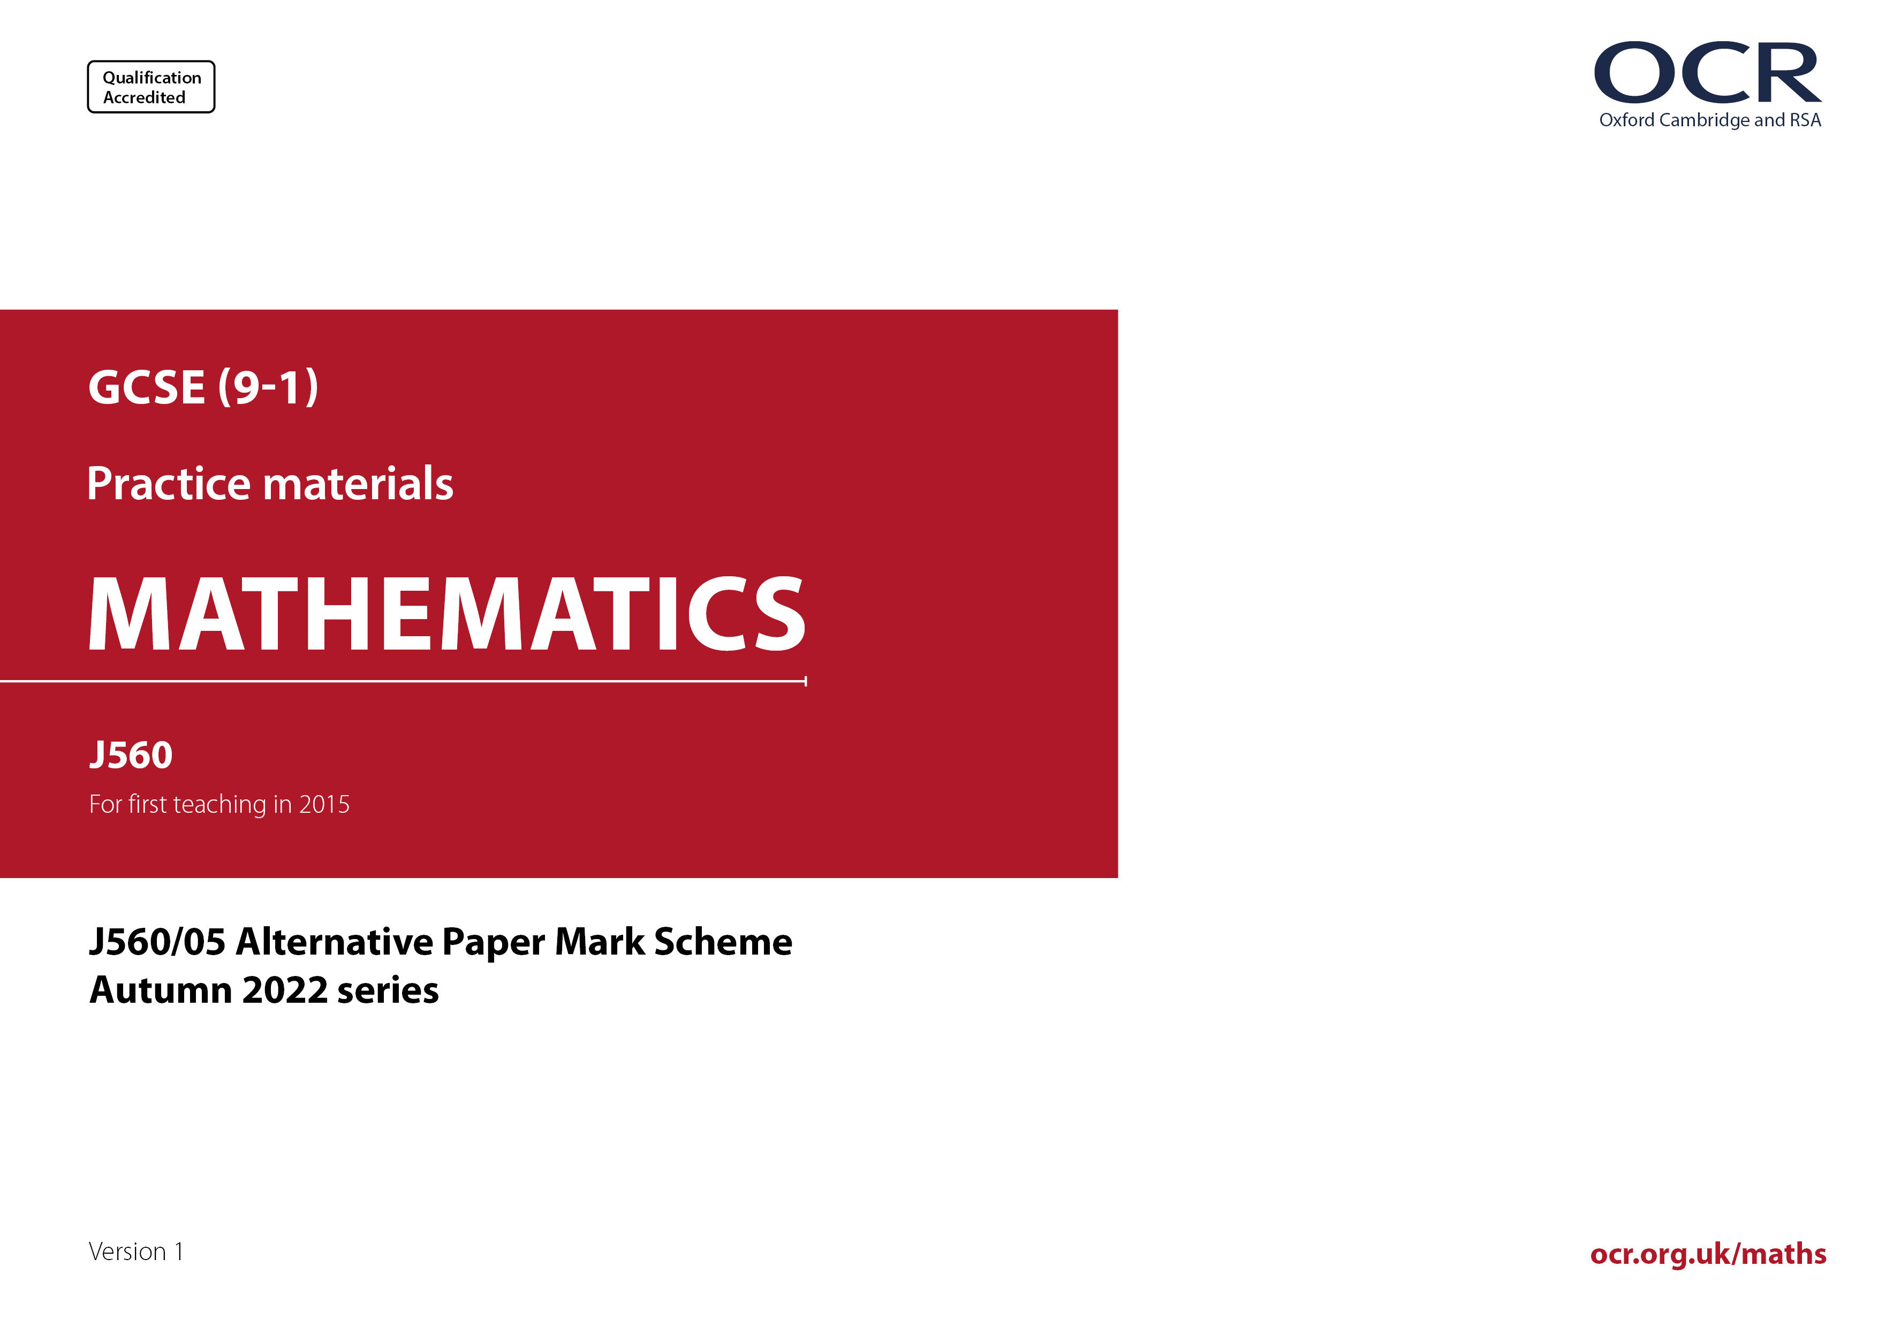
ocr.org.uk/maths
J560/05 Mark Scheme

- M marks are for using a correct method and are not lost for purely numerical errors.
A marks are for an accurate answer and depend on preceding M (method) marks. Therefore M0 A1 cannot be awarded.
B marks are independent of M (method) marks and are for a correct final answer, a partially correct answer, or a correct intermediate stage.
SC marks are for special cases that are worthy of some credit.

- The following abbreviations are commonly found in GCSE Mathematics mark schemes.

  - figs 237, for example, means any answer with only these digits. You should ignore leading or trailing zeros and any decimal point
e.g. 237000, 2.37, 2.370, 0.00237 would be acceptable but 23070 or 2374 would not.
  - isw means ignore subsequent working after correct answer obtained and applies as a default.
  - nfww means not from wrong working.
  - oe means or equivalent.
  - rot means rounded or truncated.
  - soi means seen or implied.
  - dep means that the marks are dependent on the marks indicated. You must check that the candidate has met all the criteria specified for the mark to be awarded.
  - with correct working means that full marks must not be awarded without some working. The required minimum amount of working will be defined in the guidance column and SC marks given for unsupported answers.
- Anything in the mark scheme which is in square brackets […] is not required for the mark to be earned, but if present it must be correct.

- Unless the command word requires that working is shown and the working required is stated in the mark scheme, then if the correct answer is clearly given and is not from wrong working full marks should be awarded.

Do not award the marks if the answer was obtained from an incorrect method, i.e. incorrect working is seen and the correct answer clearly follows from it.

- Where follow through (FT) is indicated in the mark scheme, marks can be awarded where the candidate’s work follows correctly from a previous answer whether or not it was correct. For questions with FT available you must ensure that you refer back to the relevant previous answer. You may find it easier to mark these questions candidate by candidate rather than question by question.

Figures or expressions that are being followed through are sometimes encompassed by single quotation marks after the word their for clarity, e.g. FT 180 × (their ‘37’ + 16), or FT 300 – √(their ‘52 + 72’). Answers to part questions which are being followed through are indicated by
e.g. FT 3 × their (a).

- In questions with no final answer line, make no deductions for wrong work after an acceptable answer (i.e. isw) unless the mark scheme says otherwise, indicated by the instruction ‘mark final answer’.

- In questions with a final answer line and incorrect answer given:

(i) If the correct answer is seen in the body of working and the answer given on the answer line is a clear transcription error allow full marks unless the mark scheme says, ‘mark final answer’. Place the annotation next to the correct answer.

(ii) If the correct answer is seen in the body of working but the answer line is blank, allow full marks. Place the annotation next to the correct answer.

(iii) If the correct answer is seen in the body of working but a completely different answer is seen on the answer line, then accuracy marks for the answer are lost. Method marks could still be awarded if there is no other method leading to the incorrect answer. Use the M0, M1, M2 annotations as appropriate and place the annotation next to the wrong answer.

- In questions with a final answer line:

(i) If one answer is provided on the answer line, mark the method that leads to that answer. A correct step, value or statement that is not
part of the method that leads to the given answer should be awarded M0 and/or B0.

(ii) If more than one answer is provided on the answer line and there is a single method provided, award method marks only.

(iii) If more than one answer is provided on the answer line and there is more than one method provided, award marks for the poorer response unless the candidate has clearly indicated which method is to be marked.

- In questions with no final answer line:

(i) If a single response is provided, mark as usual.

(ii) If more than one response is provided, award marks for the poorer response unless the candidate has clearly indicated which response is to be marked.

- When the data of a question is consistently misread in such a way as not to alter the nature or difficulty of the question, please follow the candidate’s work and allow follow through for A and B marks. Deduct 1 mark from any A or B marks earned and record this by using the MR annotation. M marks are not deducted for misreads. If a candidate corrects the misread in a later part, do not continue to follow through, but award A and B marks for the correct answer only.

- Unless the question asks for an answer to a specific degree of accuracy, always mark at the greatest number of significant figures even if this is rounded or truncated on the answer line. For example, an answer in the mark scheme is 15.75, which is seen in the working. The candidate then rounds or truncates this to 15.8, 15 or 16 on the answer line. Allow full marks for the 15.75.

- Ranges of answers given in the mark scheme are always inclusive.

- For methods not provided for in the mark scheme give as far as possible equivalent marks for equivalent work. If in doubt, consult your Team Leader.

- If in any case the mark scheme operates with considerable unfairness consult your Team Leader.

Question |  |  | Answer | Marks | Part marks and guidance
1 |  |  | 15.6[0] | 3 | M2 for 12 × $\left(\text{1} \text{+} \frac{\text{30}}{\text{100}}\right)$oe  or M1 for 12 × $\frac{\text{30}}{\text{100}}$ oe soi | M0 for 12 × (1 + 30%) without further working  M1 implied by 3.6[0] or answer 8.4[0]  M0 for 12 × 30% without further working
2 |  |  | -2, -1, 0, 1, 2 | 3 | B2 for 5 correct values with one extra or for 4 correct with no extras  or for -3 < x ≤ 2  or M1 for -1 – 2 < x or x ≤ 4 – 2 oe | For M1, condone incorrect inequality sign or equals
3 | (a) |  |  | 1
   | 2 | 3 | 5
  2 | 4 | 6 | 10
  3 | 6 | 9 | 15
  5 | 10 | 15 | 25
3 | (b) |  | $\frac{\text{4}}{\text{9}}$ oe | 2 | FT their completed table  M1 for 9, 15, 15 and 25 identified FT their table and no others | Do not accept ratio or words  isw conversion/cancelling  M1 implied by $\frac{\text{8}}{\text{15}}$
4 | (a) |  | $\frac{\text{1}}{\text{4}}$ | 1 | Accept any equivalent fraction | isw attempts to simplify
4 | (b) |  | 40[%] | 4 | M3 for 1 – $\left(\frac{\text{15}}{\text{100}} \text{÷} \text{their}\frac{\text{1}}{\text{4}}\right)$ oe  or for $\frac{\text{their} \text{25} \text{-} \text{15}}{\text{their}\text{ 25}}$ oe  or M2 for $\frac{\text{15}}{\text{100}}\text{÷} \text{their}\frac{\text{1}}{\text{4}}$ oe  or for their 25 – 15 oe  or M1 conversion of values to a common form e.g. their 25% or $\frac{\text{15}}{\text{100}}$ or $\frac{\text{85}}{\text{100}}$ seen  or their 0.25 and 0.15 or their 0.25 and 0.85 seen  OR  Alternative method using a value for the number of biscuits  e.g. if using 20 biscuits…  M3 for fraction of Rowan’s share $\frac{\text{5} \text{-} \text{3}}{\text{5}}$  or M2 for Rowan eats 5 – 3  or M1 for Rowan receives 5 or is left with 3 | M3 implied by 0.4[0] oe  their 25 is their (a) converted to %, accept both 25 and 15 as decimals for M3 or M2  Accept FT conversion to 2 figs rot  M2 implied by 0.6[0] oe, 60[%] or 10[%]  M3 for any fraction leading to 0.4[0]  M2 for 25%FT for their (a) of their biscuits – 15% of their biscuits  M1 for 25%FT for their (a) of their biscuits or 15% of their biscuits
5 |  |  | 9 with correct working | 6 | B2 for $\frac{83}{90}$ oe or $\frac{7}{90}$ oe  or M1 for $\frac{2}{9}+\frac{7}{10}$oe soi  M2dep on M1 for [distance in m =] 700 ÷ $\left(1-their\frac{83}{90}\right)$oe  or M1dep on M1 for 700 = 1 – their $\frac{83}{90}$  M1 for their distance ÷ 1000 soi with no further incorrect conversion  If 0, 1 or 2 scored then instead award SC3 for answer 9  If 0 or 1 scored then instead award SC2 for answer 9000 | ‘’Correct working” requires evidence of at least M1M2 or convincing pictorial/alternate convincing approach  0.9$\dot{2}$ or 92.$\dot{2}$% or 0.0$\dot{7}$ or 7.$\dot{7}$%. Accept conversion to 3 figs rot  0.$\dot{2}$ + 0.7 or 22.$\dot{2}$% + 70%  e.g. 700 ÷ 7 = 100 and 100 × 90 = 9000  allow M1 for 700 ÷ 1000 with no further incorrect conversion seen  Must see written distance to convert
6 | (a) |  | Point correctly plotted | 1 |  | Accuracy ± ½ small square radially, use overlay as a guide
6 | (b) |  | 320 | 2 | B1 for answer figs 32  or for 3160 or 3480 | Don’t accept percentages
6 | (c) |  | Only part of vertical scale is shown oe | 1 |  | e.g. Because the population axis starts at 3000, 3.0 [thousand]  Vertical axis does not start at 0  They may have just looked at the steepness of the graph and not the scale of the graph/numbers.  Accept it only goes up by 540.  See AG  Any incorrect statements/incorrect specific values scores zero
6 | (d) |  | Increasing trend continues oe | 1 |  | e.g. The number of births will continue to increase the same as in previous years.  If a number is given with the increase then it should be at least 60.  See AG  Any incorrect specific values scores zero
7 |  |  | 119 with correct working | 5 | B3 for x = 39  or M2 for 5x = 180 – 22 + 37 oe  or 4x – 37 = 119 or better  or M1 for 4x – 37 + x + 22 = 180 oe  A1 for x = 39  AND  M1 for 4 × their x – 37 or their x + 22  If 0 or 1 scored, instead award  SC2 for answer 119 with no or insufficient working  If 0 scored, instead award  SC1 for [x =] 39 | “Correct working” requires evidence of at least M2 or M1M1  Accept equivalents for M2  e.g. (180 – 22 + 37) ÷ 5 if no algebra seen  Accept e.g. 4x – 37 and x + 22 = 180  Using trial, allow correct substitution into  4x – 37 + x + 22 to imply M1 if 180 also stated  SC marks may be seen on diagram
8 | (a) |  | Circle radius 3 cm | 2 | B1 for circle any radius  or for 3 indicated as the radius  or for correct circle with internal lines | Allow freehand for 2 marks  or for B1 if vertical and horizontal diameters are consistent  6 indicated as diameter implies B1  B1 could be implied on a diagram  but condone for 2 marks if correct circle and internal lines are diameter or radius
8 | (b) |  | Rectangle 6 cm (width) by 5 cm (height) | 2 | B1 for any rectangle with no internal lines  or for correct rectangle but good freehand | All lines must be ruled for 2 marks  If both (a) and (b) are reversed but otherwise correct allow SC2 for both correct or SC1 for one correct.
9 |  |  | $\text{[}{\left.\left(\frac{\text{1}}{\text{5}}\right.\right)}^{\text{2}}$=] $\frac{\text{1}}{\text{25}}$ oe or 0.04  [$\sqrt{\text{0.16}}$ =] 0.4 or $\frac{\text{4}}{\text{10}}$  [10⁻¹ =] $\frac{\text{1}}{\text{10}}$ or 0.1 | M3 | M1 for each | For all method marks accept oe %’s  If e.g. $\text{[}{\left.\left(\frac{\text{1}}{\text{5}}\right.\right)}^{\text{2}}\text{=] }\frac{\text{4}}{\text{100}}$ = 0.4 then M0  Accept -0.4 or ±0.4 oe for $\sqrt{\text{0.16}}$
9 |  |  | No oe  and  ${\left(\frac{\text{1}}{\text{5}}\right)}^{\text{2}}$, 10⁻¹, $\sqrt{\text{0.16}}$ | A1 |  | Accept equivalents  Accept No oe and 10⁻¹ and $\sqrt{\text{0.16}}$ need to swap places oe  If -0.4 oe for $\sqrt{\text{0.16}}$, then accept order is $\sqrt{\text{0.16}}$, ${\left(\frac{\text{1}}{\text{5}}\right)}^{\text{2}}$, 10^{–1} oe
10 |  |  | [x = ] 12  [y = ] 9  with correct working | 6 | M4 for 21 and x + y or 21 and (4 + 3) oe  or  M3 for 63 and 3(x + y)  or  M2 for 9 × 7 soi by 63 and $\frac{6}{2}(x+y)$ oe  or  M1 for 9 × 7 soi by 63 or $\frac{6}{2}(x+y)$  AND  M1 for their 21 ÷ (4 + 3)  Alternative if trials used for the trapezium:  M4 for [parallelogram =] 63 and $\frac{6}{2}(x+y)$ correctly evaluated with $x+y$ = 21  or  M3 for 63 and $\frac{6}{2}(x+y)$ correctly evaluated with x : y in the ratio 4 : 3 but x ≠ 4 y ≠ 3  or  M2 for 9 × 7 soi by 63 and $\frac{6}{2}(x+y)$ correctly evaluated using any x and y  or  M1 9 × 7 soi by 63 or substitution into  $\frac{6}{2}\left(x+y\right)$with any x and y  If 0, 1 or 2 scored, instead award  SC3 for answer [x =] 12 and [y =] 9 with no or insufficient working  If 0 or 1 scored, instead award  SC2 for answer [x =] $\frac{40}{3}$ oe and [y =] 10 | ‘Correct working’ requires evidence of at least M3  For all method marks allow for x + y  e.g. $\frac{4}{3}y+y$, a + b oe or other variables,  Method may be seen in stages  Implied by two answers in the ratio  x : y = 4 : 3  e.g. 63 and $\frac{6}{2}\left(2+19\right)=63$  e.g. 63 and$\frac{6}{2}\left(8+6\right)=42$  e.g. 9 × 7 and $\frac{6}{2}\left(4+3\right)=21$  e.g. $\frac{6}{2}\left(5+3\right)$
11 |  |  | $\frac{7}{11}$ cao | 3 | B2 for $\frac{63}{99}$ oe fraction  or M1 for 63.63....
12 | (a) |  | The two events are dependent oe  and  $\frac{50}{70}×\frac{49}{69}$ isw | 2 | B1 for either | Accept e.g.  The second probability is not $\frac{5}{7}$ oe  The second probability is wrong oe  The second probability is $\frac{49}{69}$  There is one less for the second pick oe  It is out of 69 for the 2nd pick oe  Any incorrect statement is B0
12 | (b) |  | $\frac{15}{38}$ oe with correct working | 5 | M4 for $2\left(\frac{15}{20}×\frac{5}{19}\right)$ oe  or M3 for $\frac{15}{20}×\frac{5}{19}$ oe  or M2 for $\frac{15}{20}$ and $\frac{5}{19}$ or $\frac{15}{19}$ and $\frac{5}{20}$ oe seen  or M1 for $\frac{15}{20}$ or $\frac{5}{20}$ oe seen  If 0 or M1 scored, instead award  SC2 for $\frac{15}{n}×\frac{5}{n-1}$ oe or for $2\left(\frac{15}{20}×\frac{5}{20}\right)$oe  or for answer $\frac{30}{76}$ oe with no or insufficient working  If 0 scored  SC1 for $\frac{15}{n}$ and $\frac{5}{n-1}$ or $\frac{15}{n-1}$ and $\frac{5}{n}$ seen  or for answers $\frac{15}{76}$ oe or $\frac{3}{8}$ oe with no or insufficient working | ‘Correct working’ needs evidence of M2  Must be proper fractions and n ≤ 70  Must be proper fractions and n ≤ 70
13 |  |  | Angle AEB = angle DEC and [vertically] opposite  Angle ABE = angle ECD and same segment  Angle BAE = angle EDC and  same segment  [Triangle AEB is similar to triangle DEC] [corresponding] angles are equal oe or AAA oe  OR  After two pairs of angles with reasons gives 3rd pair of equal angles with a reason | M2  A1 | For M2 only two of the three statements and reasons are required  M1 for one pair of angles with a reason  With no errors or incorrect statements seen  If 0 scored, SC1 for at least two correct pairs of angles identified with no / incorrect reasons | Allow any unambiguous labelling for angles e.g. ABE or ABD or B, but not E  For reason accept e.g. opp ∠’s  For same segment, accept same arc but not same chord  Accept 3rd angle in triangle oe for reason with final angle if other two given correctly with correct reasons  Accept they have the ‘same/equal angles’ oe, AA and similar. Accept symbol ~ for similar  Condone angles identified on diagram for SC1
14 |  |  | [a = ] 15 000  [b = ] [0].92 | 4 | B1 for 15 000  AND  B3 for 0.92 oe  or  B2 for $\frac{13800}{15000}$ or 92% oe  or $\frac{15000-13800}{15000}$ or 0.08 oe  or  M1 for 13800 = b^{[1]}a or 13800 = 15000b^{[1]}
15 | (a) |  | $5\sqrt{6}$ final answer | 2 | B1 for $\sqrt{150}$ or $\left[\sqrt{30}=\right]\sqrt{5}\sqrt{6}$
15 | (b) |  | $\frac{5\sqrt{14}}{2}$or $\frac{5\sqrt{7}\sqrt{2}}{2}$ final answer | 3 | B2 for $\frac{35\sqrt{14}}{14}$ or $\frac{35\sqrt{7}\sqrt{2}}{14}$  or  M1 for $\frac{35}{\sqrt{14}}×\frac{\sqrt{14}}{\sqrt{14}}$ or better
15 | (c) |  | 32 | 2 | M1 for ${\sqrt[3]{8}}^{5}$ soi  or B1 for $\sqrt[3]{8}$ = 2
16 | (a) |  | 72 ÷ 40 | 1 |  | Accept $\frac{72}{40}$
16 | (b) |  | Tangent drawn to graph at  t = 20  1[.0] to 1.5 | B1  B2 | Dep on tangent or close attempt  M1dep for rise/run with values substituted | Tangent - mark intention but no daylight
17 |  |  | 20$\sqrt{3}$ final answer | 3 | M1 for ½ × 10 × 8 × sin 60 oe  B1 for sin 60 = $\frac{\sqrt{3}}{2}$
18 | (a) |  | (x + 11)(x + 5) [ = 0] | M2 | M1 for (x + a)(x + b) [= 0] where ab = 55 or  a + b = 16  or for x(x + 11) + 5(x + 11)  or x(x + 5) + 11(x + 5) | Condone omission of final bracket  If partial factors and answers –11 and –5 award M2B1
18 | (a) |  | –11 and –5 | B1 | FT their factors if of the form (x + a)(x + b) with a, b integers
18 | (b) | (i) | (x + 8)² – 9 final answer | 3 | B1 for (x + 8)²  B2FT for [+] 55 – (their a)² after (x + their a)² correctly evaluated  or B1 for [+] 55 – (their a)² shown  If 0 scored, SC2 for final answer (x + 8) – 9 | FT can be implied e.g. (x + 9)² – 26 gets  B2FT
18 | (b) | (ii) | (–8 , –9) | 2 | FT their 18(b)(i) if in form (x + a)² + b  B1FT for each value
19 | (a) |  | Correct sketch with y – intercept indicated at 1  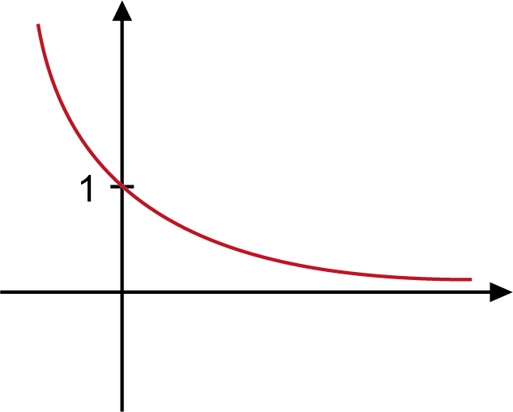 | 2 | B1 for correct decreasing shape  or any sketch with y – intercept at 1 | For 2 marks, condone curve touching but not crossing x- axis
19 | (b) |  | Correct sketch through (0, 0), (180, 0) and (360, 0) indicated  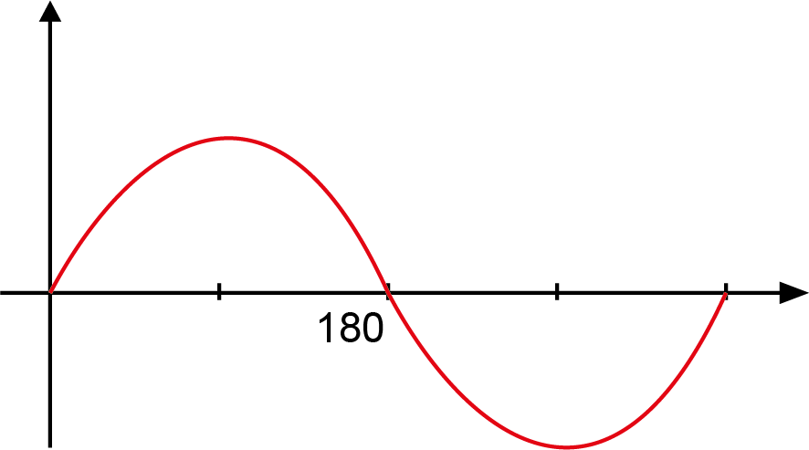 | 2 | B1 for the correct shaped curve with 180 not indicated
20 |  |  | 9² + 3² + 5² oe or better  115 oe or better  Does not fit and 11² = 121 or $\sqrt{115}$ lies between 10 and 11 oe | M2  A1  A1 | M1 for 9² + 5² or 5² + 3² or 9² + 3² all oe or better  Dep on M2A1 | M1 implied by 106, 34, or 90  e.g., $\sqrt{115}$  Accept No and $\sqrt{115}$ is less than 11  or No and $\sqrt{115}$ = 10. […]
21 | (a) |  | [k = ] 0 | 1
21 | (b) | (i) | y = 2x + 4 ruled  -3.5 to -3.3 and -1.7 to -1.5 | M2  A2 | M1 for correct freehand or short line  or for y = 2x + k ruled or y = ax + 4 ruled but not y = 4  A1 for each  After A0, SC1 for both values correct | For M2 must cross curve twice  Accuracy ± 1mm at (0, 4) and (-1, 2)  Only award if M2 scored previously  -3.3660… , -1.63397….
 | (b) | (ii) | 1 = (2x + 4)(x + 3)  2x² + 4x + 6x + 12  2x² + 10x + 11 = 0 | M1  B2  A1 | For correct expansion of brackets  B1 for 3 terms correct in expansion  Dep on M1B2 with no errors or omissions | Allow recovery from missing brackets for M1 or ‘ = 1’  For B2 accept 2x² + 10x + 12  For B1 10x counts as two terms

Appendix

Q6(c)

 | Response | Mark
1 | It/the graph/[y] axis/the number of births/the scale does not start at zero | 1
2 | Hasn’t realised the number of births is only going up by 100 each time, so it isn’t a huge increase (BOD implied axis and info on scale provided – huge increase implies steepness) | 1
3 | It has only gone up by 540 [births] (accept reference to the value of the increase if value is correct) | 1
4 | The graph has gone up by a lot, but it is only around 500 (accept reasonable approximation of increase with steepness implied) | 1
5 | The line on the graphs varied significantly but the value changed by only 600 (value is incorrect and no ref to steepness) | 0
6 | Each big tile is on the graph shows 100 births (not enough – need to refer to graph not starting as zero or steepness) | 0
7 | The steepness on the graph makes him think it has gone up a lot, but the graph is going up in 1000s (1000s is incorrect we would accept 100s or 0.1s) | 0
8 | The y axis is too small, so it makes it look like there has been a huge increase (lacks detail about scale on y-axis) | 0
9 | The scale makes it look like it has gone up a lot when it really only a little (not enough – needs to refer to steepness and scale) | 0
10 | He used the steepness of the line to judge the increase (needs detail about scale) | 0
11 | The continuing rising of the graph number of births and not reading the numbers properly (not enough – steepness and scale needed) | 0
12 | Sam didn’t read the graph correct. 2015 = 3100, 2020 = 3630. Not a huge increase (error with one value (3630), otherwise we would accept with accurate values also) | 0
13 | May have been misled by not reading the graph properly as it only went up by 640 (specific value given that is incorrect) | 0
14 | By not looking at the figures and going by the plots rising (implies steepness, but too vague with vertical scale) | 0
15 | Because of how much the line is rising may seem there is a rapid increase (no ref to scale) | 0
16 | He may think it goes up by thousands, but there have been less than a thousand births | 0
17 | By just looking at the plots on the graph and not looking at the actual numbers (right idea but need to ref steepness and scale) | 0
18 | As the graph is only going up 100 between each box yet he sees it large by the depth (not enough - if ‘steepness’ rather than ‘depth’ then fine) | 0
19 | Just because the line gets higher doesn't mean it’s a huge increase (need to ref scale) | 0
20 | Because the line increased by a lot, but the numbers didn't (not enough – need more detail about the scale) | 0
21 | May have been misled by the sharp diagonal line on the graph (no detail on scale) | 0
Q6(d)

 | Response | Mark
1 | The number of births will increase at the same/constant rate | 1
2 | The number of births will continue to increase | 1
3 | The number of births will increase by [more than] a thousand/600/60 | 1
4 | The graph will follow the same trend | 1
5 | That the number of births will carry on rising like the past years | 1
6 | Ashley has estimated this through the constant increase in number of births (trend is implied, ignore constant) | 1
7 | The graph will continue growing in the same way and shape as it was this morning (fine, describes trend – ignore ref to morning) | 1
8 | Because of how the previous years were going, Ashley thinks it will stay in that pattern (BOD – ‘stay in that pattern’ for trend) | 1
9 | 2022 will be greater than 3800 if 2021 has 3740 births (not enough as repeats what is in the question) | 0
10 | Ashley may not be right as the number of births was increasing (does not describe the assumption) | 0



We’d like to know your view on the resources we produce. Click ‘Like’ or ‘Dislike’ to send us an auto generated email about this resource. Add comments if you want to. Let us know how we can improve this resource or what else you need. Your email will not be used or shared for any marketing purposes.
Looking for another resource? There is now a quick and easy search tool to help find free resources for your qualification.
OCR is part of Cambridge University Press & Assessment, which is itself a department of the University of Cambridge.
For staff training purposes and as part of our quality assurance programme your call may be recorded or monitored.
Oxford Cambridge and RSA Examinations is a Company Limited by Guarantee. Registered in England. Registered office
The Triangle Building, Shaftesbury Road, Cambridge, CB2 8EA. Registered company number 3484466. OCR is an exempt charity.
OCR operates academic and vocational qualifications regulated by Ofqual, Qualifications Wales and CCEA as listed in their qualifications registers including A Levels, GCSEs, Cambridge Technicals and Cambridge Nationals.
OCR provides resources to help you deliver our qualifications. These resources do not represent any particular teaching method we expect you to use. We update our resources regularly and aim to make sure content is accurate but please check the OCR website so that you have the most up to date version. OCR cannot be held responsible for any errors or omissions in these resources.
Though we make every effort to check our resources, there may be contradictions between published support and the specification, so it is important that you always use information in the latest specification. We indicate any specification changes within the document itself, change the version number and provide a summary of the changes. If you do notice a discrepancy between the specification and a resource, please contact us.
© OCR 2023 - You can copy and distribute this resource freely if you keep the OCR logo and this small print intact and you acknowledge OCR as the originator of the resource.
OCR acknowledges the use of the following content: N/A
Whether you already offer OCR qualifications, are new to OCR or are thinking about switching, you can request more information using our Expression of Interest form.
Please get in touch if you want to discuss the accessibility of resources we offer to support you in delivering our qualifications.
Please note – web links are correct at date of publication but other websites may change over time. If you have any problems with a link you may want to navigate to that organisation’s website for a direct search.

