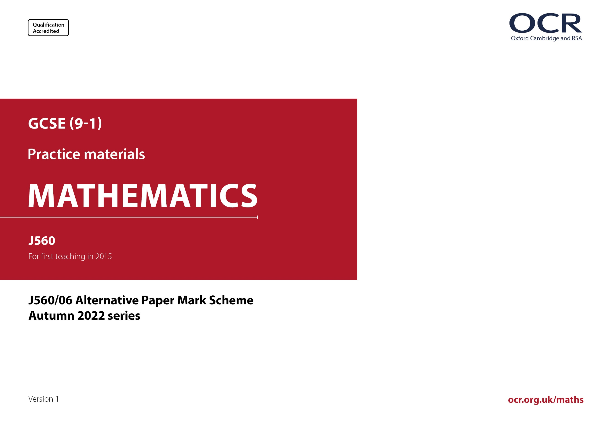
ocr.org.uk/maths

J560/06 Mark Scheme
- M marks are for using a correct method and are not lost for purely numerical errors.
A marks are for an accurate answer and depend on preceding M (method) marks. Therefore M0 A1 cannot be awarded.
B marks are independent of M (method) marks and are for a correct final answer, a partially correct answer, or a correct intermediate stage.
SC marks are for special cases that are worthy of some credit.

- The following abbreviations are commonly found in GCSE Mathematics mark schemes.

  - figs 237, for example, means any answer with only these digits. You should ignore leading or trailing zeros and any decimal point
e.g. 237000, 2.37, 2.370, 0.00237 would be acceptable but 23070 or 2374 would not.
  - isw means ignore subsequent working after correct answer obtained and applies as a default.
  - nfww means not from wrong working.
  - oe means or equivalent.
  - rot means rounded or truncated.
  - soi means seen or implied.
  - dep means that the marks are dependent on the marks indicated. You must check that the candidate has met all the criteria specified for the mark to be awarded.
  - with correct working means that full marks must not be awarded without some working. The required minimum amount of working will be defined in the guidance column and SC marks given for unsupported answers.
- Anything in the mark scheme which is in square brackets […] is not required for the mark to be earned, but if present it must be correct.

- Unless the command word requires that working is shown and the working required is stated in the mark scheme, then if the correct answer is clearly given and is not from wrong working full marks should be awarded.

Do not award the marks if the answer was obtained from an incorrect method, i.e. incorrect working is seen and the correct answer clearly follows from it.

- Where follow through (FT) is indicated in the mark scheme, marks can be awarded where the candidate’s work follows correctly from a previous answer whether or not it was correct. For questions with FT available you must ensure that you refer back to the relevant previous answer. You may find it easier to mark these questions candidate by candidate rather than question by question.

Figures or expressions that are being followed through are sometimes encompassed by single quotation marks after the word their for clarity, e.g. FT 180 × (their ‘37’ + 16), or FT 300 – √(their ‘52 + 72’). Answers to part questions which are being followed through are indicated by
e.g. FT 3 × their (a).

- In questions with no final answer line, make no deductions for wrong work after an acceptable answer (i.e. isw) unless the mark scheme says otherwise, indicated by the instruction ‘mark final answer’.

- In questions with a final answer line and incorrect answer given:

(i) If the correct answer is seen in the body of working and the answer given on the answer line is a clear transcription error allow full marks unless the mark scheme says ‘mark final answer’. Place the annotation next to the correct answer.

(ii) If the correct answer is seen in the body of working but the answer line is blank, allow full marks. Place the annotation next to the correct answer.

(iii) If the correct answer is seen in the body of working but a completely different answer is seen on the answer line, then accuracy marks for the answer are lost. Method marks could still be awarded if there is no other method leading to the incorrect answer. Use the M0, M1, M2 annotations as appropriate and place the annotation next to the wrong answer.

- In questions with a final answer line:

(i) If one answer is provided on the answer line, mark the method that leads to that answer. A correct step, value or statement that is not
part of the method that leads to the given answer should be awarded M0 and/or B0.

(ii) If more than one answer is provided on the answer line and there is a single method provided, award method marks only.

(iii) If more than one answer is provided on the answer line and there is more than one method provided, award marks for the poorer response unless the candidate has clearly indicated which method is to be marked.

- In questions with no final answer line:

(i) If a single response is provided, mark as usual.

(ii) If more than one response is provided, award marks for the poorer response unless the candidate has clearly indicated which response is to be marked.

- When the data of a question is consistently misread in such a way as not to alter the nature or difficulty of the question, please follow the candidate’s work and allow follow through for A and B marks. Deduct 1 mark from any A or B marks earned and record this by using the MR annotation. M marks are not deducted for misreads. If a candidate corrects the misread in a later part, do not continue to follow through, but award A and B marks for the correct answer only.

- Unless the question asks for an answer to a specific degree of accuracy, always mark at the greatest number of significant figures even if this is rounded or truncated on the answer line. For example, an answer in the mark scheme is 15.75, which is seen in the working. The candidate then rounds or truncates this to 15.8, 15 or 16 on the answer line. Allow full marks for the 15.75.

- Ranges of answers given in the mark scheme are always inclusive.

- For methods not provided for in the mark scheme give as far as possible equivalent marks for equivalent work. If in doubt, consult your Team Leader.

- If in any case the mark scheme operates with considerable unfairness consult your Team Leader.

Question |  |  | Answer | Marks | Part marks and guidance
1 | (a) |  | Translation  $$\left(\begin{aligned}5 \\ 6\end{aligned}\right)$$ | 1  1 |  | Marks spoilt if extra transformations  Do not accept coordinates, with a fraction bar or in words
 | (b) |  | 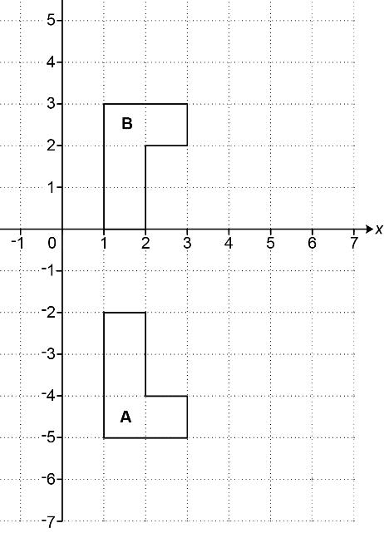 | 2 | B1 for correct orientation but wrong location  or for correct reflection but in x = -1
2 |  |  | 9 | 3 | B2 for 6 [batches]  or  M1 for at least 2 ratios or pairs equivalent to 4:7  or 18 ÷ (7 – 4) | e.g. 6 × 1.5  Allow decimals e.g. 1:1.75  or 0.57[…]:1, 8:14, 12:21, 16:28, 20:35, 24:42, 28:49, ...  Does not need ratio symbol
3 |  |  | 275 000 | 2 | M1 for 25 000 × 11 oe  If 0 scored, SC1 for 300 000 as final answer
4 | (a) |  | 0.25 + 0.8 [= 1.05] is greater than 1 | 1 |  | Condone additional statements that do not contradict  See appendix  Condone 100% for 1
 | (b) |  | Correct tree diagram | 3 | B1 for P(draw) = 0.15  B1 for two correctly placed sets of three branches with win/draw/lose labels  B1 for 0.3, their 0.15 and 0.55 correctly placed on all branches | May be on diagram or in a calculation e.g. 0.3 + 0.55 + 0.15 = 1 oe  Ignore probabilities  Accept e.g. W/D/L as labels  Condone omission of their 0.15 on printed branches
 | (c) |  | [0].15 oe | 2 | M1 for [0].6 × [0].25 | oe may beor equivalent fraction or 15%
5 | (a) |  | 7.83[30] × 10⁷ or 7.833 × 10⁷ or 7.8 × 10⁷ | 3 | B2 for 78 330 000 or 78 300 000 or 78 000 000 oe  or  M1 for 0.5222 × figs 15 soi by figs 783 | oe is other correct answers not in standard form e.g. 78.33 × 10⁶
 | (b) |  | 29.09[3…] or 29.1 or 29 | 2 | M1 for 4 364 000 000 ÷ figs 15 soi by figs 29
6 | (a) |  | Positive | 1 |  | Ignore comments about strength but not that contradict e.g. strong positive decrease
 | (b) | (i) | Clear indication of the point at (12, 90) | 1
 |  | (ii) | Cool day [with] many visitors  or  Outlier | 1 |  | See appendix
 | (c) |  | Ruled line of best fit  72 to 98 | B1  B1 | If B0 scored, FT their ruled line of best fit with positive gradient | Overlay is a guide only; their line must be between or through  (15, 60 ) to (17.5, 60 ) and (22.5, 100) to (25, 100)  If more than one line, mark the worst unless one clearly chosen e.g. vertical line from 21 to the line ½ square tolerance
7 | (a) |  | Method must include dimensions  (accept 7² for 7 × 7 and 7³ for 7 × 7 × 7 and 14² for 14 × 14)  4 × (7 × 14) + 2 × (14 × 14)  or  4 × 2 × (7 × 7) + 2 × 4 × (7 × 7)  or  8 × (7 × 7) + 8 × (7 × 7)  or  4 × 6 × (7 × 7) – 8 × (7 × 7)  or  24 × (7 × 7) – 8 × (7 × 7)  or  16 × (7 × 7)  [=784] | 2 | M1 for full method for surface area  4 × 98 + 2 × 196  or  4 × 2 × 49 + 2 × 4 × 49  or  8 × 49 + 8 × 49  24 × 49 – 8 × 49 oe  or  16 × 49 | Brackets do not need to be shown  0 for  392 + 392  1176 – 392  4 × 7 × 4 × 7  28 × 28
 | (b) |  | 12.5 nfww | 4 | M2 for (2 × 7 × 7) + (4 × 7 × 28) oe  or  M1 for calculating the surface area of one or more faces of the cuboid  AND  M1 for oe  or oe  Alternative method  M2 for 16 and 18 [exposed faces]  or  M1 for 16 or 18 [exposed faces]  AND  M1 for  or | soi by 98 + 784 or 882  e.g. 7 × 7 soi by 49  7 × 28 soi by 196  Their 882 from attempt at surface area involving 7 × (7 or 28)  soi by 1.125 or 112.5  soi by 0.125 oe may be [× 100]  soi by 1.125 or 112.5  soi by 0.125
8 |  |  | 57.2 | 4 | M2 for oe soi by 19.2  or  M1 for 24 ÷ 10 or 10 ÷ 24 or 8 ÷ 10  or 10 ÷ 8  AND  M1 for 14 + 24 + their 19.2 | Evidence may be seen on diagram  Implied by 2.4 or 0.41[6…] or 0.8 or 1.25  their 19.2 from their valid attempt using scale factors to find AB
9 |  |  | 6 nfww | 3 | M2 for 7k + 4 [= 46] or 7k = 42  or  M1 for 7k or 2⁴ soi  Alternative method:  M2 for 2^{k} = $\sqrt[7]{2^{42}}$ or 2^{k} = 64  or  M1 for (2^{k})⁷ = any of the below  $\frac{2^{46}}{2^{4}}$ , 2⁴², 4.398... × 10¹², 4.4[0] × 10¹² | Could be implied by manipulation of powers followed by ÷ 7  Accept $\frac{2^{46}}{2^{4}}$ , 4.398... × 10¹² or 4.4[0] × 10¹² in place of 2⁴²  Do not accept (2^{k})⁷ = $\frac{2^{46}}{16}$
10 |  |  | 30 and 105 | 3 | M2 for  3  2 5 7  or  M1 for  3  5  or for 3 with 5 and  3 with 2, 5, 7  Alternative method:  M1 for at least four correct multiples of 15  apart from 15  M1 for at least four correct factor pairs of 210  apart from 1 & 210 | For M2 or M1 allow 15 for 3 and 5 in the overlap  As lists, products or factor trees etc  Ignore errors when counting four correct  30, 45, 60, 75, 90. 105, …  2 & 105, 3 & 70, 4 & 55, 5 & 42,  6 & 35, 7 & 30, 10 & 21, 14 & 15
11 |  |  | 2(3x + 2)(5x − 3) | 3 | B2 for (6x + 4)(5x − 3) as final answer  or for (3x + 2)(10x − 6) as final answer  or for (3x + 2)(5x − 3) as final answer  or  M1 for two brackets which give two correct terms for 30x² + 2x – 12 or for 15x² + x – 6
12 | (a) |  | 0 | 1
 | (b) |  | 11 with correct working | 5 | M3 for $\frac{\left(15+40\right)×16}{2}$  or  M2 for attempt at total area with one reading or one calculation error  or  M1 for one area calculation  AND  M1dep for their 440 ÷ 40  If 0 or 1 scored, instead award  SC2 for answer 11 with no working or insufficient working  If 0 scored  SC1 for 440 with no working or insufficient working | “Correct working” requires evidence of at least M3  Areas may be found in stages  e.g. M3 for $\left(\frac{1}{2}×15×16\right)+\left(15×16\right)$ +$\left(\frac{1}{2}×10×16\right)$ implied by 120 + 240 + 80  e.g. use of 17 rather than 16 throughout is one error but both triangles incorrect is two errors  e.g. one of the above soi by120, 240 or 80  Dep on at least M1
13 | (a) |  | $\frac{11}{3}$ oe | 3 | M2 for 6t – 3 = 19 oe  or  M1 for 6t – 3 or 19 + 3 or 22 | 3.66[6…] or unsimplified, e.g. 22/6  e.g. 6 = 22/t
 | (b) |  | [x =] 3(y + 4) oe | 2 | M1 for y = $\frac{x}{3}$ − 4 or better  or for correct reverse flowchart with arrows  reversed ×3 + 4
14 | (a) |  | 65 nfww | 3 | M2 for [(50 × 3) – (20 × 3)] ÷ 2 oe implied by 45  or for [(50 × 3) – 20] ÷ 2 oe  or  M1 for 50 × 3 implied by 150  Alternative method:  M2 for 50 + (50 ─ 20) ÷ 2  or  M1 for (50 ─ 20) ÷ 2
 | (b) |  | [0].25 oe | 3 | B1 for y = $\frac{k}{x^{2}}$ oe soi by 4 = $\frac{k}{{1.5}^{2}}$ or k = 9  M1 for y = $\frac{their k}{6^{2}}$  OR  M2 for 1.5² × 4 = 6² × y or 4 ÷ ($\frac{6}{1.5}$)²
15 | (a) |  | [gradient =] (7.5 – 5) ÷ (5 – 0) oe  y = (their 0.5)x + c or y = mx + 5  or y – y₁ = their 0.5(x – x₁)  or y – 7.5 = m(x – 5)  or y – 5 = m(x [– 0])  y = 0.5x + 5  or y – 7.5 = 0.5(x – 5) oe  or y – 5 = 0.5(x [– 0]) oe  AND  2y = x + 10 | 1  1  1 | Must show a correct calculation of the gradient  Or  7.5 = 5m + 5 oe  This can be y = 0.5x + 5 or $\frac{y-5}{x [-0]}$ = their 0.5 oe  or y – 7.5 = 0.5(x – 5) oe  If 0 scored  SC1 for verification of A and B | Working backwards scores 0
 | (b) |  | x ≤ 5 oe  x + y ≥ 5 oe  2y < x + 10 oe | 5 | B2 for x ≤ 5 oe  or B1 for x = 5 oe or x < 5 oe  or SC1 for x ≥ 5 oe or for 0 ≤ x ≤ 5  AND  B2 for x + y ≥ 5 oe  or B1 for x + y = 5 oe  or SC1 for x + y > 5 oe  AND  B1 for 2y < x + 10
16 |  |  | 12 [hours] 52 [mins] with correct working | 5 | B4 for answers 12 [hours] 53 [mins] or 12 [hours] 52.4[…] to 52.7 [mins], with correct working  OR  B1 for 10 750  B1 for 835  M1 for (10 750 to 10 850) ÷ (825 to 835)  M1 for their 0.87… × 60 oe  If 0, 1 or 2 scored, instead award  SC3 for answer 12 [hours] 52 [mins] with no working or insufficient working  If 0 or 1 scored, instead award  SC2 for answer 12 [hours] 53 [mins] or 12 [hours] 52.4[…] to 52.7 [mins] with no working or insufficient working  If 0 scored, instead award  SC1 for 12.87[…] with no working or insufficient working | “Correct working” requires evidence of at least B1B1M1  Allow 834.9[9…] for 835  With no contradictory choice  With no contradictory choice  Do not imply this first M1 mark.  their 0.87 following from distance ÷ speed  implied by 12.87 to 13.16
17 | (a) | (i) | 15 | 1
 |  | (ii) | 25 | 1
 | (b) |  | Box plot drawn with:  Lowest = 30  Lower Quartile = 45  Median = 50  Upper quartile = 60  Highest = 70 | 3 | B2 for 4 or 5 correct markers  or  B1 for 3 correct markers | If more than 5 markers, mark the worst 5  Award the markers even if not correctly representing the information
 | (c) |  | Calculation/reasoning/use of figures  Correct interpretation | 1  1dep |  | See Appendix
18 | (a) |  | (0, 10) | 1
 | (b) |  | $-\sqrt{51}$ | 3 | B2 for $\sqrt{51}$ or −7.141[…] or −7.14  or  B1 for 7.141[…] or 7.14  or  M1 for 49 + y² = 100 oe | ± answers treat as choice
 | (c) |  | $\left(3\sqrt{10}, \sqrt{10}\right)$ and $\left(-3\sqrt{10},-\sqrt{10}\right)$  with correct working | 5 | B4 for $\left(3\sqrt{10}, \sqrt{10}\right)$ with correct working  or $\left(-3\sqrt{10},-\sqrt{10}\right)$ with correct working  or  M2 for (3y)² + y² = 100 oe  A1 for [y = ±] $\sqrt{10}$  or  M1 for 3y seen  If 0 or 1 or 2 scored, instead award  SC3 for answer $\left(3\sqrt{10}, \sqrt{10}\right)$ and $\left(-3\sqrt{10},-\sqrt{10}\right)$ with no working or insufficient working  If 0 or M1 scored, instead award  SC2 for answer $\left(3\sqrt{10}, \sqrt{10}\right)$ or $\left(-3\sqrt{10},-\sqrt{10}\right)$  or for (15, 5) and (−15, −5)  with no working or insufficient working  If 0 scored, instead award  SC1 for [y = ±] $\sqrt{10}$  or for (15, 5) and (−15, −5) with no working | “Correct working” requires evidence of at least M2  Allow $\sqrt{90}$ for 3$\sqrt{10}$  Condone for M1 if seen as 3y² + y² = 100
19 |  |  | Accept answers that round to 15.5 with correct working | 6 | M2 for $\frac{8× sin{30}}{sin13}$ oe  or  M1 for $\frac{8}{sin13}$ = $\frac{[…]}{sin30}$ oe  AND  M3 for correct cos rule with cos as the subject  $\frac{{12}^{2}+{(their 17.781…)}^{2}{-7}^{2}}{2×12×(their 17.781…)}$ oe  or  M2 for the above (M3) with one error or wrong angle selected or for  7² = 12² + (their 17.781…)² – 2 ×12 ×  (their 17.781…) × cos[…]  or  M1 for the above (M2) with one error or wrong angle selected  If 0 or 1 or 2 scored, instead award  SC3 for 15.5 (or an answer rounding to 15.5) with no working or insufficient working  If 0 or 1 scored, instead award  SC2 for 0.961 to 0.965 with no working or insufficient working  If 0 scored, instead award  SC1 for [QS =] 17.7 to 17.8 with no working | “Correct working” requires evidence of at least M1 AND M2  (17.781…)  (0.963…)  e.g. for $\frac{7^{2}+{(their 17.781…)}^{2}{-12}^{2}}{2×7×(their 17.781…)}$  e.g. for 12² = 7² + (their 17.781…)² – 2 ×7  × (their 17.781…) × cos[…]
20 |  |  | $\frac{11x-8}{2x+3}$ final answer | 4 | M3 for $\frac{16x+24-5x-32}{\left[2x+3\right]}$ soi by $\frac{11x-8}{\left[2x+3\right]}$  or  M2 for $\frac{16x+24-(5x+32)}{\left[2x+3\right]}$ or $\frac{8\left(2x+3\right)-5x-32}{\left[2x+3\right]}$  or  M1 for 8(2x + 3) | Max M3 if answer spoiled by further incorrect algebraic manipulation (e.g. incorrect cancelling of terms)  Allow full marks for a correct equivalent answer as a single fraction  e.g. $\frac{22x-16}{4x+6}$

Appendix

Q4(a)

Comment | Mark | Reason
0.25 + 0.8 add to greater than 1 | 1
They add to greater than 1 | 1 | Allow “they” or “the probabilities” etc for 0.25 and 0.8 (1.05 does not need to be seen)
0.25 + 0.8 = 1.05 which is more than 1. The probability of winning + losing should equal 1. | 1 | Winning + losing should ≤ 1 but does not contradict required evidence
Probabilities add up to 1 and 0.25 + 0.8 = 1.05 which is beyond 1 | 1 | First vague words do not contradict required evidence
0.25 + 0.8 = 1.05 and probability only goes to 1 | 1 | BOD “only goes to” as meaning “cannot be greater than”
The probabilities should add to 1 but instead 1.05 which isn’t possible | 0 | “Which isn’t possible” not enough without > 1
0.25 + 0.8 = 1.05 so they cannot both be correct | 0 | True but doesn’t say why they cannot both be correct (0.25 + 0.8 > 1)
Probabilities must add to 1 or less | 0 | True general statement but not related it to this context
They must add up to less than 1 | 0 | Incorrect, they could also add up to 1 but have not mentioned adding to > 1
They must add up to 1 | 0 | Incorrect, they could also add up to less than 1 but have not mentioned adding to > 1
0.25 + 0.8 = 1.05 and it needs to be a whole number | 0 | Sum is correct but reason does not say more than 1
They cannot be right because probabilities must add to 1 which they don’t | 0 | Probabilities do not always add to 1 and the required evidence is not given

Q6(b)(ii)

Comment | Mark | Reason
There were a lot of visitors even though it was a cold day | 1
There were a lot of visitors because it was dry | 1 | bod ‘dry’
Low temperature but more visitors | 1
It’s 12˚, a cold temperature, yet there are more than 80 visitors | 1 | Implies high number of visitors
It’s 12˚ and there were 90 visitors | 1 | BOD 12 meaning “cold” and 90 implies high number of visitors
Because the temperature is low but attendance is higher than normal | 1 | Allow higher than normal for high
As there were a lot of people but on other cold days there were not a lot of people | 1 | Acceptable: low temperature high visitors
It was cold but many people | 1 | Accept cold and implying high people numbers
Because it’s cold however as it was sunny I think that many people would have gone | 1 | BOD Cold and many people and allow “many would have”
Outlier | 1
Anomaly | 1 | BOD equivalence to “outlier”
A lot of visitors | 0 | Insufficient. There are other occasions when there are many visitors does not mention cold
Because it was really cold | 0 | Insufficient. No mention of high number of visitors
It does not correspond to the correlation | 0 | Does not mention cold or visitor numbers
It does not fit with the rest of the points | 0 | Does not mention cold or visitor numbers
It is away from the correlation line | 0 | Does not mention cold or visitor numbers
It doesn’t follow the increasing trend | 0

Q17(c)

Comment | Mark | Reason
Use of figures or reasoning needed to score any marks
Use of figures or reasoning may be 1 mark. Interpretation is dependent on figures/reasoning
(50+58)/2=54. Incorrect, new mean will be less than 53. | 2 | Useful calculation; correct interpretation
(50+58)/2=54. Incorrect, new mean will be more than 53. | 1 | Useful calculation; wrong interpretation
(50+58)/2=54. | 1 | Useful calculation
Incorrect. The mean of the two apples is 54, so the mean of the remaining apples will fall. | 2 | Implied calculation; correct interpretation
53-50=3; 58-53=5. Incorrect, new mean will be less than 53. | 2 | Useful calculation; correct interpretation
53-50=3; 58-53=5. Incorrect, new mean will be more than 53. | 1 | Useful calculations; wrong interpretation
53-50=3; 58-53=5. | 1 | Useful calculations
If there were 10 apples, then new mean = (53 × 10 - 50 - 58)/8 = 52.75. The mean would decrease | 2 | Useful calculation; correct interpretation
Useful figures/calculations/reasoning and “no” | 1 | “No” is insufficient interpretation
Useful figures/calculations/reasoning and “the mean will change” | 1 | The interpretation is equivalent to “no”
Mean will be smaller because Mia ate 2 apples | 0 | Insufficient use of figures
No, because the total weight and the number of apples have changed | 0 | No calculations/reasoning/use of figures.
No, the mean will change | 0 | No calculations/reasoning/use of figures.



We’d like to know your view on the resources we produce. Click ‘Like’ or ‘Dislike’ to send us an auto generated email about this resource. Add comments if you want to. Let us know how we can improve this resource or what else you need. Your email will not be used or shared for any marketing purposes.
Looking for another resource? There is now a quick and easy search tool to help find free resources for your qualification.
OCR is part of Cambridge University Press & Assessment, which is itself a department of the University of Cambridge.
For staff training purposes and as part of our quality assurance programme your call may be recorded or monitored.
Oxford Cambridge and RSA Examinations is a Company Limited by Guarantee. Registered in England. Registered office
The Triangle Building, Shaftesbury Road, Cambridge, CB2 8EA. Registered company number 3484466. OCR is an exempt charity.
OCR operates academic and vocational qualifications regulated by Ofqual, Qualifications Wales and CCEA as listed in their qualifications registers including A Levels, GCSEs, Cambridge Technicals and Cambridge Nationals.
OCR provides resources to help you deliver our qualifications. These resources do not represent any particular teaching method we expect you to use. We update our resources regularly and aim to make sure content is accurate but please check the OCR website so that you have the most up to date version. OCR cannot be held responsible for any errors or omissions in these resources.
Though we make every effort to check our resources, there may be contradictions between published support and the specification, so it is important that you always use information in the latest specification. We indicate any specification changes within the document itself, change the version number and provide a summary of the changes. If you do notice a discrepancy between the specification and a resource, please contact us.
© OCR 2023 - You can copy and distribute this resource freely if you keep the OCR logo and this small print intact and you acknowledge OCR as the originator of the resource.
OCR acknowledges the use of the following content: N/A
Whether you already offer OCR qualifications, are new to OCR or are thinking about switching, you can request more information using our Expression of Interest form.
Please get in touch if you want to discuss the accessibility of resources we offer to support you in delivering our qualifications.
Please note – web links are correct at date of publication but other websites may change over time. If you have any problems with a link you may want to navigate to that organisation’s website for a direct search.

