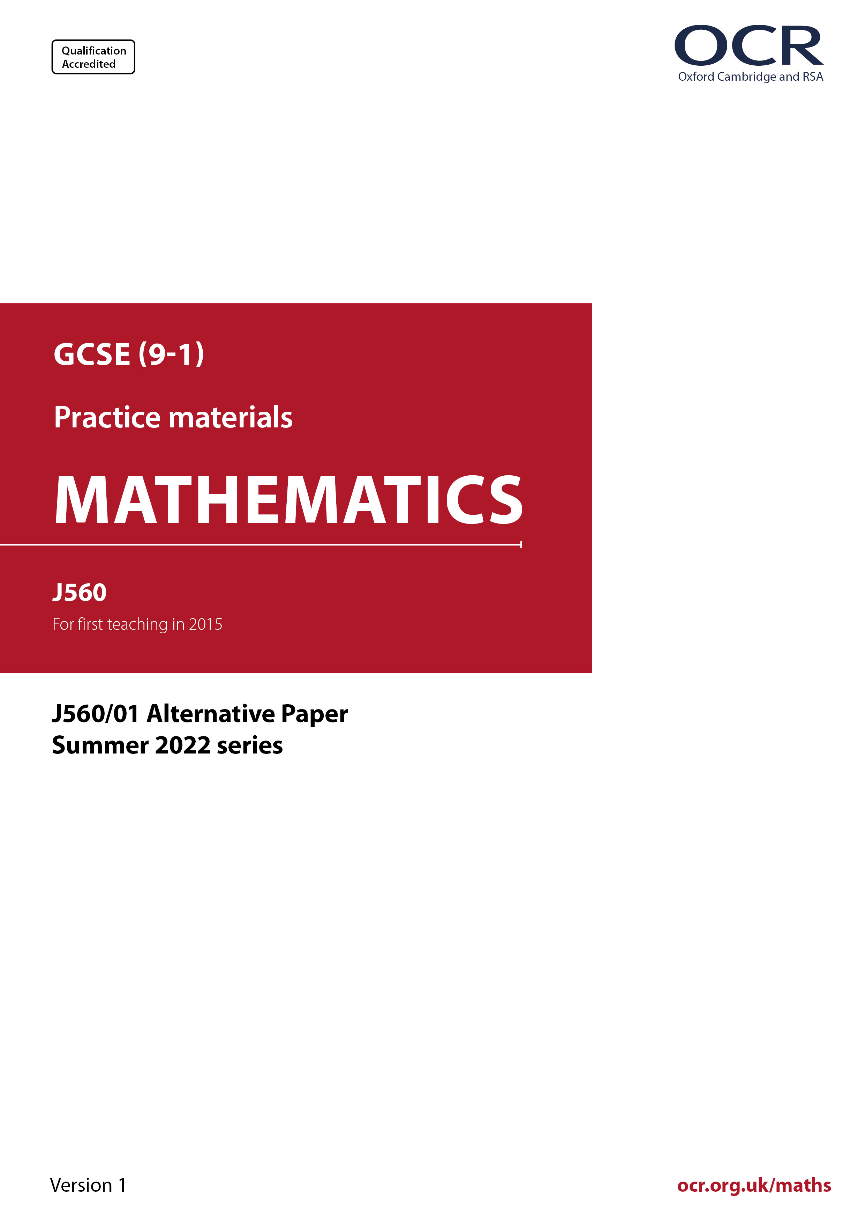
ocr.org.uk/maths

Introduction
OCR’s Alternative Papers for GCSE (9-1) Mathematics are each created by taking one of our past papers and amending the numbers/graphs/diagrams/tables/etc. in its questions.
This Alternative Paper is an amended version of one of the Summer 2022 series papers. The wording and topics assessed are essentially the same, but the responses students need to make will be different. Using both this paper and the corresponding Summer 2022 exam paper with your students at different points in the year will allow you to monitor how their learning has progressed in the time between the two papers.
Please note that when students originally sat this paper in 2022, they were given a formulae sheet. Foundation tier and Higher tier formulae sheets are published on Teach Cambridge alongside the Alternative Papers, for use with students as required.
Additional Alternative Papers and past papers are available to download from Teach Cambridge.



GCSE (9-1) Mathematics
J560/01 Paper 1 (Foundation Tier)
Alternative Paper (Summer 2022)

Time allowed: 1 hour 30 minutes

You can use:
- a scientific or graphical calculator
- geometrical instruments
- tracing paper

Name

INSTRUCTIONS
- Use black ink. You can use an HB pencil, but only for graphs and diagrams.
- Write your answer to each question in the space provided. If you need extra space, use
the lined pages at the end of this booklet. The question numbers must be clearly shown.
- Answer all the questions.
- Where appropriate, your answer should be supported with working. Marks might be
given for using a correct method, even if your answer is wrong.
- Use the π button on your calculator or take π to be 3.142 unless the question says
something different.

INFORMATION
- The total mark for this paper is 100.
- The marks for each question are shown in brackets [ ].
- This document has 24 pages.

ADVICE
- Read each question carefully before you start your answer.

Answer all the questions.

1 (a) Write down the mathematical name of this polygon.

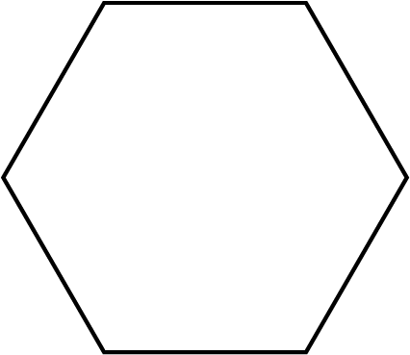

(a) ……..…………….………………. [1]

(b) How many faces does a cube have?

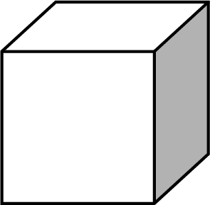

(b) ……..…………….………………. [1]

2 Here is a list of numbers.

9 6 7 3 4 12 9

(a) Find the median.

(a) ……..…………….………………. [1]

(b) Work out the range.

(b) ……..…………….………………. [2]

3 The diagram shows a pair of parallel lines.

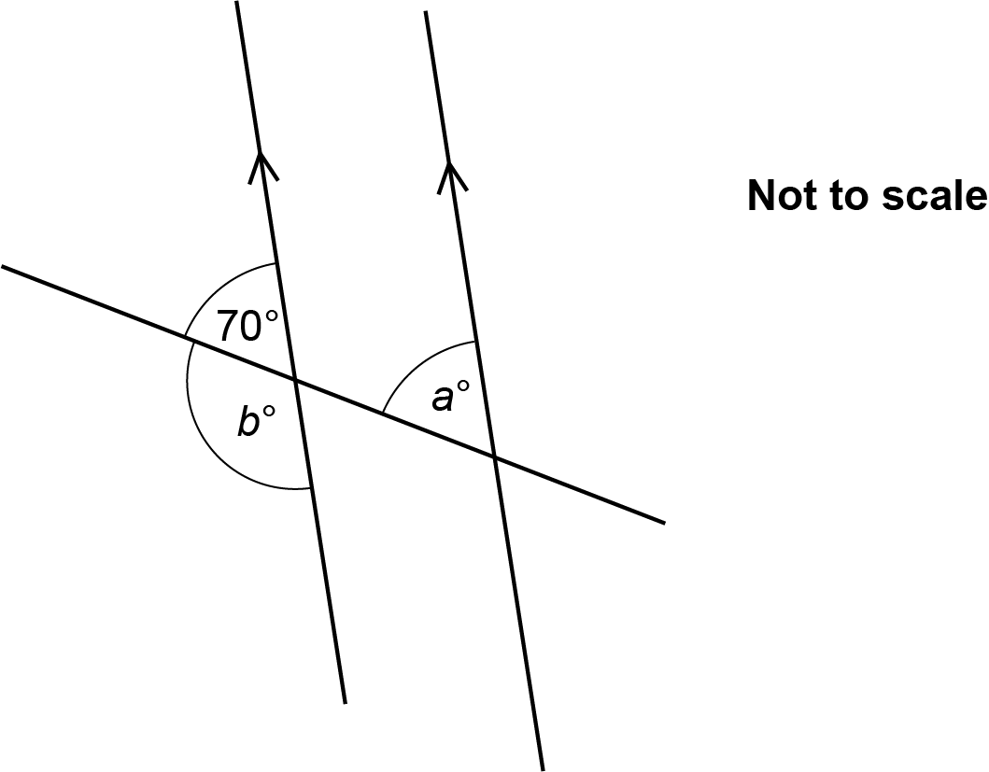

(a) Write down the value of a.

(a) a = ……..…………….………………. [1]

(b) Write down the value of b.

(b) b = ……..…………….………………. [1]

4 Ling has some empty boxes.
Each box can hold 57 pencils.
Ling has 350 pencils.

Ling says that six boxes are needed to hold all of the pencils.

Is Ling correct?
You must show your working.

..………………………………because…………………………………………………………………

………......…………………………………………………………………………………………… [2]

5 This graph shows the number of mobile phones sold by a shop in April, May and June.

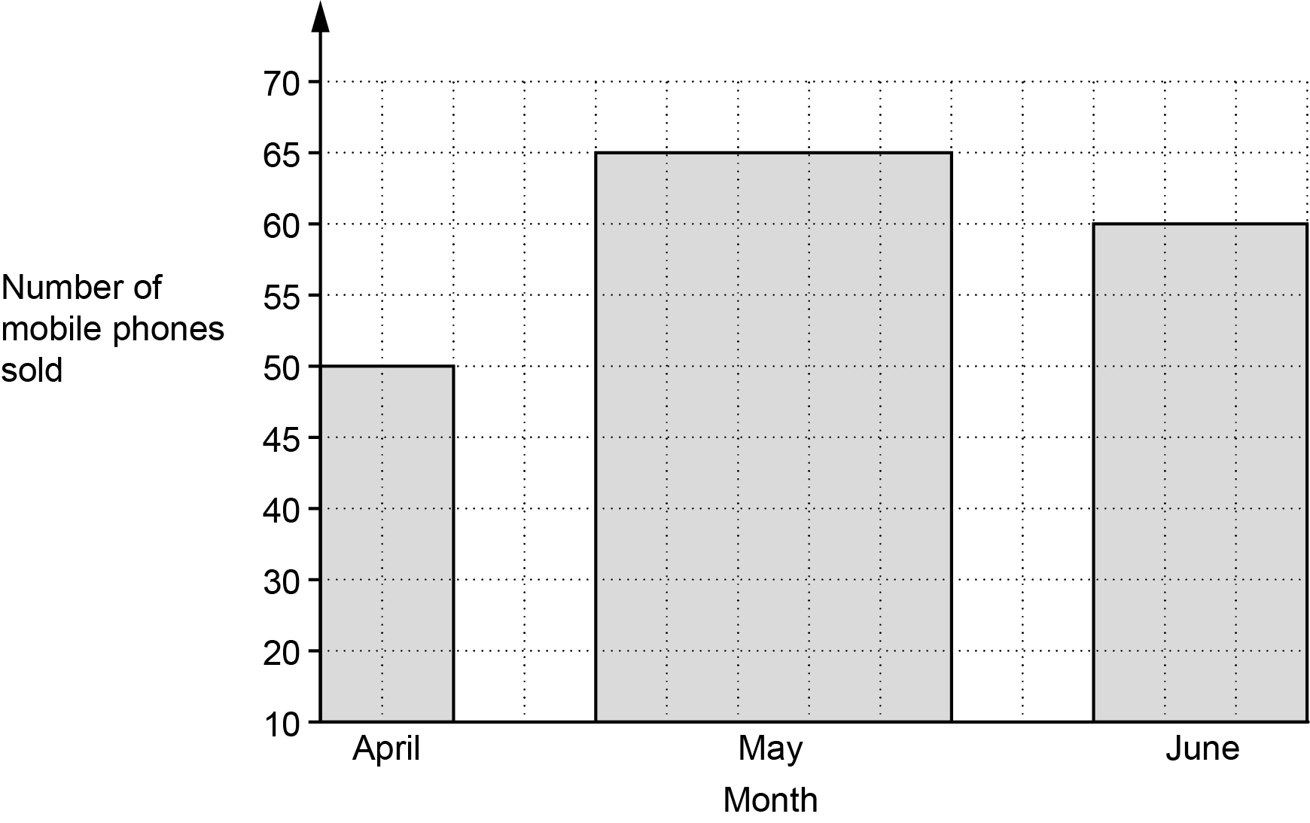

Give two reasons why the graph is misleading.

1..……..………………………………………………………………………………………………….

.…………....…………………………………………………………………………………..…………

2...……..…………………………………………………………………………………………………

..……....…………………………………………………………………………………………..…. [2]

6 Jane has these three number tiles.

4
7
9

(a) Which one of Jane’s tiles shows a prime number?
Write the number on the blank tile on the answer line.

(a) ……..…………….………………. [1]

(b) Write down a two-digit square number that can be made using two of Jane’s tiles.

(b) ……..…………….………………. [1]

(c) Write down the three-digit number closest to 500 that can be made using all three of Jane’s tiles.

(c) ……..…………….………………. [1]

7 (a) Simplify.

6t + t – 5t

(a) ……..…….……….…………………. [1]

(b) Factorise.

y ² − 5y

(b) ……..…….……….…………………. [1]

8 Write the following in order of size, smallest first.

41.2% $\frac{\text{410}}{\text{1000}}$ $\frac{\text{7}}{\text{17}}$ 0.4101

………… , ………… , ………… , ………… [2]
smallest

9 A pattern is made out of blue tiles and yellow tiles.
$\frac{\text{1}}{\text{4}}$ of the tiles are blue.
There are 39 yellow tiles.

Work out the total number of tiles.

……..…………….………………. [3]

10 Work out, using your calculator.

$\sqrt{{\text{10.5}}^{\text{2}} \text{+} {\text{36}}^{\text{2}}}$

……..…………….………………. [2]

11 200 new homes are built in a village.
Each home is either a house or a flat.
Each home either has a garage or does not have a garage.
96 of the houses have a garage and 44 of the flats have a garage.

This frequency tree shows the above information.

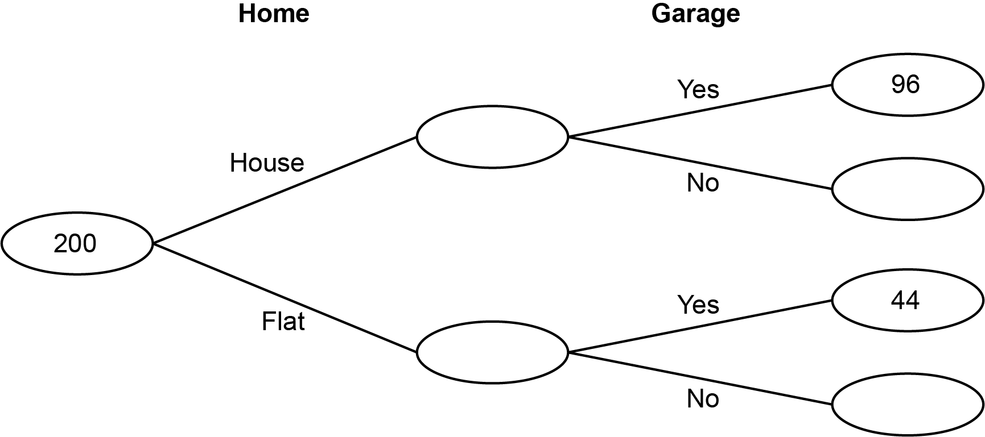

(a) $\frac{\text{3}}{\text{8}}$ of the homes are flats.

Complete the frequency tree. [4]

(b) Show that 70% of the homes have a garage.

………………………………..………………………..………………………………………………

..…………………………………………………………….………………………………………….
[2]

12 The diagram shows Alex’s garden.
The garden is a rectangle, 21 m by 10 m.

It has a lawn and a pond.
The pond is a circle of diameter 8 m.

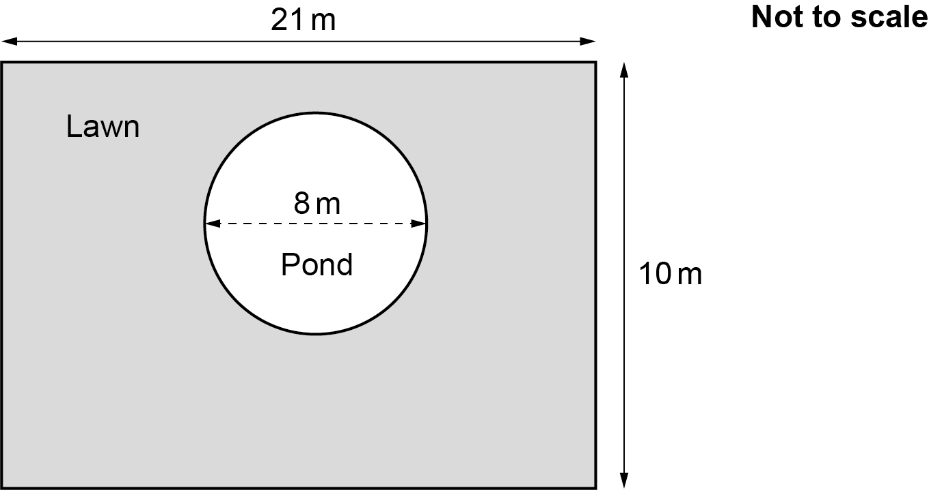

Work out the area of Alex’s lawn.

……..…………….………………. m² [4]

13 Here are the ticket prices for a theme park when bought at the gate.

Adult £24

Child £19
Family ticket
(2 adults and £90
up to 4 children)

(a) Mr and Mrs Morris take their four children to the theme park.
They buy their tickets at the gate.

How much do Mr and Mrs Morris save by buying a family ticket?

(a) £ ……..…………….………………. [4]

(b) All ticket prices are reduced by 15% if bought online rather than at the gate.
Mr and Mrs Khan take their one child to the same theme park.
They buy their tickets online.

What is the lowest possible total cost of their tickets?

(b) £ ……..…………….………………. [4]

14 Here is a rule to work out the time, in minutes, needed to cook a turkey.

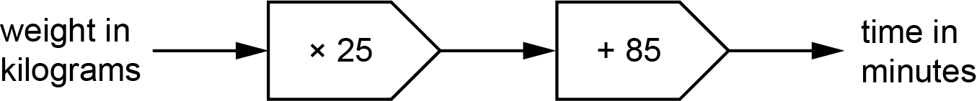

(a) Blake’s turkey takes 160 minutes to cook.

Use the rule to work out the weight of Blake’s turkey.

(a) ……..…………….………………. kg [2]

(b) Jamie cooks a different turkey.
His turkey weighs 5 kg.
Jamie wants to take his turkey out of the oven at 2:05 pm.

Use the rule to work out at what time Jamie should put his turkey in the oven.
You must show your working.

(b) ……..…………….………………. [5]

15 Vector a is drawn on this grid.

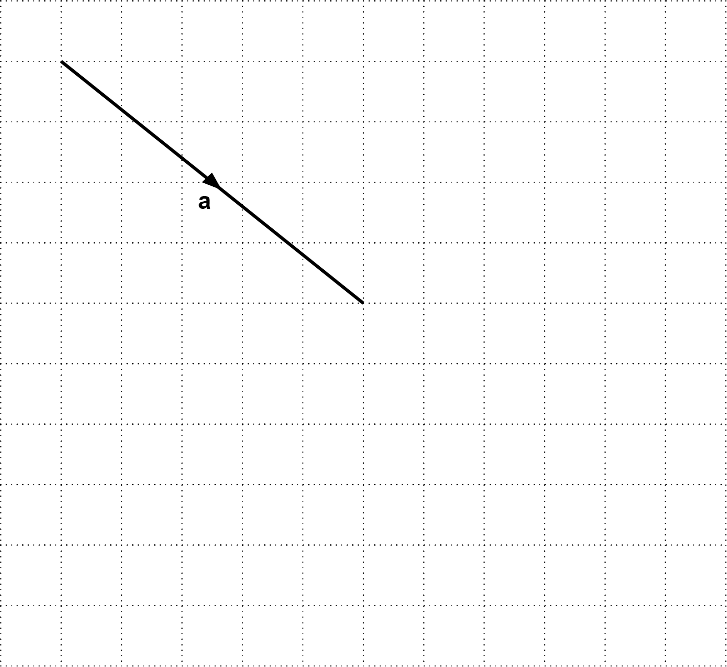

(a) Write vector a as a column vector.

( )
(a) ……..…………….………………. [2]

(b) On the grid above, draw the vector - a. [1]

16 Ashley and Kai share some money in the ratio 3 : 7.
Kai receives £160 more than Ashley.

How much money does Ashley receive?

£ ……..…………….………………. [3]

17 Solve 3x – 4 ≤ 11.
Show your solution on the number line.

[4]

18 (a) Write 8 450 000 in standard form.

(a) ……..…………….………………. [1]

(b) Write 8.04 × 10⁻² as an ordinary number.

(b) ……..…………….………………. [1]

19 A coat is on sale in a shop at a special price of £146.30.
The shop says this is a saving of 23% on their normal price.

Work out the shop’s normal price for the coat.

£ ……..…………….………………. [3]

20 This list represents four numbers.

137 x – 2 x 3x

The mean of the four numbers is 150.

Work out the numbers.
You must show your working.

137

…….…..… ……...…… ……...…… …….…..… [5]

21 The scatter diagram shows the midday temperature at 13 different heights on a mountain.

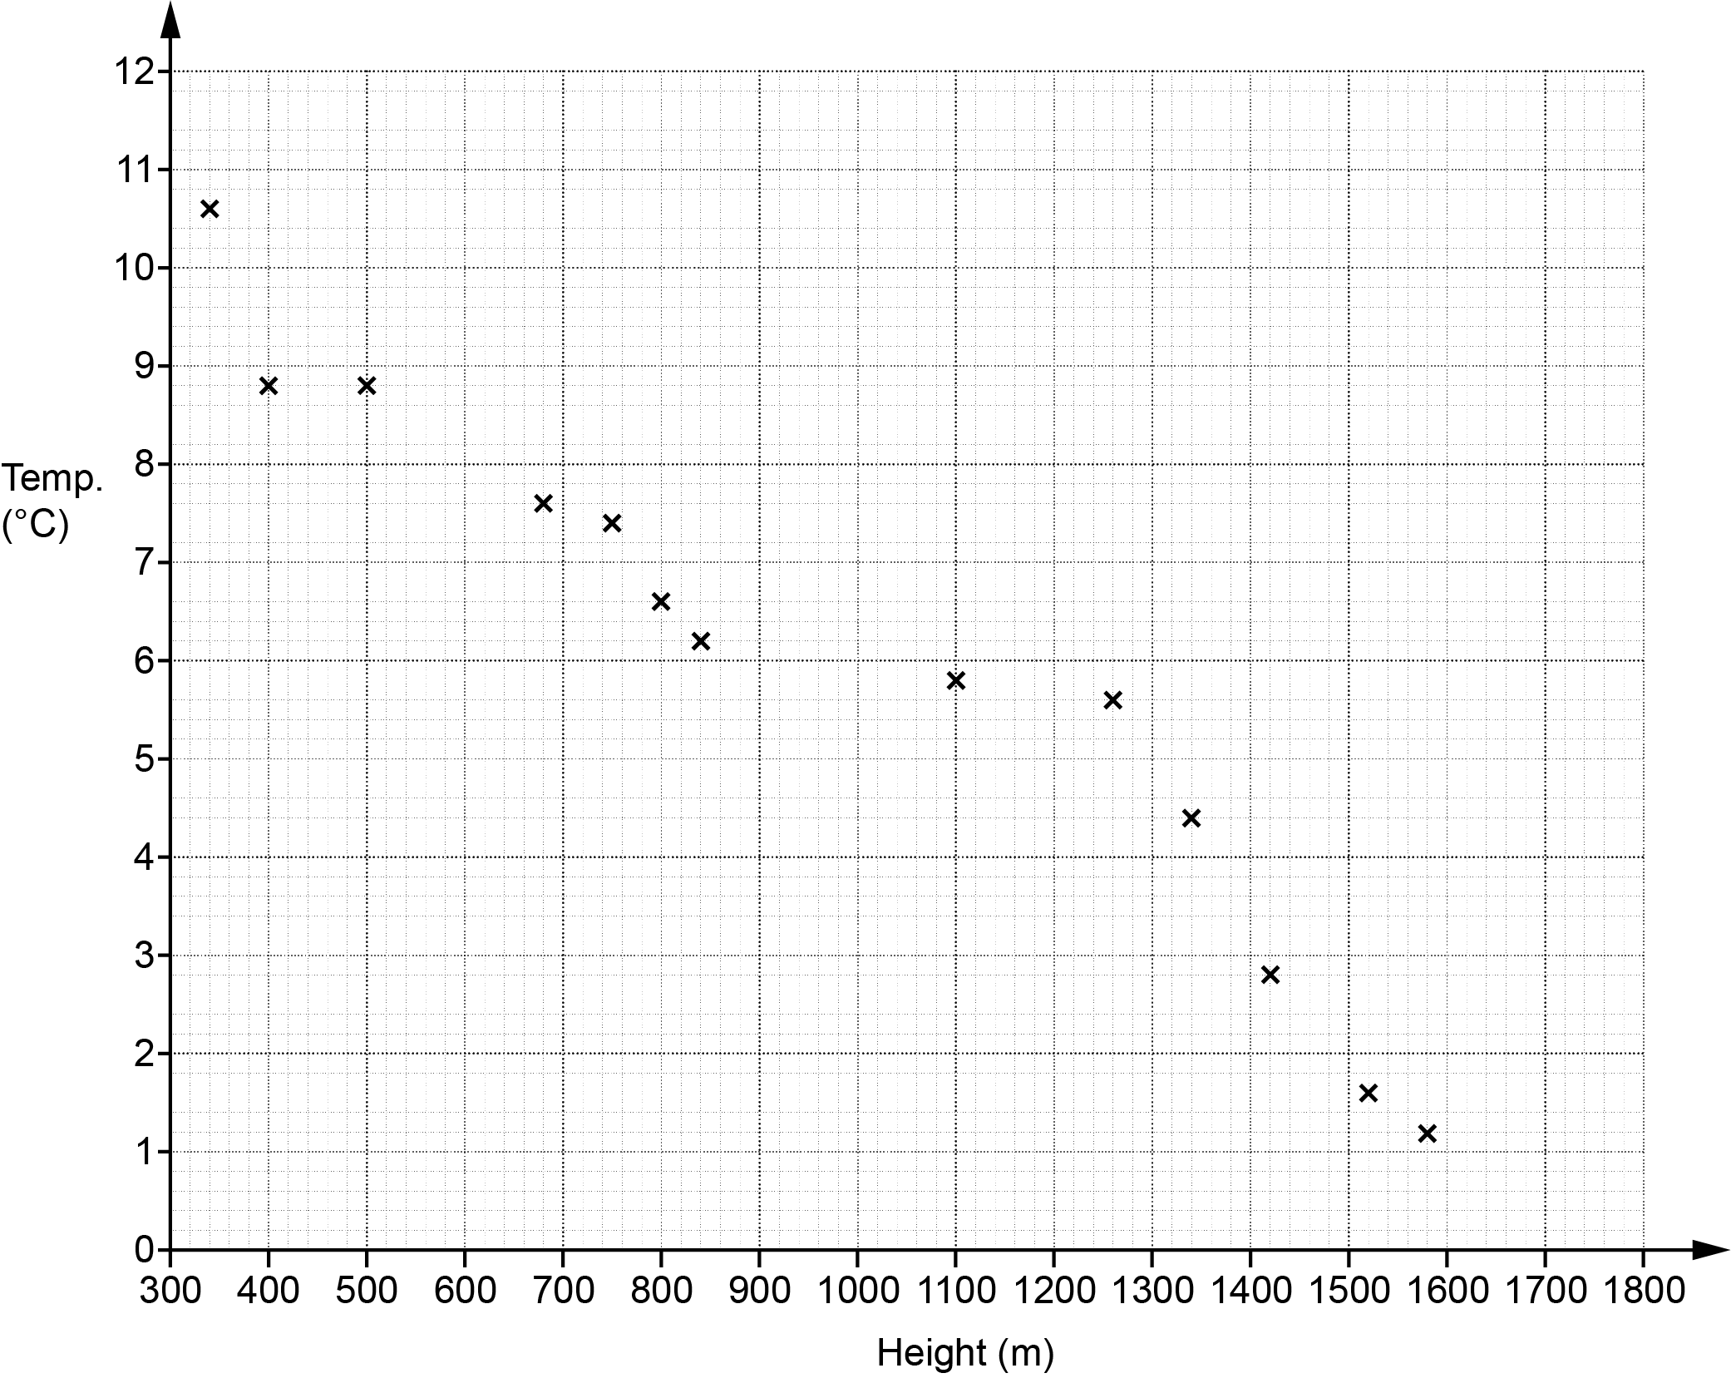

(a) The table has the information for 2 more heights.

Plot these on the scatter diagram.

Height (m) | 600 | 1200
Temperature (°C) | 8.4 | 9.2
[2]

(b) Describe the type of correlation shown in the scatter diagram.

(b) ……..…………….………………. [1]

(c) By drawing a line of best fit, estimate the temperature at 1000 m.

(c) ……..…………….………………. °C [2]

(d) Circle the outlier on the scatter diagram. [1]

(e) Explain why using the scatter diagram to estimate the temperature at 1800 m may be unreliable.

………………….…………………..…………………………………………………………………

..………………….……………………..………………………………………………………… [1]

(f) Find the fraction of the 15 temperatures which are above 8 °C.

(f) ……..…………….………………. [3]

22 (a) Complete this table for y = x ² – 3.

x | -4 | -3 | -2 | -1 | 0 | 1 | 2 | 3
y |  | 6 | 1 | -2 |  | -2 | 1 | 6
[2]

(b) Draw the graph of y = x ² – 3 for the values of x from -4 to 3.

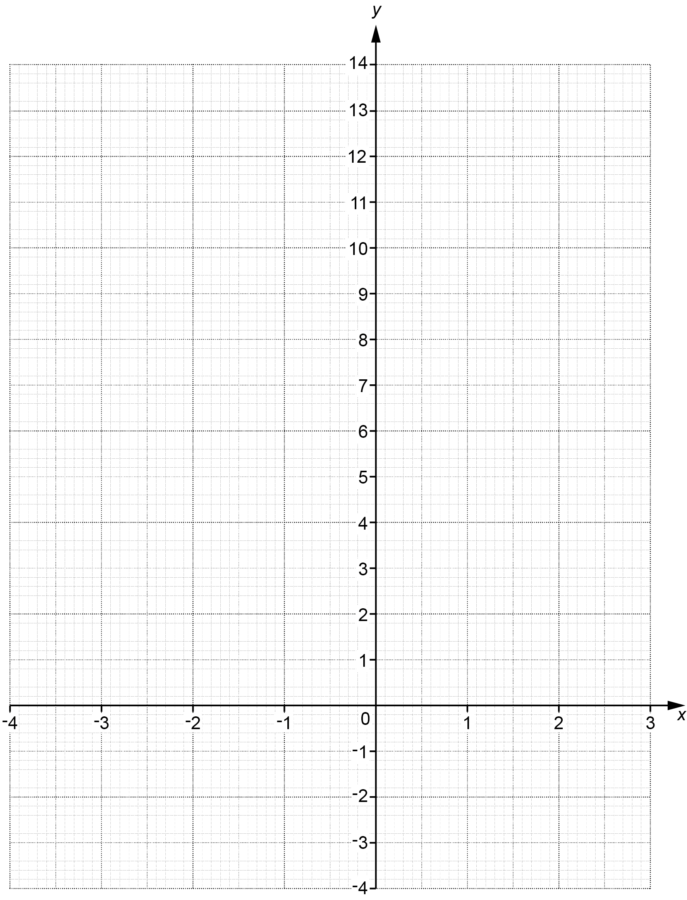
[3]

(c) Use the graph to solve the equation x² – 3 = 0.
Give your answers to 1 decimal place.

(c) x = ……..……….… or x = ……..……….… [2]

23 Three friends are going on holiday together.
They each take a suitcase.
The weight of each suitcase is 22 kg, correct to nearest kilogram.

(a) Complete the error interval for the weight, w kg, of one suitcase.

(a) ……..…………….… ⩽ w < ……..…………….… [2]

(b) The friends must pay extra if the total weight of their three suitcases is more than 67.3 kg.

Can the friends be certain that they will not have to pay extra?
Show how you decide.

....………...………………… because…………………………………………………………………….

.………….…....…………………………………………………………………………………..…………

..……....……….……………………………………………………………………………………..…. [3]

24 A machine can dig, on average, 3 cm of tunnel each minute.
It operates 24 hours each day.

(a) Work out how many days it should take to dig a tunnel of length 4.4 km.
Give your answer to the nearest day.

- ……..…………….………………. days [4]

(b) The machine actually digs an average of 3.4 cm of tunnel each minute for most of the time and an average of 2.6 cm each minute for the rest of the time.

How would this affect your answer to part (a)?

.....……..………………………………………………………………………………………………

..…...…....……………...…………………..…………………………………………………….. [1]

25 The diagram shows a square-based pyramid and a sphere.

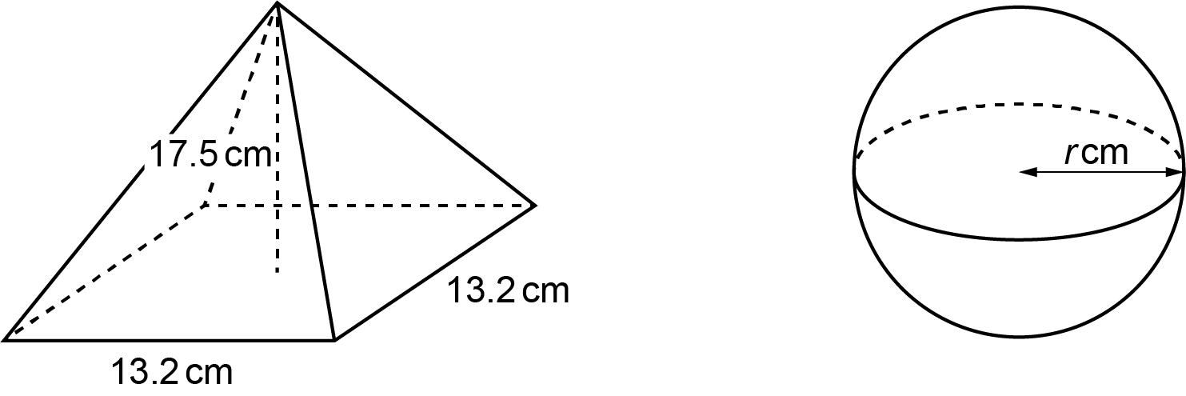

The pyramid has base length 13.2 cm and perpendicular height 17.5 cm.
The sphere has radius r cm.

The pyramid and the sphere have the same volume.

Work out the radius of the sphere.
You must show your working.

[The volume of a pyramid is × area of base × perpendicular height.

The volume V of a sphere with radius r is $\text{V} \text{=} \frac{\text{4}}{\text{3}}\text{π}{\text{r} }^{\text{3}}$.]

……..…………….………………. cm [5]

END OF QUESTION PAPER

ADDITIONAL ANSWER SPACE

If additional space is required, you should use the following lined page(s). The question number(s) must be clearly shown in the margin(s).

…………………………………………………………………………………………………………………..

…………………………………………………………………………………………………………………..

…………………………………………………………………………………………………………………..

…………………………………………………………………………………………………………………..

…………………………………………………………………………………………………………………..

…………………………………………………………………………………………………………………..

…………………………………………………………………………………………………………………..

…………………………………………………………………………………………………………………..

…………………………………………………………………………………………………………………..

…………………………………………………………………………………………………………………..

…………………………………………………………………………………………………………………..

…………………………………………………………………………………………………………………..

…………………………………………………………………………………………………………………..

…………………………………………………………………………………………………………………..

…………………………………………………………………………………………………………………..

…………………………………………………………………………………………………………………..

…………………………………………………………………………………………………………………..

…………………………………………………………………………………………………………………..

…………………………………………………………………………………………………………………..

…………………………………………………………………………………………………………………..

…………………………………………………………………………………………………………………..

…………………………………………………………………………………………………………………..

…………………………………………………………………………………………………………………..

…………………………………………………………………………………………………………………..

…………………………………………………………………………………………………………………..

…………………………………………………………………………………………………………………..

…………………………………………………………………………………………………………………..

…………………………………………………………………………………………………………………..

…………………………………………………………………………………………………………………..

…………………………………………………………………………………………………………………..

…………………………………………………………………………………………………………………..

…………………………………………………………………………………………………………………..

…………………………………………………………………………………………………………………..

…………………………………………………………………………………………………………………..

…………………………………………………………………………………………………………………..

…………………………………………………………………………………………………………………..

…………………………………………………………………………………………………………………..

…………………………………………………………………………………………………………………..

…………………………………………………………………………………………………………………..

…………………………………………………………………………………………………………………..

…………………………………………………………………………………………………………………..

…………………………………………………………………………………………………………………..

…………………………………………………………………………………………………………………..

…………………………………………………………………………………………………………………..

…………………………………………………………………………………………………………………..

…………………………………………………………………………………………………………………..

…………………………………………………………………………………………………………………..

…………………………………………………………………………………………………………………..

…………………………………………………………………………………………………………………..

Please note – web links are correct at date of publication but other websites may change over time. If you have any problems with a link you may want to navigate to that organisation’s website for a direct search.



We’d like to know your view on the resources we produce. Click ‘Like’ or ‘Dislike’ to send us an auto generated email about this resource. Add comments if you want to. Let us know how we can improve this resource or what else you need. Your email will not be used or shared for any marketing purposes.
Looking for another resource? There is now a quick and easy search tool to help find free resources for your qualification.
OCR is part of Cambridge University Press & Assessment, which is itself a department of the University of Cambridge.
For staff training purposes and as part of our quality assurance programme your call may be recorded or monitored.
Oxford Cambridge and RSA Examinations is a Company Limited by Guarantee. Registered in England. Registered office
The Triangle Building, Shaftesbury Road, Cambridge, CB2 8EA. Registered company number 3484466. OCR is an exempt charity.
OCR operates academic and vocational qualifications regulated by Ofqual, Qualifications Wales and CCEA as listed
in their qualifications registers including A Levels, GCSEs, Cambridge Technicals and Cambridge Nationals.
OCR provides resources to help you deliver our qualifications. These resources do not represent any teaching method we expect you to use. We update our resources regularly and aim to make sure content is accurate but please check the OCR website so that you have the most up to date version. OCR cannot be held responsible for any errors or omissions in these resources.
Though we make every effort to check our resources, there may be contradictions between published support and the specification, so it is important that you always use information in the latest specification. We indicate any specification changes within the document itself, change the version number and provide a summary of the changes. If you do notice a discrepancy between the specification and a resource, please contact us.
© OCR 2022 - You can copy and distribute this resource freely if you keep the OCR logo and this small print intact and you acknowledge OCR as the originator of the resource.
OCR acknowledges the use of the following content: N/A
Whether you already offer OCR qualifications, are new to OCR or are thinking about switching, you can request more information using our Expression of Interest form.
Please get in touch if you want to discuss the accessibility of resources we offer to support you in delivering our qualifications.

