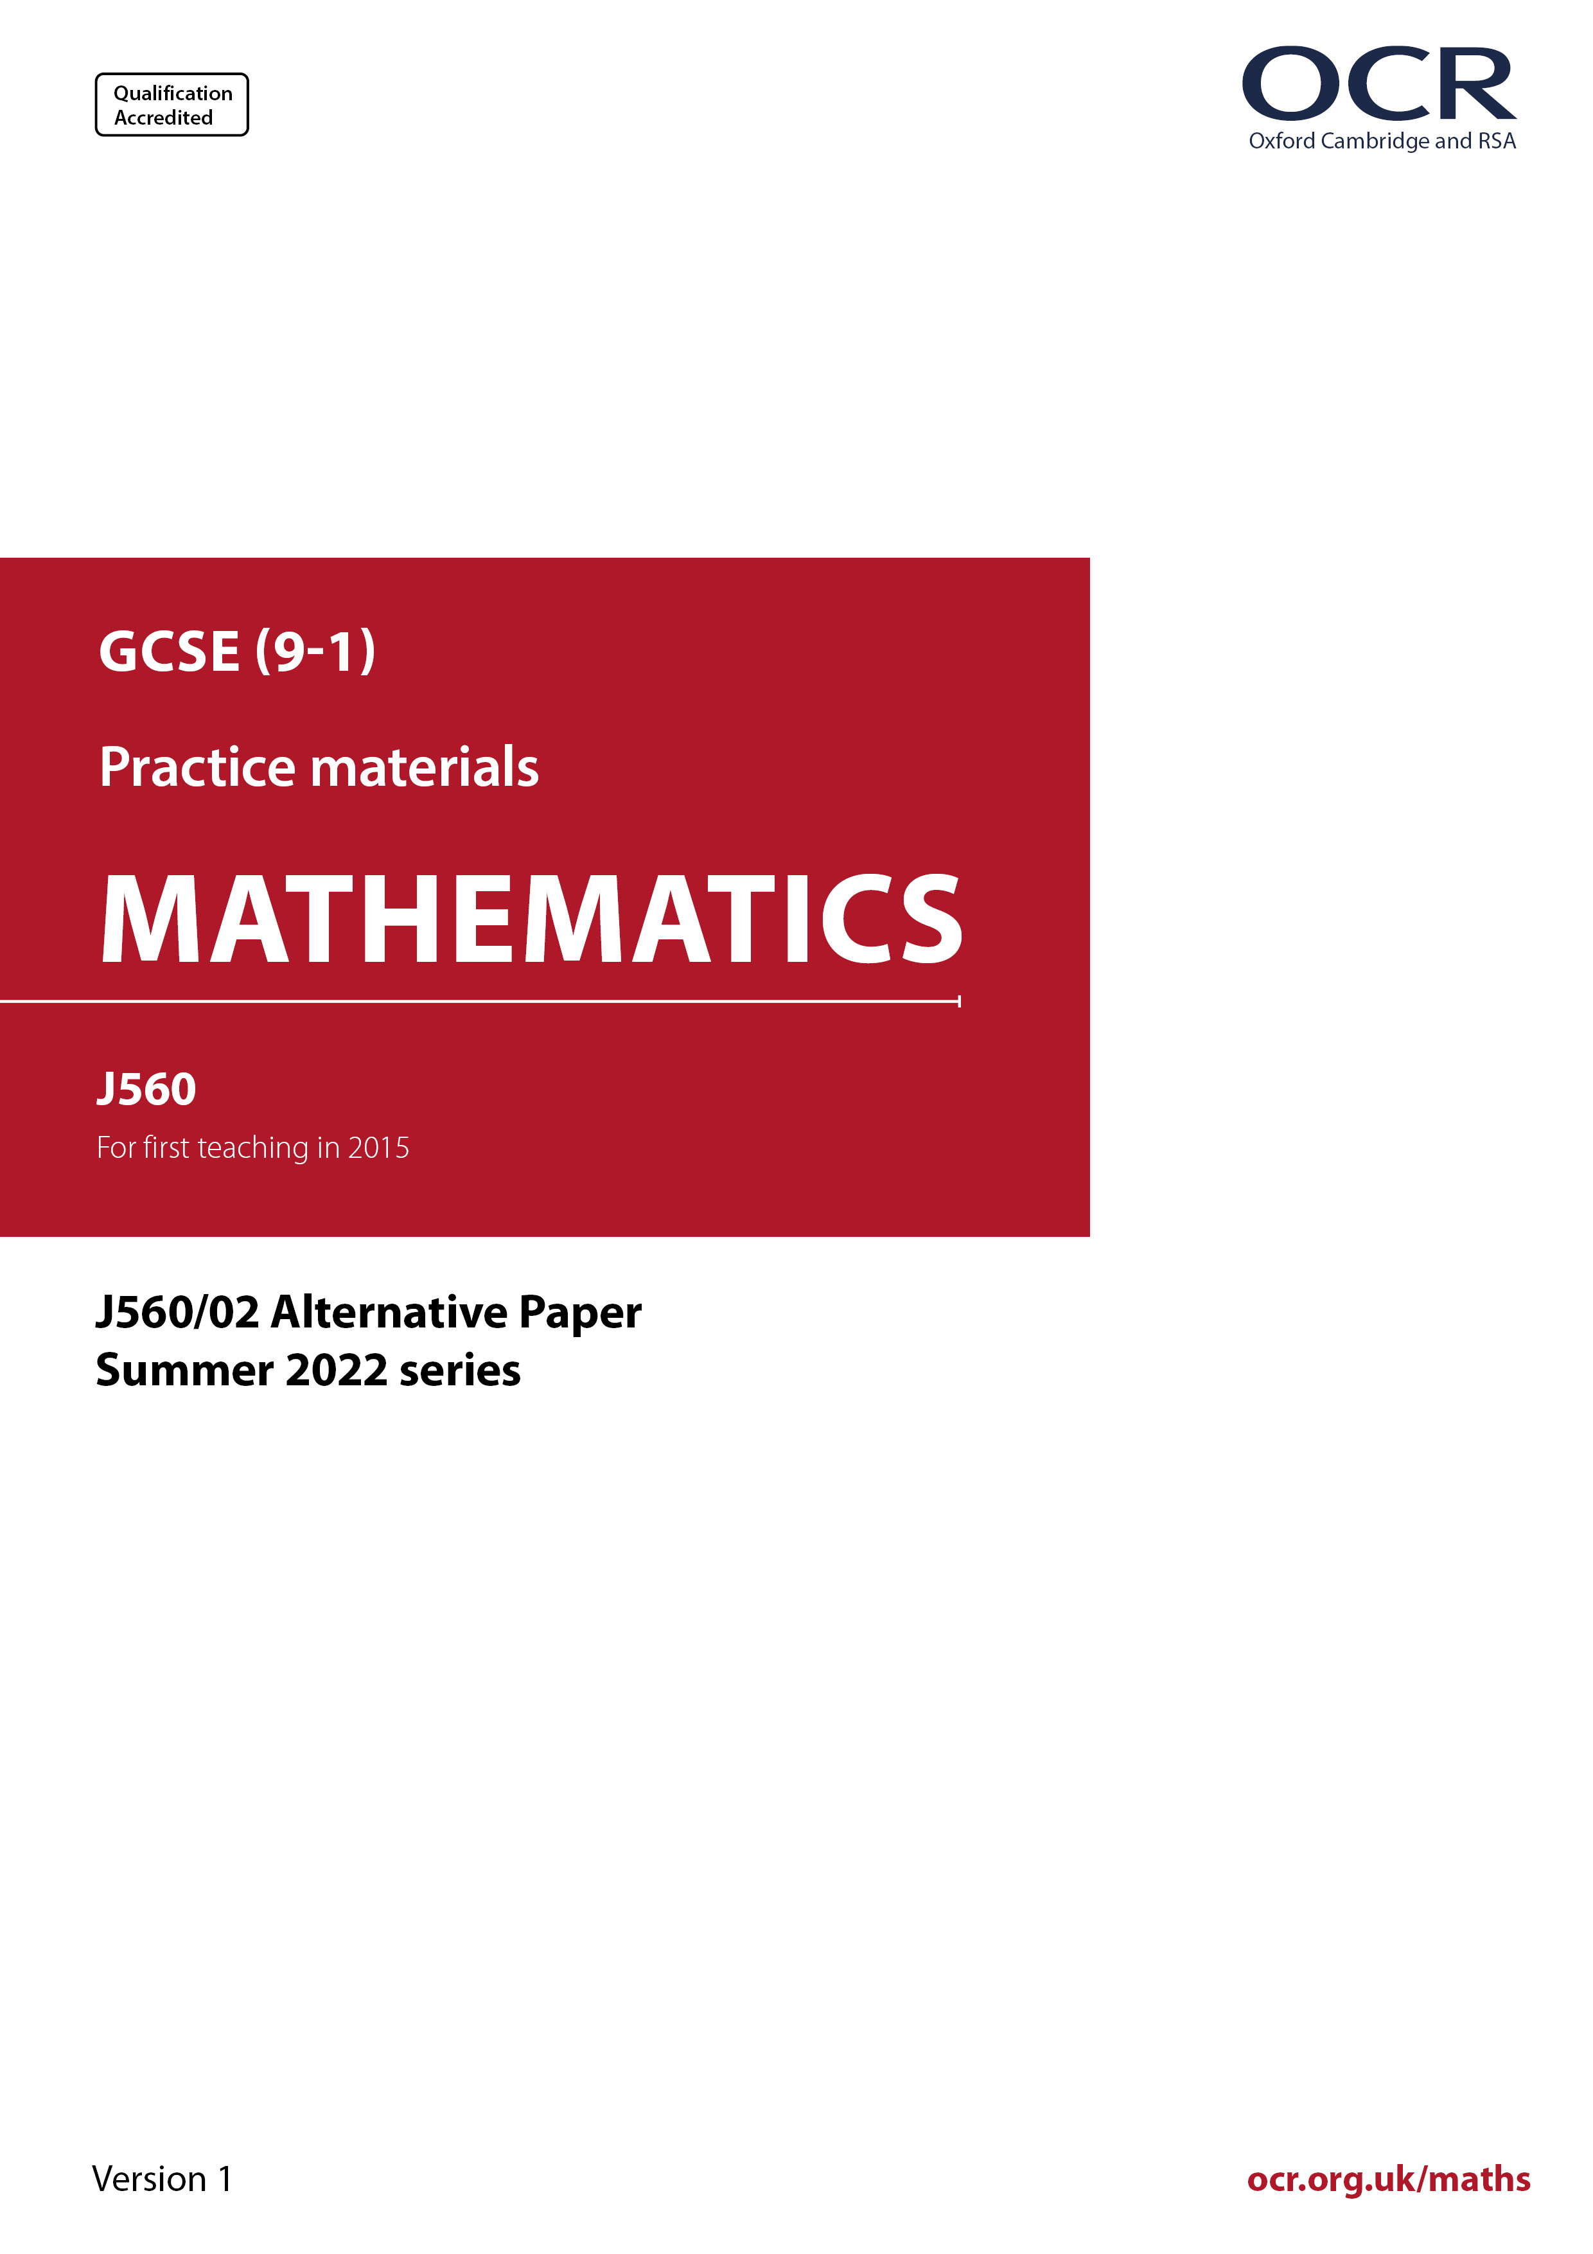
ocr.org.uk/maths

Introduction
OCR’s Alternative Papers for GCSE (9-1) Mathematics are each created by taking one of our past papers and amending the numbers/graphs/diagrams/tables/etc. in its questions.
This Alternative Paper is an amended version of one of the Summer 2022 series papers. The wording and topics assessed are essentially the same, but the responses students need to make will be different. Using both this paper and the corresponding Summer 2022 exam paper with your students at different points in the year will allow you to monitor how their learning has progressed in the time between the two papers.
Please note that when students originally sat this paper in 2022, they were given a formulae sheet. Foundation tier and Higher tier formulae sheets are published on Teach Cambridge alongside the Alternative Papers, for use with students as required.
Additional Alternative Papers and past papers are available to download from Teach Cambridge.



GCSE (9-1) Mathematics
J560/02 Paper 2 (Foundation Tier)
Alternative Paper (Summer 2022)

Time allowed: 1 hour 30 minutes


You must have:
- geometrical instruments
- tracing paper
Do not use:
- a calculator

Name

INSTRUCTIONS
- Use black ink. You can use an HB pencil, but only for graphs and diagrams.
- Write your answer to each question in the space provided. If you need extra space, use
the lined pages at the end of this booklet. The question numbers must be clearly shown.
- Answer all the questions.
- Where appropriate, your answer should be supported with working. Marks might be
given for using a correct method, even if your answer is wrong.

INFORMATION
- The total mark for this paper is 100.
- The marks for each question are shown in brackets [ ].
- This document has 24 pages.

ADVICE
- Read each question carefully before you start your answer.

Answer all the questions.

1 (a) Work out.

(i) 6 – 7

(a)(i) ……..…………….………………. [1]

(ii) 4 × –2

(ii) ……..…………….………………. [1]

(iii) $\frac{\text{3}}{\text{5}}$ + $\frac{\text{1}}{\text{5}}$

(iii) ……..…………….………………. [1]

(iv) $\frac{\text{1}}{\text{2}}$ of $\text{7}\frac{\text{1}}{\text{2}}$

(iv) ……..…………….………………. [1]

(b) Write down the largest prime factor of 70.

(b) ……..…………….………………. [2]

2 (a) What fraction of this shape is shaded?



(a) ……..…………….………………. [1]

(b) What percentage of this shape is unshaded?

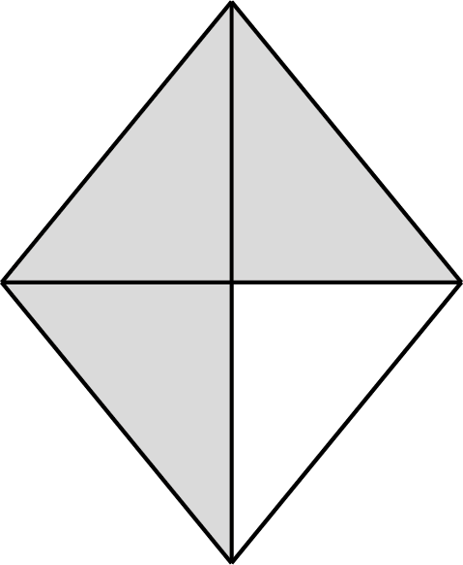

(b) ……..…………….…………….% [1]

(c) Write 0.6 as a fraction.
Give your answer in its simplest form.

(c) ……..…………….………………. [2]

(d) Work out 60% of 40.

(d) ……..…………….………………. [2]

3 Apples cost 25p each.

How many apples can be bought for £3?

……..…………….………………. [2]

4 A student makes a fair 8-sided spinner.
They write the numbers 11, 12, 13, 14, 15, 16, 17 and 18 on the spinner.

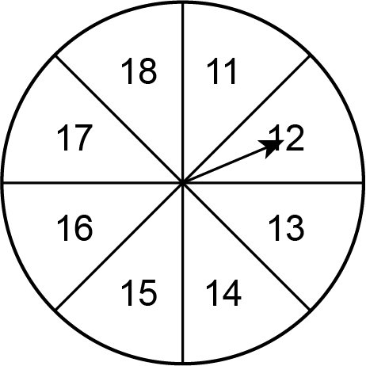

(a) Write down the probability of the student’s spinner landing on a number which is more than 13.

(a) ……..…………….………………. [1]

(b) Find the probability of the student’s spinner landing on a multiple of 6.

(b) ……..…………….………………. [2]

5 Write the ratio 3 : $\text{4}\frac{\text{1}}{\text{2}}$ in its simplest form.

……..…………….… : ……..…………….… [2]

6 Ellis has collected data on the number of students who cycled to school last week.
The bar chart shows the results for the first four days.

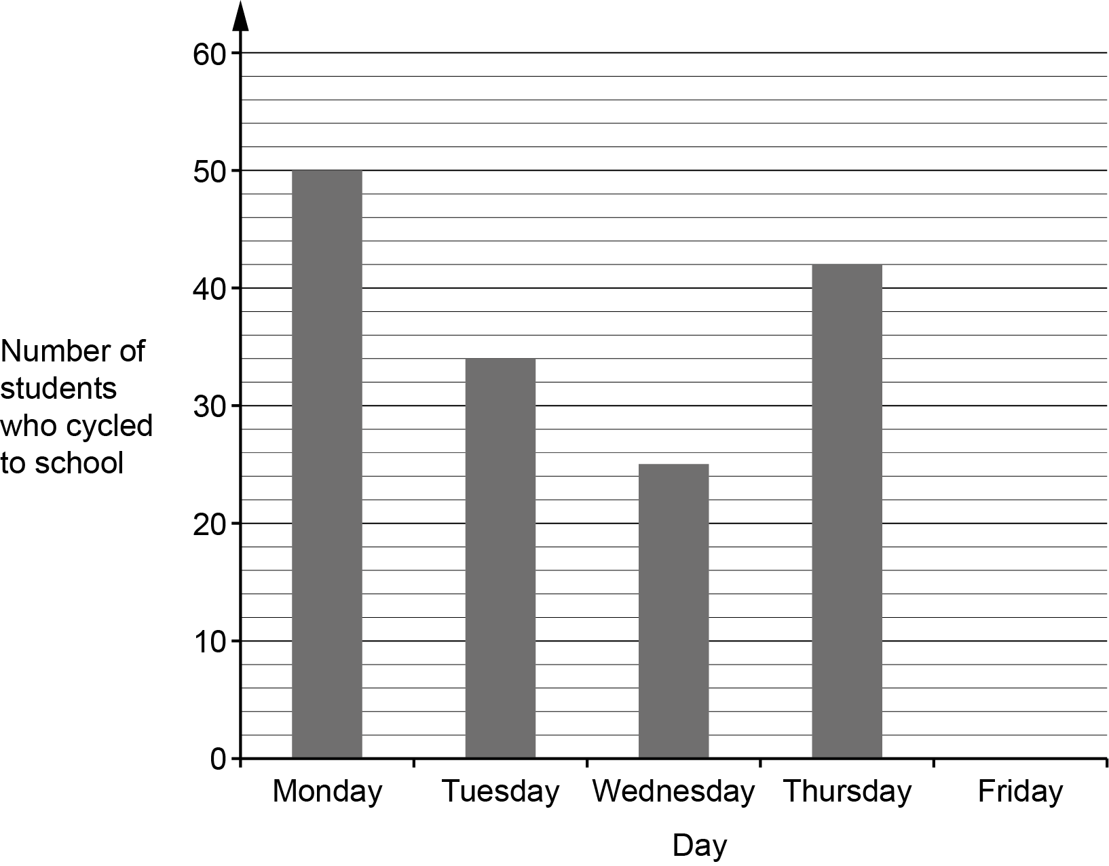

(a) On Friday there were 46 students who cycled to school.

Show this information on the bar chart. [1]

(b) Ellis says

On Wednesday 125% of the students cycled to my school.

Could this be true?
Explain how you decide.

....…...…..…………………………………………………………………………………………

….......……..………………………………………………………………………………………

..……....……….……………………………………………………………………………… [1]

(c) There are 700 students in Ellis’s school.
Find the percentage of students who cycled to Ellis’s school on Thursday.

(c) ……..…………….………………. % [3]

7 (a) Multiply out.

3(x + 5)

(a) ……..…….……….…………………. [1]

(b) Rearrange this formula to make t the subject.

r = 5t – 3

(b) ……..…….……….…………………. [2]

8 (a) Work out.

(i) 4.07 + 0.53

(a)(i) ……..…………….………………. [1]

(ii) 8.8 ÷ 11

(ii) ……..…………….………………. [1]

(b) Work out.

(2.6 – $\frac{\text{4}}{\text{5}}$) × 0.2

Give your answer as a decimal.

(b) ……..…………….………………. [3]

9 A village is putting on a fair.
30 child tickets are sold.
The ratio of the number of child tickets sold to the number of adult tickets sold is 3 : 5.

The cost of a child ticket is £1.50.
The cost of an adult ticket is £3.00.

Work out the total amount paid for the tickets.

£ ……..…………….………………. [4]

10 The diagram shows Anika’s garden.
It is in the shape of a right-angled triangle.

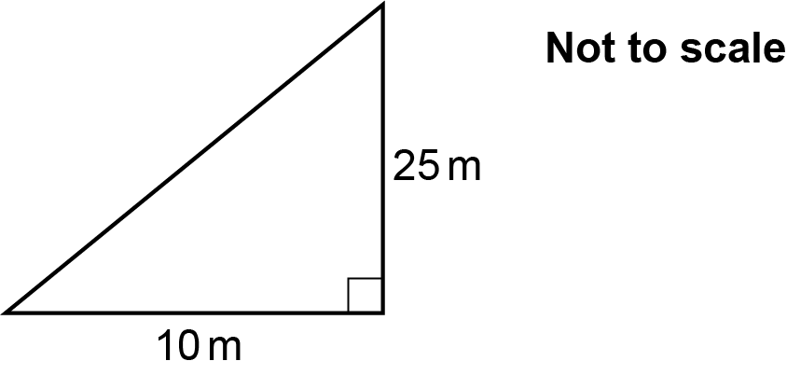

Anika is going to spread grass seed on the garden.

- A bag of grass seed covers an area of 15 m².
- Each bag of grass seed costs £3.99.

Anika can only buy whole bags of grass seed.
Anika buys the least number of bags needed for the garden.

Calculate the cost of buying the bags of grass seed that Anika needs.
You must show your working.

£ ……..…………….………………. [6]

11 Some students were asked how they travel to school.
Each student gave one answer.
The pie chart shows the proportion who walk, or travel by bike, or train.

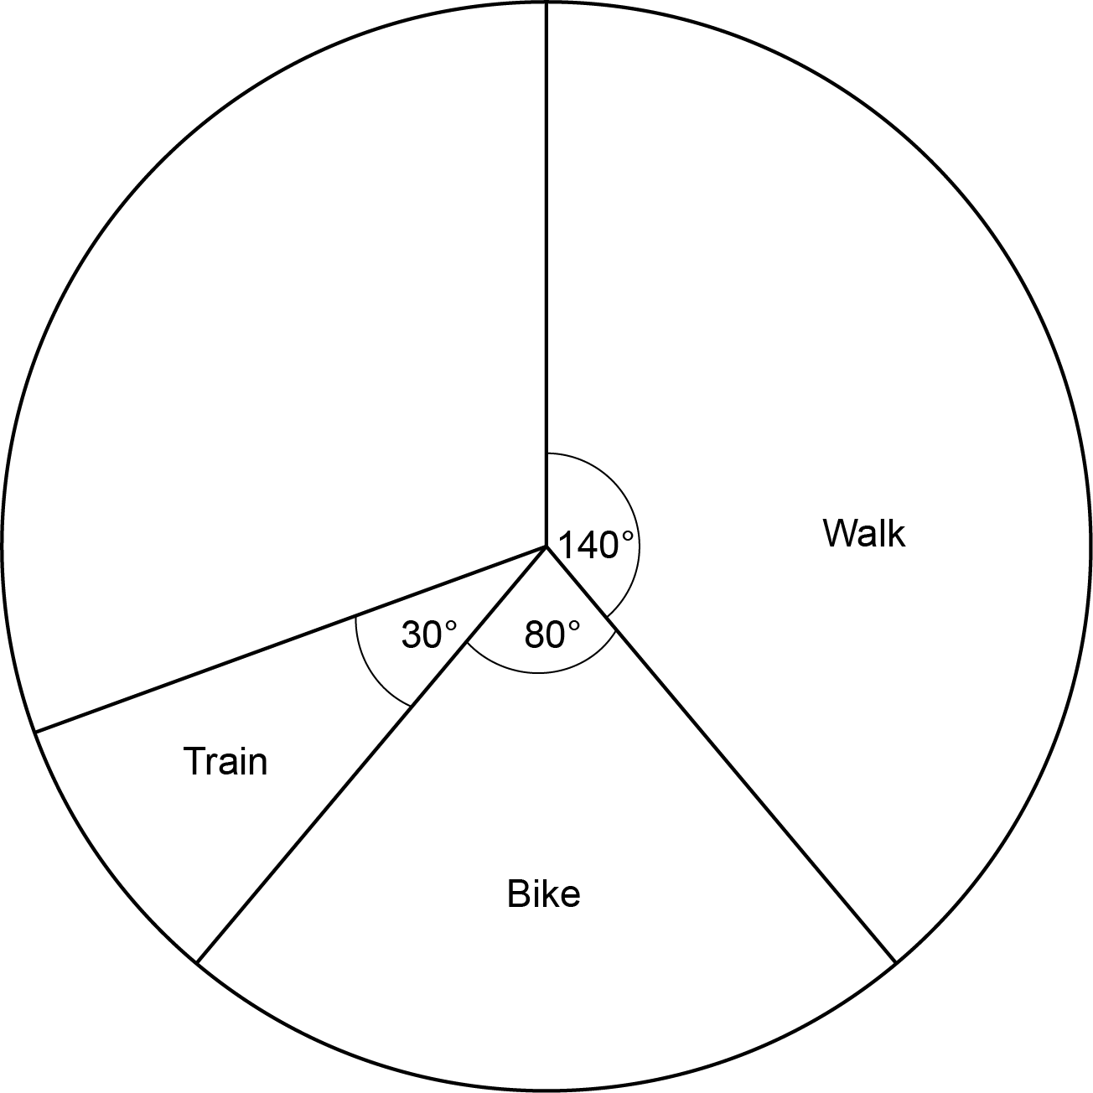

(a) All of the remaining students travel to school either by bus or by car.
The ratio of the number who travel by bus to the number who travel by car is 3 : 2.

Complete the pie chart.
You must show your working. [6]

(b) Which way of travelling to school is the mode?

……..…………….………………. [1]

12 The population of Brazil is 2.1 x 10⁸.
The population of Nepal is 3 x 10⁷.

(a) Explain why it is appropriate to use standard form for these numbers.

..……………………………………………………………………………………………………

..……………………………………………………………………………………………………

....……………………………………………………………………………………………… [1]

(b) Use the given information to work out how many more people live in Brazil than in
Nepal.
Give your answer in standard form.

(b) ……..…………….………………. [3]

13 (a) Complete this statement by writing the missing power in the box.

576 = 2 × 6² [1]

(b) Use your answer to part (a) to find the value of $\sqrt{\text{576}}$.

(b) ……..…………….………………. [2]

14 Rectangle A and rectangle B are drawn on the coordinate grid.

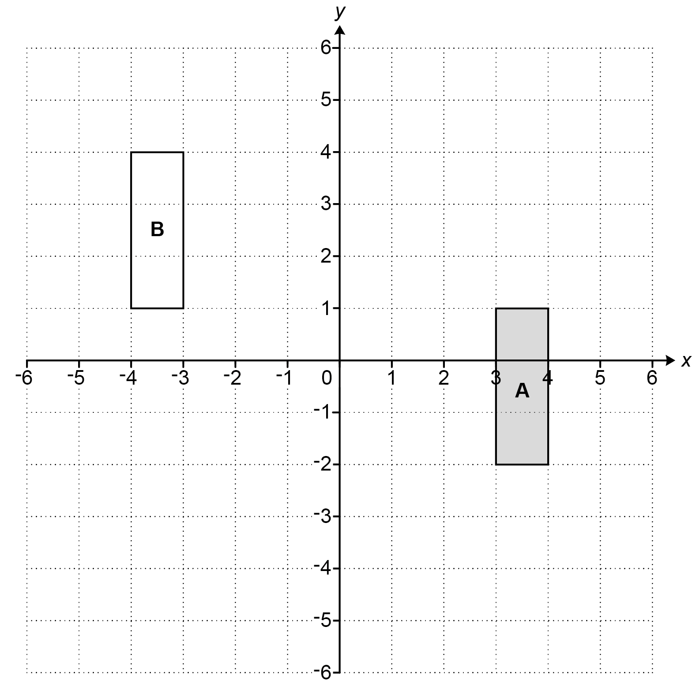

Describe fully two different single transformations that map rectangle A onto rectangle B.

1..……..………………………………………………………………………………………………….

.…………....…………………………………………………………………………………..…………

.…………....…………………………………………………………………………………..…………

2...……..…………………………………………………………………………………………………

.…………....…………………………………………………………………………………..…………

..……....……………………….……………………………………………………………………...….
[6]

15 y is inversely proportional to x.
y = 10 when x = 8.

Find the value of y when x = 16.

y = ……..…………….………………. [3]

16 A playground has a maze (M) at the centre.
There is also a climbing frame (C) and a swing (S).

The bearing of the swing from the maze is x°.

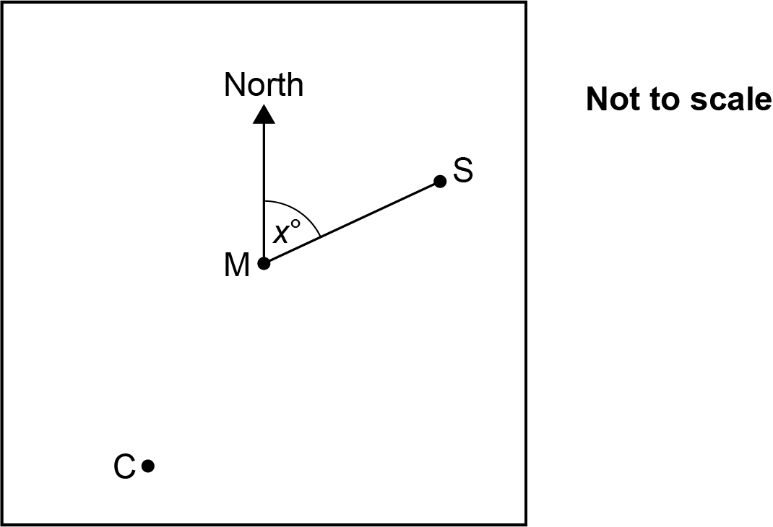

(a) The bearing of the climbing frame from the maze is 160° more than the bearing of the swing from the maze.

Write down, in terms of x, the bearing of the climbing frame from the maze.

(a) ……..…………….……………….° [1]

(b) The bearing of the climbing frame from the maze is also five times the bearing of the swing from the maze.

Work out the bearing of the climbing frame from the maze.

(b) ……..…………….……………….° [4]

17 Darcy is playing a game.
They can score 0, 2 or 4 points on each turn.
They record their scores for 100 turns.
The table shows the relative frequencies of their scores.

Score | 0 | 2 | 4
Relative frequency | 0.06 | 0.72

(a) Complete the table. [2]

(b) Darcy says

I scored less than 230 points in total in my 100 turns.

Is Darcy correct?
Show how you decide.

....……………………………………………………………………………………………… [4]

18 A bag only contains green counters, red counters and blue counters.

- The probability of picking a green counter is $\frac{\text{3}}{\text{5}}$.
- There are six blue counters.
- The probability of picking a red counter is four times as likely as picking a blue counter.

Work out the total number of counters in the bag.
You must show your working.

……..…………….………………. [5]

19 (a) Circle the value of cos 60°.

$\frac{\text{1}}{\text{3}}$ $\frac{\sqrt{\text{3}}}{\text{2}}$ $\frac{\text{1}}{\text{2}}$ $\frac{\sqrt{\text{3}}}{\text{3}}$ $\frac{\text{1}}{\text{4}}$ [1]

(b) Here is a right-angled triangle.

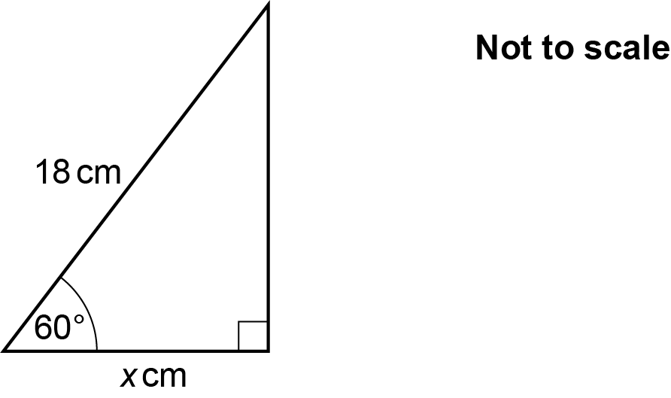

Work out the value of x.

(b) x = ……..…………….………………. [2]

20 The graph shows a parallelogram ABCD.

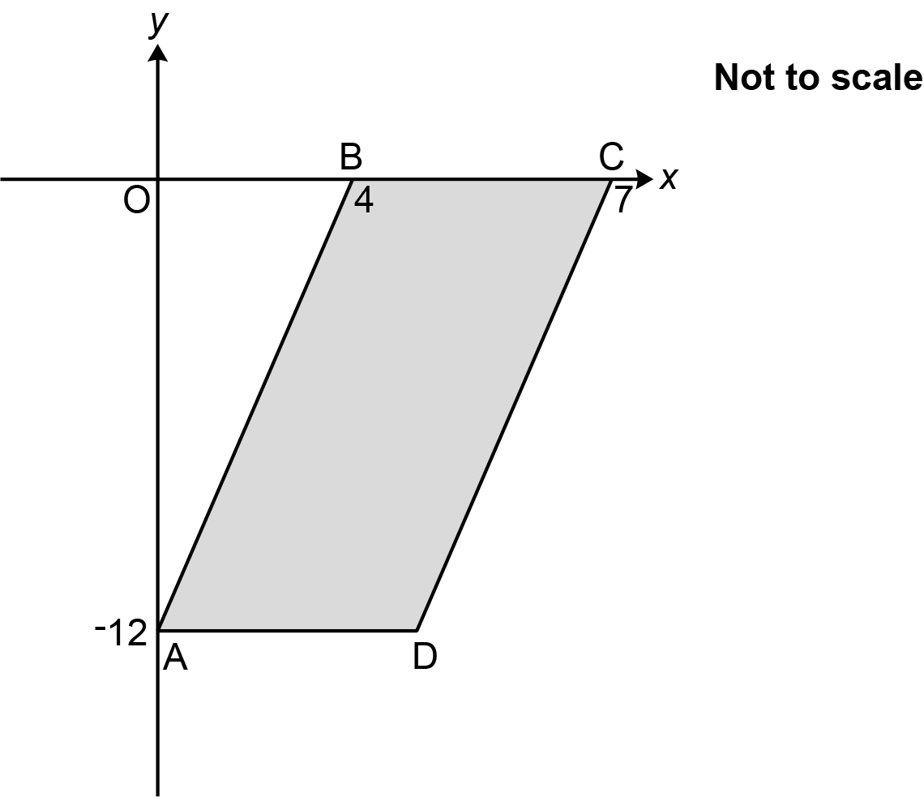

A has coordinates (0, -12), B has coordinates (4, 0) and C has coordinates (7, 0).

Find the equation of the line that passes through the points C and D, giving your answer in the form y = mx + c.
You must show your working.

……..…………….………………. [5]

21 (a)

(x + 3) (x + 5) = x ² + 8x + 15

Morgan says that the statement in the box is an equation.
Taylor says that the statement in the box is an identity.
One of them is correct.

Explain which one of Morgan or Taylor is correct.

....…...….….……….…… is correct because …………………………………………………

.….….……....…………………………………………………………………………………..…

......……...…………………………………………………………………………………………

..…….....……………………………………………………………………………………… [2]

(b) Solve by factorising.

x ² + 7x – 18 = 0

(b) x = ……..…………….… or x = ……..…………….… [3]

22 The diagram shows the scale drawing of a sandpit, ABCD.
It also shows the arc of all points in the sandpit that are 60 cm from corner B.

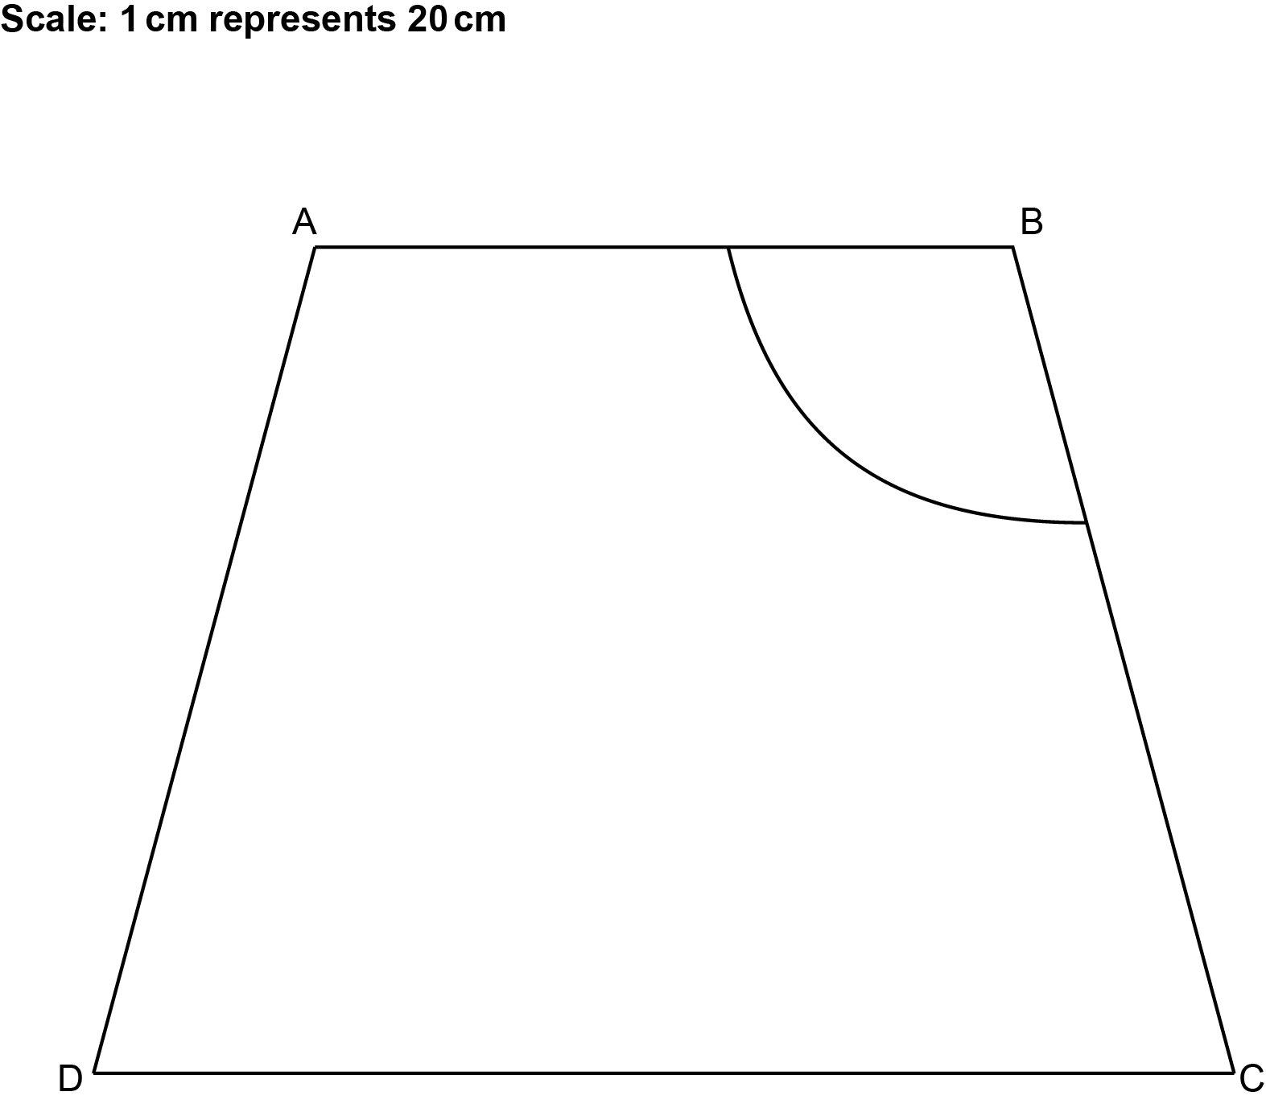

A game is played by throwing a ball into the sandpit.
Points may be scored when the ball lands in the sandpit.

- 1 point if the ball lands within 60 cm of corner B,
and
- 1 point if the ball is closer to side AB than side BC,
and
- 1 point if the ball is closer to corner C than corner D.

By completing the construction, find and shade the regions where 2 points can be scored.
Show all your construction lines. [6]

END OF QUESTION PAPER

ADDITIONAL ANSWER SPACE

If additional space is required, you should use the following lined page(s). The question number(s) must be clearly shown in the margin(s).

…………………………………………………………………………………………………………………..

…………………………………………………………………………………………………………………..

…………………………………………………………………………………………………………………..

…………………………………………………………………………………………………………………..

…………………………………………………………………………………………………………………..

…………………………………………………………………………………………………………………..

…………………………………………………………………………………………………………………..

…………………………………………………………………………………………………………………..

…………………………………………………………………………………………………………………..

…………………………………………………………………………………………………………………..

…………………………………………………………………………………………………………………..

…………………………………………………………………………………………………………………..

…………………………………………………………………………………………………………………..

…………………………………………………………………………………………………………………..

…………………………………………………………………………………………………………………..

…………………………………………………………………………………………………………………..

…………………………………………………………………………………………………………………..

…………………………………………………………………………………………………………………..

…………………………………………………………………………………………………………………..

…………………………………………………………………………………………………………………..

…………………………………………………………………………………………………………………..

…………………………………………………………………………………………………………………..

…………………………………………………………………………………………………………………..

…………………………………………………………………………………………………………………..

…………………………………………………………………………………………………………………..

…………………………………………………………………………………………………………………..

…………………………………………………………………………………………………………………..

…………………………………………………………………………………………………………………..

…………………………………………………………………………………………………………………..

…………………………………………………………………………………………………………………..

…………………………………………………………………………………………………………………..

…………………………………………………………………………………………………………………..

…………………………………………………………………………………………………………………..

…………………………………………………………………………………………………………………..

…………………………………………………………………………………………………………………..

…………………………………………………………………………………………………………………..

…………………………………………………………………………………………………………………..

…………………………………………………………………………………………………………………..

…………………………………………………………………………………………………………………..

…………………………………………………………………………………………………………………..

…………………………………………………………………………………………………………………..

…………………………………………………………………………………………………………………..

…………………………………………………………………………………………………………………..

…………………………………………………………………………………………………………………..

…………………………………………………………………………………………………………………..

…………………………………………………………………………………………………………………..

…………………………………………………………………………………………………………………..

…………………………………………………………………………………………………………………..

…………………………………………………………………………………………………………………..

Please note – web links are correct at date of publication but other websites may change over time. If you have any problems with a link you may want to navigate to that organisation’s website for a direct search.



We’d like to know your view on the resources we produce. Click ‘Like’ or ‘Dislike’ to send us an auto generated email about this resource. Add comments if you want to. Let us know how we can improve this resource or what else you need. Your email will not be used or shared for any marketing purposes.
Looking for another resource? There is now a quick and easy search tool to help find free resources for your qualification.
OCR is part of Cambridge University Press & Assessment, which is itself a department of the University of Cambridge.
For staff training purposes and as part of our quality assurance programme your call may be recorded or monitored.
Oxford Cambridge and RSA Examinations is a Company Limited by Guarantee. Registered in England. Registered office
The Triangle Building, Shaftesbury Road, Cambridge, CB2 8EA. Registered company number 3484466. OCR is an exempt charity.
OCR operates academic and vocational qualifications regulated by Ofqual, Qualifications Wales and CCEA as listed
in their qualifications registers including A Levels, GCSEs, Cambridge Technicals and Cambridge Nationals.
OCR provides resources to help you deliver our qualifications. These resources do not represent any teaching method we expect you to use. We update our resources regularly and aim to make sure content is accurate but please check the OCR website so that you have the most up to date version. OCR cannot be held responsible for any errors or omissions in these resources.
Though we make every effort to check our resources, there may be contradictions between published support and the specification, so it is important that you always use information in the latest specification. We indicate any specification changes within the document itself, change the version number and provide a summary of the changes. If you do notice a discrepancy between the specification and a resource, please contact us.
© OCR 2022 - You can copy and distribute this resource freely if you keep the OCR logo and this small print intact and you acknowledge OCR as the originator of the resource.
OCR acknowledges the use of the following content: N/A
Whether you already offer OCR qualifications, are new to OCR or are thinking about switching, you can request more information using our Expression of Interest form.
Please get in touch if you want to discuss the accessibility of resources we offer to support you in delivering our qualifications.

