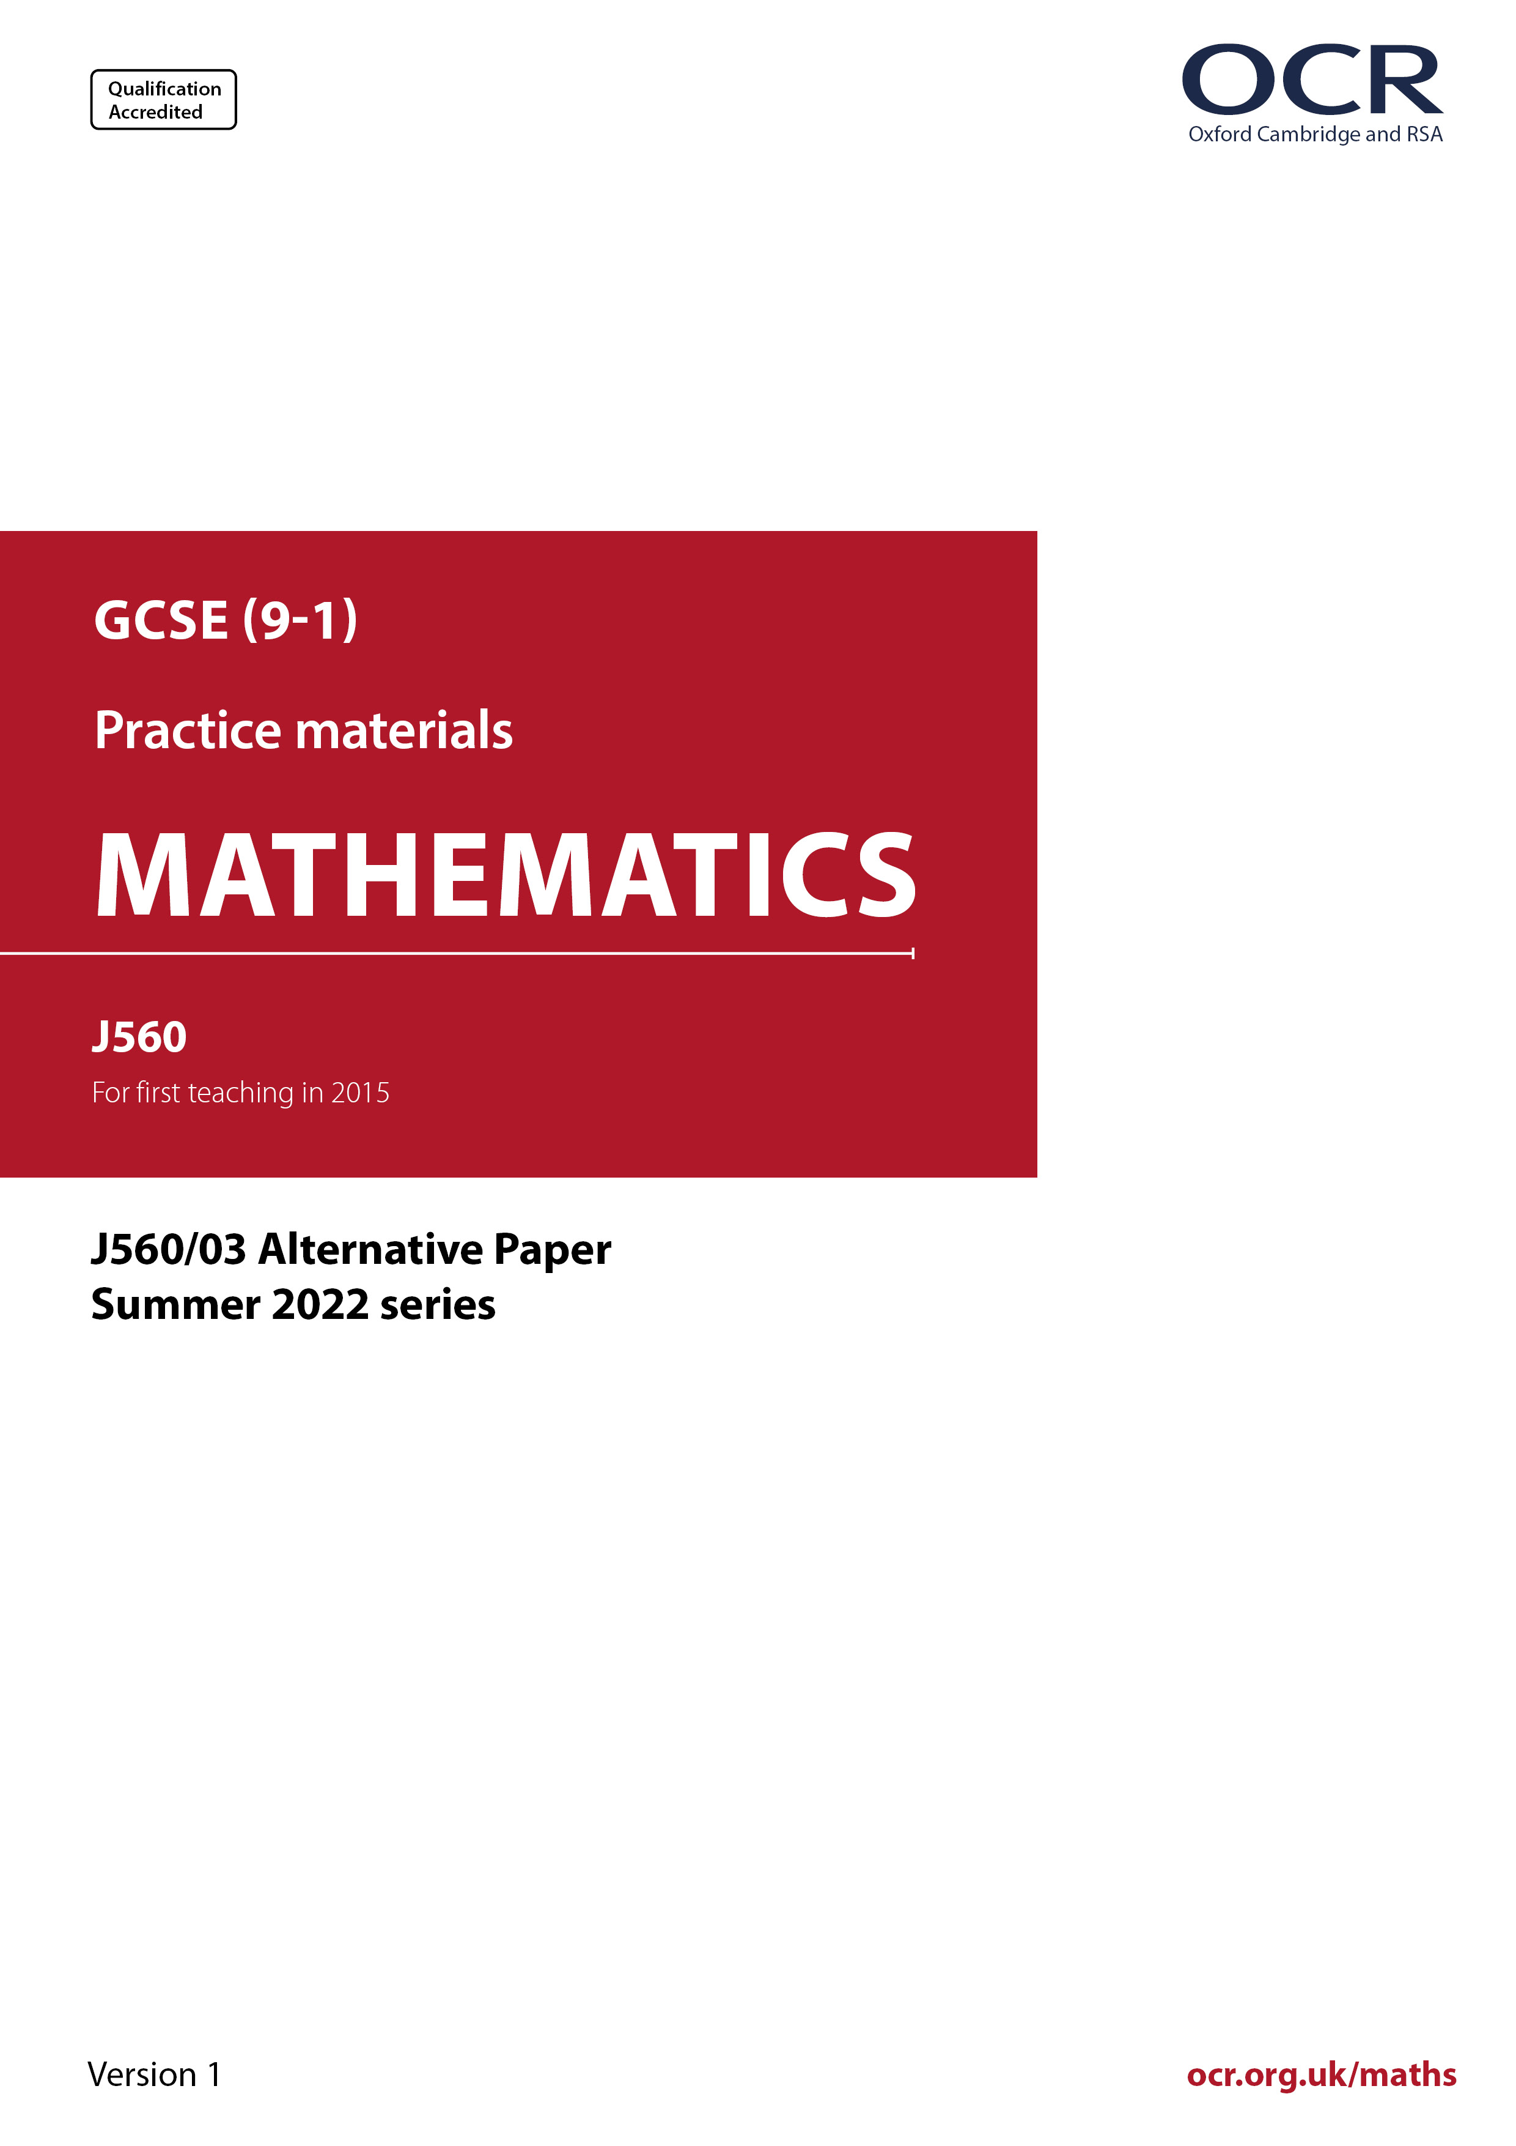
ocr.org.uk/maths

Introduction
OCR’s Alternative Papers for GCSE (9-1) Mathematics are each created by taking one of our past papers and amending the numbers/graphs/diagrams/tables/etc. in its questions.
This Alternative Paper is an amended version of one of the Summer 2022 series papers. The wording and topics assessed are essentially the same, but the responses students need to make will be different. Using both this paper and the corresponding Summer 2022 exam paper with your students at different points in the year will allow you to monitor how their learning has progressed in the time between the two papers.
Please note that when students originally sat this paper in 2022, they were given a formulae sheet. Foundation tier and Higher tier formulae sheets are published on Teach Cambridge alongside the Alternative Papers, for use with students as required.
Additional Alternative Papers and past papers are available to download from Teach Cambridge.



GCSE (9-1) Mathematics
J560/03 Paper 3 (Foundation Tier)
Alternative Paper (Summer 2022)

Time allowed: 1 hour 30 minutes

You can use:
- a scientific or graphical calculator
- geometrical instruments
- tracing paper

Name

INSTRUCTIONS
- Use black ink. You can use an HB pencil, but only for graphs and diagrams.
- Write your answer to each question in the space provided. If you need extra space, use
the lined pages at the end of this booklet. The question numbers must be clearly shown.
- Answer all the questions.
- Where appropriate, your answer should be supported with working. Marks might be
given for using a correct method, even if your answer is wrong.
- Use the π button on your calculator or take π to be 3.142 unless the question says
something different.

INFORMATION
- The total mark for this paper is 100.
- The marks for each question are shown in brackets [ ].
- This document has 24 pages.

ADVICE
- Read each question carefully before you start your answer.

Answer all the questions.

1 (a) Write down a factor of 12.

(a) [1]

(b) Write down a square number between 20 and 30.

(b) [1]

(c) Write $\frac{\text{3}}{\text{4}}$ as a decimal.

(c) [1]

(d) Find the two numbers which multiply together to make 36 and add together to make 13.

(d) and ......................... [2]

2 (a) Here is a shape.



On the diagram, draw the shape’s two lines of symmetry. [1]

(b) Here is another shape.



Write down the order of rotation symmetry of the shape.

(b) [1]

(c) (i) Sketch a quadrilateral that has exactly two lines of symmetry. [1]

(ii) Write down the mathematical name of your quadrilateral.

(c)(ii) [1]

3 Here are the first four dot patterns in a sequence.

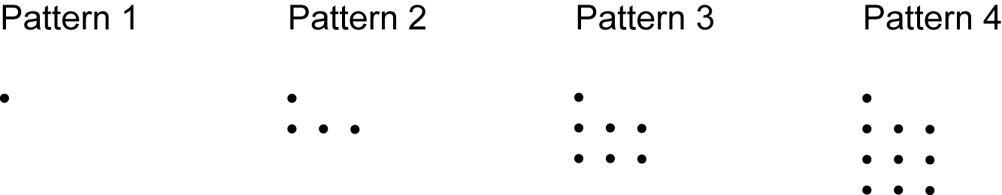

(a) Draw Pattern 5 in the sequence. [1]

(b) Without drawing, work out how many dots are in Pattern 8 of the sequence.
Explain how you worked out your answer.

................. because

[2]

4 The diagram shows a circle, centre O, and a line from O that meets the circle once.

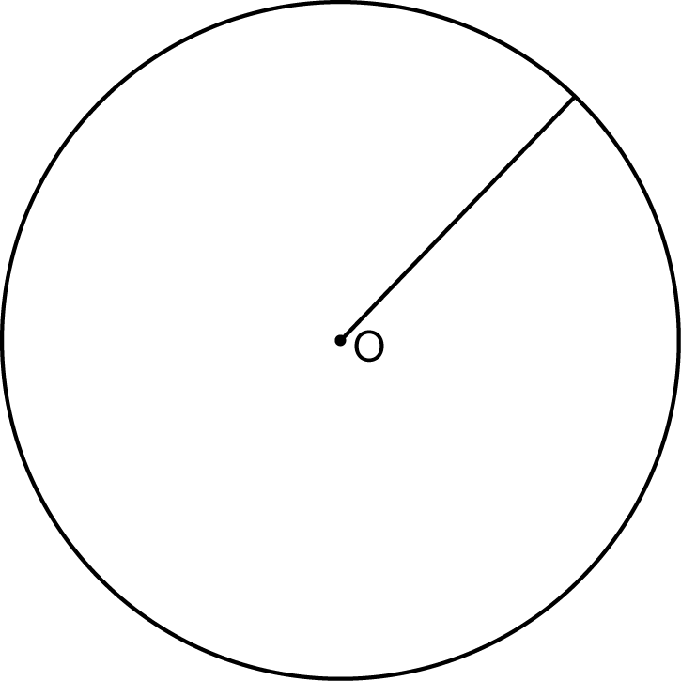

(a) On the diagram, draw a chord. [1]

(b) Write down the mathematical name of the line shown on the diagram.

(b) [1]

5 A student flips a fair coin and rolls a fair five-sided dice.
The coin can land on heads (H) or on tails (T).
The dice has sides numbered from 5 to 9.

(a) Complete this table to show all the possible outcomes.

 |  | Dice
 |  | 5 | 6 | 7 | 8 | 9
Coin | H |  |  | H7
Coin | T
[2]

(b) Find the probability of getting a tail with an even number.
Give your answer as a fraction in its simplest form.

(b) [2]

6 A test has 20 questions.

Kai attempts all of the questions.
She gets 55% of the questions correct.
Rowan gets eight of the questions wrong.

Who has the smallest number of questions wrong?
Show working to support your answer.

................ because

[3]

7 (a) In a recipe, the ratio of the amount of butter needed to the amount of flour needed is 1 : 3.
Azmi mixes 1 g of butter with 3 kg of flour.

Explain what Azmi has done wrong.

[1]

(b) Ling gives $\frac{\text{1}}{\text{5}}$ of their earnings to charity and keeps the remainder.

For Ling’s earnings, find the ratio of the amount they give to charity to the amount they keep.

Give your answer in its simplest form.

(b) : ........................... [2]

8 (a) Simplify.

3 × 4a

(a) [1]

(b) Simplify.

$\frac{\text{2}{\text{x}}^{ \text{4}}}{\text{6}\text{x}}$

(b) [2]

9 Mr Fox is paid £24.90 per hour for working on a weekday.
On a Sunday, Mr Fox is paid at 1$\frac{\text{2}}{\text{3}}$ times this hourly rate.

How much does Mr Fox earn for working 7 hours on a Sunday?

£ [3]

10 Each edge of a fair spinner is coloured either red or blue.

The scale shows the probability of the spinner landing on red and of landing on blue.

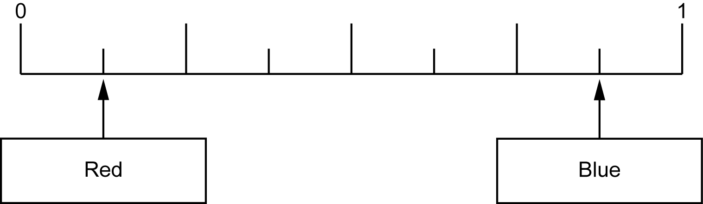

(a) Write down, as a fraction, the probability of the spinner landing on red.

(a) [1]

(b) Show that the spinner could not have 15 edges. [2]

11 Frankie invests £600 in a savings account that pays 4% simple interest per year.

Work out the total amount of interest Frankie will have earned at the end of the 6th year.

£ [2]

12 Sam goes on holiday.
They change £395 into euros (€) at a rate of £1 = €1.13.
They spend €281.29 of this money.
After the holiday, Sam changes the remaining euros back into pounds at a rate of £1 = €1.26.

Work out how many pounds Sam gets back.

£ [4]

13 In a fish tank, the fish are either blue or gold or red.

There are 38 red fish.
$\frac{\text{3}}{\text{5}}$ of the fish are blue.
$\frac{\text{1}}{\text{12}}$ of the fish are gold.

Work out the total number of fish in the fish tank.
You must show your working.

[5]

14 In a dance competition, four judges award marks to each dancer.
Each judge can award 1, 2, 3, 4 or 5 marks.

The four judges’ median mark, m, is put into the formula

S = 10m – 5

to get the dancer’s score, S.

(a) Taylor is awarded marks of 3, 1, 2 and 3.
Work out Taylor’s score.

(a) [3]

(b) Reece gets a score of 10.
Reece says

The judges must have awarded marks of 1, 1, 2 and 2
because the median is 1.5
and 1.5 × 10 – 5 = 10.

Why is Reece not correct?
Show working to support your reason.

[2]

15 In this question, all lengths are in centimetres.

The diagram shows an equilateral triangle and a square.

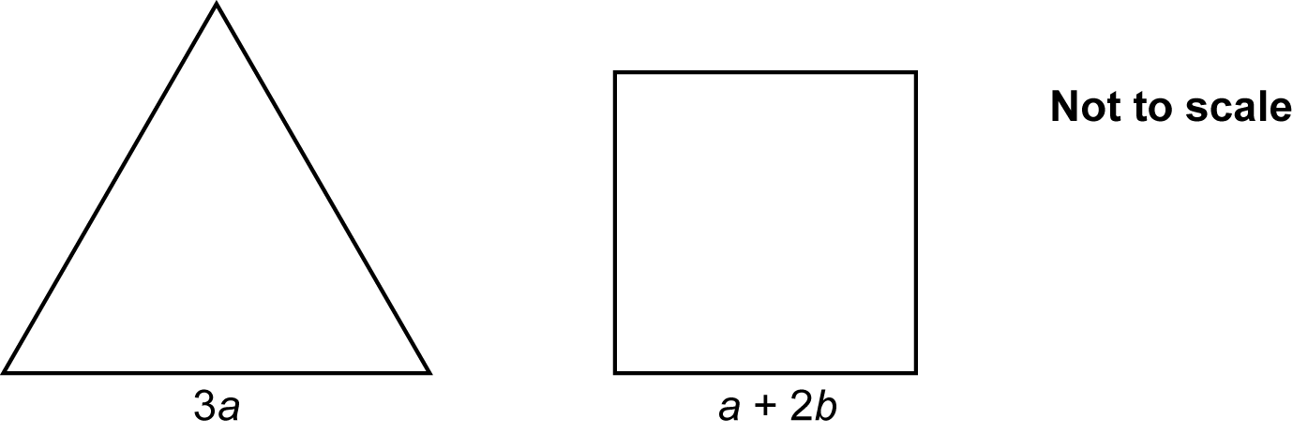

The perimeter of each shape is 72 cm.

Find the value of b.

b = [4]

16 For each statement, complete the box to show the power of 10.

(a) One thousand = 10 [1]

(b) One hundredth = 10 [1]

17 Some boxes are each in the shape of a cuboid.
The base of each box is exactly 25 cm by 45 cm.

The boxes are to be placed on their base, side by side against a wall.
If all the shorter sides or if all the longer sides are against the wall, they fit perfectly with no gaps.

Find the shortest possible length of the wall.

cm [4]

18 The mass of a stone is 675 g.
The density of the stone is 1.8 g / cm3.

(a) Work out the volume of the stone.

(a) cm3 [2]

(b) Write 1.8 g / cm3 in kg / m3.

(b) kg / m3 [1]

19 (a) Multiply out and simplify.

(x + 6)(x − 5)

(a) [2]

(b) Factorise.

x2 − 36

(b) [1]

20 Amaya travels to school by either walking, cycling or using a bus.
The probability that Amaya walks is always 0.4.
The probability that Amaya cycles is always 0.45.

(a) Complete the tree diagram for Monday and Tuesday.

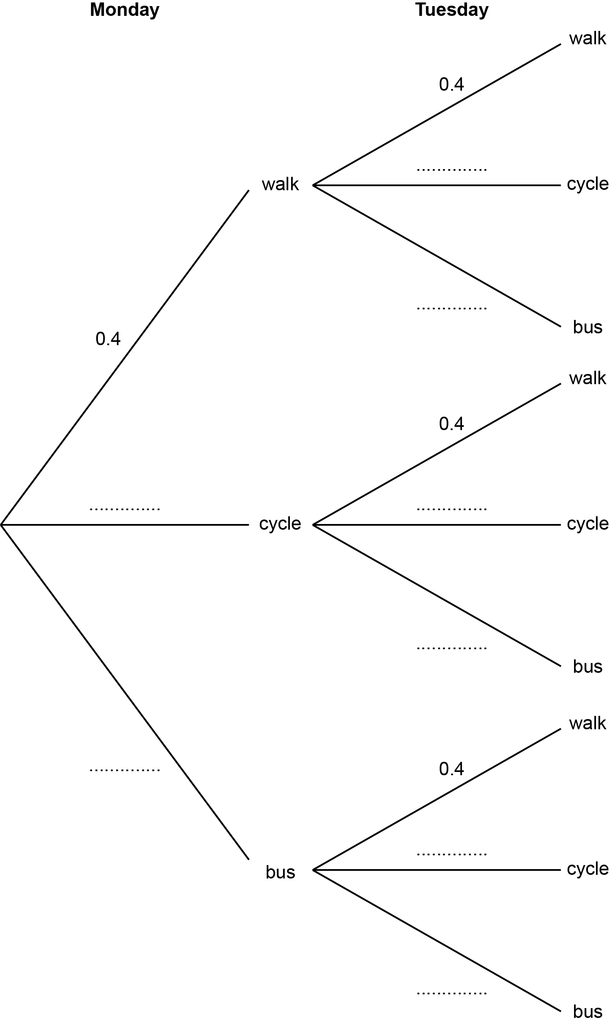
[3]

(b) Show that the probability that Amaya travels to school by the same method
on Monday and Tuesday is 0.385. [3]

21 Solve the simultaneous equations.

x + 5y = 13
x + 3y = 7

x = [3]

y = [3]

22 A sports club has 245 members.

Some of the members wish to change a club rule.
To change a club rule, at least 80% of all the members must vote ‘yes’.

At a meeting of the sports club, 5 members were absent and did not vote.
The other members voted yes : no : don’t know in the ratio 13 : 2 : 1.

Did enough members vote ‘yes’ to change the rule?
Show how you decide.

.............. because

[5]

23 This is a sketch of the graph of y = x2 – 10x + 21.

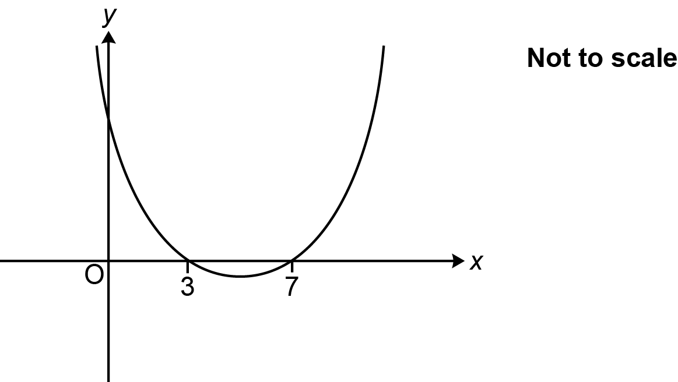

(a) Write down the value of the y-intercept.

(a) [1]

(b) Write down the x-coordinate of the turning point.

(b) [1]

24 2000 fish are released into a new lake which has no fish.
The number of fish is expected to increase by 5% each year.

(a) The table shows the expected number of fish in the lake at the end of 1 year and
at the end of 2 years.

Complete the table.
Round your answers to the nearest integer.

Years after release | 0 | 1 | 2 | 3 | 4
Expected number of fish | 2000 | 2100 | 2205
[3]

(b) Use the table to draw a suitable graph to show the expected number of fish in the lake.

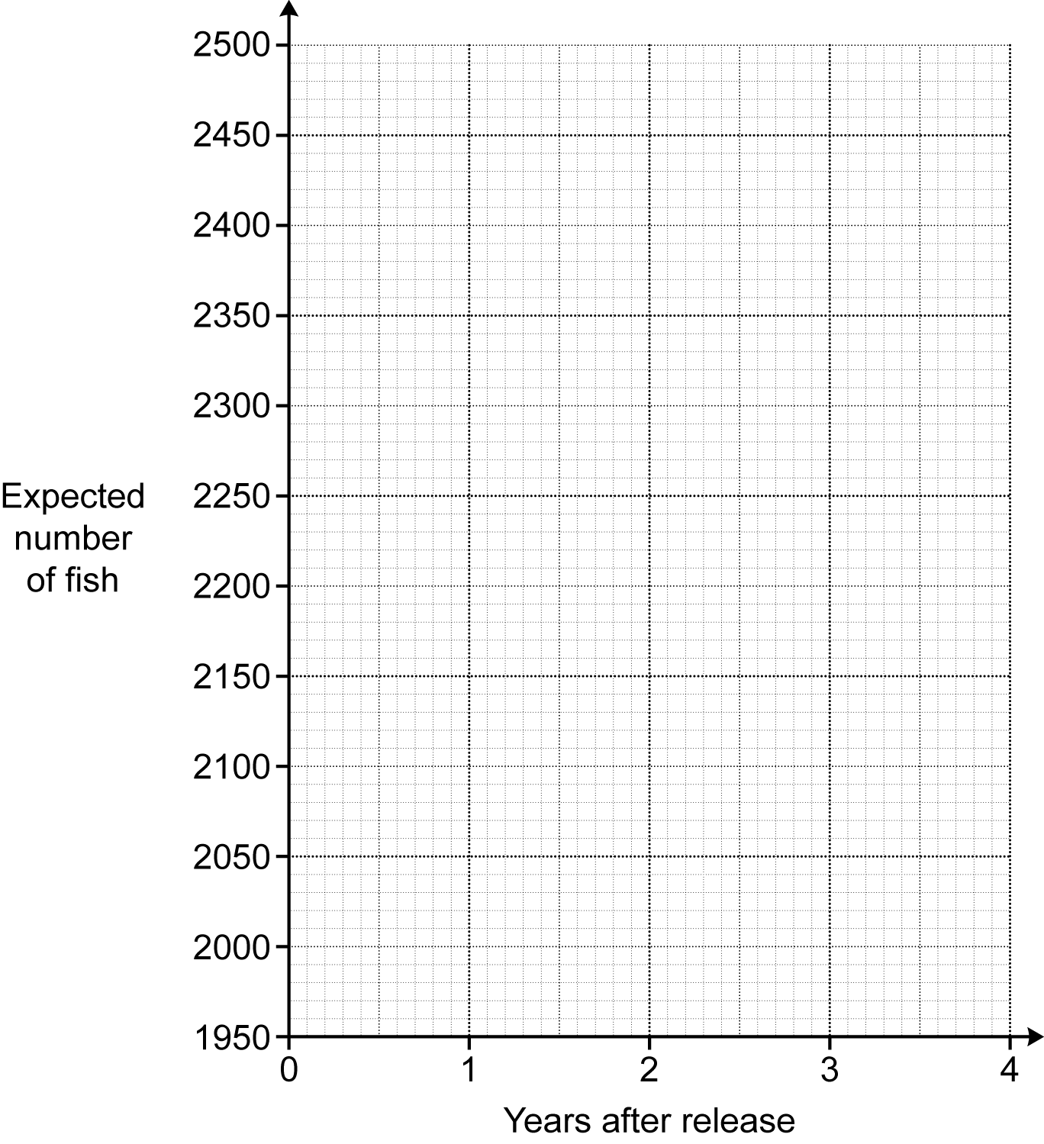
[3]

(c) A maximum of 2500 fish can live in the lake.

What effect would you expect this to have on the shape of your graph after 4 years?

[2]

TURN OVER FOR QUESTIONS 25 AND 26

25 A garage is trying to sell a car.
The price of the car is normally £24 000.

In a sale, the price of the car is reduced by 25%.
As a special offer, the sale price is then reduced by r %.
The special offer price is £14 400.

Find the value of r.
You must show your working.

r = [5]

26 The diagram shows a triangular prism and a cube.
The ends of the prism are right-angled triangles with base 24 cm and height 18 cm.
The prism is 27 cm long.

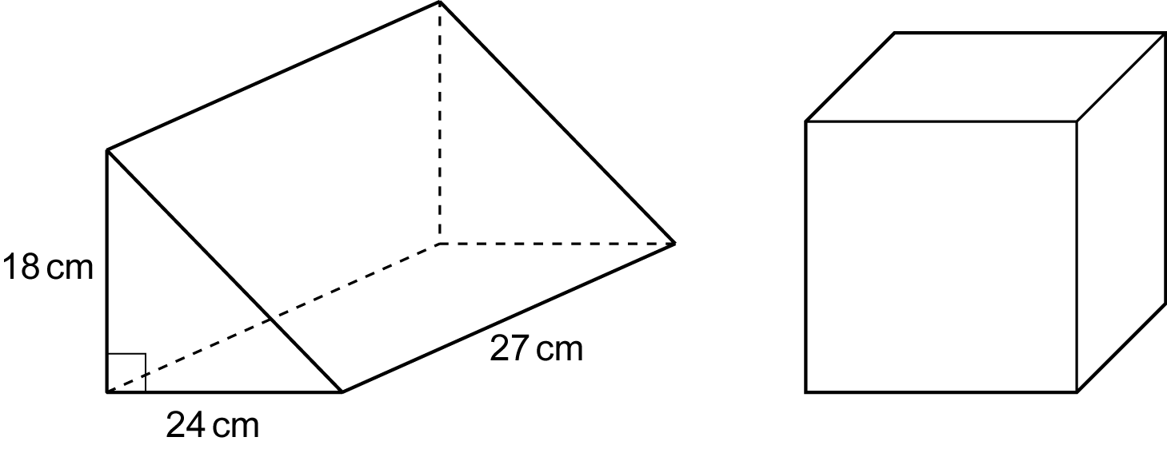
Not to scale

The volume of the prism is equal to the volume of the cube.

Find the surface area of the cube.
You must show your working.

cm2 [6]

END OF QUESTION PAPER

ADDITIONAL ANSWER SPACE

If additional space is required, you should use the following lined page(s). The question number(s) must be clearly shown in the margin(s).

.............................................................................................................................................................

.............................................................................................................................................................

.............................................................................................................................................................

.............................................................................................................................................................

.............................................................................................................................................................

.............................................................................................................................................................

.............................................................................................................................................................

.............................................................................................................................................................

.............................................................................................................................................................

.............................................................................................................................................................

.............................................................................................................................................................

.............................................................................................................................................................

.............................................................................................................................................................

.............................................................................................................................................................

.............................................................................................................................................................

.............................................................................................................................................................

.............................................................................................................................................................

.............................................................................................................................................................

.............................................................................................................................................................

.............................................................................................................................................................

Please note – web links are correct at date of publication but other websites may change over time. If you have any problems with a link you may want to navigate to that organisation’s website for a direct search.



We’d like to know your view on the resources we produce. Click ‘Like’ or ‘Dislike’ to send us an auto generated email about this resource. Add comments if you want to. Let us know how we can improve this resource or what else you need. Your email will not be used or shared for any marketing purposes.
Looking for another resource? There is now a quick and easy search tool to help find free resources for your qualification.
OCR is part of Cambridge University Press & Assessment, which is itself a department of the University of Cambridge.
For staff training purposes and as part of our quality assurance programme your call may be recorded or monitored.
Oxford Cambridge and RSA Examinations is a Company Limited by Guarantee. Registered in England. Registered office
The Triangle Building, Shaftesbury Road, Cambridge, CB2 8EA. Registered company number 3484466. OCR is an exempt charity.
OCR operates academic and vocational qualifications regulated by Ofqual, Qualifications Wales and CCEA as listed
in their qualifications registers including A Levels, GCSEs, Cambridge Technicals and Cambridge Nationals.
OCR provides resources to help you deliver our qualifications. These resources do not represent any teaching method we expect you to use. We update our resources regularly and aim to make sure content is accurate but please check the OCR website so that you have the most up to date version. OCR cannot be held responsible for any errors or omissions in these resources.
Though we make every effort to check our resources, there may be contradictions between published support and the specification, so it is important that you always use information in the latest specification. We indicate any specification changes within the document itself, change the version number and provide a summary of the changes. If you do notice a discrepancy between the specification and a resource, please contact us.
© OCR 2022 - You can copy and distribute this resource freely if you keep the OCR logo and this small print intact and you acknowledge OCR as the originator of the resource.
OCR acknowledges the use of the following content: N/A
Whether you already offer OCR qualifications, are new to OCR or are thinking about switching, you can request more information using our Expression of Interest form.
Please get in touch if you want to discuss the accessibility of resources we offer to support you in delivering our qualifications.

