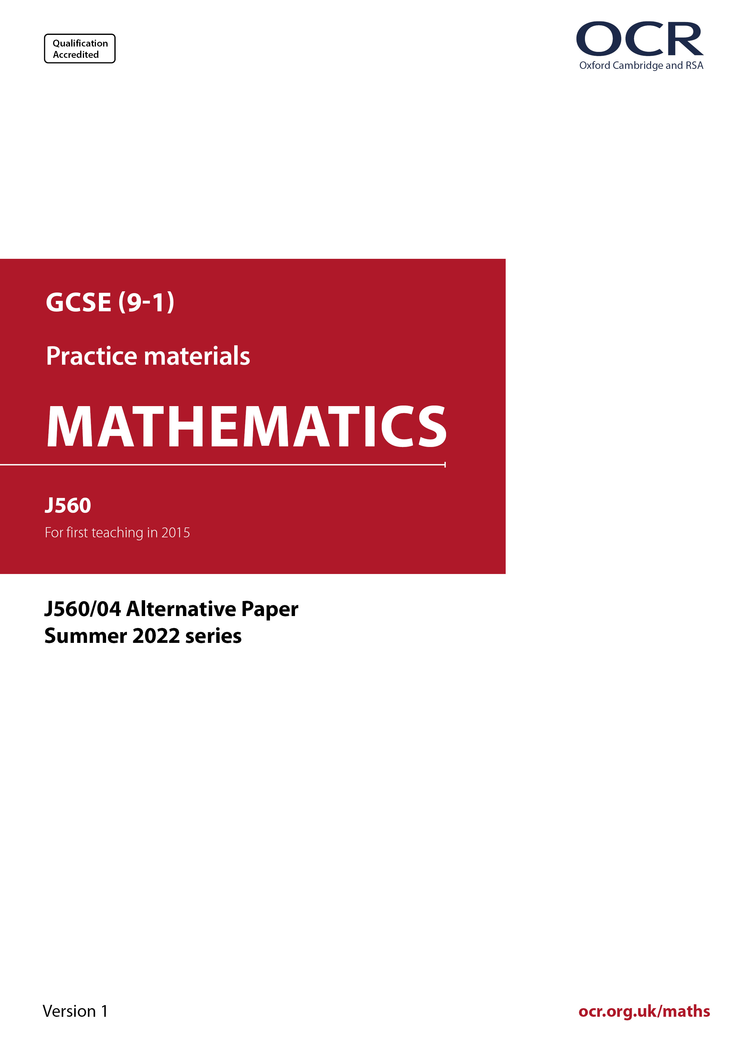
ocr.org.uk/maths

Introduction
OCR’s Alternative Papers for GCSE (9-1) Mathematics are each created by taking one of our past papers and amending the numbers/graphs/diagrams/tables/etc. in its questions.
This Alternative Paper is an amended version of one of the Summer 2022 series papers. The wording and topics assessed are essentially the same, but the responses students need to make will be different. Using both this paper and the corresponding Summer 2022 exam paper with your students at different points in the year will allow you to monitor how their learning has progressed in the time between the two papers.
Please note that when students originally sat this paper in 2022, they were given a formulae sheet. Foundation tier and Higher tier formulae sheets are published on Teach Cambridge alongside the Alternative Papers, for use with students as required.
Additional Alternative Papers and past papers are available to download from Teach Cambridge.



GCSE (9-1) Mathematics
J560/04 Paper 4 (Higher Tier)
Alternative Paper (Summer 2022)

Time allowed: 1 hour 30 minutes

You can use:
- a scientific or graphical calculator
- geometrical instruments
- tracing paper

Name

INSTRUCTIONS
- Use black ink. You can use an HB pencil, but only for graphs and diagrams.
- Write your answer to each question in the space provided. You can use extra paper if
you need to, but you must clearly show your candidate number, the centre number and
the question numbers.
- Answer all the questions.
- Where appropriate, your answer should be supported with working. Marks might be
given for using a correct method, even if your answer is wrong.
- Use the π button on your calculator or take π to be 3.142 unless the question says
something different.

INFORMATION
- The total mark for this paper is 100.
- The marks for each question are shown in brackets [ ].
- This document has 20 pages.

ADVICE
- Read each question carefully before you start your answer.

Answer all the questions.

1 (a) Write 8 450 000 in standard form.

(a) ……..…………….………………. [1]

(b) Writ e 8.04 × 10⁻² as an ordinary number.

(b) ……..…………….………………. [1]

2 Calculate.

$\frac{\text{392}}{{\text{3.5}}^{\text{2}}}-\frac{\text{6.4} \text{+ }\text{12.2}}{\text{7.4} - \text{5.8}}$

……..…………….………………. [2]

3 In January 2019, an art collector bought an antique painting.
In January 2021, they sold it for £16 854.

Assume the value of the painting increased by 6% each year.

Calculate the art collector’s profit.
You must show your working.

£ ……..…………….………………. [5]

4 Three regular polygons meet at a point.

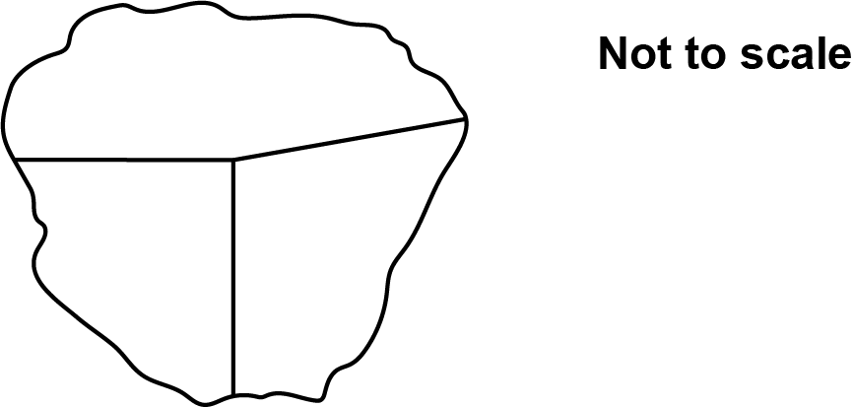

One of the polygons is a square and another is a hexagon.

Find the number of sides of the third polygon.
You must show your working.

……..…………….………………. [6]

5 The scatter diagram shows the midday temperature at 13 different heights on a mountain.

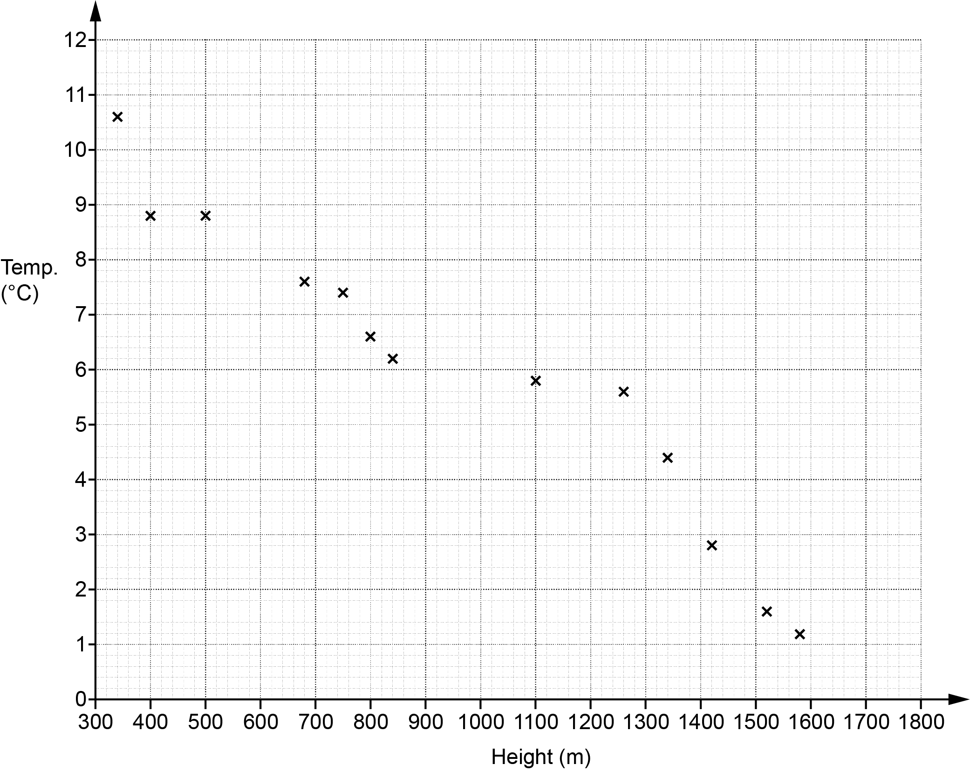

(a) The table has the information for 2 more heights.

Plot these on the scatter diagram.

Height (m) | 600 | 1200
Temperature (°C) | 8.4 | 9.2
[2]

(b) Describe the type of correlation shown in the scatter diagram.

(b) ……..…………….………………. [1]

(c) By drawing a line of best fit, estimate the temperature at 1000 m.

(c) ……..…………….………………. °C [2]

(d) Circle the outlier on the scatter diagram. [1]

(c) Explain why using the scatter diagram to estimate the temperature at 1800 m may be unreliable.

………………….…………………..…………………………………………………………………

..………………….……………………..………………………………………………………… [1]

(f) Find the fraction of the 15 temperatures which are above 8 °C.

(f) ……..…………….………………. [3]

6 A machine can dig, on average, 3 cm of tunnel each minute.
It operates 24 hours each day.

(a) Work out how many days it should take to dig a tunnel of length 4.4 km.
Give your answer to the nearest day.

(a) ……..…………….………………. days [4]

(b) The machine actually digs an average of 3.4 cm of tunnel each minute for most of the time and an average of 2.6 cm each minute for the rest of the time.

How would this affect your answer to part (a)?

.....……..………………………………………………………………………………………………

..…...…....……………...…………………..…………………………………………………….. [1]

7 The diagram shows a square-based pyramid and a sphere.

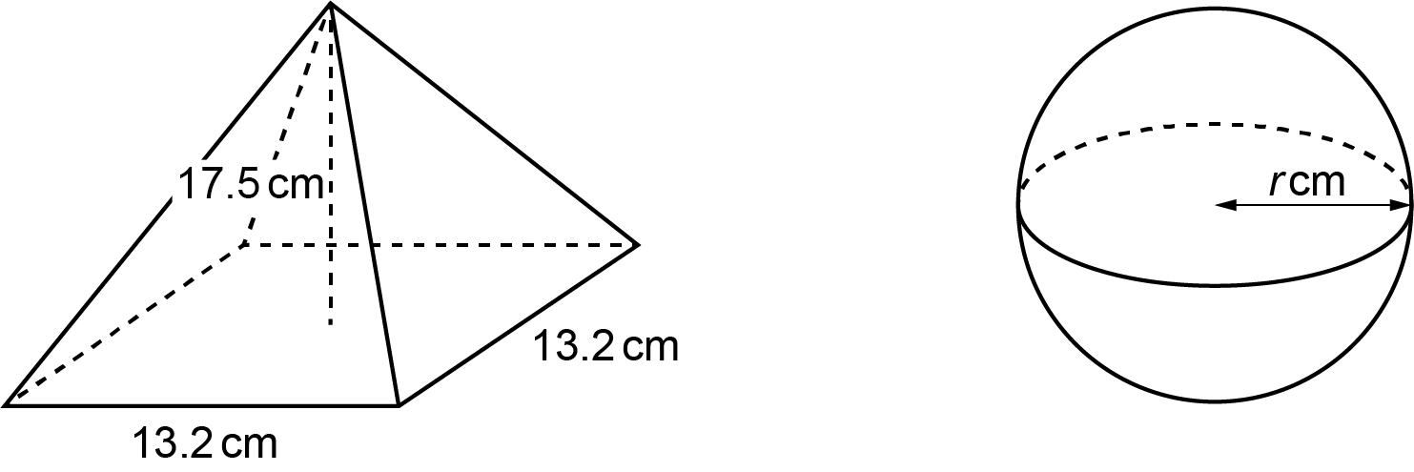

The pyramid has base length 13.2 cm and perpendicular height 17.5 cm.
The sphere has radius r cm.

The pyramid and the sphere have the same volume.

Work out the radius of the sphere.
You must show your working.

[The volume of a pyramid is × area of base × perpendicular height.

The volume V of a sphere with radius r is $\text{V} \text{=} \frac{\text{4}}{\text{3}}\text{π}{\text{r} }^{\text{3}}$.]

……..…………….………………. cm [5]

8 Here is a table of values for y = x ² + 3x – 3.

x | ⁻5 | ⁻4 | –3 | –2 | –1 | 0 | 1 | 2
y | 7 | 1 | ⁻3 | –5 | –5 | –3 | 1 | 7

(a) Draw the graph of y = x ² + 3x – 3 for –5 ⩽ x ⩽ 2.

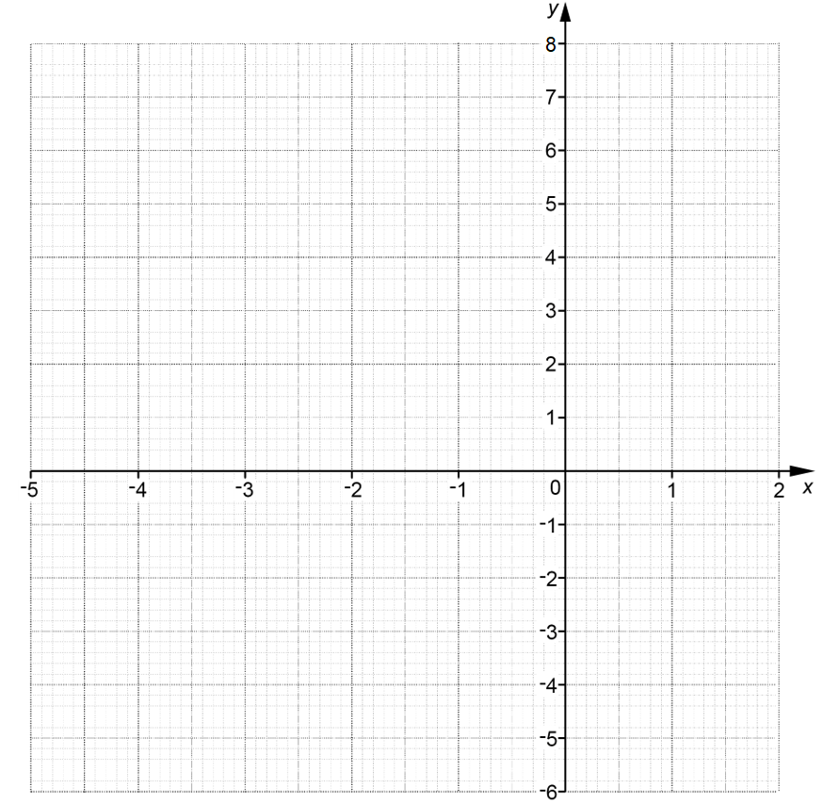
[3]

(b) Write down the equation of the line of symmetry of the graph.

(b) ……..…………….………………. [1]

(c) Use the graph to solve the equation x ² + 3x – 3 = 0.
Give your answers to 1 decimal place.

(c) x = ……..…………… or x = ……..…………… [2]

9 Points A, B and C lie on the circumference of a circle, centre O.

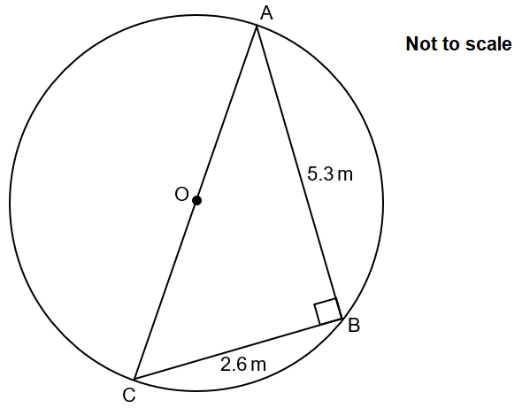

Angle ABC = 90°, AB = 5.3 m and BC = 2.6 m.

Work out the circumference of the circle.
You must show your working.

……..…………….………………. m [5]

10 A student is researching the difference in how much exercise adults and children do.
To collect their data, the student interviews the first 20 people found in the library at 2 pm on one Monday afternoon.

(a) Make three different criticisms of the student’s method of collecting data.

1..……..……………………………………………………………………………………………….

.…………....……………………………………………………………………………………..……

.…………....……………………………………………………………………………………..……

2...……..………………………………………………………………………………………………

.…………....…………………………………………………………………………………..………

.…………....……………………………………………………………………………………..……

3...……..………………………………………………………………………………………………

.…………....……………………………………………………………………………………..……

..……....…………………………………………………………………………………..…………..
[3]

(b) Here is the data collection table that the student used.

Hours exercised in a week (h) | Adult tally | Child tally
0 ⩽ h ⩽ 3
3 ⩽ h ⩽ 6
6 ⩽ h ⩽ 9
9 ⩽ h ⩽ 12
12 ⩽ h ⩽ 18

Make one criticism of the student’s table.

..……………………….………………………………………………………………………………

..……………………….………………………………………………………………………………

....………………….……………………………………………………………………………… [1]

11 Li buys fence panels that fit tightly together.

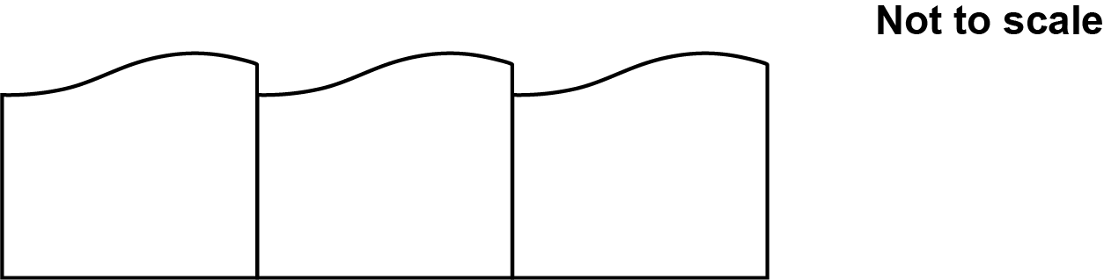

Each panel has a length of 1.8 m, correct to 1 decimal place.
Li measures the length of a garden as 32 m, correct to the nearest metre.

Work out the minimum number of panels Li should buy in order to be certain that there are enough panels for the length of the garden.
Show how you decide.

……..…………….………………. [4]

12 (a) Points A, B and C lie on the circumference of a circle.
EAF is a tangent to the circle.

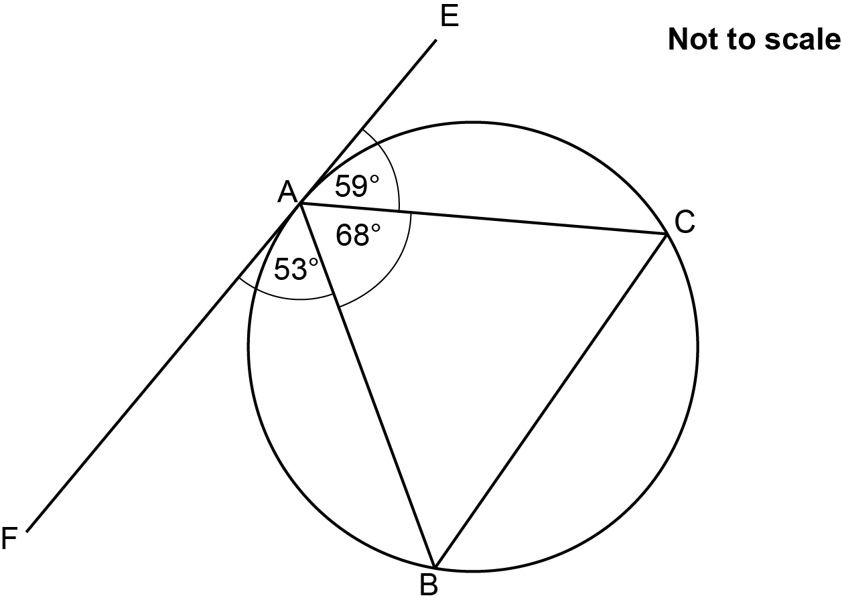

Write down the value of angle ABC giving a reason for your answer.

Angle ABC = .…………....……..° because………………………………...……………..………

.....……..………………………………………………………………………………………………

..……....………………………………………………………………………………………..…. [2]

(b) Points G, H and J lie on the circumference of a circle, centre O.

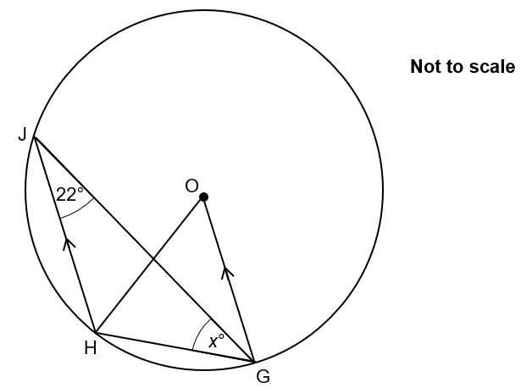

Angle HJG = 22° and angle HGJ = x°.
Lines HJ and GO are parallel.

Find the value of x.
You must show your working.

(b) x = ……..…………….………………. [5]

13 Here is a restaurant’s menu.

Starter Main Dessert
Prawn Cocktail Hunter’s Chicken Trifle
Duck Spring Rolls Beef Curry Ice Cream
Lamb Meatballs Steak Cheesecake
Leaf Salad (V) Fish Pie Chocolate Cake
Mushroom Soup (V) Lasagne Bakewell Tart
Dough Balls (V) Vegetable Hot Pot (V) Fruit Salad (V)
Macaroni Cheese (V) Cherry Pie (V)
Apple Crumble (V)

(V) denotes vegetarian

(a) A 3-course meal consists of one starter, one main and one dessert.

Work out how many different 3-course meals can be chosen from the menu.

(a) ……..…………….………………. [2]

(b) Find the fraction of the 3-course meals which are completely vegetarian (V).

(b) ……..…………….………………. [2]

14 (x + 3)(2x + a)(bx + 2) = 6x³ + 10x² – 32x – 24

Find the value of a and the value of b.

a = ……….………….……………………

b = ……..…………….………………. [2]

15 Use algebra to prove that an odd number multiplied by a number that is 4 more than that odd number always gives an answer that is an odd number. [4]

16 Reece bought a house at the start of 2017.
Reece assumes the value of the house, £V, can be predicted using the formula

V = 195 000 x 1.045^{n}

where n is the number of years after the start of 2017.

(a) Explain how you know that the value of the house is predicted to increase each year.

..……………………………….………………………………………………………………………

....…………………………….…………………………………………………………………… [1]

(b) Write down the percentage increase per year that is used in the formula.

(b) ……..…………….………………. % [1]

(c) Write down the value of the house at the start of 2017.

(c) £……..…………….………………. [1]

(d) Calculate the predicted value of the house at the start of 2021, giving your answer correct to 4 significant figures.

(d) £……..…………….………………. [2]

(e) (i) Compared with its value at the start of 2017, show that the formula predicts the
house will have doubled in value at some point during 2032. [3]

(ii) Give one reason why this may not happen.

………………….………………………………………………………………………………

....…………………..……………………………………………………………………… [1]

17 There are 15 sweets in a bag.
9 of the sweets are toffee and 6 are mint.
Jamie takes two of the sweets at random.

Work out the probability that Jamie takes one of each type of sweet.

……..…………….………………. [4]

18 The diagram shows a circle, centre the origin.

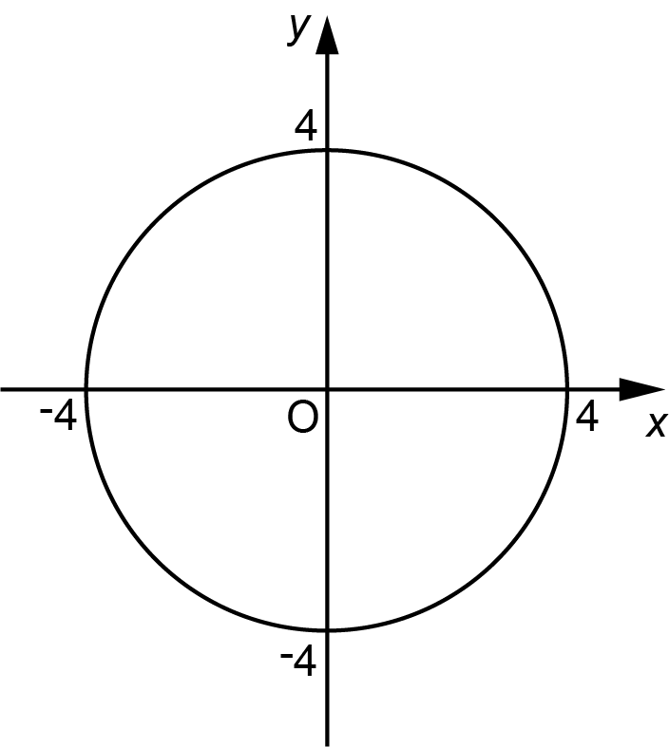

Write down the equation of the circle.

……..…………….………………. [2]

19 (a) Write as a single fraction in its simplest form.

$\frac{\text{3}}{\text{n} \text{+} \text{1}}$ – $\frac{\text{6}\text{n}}{\text{2}{\text{n}}^{\text{2}} \text{+} \text{3}}$

(a) ……..…………….………………. [4]

(b) Simplify.

$\frac{{\text{x}}^{ \text{2}}\text{ + 2}\text{x} - \text{15}}{\text{3}{\text{x}}^{ \text{2}} - \text{5}\text{x} - \text{12}}$

(b) ……..…………….………………. [5]

TURN OVER FOR QUESTION 20

20 Solve this inequality.

x² – 5x – 14 < 0

Give your answer using set notation.
You must show your working.

……..…………….………………. [5]

END OF QUESTION PAPER

Please note – web links are correct at date of publication but other websites may change over time. If you have any problems with a link you may want to navigate to that organisation’s website for a direct search.



We’d like to know your view on the resources we produce. Click ‘Like’ or ‘Dislike’ to send us an auto generated email about this resource. Add comments if you want to. Let us know how we can improve this resource or what else you need. Your email will not be used or shared for any marketing purposes.
Looking for another resource? There is now a quick and easy search tool to help find free resources for your qualification.
OCR is part of Cambridge University Press & Assessment, which is itself a department of the University of Cambridge.
For staff training purposes and as part of our quality assurance programme your call may be recorded or monitored.
Oxford Cambridge and RSA Examinations is a Company Limited by Guarantee. Registered in England. Registered office
The Triangle Building, Shaftesbury Road, Cambridge, CB2 8EA. Registered company number 3484466. OCR is an exempt charity.
OCR operates academic and vocational qualifications regulated by Ofqual, Qualifications Wales and CCEA as listed
in their qualifications registers including A Levels, GCSEs, Cambridge Technicals and Cambridge Nationals.
OCR provides resources to help you deliver our qualifications. These resources do not represent any teaching method we expect you to use. We update our resources regularly and aim to make sure content is accurate but please check the OCR website so that you have the most up to date version. OCR cannot be held responsible for any errors or omissions in these resources.
Though we make every effort to check our resources, there may be contradictions between published support and the specification, so it is important that you always use information in the latest specification. We indicate any specification changes within the document itself, change the version number and provide a summary of the changes. If you do notice a discrepancy between the specification and a resource, please contact us.
© OCR 2022 - You can copy and distribute this resource freely if you keep the OCR logo and this small print intact and you acknowledge OCR as the originator of the resource.
OCR acknowledges the use of the following content: N/A
Whether you already offer OCR qualifications, are new to OCR or are thinking about switching, you can request more information using our Expression of Interest form.
Please get in touch if you want to discuss the accessibility of resources we offer to support you in delivering our qualifications.

