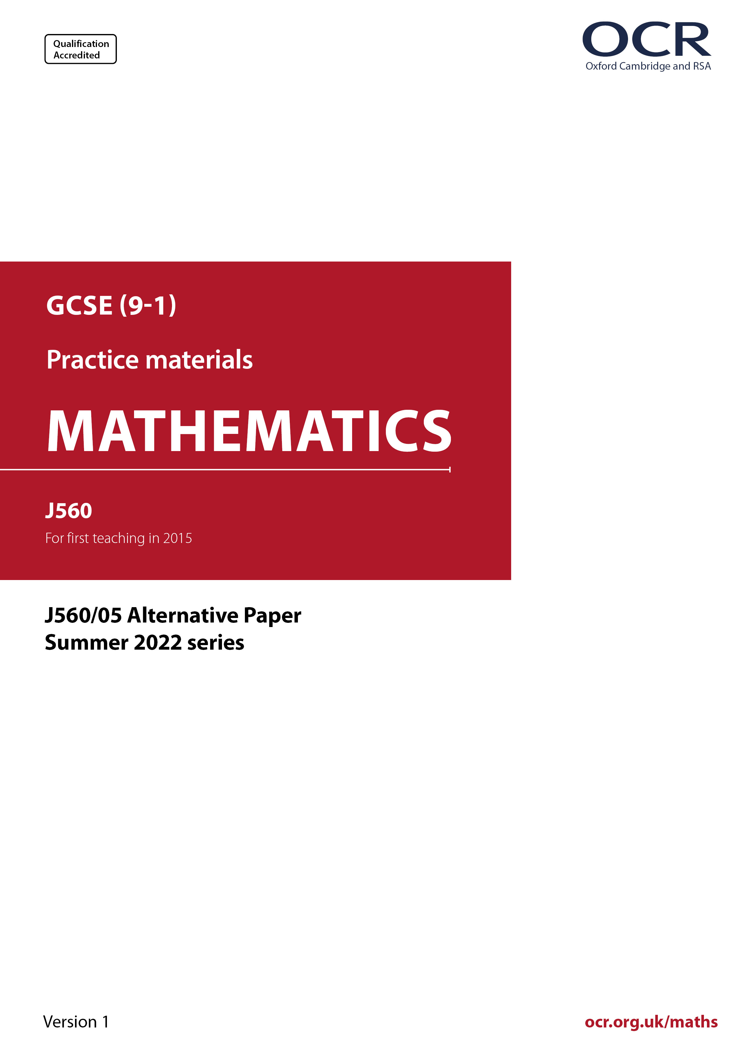
r
ocr.org.uk/maths

Introduction
OCR’s Alternative Papers for GCSE (9-1) Mathematics are each created by taking one of our past papers and amending the numbers/graphs/diagrams/tables/etc. in its questions.
This Alternative Paper is an amended version of one of the Summer 2022 series papers. The wording and topics assessed are essentially the same, but the responses students need to make will be different. Using both this paper and the corresponding Summer 2022 exam paper with your students at different points in the year will allow you to monitor how their learning has progressed in the time between the two papers.
Please note that when students originally sat this paper in 2022, they were given a formulae sheet. Foundation tier and Higher tier formulae sheets are published on Teach Cambridge alongside the Alternative Papers, for use with students as required.
Additional Alternative Papers and past papers are available to download from Teach Cambridge.



GCSE (9-1) Mathematics
J560/05 Paper 5 (Higher Tier)
Alternative Paper (Summer 2022)

Time allowed: 1 hour 30 minutes


You must have:
- geometrical instruments
- tracing paper
Do not use:
- a calculator

Name

INSTRUCTIONS
- Use black ink. You can use an HB pencil, but only for graphs and diagrams.
- Write your answer to each question in the space provided. If you need extra space, use
the lined pages at the end of this booklet. The question numbers must be clearly shown.
- Answer all the questions.
- Where appropriate, your answer should be supported with working. Marks might be
given for using a correct method, even if your answer is wrong.

INFORMATION
- The total mark for this paper is 100.
- The marks for each question are shown in brackets [ ].
- This document has 24 pages.

ADVICE
- Read each question carefully before you start your answer.

Answer all the questions.

1 Two pupils are given data that shows the estimated number of games console users in a country from 2016 to 2020.

(a) Morgan creates this pie chart to show the data.

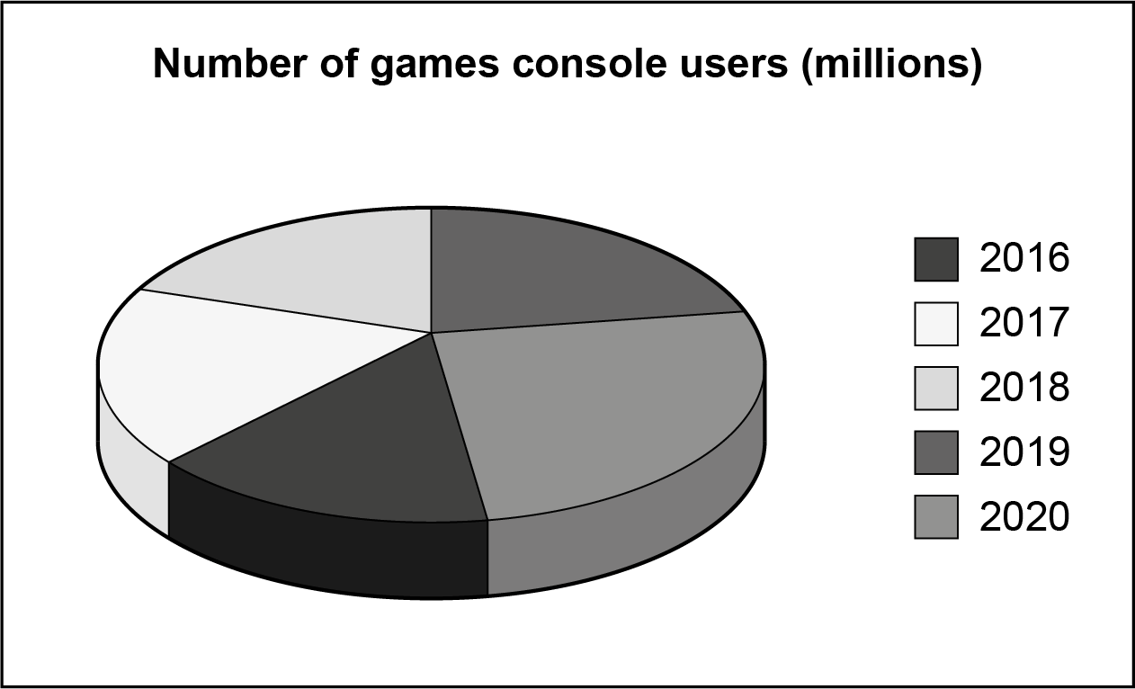

Write down two reasons why Morgan’s pie chart is not suitable to represent the data.

1..……..………………………………………………………………………………………….…

.…………....…………………………………………………………………………………..……

2...……..……………………………………………………………………………………………

....……....……………………………..………………………………………………………….[2]

(b) Charlie creates this line graph to show the same data.

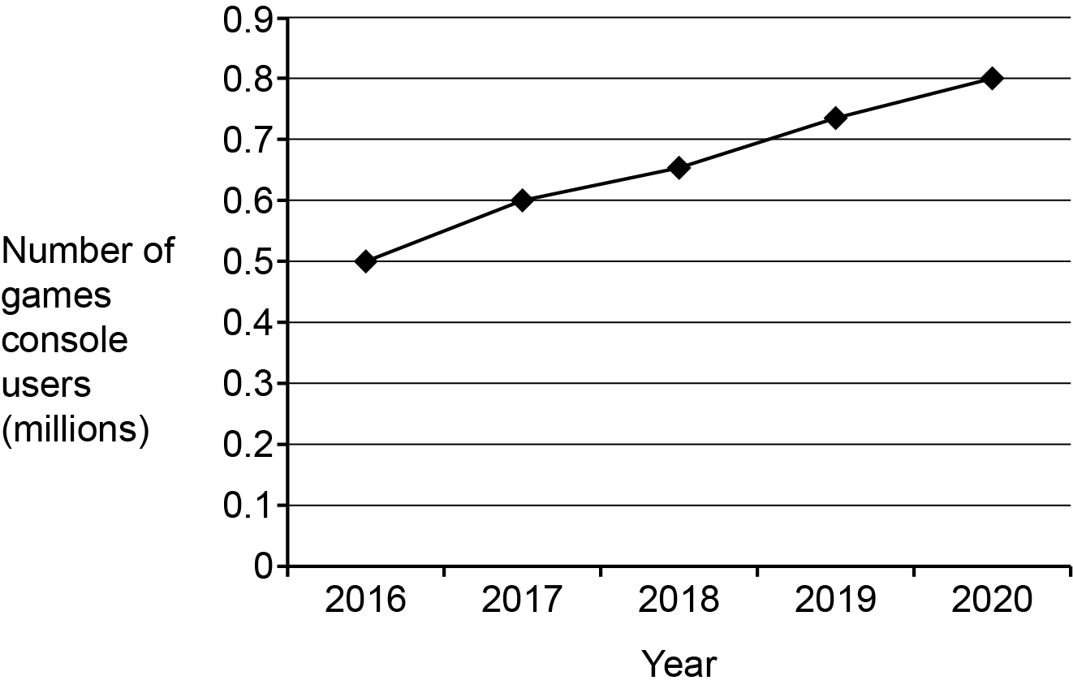

Work out the percentage increase in the number of games console users from 2016
to 2020.

(b) ……..…………….………………. % [4]

2 The scale diagram below shows the position of two ships, R and S.

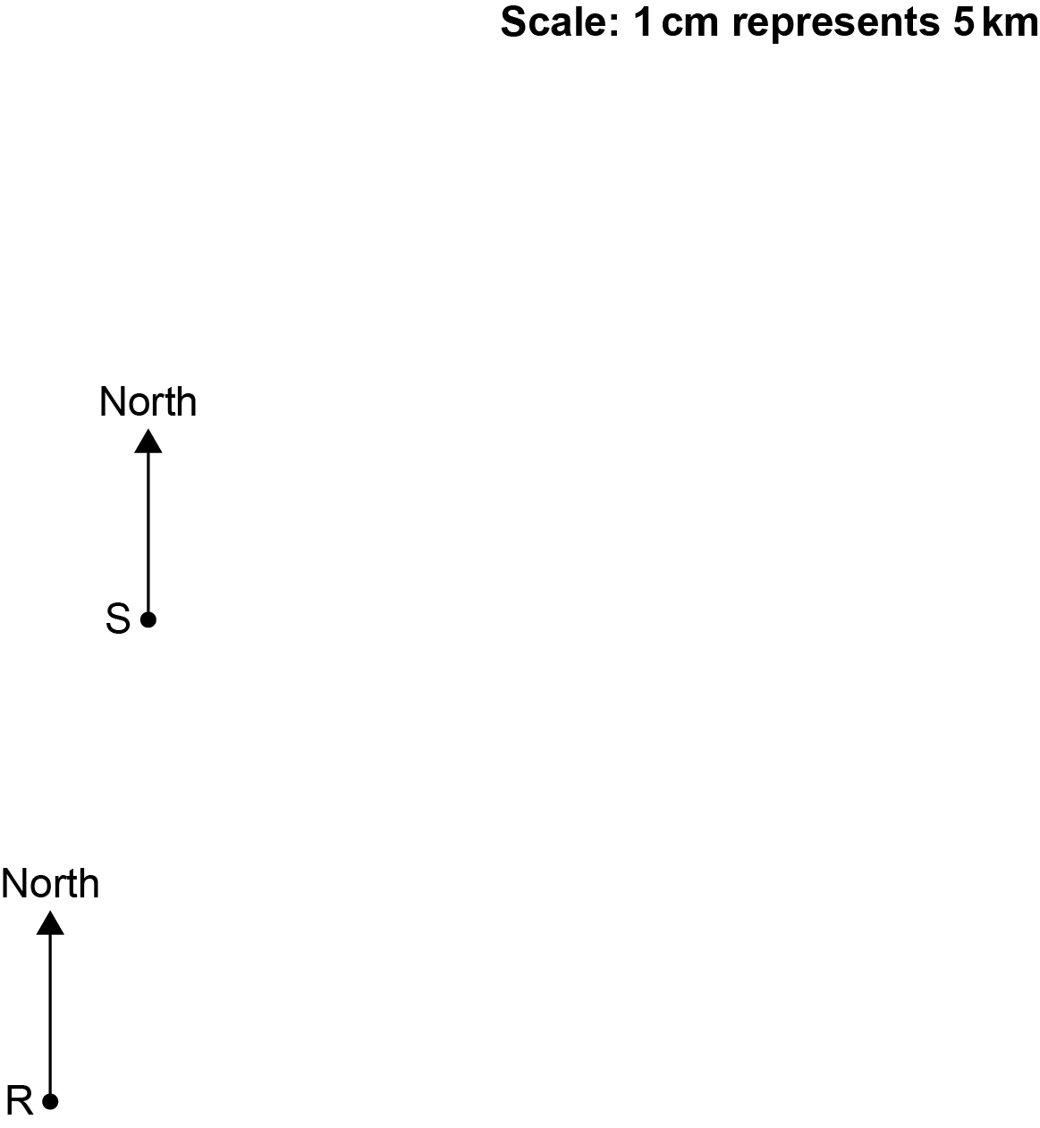

The bearing of a lighthouse from ship R is 078°.
The bearing of the lighthouse from ship S is 114°.

Use construction to find the distance from ship R to the lighthouse.
Give your answer to the nearest 0.1 km.

……..…………….………………. km [4]

3 The population of Brazil is 2.1 x 10⁸.
The population of Nepal is 3 x 10⁷.

(a) Explain why it is appropriate to use standard form for these numbers.

..……………………………………………………………………………………………………

..……………………………………………………………………………………………………

....……………………………………………………………………………………………… [1]

(b) Use the given information to work out how many more people live in Brazil than in Nepal.
Give your answer in standard form.

(b) ……..…………….………………. [3]

4 (a) Complete this statement by writing the missing power in the box.

576 = 2 × 6² [1]

(b) Use your answer to part (a) to find the value of $\sqrt{\text{576}}$.

(b) ……..…………….………………. [2]

5 Recipes measure small quantities in teaspoons and tablespoons.
3 teaspoons is equivalent to 1 tablespoon.

A curry recipe uses $\frac{\text{2}}{\text{3}}$ of a teaspoon of salt and 3 tablespoons of lemon juice.

The ratio of salt to lemon juice used in the recipe can be written in the form 1 : n.

Find the value of n.

n = ……..…………….………………. [3]

6 Darcy is playing a game.
They can score 0, 2 or 4 points on each turn.
They record their scores for 100 turns.
The table shows the relative frequencies of their scores.

Score | 0 | 2 | 4
Relative frequency | 0.06 | 0.72

(a) Complete the table. [2]

(b) Darcy says

I scored less than 230 points in total in my 100 turns.

Is Darcy correct?
Show how you decide.

....……………………………………………………………………………………………… [4]

7 (a) A car accelerates at 6.08 m/s² for 10.3 seconds from an initial velocity of 4.92 m/s.

Amaya rounds each value to 1 significant figure.
Amaya uses the rounded values and the formula

to estimate the distance travelled in the 10.3 seconds.
Amaya’s answer is 250 metres.

Using Amaya’s method, show that their answer is wrong. [4]

(b) Rearrange this formula to make x the subject.

$\text{E} \text{=} \frac{\text{1}}{\text{2}}\text{k}{\text{x}}^{\text{2}}$

(b) ……..…………….………………. [3]

8 A bag only contains green counters, red counters and blue counters.

- The probability of picking a green counter is $\frac{\text{3}}{\text{5}}$.
- There are six blue counters.
- The probability of picking a red counter is four times as likely as picking a blue counter.

Work out the total number of counters in the bag.
You must show your working.

……..…………….………………. [5]

9 The diagram shows the scale drawing of a sandpit, ABCD.
It also shows the arc of all points in the sandpit that are 60 cm from corner B.

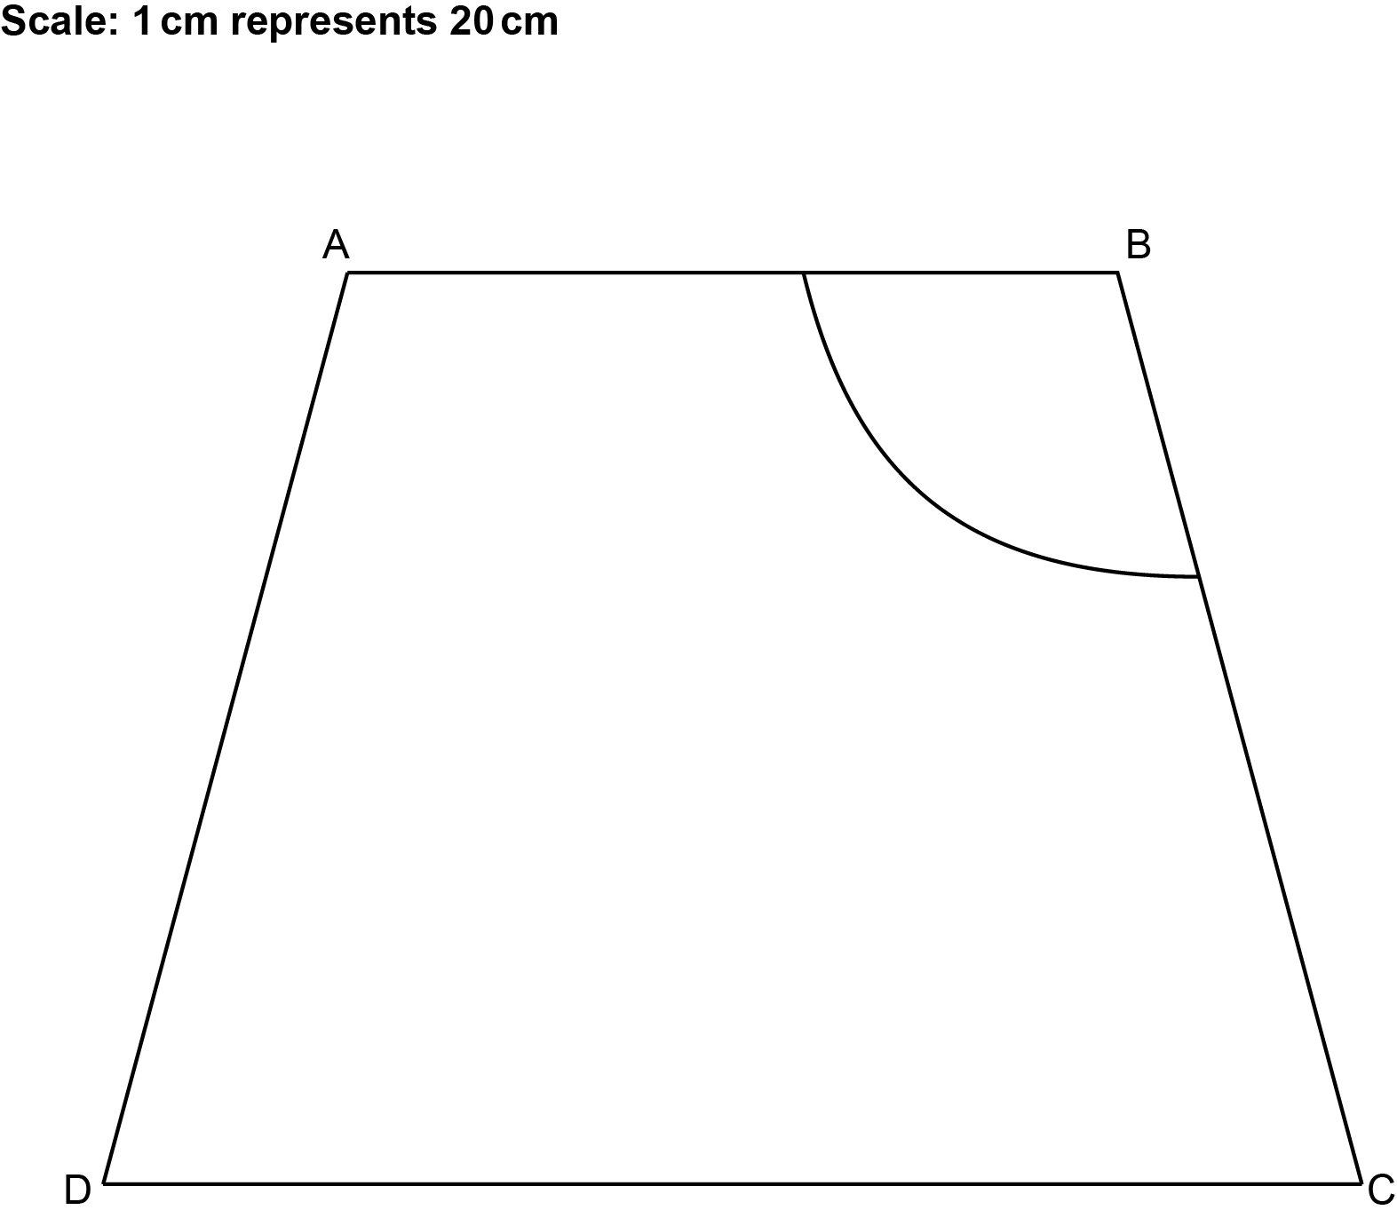

A game is played by throwing a ball into the sandpit.
Points may be scored when the ball lands in the sandpit.

- 1 point if the ball lands within 60 cm of corner B,
and
- 1 point if the ball is closer to side AB than side BC,
and
- 1 point if the ball is closer to corner C than corner D.

By completing the construction, find and shade the regions where 2 points can be scored.
Show all your construction lines. [6]

10 (a) Enlarge triangle A with scale factor 2.5 and centre of enlargement (–8, –4).

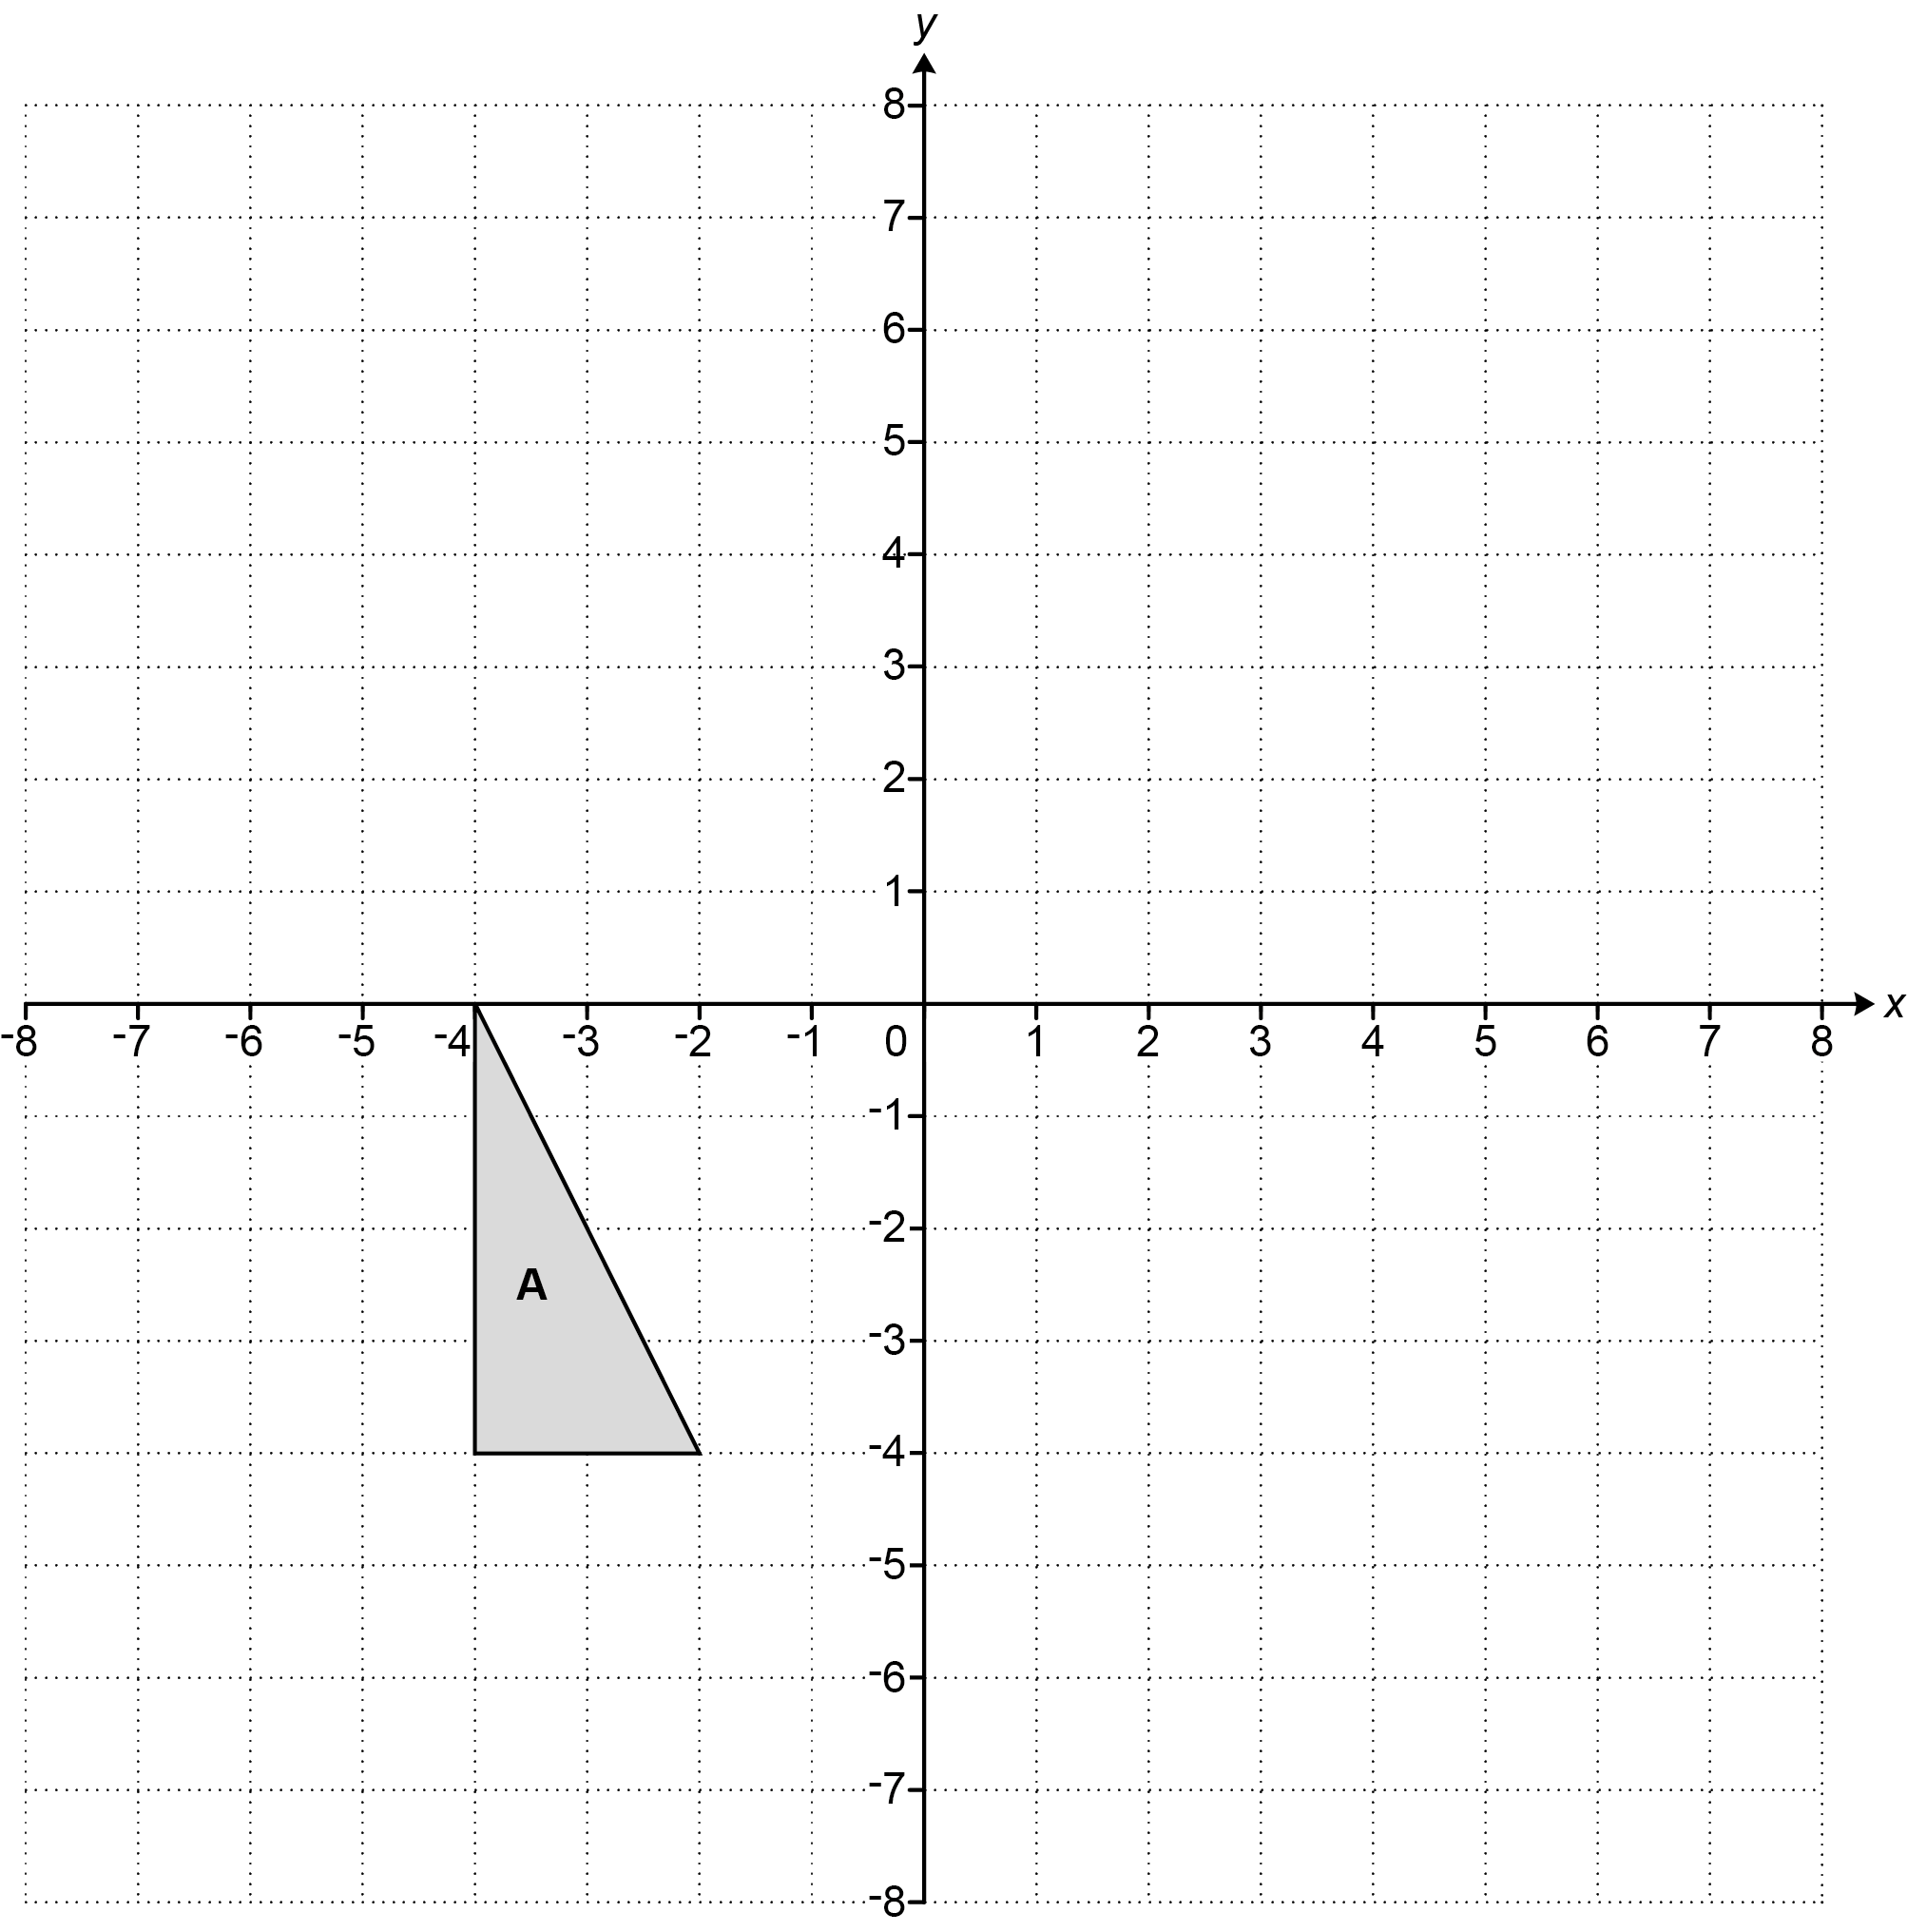

[3]

(b) Triangle A and triangle B are shown on the coordinate grid below.

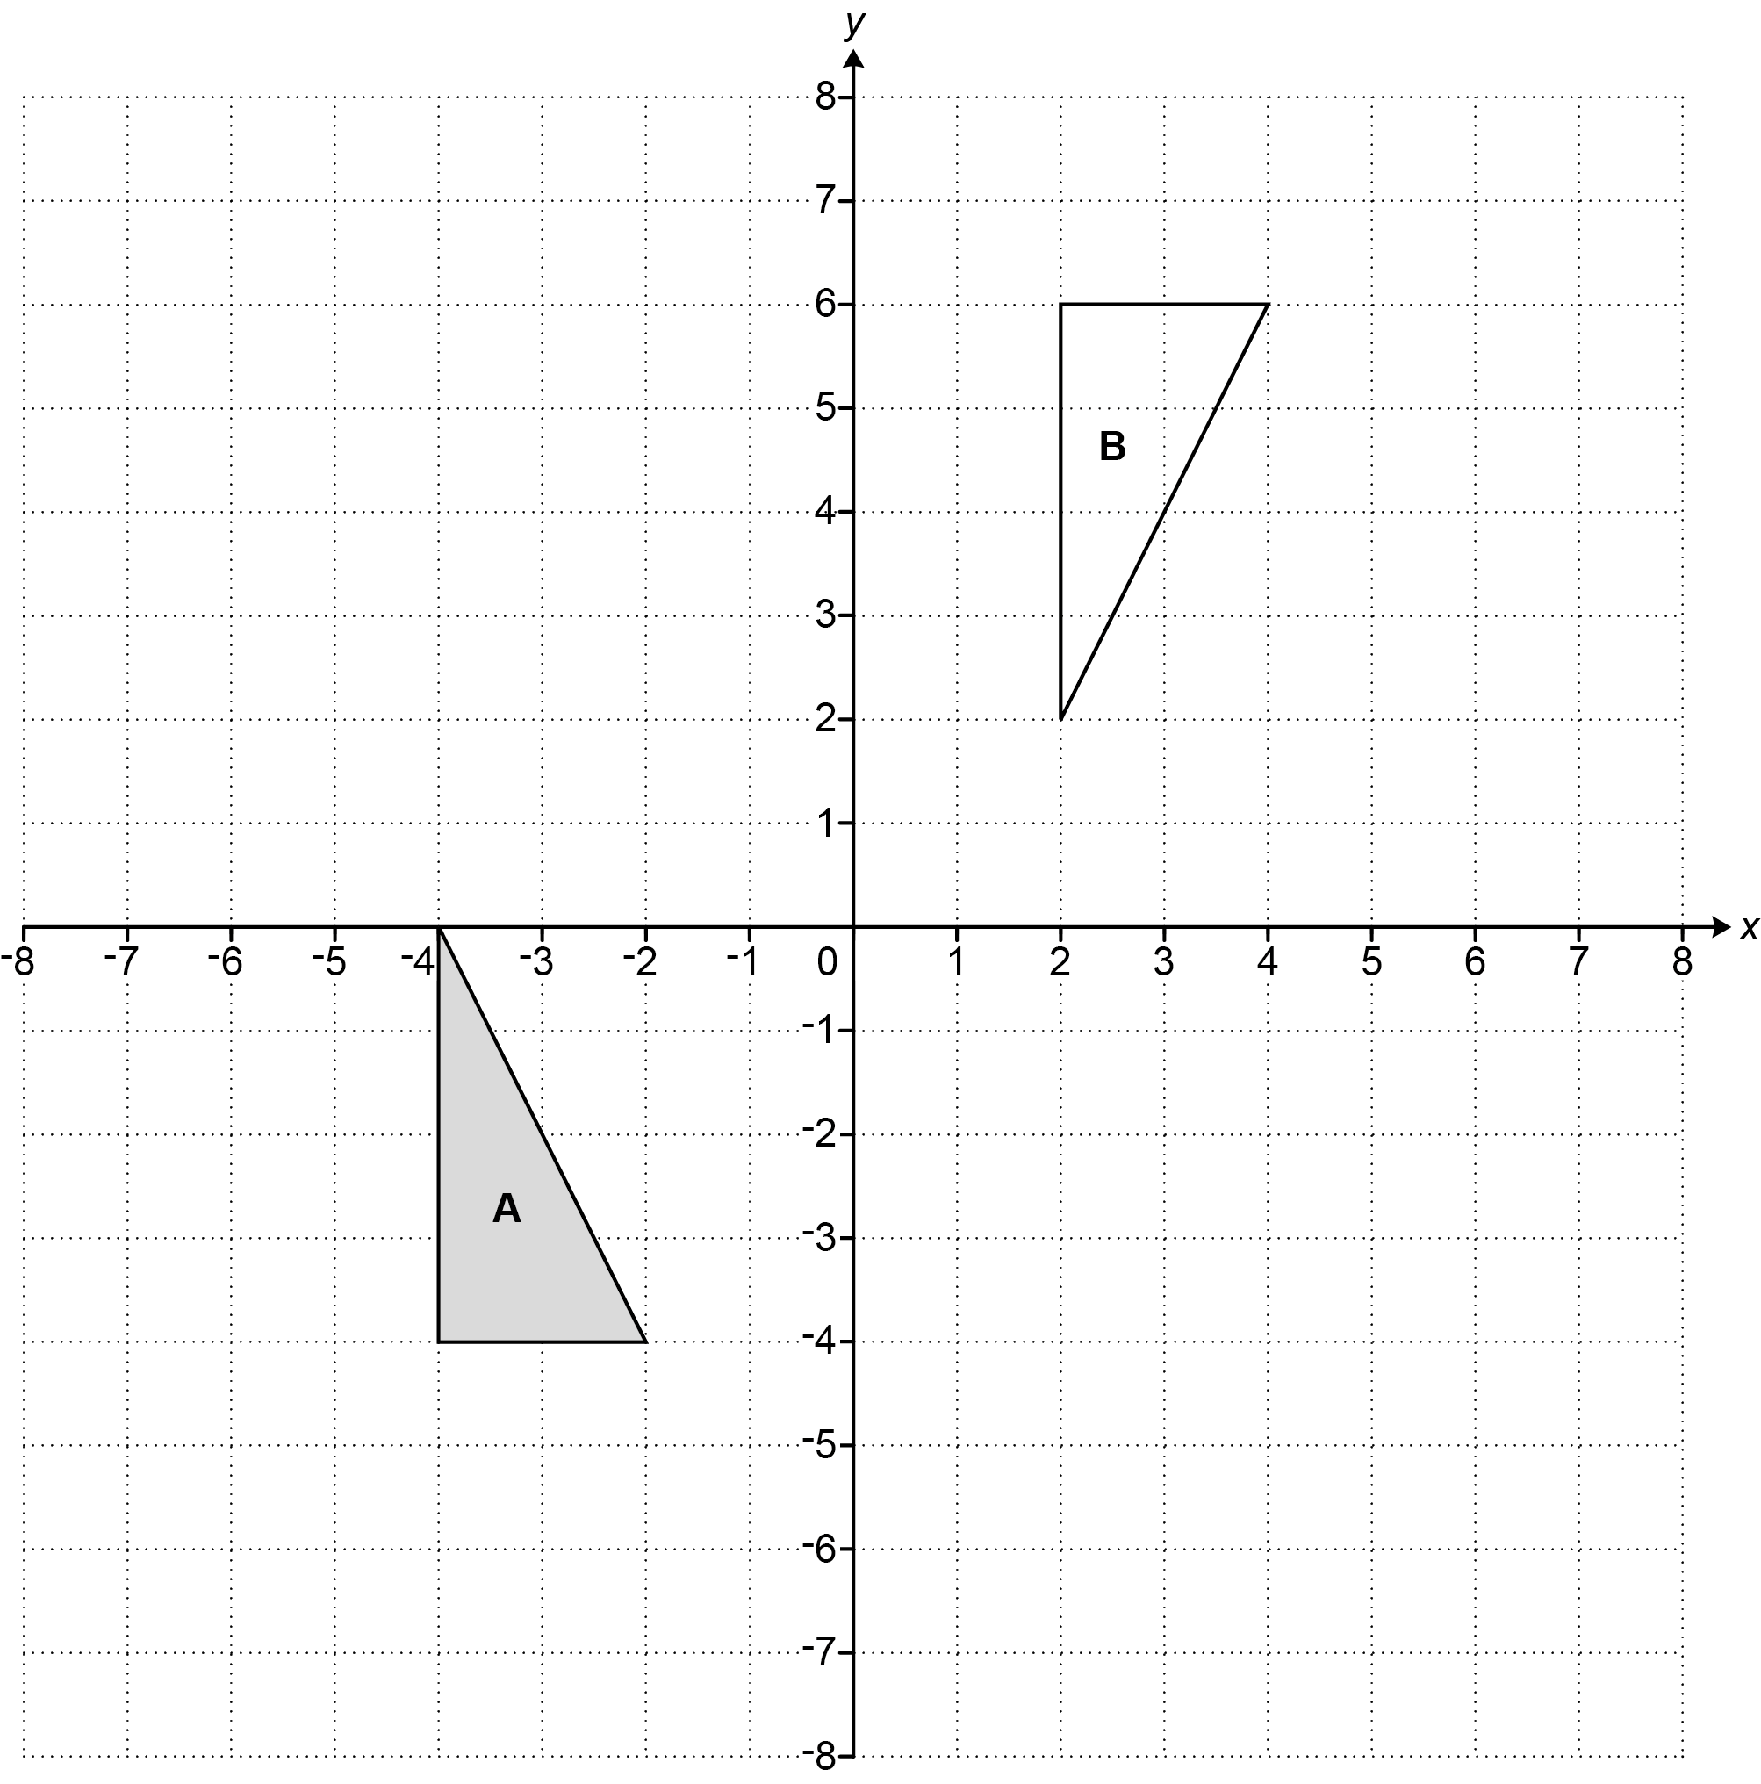

Triangle A is mapped onto triangle B using a combination of two transformations:

- a transformation T, followed by
- a reflection in the y-axis.

Describe fully transformation T.

..……………………………………………………………………………………………………

....……………………………………………………………………………………………… [4]

11 y is inversely proportional to x².
y = 8 when x = 3.

Find the value of y when x = 12.

y = ……..…………….………………. [3]

12 Harper goes for a training run.
The graph shows their speed as they run.

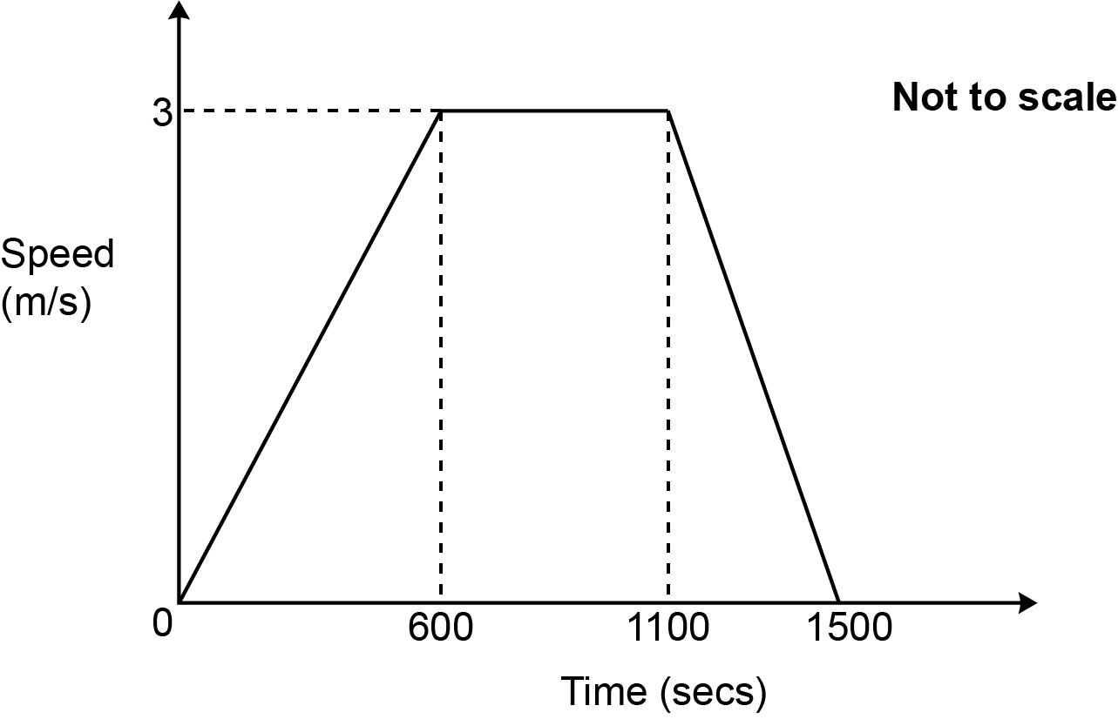

(a) Write down Harper’s acceleration between 600 seconds and 1100 seconds.

(a) ……..…………….………………. m/s² [1]

(b) Work out Harper’s average speed, in m/s, during the 1500 seconds.
You must show your working.

(b) ……..…………….………………. m/s [5]

13 The graph of y = x² + 8x – 4 is shown below.
The roots of the equation x² + 8x – 4 = 0 are at p and q.

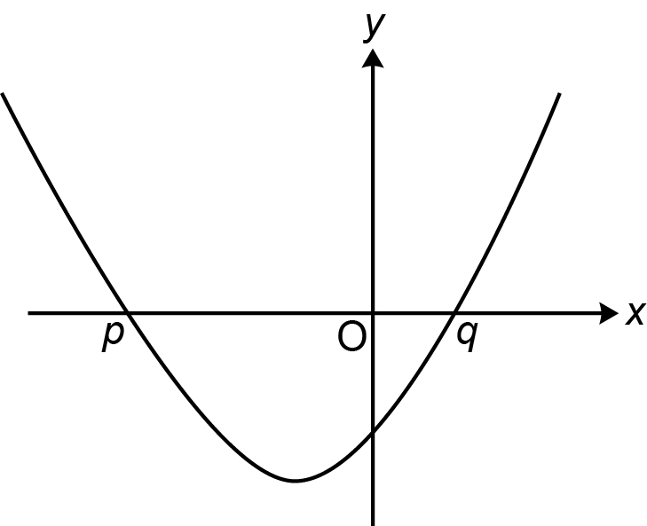

(a) (i) Calculate y when x = 1.

(a) (i) y =……..…………….………………. [1]

(ii) Without solving the equation, explain why q must lie between 0 and 1.

………………………………………………………………………………………………

..………………………………………………………………………………………… [2]

(iii) Explain why using a method of iteration is not the most appropriate way of finding a solution to this equation.

………………………………………………………………………………………………

..………………………………………………………………………………………… [1]

(b) The exact value of q is $\frac{-\text{8} + \sqrt{\text{80}}}{\text{2}}$.

Write $\frac{-\text{8} + \sqrt{\text{80}}}{\text{2}}$ in the form $\text{a}+\text{b}\sqrt{\text{c}}$.

(b) ……..…………….………………. [3]

14 In a survey about snacks, some students were asked whether they like popcorn (P) and whether they like fruit (F).

The Venn diagram shows some of the results.
x students liked both types of snacks.

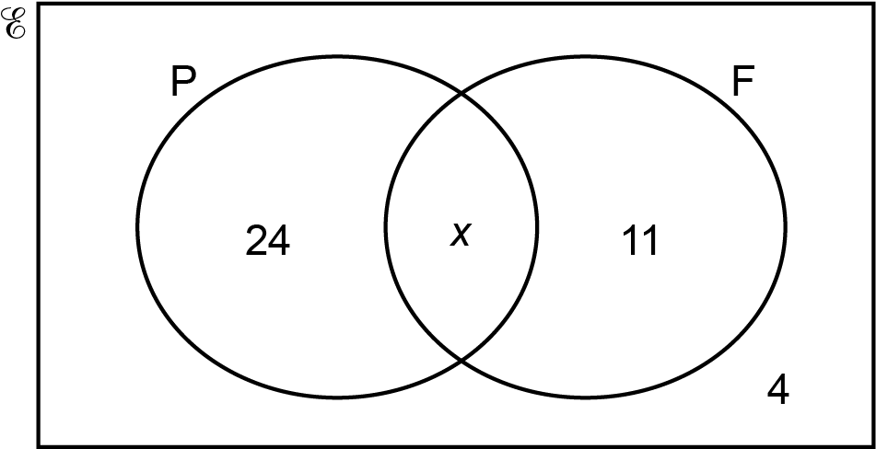

- The ratio of the number of students who liked popcorn to the number who liked fruit was
3 : 2.

Work out the total number of students in the survey.

(a) ……..…………….………………. [4]

(b) One of the students is selected at random.

Find the probability that this student does not like fruit given that they like popcorn.

(b) ……..…………….………………. [2]

15 ABCD is a square of side length 1 cm.
AC is the diagonal of the square.

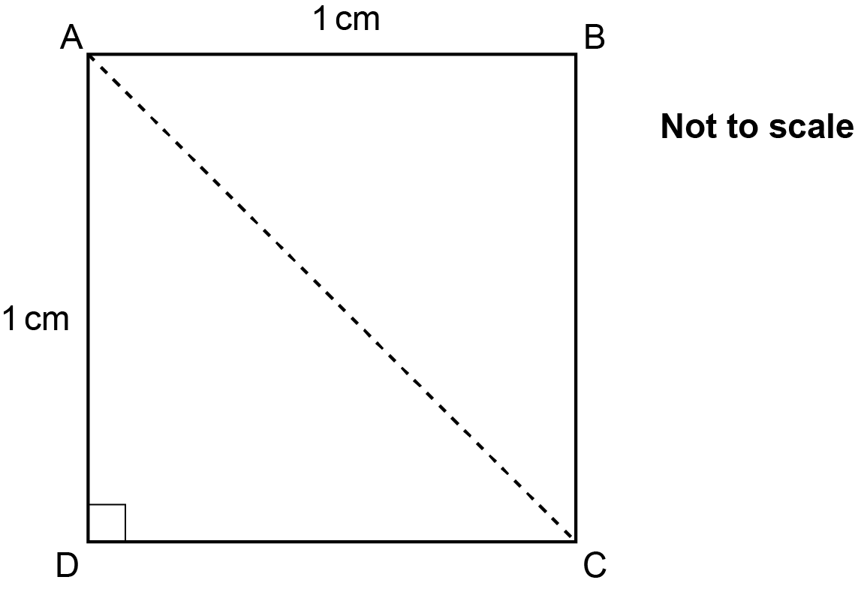

Using this diagram, show that cos 45° = $\frac{\text{1}}{\sqrt{\text{2}}}$ [4]

16 Work out $\text{0.}\overset{\text{•}}{\text{3}}×\text{0.}\overset{\text{•}}{\text{8}}\overset{\text{•}}{\text{1}}$ giving your answer as a fraction in its simplest form.
You must show your working.

……..…………….………………. [5]

17 Li is making some wooden frames.
Li has a strip of wood 1.8 m long and 1.5 cm wide.

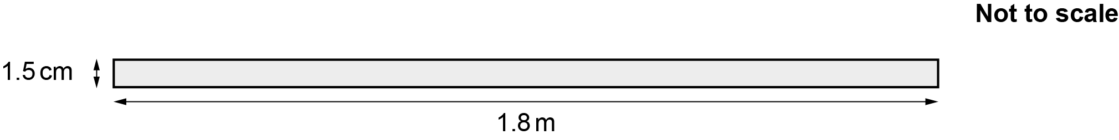

Each frame will be made from four pieces of wood cut from the strip to form a rectangle, as shown below.

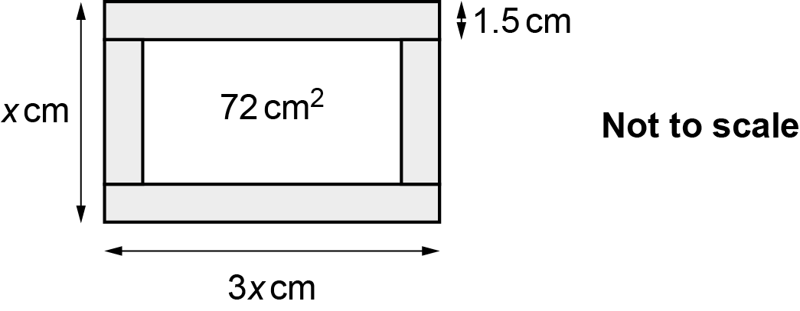

The width of each frame is x cm.
The length of each frame is 3x cm.
The area enclosed by each frame must be 72 cm².

Work out the maximum number of frames Li can make from the 1.8 m length of wood.
You must show your working.

……..…………….………………. [6]

18 The diagram shows a shaded shape made by removing sector OAB from sector OCD.
Both sectors have an angle of 45°.
The radius, OA, of the smaller sector is r cm.
The ratio of radius OA to radius OC is 3 : 4.

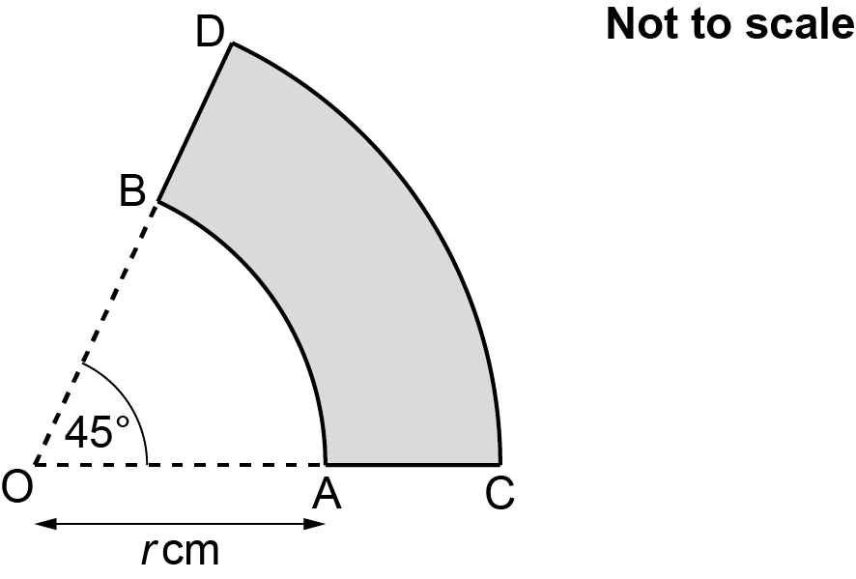

Work out, in terms of π and r, the total length of arc AB and arc CD.
Give your answer in its simplest form.
You must show your working.

……..…………….………………. cm [5]

19 The graph below shows a circle with centre (0, 0) and equation x ² + y ² = 100.

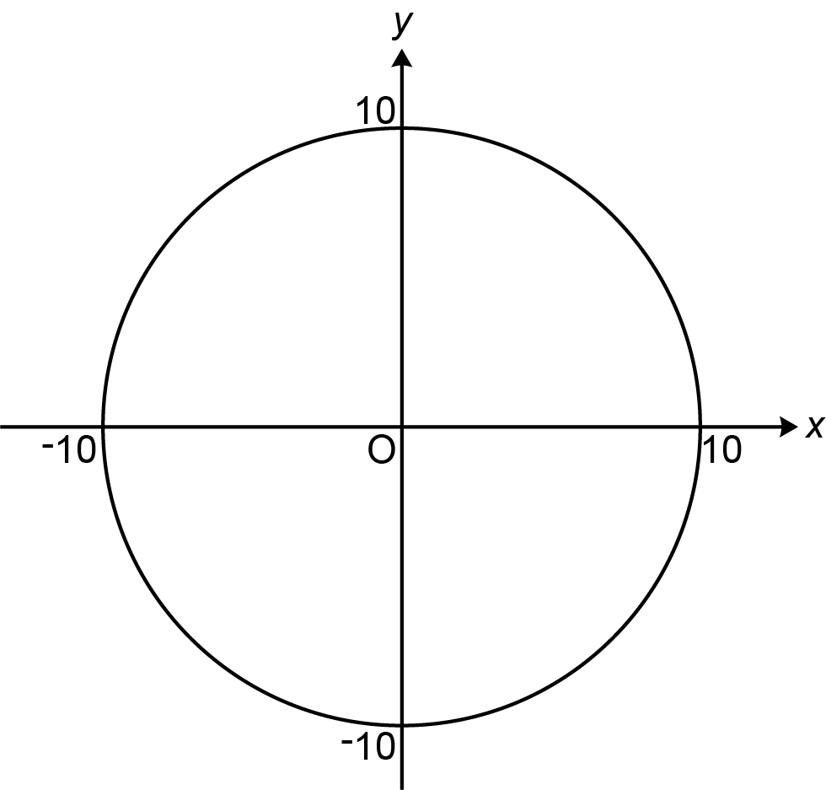

- Show that the point (8, –6) lies on the circumference of the circle. [2]

(b) Find the equation of the tangent to the circle at the point (8, –6), giving your answer in the form y = mx + c.

(b) ……..…………….………………. [5]

END OF QUESTION PAPER

ADDITIONAL ANSWER SPACE

If additional space is required, you should use the following lined page(s). The question number(s) must be clearly shown in the margin(s).

…………………………………………………………………………………………………………………..

…………………………………………………………………………………………………………………..

…………………………………………………………………………………………………………………..

…………………………………………………………………………………………………………………..

…………………………………………………………………………………………………………………..

…………………………………………………………………………………………………………………..

…………………………………………………………………………………………………………………..

…………………………………………………………………………………………………………………..

…………………………………………………………………………………………………………………..

…………………………………………………………………………………………………………………..

…………………………………………………………………………………………………………………..

…………………………………………………………………………………………………………………..

…………………………………………………………………………………………………………………..

…………………………………………………………………………………………………………………..

…………………………………………………………………………………………………………………..

…………………………………………………………………………………………………………………..

…………………………………………………………………………………………………………………..

…………………………………………………………………………………………………………………..

…………………………………………………………………………………………………………………..

…………………………………………………………………………………………………………………..

…………………………………………………………………………………………………………………..

…………………………………………………………………………………………………………………..

…………………………………………………………………………………………………………………..

Please note – web links are correct at date of publication but other websites may change over time. If you have any problems with a link you may want to navigate to that organisation’s website for a direct search.



We’d like to know your view on the resources we produce. Click ‘Like’ or ‘Dislike’ to send us an auto generated email about this resource. Add comments if you want to. Let us know how we can improve this resource or what else you need. Your email will not be used or shared for any marketing purposes.
Looking for another resource? There is now a quick and easy search tool to help find free resources for your qualification.
OCR is part of Cambridge University Press & Assessment, which is itself a department of the University of Cambridge.
For staff training purposes and as part of our quality assurance programme your call may be recorded or monitored.
Oxford Cambridge and RSA Examinations is a Company Limited by Guarantee. Registered in England. Registered office
The Triangle Building, Shaftesbury Road, Cambridge, CB2 8EA. Registered company number 3484466. OCR is an exempt charity.
OCR operates academic and vocational qualifications regulated by Ofqual, Qualifications Wales and CCEA as listed
in their qualifications registers including A Levels, GCSEs, Cambridge Technicals and Cambridge Nationals.
OCR provides resources to help you deliver our qualifications. These resources do not represent any teaching method we expect you to use. We update our resources regularly and aim to make sure content is accurate but please check the OCR website so that you have the most up to date version. OCR cannot be held responsible for any errors or omissions in these resources.
Though we make every effort to check our resources, there may be contradictions between published support and the specification, so it is important that you always use information in the latest specification. We indicate any specification changes within the document itself, change the version number and provide a summary of the changes. If you do notice a discrepancy between the specification and a resource, please contact us.
© OCR 2022 - You can copy and distribute this resource freely if you keep the OCR logo and this small print intact and you acknowledge OCR as the originator of the resource.
OCR acknowledges the use of the following content: N/A
Whether you already offer OCR qualifications, are new to OCR or are thinking about switching, you can request more information using our Expression of Interest form.
Please get in touch if you want to discuss the accessibility of resources we offer to support you in delivering our qualifications.

