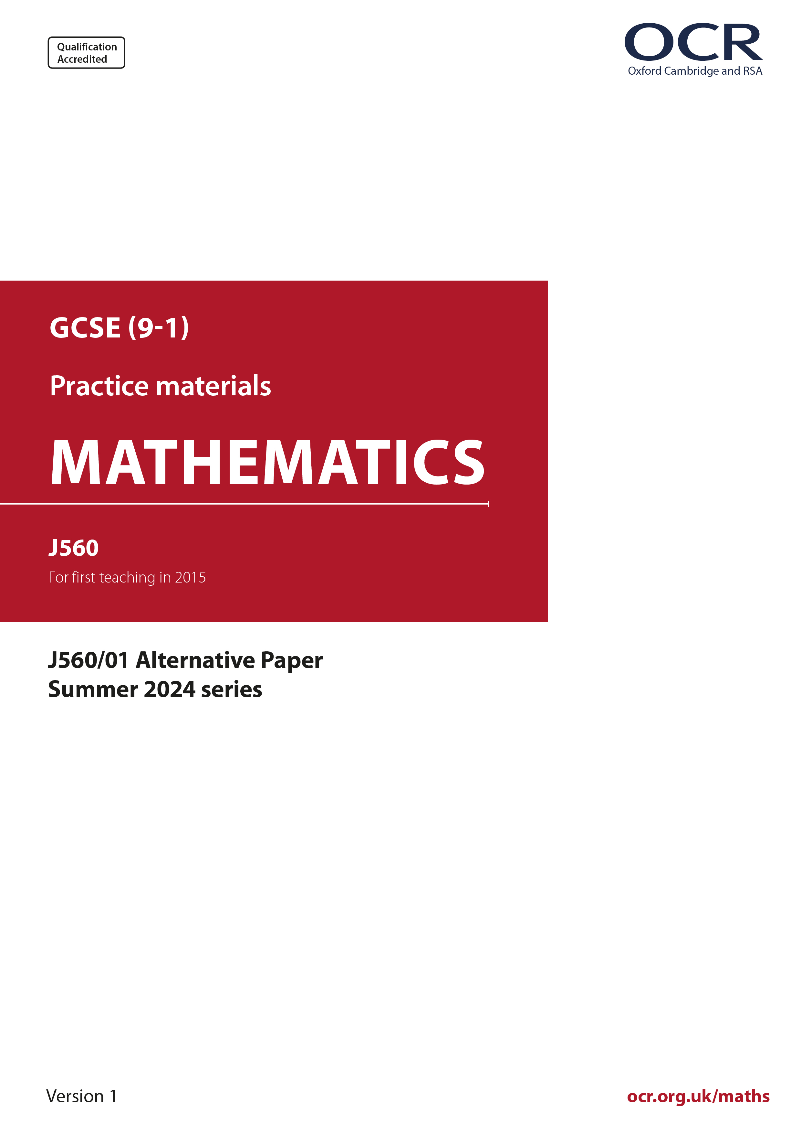
ocr.org.uk/maths

Introduction
OCR’s Alternative Papers for GCSE (9-1) Mathematics are each created by taking one of our past papers and amending the numbers/graphs/diagrams/tables/etc. in its questions.
This Alternative Paper is an amended version of one of the Summer 2024 series papers. The wording and topics assessed are essentially the same, but the responses students need to make will be different. Using both this paper and the corresponding Summer 2024 exam paper with your students at different points in the year will allow you to monitor how their learning has progressed in the time between the two papers.
Please note that when students originally sat this paper in 2024, they were given a formulae sheet. Foundation tier and Higher tier formulae sheets are published on Teach Cambridge alongside the Alternative Papers, for use with students as required.
Additional Alternative Papers and past papers are available to download from Teach Cambridge.



GCSE (9-1) Mathematics
J560/01 Paper 1 (Foundation Tier)
Alternative Paper (Summer 2024)

Time allowed: 1 hour 30 minutes

F
You must have:
- the Formulae Sheet for Foundation Tier (inside this document)

You can use:
- a scientific or graphical calculator
- geometrical instruments
- tracing paper

Name

INSTRUCTIONS
- Use black ink. You can use an HB pencil, but only for graphs and diagrams.
- Write your answer to each question in the space provided. You can use extra paper if you need to, but you must clearly show your candidate number, the centre number and the question numbers
- Answer all the questions.
- Where appropriate, your answer should be supported with working. Marks might be
given for using a correct method, even if your answer is wrong.
- Use the π button on your calculator or take π to be 3.142 unless the question says
something different.

INFORMATION
- The total mark for this paper is 100.
- The marks for each question are shown in brackets [ ].
- This document has 19 pages.

ADVICE
- Read each question carefully before you start your answer.

- Write down an example of each of the following.

- An odd number.
(a) .......................................................... [1]

- A multiple of 9.
(b) .......................................................... [1]

- A cube number between 70 and 200.
(c) .......................................................... [1]

- A prime number greater than 3.
(d) .......................................................... [1]

- Here is a list of five numbers.

12 13 6 5 8

- Write down the median.
(a) .......................................................... [1]

- A sixth number is added to the list.
The range of the six numbers is 11.

Work out a possible value for the sixth number.
(b) .......................................................... [2]

(a) Measure angle x.



(a) x = ..........................................................° [1]

- The angles of a triangle are 42°, 96° and 42°.

Explain how you know the triangle is isosceles.

...........................................................................................................................................

..................................................................................................................................... [1]

- The diagram shows two sides of a parallelogram drawn on a one-centimetre grid.

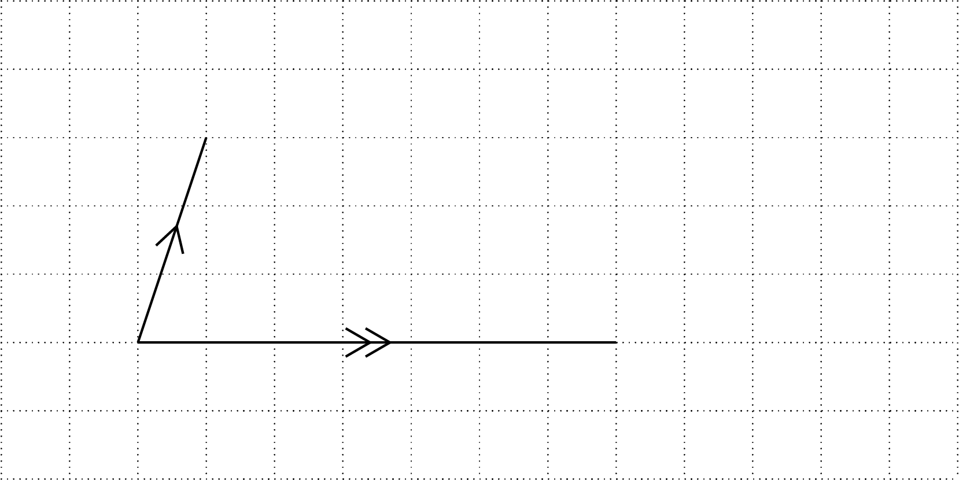

- Complete the drawing of the parallelogram.
Include notation to show that the drawing is a parallelogram. [2]

- Work out the area of the parallelogram.

(c)(ii) .......................................................... cm² [2]

- Here are the first three dot patterns in a sequence.

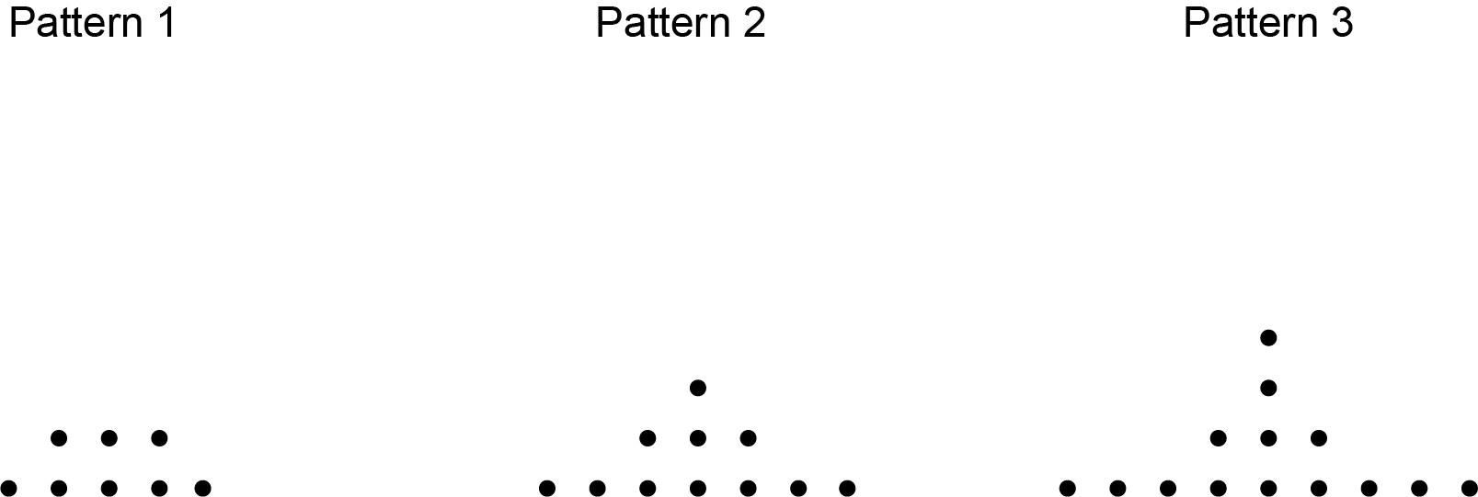

- Draw Pattern 4 in the sequence. [1]
- Without drawing, work out how many dots are in Pattern 10 of the sequence.
Explain how you worked out your answer.

...........................................................................................................................................

...........................................................................................................................................

..................................................................................................................................... [2]

- A teacher writes down a number.
They add 7 to the number and then divide by 9.
Their answer is 52.

What number did the teacher write down?
.......................................................... [2]

- A play group offers four activities to their children.

Colouring (C) Painting (P) Reading (R) Skipping (S)

- Complete the list below to show all the possible combinations of two different activities. You may not need all the answer lines.
P
C
..................................... and .....................................

..................................... and .....................................

..................................... and .....................................

..................................... and .....................................

..................................... and .....................................

..................................... and .....................................

..................................... and .....................................

..................................... and .....................................

..................................... and .....................................
[2]

- Write down the fraction of the combinations that include Skipping (S).
(b) .......................................................... [1]

- This grid shows a vertical line going through the point T.

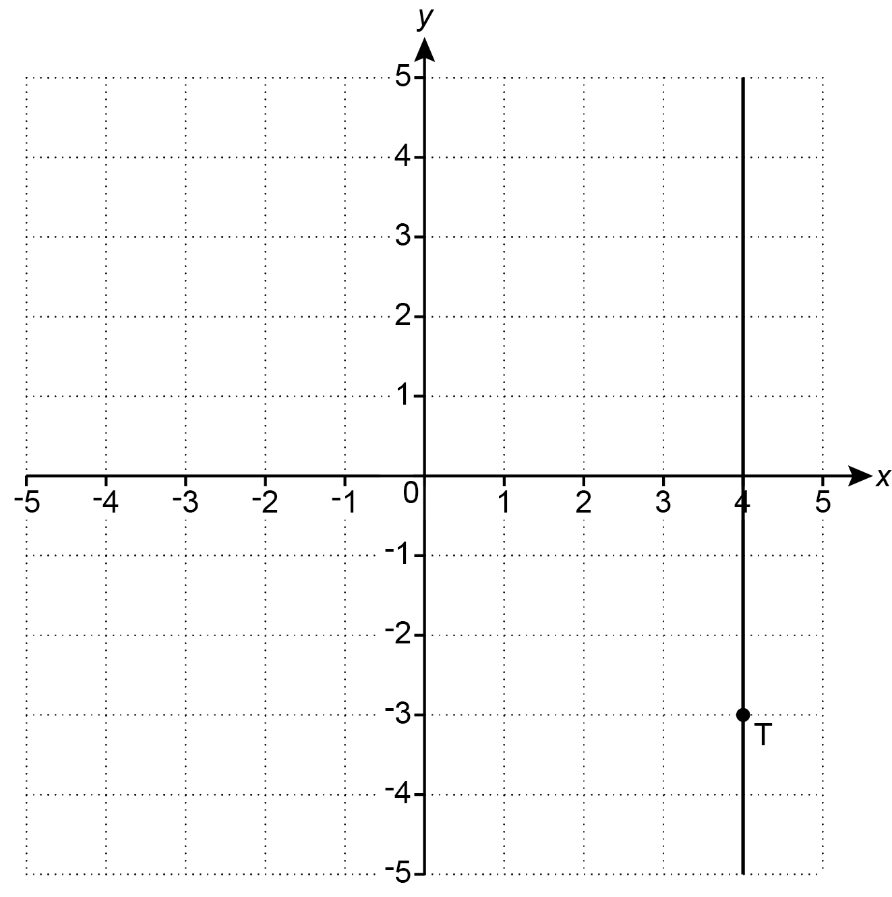

- (i) Write down the coordinates of point T.
(a)(i) ( ........................... , ........................... ) [1]

- Plot the point (-2, 3). [1]

- Write down the equation of the vertical line going through point T.
(b) .......................................................... [1]

- Here is a formula.

a = b (c − d)

- Find the value of a when b = 4, c = 8 and d = 6.
(a) a = .......................................................... [1]

- Find the value of c when a = 26, b = 4 and d = 3.
(b) c = .......................................................... [3]

- A bag only contains red counters and blue counters.
of the counters are red.
There are 30 blue counters.

Complete the table to show the fraction of the counters that are blue and the number of red counters.

 | red | blue
fraction |  | ...................
number | ................... | 30
[3]

(a) Write the ratio 28 : 21 in its simplest form.
(a) .......................................................... [1]

- The scale of a map is 1 : 20 000.

Two castles are 4 kilometres apart on the ground.

Work out how far apart the two castles are on the map.
Give your answer in centimetres.
(b) .......................................................... cm [3]

- Sam eats 40% of a 600 g pack of cereal every day.

Sam has no cereal left.
The cereal is no longer sold in 600 g packs.
Instead, the cereal is now sold in 400 g packs.

Sam wants to continue to eat the same amount of cereal every day.

Work out the minimum number of 400 g packs of cereal that Sam must buy to have enough for 7 days.
You must show your working.
.......................................................... 400 g packs [5]

- Increase £86 by 18%.
£ .......................................................... [3]

- 50 students are asked how many books they have read this month.
The table shows the results.

Number of books | Frequency
0 | 11
1 | 10
2 | 9
3 | 7
4 | 8
5 | 5
Total | 50

Work out the mean number of books read this month by the 50 students.
.......................................................... [3]

- A machine makes 11 boxes in 12 minutes.
The machine works continuously.

Work out how many boxes are made by this machine in 8 hours.
.......................................................... [4]

- The population of an island is 51 000 people.
The area of the island is 480 km².

Calculate the population density of the island in people per km².
.......................................................... people per km² [2]

- A sports team scored 600 points.

The defenders scored of the points.

The midfielders and the forwards scored the remainder of the points in the ratio 1 : 5.

Find the percentage of the 600 points that were scored by the forwards.
You must show your working.

.......................................................... % [5]

- Triangle A is drawn on the grid below.

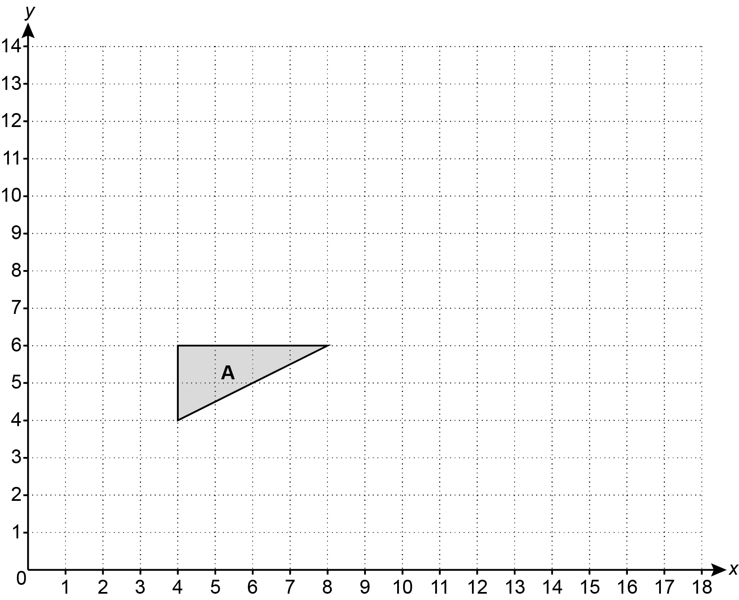

Enlarge triangle A with scale factor and centre of enlargement (0, 0). [3]

- Solve 8x + 17 > 1.

Show your solution on the number line.
[4]

- Work out.

Write your answer correct to 4 significant figures.
.......................................................... [3]

- The diagram shows a triangle and a trapezium.

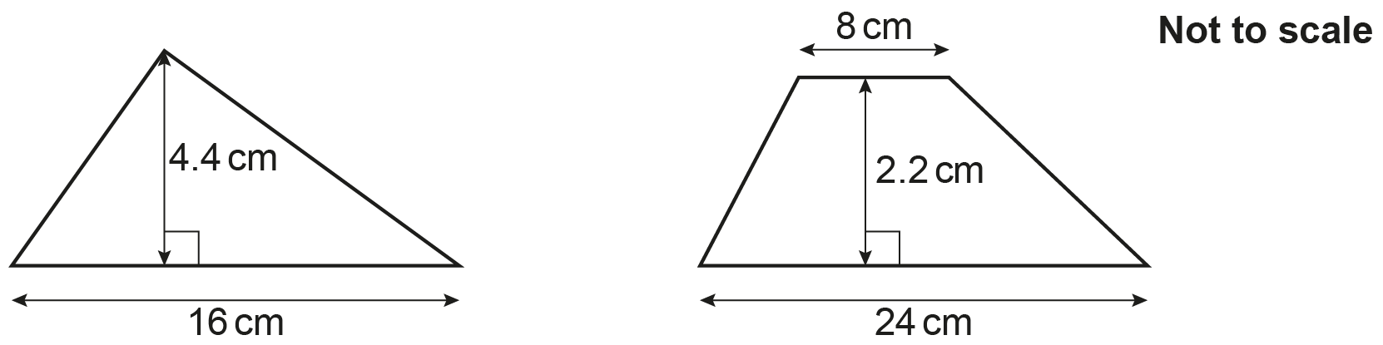

Show that they have the same area. [3]

- A school is deciding on a charity to support.
Each student at the school votes for one of four charities, A, B, C or D.
The results are to be shown in a pie chart.

This pie chart shows the sector for charity A.
Twice as many students voted for charity C than charity B.
Three times as many students voted for charity D than charity C.

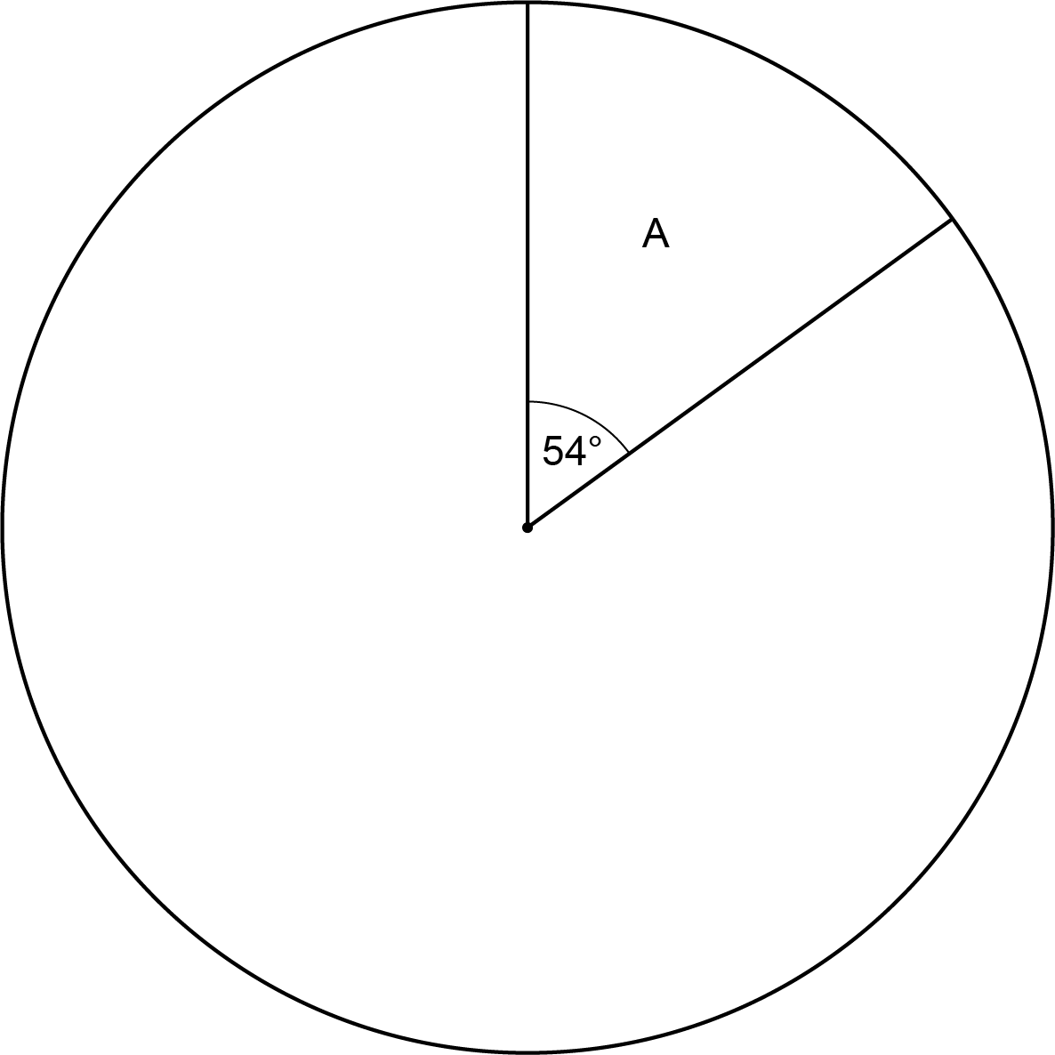

- (i) Show that the sector for charity B will have an angle of 34°. [2]
- Complete the pie chart. [3]

- 72 students voted for charity A.

Calculate the total number of students at the school.
(b) .......................................................... [2]

- The school asks 80 of the students to choose a new logo from three designs G, H and J.
The same results are shown in a pie chart and in a bar chart.

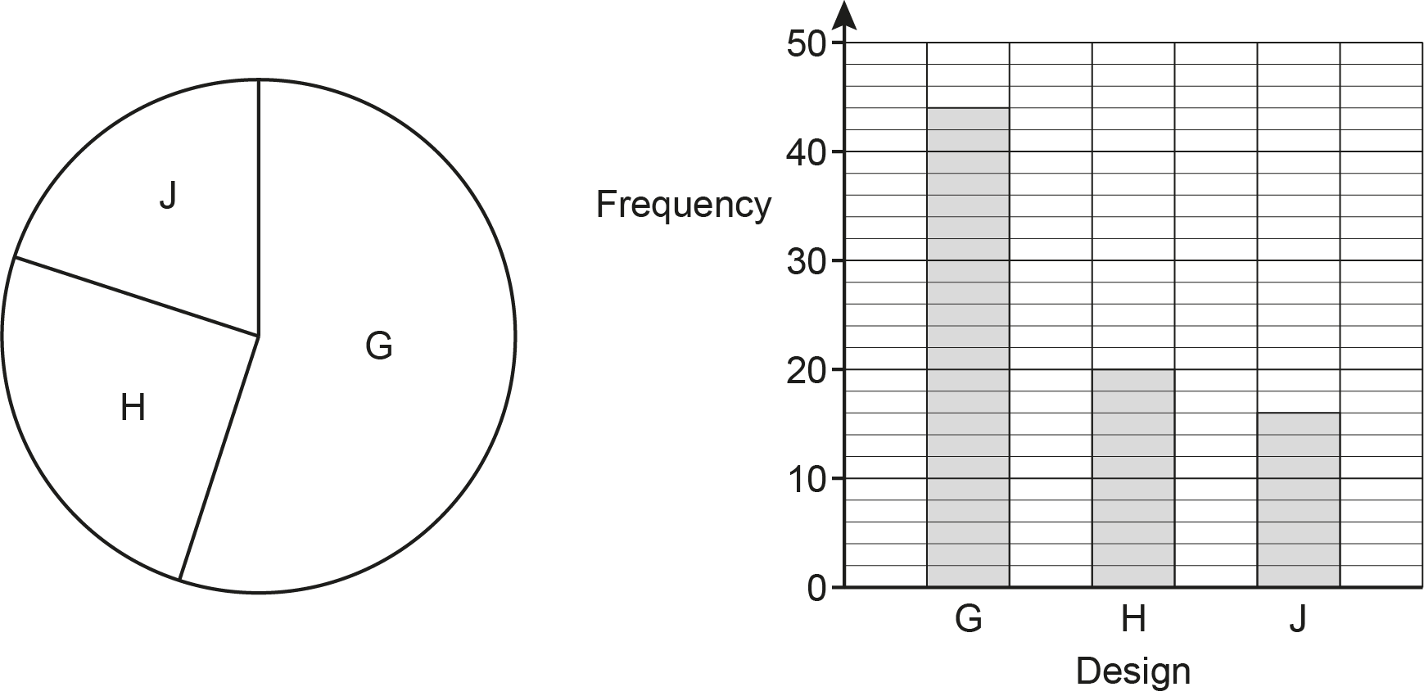

- Give one advantage of using the pie chart rather than the bar chart.

.................................................................................................................................

............................................................................................................................ [1]

- Give one disadvantage of using the pie chart rather than the bar chart.

.................................................................................................................................

............................................................................................................................ [1]

- The same dog food is sold in three different sized packs. The diagram shows the price of each pack.

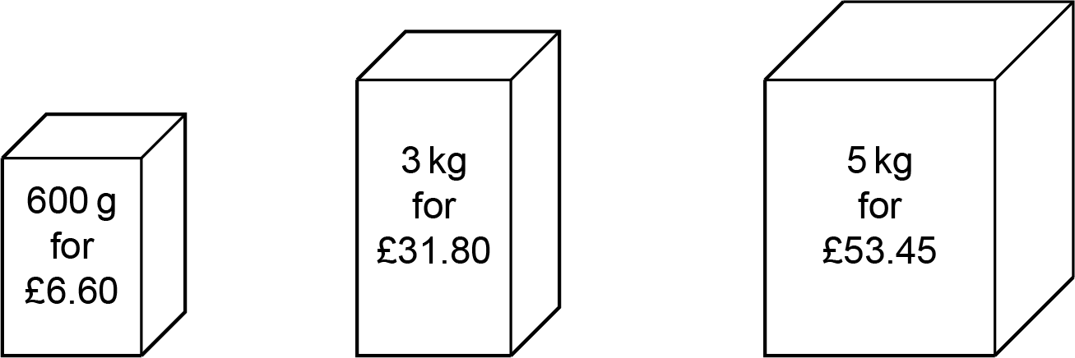

Which pack is the best value for money?
Show how you decide.
The.........................................pack because .............................................................................

.............................................................................................................................................. [3]

- A garage is 6 metres long, correct to the nearest metre.
A van is 5.5 metres long, correct to 1 decimal place.

Show that the van may not fit in the garage. [3]

- The diagram shows a straight line crossing two parallel lines.

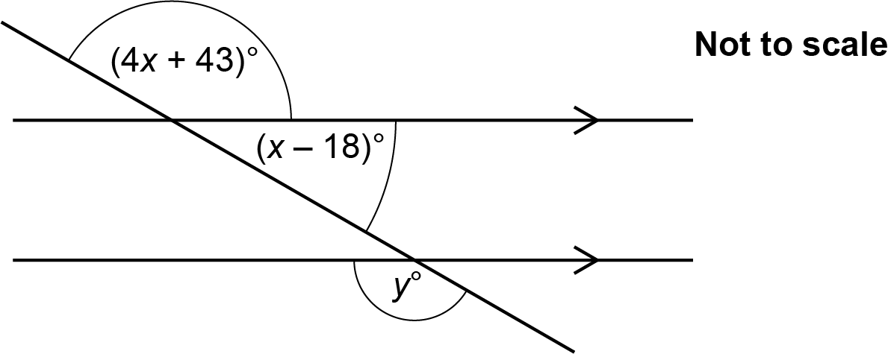

Find the value of y.
You must show your working.
y = .......................................................... [5]

- The diagram shows a trapezium.

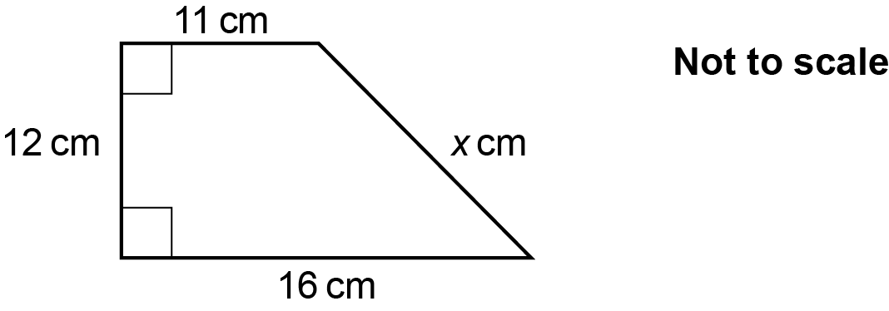

Calculate the value of x.
x = .......................................................... [4]

- Solve the simultaneous equations.

6x − 2y = 22
3x + 4y = 16
x = ..........................................................

y = .......................................................... [3]

- Write the following in order of size, smallest first.

0.8 2⁻³ 2 × 10⁻¹

Show how you decide.
........................ , ........................ , ........................ , [3]
smallest
END OF QUESTION PAPER

Please note – web links are correct at date of publication but other websites may change over time. If you have any problems with a link you may want to navigate to that organisation’s website for a direct search.



We’d like to know your view on the resources we produce. Click ‘Like’ or ‘Dislike’ to send us an auto generated email about this resource. Add comments if you want to. Let us know how we can improve this resource or what else you need. Your email will not be used or shared for any marketing purposes.
Looking for another resource? There is now a quick and easy search tool to help find free resources for your qualification.
OCR is part of Cambridge University Press & Assessment, which is itself a department of the University of Cambridge.
For staff training purposes and as part of our quality assurance programme your call may be recorded or monitored. © OCR 2024 Oxford Cambridge and RSA Examinations is a Company Limited by Guarantee. Registered in England. Registered office The Triangle Building, Shaftesbury Road, Cambridge, CB2 8EA. Registered company number 3484466. OCR is an exempt charity.
OCR operates academic and vocational qualifications regulated by Ofqual, Qualifications Wales and CCEA as listed in their qualifications registers including A Levels, GCSEs, Cambridge Technicals and Cambridge Nationals.
OCR provides resources to help you deliver our qualifications. These resources do not represent any teaching method we expect you to use. We update our resources regularly and aim to make sure content is accurate but please check the OCR website so that you have the most up to date version. OCR cannot be held responsible for any errors or omissions in these resources.
Though we make every effort to check our resources, there may be contradictions between published support and the specification, so it is important that you always use information in the latest specification. We indicate any specification changes within the document itself, change the version number and provide a summary of the changes. If you do notice a discrepancy between the specification and a resource, please contact us.
You can copy and distribute this resource in your centre, in line with any specific restrictions detailed in the resource. Resources intended for teacher use should not be shared with students. Resources should not be published on social media platforms or other websites.
OCR acknowledges the use of the following content: N/A
Whether you already offer OCR qualifications, are new to OCR or are thinking about switching, you can request more information using our Expression of Interest form.
Please get in touch if you want to discuss the accessibility of resources we offer to support you in delivering our qualifications.

