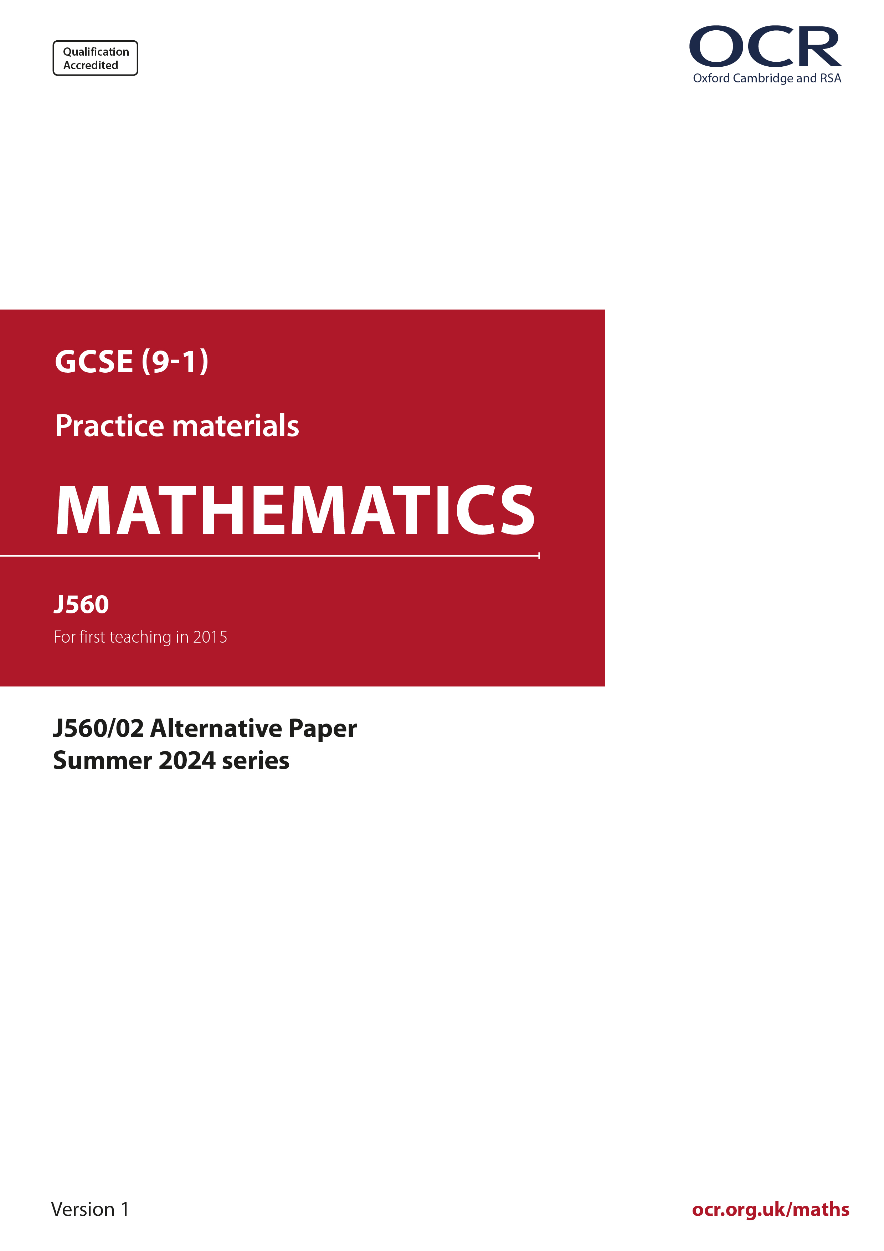
ocr.org.uk/maths

Introduction
OCR’s Alternative Papers for GCSE (9-1) Mathematics are each created by taking one of our past papers and amending the numbers/graphs/diagrams/tables/etc. in its questions.
This Alternative Paper is an amended version of one of the Summer 2024 series papers. The wording and topics assessed are essentially the same, but the responses students need to make will be different. Using both this paper and the corresponding Summer 2024 exam paper with your students at different points in the year will allow you to monitor how their learning has progressed in the time between the two papers.
Please note that when students originally sat this paper in 2024, they were given a formulae sheet. Foundation tier and Higher tier formulae sheets are published on Teach Cambridge alongside the Alternative Papers, for use with students as required.
Additional Alternative Papers and past papers are available to download from Teach Cambridge.



GCSE (9-1) Mathematics
J560/02 Paper 2 (Foundation Tier)
Alternative Paper (Summer 2024)

Time allowed: 1 hour 30 minutes

F
You must have:
- the Formulae Sheet for Foundation Tier (inside this document)

You can use:
- geometrical instruments
- tracing paper

Name

INSTRUCTIONS
- Use black ink. You can use an HB pencil, but only for graphs and diagrams.
- Write your answer to each question in the space provided. You can use extra paper if you need to, but you must clearly show your candidate number, the centre number and the question numbers
- Answer all the questions.
- Where appropriate, your answer should be supported with working. Marks might be
given for using a correct method, even if your answer is wrong.

INFORMATION
- The total mark for this paper is 100.
- The marks for each question are shown in brackets [ ].
- This document has 19 pages.

ADVICE
- Read each question carefully before you start your answer.

- Work out.

- 3.8 + 7.2
(a) .......................................................... [1]

- £3.70 − £0.46
(b) £ .......................................................... [1]

- Work out.

- -9 − 5
(a) .......................................................... [1]

- -56 ÷ 8
(b) .......................................................... [1]

- (⁻6)²
(c) .......................................................... [1]
(a) Reflect the triangle in the mirror line.

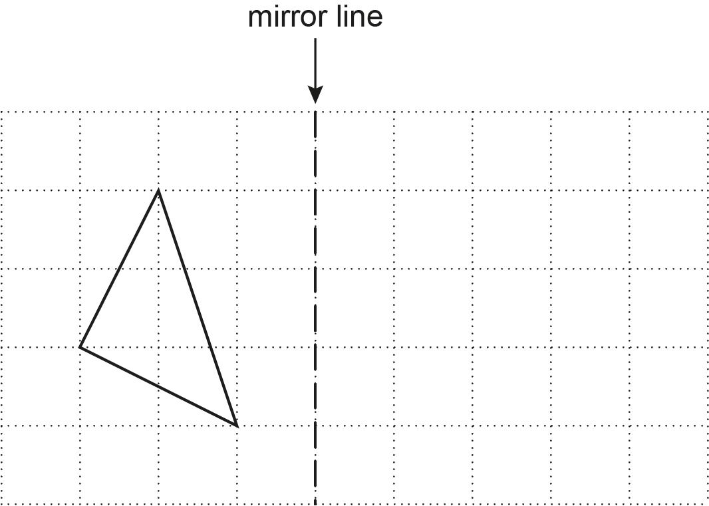
[2]

- Rotate the triangle 90° clockwise around the point P.

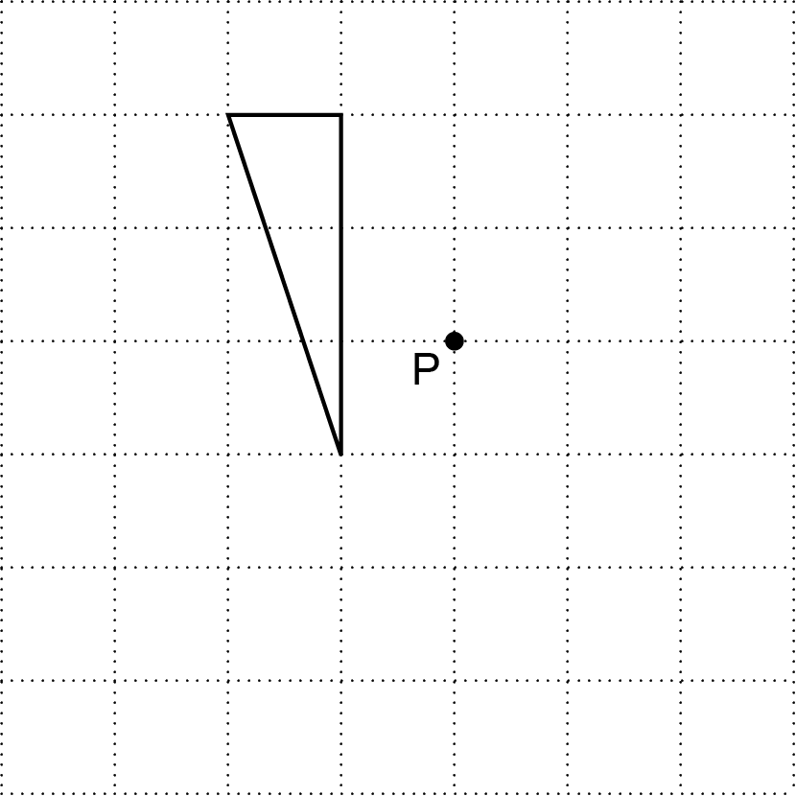
[2]

- The diameter of a circle is 10 cm.

Find the length of the radius of the circle.
.......................................................... cm [1]

- This probability scale shows the probability of picking a red crayon from a box of crayons.

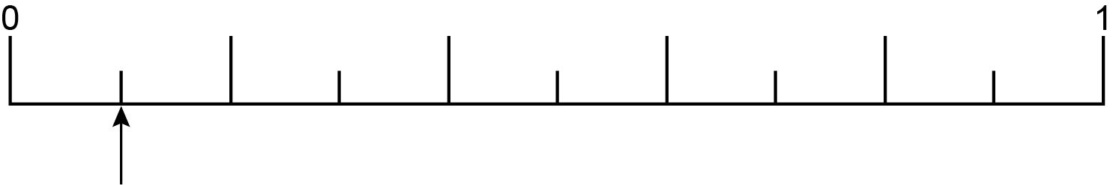

- Write down, as a fraction, the probability of picking a red crayon.
(a) .......................................................... [1]

- On the probability scale above, mark with an arrow (↑) the probability of not picking a red crayon. [1]

- A garden sprinkler uses water at a rate of 14 litres per minute.

How much water is used by the garden sprinkler in 15 minutes?
.......................................................... litres [2]

(a) Write 0.8 as a fraction in its simplest form.
(a) .......................................................... [2]
- Write as a mixed number.
(b) .......................................................... [1]

- Use one of these symbols <, > or = to make each statement true.

480 g .......................... 4.8 kg
2 km .......................... 225 m
30 mm .......................... 3 cm
[3]

- Work out the following, giving each answer as a fraction in its simplest form.

- –
(a) .......................................................... [2]

- ÷
(b) .......................................................... [3]
- Simplify.

- 9a + 3b − 2a + b
(a) .......................................................... [2]

- 3w × 8y
(b) .......................................................... [1]

- The table shows the plan view and front elevation of some 3D solids.

Write the name of each 3D solid in the third column of the table.

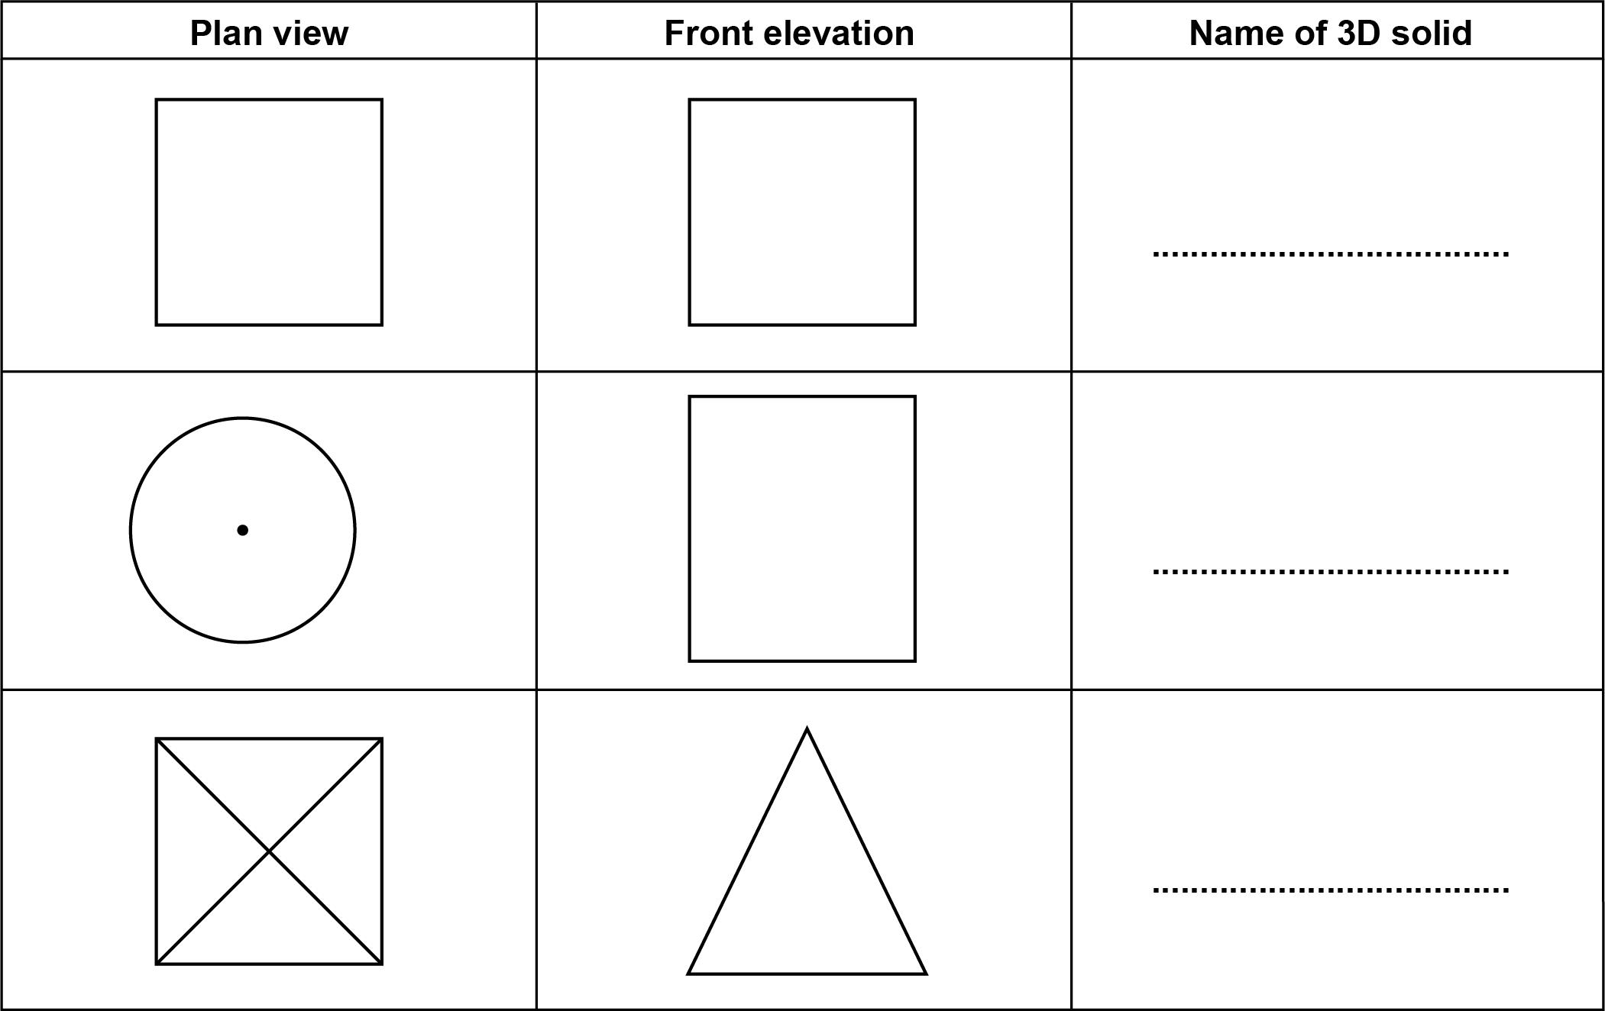
[3]
- Complete each statement by writing the missing power in the box.

- 5² × 5⁶ = 5 [1]

- (3³)² = 3 [1]

(a) Work out the next term in this sequence.
2 5 9 14 ...............
[1]

- In the Fibonacci sequence below, the next term is found by adding the two previous terms.
The second term is 8, the third term is 11 and the fourth term is 19.

Work out the first and fifth terms of the sequence.
............... 8 11 19 ...............
[2]

- Use the formula

v² = u² + 2as

to find the final velocity when

- the initial velocity is 5 m/s
- the acceleration is 3 m/s²
- the distance travelled is 4 m.
.......................................................... m/s [3]

- Compost is used to grow plants.
Jane has a sack containing 60 litres of compost.
She uses this compost to fill pots for her plants.

- Jane fills ten large pots each holding 5.5 litres.

Work out how much compost is left in the sack.
(a) .......................................................... litres [2]

- Jane uses the remaining compost to fill small pots each holding 800 ml.

Work out the maximum number of small pots Jane can fill with the remaining compost.
(b) .......................................................... [3]

- Work out how much compost will then be left in the sack.
(c) ..................................................... ml [2]

- The table shows how much Ivan earns per hour.

Work done on Monday to Friday | £20.23 per hour
Work done on Saturday or Sunday | £30.18 per hour

One week Ivan works for 30 hours between Monday and Friday and then for 5 hours
on Saturday.

- Ivan says

I will earn at least £700 for my work this week.

By rounding each value to the nearest integer, use estimation to show that Ivan may
be correct. [5]
- Give one reason why your working in part (a) shows that Ivan can be certain of earning at least £700 for his work in this week.
...........................................................................................................................................

..................................................................................................................................... [1]
- Work out.

1.8 ÷ 0.06
..................................................... [2]

- Amaya has these four number cards.

0
4
7
9

Amaya takes two of the cards at random without replacement and finds the positive difference between the two numbers.

- Complete the table to show all of the possible differences.

 |  | First card
Second  card | Difference | 0 | 4 | 7 | 9
Second  card | 0 |  | 4 | 7 | 9
Second  card | 4 | 4 |  | 3
Second  card | 7 | 7
Second  card | 9 | 9
[2]

- Find the probability that Amaya takes two cards with a difference that is an even number or a factor of 14.
(b) ..................................................... [2]
Using ruler and compasses only, construct the perpendicular bisector of the line AB.
Leave your construction lines visible.
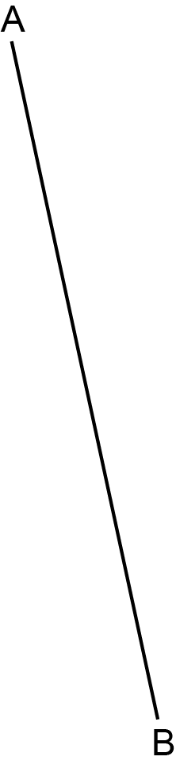
[2]

- Vector a is drawn on this grid.

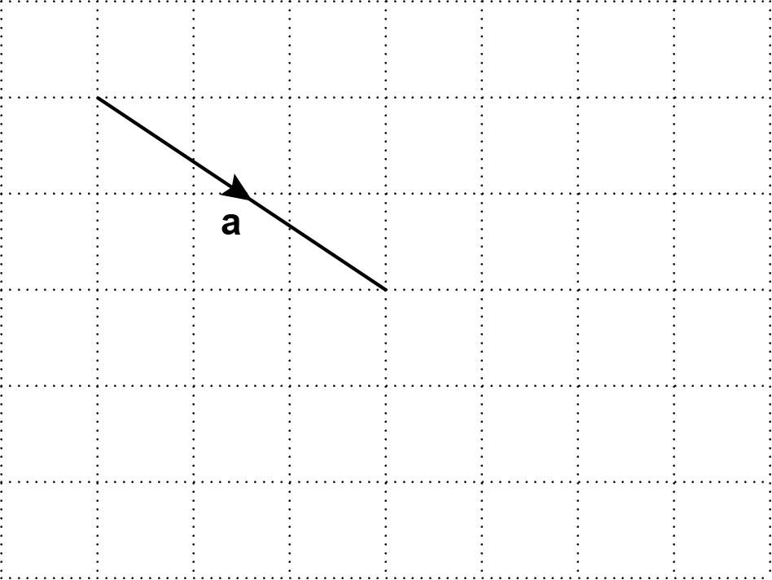

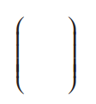
- Write vector a as a column vector.
(a)
[2]

- A vector is drawn on this grid.

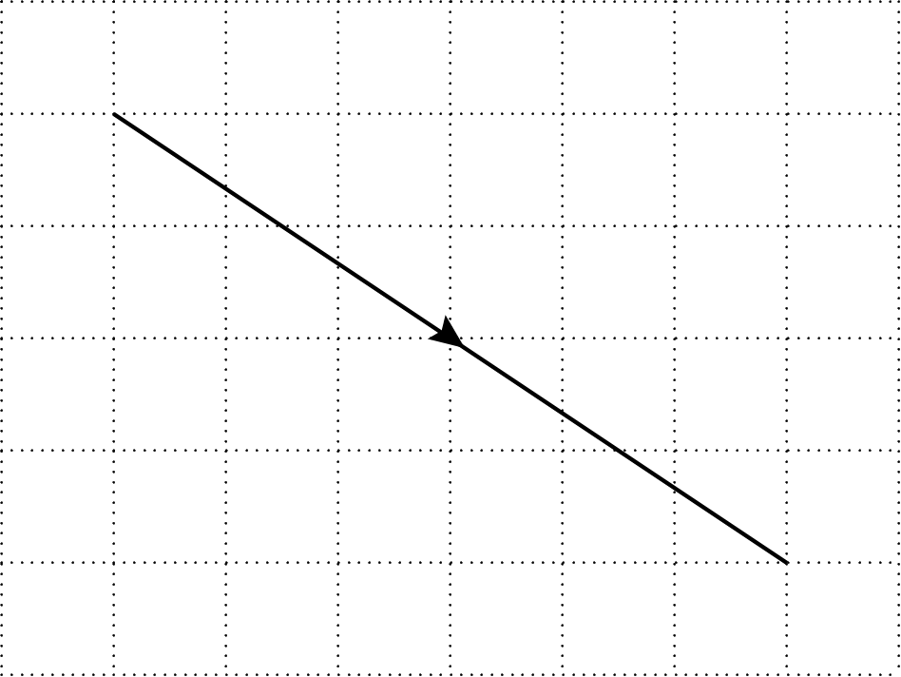

Write this vector in terms of a.

(b) ..................................................... [1]

(a) Kai makes a journey of 100 miles from his home to the airport.
30% of the journey is on roads with a speed limit of 60 miles per hour.
of the journey is on roads with a speed limit of 30 miles per hour.
The remainder of the journey takes a time of 1 hour 16 minutes.

Kai leaves home at 09 50 and does not exceed the speed limits on the journey.

Find the earliest time that Kai could arrive at the airport.

You must show your working.
(a) ..................................................... [6]

- Write down an assumption you have made when working out the answer to part (a).

...........................................................................................................................................

..................................................................................................................................... [1]
- The scatter diagram shows the test scores for 20 pupils in French and Spanish.

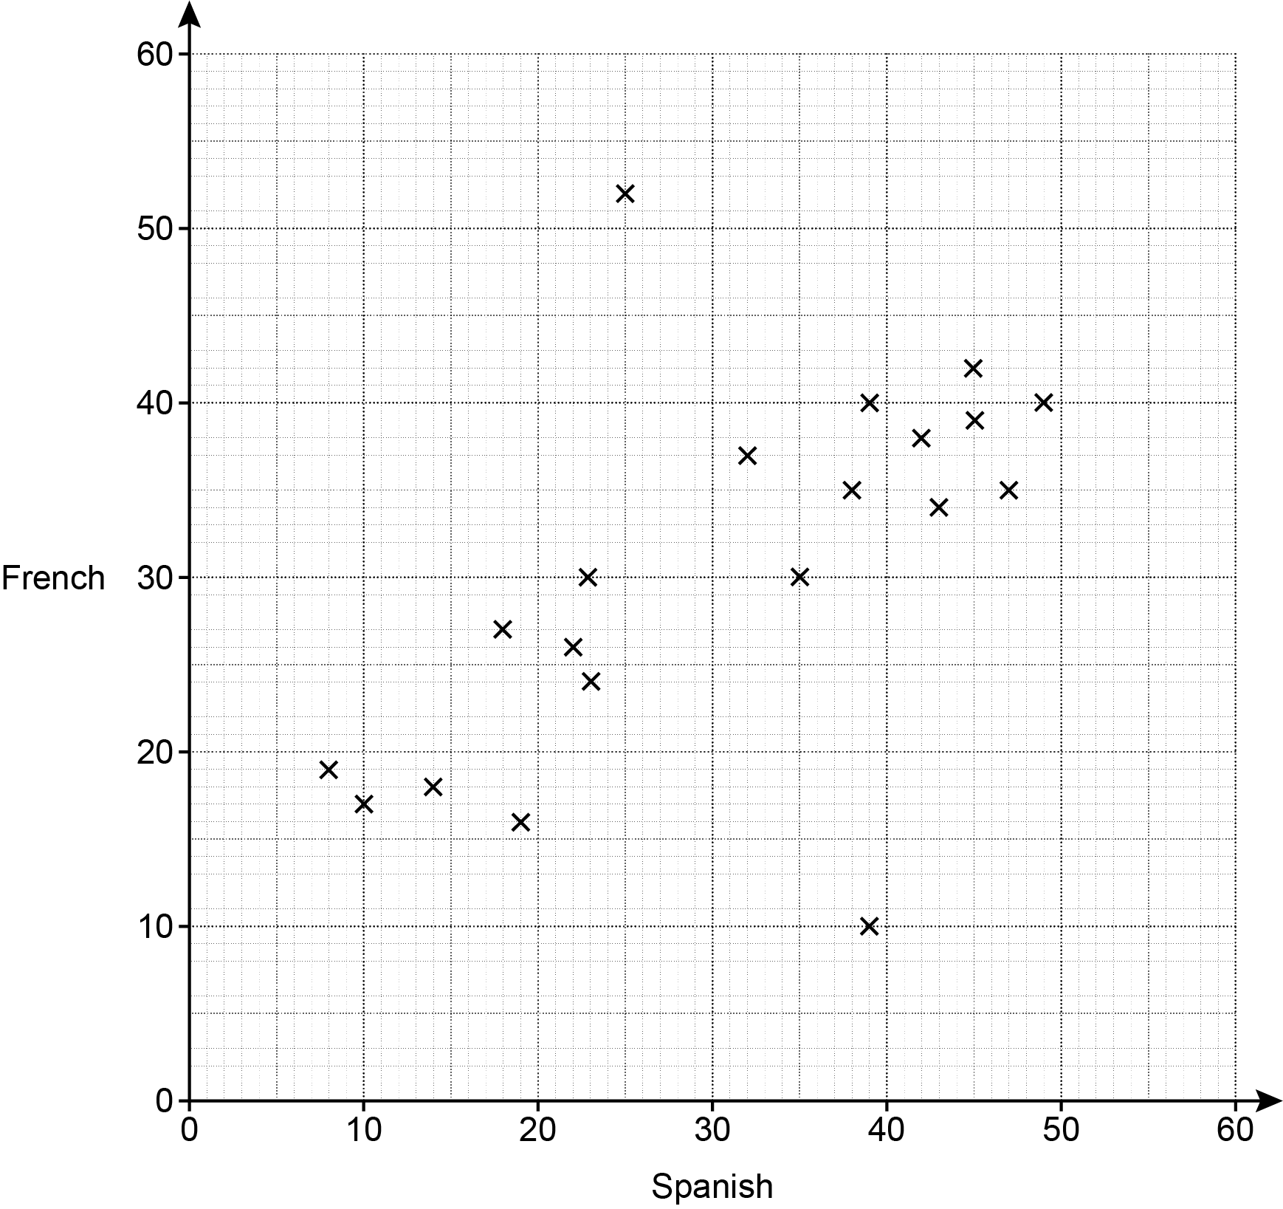

- Describe the type of correlation shown in the scatter diagram.

(a) ..................................................... [1]

- One pupil took the French test but was then ill during the Spanish test and had to leave early.

On the scatter diagram, circle the point that is most likely to represent this pupil. [1]

- By drawing a line of best fit, estimate the test score in Spanish for a pupil who scored 32 in the French test.

(c) ..................................................... [2]

- Explain why using the scatter diagram to estimate the test score in French for a pupil who scored 55 in Spanish may be unreliable.

...........................................................................................................................................

..................................................................................................................................... [1]
- Find the percentage of the 20 pupils who scored more than 30 marks in both Spanish and French.
(e) ..................................................... % [3]

- The diagram shows an equilateral triangle and a rectangle.

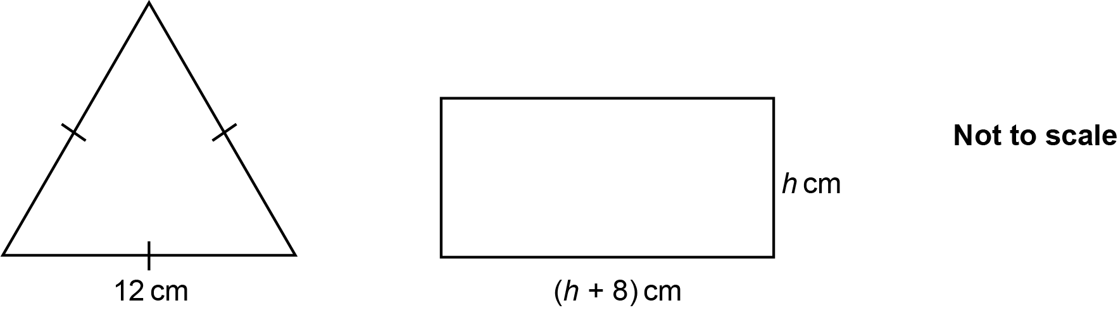

The equilateral triangle has the same perimeter as the rectangle.

Find the value of h.
h = ..................................................... [4]

- Ryan invests £20 000 at a rate of 2% per year compound interest.

Show that the total amount of interest Ryan will have received after 2 years is £808. [4]

- A machine makes pins that should be 20.0 mm long, correct to 1 decimal place.

Charlie checks the accuracy of the machine by taking a random sample of 10 of the pins. Here are the lengths, in mm correct to 1 decimal place, of the pins in Charlie’s sample.

19.5 20.0 20.0 20.0 20.2 20.0 20.0 20.0 20.5 20.0

The machine makes 3000 of these pins that day.

Charlie says

7 of the 10 pins in the sample are of the correct length. That is 70%.
Therefore, 2100 of the 3000 pins will be of the correct length because that is 70%.

Give a reason why Charlie’s claim may be unreliable.

....................................................................................................................................................

.............................................................................................................................................. [1]

- In a survey, 40 people were asked whether they have a cat (C) or a dog (D).

The Venn diagram shows some of the results.

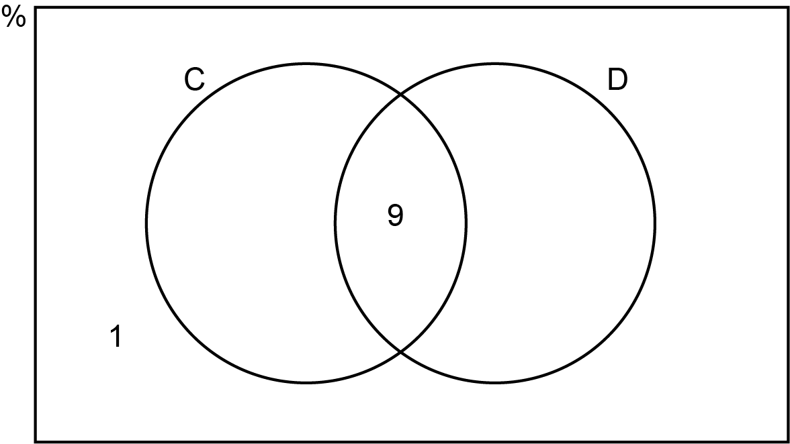

The ratio of those that only have a cat to those that only have a dog is 3 : 2.

One of the 40 people is chosen at random.

Find the probability that they have a dog.
You must show your working.
...................................................... [5]

- In this question, all lengths are in centimetres.

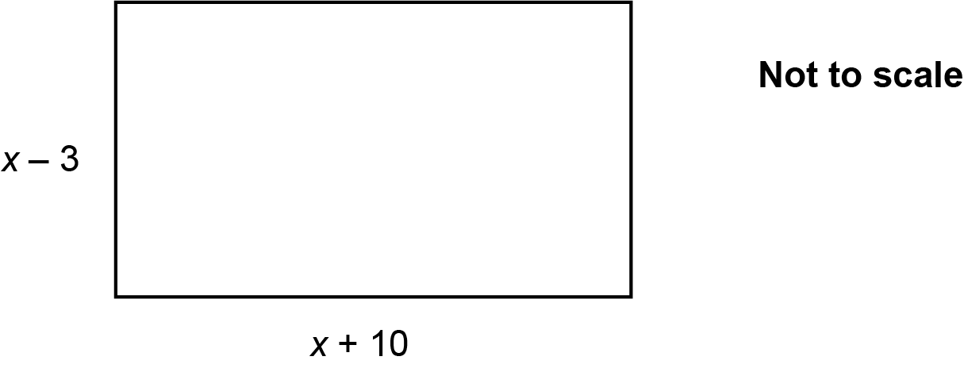

The area of the rectangle is 90 cm².

- Show that x² + 7x − 120 = 0. [4]
(i) Solve by factorising.

x² + 7x − 120 = 0
(b)(i) x = ....................... or x = ...................... [3]

- Find the length of the shorter side of the rectangle.
(ii) ...................................................... cm [1]

END OF QUESTION PAPER

Please note – web links are correct at date of publication but other websites may change over time. If you have any problems with a link you may want to navigate to that organisation’s website for a direct search.



We’d like to know your view on the resources we produce. Click ‘Like’ or ‘Dislike’ to send us an auto generated email about this resource. Add comments if you want to. Let us know how we can improve this resource or what else you need. Your email will not be used or shared for any marketing purposes.
Looking for another resource? There is now a quick and easy search tool to help find free resources for your qualification.
OCR is part of Cambridge University Press & Assessment, which is itself a department of the University of Cambridge.
For staff training purposes and as part of our quality assurance programme your call may be recorded or monitored. © OCR 2024 Oxford Cambridge and RSA Examinations is a Company Limited by Guarantee. Registered in England. Registered office The Triangle Building, Shaftesbury Road, Cambridge, CB2 8EA. Registered company number 3484466. OCR is an exempt charity.
OCR operates academic and vocational qualifications regulated by Ofqual, Qualifications Wales and CCEA as listed in their qualifications registers including A Levels, GCSEs, Cambridge Technicals and Cambridge Nationals.
OCR provides resources to help you deliver our qualifications. These resources do not represent any teaching method we expect you to use. We update our resources regularly and aim to make sure content is accurate but please check the OCR website so that you have the most up to date version. OCR cannot be held responsible for any errors or omissions in these resources.
Though we make every effort to check our resources, there may be contradictions between published support and the specification, so it is important that you always use information in the latest specification. We indicate any specification changes within the document itself, change the version number and provide a summary of the changes. If you do notice a discrepancy between the specification and a resource, please contact us.
You can copy and distribute this resource in your centre, in line with any specific restrictions detailed in the resource. Resources intended for teacher use should not be shared with students. Resources should not be published on social media platforms or other websites.
OCR acknowledges the use of the following content: N/A
Whether you already offer OCR qualifications, are new to OCR or are thinking about switching, you can request more information using our Expression of Interest form.
Please get in touch if you want to discuss the accessibility of resources we offer to support you in delivering our qualifications.

