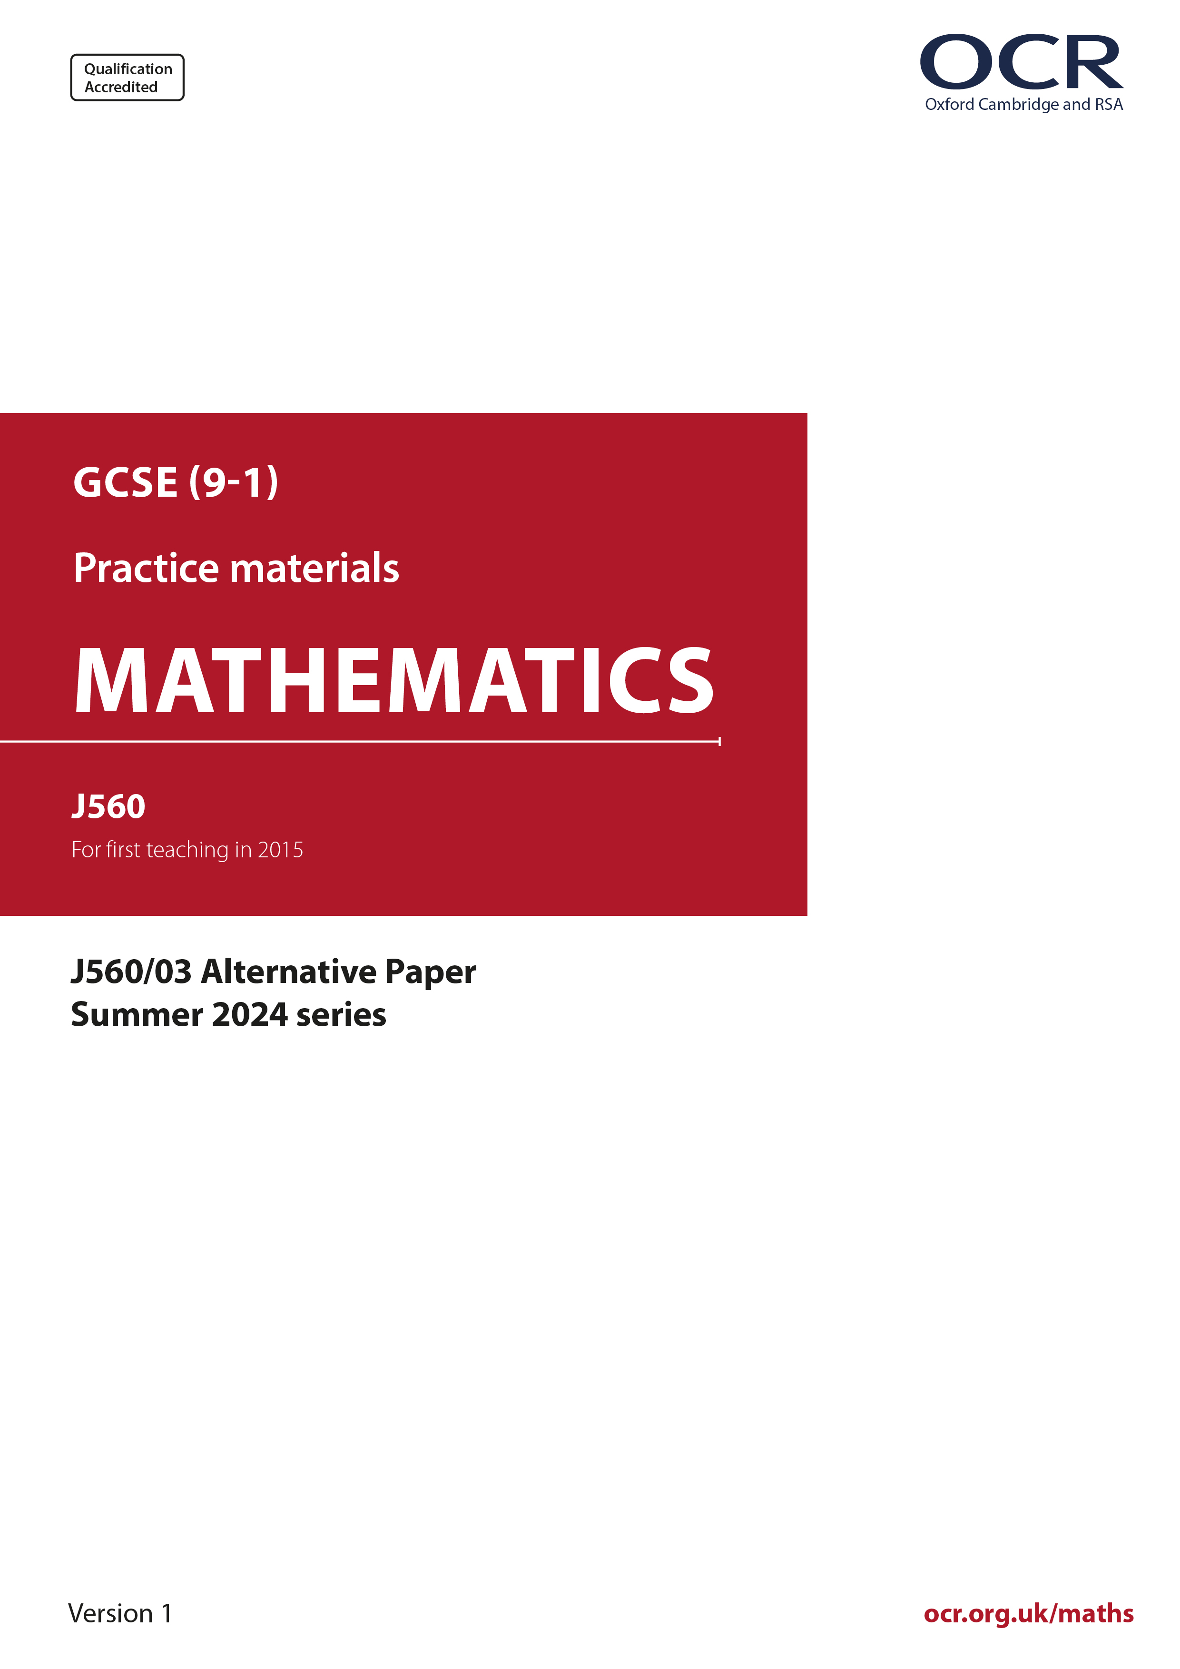
ocr.org.uk/maths

Introduction
OCR’s Alternative Papers for GCSE (9-1) Mathematics are each created by taking one of our past papers and amending the numbers/graphs/diagrams/tables/etc. in its questions.
This Alternative Paper is an amended version of one of the Summer 2024 series papers. The wording and topics assessed are essentially the same, but the responses students need to make will be different. Using both this paper and the corresponding Summer 2024 exam paper with your students at different points in the year will allow you to monitor how their learning has progressed in the time between the two papers.
Please note that when students originally sat this paper in 2024, they were given a formulae sheet. Foundation tier and Higher tier formulae sheets are published on Teach Cambridge alongside the Alternative Papers, for use with students as required.
Additional Alternative Papers and past papers are available to download from Teach Cambridge.



GCSE (9-1) Mathematics
J560/03 Paper 3 (Foundation Tier)
Alternative Paper (Summer 2024 )

Time allowed: 1 hour 30 minutes

F
You must have:
- the Formulae Sheet for Foundation Tier (inside this document)

You can use:
- a scientific or graphical calculator
- geometrical instruments
- tracing paper

Name

INSTRUCTIONS
- Use black ink. You can use an HB pencil, but only for graphs and diagrams.
- Write your answer to each question in the space provided. You can use extra paper if you need to, but you must clearly show your candidate number, the centre number and the question numbers
- Answer all the questions.
- Where appropriate, your answer should be supported with working. Marks might be
given for using a correct method, even if your answer is wrong.
- Use the π button on your calculator or take π to be 3.142 unless the question says
something different.

INFORMATION
- The total mark for this paper is 100.
- The marks for each question are shown in brackets [ ].
- This document has 19 pages.

ADVICE
- Read each question carefully before you start your answer.

(a) Write down the mathematical name of this solid.
Choose from the list in the box.

cone
cube
cylinder
prism
sphere

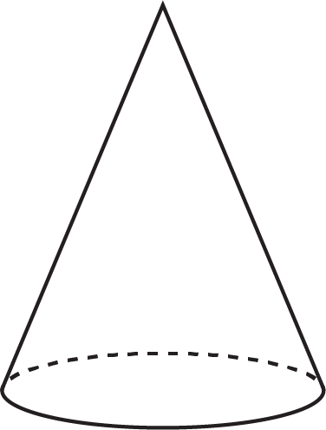
(a) .......................................................... [1]

- The diagram shows a cuboid.

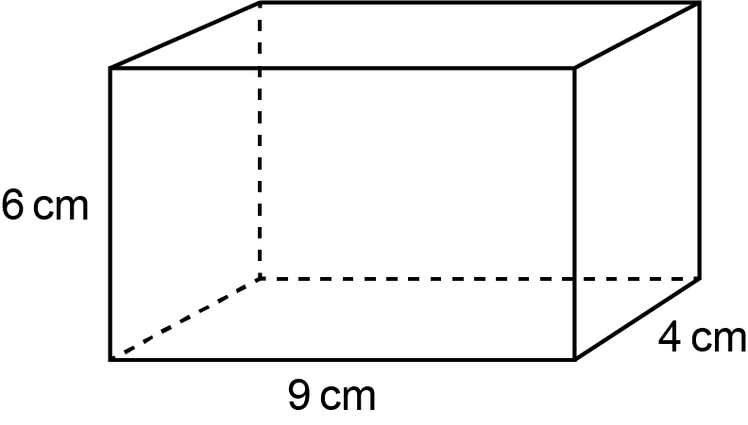

- How many faces does the cuboid have?
(b)(i) .......................................................... [1]

- The cuboid has dimensions 9 cm, 6 cm and 4 cm.

Work out the volume of the cuboid.
(ii) .......................................................... cm³ [2]
- This table shows the weight of each ingredient used to make 6.5 kg of concrete.

Complete this table to show the weight of each ingredient used to make 52 kg of the same concrete.

Ingredient | Weight (kg) | Weight (kg)
Cement | 1 | 8
Gravel | 3.5
Sand | 2
Total weight | 6.5 | 52
[2]

(a) Use your calculator to work out.

- 4⁶
(a)(i) .......................................................... [1]

(ii) .......................................................... [1]

- Complete this statement to make it correct.
Give your answer as a number in ordinary form.

[2]

- A watch costs £189.60.
The exchange rate is 1 dollar ($) = £0.79.

Calculate the price of the watch in dollars ($).
$ .......................................................... [2]

(a) Work out of 112.
Give your answer correct to 1 decimal place.
(a) .......................................................... [3]

- Write 1200 metres as a fraction of 3 kilometres.
Give your answer in its simplest form.
(b) .......................................................... [3]

- Yoshi and Layla share £18 in the ratio 3 : 1.

- Write down the letter of the correct calculation to work out Yoshi’s share.

A: B: C: D:
(a) .......................................................... [1]

- Work out Layla’s share.
(b) £ .......................................................... [2]
- A circle has radius 6 cm.

Work out the area of the circle.
.......................................................... cm² [2]

- Kofi buys some keyrings.
Each keyring costs £1.39.
Kofi pays with a £20 note and buys the largest number of keyrings possible.

How much change should Kofi receive?
.......................................................... p [4]

- When Heidi walks to school she always takes 32 minutes.
When Heidi cycles to school her speed is double her walking speed.

- One day Heidi leaves home at 08 10 and cycles to school.

Find the time that Heidi arrives at school.
(a) .......................................................... [2]

- On another day Heidi cycles half-way to school.
She walks the rest of the way at her normal walking speed.

Find how many minutes Heidi takes to get to school on this day.
(b) .......................................... minutes [3]

(a) Simplify.

h × h × h × h × h
(a) .......................................... [1]

- Factorise fully.

4fg + 12f
(b) .......................................... [2]

- Choose a word from this list which best describes each statement.

Equation
Expression
Formula
Identity
Inequality
Term

- x² + 4x + 3 = 0 (a) .......................................... [1]
- x² + 4x + 3 > 0. (b) .......................................... [1]

- At an adventure park, all children participate in three activities, choosing exactly one activity from each of three options.

Option | Activity
1 | football or golf
2 | bowling or climbing
3 | rafting or swimming or tennis

On one Monday morning, 100 children visited the adventure park.

The frequency tree shows the number of children choosing some of the activities.

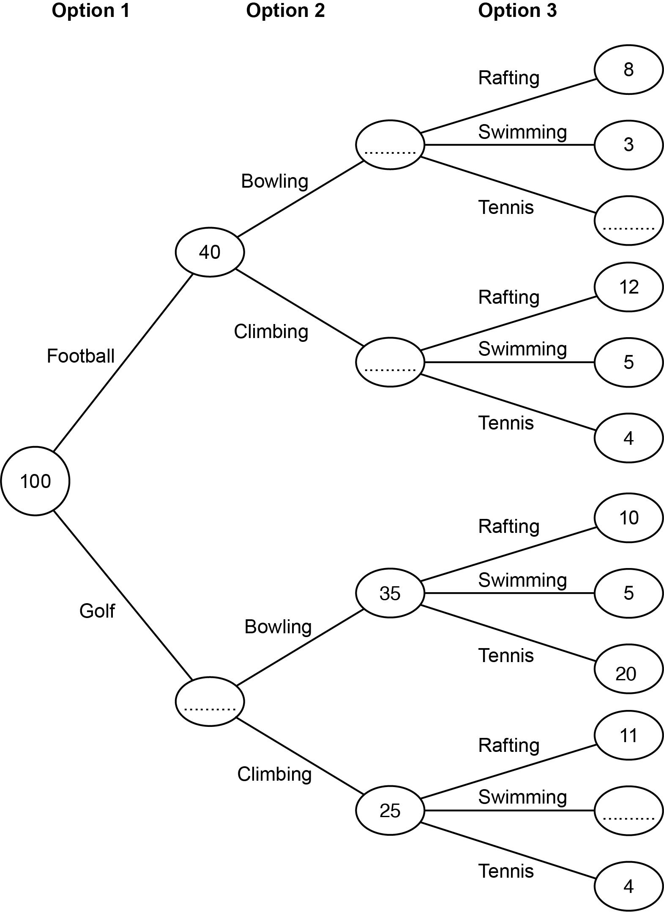
- Complete the frequency tree. [3]

- Which was the most popular activity out of rafting, swimming and tennis?
Show how you decide.
................................................. because ..........................................................................

...........................................................................................................................................

..................................................................................................................................... [3]

- One of the 100 children is picked at random.

Find the probability that this child chose climbing.
(c) .......................................... [2]

- Jane says

60% of all children coming to the adventure park choose golf.

What assumption has Jane made?

...........................................................................................................................................

..................................................................................................................................... [1]

- Gabi and Finley both have the same number of newspapers to deliver.

By 8am
- Gabi has delivered 36% of her newspapers
- Finley has delivered of his newspapers.

- Who has delivered the greater proportion of their newspapers?
Show how you decide.
................................................. because ..........................................................................

..................................................................................................................................... [3]

- Work out the smallest possible number of newspapers that Gabi must deliver.
(b) .......................................... [2]

- A number, n, is given as 3.8, truncated to 1 decimal place.

Complete the error interval for n using a number and a symbol.
...................... ≤ n ................... 3.9 [2]

- In this question all measurements are in centimetres.

The shaded shape is made by cutting a square from the corner of a rectangle.

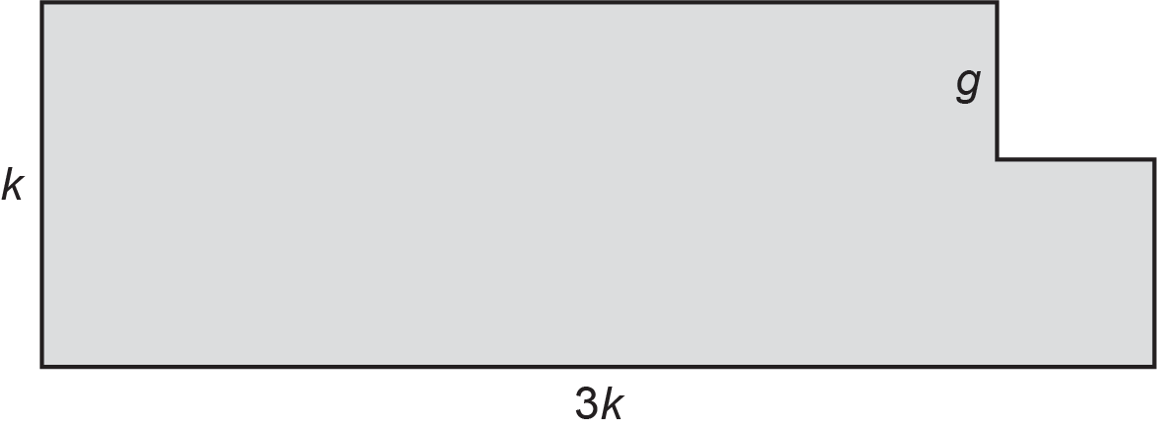
The width of the rectangle is k.
The length of the rectangle is 3k.
Each side of the square is g.

- Write down the relationship between the length and the width of the rectangle.

..................................................................................................................................... [1]

- Find an expression for the area of the shaded shape.
Give your answer in its simplest form.
(b) .......................................... [2]

(i) Find an expression for the perimeter of the shaded shape.
Give your answer in its simplest form.
(c)(i) .......................................... [3]

- Find the value of k when the perimeter of the shaded shape is 81.6.
(ii) k = .......................................... [2]

- Here is a table of values for y = 2x² − 4x .

x | -2 | -1 | 0 | 1 | 2 | 3
y | 16 | 6 | 0 | -2 | 0 | 6

- Draw the graph of y = 2x² − 4x for values of x from -2 to 3.

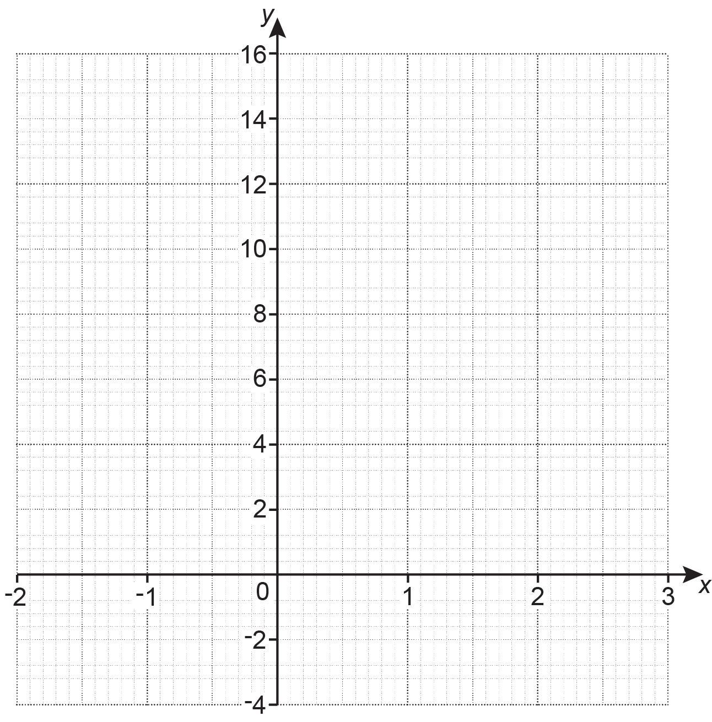
[3]

- Use your graph to find the x-coordinates of the points where the graph of y = 2x² − 4x crosses the line y = 4.
(b) x = ................... and x = ................... [2]

- Kai invests some money in a savings account that pays 5% simple interest per year.
After 4 years the total interest that Kai’s investment has earned is £360.

Find the total value of Kai’s investment after 4 years.
You must show your working.
£ .......................................... [5]

- The diagram shows two straight lines AB and DC that intersect at P.
DA is parallel to BC.

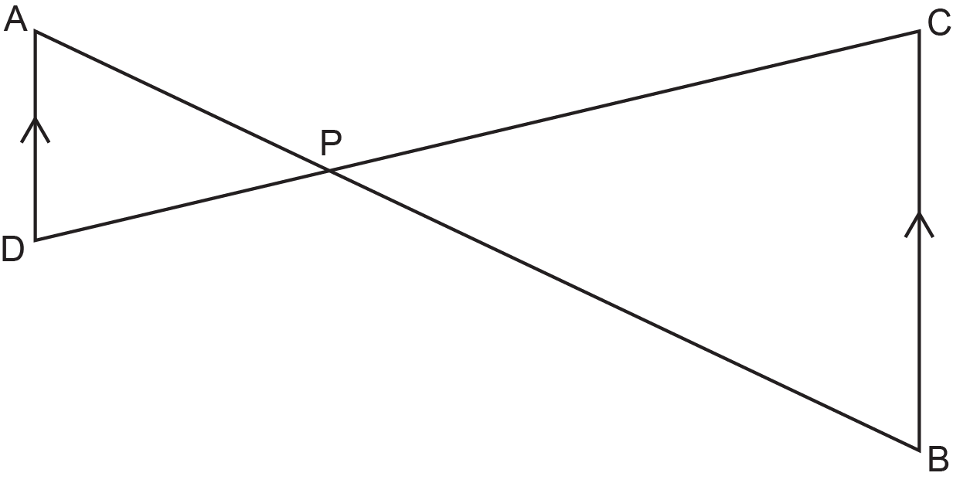

Complete these statements to show that triangle PAD is similar to triangle PBC.
alternate
CBP
DAP
Angle ................ = angle ................ because they are ................................................... angles
DPA

Angle ................ = angle ................ because they are ................................................... angles

Angle ................ = angle ................ because they are ................................................... angles

Triangle PAD is similar to triangle PBC because ..............................................................................................................................................

.............................................................................................................................................. [4]

- The graph shows a household’s average daily expenditure, in pounds (£).

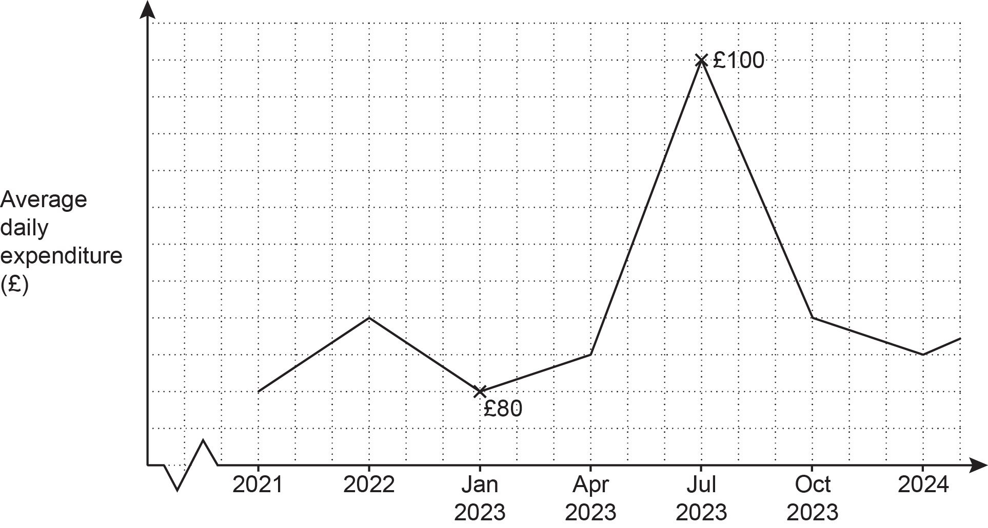

Give two different reasons why this graph is misleading.

Reason 1: .................................................................................................................................

....................................................................................................................................................

Reason 2: .................................................................................................................................

.............................................................................................................................................. [2]

- The word GEOMETRIC is spelt using tiles.

The tiles are put into an empty bag.

One at a time, 99 children each take a tile at random from the bag.
They record the letter and then put the tile back in the bag.

Work out how many times the letter E is expected to be taken from the bag.
.......................................... [3]

- 1 cm on a map represents 120 km in real life.

- Below is part of the map showing City A and City B.

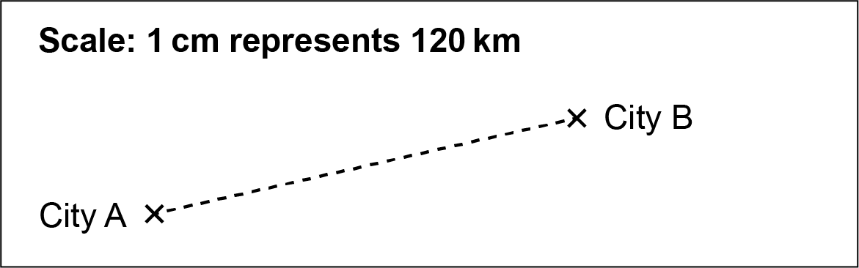

Alex is planning to walk from City A to City B for charity.

Alex measures the straight-line distance on the map from City A to City B accurately as 5 cm. Alex says she will walk from City A to City B at an average speed of 2.5 km/h for 10 hours per day.

- Use this information to work out how many days Alex needs to complete the walk from City A to City B.
(a)(i) .......................................... days [4]

- Explain why the information used in part (i) is likely to give an underestimate for the number of days Alex needs to complete the walk.

.................................................................................................................................

............................................................................................................................ [1]

- Riley writes the scale of the map, 1 cm represents 120 km, as the ratio 1 : 120.

Explain Riley ’s error and write the scale correctly in the form 1 : n.
Riley’s error is ................................................................................................................

.........................................................................................................................................

The correct answer is 1: .......................................... [2]

- The diagram shows a regular pentagon made using ten congruent right-angled triangles.
The length of one side of the pentagon is 16 cm.

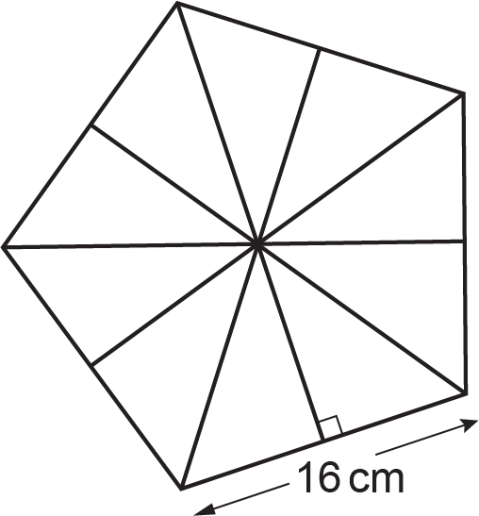

- Show that the area of the pentagon is 440.44 cm², correct to 2 decimal places. [6]
- The regular pentagon is the base of a pyramid.

The pyramid has volume 850 cm³.
The perpendicular height of the pyramid is h cm.

Calculate the value of h.
[The volume of a pyramid is × area of base × perpendicular height.]
(b) h = .......................................... [3]

(a) Two numbers, A and B, are written as the product of their prime factors.

A = 2² × 3 × 5²
B = 2⁴ × 5

Find the lowest common multiple (LCM) of A and B.
Give your answer as an ordinary number.
(a) .......................................... [2]

- A number, R, is written as the product of its prime factors.

R = 2 × 3 × 5² × k, where k is a prime number.

The highest common factor (HCF) of R and another number, P, is 51.
Find the value of k.
(b) k = .......................................... [2]

END OF QUESTION PAPER

Please note – web links are correct at date of publication but other websites may change over time. If you have any problems with a link you may want to navigate to that organisation’s website for a direct search.



We’d like to know your view on the resources we produce. Click ‘Like’ or ‘Dislike’ to send us an auto generated email about this resource. Add comments if you want to. Let us know how we can improve this resource or what else you need. Your email will not be used or shared for any marketing purposes.
Looking for another resource? There is now a quick and easy search tool to help find free resources for your qualification.
OCR is part of Cambridge University Press & Assessment, which is itself a department of the University of Cambridge.
For staff training purposes and as part of our quality assurance programme your call may be recorded or monitored. © OCR 2024 Oxford Cambridge and RSA Examinations is a Company Limited by Guarantee. Registered in England. Registered office The Triangle Building, Shaftesbury Road, Cambridge, CB2 8EA. Registered company number 3484466. OCR is an exempt charity.
OCR operates academic and vocational qualifications regulated by Ofqual, Qualifications Wales and CCEA as listed in their qualifications registers including A Levels, GCSEs, Cambridge Technicals and Cambridge Nationals.
OCR provides resources to help you deliver our qualifications. These resources do not represent any teaching method we expect you to use. We update our resources regularly and aim to make sure content is accurate but please check the OCR website so that you have the most up to date version. OCR cannot be held responsible for any errors or omissions in these resources.
Though we make every effort to check our resources, there may be contradictions between published support and the specification, so it is important that you always use information in the latest specification. We indicate any specification changes within the document itself, change the version number and provide a summary of the changes. If you do notice a discrepancy between the specification and a resource, please contact us.
You can copy and distribute this resource in your centre, in line with any specific restrictions detailed in the resource. Resources intended for teacher use should not be shared with students. Resources should not be published on social media platforms or other websites.
OCR acknowledges the use of the following content: N/A
Whether you already offer OCR qualifications, are new to OCR or are thinking about switching, you can request more information using our Expression of Interest form.
Please get in touch if you want to discuss the accessibility of resources we offer to support you in delivering our qualifications.

