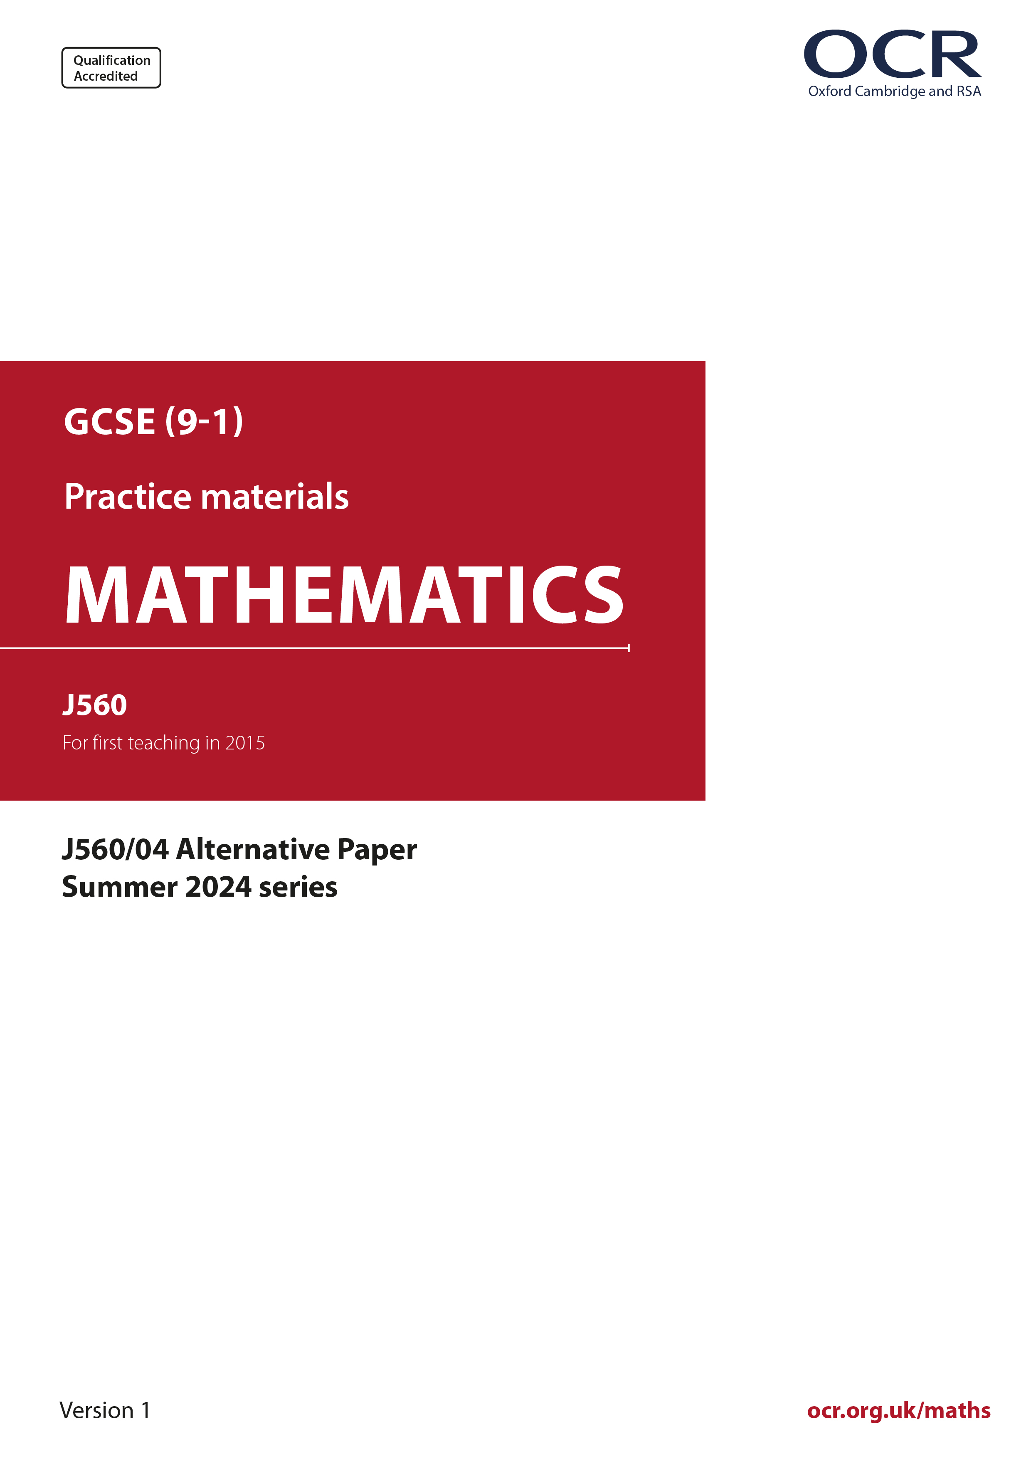
ocr.org.uk/maths

Introduction
OCR’s Alternative Papers for GCSE (9-1) Mathematics are each created by taking one of our past papers and amending the numbers/graphs/diagrams/tables/etc. in its questions.
This Alternative Paper is an amended version of one of the Summer 2024 series papers. The wording and topics assessed are essentially the same, but the responses students need to make will be different. Using both this paper and the corresponding June 2024 exam paper with your students at different points in the year will allow you to monitor how their learning has progressed in the time between the two papers.
Please note that when students originally sat this paper in 2024, they were given a formulae sheet. Foundation tier and Higher tier formulae sheets are published on Teach Cambridge alongside the Alternative Papers, for use with students as required.
Additional Alternative Papers and past papers are available to download from Teach Cambridge.



GCSE (9-1) Mathematics
J560/04 Paper 4 (Higher Tier)
Alternative Paper (Summer 2024)

Time allowed: 1 hour 30 minutes

H
You must have:
- the Formulae Sheet for Foundation Tier (inside this document)

You can use:
- a scientific or graphical calculator
- geometrical instruments
- tracing paper

Name

INSTRUCTIONS
- Use black ink. You can use an HB pencil, but only for graphs and diagrams.
- Write your answer to each question in the space provided. You can use extra paper if you need to, but you must clearly show your candidate number, the centre number and the question numbers
- Answer all the questions.
- Where appropriate, your answer should be supported with working. Marks might be
given for using a correct method, even if your answer is wrong.
- Use the π button on your calculator or take π to be 3.142 unless the question says
something different.

INFORMATION
- The total mark for this paper is 100.
- The marks for each question are shown in brackets [ ].
- This document has 19 pages.

ADVICE
- Read each question carefully before you start your answer.

- Work out.

Write your answer correct to 4 significant figures.
.......................................................... [3]
- The diagram shows a triangle and a trapezium.

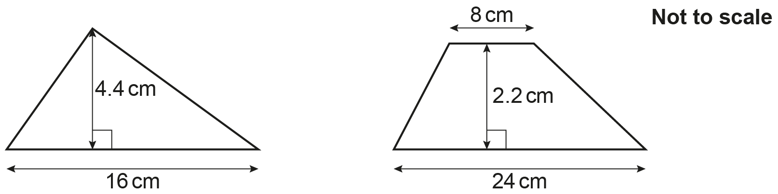

Show that they have the same area. [3]

- Four numbers are written, in ascending order, as algebraic expressions.

a a + b a + 2b 3a − b

The mean of these four numbers is 18.
The range of these four numbers is 20.

Find the value of a and the value of b.
You must show your working.
a = ..........................................................

b = .......................................................... [5]

- A school is deciding on a charity to support.
Each student at the school votes for one of four charities, A, B, C or D.
The results are to be shown in a pie chart.

This pie chart shows the sector for charity A.
Twice as many students voted for charity C than charity B.
Three times as many students voted for charity D than charity C.

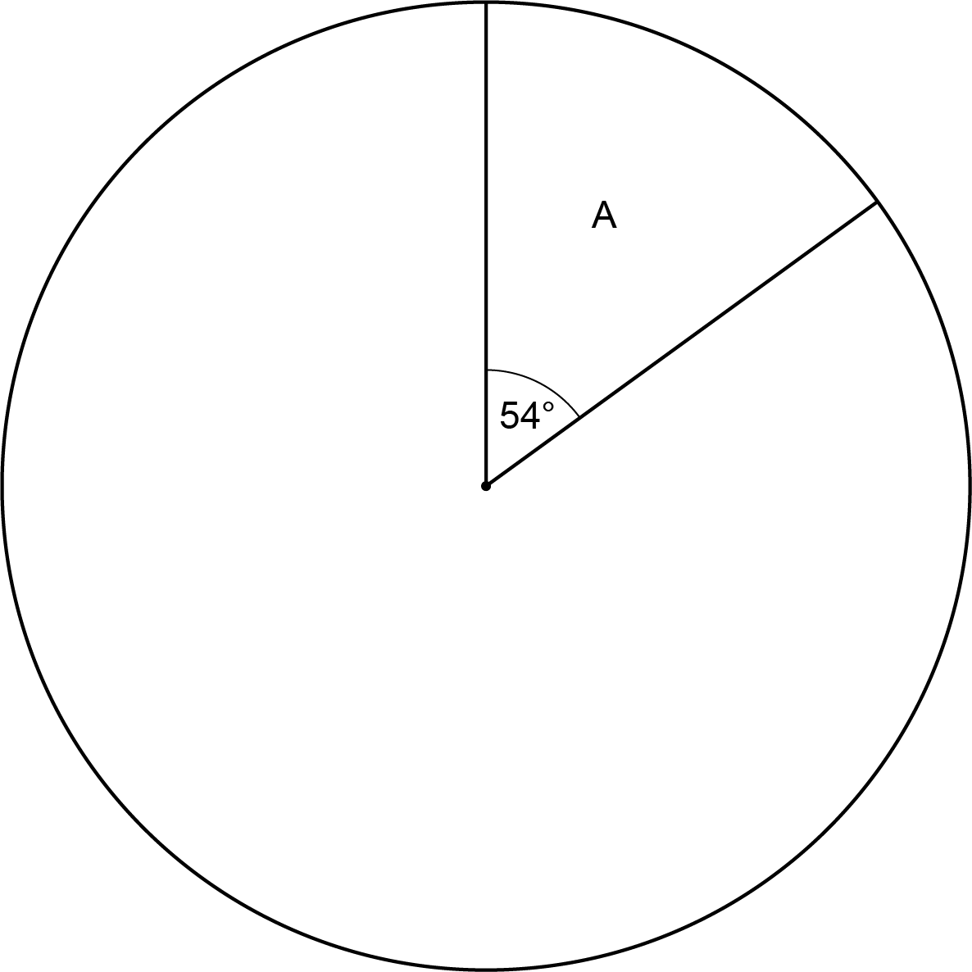

(i) Show that the sector for charity B will have an angle of 34°. [2]
- Complete the pie chart. [3]

- 72 students voted for charity A.

Calculate the total number of students at the school.
(b) .......................................................... [2]

- The school asks 80 of the students to choose a new logo from three designs G, H and J.
The same results are shown in a pie chart and in a bar chart.

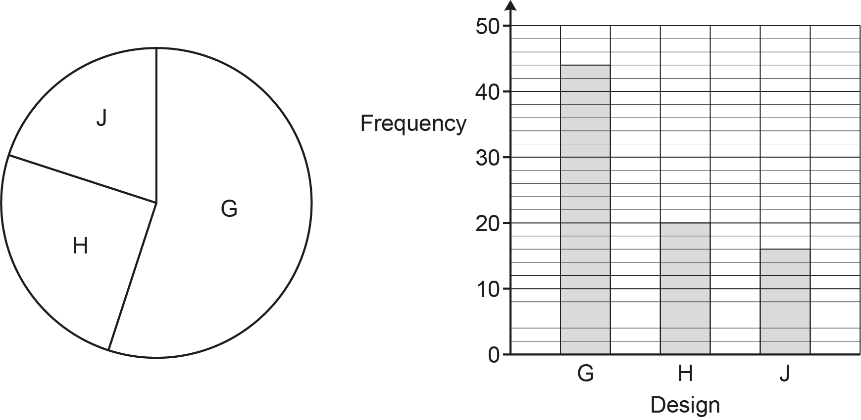

- Give one advantage of using the pie chart rather than the bar chart.

.................................................................................................................................

............................................................................................................................ [1]

- Give one disadvantage of using the pie chart rather than the bar chart.

.................................................................................................................................

............................................................................................................................ [1]

- The same dog food is sold in three different sized packs. The diagram shows the price of each pack.

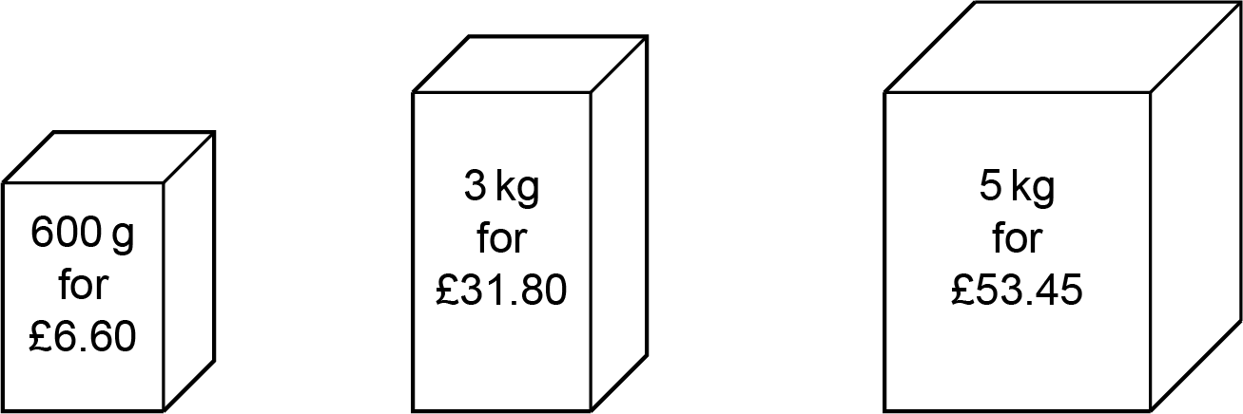

Which pack is the best value for money?
Show how you decide.
The.........................................pack because .............................................................................

....................................................................................................................................................

.............................................................................................................................................. [3]

- A regular polygon has n sides.
The interior angle of the polygon is 7 times its exterior angle.

Find the value of n.
n = .......................................................... [4]

- Write the following in order of size, smallest first.

0.8 2-3 2 × 10⁻¹

Show how you decide.
........................ , ........................ , ........................ [3]
smallest

- The price of a television is increased by 38%.
In a sale, the new price of the television is decreased by r %.

The overall percentage increase in the price of the television is 17.3%.

Find the value of r.
You must show your working.
r = .......................................................... [5]

- Sasha and Taylor each have a stamp collection.

They organise their stamp collections according to where the stamps come from: United Kingdom (UK), European Union (EU), Other.

The table shows the number of stamps in each collection and the ratio UK : EU : Other.

 | Number of stamps | Ratio  UK : EU : Other
Sasha’s collection | 1210 | 7 : 2 : 2
Taylor’s collection | 531 | 6 : 1 : 2

When they put the two stamp collections together, Sasha and Taylor claim that at least
of all the stamps come from the UK.

Are they correct?
Show how you decide.
They are ..................................................... because….............................................................

....................................................................................................................................................

.............................................................................................................................................. [5]

- Here is a question and an incorrect solution.

Question:
You are given
y x and y = 9 when x = 2.
Find a formula linking x and y.
Solution:
y x so y = x - c
Substituting y = 9 and x = 2 gives 9 = 2 - c
c = -7
So, y = x - 7

Describe the error made and write out a correct solution.

The error is ................................................................................................................................

....................................................................................................................................................

A correct solution is....................................................................................................................

....................................................................................................................................................

....................................................................................................................................................

....................................................................................................................................................

....................................................................................................................................................

.............................................................................................................................................. [3]

- A student attempts two tasks.
The result of each task is either “Pass” or “No pass”.

The probability of the student passing the first task is 0.4.
The probability of the student passing the second task is x.

- Complete the tree diagram.

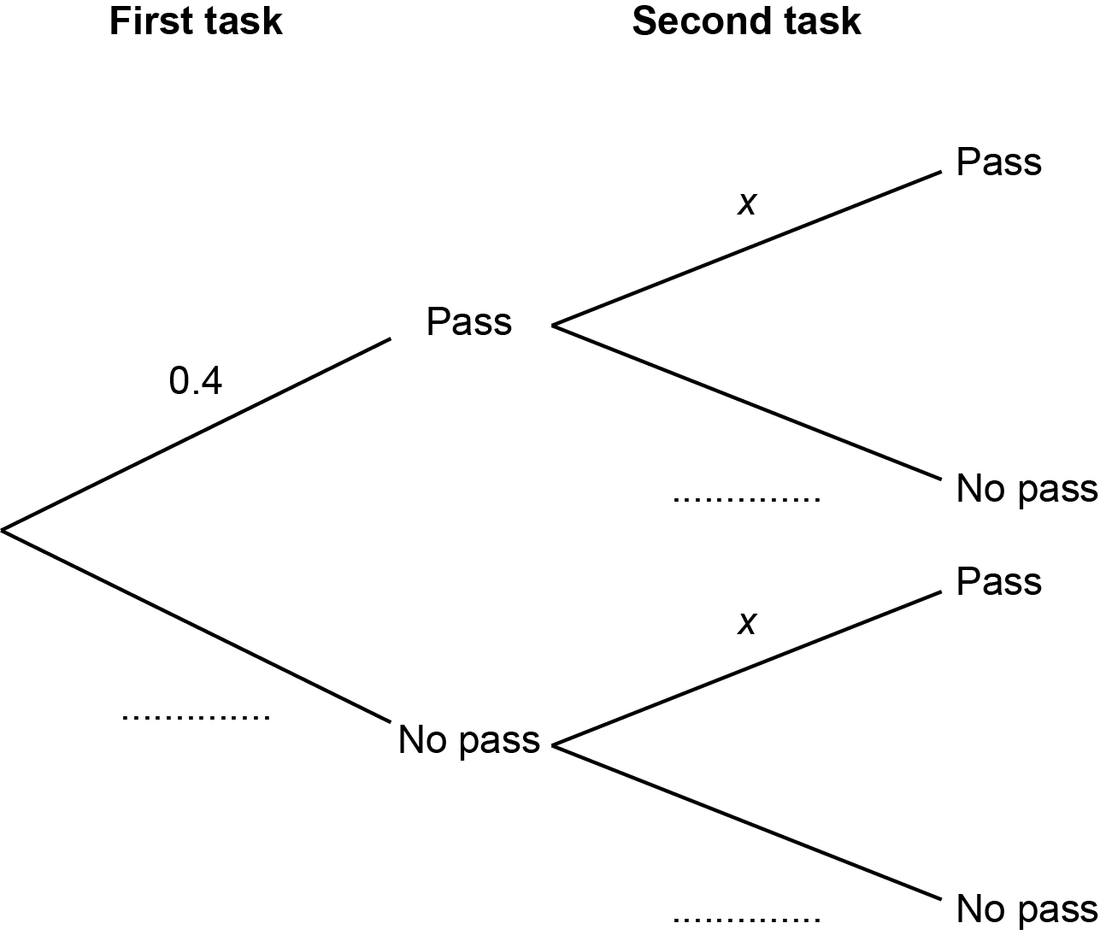
[2]

- Write down the mathematical assumption that has been made about the two tasks.

..................................................................................................................................... [1]

- The probability of the student passing just one of these two tasks is 0.472.

Work out the value of x.
(c) x = .......................................................... [4]
(a) P, Q, R and S are points on the circumference of a circle, centre O.
Angle SQR = 12° and angle SPQ = 54°.

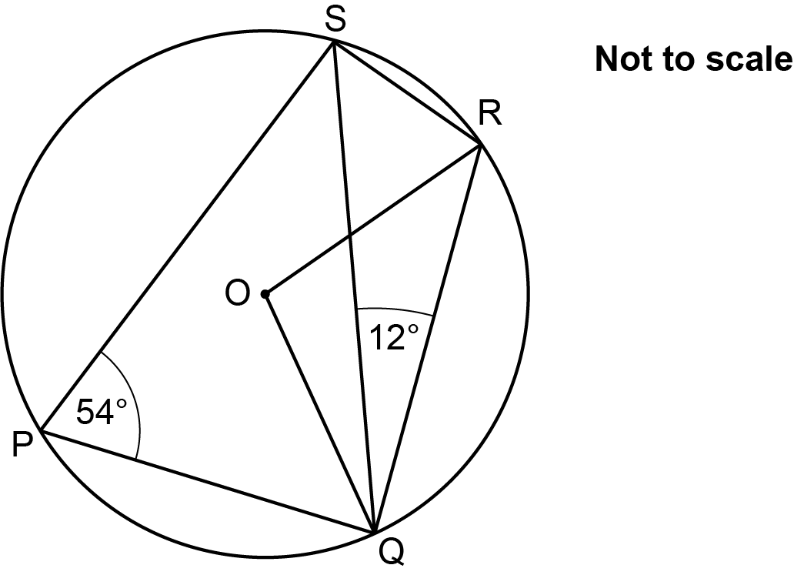

Find the size of angle ROQ.
(a) Angle ROQ = ..........................................................° [3]

- D, E and F are points on the circumference of a circle.

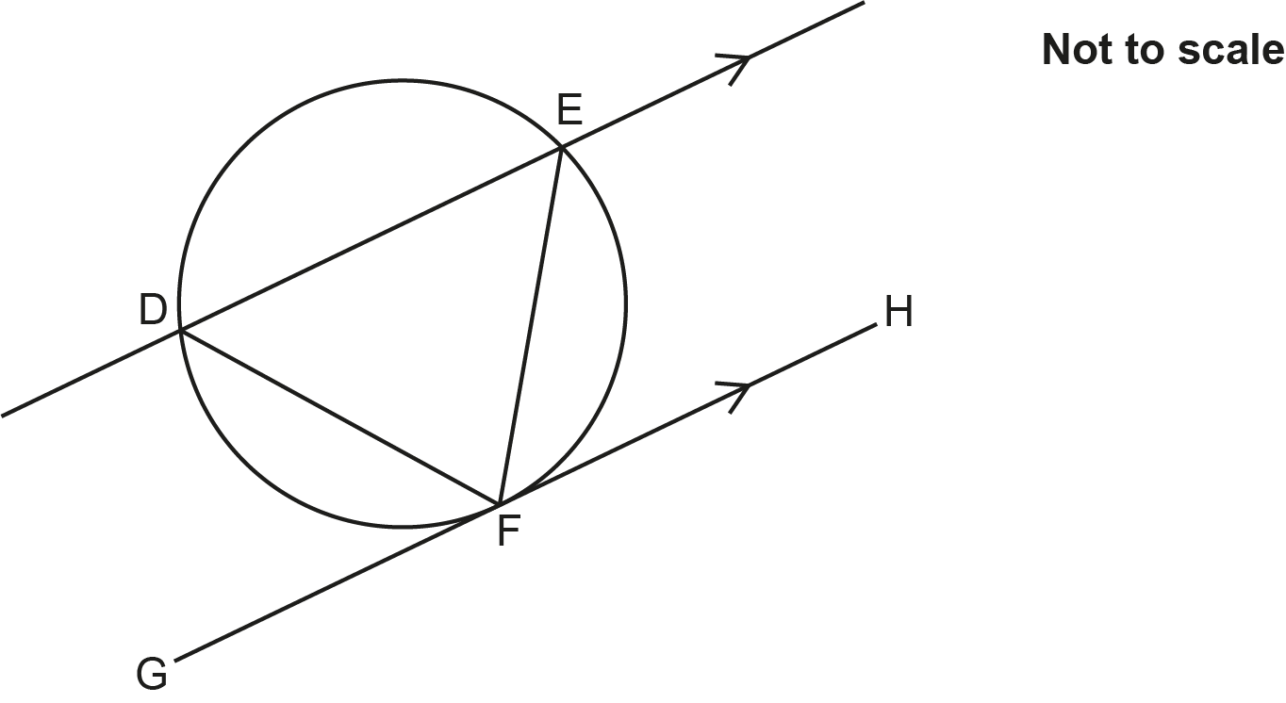

Line GH is a tangent to the circle at F.

Line DE is parallel to line GH.

Complete these statements to prove that triangle DEF is isosceles.
Give reasons for your statements.
You may not need all of the lines.

Angle ............... = Angle .............................. because......................................................

..........................................................................................................................................

Angle ............... = Angle .............................. because......................................................

..........................................................................................................................................

Angle ............... = Angle .............................. because......................................................

..........................................................................................................................................

Angle ............... = Angle .............................. because......................................................

..........................................................................................................................................

Angle ............... = Angle .............................. because......................................................

..........................................................................................................................................

Triangle DEF is isosceles because .......................................................... [3]

- Function A and function B are shown below.

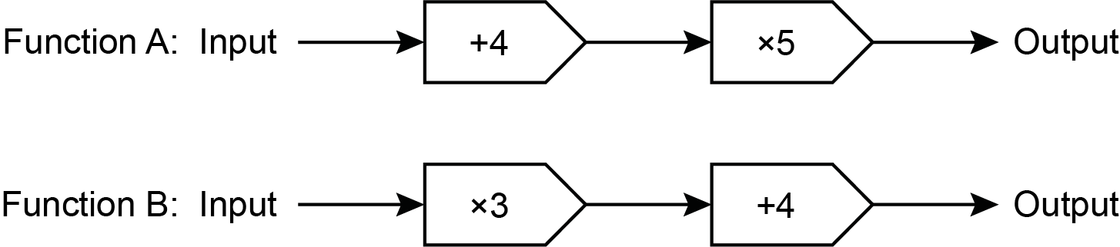

- The output of function B is x.

Write an algebraic expression, in terms of x, for the inverse of function B.
(i) .......................................................... [2]

- Function C is shown below as a composite function.

Complete the diagram below using two arithmetic operations to show function C as a single function.
[4]

- The diagram shows a circle, centre O and radius 65 cm.

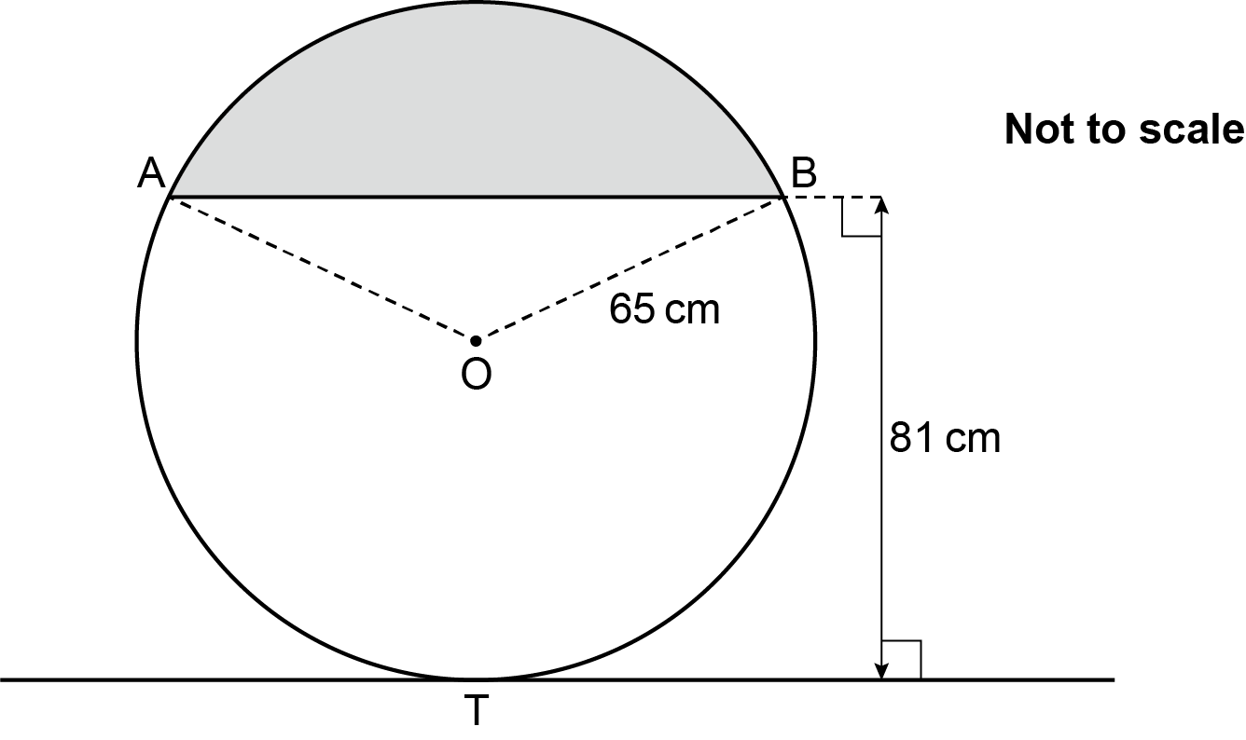

AB is a chord of the circle.
The line through T is a tangent to the circle.

The chord is parallel to the tangent.
The perpendicular distance between the chord and the tangent is 81 cm.

Calculate the area of the shaded segment.
You must show your working.
.......................................................... cm² [6]

- (a) Solve by factorisation.

5x² + 3x − 14 = 0
(a) x = ....................... or x = ....................... [3]

- Write x² + 10x + 19 in the form (x + a) ² − b.
(b) .......................................................... [3]

(i) Write down the coordinates of the turning point of the graph y = (x − 2) ² + 7.
(c)(i) ( .................., ..................) [2]

- Describe the single transformation which maps the graph of y = x² onto the graph of y = (x − 2) ² + 7.
(ii) .......................................................... [2]
- A lift can travel at a maximum speed of 9.78 m/s, correct to 3 significant figures.
The lift travels a distance of 192 m, correct to the nearest metre, between the ground floor and the top floor of a building.

- Use the above information to work out the shortest possible time for the lift to travel between the ground floor and the top floor.
You must show your working.

(a) .......................................................... s [4]

- Explain why your answer to part (a) may not be possible to achieve.

...........................................................................................................................................

..................................................................................................................................... [1]

- The box plot shows the distribution of the waiting time of cars at a road junction.

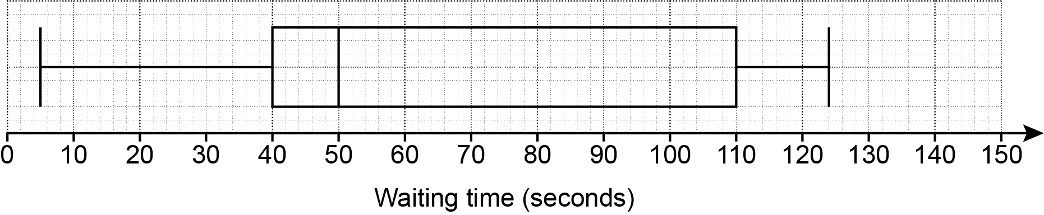

- Write down the median waiting time.
(a) .......................................................... s [1]

- What percentage of the waiting times were less than 40 seconds?
(b) .......................................................... % [1]

- Given that a randomly chosen car waited for more than 40 seconds, write down the probability that the car waited for more than 110 seconds.
(c) .......................................................... [1]

(a) The graph shows the speed of an object during the first 20 seconds of its motion.

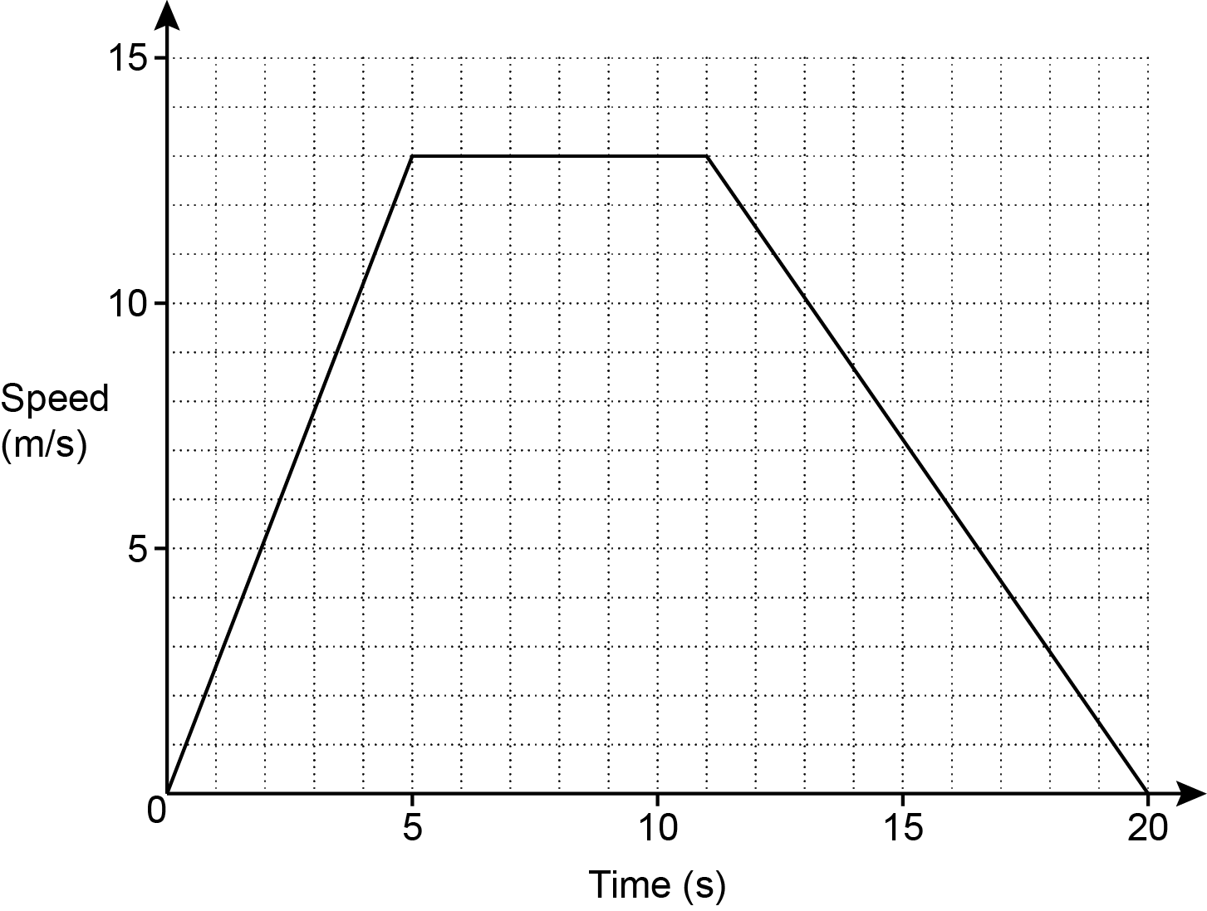

Calculate the distance travelled by the object during the 20 seconds.
(a) .......................................................... m [3]

- The graph shows the distance travelled by an object during the first 4 seconds of
its motion.

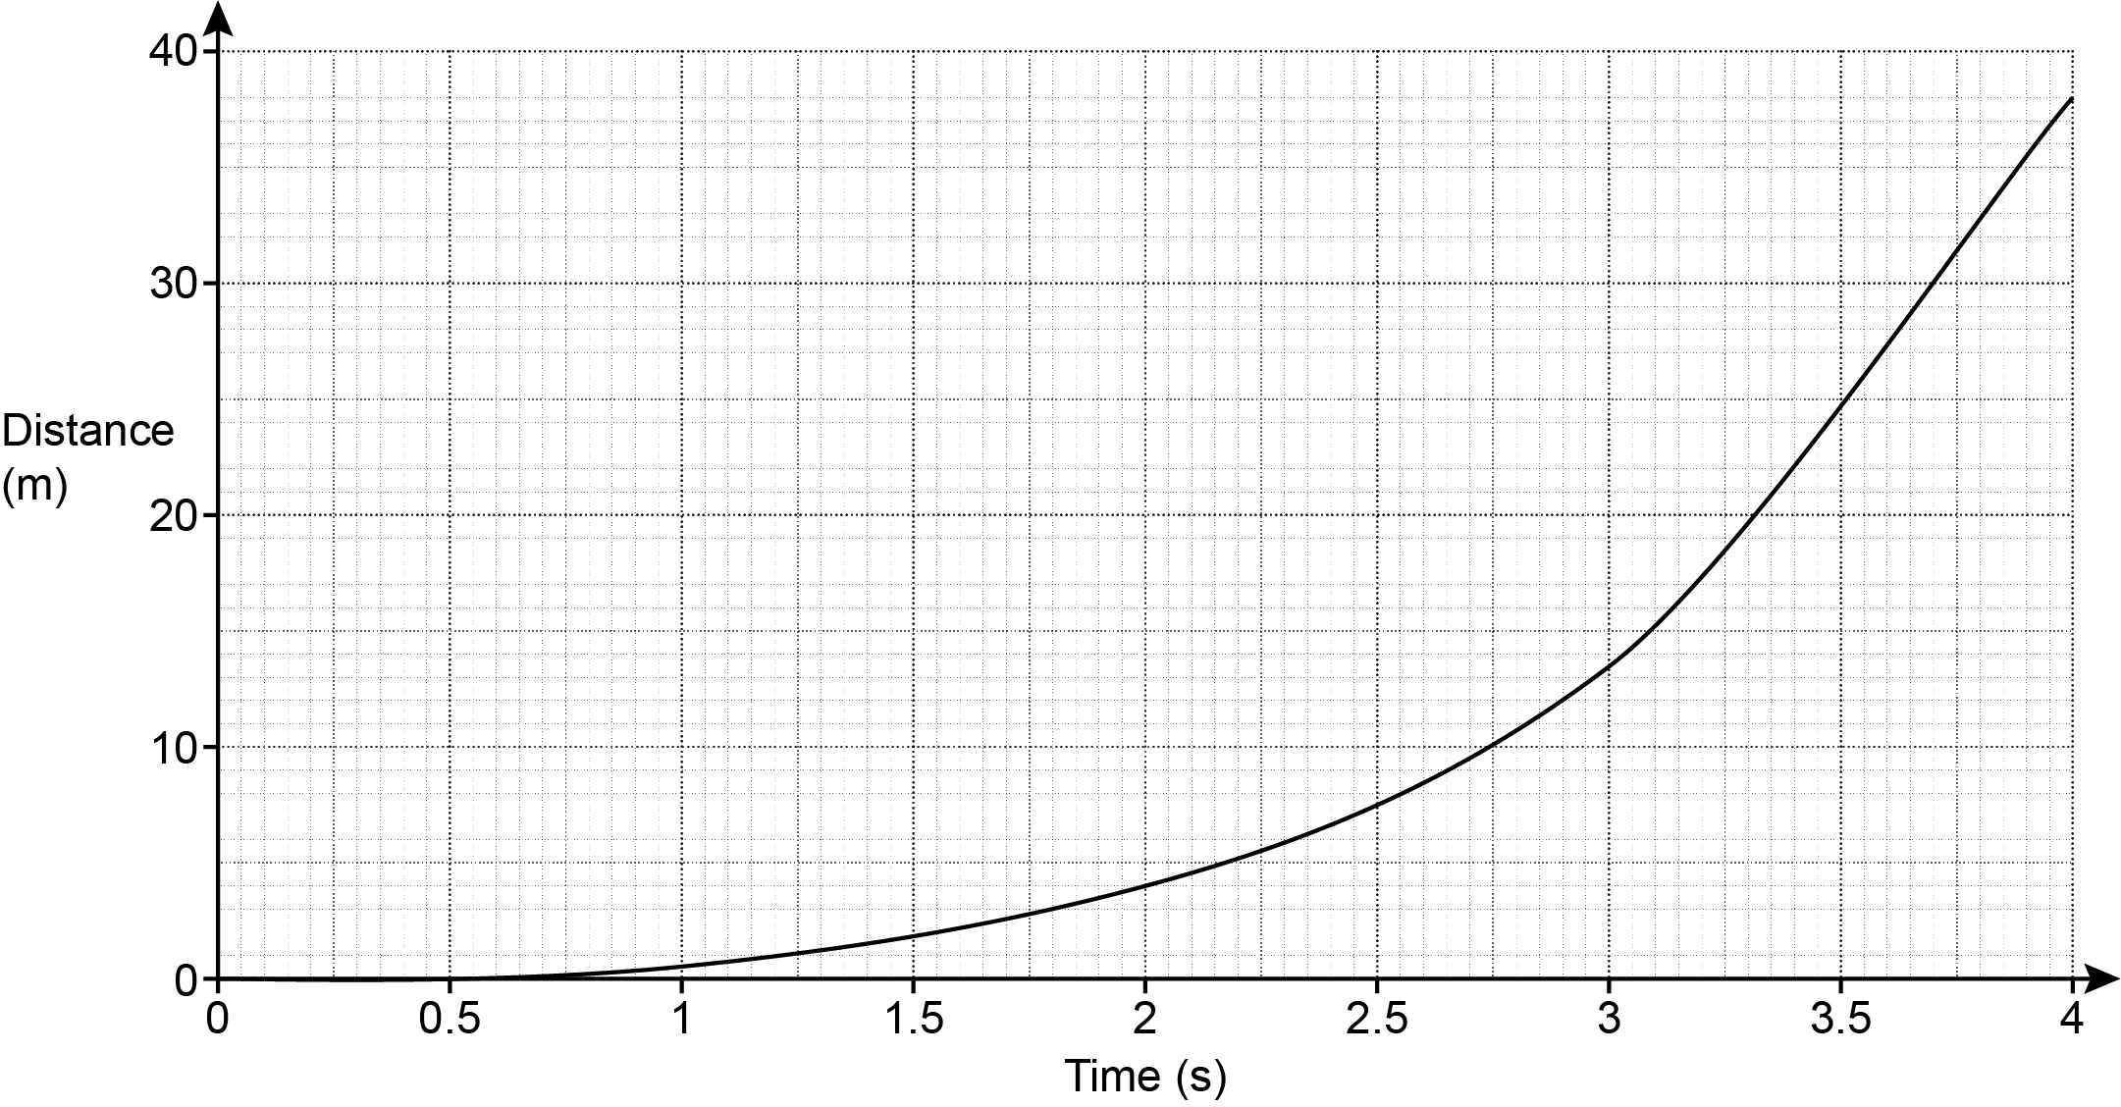

- Work out the average speed of this object between 2 and 4 seconds.
(b)(i) .......................................................... m/s [2]

- Use the graph to estimate the speed of this object at 3 seconds.
You must show working to support your estimate.
(ii) .......................................................... m/s [3]

- What happens to the speed of this object during these 4 seconds of motion. Explain how you know.

The speed ...............................................................................................................

I know this because .................................................................................................

............................................................................................................................ [1]

- Show that can be written in the form
You must show each step in your working.
[5]

END OF QUESTION PAPER

Please note – web links are correct at date of publication but other websites may change over time. If you have any problems with a link you may want to navigate to that organisation’s website for a direct search.



We’d like to know your view on the resources we produce. Click ‘Like’ or ‘Dislike’ to send us an auto generated email about this resource. Add comments if you want to. Let us know how we can improve this resource or what else you need. Your email will not be used or shared for any marketing purposes.
Looking for another resource? There is now a quick and easy search tool to help find free resources for your qualification.
OCR is part of Cambridge University Press & Assessment, which is itself a department of the University of Cambridge.
For staff training purposes and as part of our quality assurance programme your call may be recorded or monitored. © OCR 2024 Oxford Cambridge and RSA Examinations is a Company Limited by Guarantee. Registered in England. Registered office The Triangle Building, Shaftesbury Road, Cambridge, CB2 8EA. Registered company number 3484466. OCR is an exempt charity.
OCR operates academic and vocational qualifications regulated by Ofqual, Qualifications Wales and CCEA as listed in their qualifications registers including A Levels, GCSEs, Cambridge Technicals and Cambridge Nationals.
OCR provides resources to help you deliver our qualifications. These resources do not represent any teaching method we expect you to use. We update our resources regularly and aim to make sure content is accurate but please check the OCR website so that you have the most up to date version. OCR cannot be held responsible for any errors or omissions in these resources.
Though we make every effort to check our resources, there may be contradictions between published support and the specification, so it is important that you always use information in the latest specification. We indicate any specification changes within the document itself, change the version number and provide a summary of the changes. If you do notice a discrepancy between the specification and a resource, please contact us.
You can copy and distribute this resource in your centre, in line with any specific restrictions detailed in the resource. Resources intended for teacher use should not be shared with students. Resources should not be published on social media platforms or other websites.
OCR acknowledges the use of the following content: N/A
Whether you already offer OCR qualifications, are new to OCR or are thinking about switching, you can request more information using our Expression of Interest form.
Please get in touch if you want to discuss the accessibility of resources we offer to support you in delivering our qualifications.

