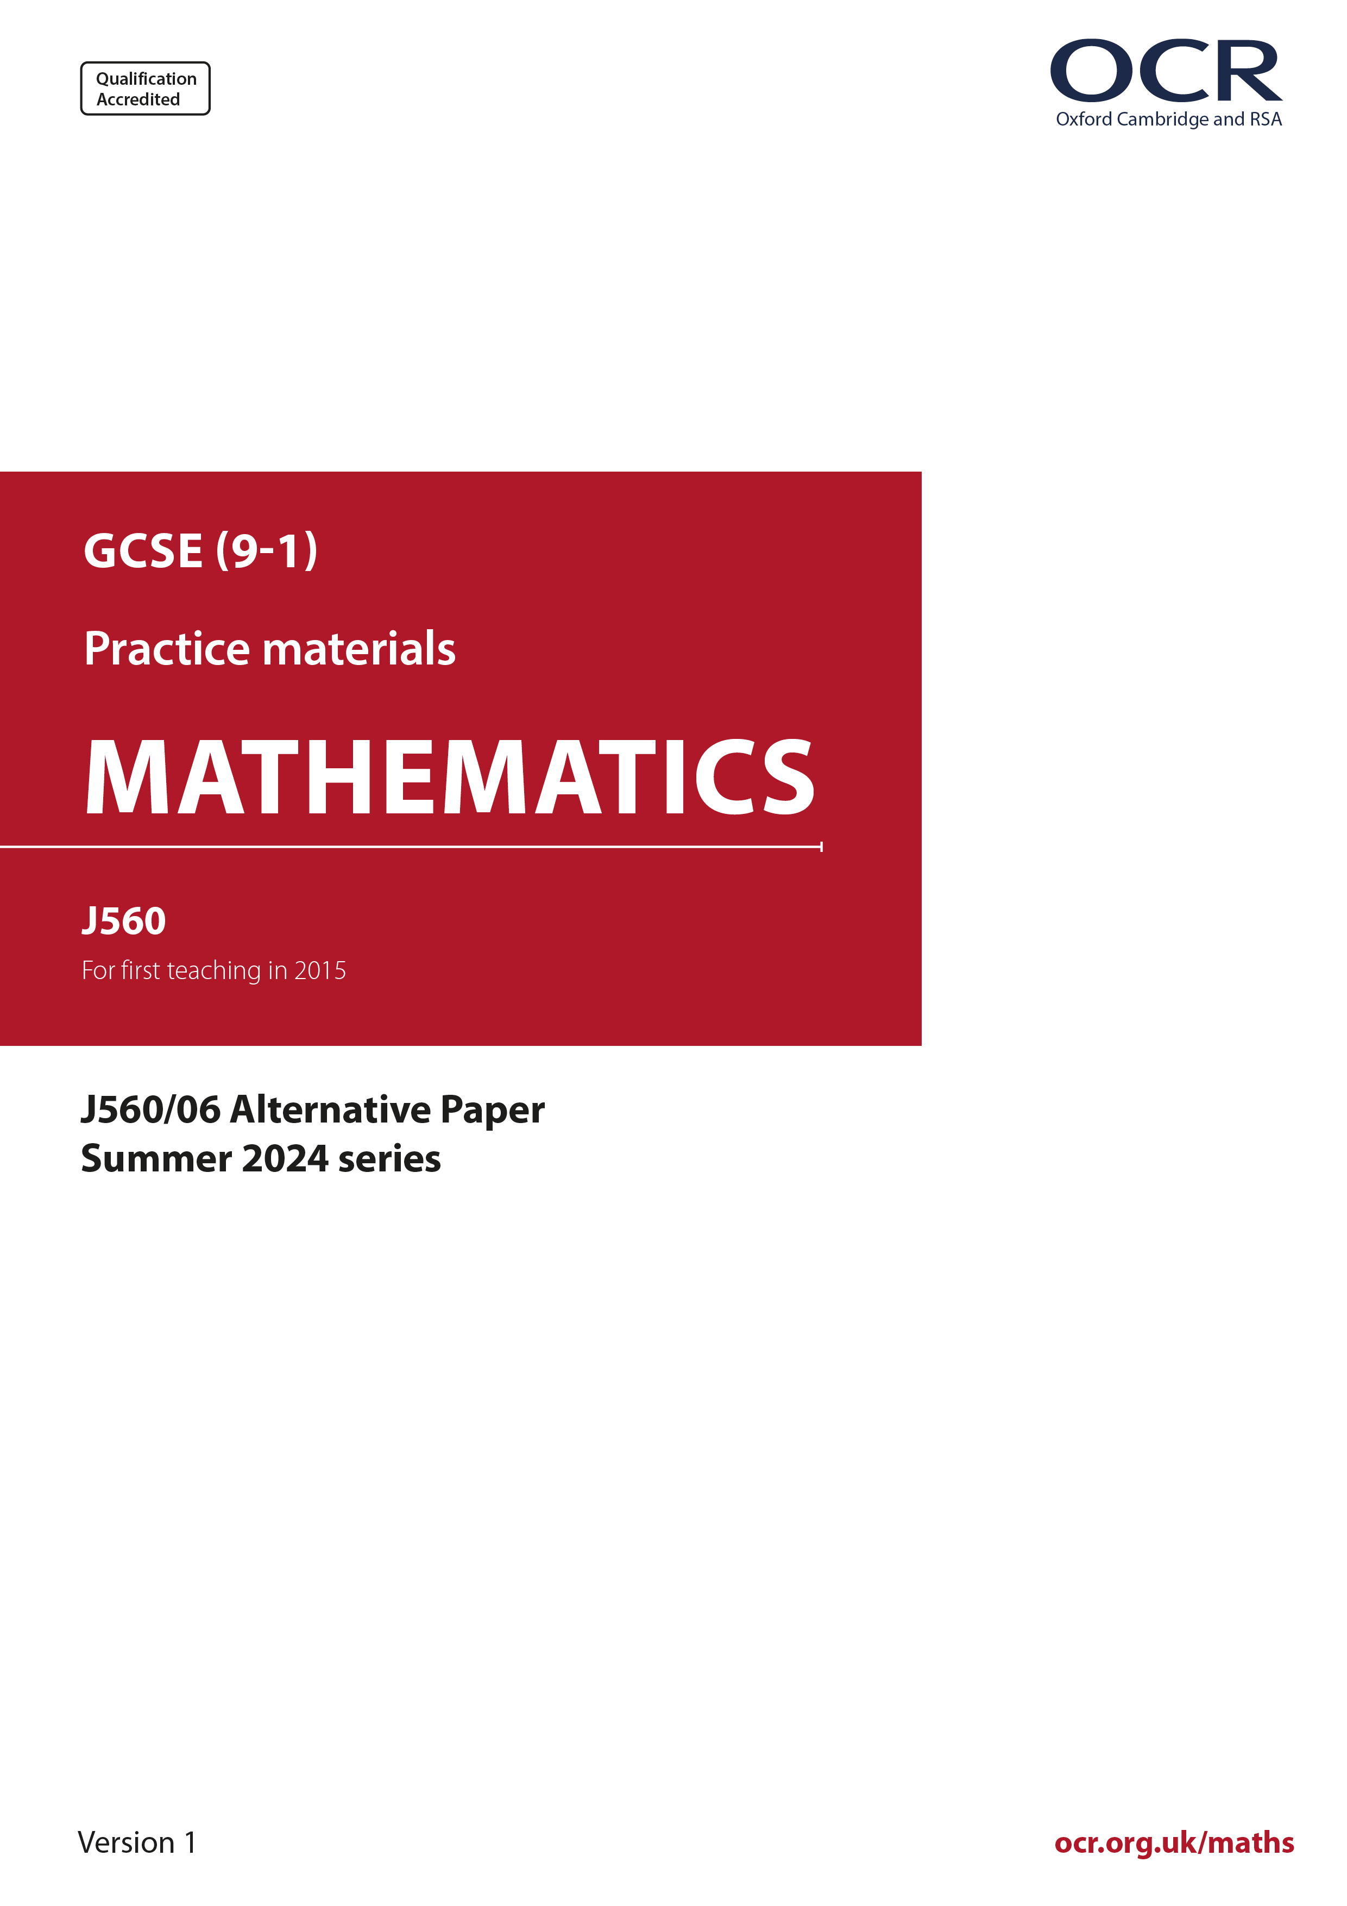
ocr.org.uk/maths

Introduction
OCR’s Alternative Papers for GCSE (9-1) Mathematics are each created by taking one of our past papers and amending the numbers/graphs/diagrams/tables/etc. in its questions.
This Alternative Paper is an amended version of one of the Summer 2024 series papers. The wording and topics assessed are essentially the same, but the responses students need to make will be different. Using both this paper and the corresponding Summer 2024 exam paper with your students at different points in the year will allow you to monitor how their learning has progressed in the time between the two papers.
Please note that when students originally sat this paper in 2024, they were given a formulae sheet. Foundation tier and Higher tier formulae sheets are published on Teach Cambridge alongside the Alternative Papers, for use with students as required.
Additional Alternative Papers and past papers are available to download from Teach Cambridge.



GCSE (9-1) Mathematics
J560/06 Paper 6 (Higher Tier)
Alternative Paper (Summer 2024)

Time allowed: 1 hour 30 minutes

H
You must have:
- the Formulae Sheet for Foundation Tier (inside this document)

You can use:
- a scientific or graphical calculator
- geometrical instruments
- tracing paper

Name

INSTRUCTIONS
- Use black ink. You can use an HB pencil, but only for graphs and diagrams.
- Write your answer to each question in the space provided. You can use extra paper if you need to, but you must clearly show your candidate number, the centre number and the question numbers
- Answer all the questions.
- Where appropriate, your answer should be supported with working. Marks might be
given for using a correct method, even if your answer is wrong.
- Use the π button on your calculator or take π to be 3.142 unless the question says
something different.

INFORMATION
- The total mark for this paper is 100.
- The marks for each question are shown in brackets [ ].
- This document has 20 pages.

ADVICE
- Read each question carefully before you start your answer.

- Below are six graphs, numbered 1 to 6, that show different relationships between x and y.

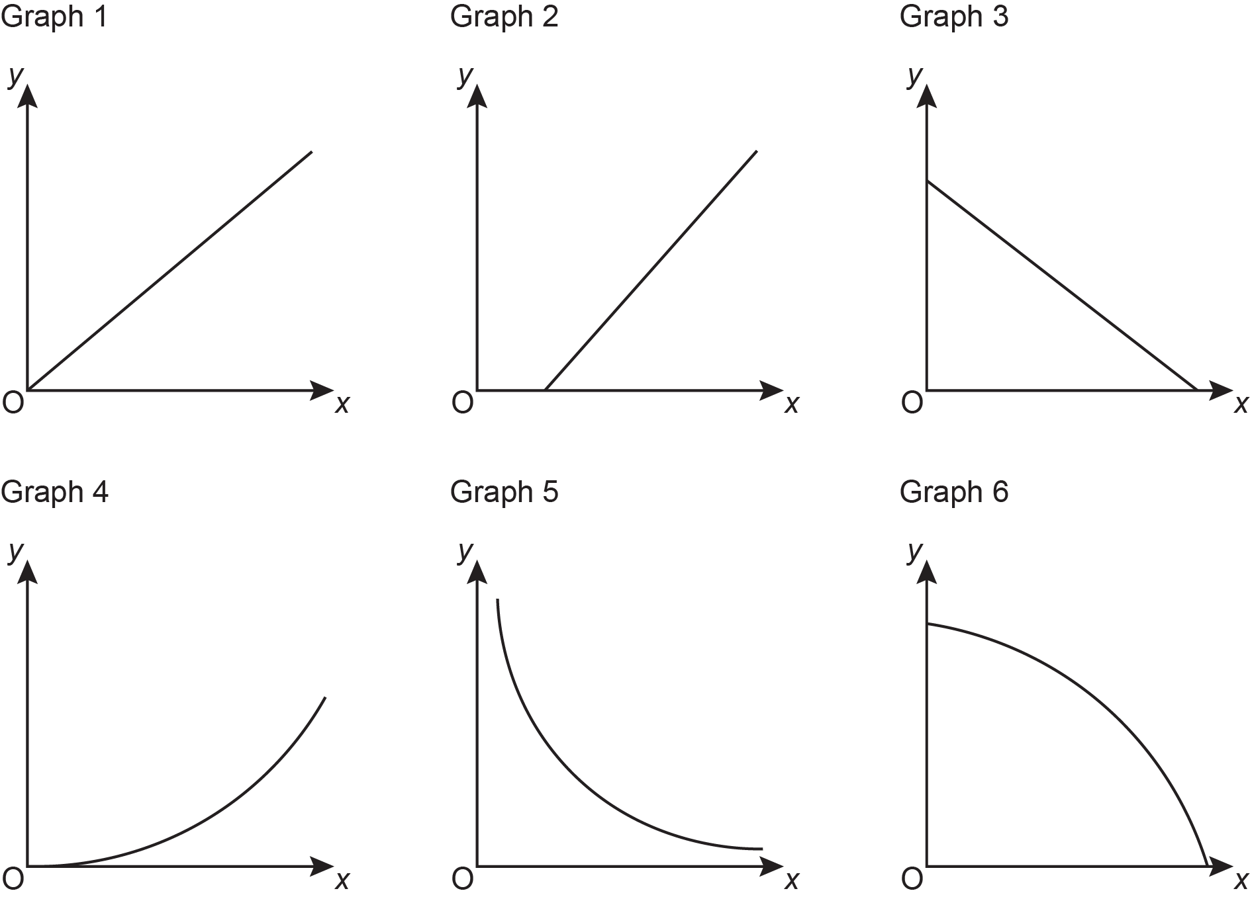

For each description below, write down the number of the graph that best represents the relationship between x and y.

x: temperature in °F
y: temperature in °C, where Graph ............................

x: time taken to run 100 m
y:. average speed when running 100 m Graph ............................

x: radius of a solid sphere made from clay
y: mass of the same solid sphere. Graph ............................
[3]

- The graph shows a household’s average daily expenditure, in pounds (£).

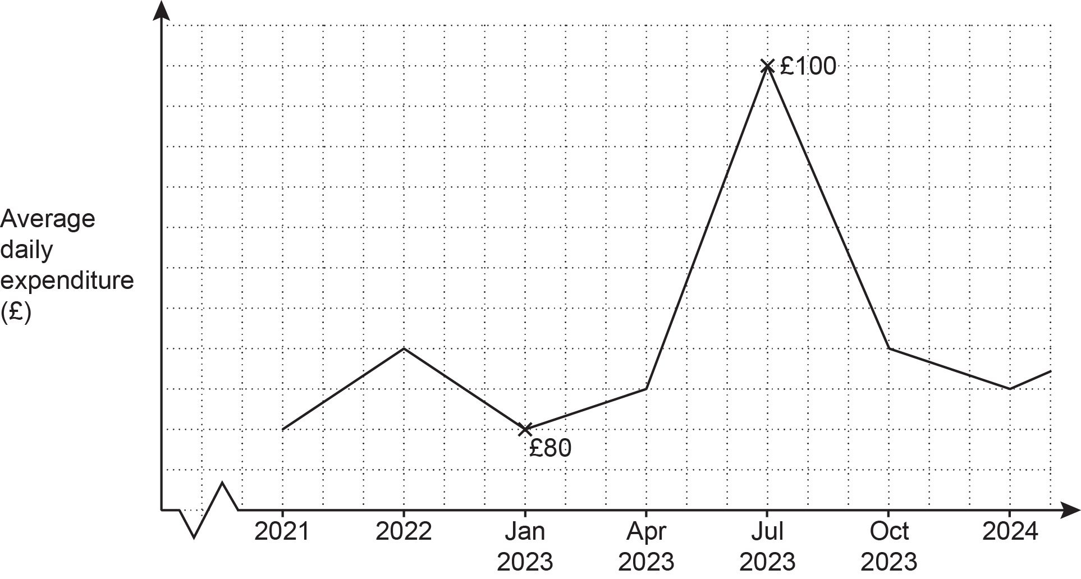

Give two different reasons why this graph is misleading.

Reason 1: ..................................................................................................................................

....................................................................................................................................................

Reason 2: ..................................................................................................................................

.............................................................................................................................................. [2]

- The word GEOMETRIC is spelt using tiles.

The tiles are put into an empty bag.

One at a time, 99 children each take a tile at random from the bag.
They record the letter and then put the tile back in the bag.

Work out how many times the letter E is expected to be taken from the bag.
.......................................................... [3]

- 1 cm on a map represents 120 km in real life.

- Below is part of the map showing City A and City B.

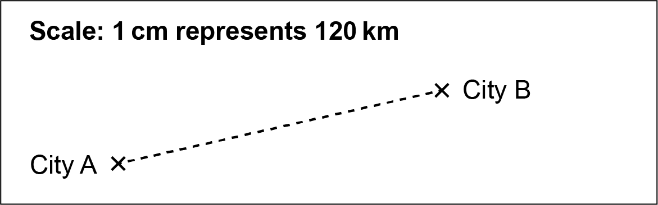

Alex is planning to walk from City A to City B for charity.

Alex measures the straight-line distance on the map from City A to City B accurately as 5 cm.
Alex says she will walk from City A to City B at an average speed of 2.5 km/h for 10 hours per day.

- Use this information to work out how many days Alex needs to complete the walk from City A to City B.
(a)(i) .......................................................... days [4]

- Explain why the information used in part (i) is likely to give an underestimate for the number of days Alex needs to complete the walk.

.................................................................................................................................

............................................................................................................................ [1]

- Riley writes the scale of the map, 1 cm represents 120 km, as the ratio 1 : 120.

Explain Riley ’s error and write the scale correctly in the form 1 : n.
Riley’s error is……………………………………………………………………………………

...........................................................................................................................................

The correct answer is 1 :.......................................................... [2]
- The diagram shows a regular pentagon made using ten congruent right-angled triangles.
The length of one side of the pentagon is 16 cm.

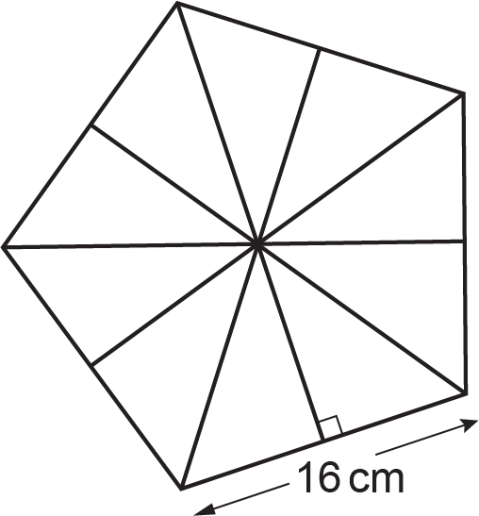

- Show that the area of the pentagon is 440.44 cm², correct to 2 decimal places. [6]
- The regular pentagon is the base of a pyramid.

The pyramid has volume 850 cm³.
The perpendicular height of the pyramid is h cm.

Calculate the value of h.

[The volume of a pyramid is × area of base × perpendicular height.]
(b) h = .......................................................... [3]
(a) Two numbers, A and B, are written as the product of their prime factors.

A = 2² × 3 × 5²
B = 2⁴ × 5

Find the lowest common multiple (LCM) of A and B.
Give your answer as an ordinary number.
(a) .......................................... [2]

- A number, R, is written as the product of its prime factors.

R = 2 × 3 × 5² × k, where k is a prime number.

The highest common factor (HCF) of R and another number, P, is 51.
Find the value of k.
(b) k = .......................................... [2]

- Two bags of fruit contain only apples and bananas.
In bag X, the ratio of apples to bananas is 3 : 7.
In bag Y, of the fruit are apples.

- Jack says

Bag X and bag Y contain the same number of apples.

Tick the correct statement.

Jack is definitely correct
Jack might be correct, or might not be correct
Jack is definitely not correct

Show how you decided.
...........................................................................................................................................

...........................................................................................................................................

..................................................................................................................................... [3]

- Jack adds 4 bananas to bag X.
The ratio of apples to bananas is now 2 : 5.

How many apples are in bag X?
(b) ........................................................... [3]
(a) Complete this table for y = x³ − 2x².

x | -2 | -1 | 0 | 1 | 2 | 3
y | -16 |  | 0 | -1 | 0
[2]

- Draw the graph of y = x³ − 2x² for values of x from -2 to 3.

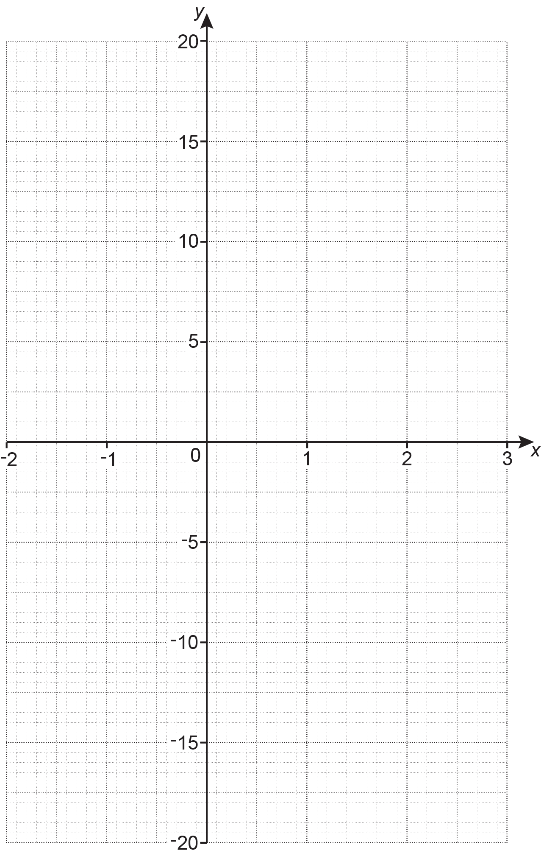
[3]

- Use the graph to solve the equation x³ − 2x² = 3.
Give your answer to 1 decimal place.
(c) .......................................................... [1]
- The diagram shows a shaded sector inside a parallelogram.
The sector has an angle of 30°.
The parallelogram, ABCD, has length BC = 18 cm and AB = 10 cm.
The perpendicular distance between BC and AD is 5 cm.

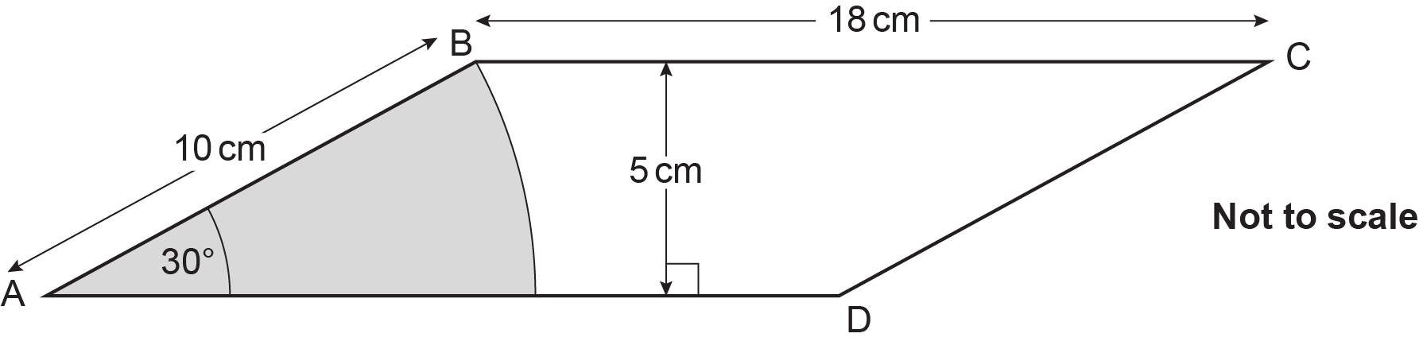

- Show that the area of the sector is 26.2 cm², correct to 3 significant figures. [3]
- Work out the percentage of the parallelogram that is not shaded.
(b) .......................................................... % [4]
- Ten consecutive numbers are written in ascending order in this grid, starting from the top and working left to right.

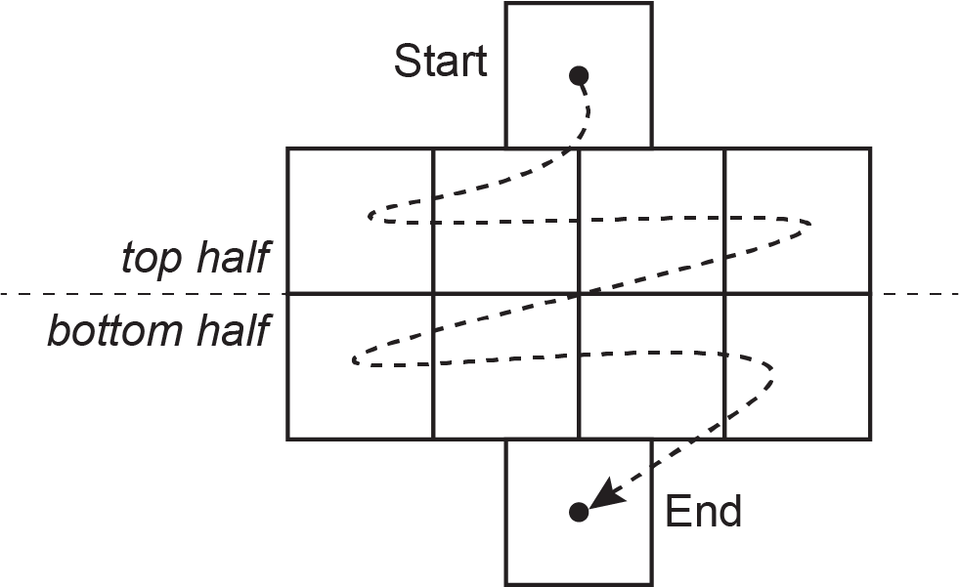

- Finley writes the numbers 5 to 14 in the grid.

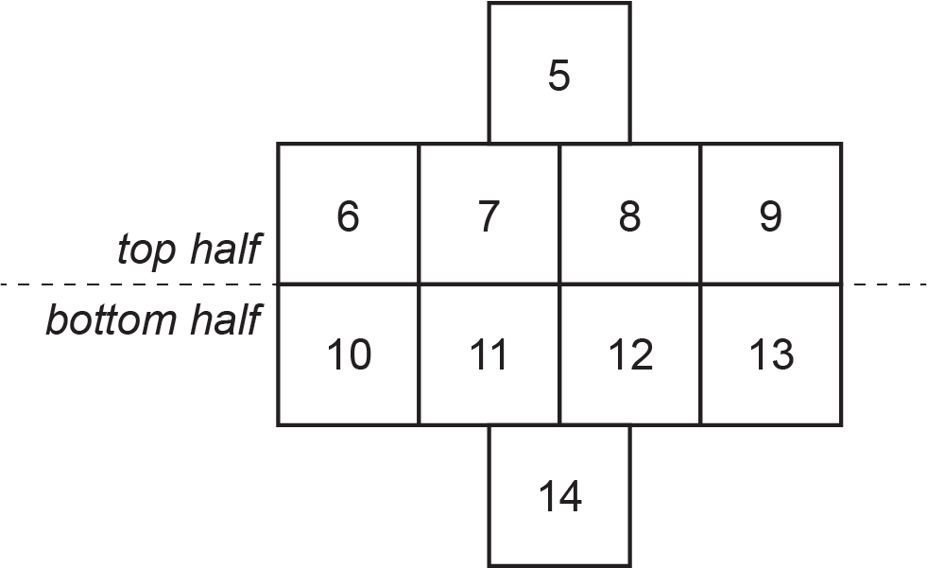

Show that for Finley’s grid, the sum of the numbers in the top half of the grid is 25 less than the sum of the numbers in the bottom half of the grid. [1]

- Use algebra to prove that for any set of ten consecutive numbers written in this grid in the same way, the sum of the numbers in the top half of the grid is 25 less than the sum of the numbers in the bottom half of the grid. [5]

- Kareem travels to work each day by train.

He records whether
- the train is on time or late
- there are seats available or no seats available.

Kareem’s results are shown on this partly completed frequency tree.

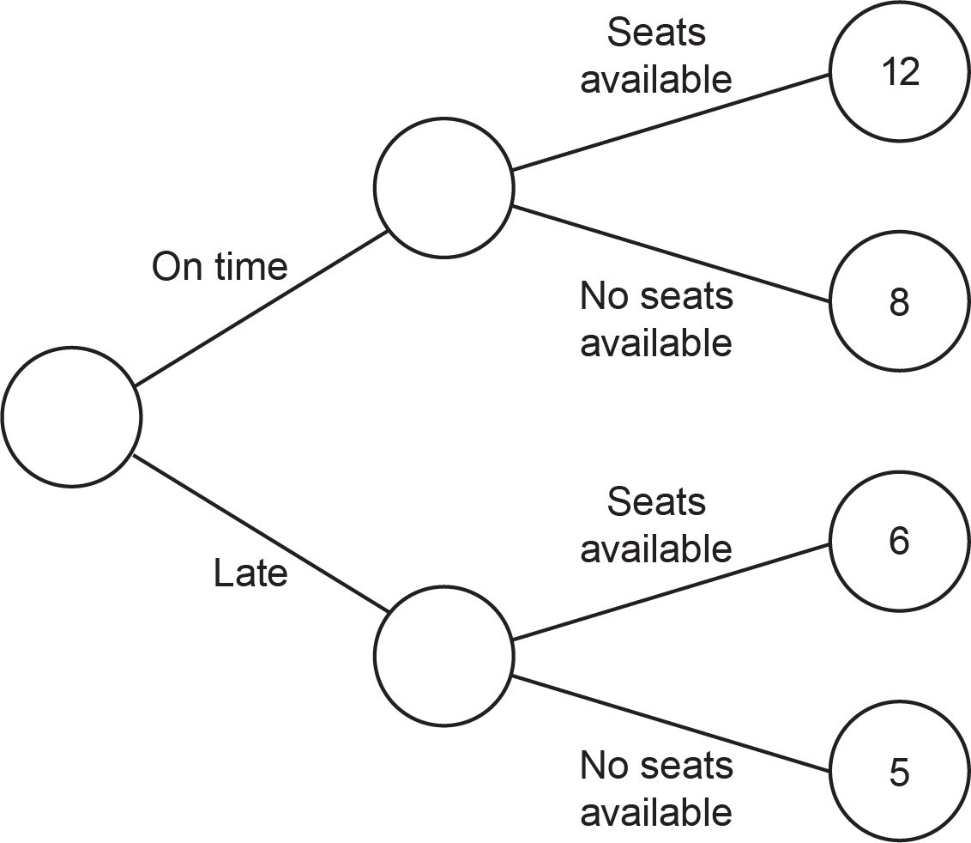

- Find the relative frequency of there being no seats available on Kareem’s train journey.
(a) .......................................................... [2]

- Kareem says

If the train is late, travellers are less likely to find seats available than if the train was on time.

Does Kareem’s data suggest he is correct?
Show how you decide.
............................................. because ..............................................................................

...........................................................................................................................................

..................................................................................................................................... [3]

- The region R is shown on this grid.

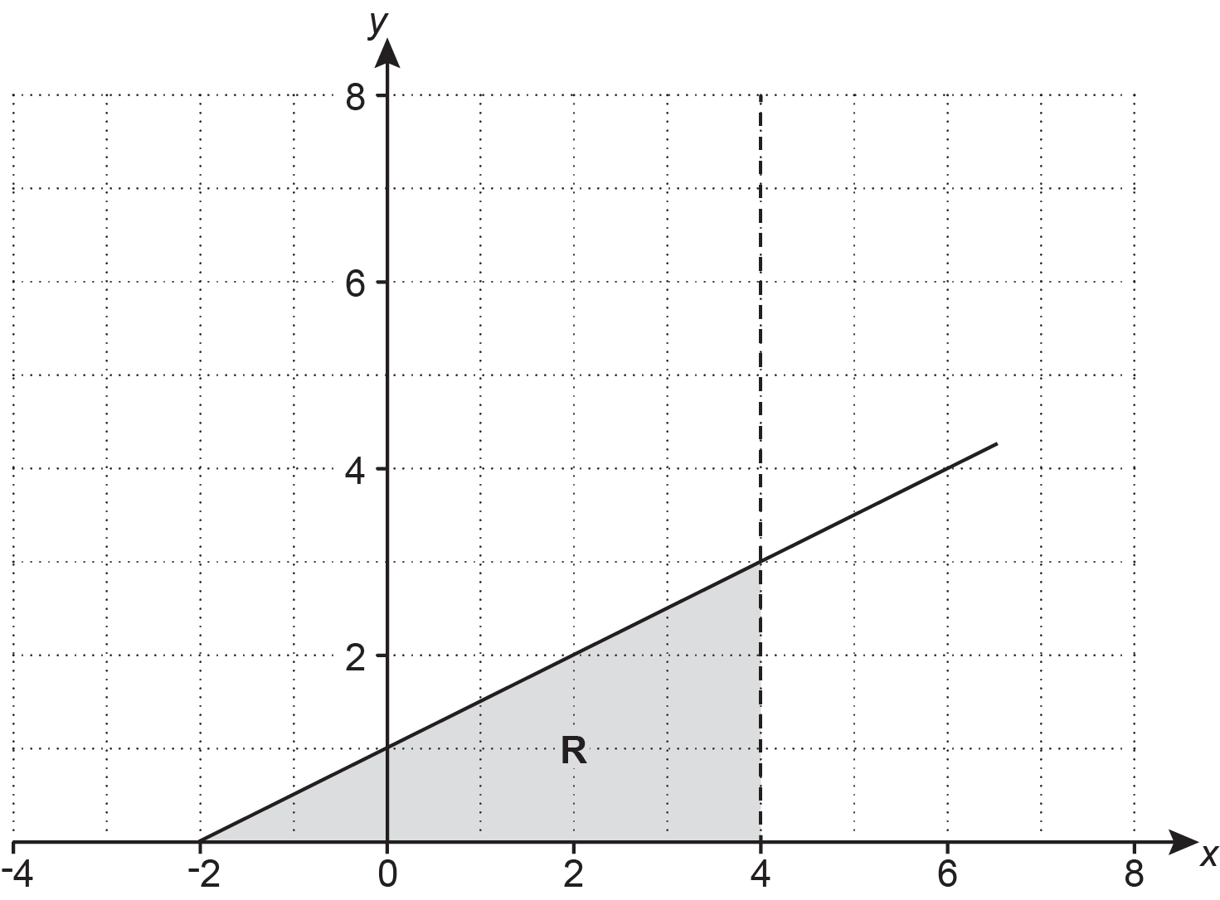

The region R is defined by three inequalities.
The first inequality is given below.

Complete the second inequality and write down the third inequality needed to define region R.

y ≥ 0

2y .......... x + 2

................................ [3]

- A group of students record the time taken to travel to school.
All students in the group took less than an hour to travel to school.
Some of their results are recorded on this histogram.

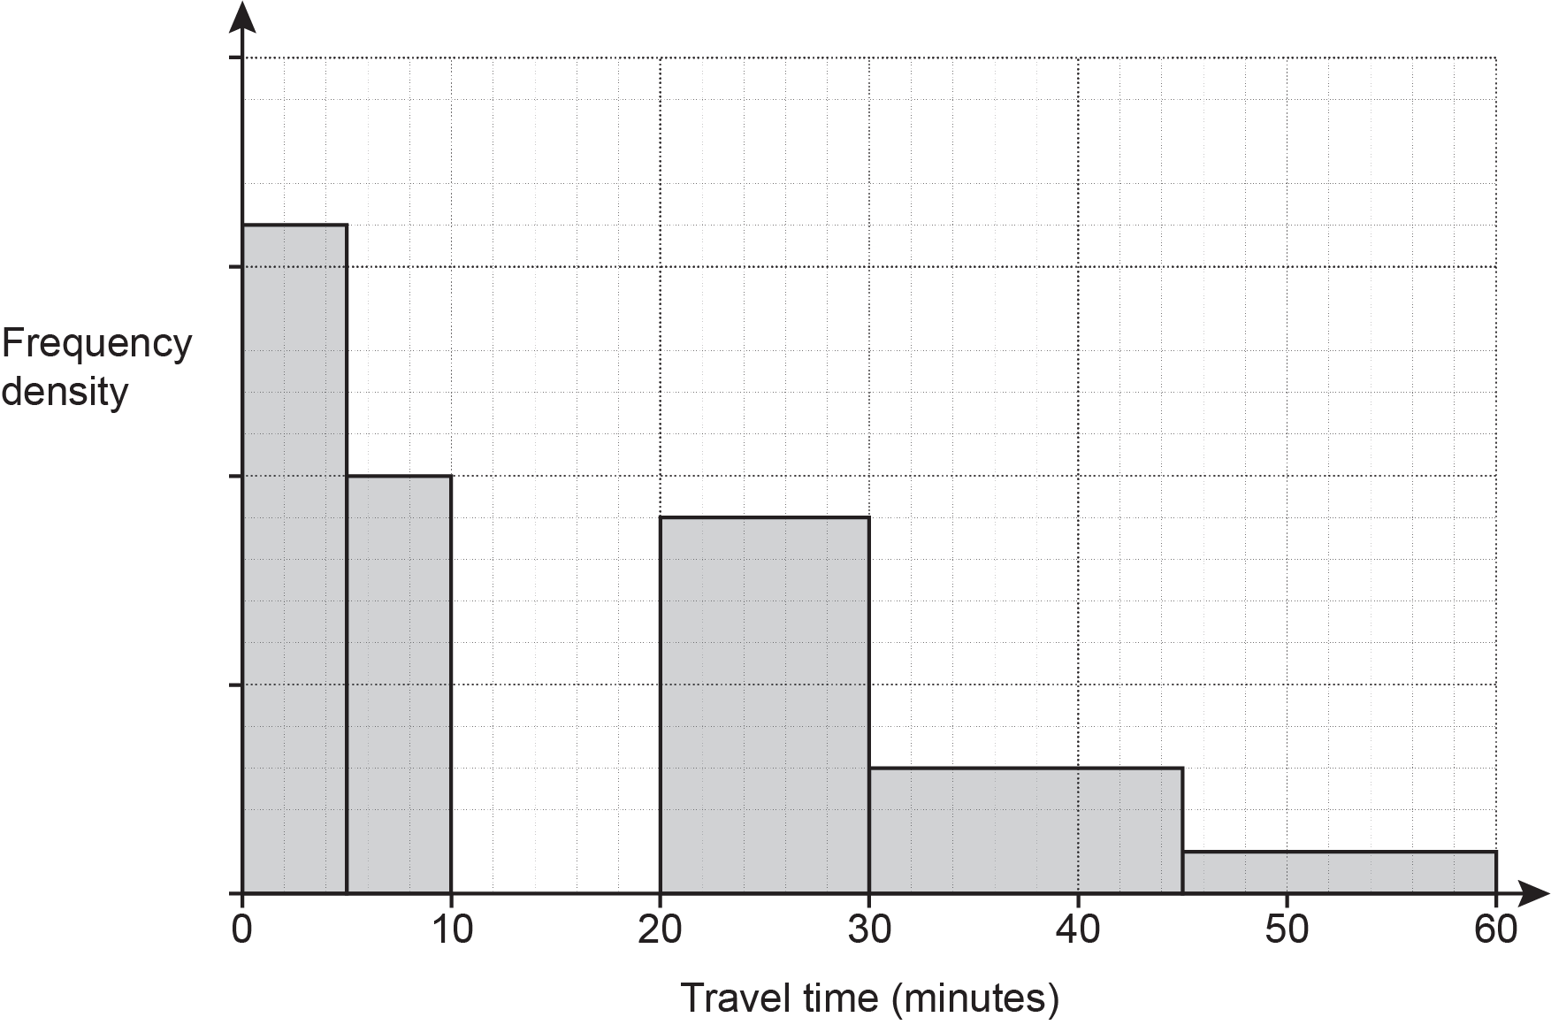

3 students took more than 45 minutes to travel to school.

- How many students took more than 20 minutes to travel to school?
(a) .......................................................... students [4]

- 14 students took between 10 and 20 minutes to travel to school.

Add these students’ results to the histogram. [2]

- The sketch shows the coordinate axes and the point (0, 8).

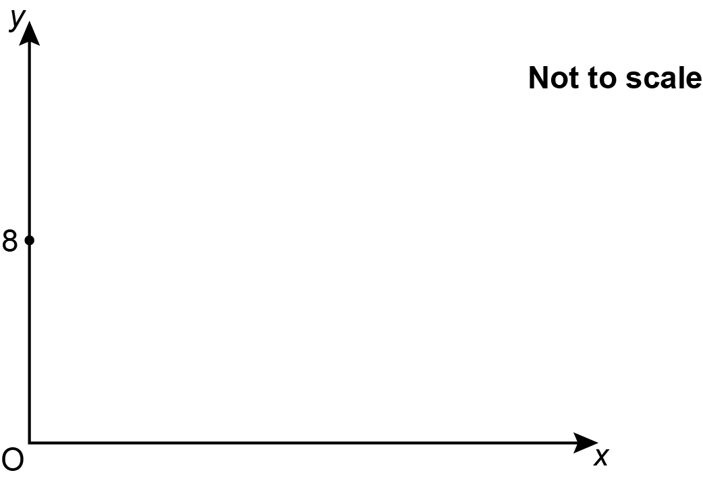

The distance from the point (0, 8) to a point (6, t) is 7.5 units.

Work out the two possible values of t.
You must show your working and you may use the sketch to help.
t = ......................... and ......................... [5]

- y is inversely proportional to x⁴.
y = 4 when x = 6.

Find a formula linking x and y.
........................................................... [3]

- Write in the form kxm.
.......................................................... [4]

(a) Without using a calculator, show that $\text{0}.\dot{\text{4}}\dot{\text{5}}$ can be written as . [3]
- Explain how $\frac{\text{5}}{\text{11}}=\text{0}.\dot{\text{4}}\dot{\text{5}}$ can be used to find as a decimal and write down its value.
...........................................................................................................................................

............................................................................................................. = ............... [2]

- The diagram shows two triangles ABC and ADC.

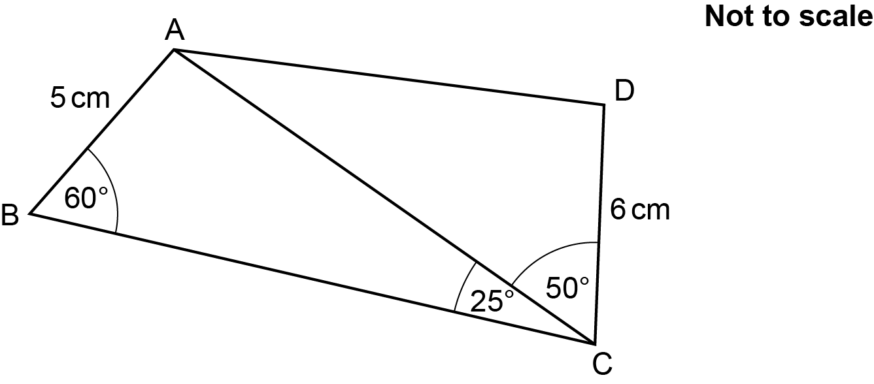

Angle ABC = 60°, angle ACB = 25° and angle ACD = 50°.
AB = 5 cm and DC = 6 cm.

Calculate length AD.
You must show your working.
AD = .......................................................... cm [6]

- The diagram shows a circle with centre (0, 0) and a tangent at (5, -12).
The tangent at (5, -12) crosses the x-axis at (p, 0).

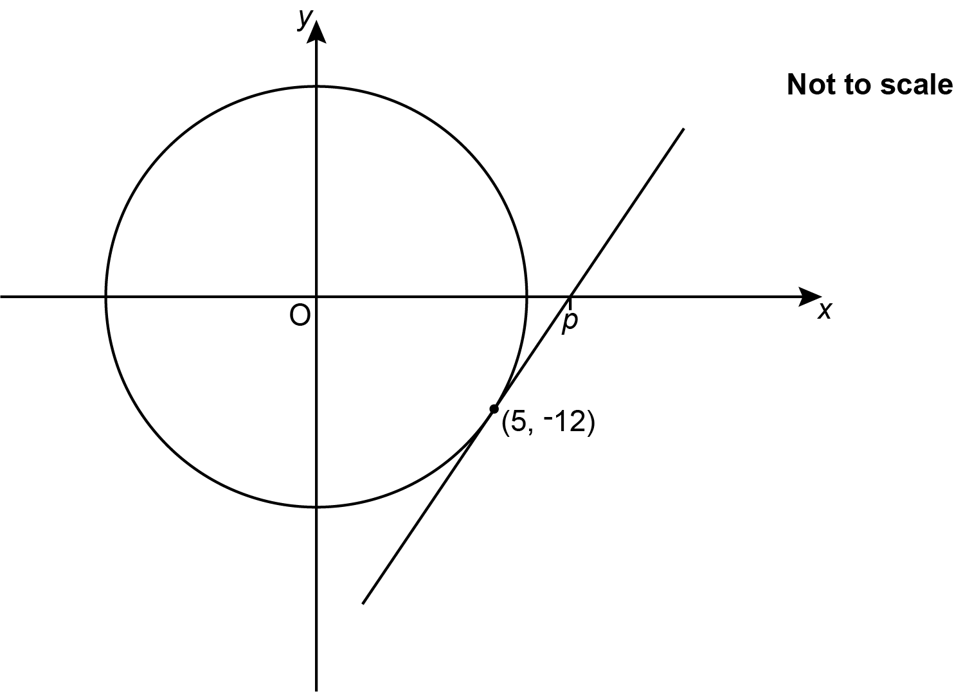

Find the exact value of p.
You must show your working.
p = .......................................................... [5]

Turn over for Question 20

- Write as a single fraction in its simplest form.

........................................................... [5]

END OF QUESTION PAPER

Please note – web links are correct at date of publication but other websites may change over time. If you have any problems with a link you may want to navigate to that organisation’s website for a direct search.



We’d like to know your view on the resources we produce. Click ‘Like’ or ‘Dislike’ to send us an auto generated email about this resource. Add comments if you want to. Let us know how we can improve this resource or what else you need. Your email will not be used or shared for any marketing purposes.
Looking for another resource? There is now a quick and easy search tool to help find free resources for your qualification.
OCR is part of Cambridge University Press & Assessment, which is itself a department of the University of Cambridge.
For staff training purposes and as part of our quality assurance programme your call may be recorded or monitored. © OCR 2024 Oxford Cambridge and RSA Examinations is a Company Limited by Guarantee. Registered in England. Registered office The Triangle Building, Shaftesbury Road, Cambridge, CB2 8EA. Registered company number 3484466. OCR is an exempt charity.
OCR operates academic and vocational qualifications regulated by Ofqual, Qualifications Wales and CCEA as listed in their qualifications registers including A Levels, GCSEs, Cambridge Technicals and Cambridge Nationals.
OCR provides resources to help you deliver our qualifications. These resources do not represent any teaching method we expect you to use. We update our resources regularly and aim to make sure content is accurate but please check the OCR website so that you have the most up to date version. OCR cannot be held responsible for any errors or omissions in these resources.
Though we make every effort to check our resources, there may be contradictions between published support and the specification, so it is important that you always use information in the latest specification. We indicate any specification changes within the document itself, change the version number and provide a summary of the changes. If you do notice a discrepancy between the specification and a resource, please contact us.
You can copy and distribute this resource in your centre, in line with any specific restrictions detailed in the resource. Resources intended for teacher use should not be shared with students. Resources should not be published on social media platforms or other websites.
OCR acknowledges the use of the following content: N/A
Whether you already offer OCR qualifications, are new to OCR or are thinking about switching, you can request more information using our Expression of Interest form.
Please get in touch if you want to discuss the accessibility of resources we offer to support you in delivering our qualifications.

