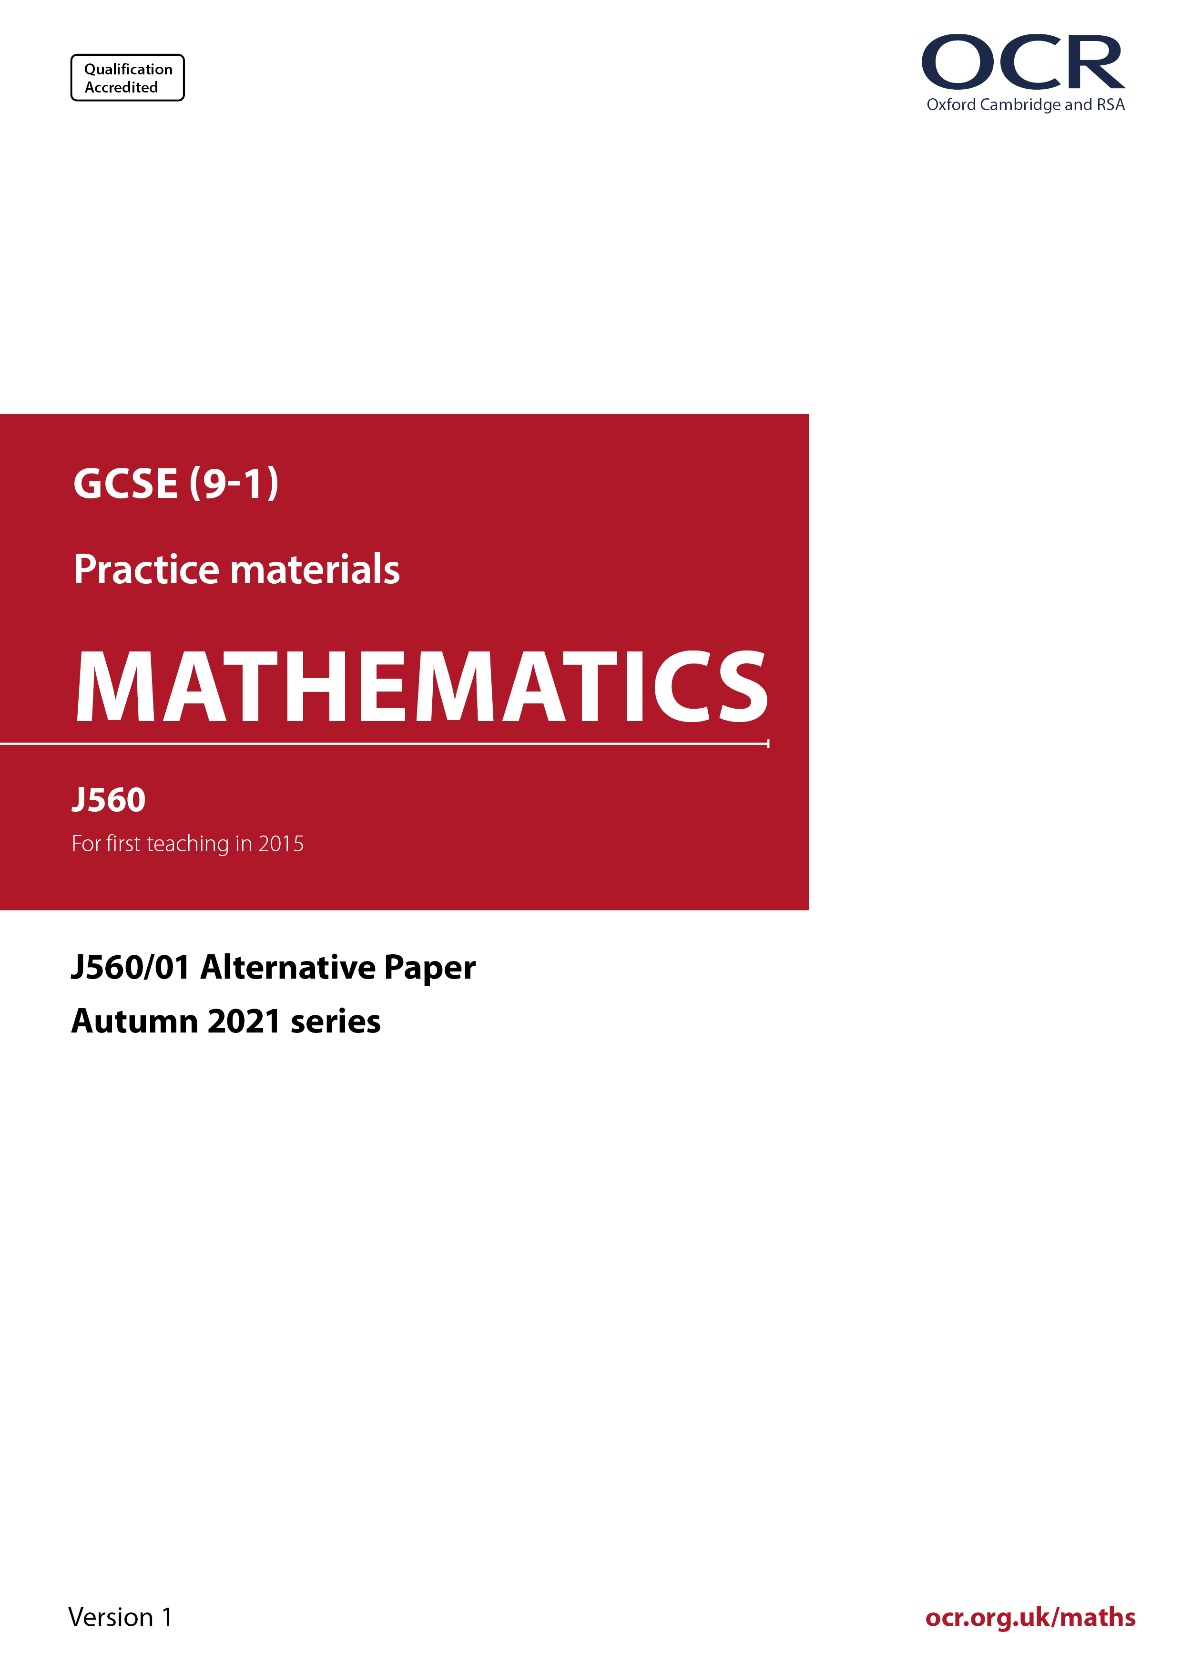
ocr.org.uk/maths

Introduction
OCR’s Alternative Papers for GCSE (9-1) Mathematics are each created by taking one of our past papers and amending the numbers/graphs/diagrams/tables/etc. in its questions.
This Alternative Paper is an amended version of one of the November 2021 series papers. The wording and topics assessed are essentially the same, but the responses students need to make will be different. Using both this paper and the corresponding November 2021 exam paper with your students at different points in the year will allow you to monitor how their learning has progressed in the time between the two papers.
Additional Alternative Papers and past papers are available to download from the OCR website.



GCSE (9-1) Mathematics
J560/01 Paper 1 (Foundation Tier)
Alternative Paper (November 2021)

Time allowed: 1 hour 30 minutes

You may use:
- a scientific or graphical calculator
- geometrical instruments
- tracing paper

Name

INSTRUCTIONS
- Use black ink. You can use an HB pencil, but only for graphs and diagrams.
- Write your answer to each question in the space provided. You can use extra paper if
you need to, but you must clearly show your candidate number, the centre number and
the question numbers.
- Answer all the questions.
- Where appropriate, your answer should be supported with working. Marks might be
given for using a correct method, even if your answer is wrong.
- Use the π button on your calculator or take π to be 3.142 unless the question says
something different.

INFORMATION
- The total mark for this paper is 100.
- The marks for each question are shown in brackets [ ].
- This document has 23 pages.

ADVICE
- Read each question carefully before you start your answer.

Answer all the questions.

1 (a) Measure the length of this line.

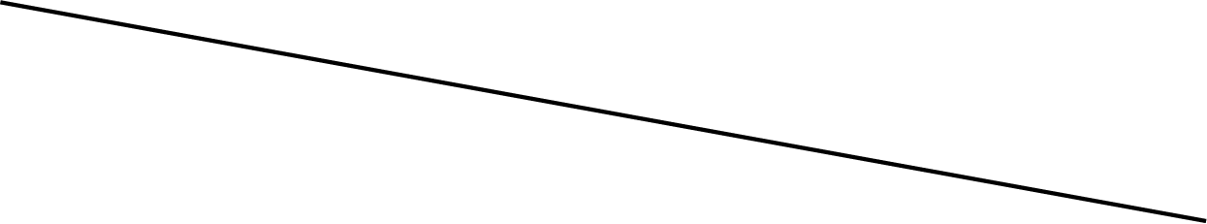

(a) ……..…………….………………. cm [1]

(b) The diagram shows an angle.

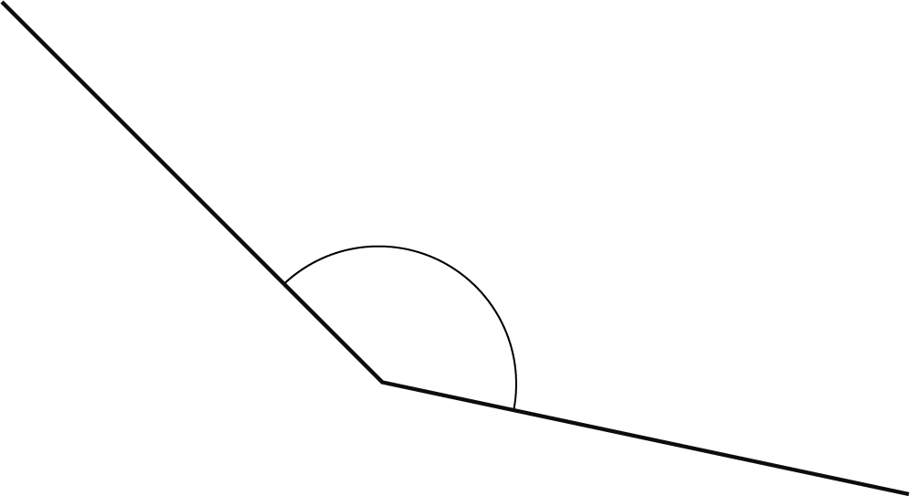

(i) Measure the angle.

(b)(i) ……..…………….……………….° [1]

(ii) Write down the mathematical name of this type of angle.

(ii) ……..…………….………………. [1]

2 Write down each of the following.

(a) An even number.

(a) ……..…………….………………. [1]

(b) A cube number.

(b) ……..…………….………………. [1]

(c) A prime number between 50 and 60.

(c) ……..…………….………………. [1]

(d) A multiple of 7.

(d) ……..…………….………………. [1]

3 Here is a rectangle.



(a) On the diagram, draw all of the lines of symmetry. [2]

(b) Write down the order of rotation symmetry of the rectangle.

(b) ……..…………….………………. [1]

4 Here is a list of numbers.

6 8 2 3 8 3

(a) Work out the range of the numbers.

(a) ……..…………….………………. [2]

(b) Work out the mean of the numbers.

(b) ……..…………….………………. [2]

5 (a) Round 456 to the nearest ten.

(a) ……..…………….………………. [1]

(b) Round 749 438 to 3 significant figures.

(b) ……..…………….………………. [1]

6 Write the following numbers in order of size, smallest first.

0.63 0.66 0.646 0.625

................ , ................ , ................ , ................
smallest [2]

7 Solve.

(a) y − 18 = 20

(a) y = ……..…………….………………. [1]

(b) 8x + 5 = 41

(b) x = ……..…………….………………. [2]

8 Point G is shown on this grid.

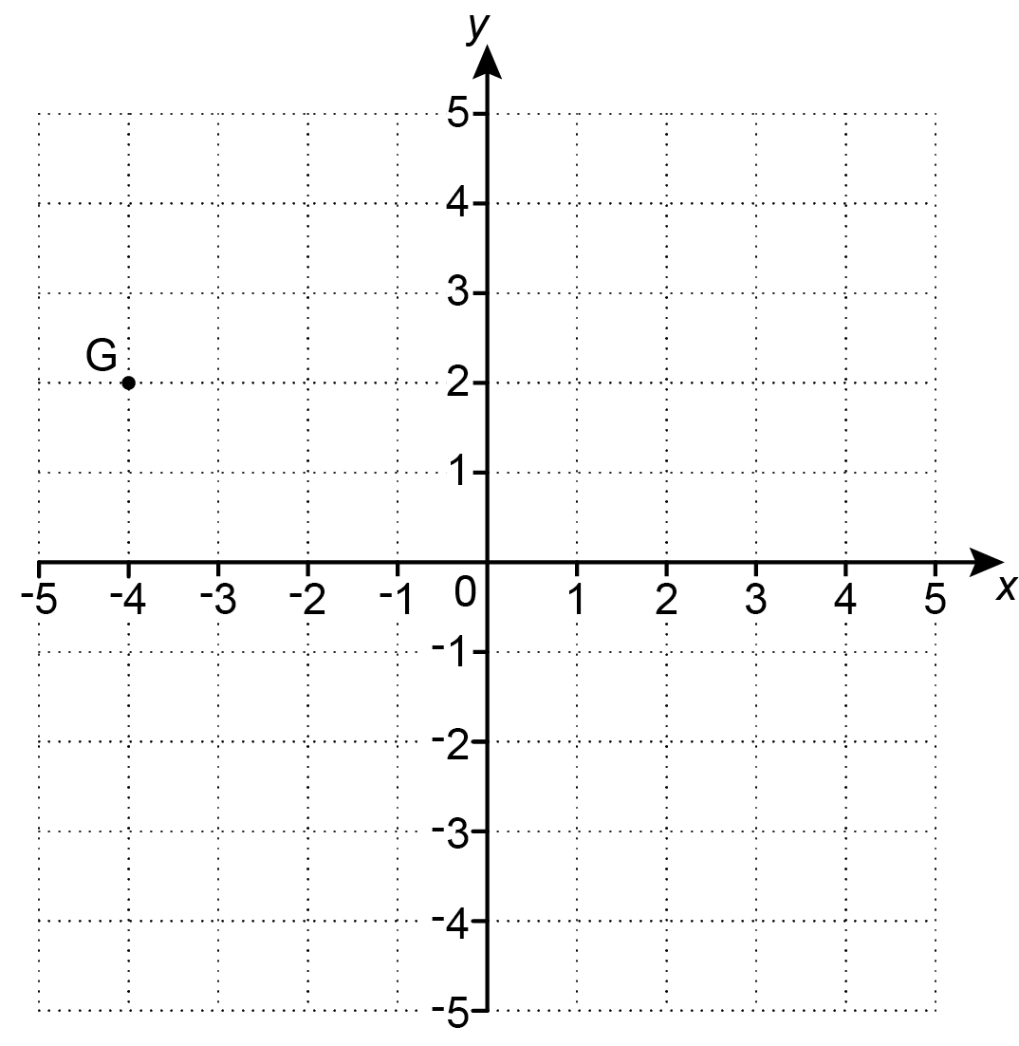

(a) Write down the coordinates of point G.

(a) (......................... , .........................) [1]

(b) Plot point H on the grid at (1, -3). [1]

9 A student thinks of a number.
They square it and then subtract 9.
Their answer is 315.

What number is the student thinking of?

……..…………….………………. [2]

10 (a) Simplify.

2ad ² $×$ 4d

(a) ……..…………….………………. [2]

(b) Factorise.

45x – 5x ²

(b) ……..…………….………………. [2]

11 A rectangle, 10 cm by 5 cm, and a semicircle are joined to make this shape.

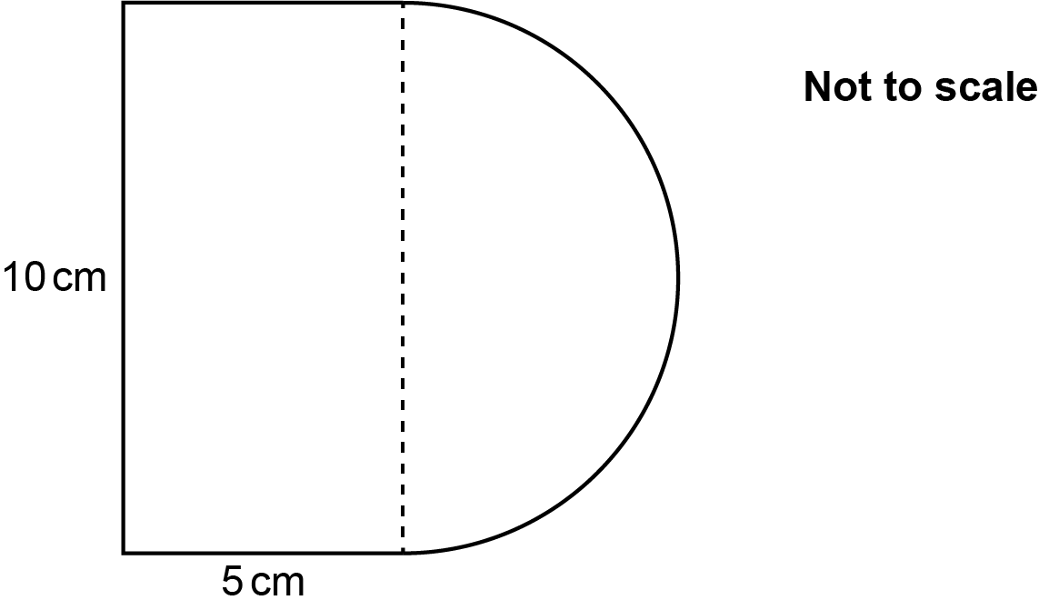

Work out the area of the shape.

……..…………….………………. cm² [4]

12 A conversion graph between pounds (£) and euros (€) is shown below.

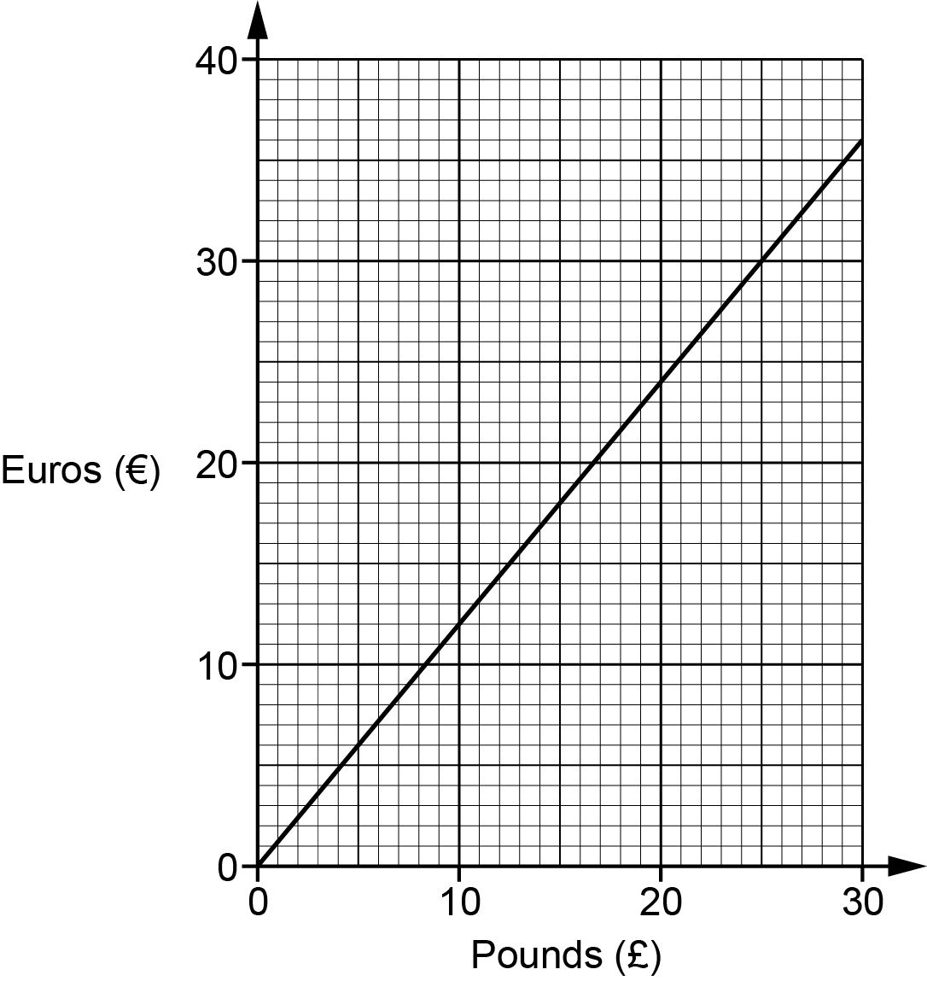

(a) Explain fully how the graph shows that the number of euros is directly proportional to the number of pounds.

[2]

(b) Use the conversion graph to change £20 into euros.

(b) € ……..…………….………………. [1]

(c) Some trainers cost £180 in the UK.
The same trainers cost €195 in France.

Show that the trainers cost less in France.

[4]

(d) If the trainers are brought from France there is an extra charge for tax and delivery.

Kai wants to pay the lowest total amount for the trainers.

Write down the maximum extra charge for tax and delivery that Kai should be
willing to pay.
Give your answer in euros.

(d) € ……..…………….………………. [1]

13 A biased five-sided spinner is numbered 1, 2, 3, 4 and 5.

The table shows the probability of the spinner landing on 2, 4 and 5.

Number | 1 | 2 | 3 | 4 | 5
Probability |  | 0.30 |  | 0.20 | 0.30

The spinner is three times more likely to land on 1 than on 3.

Complete the table. [4]

14 (a) Here are the first four terms of a sequence.

7 15 23 31

(i) Write down the next term in the sequence.

(a)(i) ……..…………….………………. [1]

(ii) Explain how you worked out your answer.

....……………………………………………………………………………………… [1]

(b) The nth term of a different sequence is given by 3n + 1.

Explain why 32 is not a term in this sequence.

..……………………………………………………………………………………………………

....……………………………………………………………………………………………… [2]

15 For each graph below, select its possible equation from this list.

A y = x³ | B y = -2 | C y = x
D x = -2 | E y = x² + 2 | F y = -2x + 1

Write the letter of the equation beneath each graph.

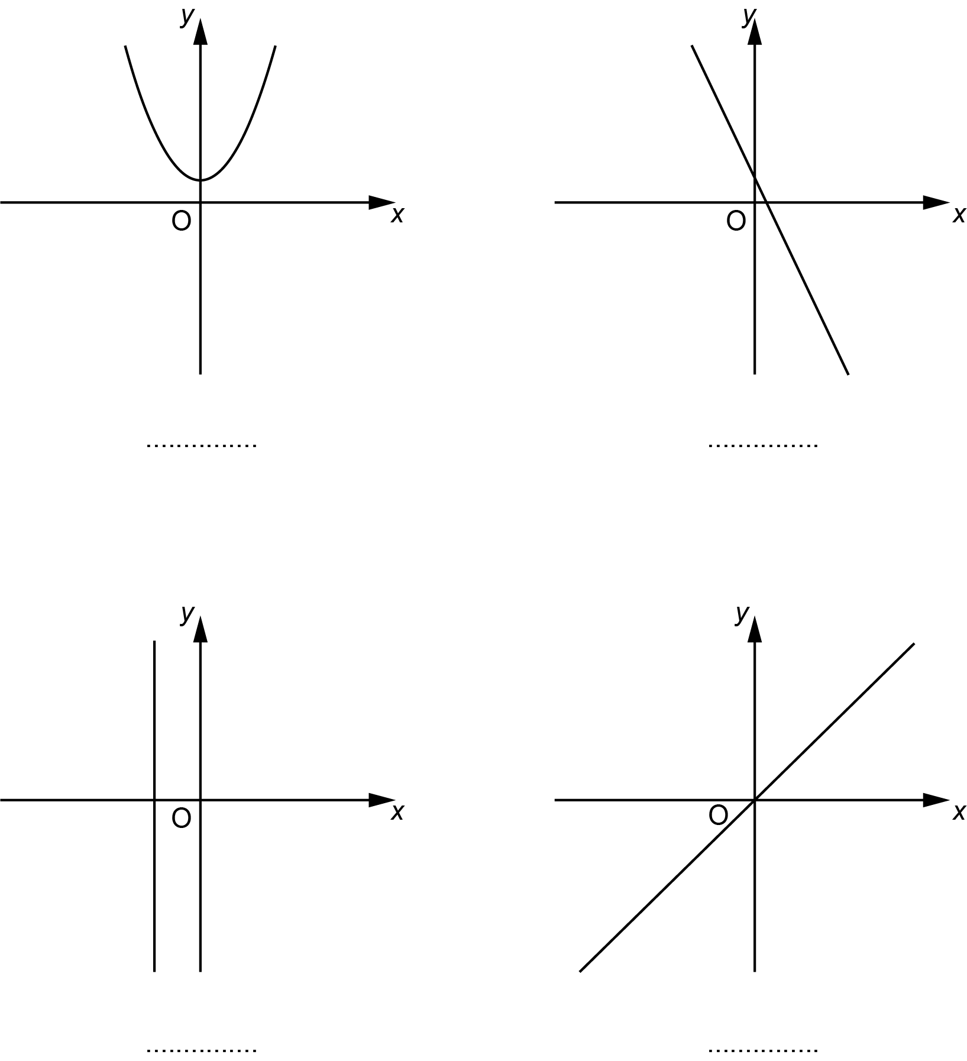
[4]

16 Azmi’s wage is £1500 each month.
They spend of their wage on rent.
They spend £370 of their wage on other items.

What fraction of their wage does Azmi have left?
Give your answer in its simplest form.

……..…………….………………. [4]

17 These two triangles are mathematically similar.

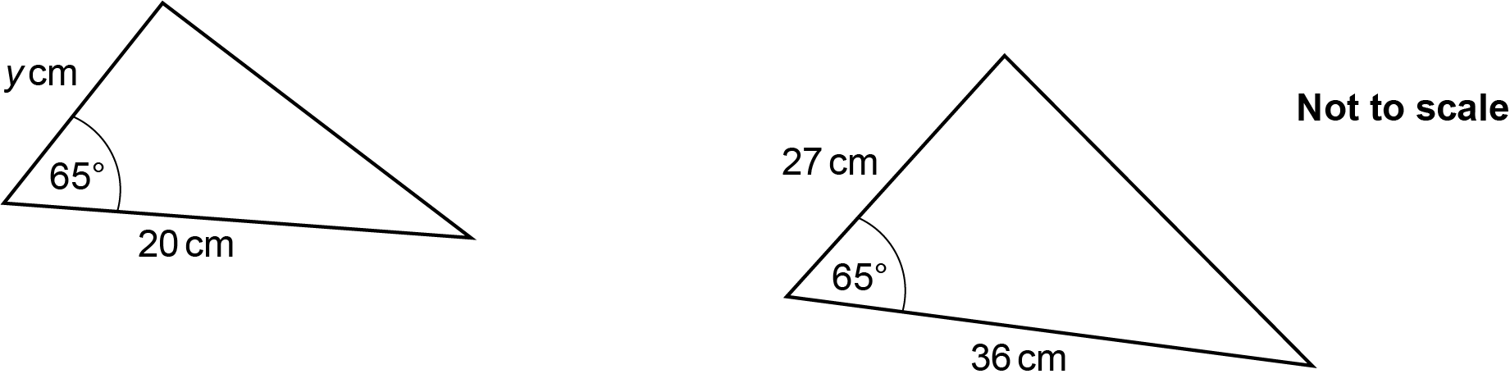

Work out the value of y.

y = ……..…………….………………. [2]

18 Alex throws two fair four-sided dice, each numbered 1, 2, 4 and 5.
Alex multiplies together the two numbers that the dice land on to produce a score.

Find the probability that Alex’s score is a prime number.

……..…………….………………. [4]

19 (a) Fountain A squirts water every 36 minutes.
Fountain B squirts water every 84 minutes.
They squirt water together at 14:53.

Find the next time they squirt water together.

(a) ……..…………….………………. [4]

(b) A school sends 150 students from Year 8 and 105 students from Year 9 to a museum.

The school divides these students into groups using the following rules.

- The groups must all be the same size.
- All students in any group must be from the same year.
- There should be as few groups as possible.

Find the size of each group and the total number of groups.

(b) Size of each group = ……..…..…………….……………….

Total number of groups = ……..…………….………………. [4]

20 (a) Over a long period of time, it is found that the probability of a train from Bewford to London being late is 0.3.

(i) One morning there are two trains from Bewford to London.

Use the information to complete the tree diagram.

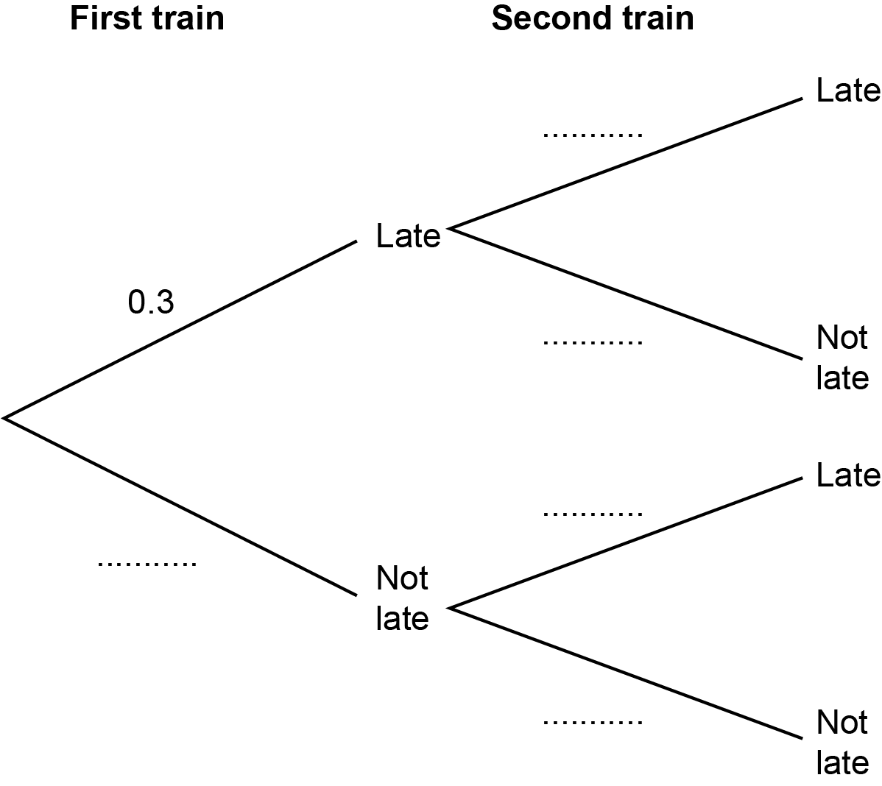
[2]

(ii) Work out the probability that both trains are not late.

(a)(ii) ……..…………….………………. [2]

(iii) Give a reason why the probabilities used in the tree diagram for the second train may not be reliable.

..…………………………………….………………………………………………………

....…….……………………………………………………………………...………… [1]

(b) Charlie takes a train from London to Bewford and then another train to Agon.
The tree diagram shows the probabilities of Charlie’s trains being late or not late.

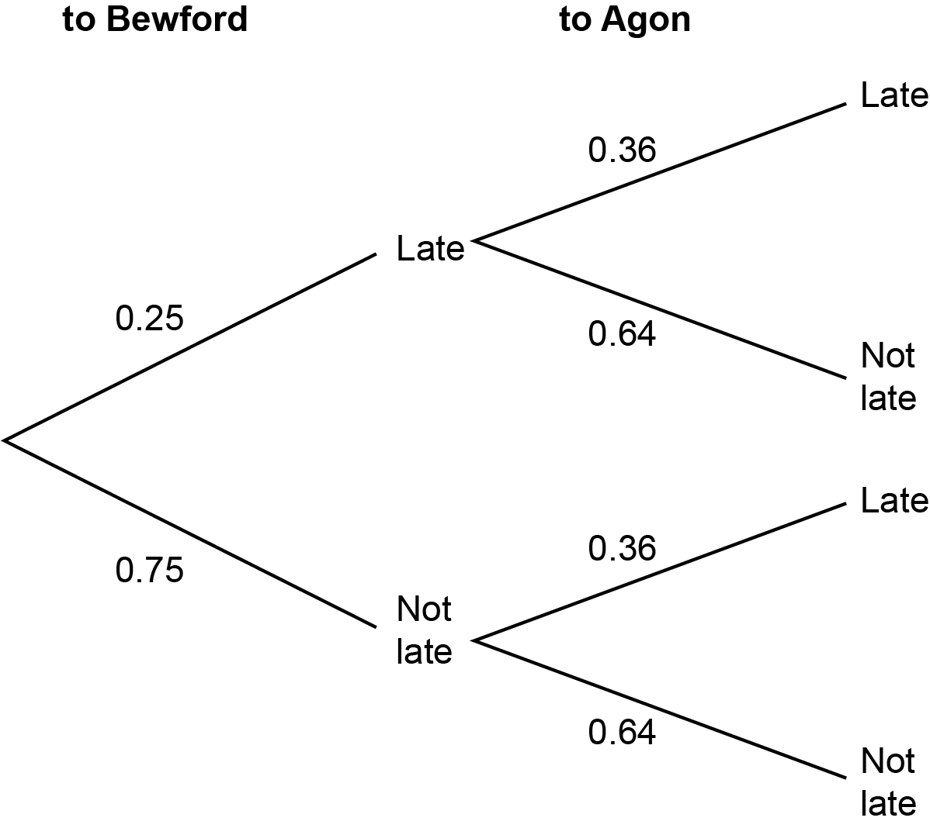

Charlie will not catch the train to Agon if the train to Bewford is late and the train to Agon is not late.

Work out the probability that Charlie will catch the train to Agon.

(b) ……..…………….………………. [3]

21 The price of a plane ticket is increased by 18% to £1475.

Find the original price of the plane ticket.

£ ……..…………….………………. [3]

22 Morgan buys 4 drinks and 3 cakes for £14.05.
Frankie buys 2 drinks and 5 cakes for £14.55.

Assume that each drink costs the same and that each cake costs the same.

Calculate the cost of one drink and the cost of one cake.
You must show your working.

Cost of one drink £……..…………….……………….

Cost of one cake £……..…………….………………. [5]

23 Here is a right-angled triangle.

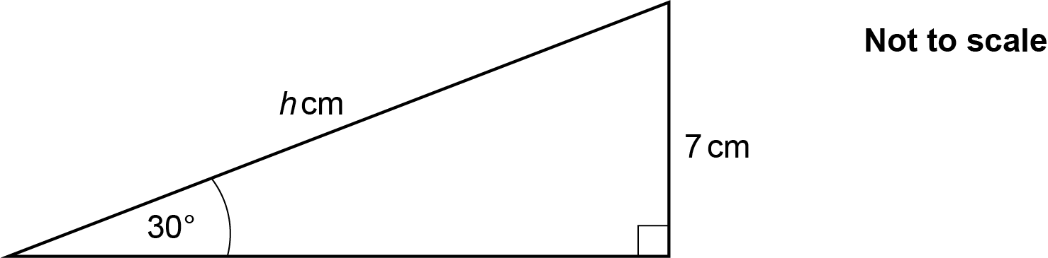

Work out the value of h.

h = ……..…………….………………. [3]

24 Taylor invests £8000 at a rate of 0.9% per year compound interest.

Calculate the total amount of interest Taylor will have earned after 6 years.
Give your answer correct to the nearest penny.

£ ……..…………….………………. [4]

25 Harper and Li travel the same distance from town A to town B.

Harper travels at an average speed of 48 kilometres per hour (km/h).
Li travels at an average speed of 14 metres per second (m/s).

The journey takes Harper 5 hours.

Calculate how long the journey takes Li.
Give your answer in hours and minutes, correct to the nearest minute.
You must show your working.

................hours ................ minutes [6]

Please note – web links are correct at date of publication but other websites may change over time. If you have any problems with a link you may want to navigate to that organisation’s website for a direct search.


We’d like to know your view on the resources we produce. Click ‘Like’ or ‘Dislike’ to send us an auto generated email about this resource. Add comments if you want to. Let us know how we can improve this resource or what else you need. Your email will not be used or shared for any marketing purposes.
Looking for another resource? There is now a quick and easy search tool to help find free resources for your qualification.
OCR is part of Cambridge University Press & Assessment, which is itself a department of the University of Cambridge.
For staff training purposes and as part of our quality assurance programme your call may be recorded or monitored.
Oxford Cambridge and RSA Examinations is a Company Limited by Guarantee. Registered in England. Registered office
The Triangle Building, Shaftesbury Road, Cambridge, CB2 8EA. Registered company number 3484466. OCR is an exempt charity.
OCR operates academic and vocational qualifications regulated by Ofqual, Qualifications Wales and CCEA as listed
in their qualifications registers including A Levels, GCSEs, Cambridge Technicals and Cambridge Nationals.
OCR provides resources to help you deliver our qualifications. These resources do not represent any particular teaching method we expect you to use. We update our resources regularly and aim to make sure content is accurate but please check the OCR website so that you have the most up to date version. OCR cannot be held responsible for any errors or omissions in these resources.
Though we make every effort to check our resources, there may be contradictions between published support and the specification, so it is important that you always use information in the latest specification. We indicate any specification changes within the document itself, change the version number and provide a summary of the changes. If you do notice a discrepancy between the specification and a resource, please contact us.
© OCR 2022 - You can copy and distribute this resource freely if you keep the OCR logo and this small print intact and you acknowledge OCR as the originator of the resource.
OCR acknowledges the use of the following content: N/A
Whether you already offer OCR qualifications, are new to OCR or are thinking about switching, you can request more information using our Expression of Interest form.
Please get in touch if you want to discuss the accessibility of resources we offer to support you in delivering our qualifications.

