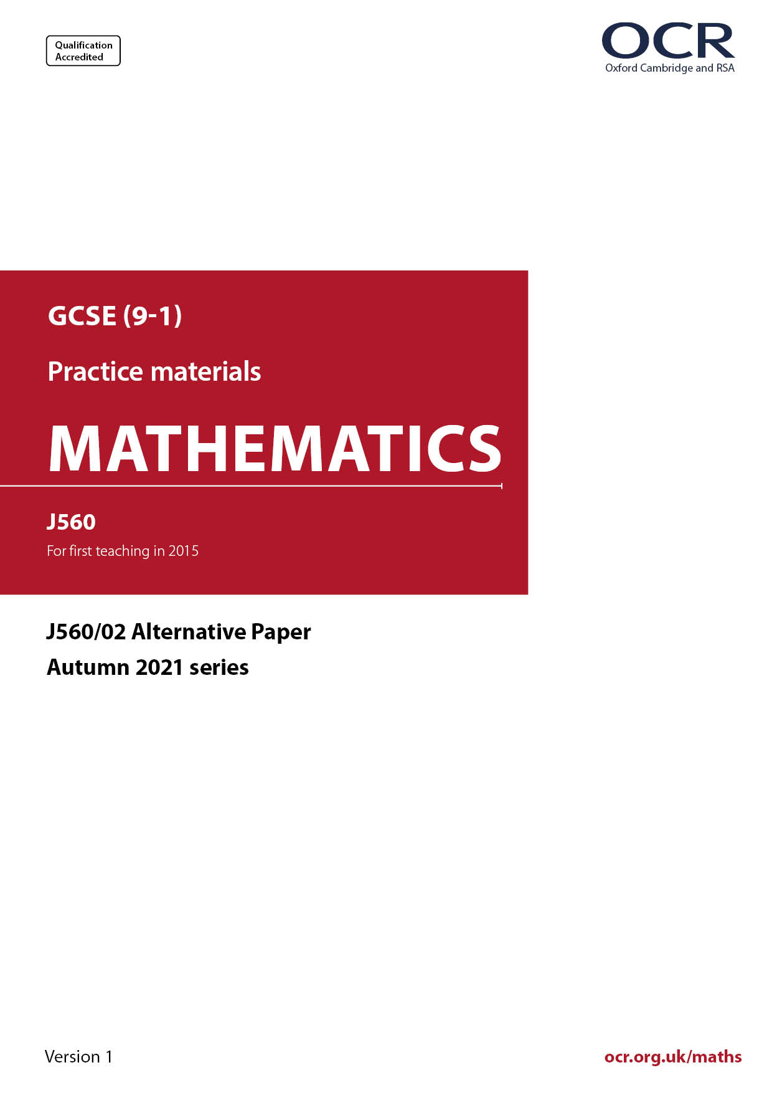
ocr.org.uk/maths

Introduction
OCR’s Alternative Papers for GCSE (9-1) Mathematics are each created by taking one of our past papers and amending the numbers/graphs/diagrams/tables/etc. in its questions.
This Alternative Paper is an amended version of one of the November 2021 series papers. The wording and topics assessed are essentially the same, but the responses students need to make will be different. Using both this paper and the corresponding November 2021 exam paper with your students at different points in the year will allow you to monitor how their learning has progressed in the time between the two papers.
Additional Alternative Papers and past papers are available to download from the OCR website.



GCSE (9-1) Mathematics
J560/02 Paper 2 (Foundation Tier)
Alternative Paper (November 2021)

Time allowed: 1 hour 30 minutes


You may use:
- geometrical instruments
- tracing paper

Do not use:
- a calculator

Name

INSTRUCTIONS
- Use black ink. You can use an HB pencil, but only for graphs and diagrams.
- Write your answer to each question in the space provided. You can use extra paper if
you need to, but you must clearly show your candidate number, the centre number and
the question numbers.
- Answer all the questions.
- Where appropriate, your answer should be supported with working. Marks might be
given for using a correct method, even if your answer is wrong.

INFORMATION
- The total mark for this paper is 100.
- The marks for each question are shown in brackets [ ].
- This document has 20 pages.

ADVICE
- Read each question carefully before you start your answer.

Answer all the questions.

1 (a) How many sides does a hexagon have?

(a) ……..…………….………………. [1]

(b) Write down the mathematical name of this solid.

(b) ……..…………….………………. [1]

(c) The angles in a triangle are 50°, 50° and 80°.

Write down the mathematical name for this type of triangle.

(c) ……..…………….………………. [1]

2 Work out.

(a) 3 + -5

(a) ……..…………….………………. [1]

(b) -3 $×$ -4

(b) ……..…………….………………. [1]

3 (a) Work out.

8.12 $÷$ 4

(a) ……..…………….………………. [1]

(b) 15 $×$ 0.8

(b) ……..…………….………………. [2]

4 Use one of these symbols $<$, $>$ or $=$ to make each statement true.

(a) $\frac{\text{3}}{\text{40}}$ ……………........ 0.075 [1]

(b) 0.53 .......................... 0.503 [1]

5 (a) Work out.
6 $+$ 14 $÷$ 2

(a) ……..…………….………………. [1]

(b) Insert one pair of brackets to make the calculation correct.

4 $×$ 7 $+$ 8 $÷$ 4 $=$ 9 [1]

6 In a quiz, Ali answered 18 of the 30 questions correctly.

(a) What fraction of the questions did Ali answer correctly?
Give your fraction in its lowest terms.

(a) ……..…………….………………. [2]

(b) Write the fraction as a decimal.

(b) ……..…………….………………. [1]

7 (a) Write $\frac{\text{17}}{\text{5}}$ as a mixed number.

(a) ……..…………….………………. [1]

(b) Work out.

(i) $\frac{\text{1}}{\text{4}}$ + $\frac{\text{5}}{\text{12}}$

(b)(i) ……..…………….………………. [2]

(ii) 5 $÷$ $\frac{\text{1}}{\text{4}}$

(ii) ……..…………….………………. [1]

8 Here is a function.

(a) Find the output when the input is 5.

(a) ……..…………….………………. [1]

(b) Find the input when the output is 60.

(b) ……..…………….………………. [2]

9 A shopper buys 6 apples costing 55p each and 3 peaches.
They pay with a £5 note and receive 14p in change.
Each peach costs the same amount.

Work out the cost of one peach.
You must show your working.

……..…………….………………. p [5]

10 Blake and Rowan are making pancakes using the ingredients below.

Ingredients to make
20 pancakes

125 ml water
300 ml milk
160 g flour
80 g butter
4 eggs

(a) The ratio of the amount of water to the amount of milk needed is 125 : 300.

Write this ratio in its simplest form.

(a) ……..…………….… : ……..…………….… [2]

(b) Blake makes 30 pancakes.

Work out how much flour he needs.

(b) ……..…………….………………. g [2]

(c) Rowan has 220 g of butter and 12 eggs.
She has plenty of the other ingredients.

Work out the maximum number of pancakes that she can make.

(c) ……..…………….………………. [4]
11 Ben (B), Kai (K), Reece (R) and Sundip (S) are in a relay team.
Ben always runs first in the team.
The order for the other three is chosen at random.

(a) Complete this table to show all the possible orders for the team.
The first row has been completed for you.
You may not need to use all the rows.

First | Second | Third | Fourth
B | K | R | S
[2]

(b) Find the probability that Kai will run last.

(b) ……..…………….………………. [2]

12 The shape below is formed by a rectangle of width 6 cm and a regular hexagon.
For the rectangle, the ratio of the width to the length is 3 : 5.

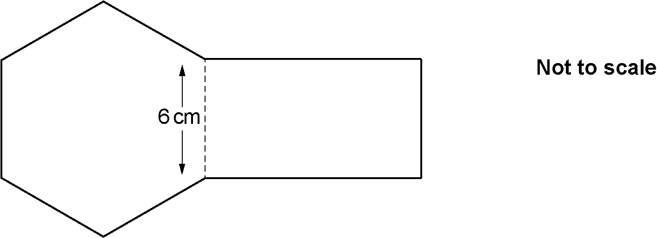

Work out the perimeter of the shape.

……..…………….………………. cm [4]

13 (a) Darcy is given this question.

Write 50 as a product of prime factors.
Give your answer in index form.

Darcy’s answer is 1 $×$ 2 $×$ 5².

Is Darcy correct?
Explain your answer.

……………..………………………………………………………………………………………

………………….……………………………………………………………………………… [1]

- Complete the power of 2.

$\frac{\text{1}}{\text{16}}$ $=$ 2

[1]

(c) Work out.

$\sqrt{\text{64}}$ $×$ 3²

(c) ……..…………….………………. [3]

14 A car mechanic has a tin containing 4 litres of engine oil.
Each week they use 350 millilitres of this oil for their vehicles.

The car mechanic says

After 9 weeks I will have used over 80% of the oil in this tin.

Are they correct?
Show how you decide.

..…………..………………………………………………………………………………………………

....………………………………..…………………………………………………………………… [5]

15 Solve the inequality.

3(x $-$ 4) $>$ 15

……..…………….………………. [3]

16 Here are sketches of five graphs.

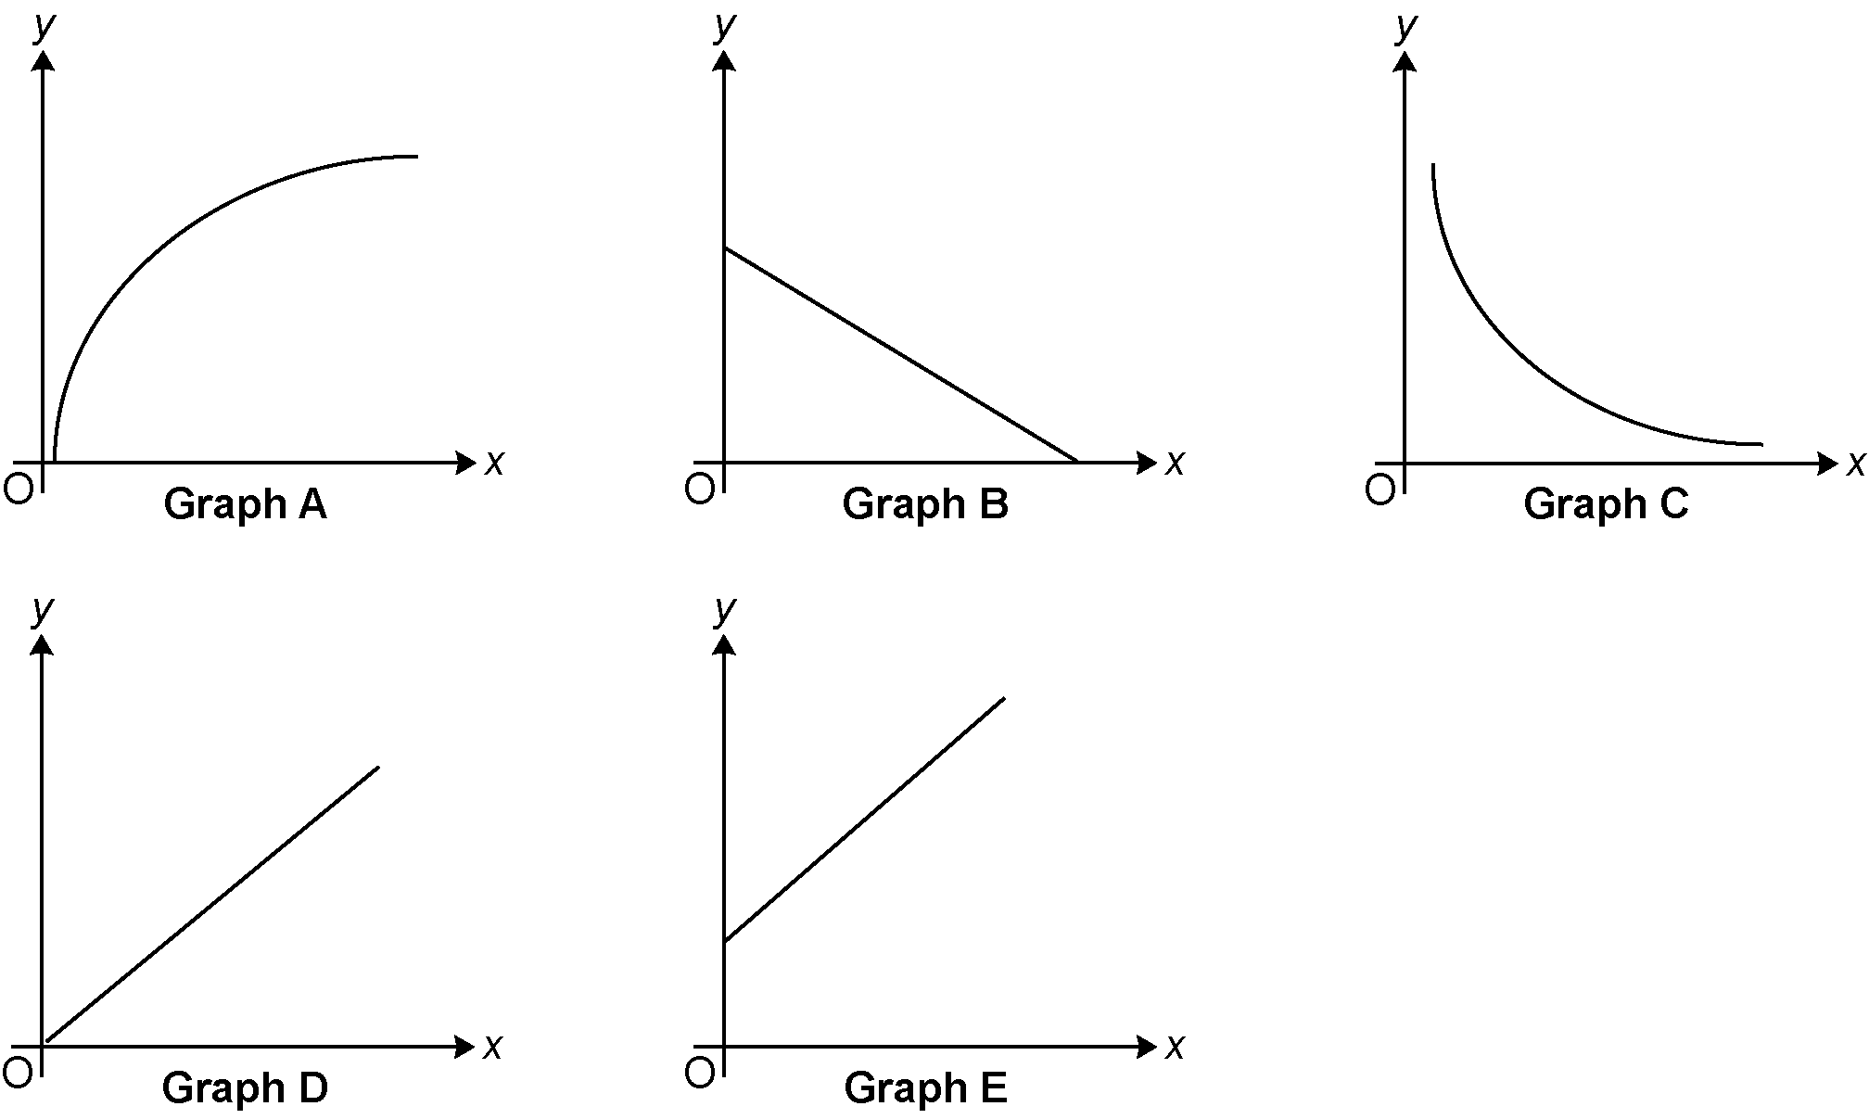

Write the letter of the graph that represents the following relationships.

(a) y is directly proportional to x.

(a) ……..…………….………………. [1]

(b) y is inversely proportional to x.

(b) ……..…………….………………. [1]

17 (a) The diagram shows a prism.

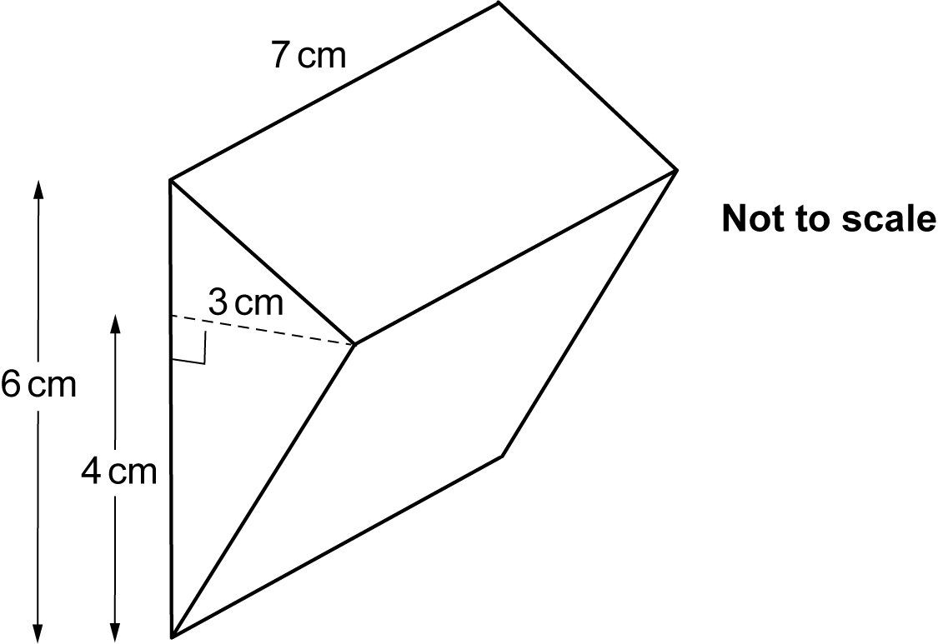

(i) On the one-centimetre square grid below, draw an accurate side view of the prism from the direction of the arrow.


[3]

(ii) Show that the volume of the prism is 63 cm³.
[2]

(b) A cuboid with a square base has a volume of 56 cm³.
The length of one side of the cuboid’s square base is 2 cm.

Work out the height of the cuboid.

(b) ……..…………….………………. cm [3]

18 The table shows the marks obtained by 10 students in spelling tests in January and March.

Mark in January | 26 | 53 | 30 | 48 | 50 | 66 | 70 | 44 | 37 | 38
Mark in March | 45 | 61 | 69 | 61 | 71 | 85 | 89 | 63 | 51 | 53

The marks for the first six students are plotted on the scatter diagram.

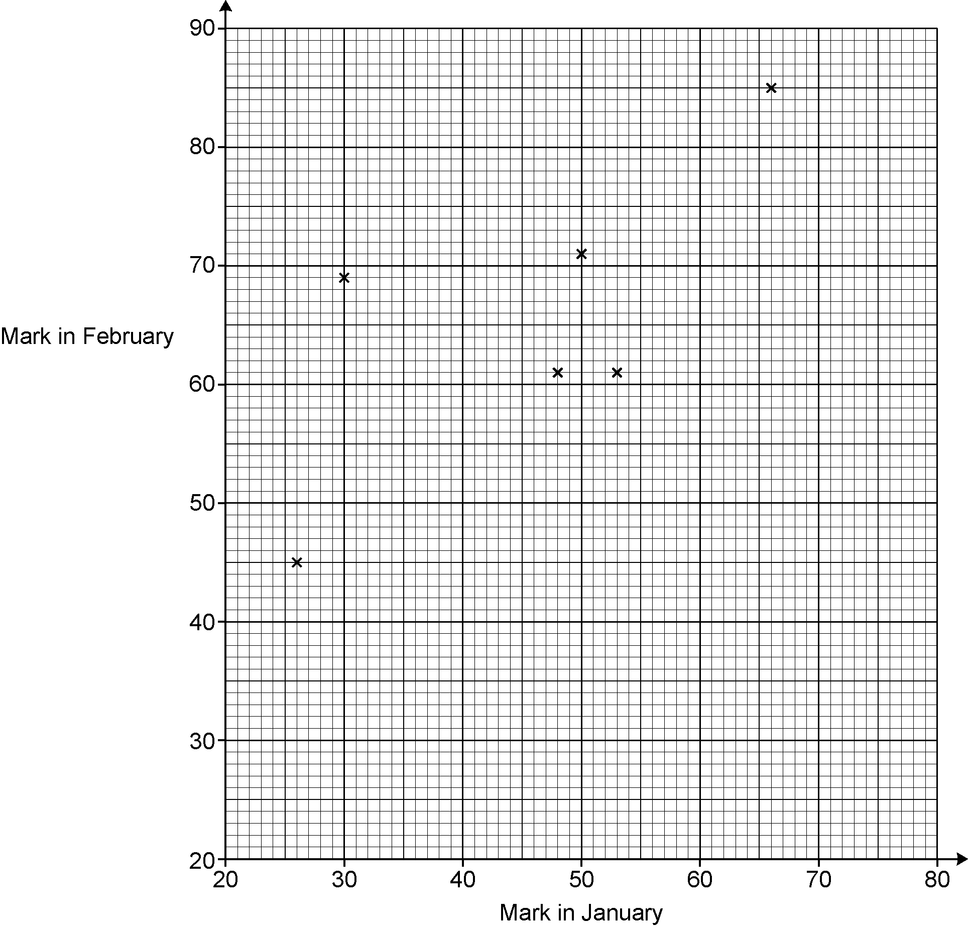
March

(a) Plot the marks for the remaining four students. [2]

(b) Describe the type of correlation shown in the completed scatter diagram.

...……………………………………………………………………………………………… [1]

(c) (i) On the scatter diagram, circle the student that made the greatest improvement in
their marks from January to March. [1]

(ii) Work out the percentage change in this student’s marks from January to March.

(c)(ii) ……..…………….………………. % [3]

(d) Another student, Sam, scored 75 marks in the test in January but was absent for the test in March.

Sam says

I could use a line of best fit on the scatter diagram to estimate the marks I may have achieved in the test in March.

Is Sam’s method reliable?
Give a reason for your answer.

..……………………………………………………………………………………………………

....……………………………………………………………………………………………… [1]

19 A worker received a 20% pay increase in 2017 and a further 10% pay increase in 2018.
The worker says

Over these two years, my pay increased by 20% + 10% = 30%.

The worker is incorrect.

Work out the correct percentage increase.
You must show your working.

....…………………………………..………………………………………………………………… [5]

20 Force is measured in newtons (N).
A force of 297.3 N is applied to a rectangular surface of length 5.9 cm and width 5.1 cm.

Work out an estimate of the pressure, in N/cm², applied to this rectangular surface.

[The formula for pressure is: Pressure $=$ $\frac{\text{Force}}{\text{Area}}$ ]

……..…………….………………. N/cm² [4]

21 (a) Complete this table for y $=$ x ² + 2.

x | -3 | -2 | -1 | 0 | 1 | 2 | 3
y |  | 6 | 3 |  | 3 | 6 | 11
[2]

(b) Draw the graph of y $=$ x ² + 2 for values of x from -3 to 3.

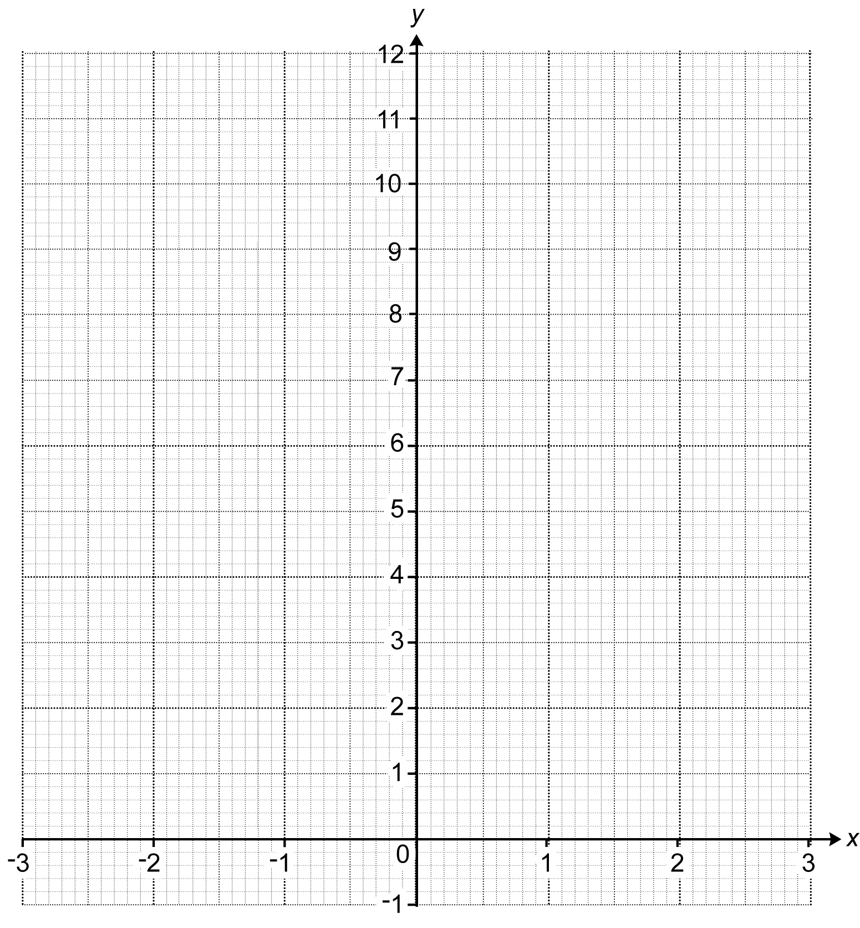
[3]

(c) Use your graph to solve x ² + 2 $=$ 8.

(c) x $=$ .…………….… or x $=$ .…………….… [2]

22 A journalist is going to do a survey to find out whether people aged 50 or less spend less
time watching television than people aged more than 50.

The journalist says their sample will be the first 20 people to go into a particular park after 9 am next Monday.

(a) Give one reason why the journalist’s sample is unlikely to give reliable information.

..……………………………………………………………………………………………………

....……………………………………………………………………………………………… [1]

(b) Make three suggestions to help the journalist obtain a sample that may give more reliable information.

1....……..………….….……………………………………………………………………………

.…………..……………………………………………………………………………..…………

2.....……..………………….………………………………………………………………………

….....…….…………………………………………………………………………………………

3..…….....………………………………………………………………………………….………
[3]

23 The diagram shows a straight line crossing two parallel lines.

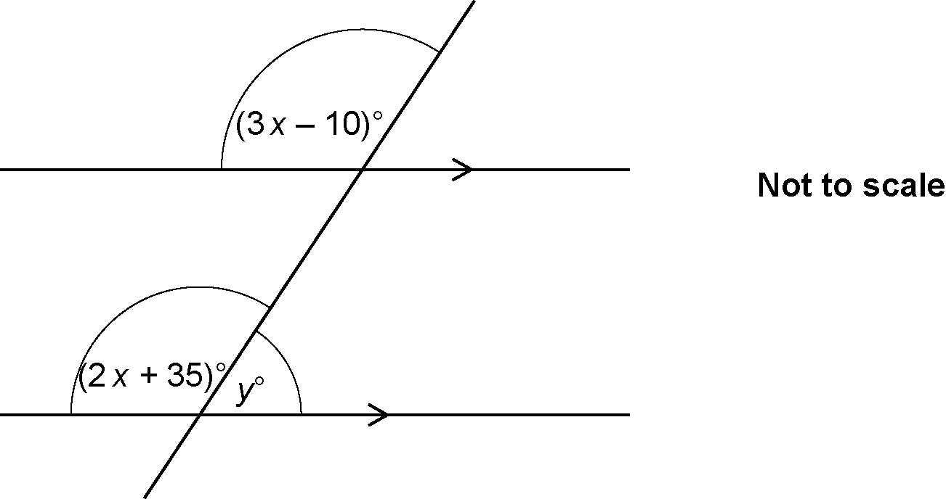

Find the value of y.
You must show your working.

y = ……..…………….………………. [6]

ADDITIONAL ANSWER SPACE

If additional space is required, you should use the following lined page(s). The question number(s) must be clearly shown in the margin(s).

…………………………………………………………………………………………………………………..

…………………………………………………………………………………………………………………..

…………………………………………………………………………………………………………………..

…………………………………………………………………………………………………………………..

…………………………………………………………………………………………………………………..

…………………………………………………………………………………………………………………..

…………………………………………………………………………………………………………………..

…………………………………………………………………………………………………………………..

…………………………………………………………………………………………………………………..

…………………………………………………………………………………………………………………..

…………………………………………………………………………………………………………………..

…………………………………………………………………………………………………………………..

…………………………………………………………………………………………………………………..

…………………………………………………………………………………………………………………..

…………………………………………………………………………………………………………………..

…………………………………………………………………………………………………………………..

…………………………………………………………………………………………………………………..

…………………………………………………………………………………………………………………..

…………………………………………………………………………………………………………………..

…………………………………………………………………………………………………………………..

…………………………………………………………………………………………………………………..

…………………………………………………………………………………………………………………..

…………………………………………………………………………………………………………………..

Please note – web links are correct at date of publication but other websites may change over time. If you have any problems with a link you may want to navigate to that organisation’s website for a direct search.


We’d like to know your view on the resources we produce. Click ‘Like’ or ‘Dislike’ to send us an auto generated email about this resource. Add comments if you want to. Let us know how we can improve this resource or what else you need. Your email will not be used or shared for any marketing purposes.
Looking for another resource? There is now a quick and easy search tool to help find free resources for your qualification.
OCR is part of Cambridge University Press & Assessment, which is itself a department of the University of Cambridge.
For staff training purposes and as part of our quality assurance programme your call may be recorded or monitored.
Oxford Cambridge and RSA Examinations is a Company Limited by Guarantee. Registered in England. Registered office
The Triangle Building, Shaftesbury Road, Cambridge, CB2 8EA. Registered company number 3484466. OCR is an exempt charity.
OCR operates academic and vocational qualifications regulated by Ofqual, Qualifications Wales and CCEA as listed
in their qualifications registers including A Levels, GCSEs, Cambridge Technicals and Cambridge Nationals.
OCR provides resources to help you deliver our qualifications. These resources do not represent any teaching method we expect you to use. We update our resources regularly and aim to make sure content is accurate but please check the OCR website so that you have the most up to date version. OCR cannot be held responsible for any errors or omissions in these resources.
Though we make every effort to check our resources, there may be contradictions between published support and the specification, so it is important that you always use information in the latest specification. We indicate any specification changes within the document itself, change the version number and provide a summary of the changes. If you do notice a discrepancy between the specification and a resource, please contact us.
© OCR 2022 - You can copy and distribute this resource freely if you keep the OCR logo and this small print intact and you acknowledge OCR as the originator of the resource.
OCR acknowledges the use of the following content: N/A
Whether you already offer OCR qualifications, are new to OCR or are thinking about switching, you can request more information using our Expression of Interest form.
Please get in touch if you want to discuss the accessibility of resources we offer to support you in delivering our qualifications.

