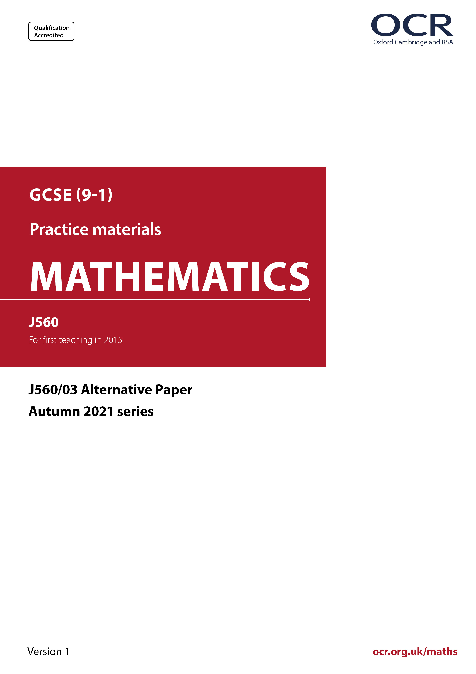
ocr.org.uk/maths

Introduction
OCR’s Alternative Papers for GCSE (9-1) Mathematics are each created by taking one of our past papers and amending the numbers/graphs/diagrams/tables/etc. in its questions.
This Alternative Paper is an amended version of one of the November 2021 series papers. The wording and topics assessed are essentially the same, but the responses students need to make will be different. Using both this paper and the corresponding November 2021 exam paper with your students at different points in the year will allow you to monitor how their learning has progressed in the time between the two papers.
Additional Alternative Papers and past papers are available to download from the OCR website.



GCSE (9-1) Mathematics
J560/03 Paper 3 (Foundation Tier)
Alternative Paper (November 2021)

Time allowed: 1 hour 30 minutes

You may use:
- a scientific or graphical calculator
- geometrical instruments
- tracing paper

Name

INSTRUCTIONS
- Use black ink. You can use an HB pencil, but only for graphs and diagrams.
- Write your answer to each question in the space provided. You can use extra paper if
you need to, but you must clearly show your candidate number, the centre number and
the question numbers.
- Answer all the questions.
- Where appropriate, your answer should be supported with working. Marks might be
given for using a correct method, even if your answer is wrong.
- Use the π button on your calculator or take π to be 3.142 unless the question says
something different.

INFORMATION
- The total mark for this paper is 100.
- The marks for each question are shown in brackets [ ].
- This document has 24 pages.

ADVICE
- Read each question carefully before you start your answer.

Answer all the questions.

1 In a survey, some students chose their favourite type of film from a list of five.
The bar chart shows the results.

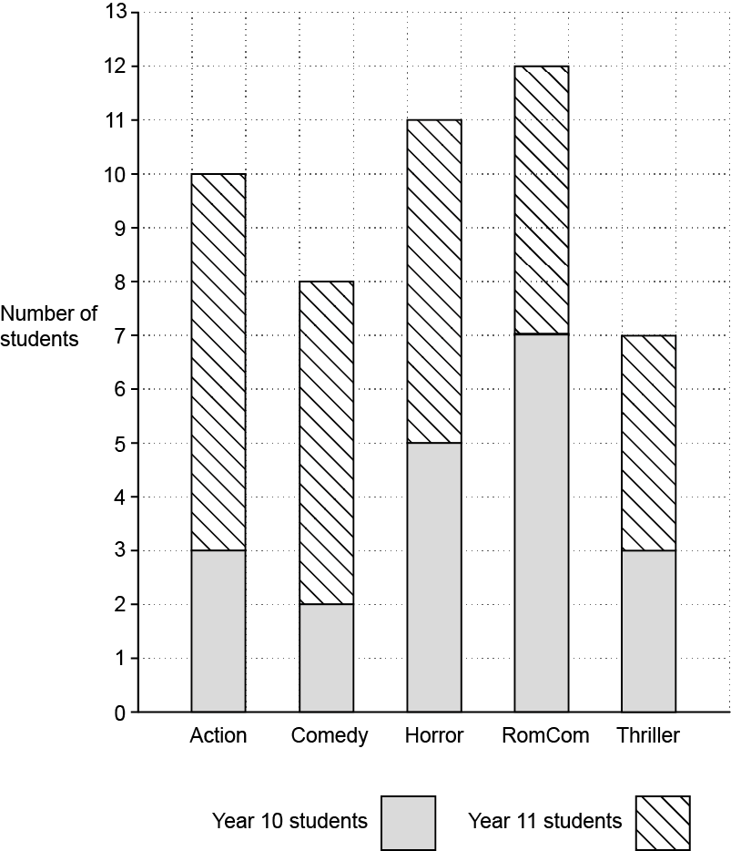

(a) (i) How many students chose Horror films?

(a)(i) ……..…………….………………. [1]

(ii) How many Year 11 students chose Horror films?

(ii) ……..…………….………………. [1]

(b) What type of film was chosen by the least Year 10 students?

(b) ……..…………….…………..…………….… [1]

(c) How many students took part in the survey?

(c) ……..…………….…..……..…………….… [2]

(d) 20 Year 10 students took part in the survey.

Write the ratio

number of Year 10 students taking part : number of Year 11 students taking part

in its simplest form.

(d) ……..…………….… : ……..…………….… [3]

2 Use your calculator to work out.

(a) ……..…………….…………..…………….… [1]

- 5⁴

(b) ……..…………….…………..…………….… [1]

3 There are 200 coins in a jar.
15% of the coins are 10p coins.

of the coins are 20p coins.

The rest of the coins are 5p coins.

Work out the total value, in £, of the 200 coins.
You must show your working.

£ ……..…………….…………..…………….… [6]

4 A sports team played the same number of matches in 2019 and 2020.
The two pie charts summarise their results.

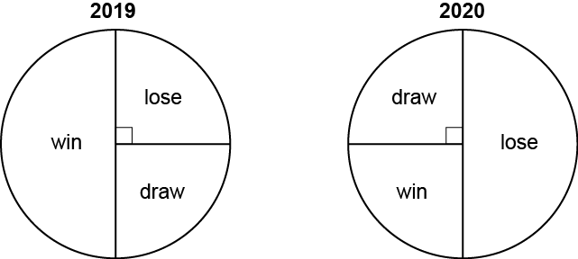

- What fraction of the matches did the team win in 2019?

(a) ……..…………….…………..…………….… [1]

- Did the team’s results improve in 2020?
Explain how you know.

................... because ………………………………………………………………………….

………………………………………………………………………………………………… [1]

5 Increase 400 by 27%.

……..…………….…………..…………….… [3]

6 The diagram shows how a rhombus is made by joining two isosceles triangles.
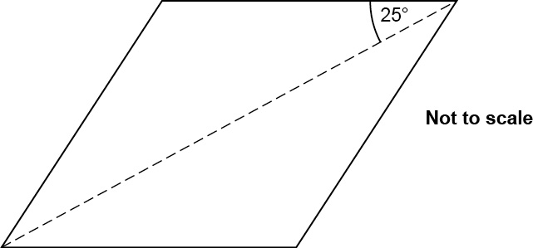

- Find the size of each interior angle of the rhombus.

(a) ...............°, ...............°, ...............°, ...............° [1]

- The same rhombus can be made by joining two copies of a different isosceles triangle.

Find the size of each angle of this triangle.

(b) ...............°, ...............°, ...............° [2]
7 Callum’s bath has a hot tap and a cold tap.
When turned on full, each tap on its own will fill the bath in 8 minutes.

Callum turns both taps on full.

How long will it take to fill the bath?

..……….…………..…………….… minutes [2]

8 Simplify.

4p + 3h – p + 2h

..……….…………..……………………… [2]

9 = {1, 2, 3, 4, 5, 6, 7, 8, 9, 10, 11, 12, 13, 14, 15, 16}
Set A = {even numbers}
Set B = {multiples of 3}

- The elements 1 and 2 have been entered on this Venn diagram.

Complete the Venn diagram to show all of the elements.

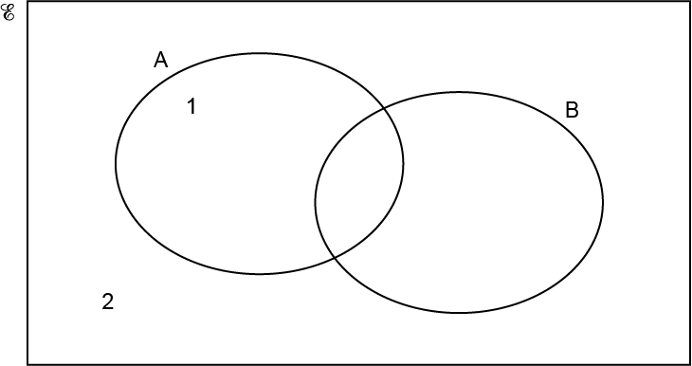
1
2
[3]

- = {all positive integers}
Set L = {even numbers}
Set M = {multiples of 4}

Three Venn diagrams, numbered 1 to 3, are shown below.

Which diagram best shows the relationship between Set L and Set M?
Give a reason for your choice.

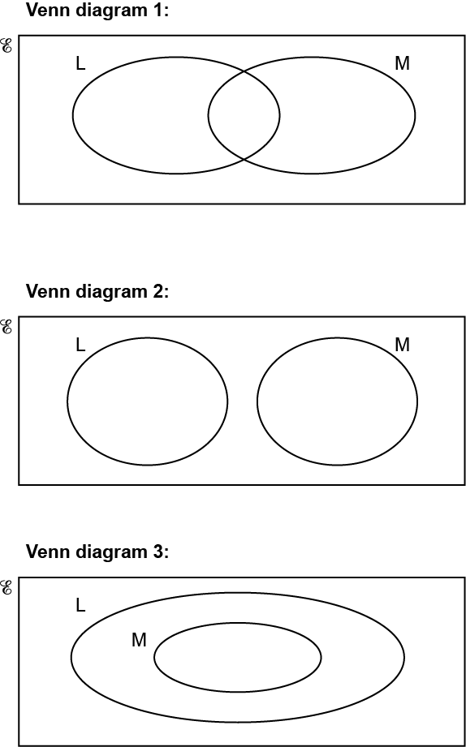

Venn diagram ................... because ................................................................................

..................................................................................................................................... [2]

10 A student has some cubes that are all the same size.
Each cube is 5 cm by 5 cm by 5 cm.

They put 4 of these cubes together to make this shape.

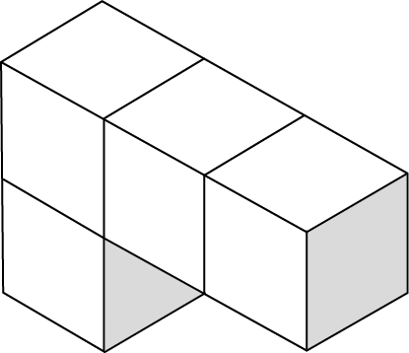

Calculate the surface area of the shape.

................................................... ${\text{cm}}^{\text{2}}$ [4]

11 Here are some algebraic statements.

y 3x 2(x + 1) = 2x + 2 u = v – at 3x = 9 2x + y

From the list above, write down an example of each of the following.

- An inequality.

(a) ……..…………….………..…………….… [1]

- An equation.

(b) ……..…………….………..…………….… [1]

(c) An expression.

(c) ……..…………….………..…………….… [1]

12 Rearrange this formula to make b the subject.

A = 2b – 3c

…………………........................................... [2]

13 Rowan has 40 m of ribbon.
They cut the ribbon into lengths of 70 cm.

What is the least length of ribbon, in cm, that can be left over?
You must show your working.

..................................................... cm [5]

14 This table shows the names and areas of five lakes.

Name of Lake | Area in km²
Caspian | 3.71 × 10⁵
Geneva | 5.81 × 10²
Superior | 8.21 × 10⁴
Albert | 5.30 × 10³
Peipus | 3.56 × 10³

- Write the area of Lake Superior as an ordinary number.

- ..................................................... km² [1]

- Write the lakes in the order of their area, starting with the smallest.

.......................... .......................... .......................... .......................... .......................... [2]
smallest largest

(c) Calculate the difference between the areas of Lake Albert and Lake Geneva.
Give your answer in standard form, correct to 2 significant figures.

- ..................................................... km² [4]
15 Ellis, Ling and Amit share a flat.

- The monthly rent is £784.
They share the rent in the ratio 2 : 2 : 3.

How much does Amit pay for rent each month?

(a) £ .......................................................... [2]

- Ellis, Ling and Amit also share the fuel bill in the ratio 2 : 2 : 3.
Ellis pays £32 for fuel each month.

How much does Amit pay for fuel each month?

(b) £ .......................................................... [2]

16 Triangle A and triangle B are drawn on the coordinate grid.

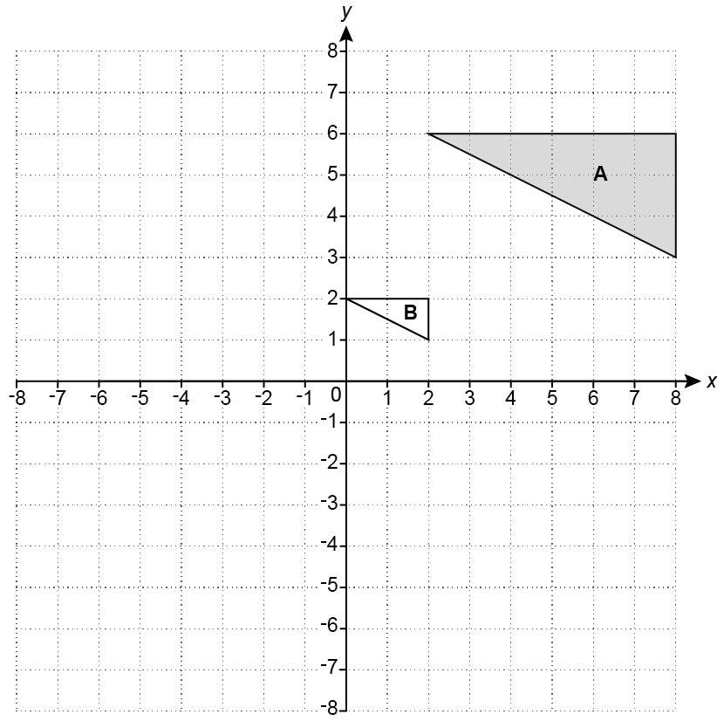

- Reflect triangle A in the line y = 0. [2]

- Describe fully the single transformation that maps triangle A onto triangle B.

..........................................................................................................................................

..................................................................................................................................... [3]

17 Azmi throws a six-sided dice 300 times.
The table shows the frequencies of their results.

- Complete the table to show the relative frequencies.

Number on dice | 1 | 2 | 3 | 4 | 5 | 6
Frequency | 42 | 24 | 51 | 63 | 48 | 72
Relative frequency | 0.14
[2]

- Azmi thinks that the dice may be biased.

- Explain why evidence from the table could support their opinion.

.................................................................................................................................

.................................................................................................................................

............................................................................................................................ [1]

- Explain why the dice may, in fact, not be biased.

.................................................................................................................................

.................................................................................................................................

............................................................................................................................ [1]

18 A carpenter measures the length, k metres, of a piece of wood.

They write

2.45 ≤ k < 2.55.

- Put rings around all possible values of k in the list below.

2.54 2.449 2.49 2.55 2.65
[2]

- The carpenter says

2.45 ≤ k < 2.55 means that the length of the piece of wood is 2.5 metres correct to the nearest centimetre.

- Explain how you know that she is incorrect.

.................................................................................................................................

............................................................................................................................ [1]

- Complete the interval for 2.5m, correct to the nearest centimetre.

(b)(ii) 2.495 ≤ k < ......................................................... [1]

19 (a) Beth says

My normal typing speed is 45 words per minute.
Therefore, I estimate that my normal typing speed is about 280 characters per
minute.

Each letter, space and piece of punctuation counts as a character.

How many letters per word is Beth most likely to have used in making the estimate?
Show how you decide.

- ............................................................. [3]

- Beth starts some homework at their normal typing speed.
Beth types 48 words in 1 minute 24 seconds.

What may be true about the length of the words that Beth has just typed?
Show how you decide.

...........................................................................................................................................

..................................................................................................................................... [3]

20 The diagram shows rectangle ABCD.

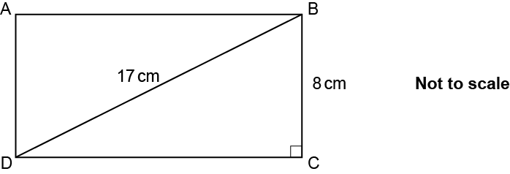

DB = 17 cm and BC = 8 cm.

Calculate the area of the rectangle.
You must show your working.

................................................... cm² [5]

21 (a) A straight line has the equation y = 5x – 3.

Write down the gradient of the line.

- ............................................................. [1]

- Here are the equations of four straight lines.

y = 3x + 4 y = 5x + 3 y = 3 – x y = x – 3

- Which of the four straight lines is parallel to y = 5x – 3?

(b)(i) ............................................................. [1]

- A student says

y = 3x + 4 is the steepest of the four straight lines because it has the largest number added.

Explain why the student is wrong.

...........................................................................................................................................

..................................................................................................................................... [1]

- Here is part of the graph of y = 5x – 3.

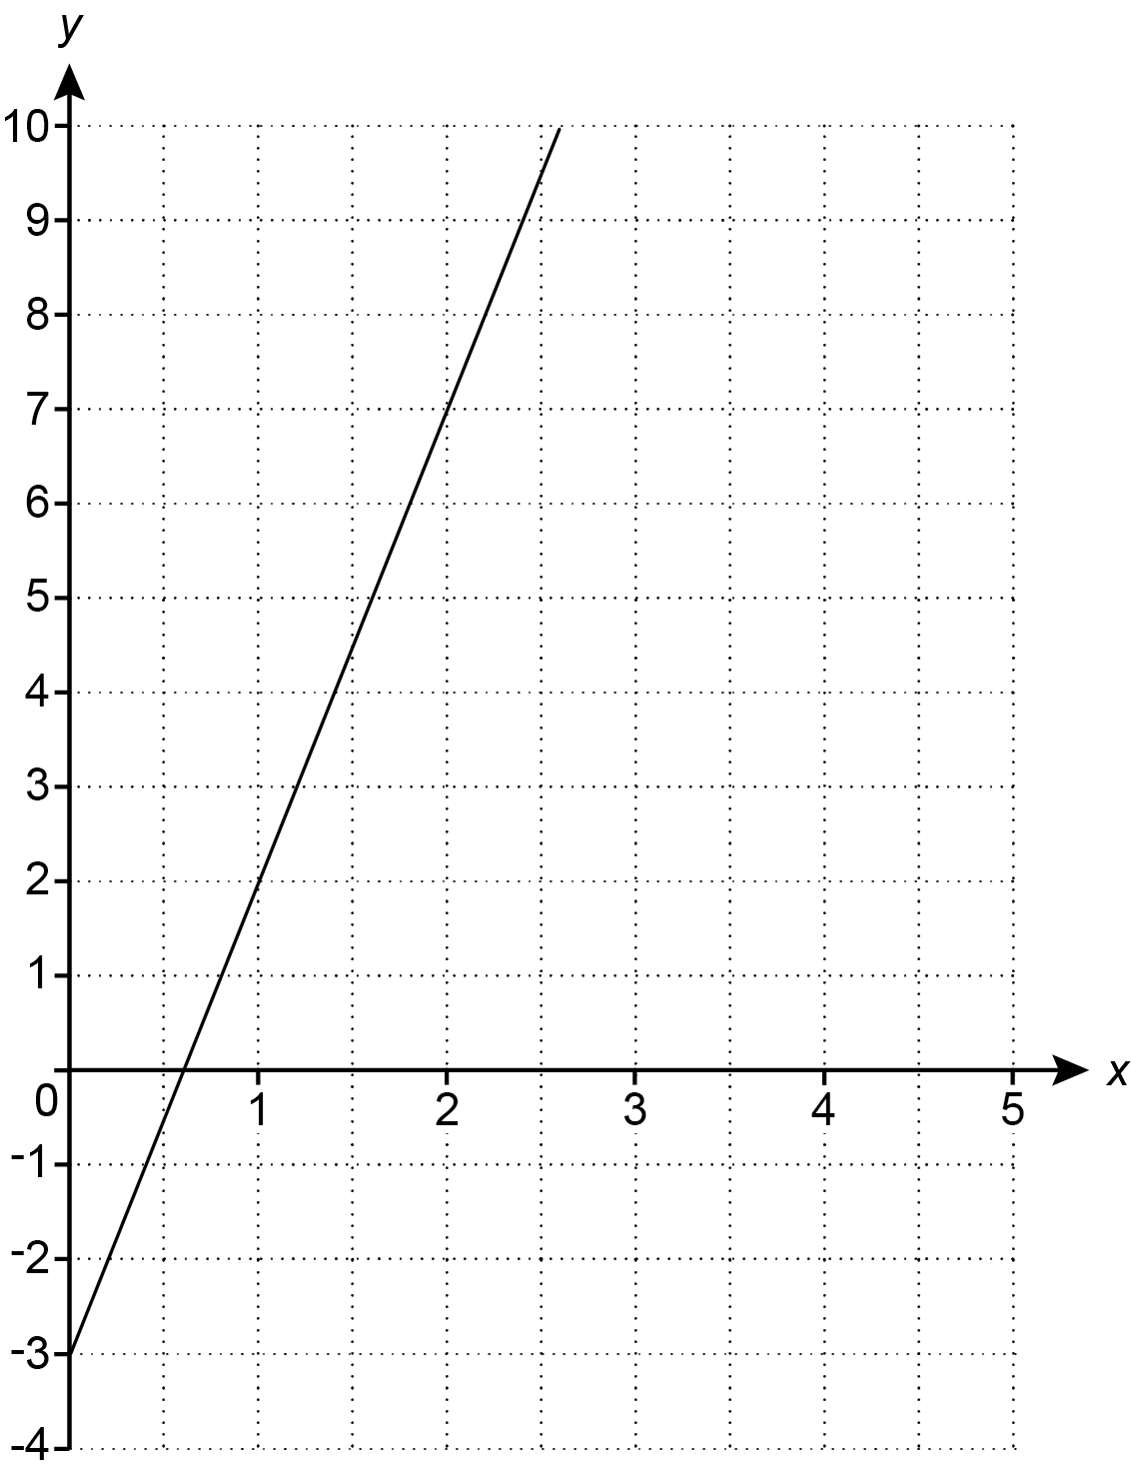

The line continues upwards.

Will the line pass above, below or through the point (30, 150)?
Show how you decide.

The line y = 5x – 3 will pass .............................. the point (30, 150) because ……………

...........................................................................................................................................

..................................................................................................................................... [2]

22 In this question, all measurements are in centimetres.

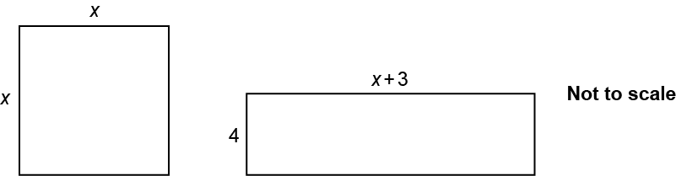

The square and the rectangle have the same area.

(a) Show that x² – 4x – 12 = 0. [3]

(b) Solve x² – 4x – 12 = 0.

(b) x = ...................... or x = .................... [3]

- Explain why one of the answers in part (b) is not possible in the context of the question.

...........................................................................................................................................

..................................................................................................................................... [1]

- Write down the following.

- The area of the square.

(d)(i) ..................................................... cm² [1]

- The length of the rectangle.

(ii) ....................................................... cm [1]

23 A bag of sweets contains jellies, mints and toffees.

The ratio of jellies to mints is 3n : 2.
The ratio of mints to toffees is 3 : 5n.

Work out the ratio of jellies to toffees.
Give your answer in its simplest form.

............................ : ........................... [4]

Please note – web links are correct at date of publication but other websites may change over time. If you have any problems with a link you may want to navigate to that organisation’s website for a direct search.



We’d like to know your view on the resources we produce. Click ‘Like’ or ‘Dislike’ to send us an auto generated email about this resource. Add comments if you want to. Let us know how we can improve this resource or what else you need. Your email will not be used or shared for any marketing purposes.
Looking for another resource? There is now a quick and easy search tool to help find free resources for your qualification.
OCR is part of Cambridge University Press & Assessment, which is itself a department of the University of Cambridge.
For staff training purposes and as part of our quality assurance programme your call may be recorded or monitored.
Oxford Cambridge and RSA Examinations is a Company Limited by Guarantee. Registered in England. Registered office
The Triangle Building, Shaftesbury Road, Cambridge, CB2 8EA. Registered company number 3484466. OCR is an exempt charity.
OCR operates academic and vocational qualifications regulated by Ofqual, Qualifications Wales and CCEA as listed
in their qualifications registers including A Levels, GCSEs, Cambridge Technicals and Cambridge Nationals.
OCR provides resources to help you deliver our qualifications. These resources do not represent any particular teaching method we expect you to use. We update our resources regularly and aim to make sure content is accurate but please check the OCR website so that you have the most up to date version. OCR cannot be held responsible for any errors or omissions in these resources.
Though we make every effort to check our resources, there may be contradictions between published support and the specification, so it is important that you always use information in the latest specification. We indicate any specification changes within the document itself, change the version number and provide a summary of the changes. If you do notice a discrepancy between the specification and a resource, please contact us.
© OCR 2022 - You can copy and distribute this resource freely if you keep the OCR logo and this small print intact and you acknowledge OCR as the originator of the resource.
OCR acknowledges the use of the following content: N/A
Whether you already offer OCR qualifications, are new to OCR or are thinking about switching, you can request more information using our Expression of Interest form.
Please get in touch if you want to discuss the accessibility of resources we offer to support you in delivering our qualifications.

