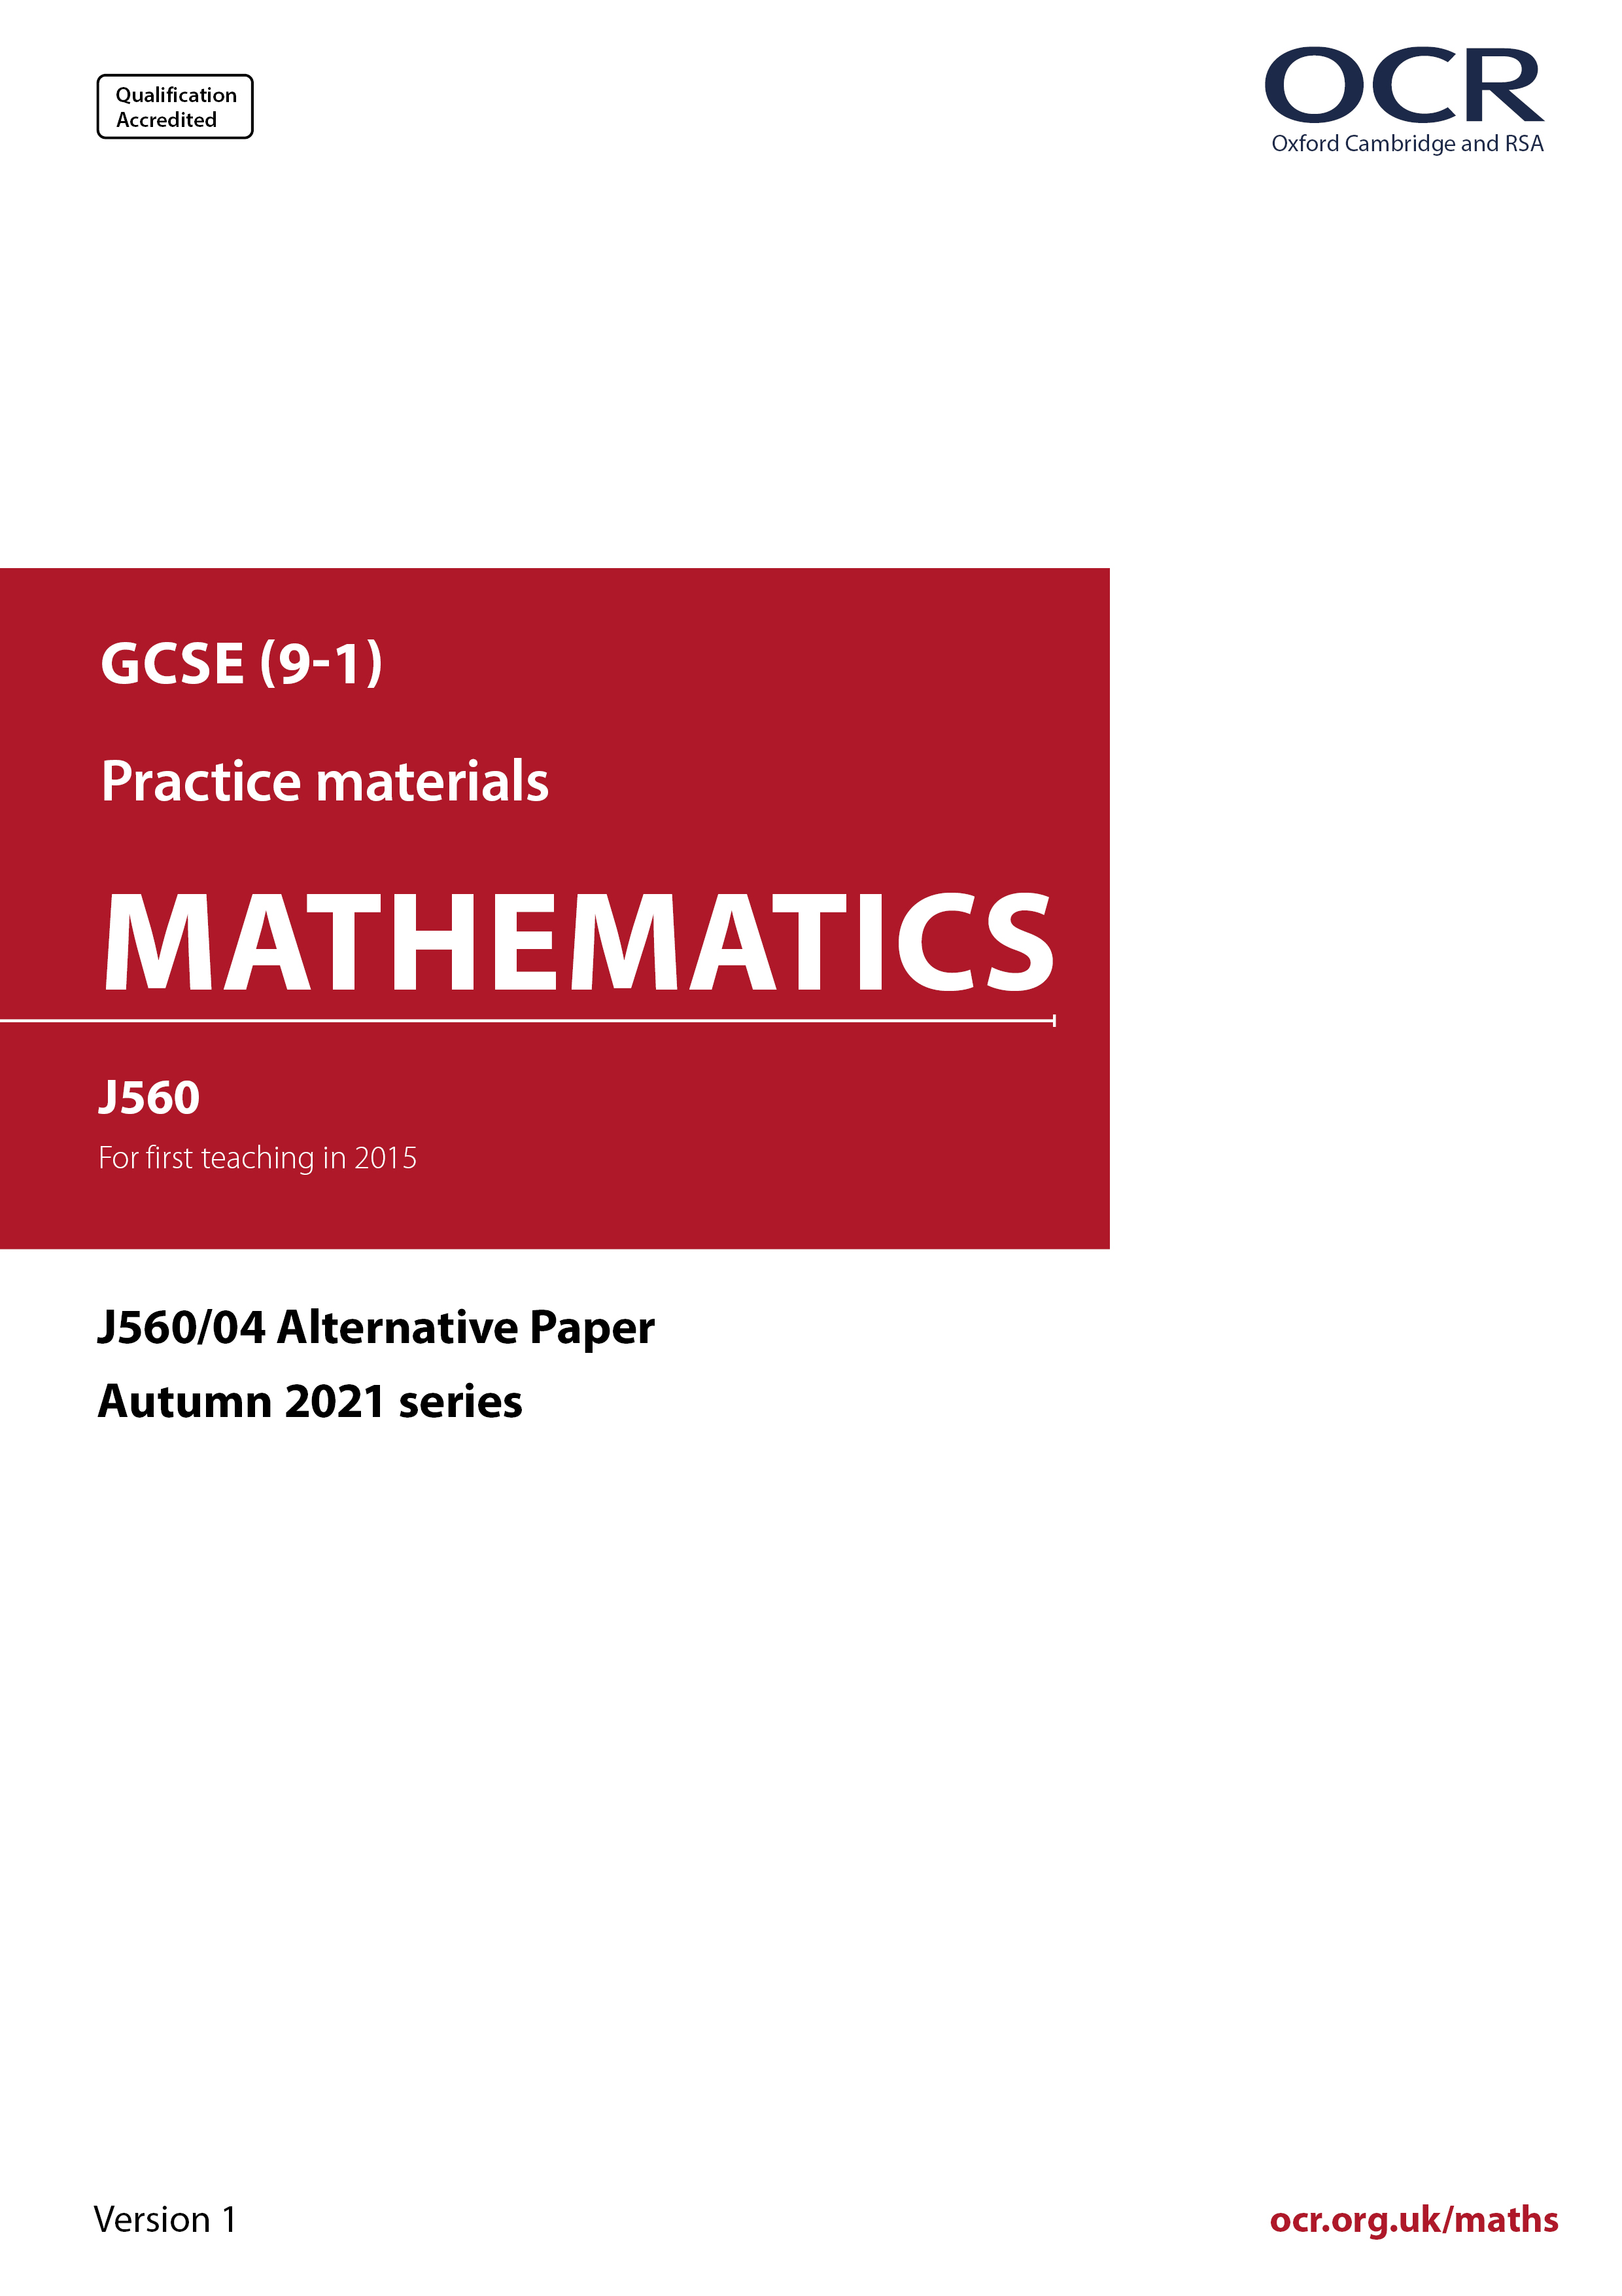
ocr.org.uk/maths

Introduction
OCR’s Alternative Papers for GCSE (9-1) Mathematics are each created by taking one of our past papers and amending the numbers/graphs/diagrams/tables/etc. in its questions.
This Alternative Paper is an amended version of one of the November 2021 series papers. The wording and topics assessed are essentially the same, but the responses students need to make will be different. Using both this paper and the corresponding November 2021 exam paper with your students at different points in the year will allow you to monitor how their learning has progressed in the time between the two papers.
Additional Alternative Papers and past papers are available to download from the OCR website.



GCSE (9-1) Mathematics
J560/04 Paper 1 (Higher Tier)
Alternative Paper (November 2021)

Time allowed: 1 hour 30 minutes

You may use:
- a scientific or graphical calculator
- geometrical instruments
- tracing paper

Name

INSTRUCTIONS
- Use black ink. You can use an HB pencil, but only for graphs and diagrams.
- Write your answer to each question in the space provided. You can use extra paper if
you need to, but you must clearly show your candidate number, the centre number and
the question numbers.
- Answer all the questions.
- Where appropriate, your answer should be supported with working. Marks might be
given for using a correct method, even if your answer is wrong.
- Use the π button on your calculator or take π to be 3.142 unless the question says
something different.

INFORMATION
- The total mark for this paper is 100.
- The marks for each question are shown in brackets [ ].
- This document has 21 pages.

ADVICE
- Read each question carefully before you start your answer.

Answer all the questions.

1 Calculate.

(a)

(a) ……..…………….………………. [1]

(b)

Write your answer correct to 3 significant figures.

(b) ……..…………….………………. [3]

2 Calculate the area of this trapezium.

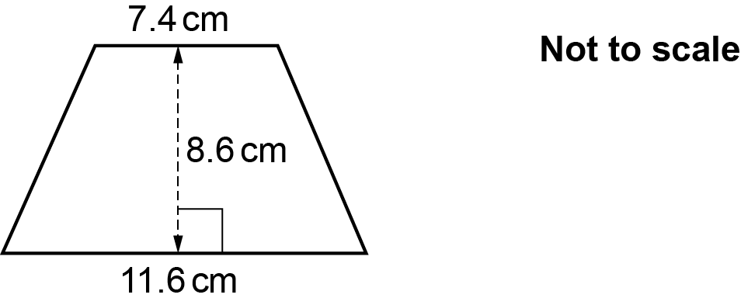

……..…………….………………. cm² [2]

3 Simplify.

……..…………….………………. [1]

4 Alex throws two fair four-sided dice, each numbered 1, 2, 4 and 5.
Alex multiplies together the two numbers that the dice land on to produce a score.

Find the probability that Alex’s score is a prime number.

……..…………….………………. [4]

5 (a) Fountain A squirts water every 36 minutes.
Fountain B squirts water every 84 minutes.
They squirt water together at 14:53.

Find the next time they squirt water together.

(a) ……..…………….………………. [4]

(b) A school sends 150 students from Year 8 and 105 students from Year 9 to a museum.

The school divides these students into groups using the following rules.

- The groups must all be the same size.
- All students in any group must be from the same year.
- There should be as few groups as possible.

Find the size of each group and the total number of groups.

(b) Size of each group = ……..………..……….……………….

Total number of groups = ……..…………….………………. [4]

6 A shop sells the same milk in three different sized cartons.
The diagram shows the price of each carton.

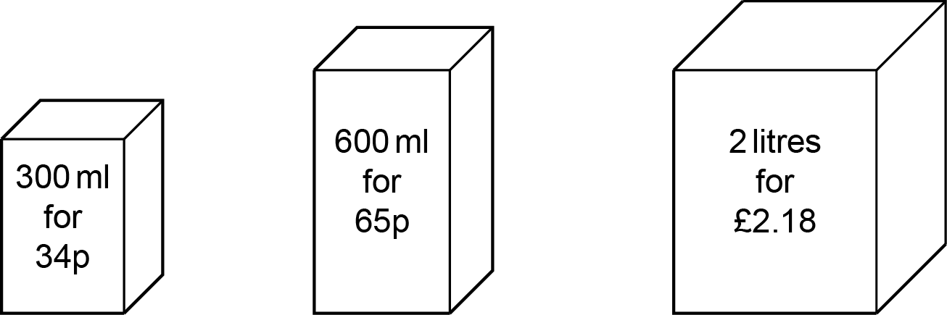

(a) Which carton is the best value for money?
Show how you decide.

.…………....…………………………………………………………………………………..…..

.....……..…………………………………………………………………………………..………

..……....………………………………………………………………………………………. [3]

(b) A student only buys milk on a Saturday morning.
They use 275 ml of milk each day.
Any unused milk has to be thrown away at the end of the following Friday.

Show that it is cheaper for the student to buy the milk they need in 2 litre cartons than in 600 ml cartons. [3]

7 (a) Over a long period of time, it is found that the probability of a train from Bewford to London being late is 0.3.

(i) One morning there are two trains from Bewford to London.

Use the information to complete the tree diagram.

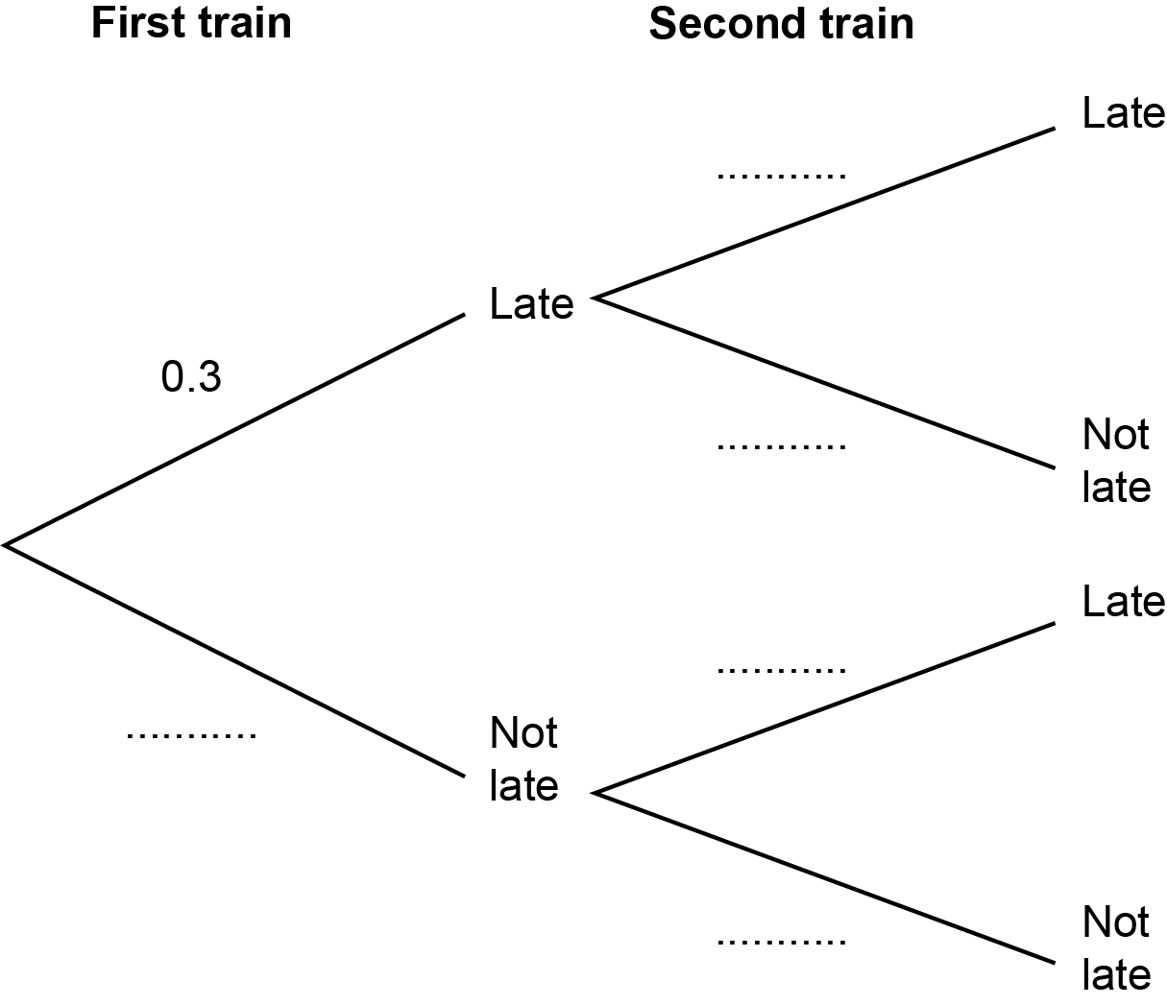
[2]

(ii) Work out the probability that both trains are not late.

(a)(ii) ……..…………….………………. [2]

(iii) Give a reason why the probabilities used in the tree diagram for the second train may not be reliable.

..…………………………………….……………………………………………………...…

....…….……………………………………………………………………...…………… [1]

(b) Charlie takes a train from London to Bewford and then another train to Agon.
The tree diagram shows the probabilities of Charlie’s trains being late or not late.

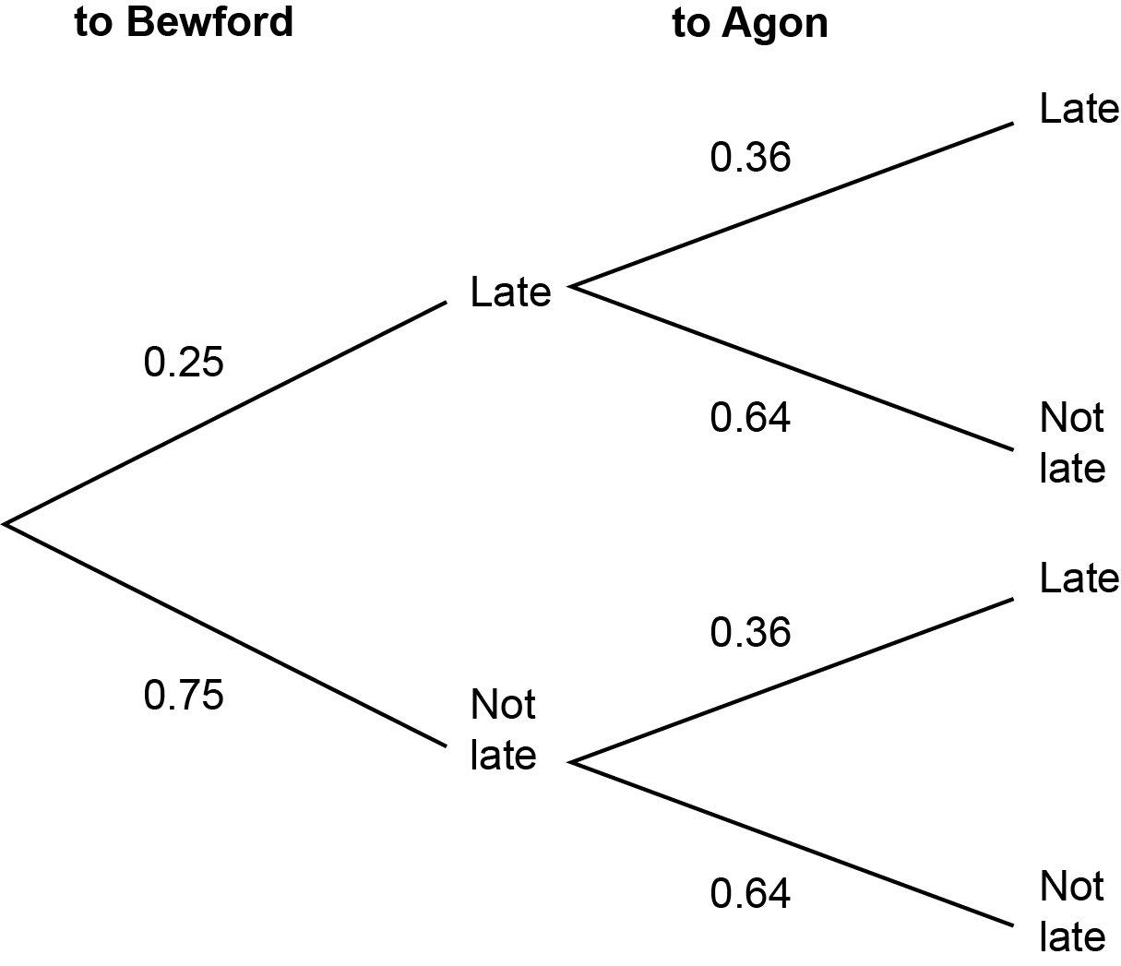

Charlie will not catch the train to Agon if the train to Bewford is late and the train to Agon is not late.

Work out the probability that Charlie will catch the train to Agon.

(b) ……..…………….………………. [3]

8 Blake invests £8000 at a simple interest rate of r % each year.
After 5 years the value of their investment is £8900.

Find the value of r.

r = ……..…………….………………. [4]

9 The price of a plane ticket is increased by 18% to £1475.

Find the original price of the plane ticket.

£ ……..…………….………………. [3]

10 Li, Jamie and Morgan play a computer game.

Li goes first and scores n points.

- Jamie scores 7 points more than 5 times the number of points scored by Li.
- Morgan scores 13 less points than Jamie.
- The three people score a total of 628 points.

Work out how many points they each score.
You must show your working.

Li = ……..……..………….……………….

Jamie = ……..…………….……………..…….

Morgan = ……..…………….………………. [7]

11 The diagram shows two triangles ACO and BDO.

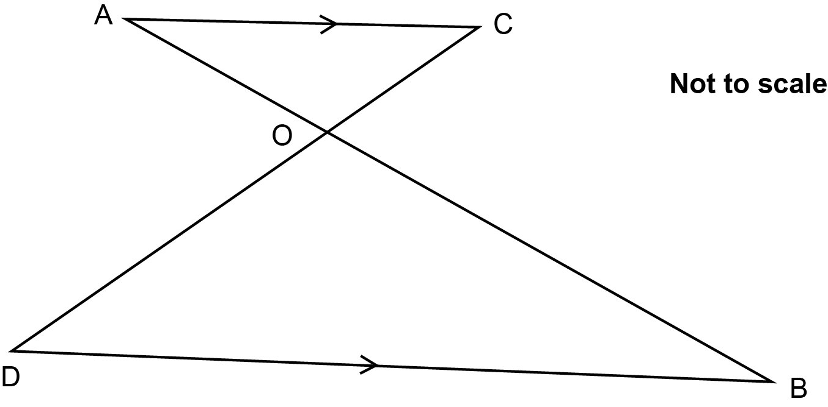

AC is parallel to DB.
The lines AB and CD meet at O.

Complete these statements to show that triangles ACO and BDO are similar.

Angle OAC = angle OBD because they are alternate angles.

Angle OCA = angle .................... because ……………………………………………………………

Angle AOC = angle ………. because …………………………….……………………………………

Triangles ACO and BDO are similar because………………………………………………….……

....………………………………………………………………..………………………….………… [3]

12 (a) The region R is shown on this grid.

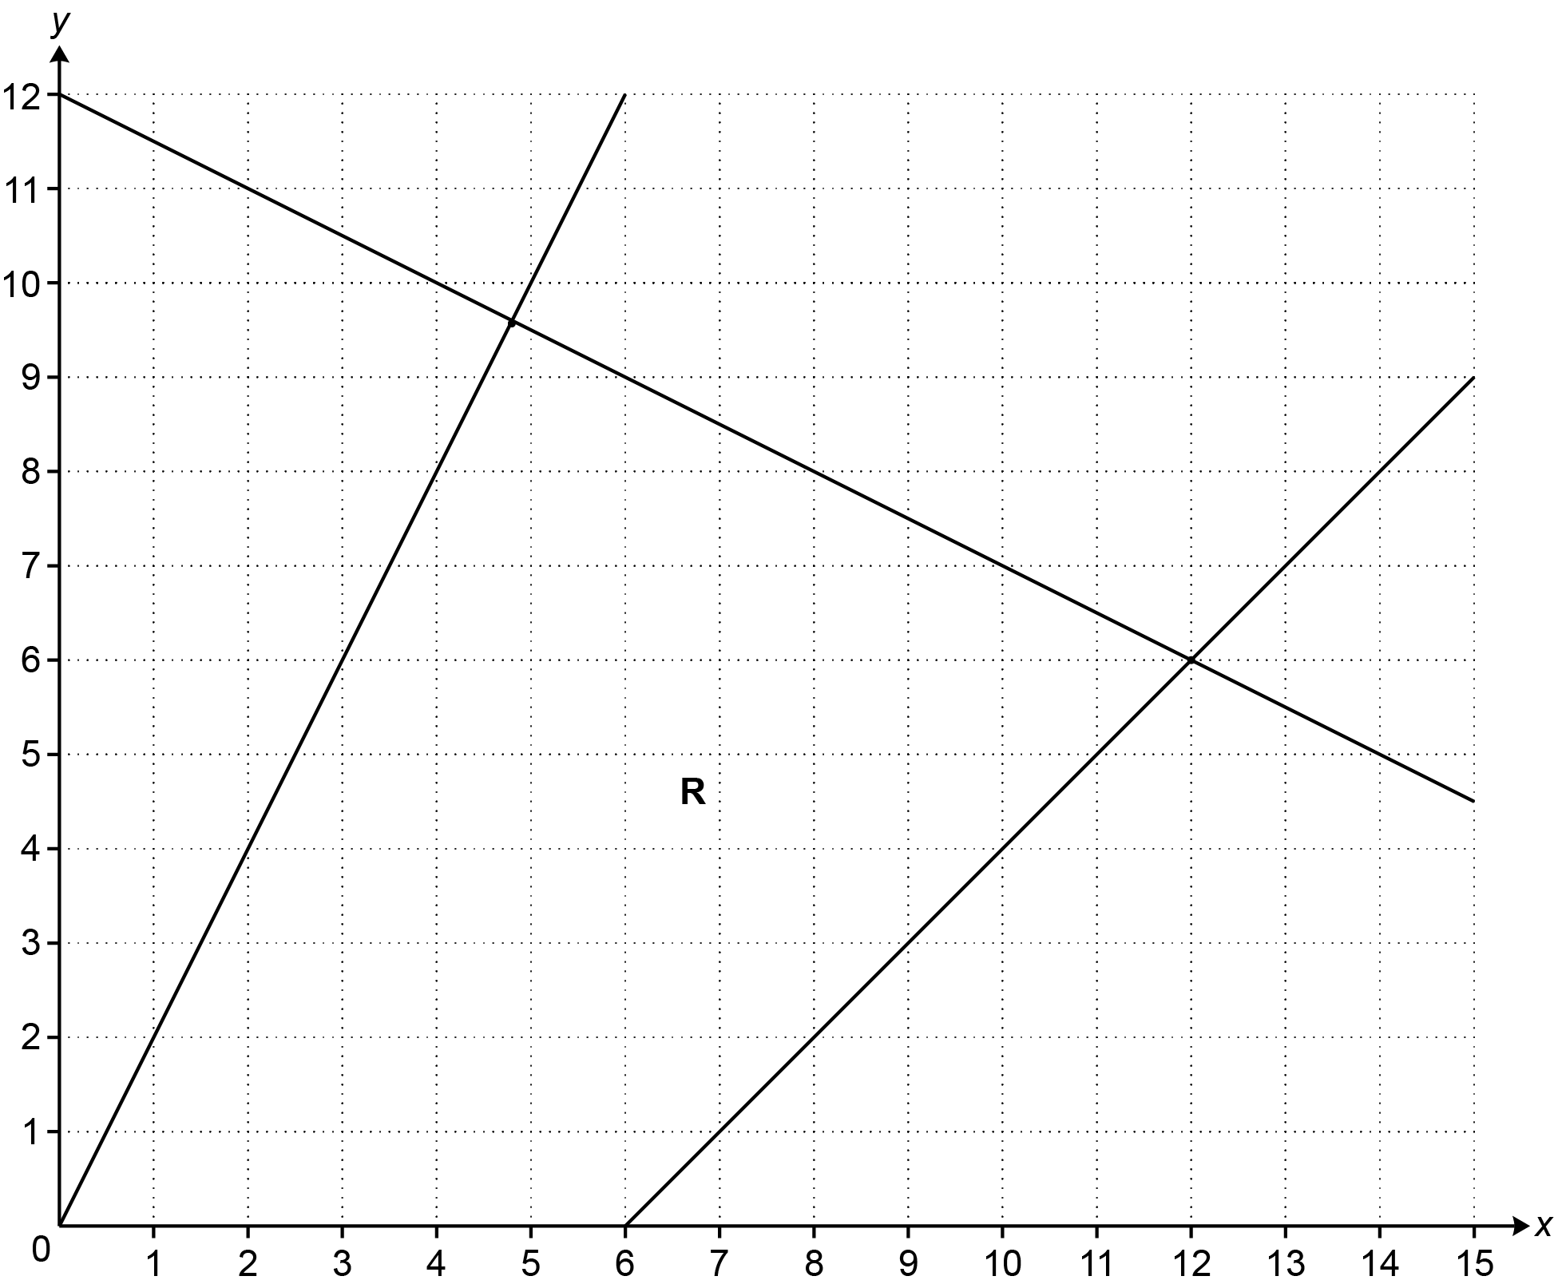

Region R is defined by four inequalities.
One of the inequalities is y ≥ 0.

Use the symbols ≤ and ≥ to complete the other three inequalities.
y | ≥ 0
y | ............... | 2x
x + 2y | ............... | 24
y | ............... | x − 6
[2]

(b) The inequality y ≥ 0 is replaced by a new inequality.
Region R is then a trapezium.
The point (6, 0) is still one of the corners of Region R.

Write down the new inequality.

(b) ……..…………….………………. [3]

13 The height, h cm, of each member of a tennis club is recorded.
The histogram shows some of the results.

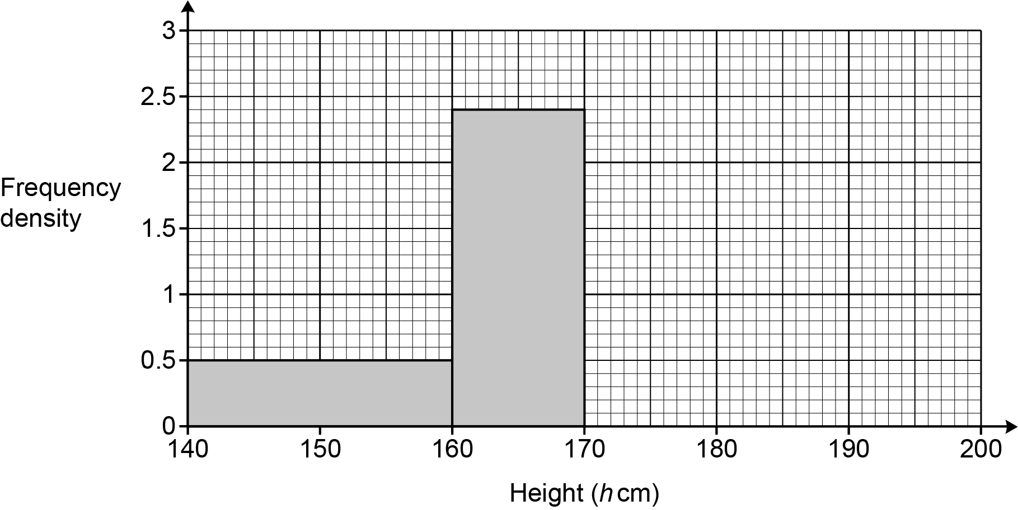

40% of the members have a height in the interval 160 ≤ h < 170.
30% of the members have a height in the interval 170 ≤ h < 180.
100% of the members have a height in the interval 140 ≤ h < 200.

Complete the histogram for the intervals 170 ≤ h < 180 and 180 ≤ h < 200. [6]

14 Find the coordinates of the turning point of the graph of y = .

( .......................... , .......................... ) [4]

15 Here are the first four terms of a quadratic sequence.

4 7 14 25

The nth term is an² + bn + c.

Find the values of a, b and c.

a = ……………………….……………….

b = ……..………..……….……………….

c = ……..………..……….………………. [4]

16 The formula

P =

is used to predict the population, P, of an island n years after 2019.

(a) Write down the population of the island in 2019.

(a) ……..…………….………………. [1]

(b) Write down the percentage growth rate used in the formula.

(b) ……..…………….………………% [1]

(c) (i) Work out the population predicted by the formula for the year 2030.

(c)(i) ……..…………….………………. [2]

(ii) Give one reason why the answer to (c)(i) may not be reliable.

……………...………………………………………………………………………………...

....…….………………………………………………………………………...………… [1]

17 The diagram shows triangle ABC.

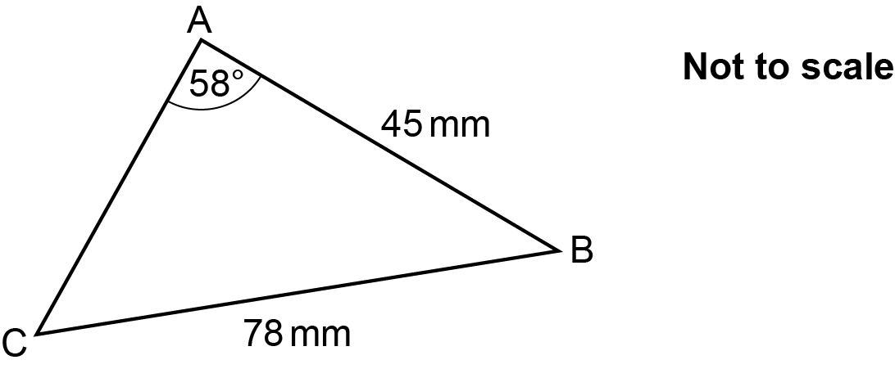

AB = 45 mm, BC = 78 mm and angle BAC = 58°.

Calculate length AC.
You must show your working.

……..…………….………………. mm [6]

18 (a) For each graph below, select its possible equation from this list.

y = x y = x ² y = $\frac{\text{1}}{\text{x}}$

y = $\text{sin}{\text{x}}$ y = $\text{cos}{\text{x}}$ y = $\text{tan}{\text{x}}$

y = 3^{.x} y = ${\left(\frac{\text{1}}{\text{3}}\right)}^{\text{x}}$

(i) 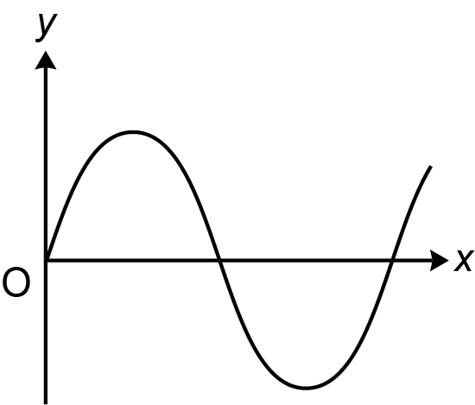

(a)(i) y = ……..…………….……. [1]

(ii) 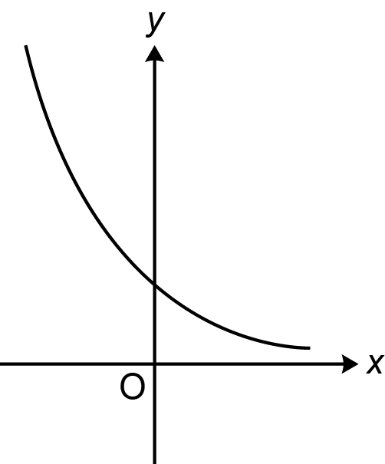

(ii) y = ……..…………….……. [1]

(b) Here is a sketch of y = x ³.

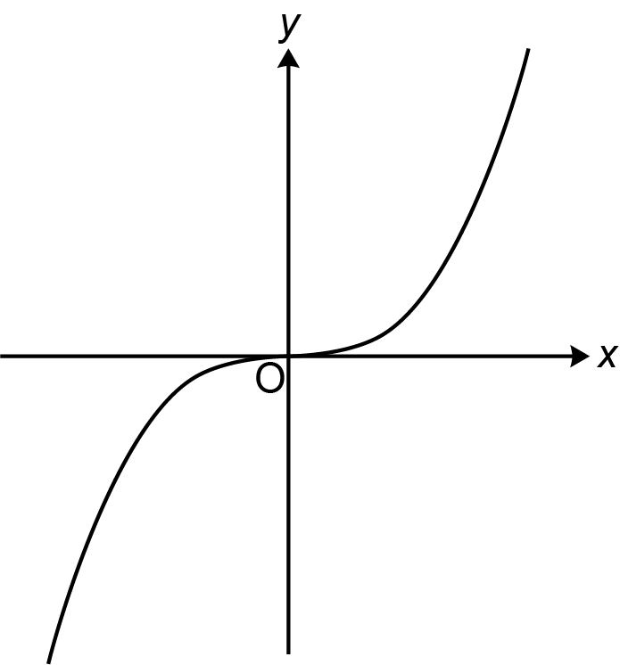

On the axes below, sketch the graphs of
(i)

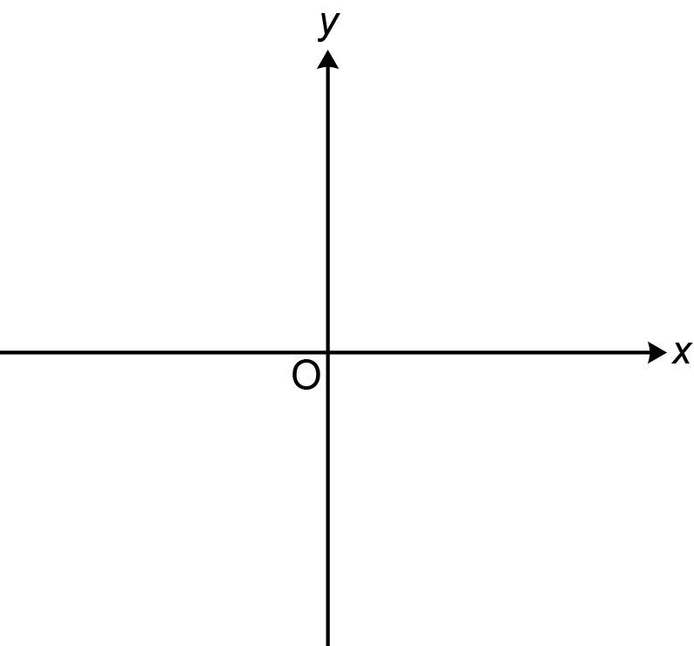
[1]

(ii) , showing the values of any intercepts with the axes.

[3]

19 ABC is an isosceles triangle.
The sides of the triangle ABC are all tangents to a circle of radius 5 cm, centre O.

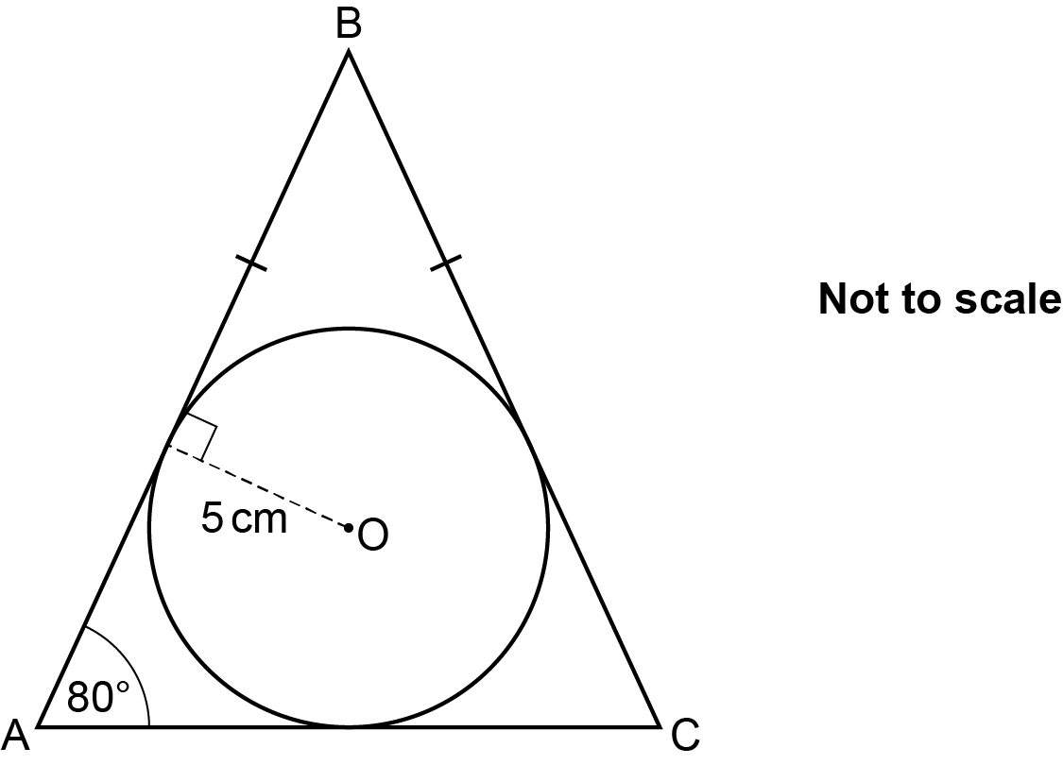

Angle BAC = 80° and BA = BC.

(a) Show that length BO is 28.79 cm, correct to 2 decimal places. [4]

(b) Find the area of triangle ABC.
You must show your working.

(b) ……..…………….………………. cm² [5]

20 Solve algebraically.

You must show your working.

x = ................... y = ...................

x = ................... y = ................... [5]

Please note – web links are correct at date of publication but other websites may change over time. If you have any problems with a link you may want to navigate to that organisation’s website for a direct search.


We’d like to know your view on the resources we produce. Click ‘Like’ or ‘Dislike’ to send us an auto generated email about this resource. Add comments if you want to. Let us know how we can improve this resource or what else you need. Your email will not be used or shared for any marketing purposes.
Looking for another resource? There is now a quick and easy search tool to help find free resources for your qualification.
OCR is part of Cambridge University Press & Assessment, which is itself a department of the University of Cambridge.
For staff training purposes and as part of our quality assurance programme your call may be recorded or monitored.
Oxford Cambridge and RSA Examinations is a Company Limited by Guarantee. Registered in England. Registered office
The Triangle Building, Shaftesbury Road, Cambridge, CB2 8EA. Registered company number 3484466. OCR is an exempt charity.
OCR operates academic and vocational qualifications regulated by Ofqual, Qualifications Wales and CCEA as listed
in their qualifications registers including A Levels, GCSEs, Cambridge Technicals and Cambridge Nationals.
OCR provides resources to help you deliver our qualifications. These resources do not represent any particular teaching method we expect you to use. We update our resources regularly and aim to make sure content is accurate but please check the OCR website so that you have the most up to date version. OCR cannot be held responsible for any errors or omissions in these resources.
Though we make every effort to check our resources, there may be contradictions between published support and the specification, so it is important that you always use information in the latest specification. We indicate any specification changes within the document itself, change the version number and provide a summary of the changes. If you do notice a discrepancy between the specification and a resource, please contact us.
© OCR 2022 - You can copy and distribute this resource freely if you keep the OCR logo and this small print intact and you acknowledge OCR as the originator of the resource.
OCR acknowledges the use of the following content: N/A
Whether you already offer OCR qualifications, are new to OCR or are thinking about switching, you can request more information using our Expression of Interest form.
Please get in touch if you want to discuss the accessibility of resources we offer to support you in delivering our qualifications.

