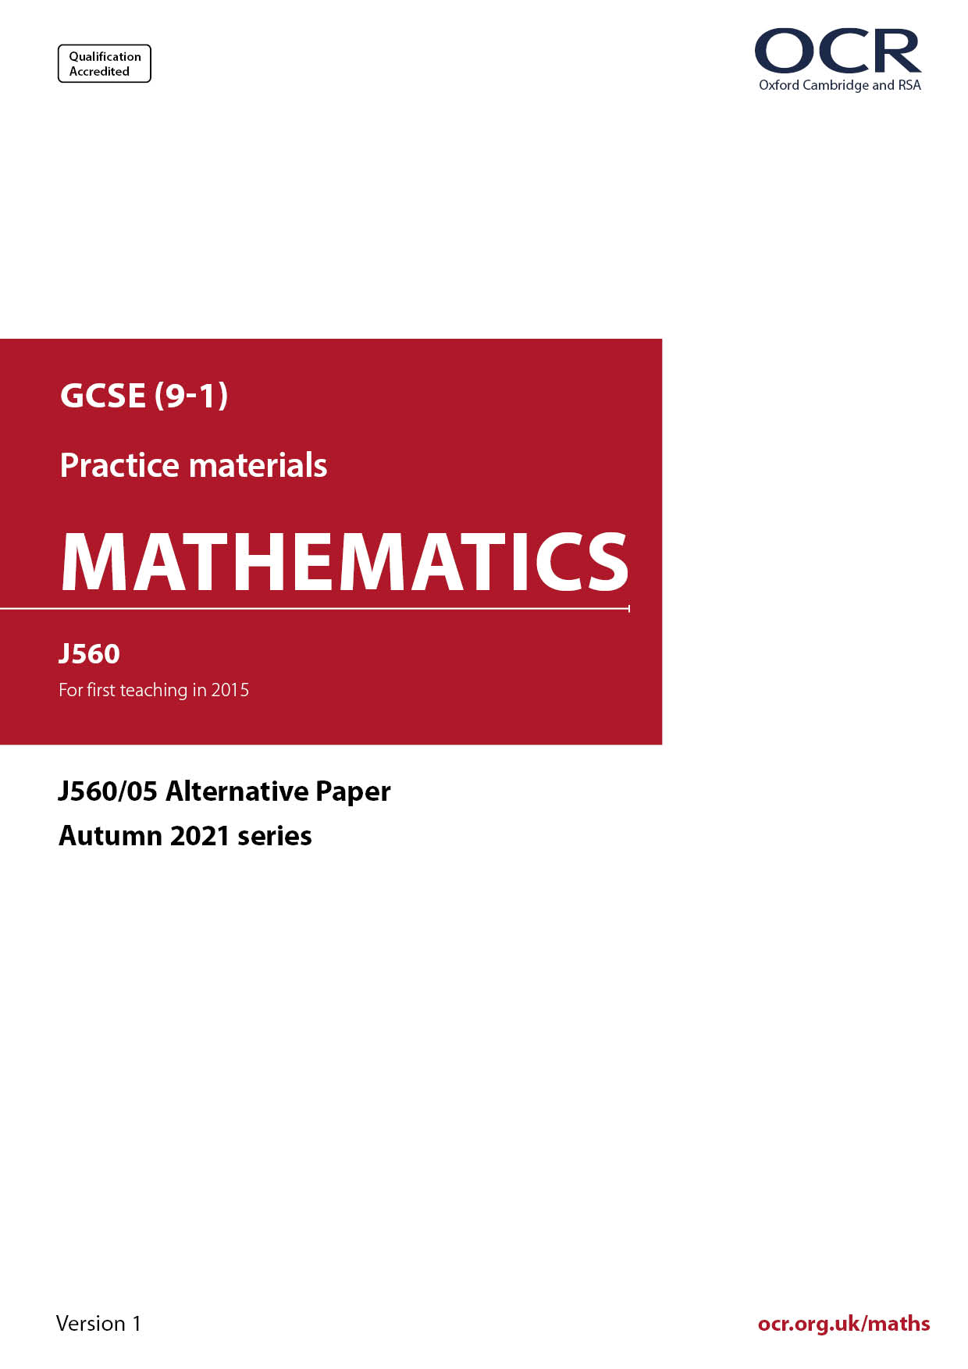
_{GCSE}
ocr.org.uk/maths

Introduction
OCR’s Alternative Papers for GCSE (9-1) Mathematics are each created by taking one of our past papers and amending the numbers/graphs/diagrams/tables/etc. in its questions.
This Alternative Paper is an amended version of one of the November 2021 series papers. The wording and topics assessed are essentially the same, but the responses students need to make will be different. Using both this paper and the corresponding November 2021 exam paper with your students at different points in the year will allow you to monitor how their learning has progressed in the time between the two papers.
Additional Alternative Papers and past papers are available to download from the OCR website.



GCSE (9-1) Mathematics
J560/05 Paper 5 (Higher Tier)
Alternative Paper (November 2021)

Time allowed: 1 hour 30 minutes


You may use:
- geometrical instruments
- tracing paper

Do not use:
- a calculator

Name

INSTRUCTIONS
- Use black ink. You can use an HB pencil, but only for graphs and diagrams.
- Write your answer to each question in the space provided. You can use extra paper if
you need to, but you must clearly show your candidate number, the centre number and
the question numbers.
- Answer all the questions.
- Where appropriate, your answer should be supported with working. Marks might be
given for using a correct method, even if your answer is wrong.

INFORMATION
- The total mark for this paper is 100.
- The marks for each question are shown in brackets [ ].
- This document has 20 pages.

ADVICE
- Read each question carefully before you start your answer.

Answer all the questions.

1 Work out.

4 $\frac{\text{2}}{\text{7}}$ $×$ $\frac{\text{7}}{\text{25}}$

Give your answer as a mixed number in its simplest form.

……..…………….………………. [3]

2 (a) Kai is given this question.

Write 60 as a product of prime factors.
Give your answer in index form.

Kai’s answer is 1 $×$ 2² $×$ 3 $×$ 5.

Is Kai correct?
Explain your answer.

..……………………………………………………………………………………………………

....……………………………………………………………………………………………… [1]

(b) Find the value of x.

$\frac{\text{1}}{\text{27}}$ $=$ 3 ^{X}

(b) x $=$ ……..…………….………………. [1]

3 A car mechanic has a tin containing 4 litres of engine oil.
Each week they use 350 millilitres of this oil for their vehicles.

The car mechanic says

After 9 weeks I will have used over 80% of the oil in this tin.

Are they correct?
Show how you decide.

..…………..………………………………………………………………………………………………

....………………………………..…………………………………………………………………… [5]

4 The table shows the marks obtained by 10 students in spelling tests in January and March.

Mark in January | 26 | 53 | 30 | 48 | 50 | 66 | 70 | 44 | 37 | 38
Mark in March | 45 | 61 | 69 | 61 | 71 | 85 | 89 | 63 | 51 | 53

The marks for the first six students are plotted on the scatter diagram.

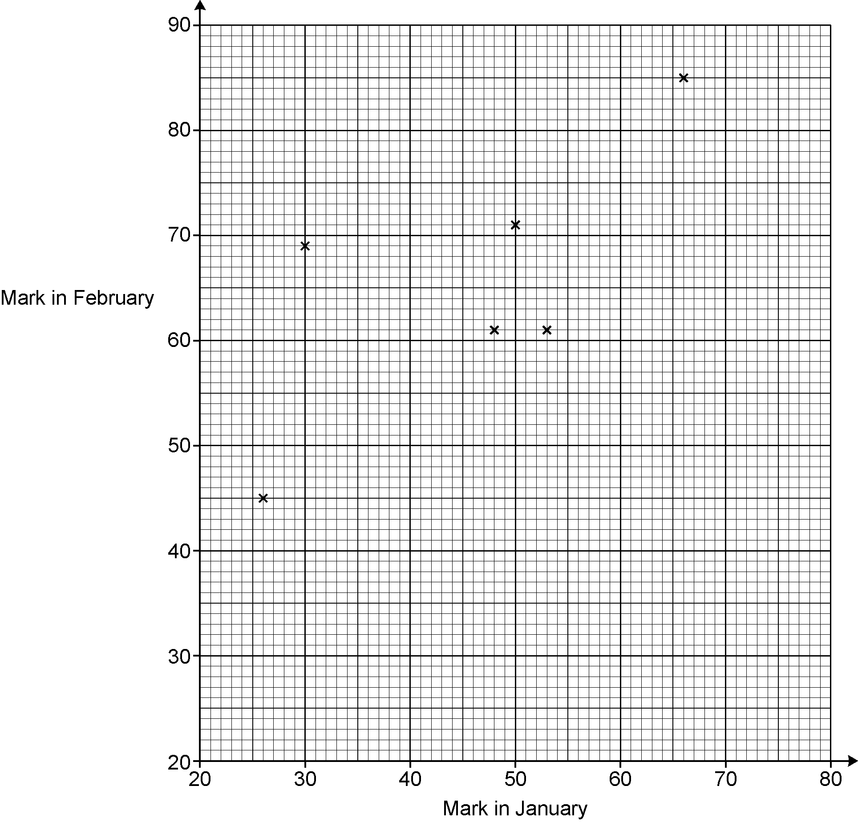
March

(a) Plot the marks for the remaining four students. [2]

(b) Describe the type of correlation shown in the completed scatter diagram.

...……………………………………………………………………………………………… [1]

(c) (i) On the scatter diagram, circle the student that made the greatest improvement in
their marks from January to March. [1]

(ii) Work out the percentage change in this student’s marks from January to March.

(c)(ii) ……..…………….………………. % [3]

(d) Another student, Sam, scored 75 marks in the test in January but was absent for the test in March.

Sam says

I could use a line of best fit on the scatter diagram to estimate the marks I may have achieved in the test in March.

Is Sam’s method reliable?
Give a reason for your answer.

..……………………………………………………………………………………………………

....……………………………………………………………………………………………… [1]

5 Work out the volume of this prism.

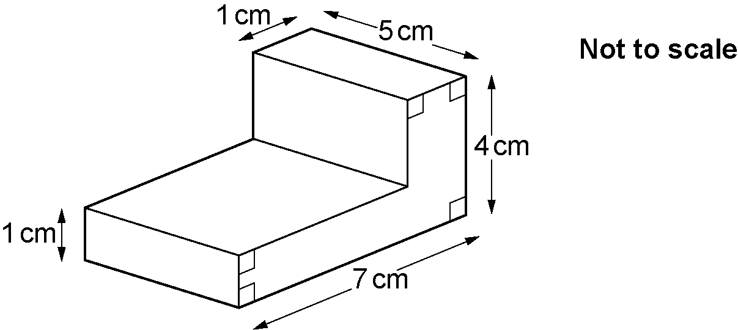

……..…………….………………. cm³ [4]

6 Here are sketches of five graphs.

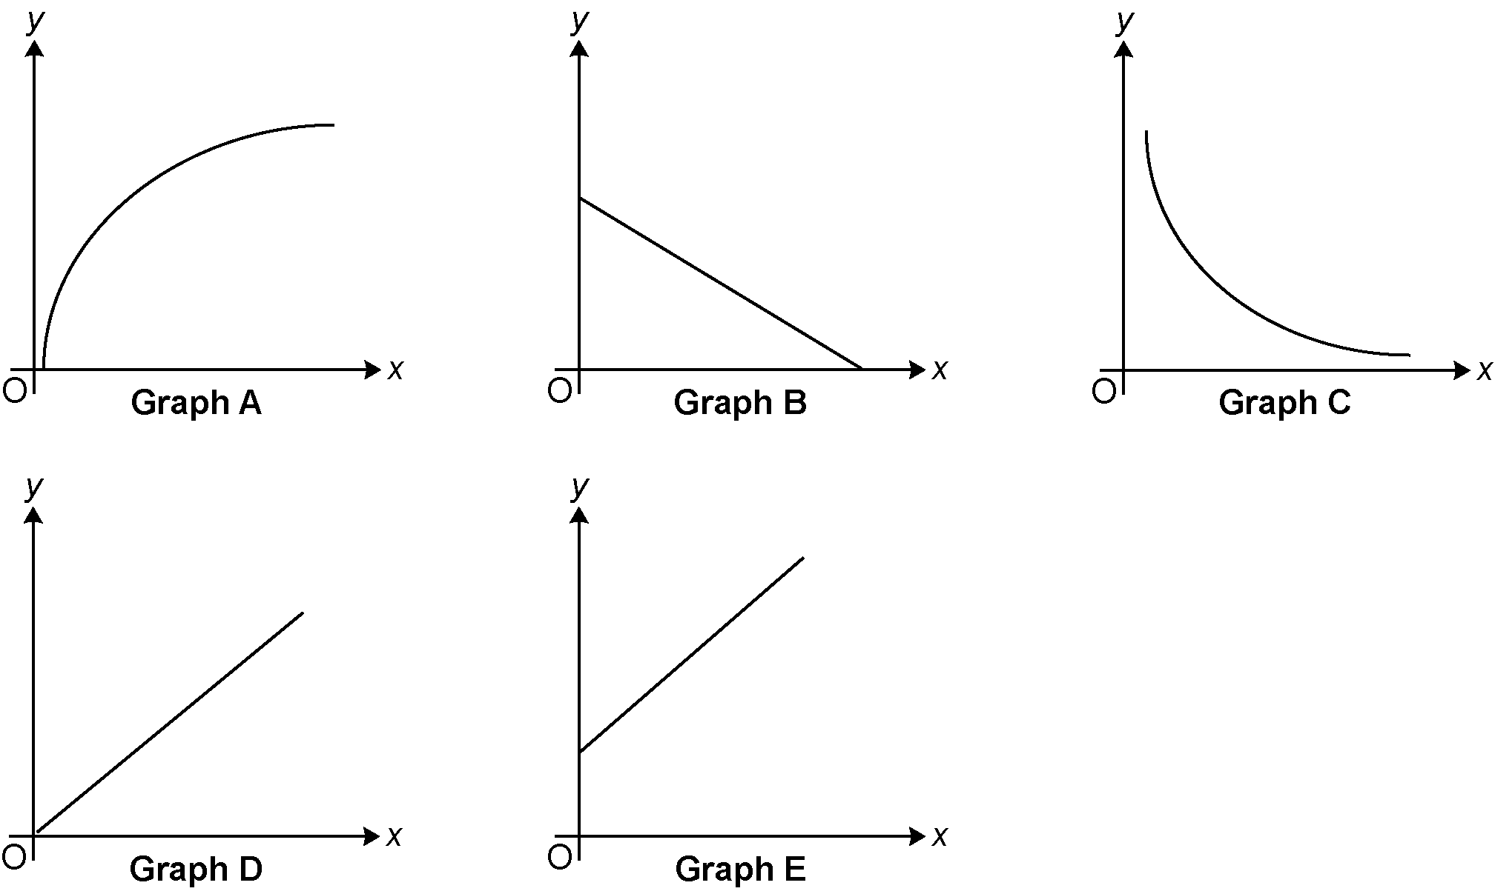

Write the letter of the graph that represents the following relationships.

(a) y is directly proportional to x.

(a) ……..…………….………………. [1]

(b) y is inversely proportional to x.

(b) ……..…………….………………. [1]

7 (a) Solve the inequality.

3(x $–$ 2) $>$ x

(a) ……..…………….………………. [3]

(b) Show your answer to part (a) on the number line.

[2]

8 (a) Complete the table for y = 1 + $\frac{\text{6}}{\text{x}}$.

x | -6 | -3 | -2 | -1 | 1 | 2 | 3 | 6
y | 0 |  | -2 | -5 | 7 | 4 | 3 | 2

[1]

(b) Draw the graph of y $=$ 1 + $\frac{\text{6}}{\text{x}}$ for -6 ≤ x ≤ 6, x $≠$ 0.

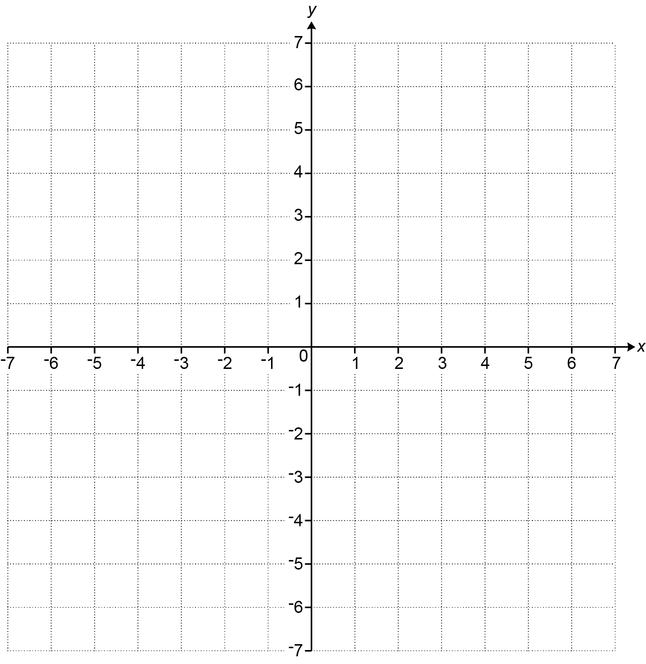
[3]

9 A worker received a 20% pay increase in 2017 and a further 10% pay increase in 2018.
The worker says

Over these two years, my pay increased by 20% + 10% = 30%.

The worker is incorrect.

Work out the correct percentage increase.
You must show your working.

....…………………………………..………………………………………………………………… [5]

10 Force is measured in newtons (N).
A force of 297.3 N is applied to a rectangular surface of length 5.9 cm and width 5.1 cm.

Work out an estimate of the pressure, in N/cm², applied to this rectangular surface.

[The formula for pressure is: Pressure $=$ $\frac{\text{Force}}{\text{Area}}$ ]

……..…………….………………. N/cm² [4]
11 The diagram shows a quadrilateral ABCD.

AD $=$ 12 cm, angle BAD $=$ 30° and angle ABD $=$ angle BDC $=$ 90°.
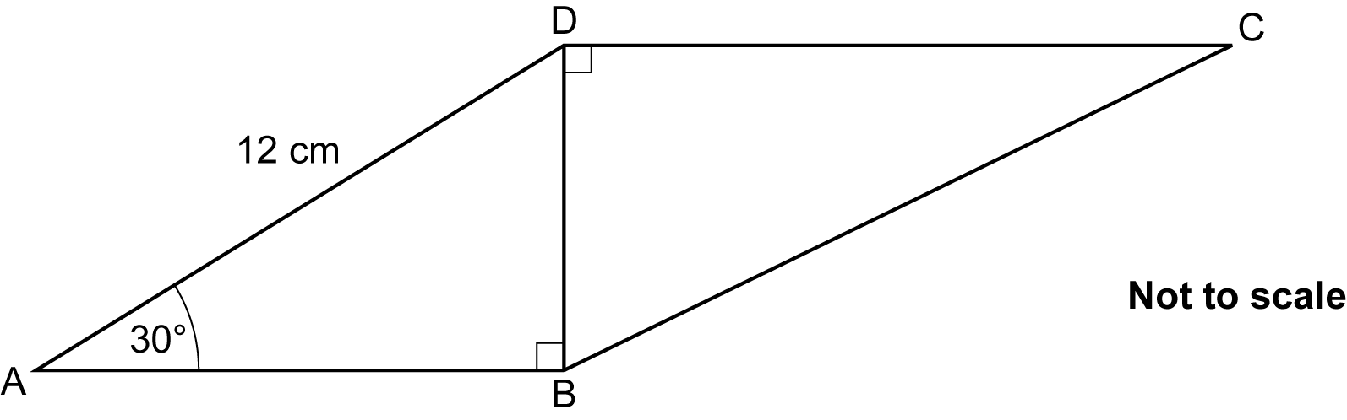

The ratio of length DC to length DB is $\frac{\text{4}}{\text{3}}$ : 1.

Work out length BC.
You must show your working.

……..…………….………………. cm [7]

12 The box plot shows the distribution of the lengths, in cm, of 60 full-grown hamsters owned by a pet shop.

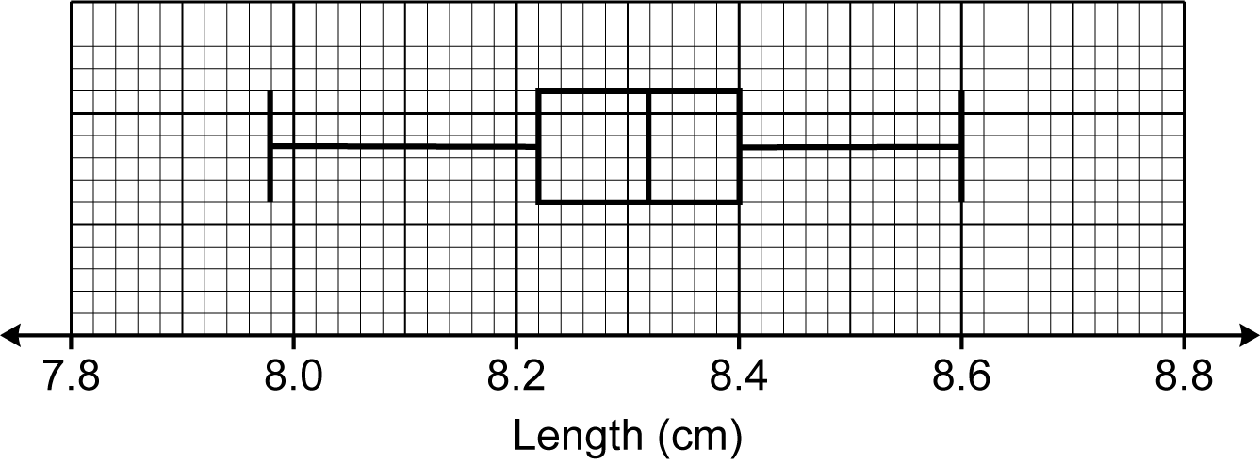

(a) Find the range.

- ……..…………….………………. cm [2]

(b) Work out the number of these hamsters that have a length of at least 8.4 cm.

- ……..…………….………………. [2]

(c) Azmi owns 5 full-grown hamsters.
Azmi picks the third longest hamster and measures its length.
Azmi then looks at the box plot.

Azmi says

This hamster is 8.25 cm long.
Therefore, the hamsters I own are shorter than the full-grown hamsters owned by the pet shop.

(i) Give a mathematical reason to support Azmi’s conclusion.

………………………………………………………………………………………………

..………………………………………………………………………………………… [1]

(ii) Give a mathematical reason why Azmi’s conclusion may be unreliable.

………………………………………………………………………………………………

..………………………………………………………………………………………… [1]

13 (a) Write $\frac{\text{4}}{\text{11}}$ as a recurring decimal.

(a) ……..…………….………………. [2]

(b) Write $\text{0.6}\dot{\text{4}}$ as a fraction in its simplest form.

(b) ……..…………….………………. [3]

14 Two solid ornaments are mathematically similar.
The larger ornament is three times as tall as the smaller ornament.

The smaller ornament has a volume of 20 cm³.

Work out the volume of the larger ornament.

……..…………….………………. cm³ [2]

15 Write $\sqrt{\text{75}}$ $–$ $\sqrt{\text{12}}$ in the form k $\sqrt{\text{3}}$.

……..…………….………………. [3]

16 In a group of 50 students, 26 own a laptop, 20 own a tablet and 10 own neither.

A student is chosen at random from those that own a tablet.

Find the probability that they also own a laptop.
You must show your working.

……..…………….………………. [5]

17 Simplify fully.

$$\frac{\text{3}{\text{x}}^{ \text{2}}-\text{12}}{{\text{x}}^{ \text{2}} \text{+ }\text{8}\text{x} \text{+ }\text{12}}$$

……..…………….………………. [5]

18 A, B, C and D are points on the circumference of a circle.

EF is the tangent to the circle at D.

Angle BDF = 75°.
D
E
F
C
B
A
75º
Not to scale

The ratio angle BCD : angle CBD is 7 : 3.

Work out angle CBD.
You must show your working.

……..…………….……………….° [5]

19 The point (4, 6$\sqrt{\text{3}}$) lies on the circumference of a circle, centre (0, 0).

Find the equation of the circle.

……..…………….………………. [4]

20 3x + y ² $=$ 7 and 6x $+$ z $=$ 8.

Write z in terms of y.
Give your answer in its simplest form.

……..…………….………………. [4]

21 AOB is a sector of a circle, centre O and radius 8 cm.

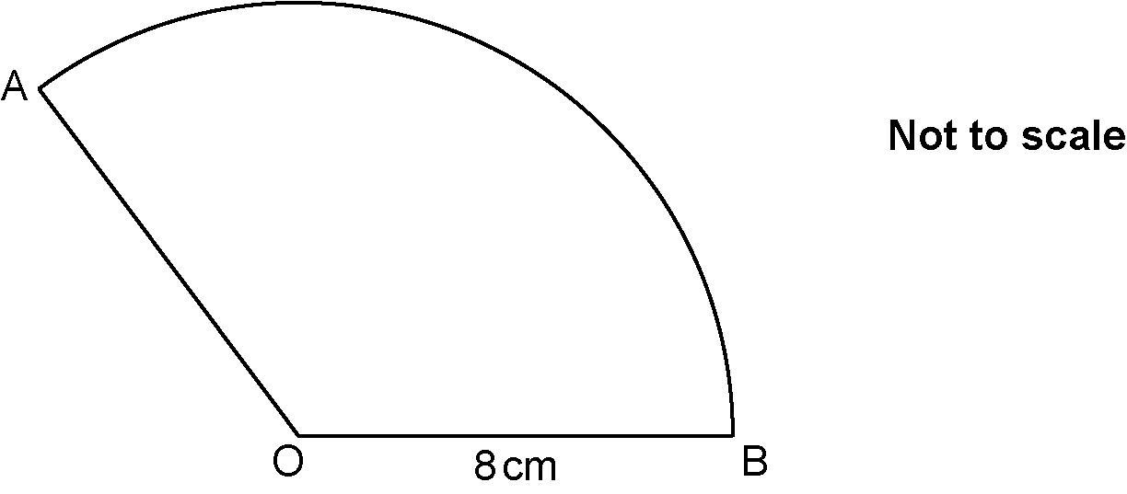

The area of the sector is 24π cm².

Work out the perimeter of the sector.
Give your answer in the form a $+$ bπ, where a and b are integers.
You must show your working.

……..…………….………………. cm [6]

22 n is a positive integer.

Prove that (2n $-$ 1)(n $+$ 5)(n $-$ 2) $+$ 3n(n $+$ 1) is always even.

……..…………….………………. [6]

Please note – web links are correct at date of publication but other websites may change over time. If you have any problems with a link you may want to navigate to that organisation’s website for a direct search.


We’d like to know your view on the resources we produce. Click ‘Like’ or ‘Dislike’ to send us an auto generated email about this resource. Add comments if you want to. Let us know how we can improve this resource or what else you need. Your email will not be used or shared for any marketing purposes.
Looking for another resource? There is now a quick and easy search tool to help find free resources for your qualification.
OCR is part of Cambridge University Press & Assessment, which is itself a department of the University of Cambridge.
For staff training purposes and as part of our quality assurance programme your call may be recorded or monitored.
Oxford Cambridge and RSA Examinations is a Company Limited by Guarantee. Registered in England. Registered office
The Triangle Building, Shaftesbury Road, Cambridge, CB2 8EA. Registered company number 3484466. OCR is an exempt charity.
OCR operates academic and vocational qualifications regulated by Ofqual, Qualifications Wales and CCEA as listed
in their qualifications registers including A Levels, GCSEs, Cambridge Technicals and Cambridge Nationals.
OCR provides resources to help you deliver our qualifications. These resources do not represent any particular teaching method we expect you to use. We update our resources regularly and aim to make sure content is accurate but please check the OCR website so that you have the most up to date version. OCR cannot be held responsible for any errors or omissions in these resources.
Though we make every effort to check our resources, there may be contradictions between published support and the specification, so it is important that you always use information in the latest specification. We indicate any specification changes within the document itself, change the version number and provide a summary of the changes. If you do notice a discrepancy between the specification and a resource, please contact us.
© OCR 2022 - You can copy and distribute this resource freely if you keep the OCR logo and this small print intact and you acknowledge OCR as the originator of the resource.
OCR acknowledges the use of the following content: N/A
Whether you already offer OCR qualifications, are new to OCR or are thinking about switching, you can request more information using our Expression of Interest form.
Please get in touch if you want to discuss the accessibility of resources we offer to support you in delivering our qualifications.

