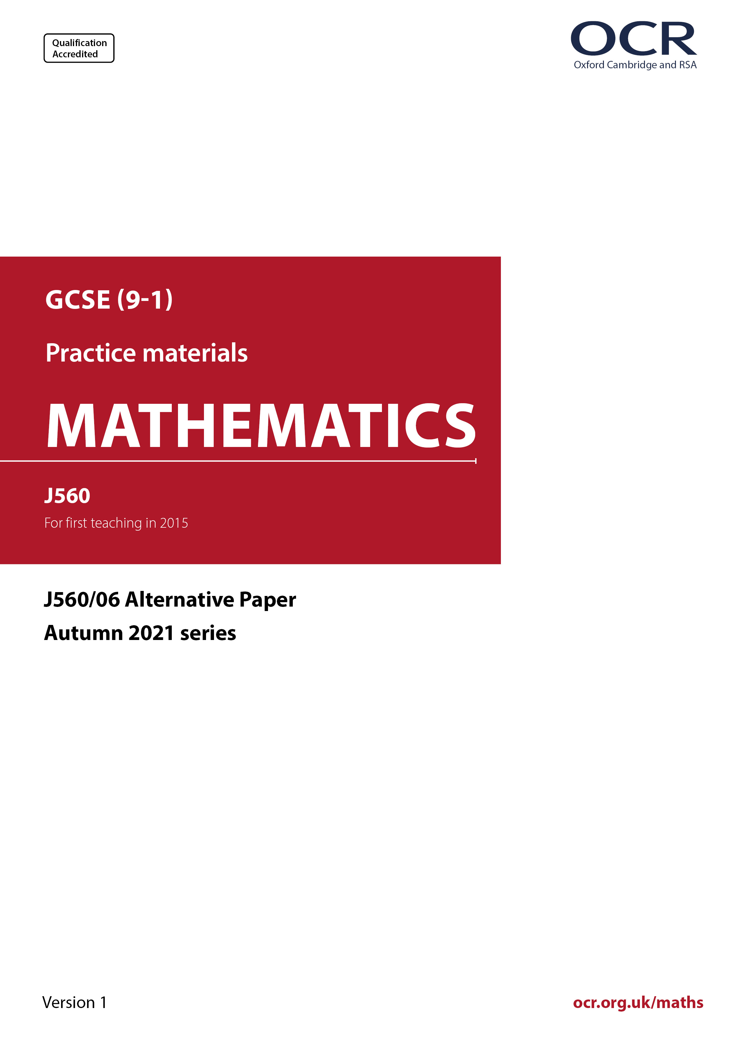
ocr.org.uk/maths

Introduction
OCR’s Alternative Papers for GCSE (9-1) Mathematics are each created by taking one of our past papers and amending the numbers/graphs/diagrams/tables/etc. in its questions.
This Alternative Paper is an amended version of one of the November 2021 series papers. The wording and topics assessed are essentially the same, but the responses students need to make will be different. Using both this paper and the corresponding November 2021 exam paper with your students at different points in the year will allow you to monitor how their learning has progressed in the time between the two papers.
Additional Alternative Papers and past papers are available to download from the OCR website.



GCSE (9-1) Mathematics
J560/06 Paper 6 (Higher Tier)
Alternative Paper (November 2021)

Time allowed: 1 hour 30 minutes

You may use:
- a scientific or graphical calculator
- geometrical instruments
- tracing paper

Name

INSTRUCTIONS
- Use black ink. You can use an HB pencil, but only for graphs and diagrams.
- Write your answer to each question in the space provided. You can use extra paper if
you need to, but you must clearly show your candidate number, the centre number and
the question numbers.
- Answer all the questions.
- Where appropriate, your answer should be supported with working. Marks might be
given for using a correct method, even if your answer is wrong.
- Use the π button on your calculator or take π to be 3.142 unless the question says
something different.

INFORMATION
- The total mark for this paper is 100.
- The marks for each question are shown in brackets [ ].
- This document has 20 pages.

ADVICE
- Read each question carefully before you start your answer.

Answer all the questions.

1 This table shows the names and areas of five lakes.

Name of Lake | Area in km²
Caspian | 3.71 × 10⁵
Geneva | 5.81 × 10²
Superior | 8.21 × 10⁴
Albert | 5.30 × 10³
Peipus | 3.56 × 10³

- Write the area of Lake Superior as an ordinary number.

- ..................................................... km² [1]

- Write the lakes in the order of their area, starting with the smallest.

.......................... .......................... .......................... .......................... .......................... [2]
smallest largest

(c) Calculate the difference between the areas of Lake Albert and Lake Geneva.
Give your answer in standard form, correct to 2 significant figures.

- ..................................................... km² [4]

2 Ellis, Ling and Amit share a flat.

- The monthly rent is £784.
They share the rent in the ratio 2 : 2 : 3.

How much does Amit pay for rent each month?

- £ .......................................................... [2]

(b) Ellis, Ling and Amit also share the fuel bill in the ratio 2 : 2 : 3.
Ellis pays £32 for fuel each month.
How much does Amit pay for fuel each month?

(b) £ .......................................................... [2]

3 Multiply out and simplify.

2(x + 3) – (x – 4)

........................................................... [2]

4 Triangle A and triangle B are drawn on the coordinate grid.

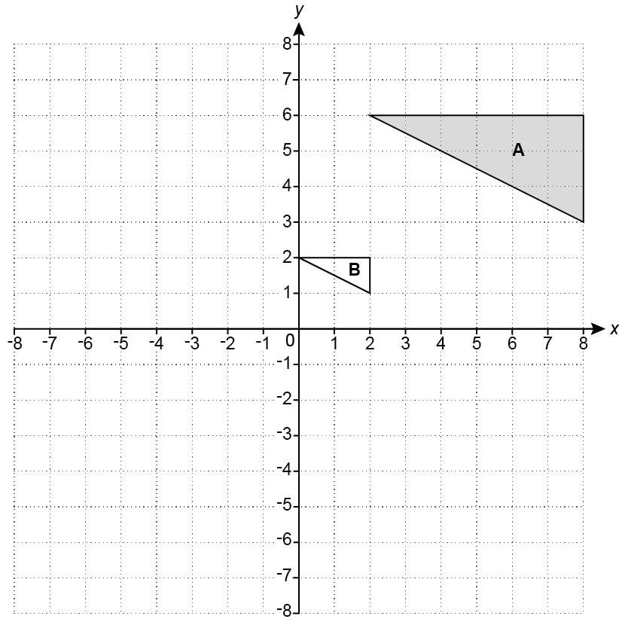

(a) Reflect triangle A in the line y = 0. [2]

(b) Describe fully the single transformation that maps triangle A onto triangle B.

..........................................................................................................................................

..................................................................................................................................... [3]
5 Azmi throws a six-sided dice 300 times.
The table shows the frequencies of their results.

- Complete the table to show the relative frequencies.

Number on dice | 1 | 2 | 3 | 4 | 5 | 6
Frequency | 42 | 24 | 51 | 63 | 48 | 72
Relative frequency | 0.14
[2]

- Azmi thinks that the dice may be biased.

- Explain why evidence from the table could support their opinion.

.................................................................................................................................

.................................................................................................................................

............................................................................................................................ [1]

- Explain why the dice may, in fact, not be biased.

.................................................................................................................................

.................................................................................................................................

............................................................................................................................ [1]

6 A bag of sweets contains jellies, mints and toffees.

The ratio of jellies to mints is 3n : 2.
The ratio of mints to toffees is 3 : 5n.

Work out the ratio of jellies to toffees.
Give your answer in its simplest form.

............................ : ........................... [4]

7 The scale drawing represents a park, ABCD.

Scale: 1 cm represents 10 m

A straight path goes across the park from A.
The path is always the same distance from side AB and side AD.

(a) Construct the route followed by the path.
Show all your construction lines. [2]

- A bench is to be placed on the path.
The bench must be no more than 40 m from C.

Construct the locus of the possible positions of the bench.
Indicate clearly on the diagram where the bench can be placed. [3]

8 (a) Train A travels 180 km at a constant speed of 75 km/h.
Train B travels 180 km at a constant speed of 72 km/h.

How many more minutes does train B take to travel 180 km than train A?

- ............................................ minutes [4]

(b) Train C has a speed of x metres per second.

Write an algebraic expression for train C’s speed in kilometres per hour.

(b) ................................................... km/h [2]
9 The width, w, of a kitchen cupboard is 80 cm, correct to the nearest centimetre.

(a) Complete the error interval for the width, w.

(a) ...................... ≤ w < ....................... [2]

(b) Six of these kitchen cupboards are to be placed side by side along a kitchen wall.
The wall is 483 cm long, correct to the nearest centimetre.

- Show that the six cupboards may not fit along the wall. [3]

- Find the upper bound of the space remaining if six cupboards do fit along the wall.

(b)(ii) .................................................... cm [3]

10 An equilateral triangle, a regular 15-sided polygon and another regular polygon meet at a point.

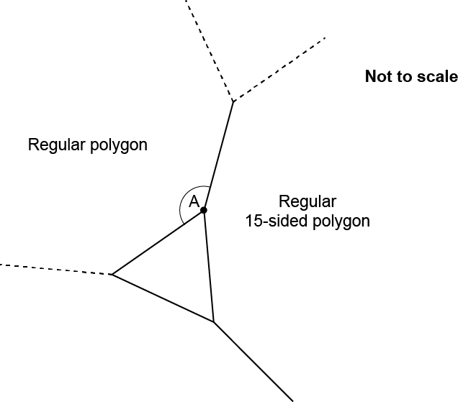

- Show that angle A is 144°. [3]

- Work out the number of sides of the other regular polygon.

(b) .......................................................... [2]
11 In a class of 32 students

- 18 study French (F)
- 15 study German (G)
- 4 do not study either subject.

(a) Complete the Venn diagram.

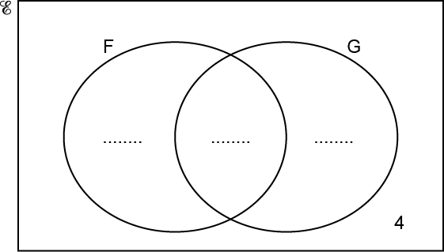

[3]

(b) Two of the 32 students are chosen at random.

Calculate the probability that one of these two students studies French but not German and the other studies German but not French.
You must show your working.

(b) .......................................................... [5]

12 A solid metal sphere has mass 240 g.
The density of the metal is 8.66 g/cm³.

Show that the surface area of this sphere is 44.3 cm², correct to 3 significant figures.
You must show your working.

[For a sphere with radius r : Volume =$\frac{\text{4}}{\text{3}}$ πr ³ Surface area = 4πr ².] [6]

13 A straight line passes through the point (6, -3) and is perpendicular to the line y = 3x + 2.

Find the equation of the line, giving your answer in the form y = mx + c.

…........................................................ [4]

14 y is inversely proportional to the square root of x.
y = 6 when x = 49.

- Find a formula linking x and y.

- .......................................................... [3]

(b) Find the value of x when y = 30.

(b) x = ........................................................... [3]

15 (a) Show that the equation x³ + 2x – 2 = 0 has a solution between x = 0 and x = 1. [3]

(b) Find this solution correct to 1 decimal place.
You must show your working.

- x = .......................................................... [4]

16 The following kinematics formulas may be used in this question.

v = u + at

s = ut + $\frac{\text{1}}{\text{2}}$ at ²

v ² = u ² + 2as

The initial velocity of a particle is 16 m/s.
The acceleration of the particle is -5 m/s².
After t seconds, the particle has travelled 24 m.

(a) Show that 5t ² – 32t + 48 = 0. [3]

(b) Solve 5t ² – 32t + 48 = 0.

(b) t = ........................................................... [3]

- Show that the particle is stationary when it has travelled 25.6 m.

..........................................................................................................................................

..................................................................................................................................... [3]

17 The diagram shows a pyramid ABCDE.

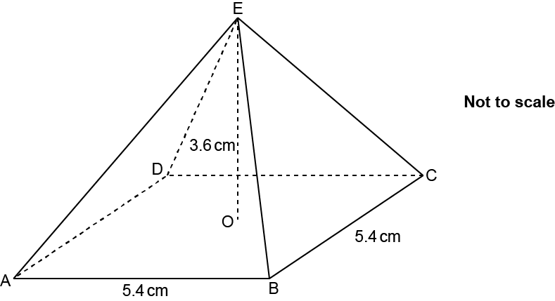

The pyramid has a square horizontal base ABCD with side 5.4 cm.

The vertex E is vertically above the centre O of the base.
The height OE of the pyramid is 3.6 cm.

Calculate the surface area of the pyramid.
You must show your working.

................................................... cm² [5]

18 Rearrange this formula to make a the subject.

........................................................... [5]



We’d like to know your view on the resources we produce. Click ‘Like’ or ‘Dislike’ to send us an auto generated email about this resource. Add comments if you want to. Let us know how we can improve this resource or what else you need. Your email will not be used or shared for any marketing purposes.
Looking for another resource? There is now a quick and easy search tool to help find free resources for your qualification.
OCR is part of Cambridge University Press & Assessment, which is itself a department of the University of Cambridge.
For staff training purposes and as part of our quality assurance programme your call may be recorded or monitored.
Oxford Cambridge and RSA Examinations is a Company Limited by Guarantee. Registered in England. Registered office
The Triangle Building, Shaftesbury Road, Cambridge, CB2 8EA. Registered company number 3484466. OCR is an exempt charity.
OCR operates academic and vocational qualifications regulated by Ofqual, Qualifications Wales and CCEA as listed
in their qualifications registers including A Levels, GCSEs, Cambridge Technicals and Cambridge Nationals.
OCR provides resources to help you deliver our qualifications. These resources do not represent any particular teaching method we expect you to use. We update our resources regularly and aim to make sure content is accurate but please check the OCR website so that you have the most up to date version. OCR cannot be held responsible for any errors or omissions in these resources.
Though we make every effort to check our resources, there may be contradictions between published support and the specification, so it is important that you always use information in the latest specification. We indicate any specification changes within the document itself, change the version number and provide a summary of the changes. If you do notice a discrepancy between the specification and a resource, please contact us.
© OCR 2022 - You can copy and distribute this resource freely if you keep the OCR logo and this small print intact and you acknowledge OCR as the originator of the resource.
OCR acknowledges the use of the following content: N/A
Whether you already offer OCR qualifications, are new to OCR or are thinking about switching, you can request more information using our Expression of Interest form.
Please get in touch if you want to discuss the accessibility of resources we offer to support you in delivering our qualifications.

