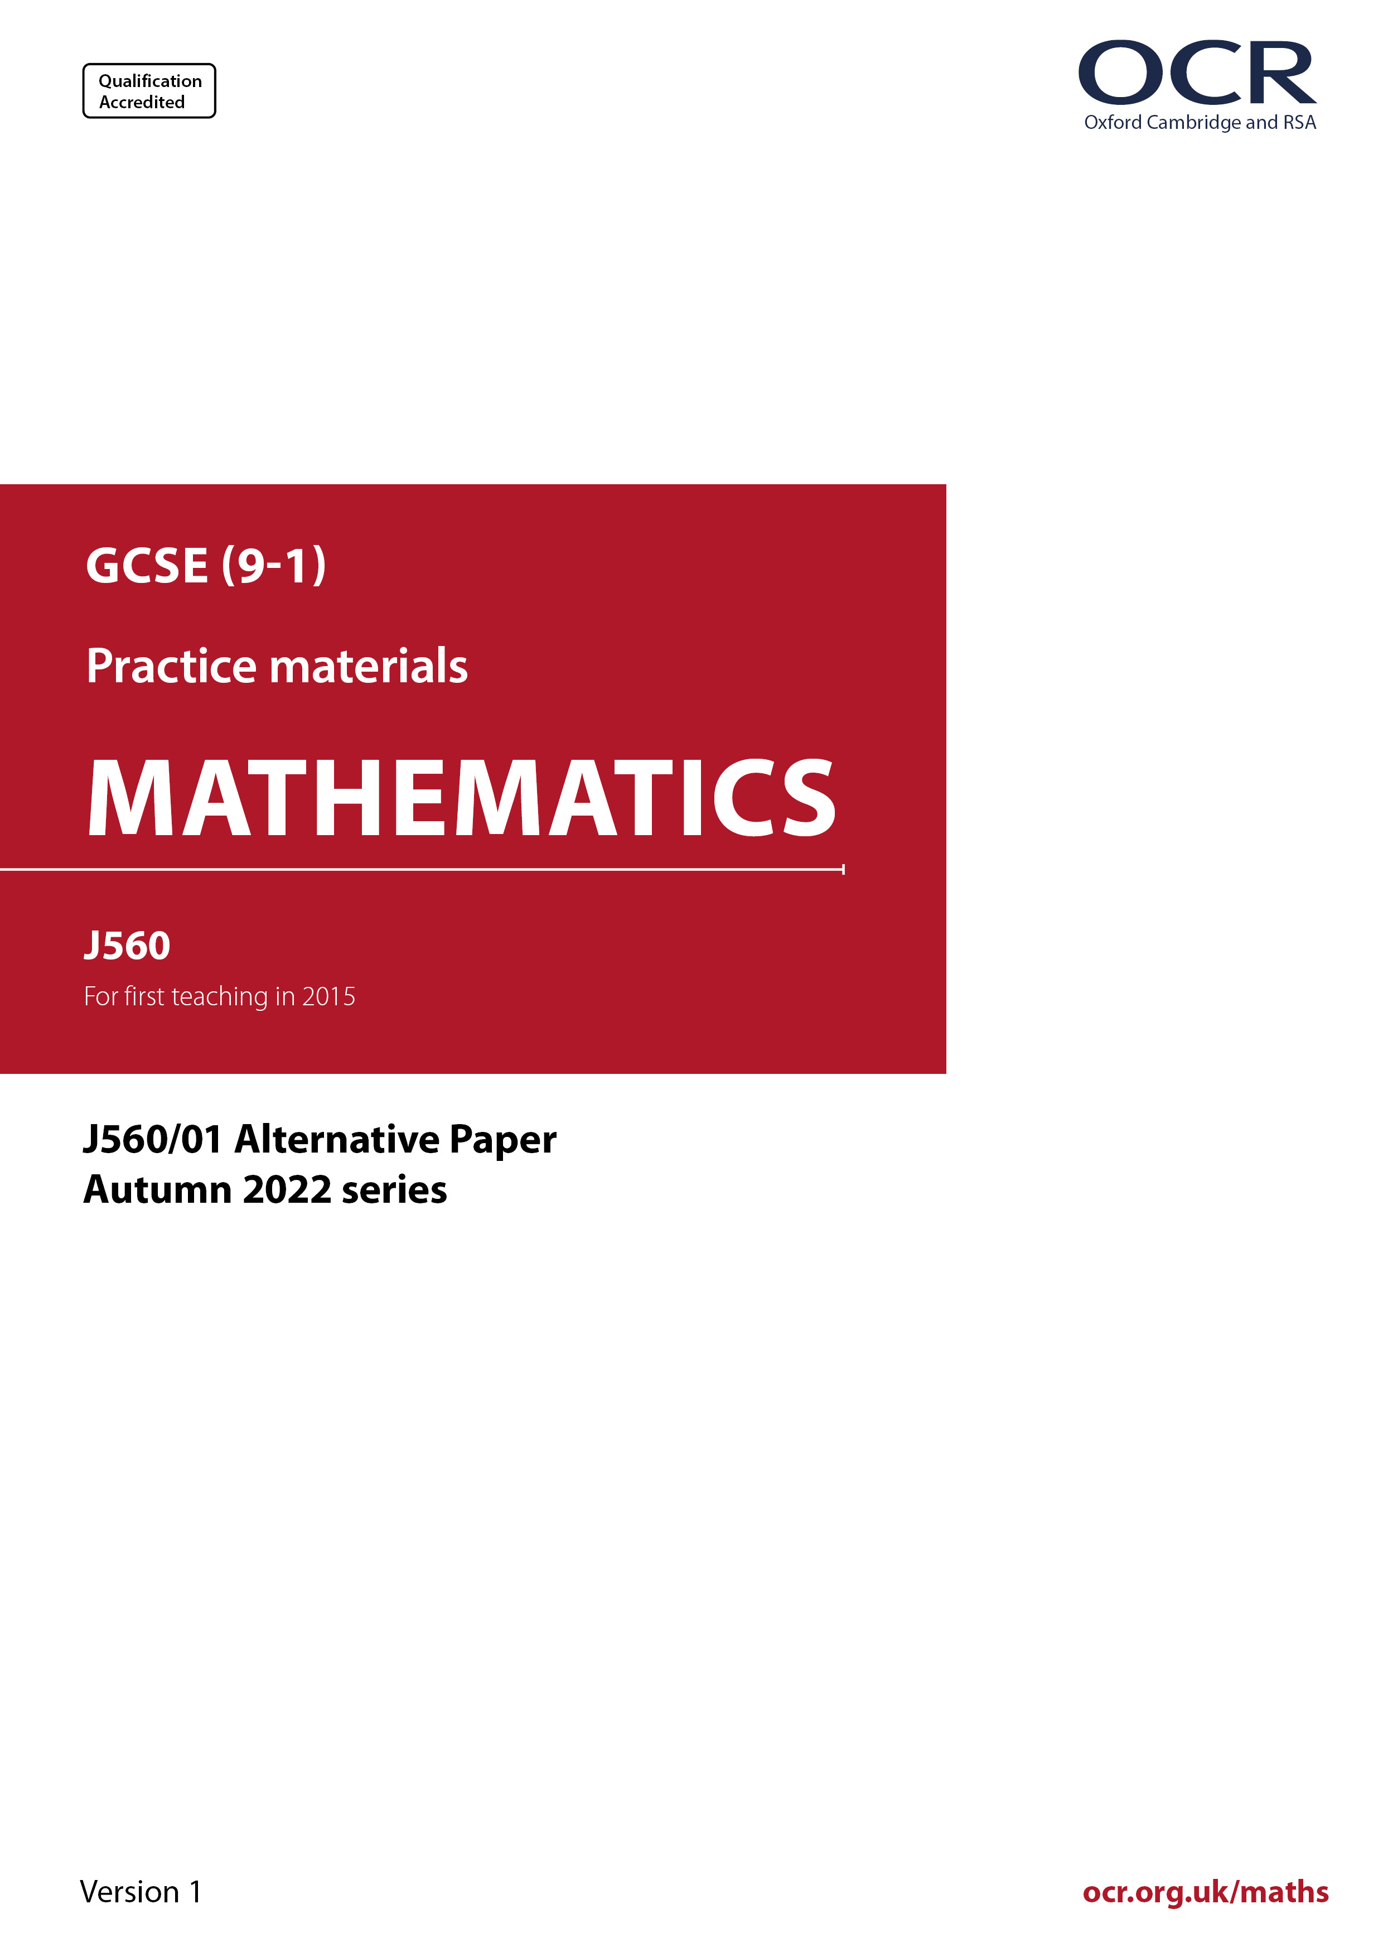
ocr.org.uk/maths

Introduction
OCR’s Alternative Papers for GCSE (9-1) Mathematics are each created by taking one of our past papers and amending the numbers/graphs/diagrams/tables/etc. in its questions.
This Alternative Paper is an amended version of one of the November 2022 series papers. The wording and topics assessed are essentially the same, but the responses students need to make will be different. Using both this paper and the corresponding November 2022 exam paper with your students at different points in the year will allow you to monitor how their learning has progressed in the time between the two papers.
Please note that when students originally sat this paper in 2022, they were given a formulae sheet. Foundation tier and Higher tier formulae sheets are published on Teach Cambridge alongside the Alternative Papers, for use with students as required.
Additional Alternative Papers and past papers are available to download from Teach Cambridge.



GCSE (9-1) Mathematics
J560/01 Paper 1 (Foundation Tier)
Alternative Paper (November 2022)

Time allowed: 1 hour 30 minutes

F
You can use:
- a scientific or graphical calculator
- geometrical instruments
- tracing paper

Name

INSTRUCTIONS
- Use black ink. You can use an HB pencil, but only for graphs and diagrams.
- Write your answer to each question in the space provided. If you need extra space, use
the lined pages at the end of this booklet. The question numbers must be clearly shown.
- Answer all the questions.
- Where appropriate, your answer should be supported with working. Marks might be
given for using a correct method, even if your answer is wrong.
- Use the π button on your calculator or take π to be 3.142 unless the question says
something different.

INFORMATION
- The total mark for this paper is 100.
- The marks for each question are shown in brackets [ ].
- This document has 24 pages.

ADVICE
- Read each question carefully before you start your answer.

Answer all the questions.

1 The bar chart shows the number of points scored by some quiz players.

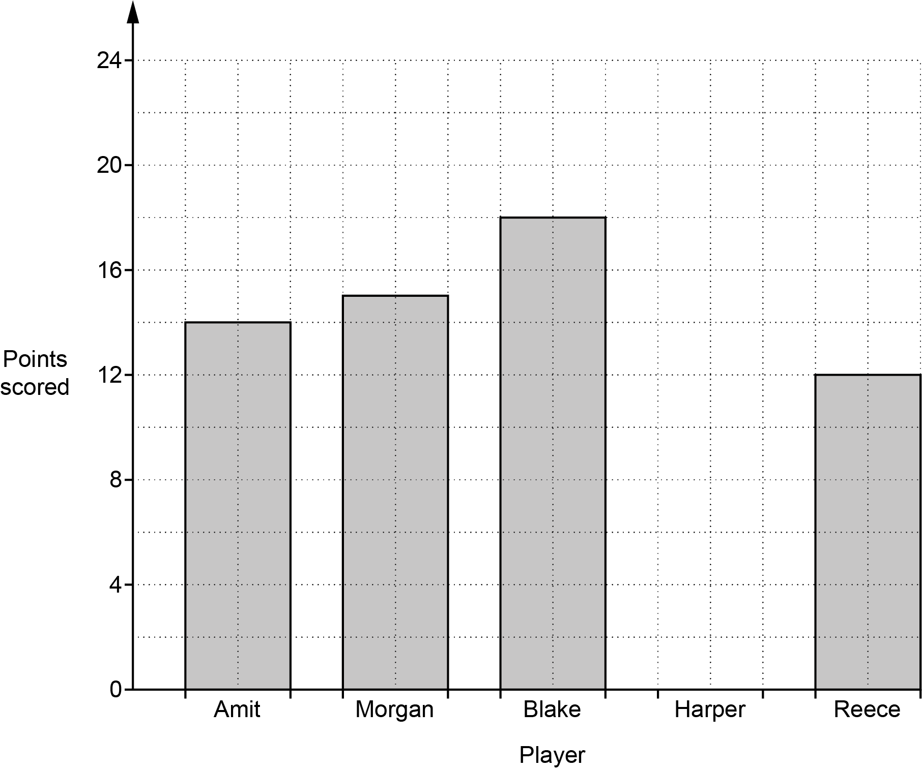

(a) How many points were scored by Reece?

(a) ……..…………….………………. [1]

(b) How many more points were scored by Blake than Amit?

(b) ……..…………….………………. [1]

(c) Harper scored 17 points.

Complete the bar chart to show this information. [1]

2 (a) Write down each of the following.

(i) An odd number between 12 and 18.

(a)(i) ……..…………….………………. [1]

(ii) A square number between 30 and 50.

(ii) ……..…………….………………. [1]

(iii) The cube root of 27.

(iii) ……..…………….………………. [1]

(b) 5 is a factor of 65.

Find a factor of 65 between 10 and 20.

(b) ……..…………….………………. [1]

3 Ling has 10 toy cars in a box.
1 is red, 2 are blue, 3 are white and 4 are black.
Ling takes a toy car at random.

Mark with an arrow ( ) the probability that the toy car is

(a) black,

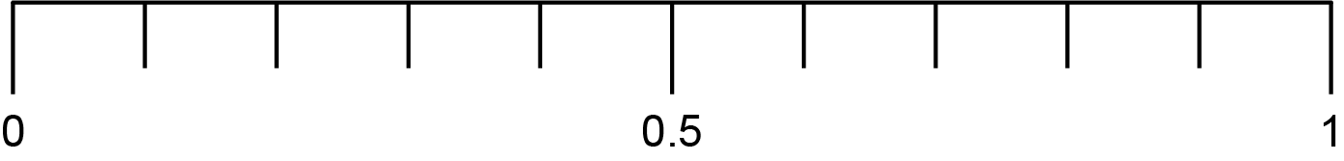
[1]

(b) yellow.

[1]

4 Point A is shown on this grid.

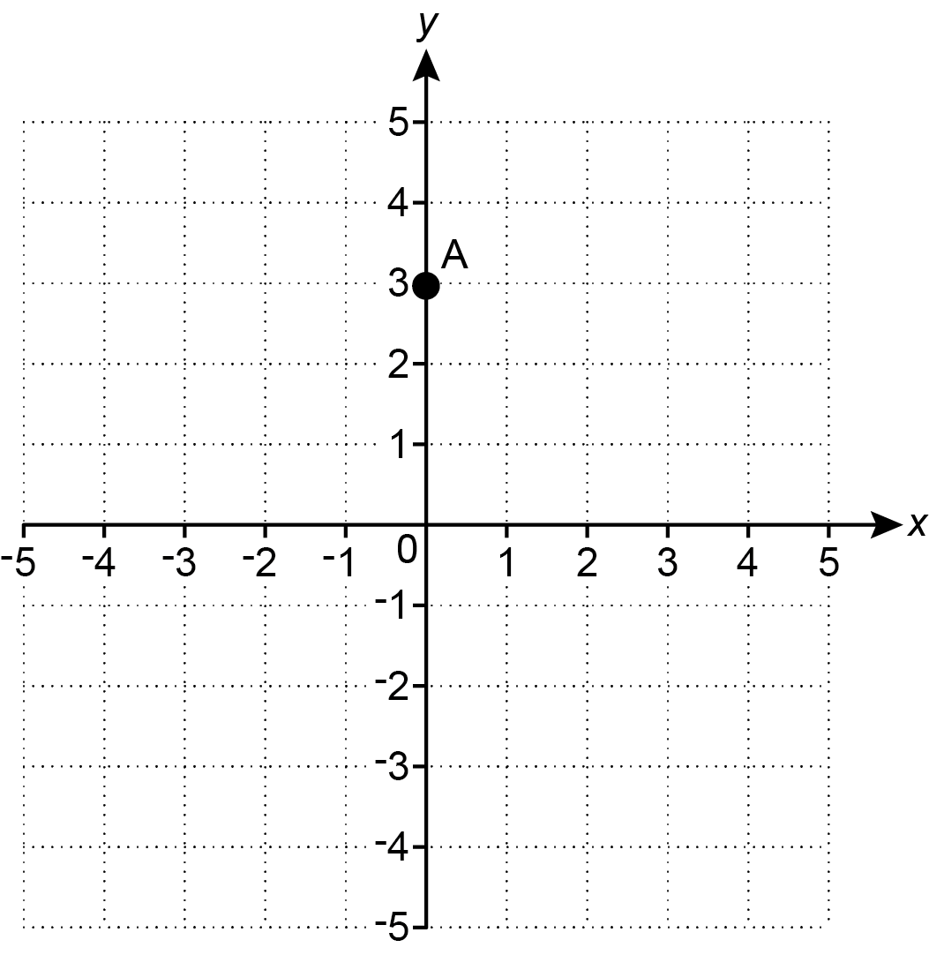

(a) Write down the coordinates of point A.

(a) (……..…………….… , ……..…………….…) [1]

(b) Plot point B on the grid at (-4, 4). [1]

5 (a) The diagram shows a square.

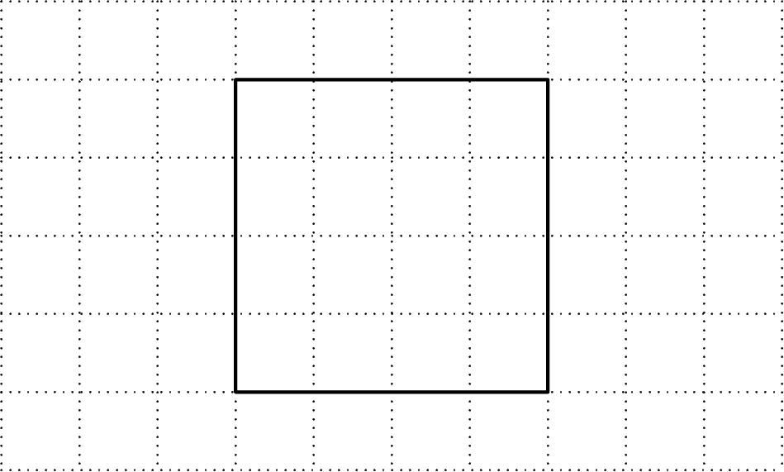

The square has rotation symmetry of order 4.

Mark the centre of rotation with a cross (X). [1]

(b) On the grid below, draw a four-sided shape that has rotation symmetry of order 2.

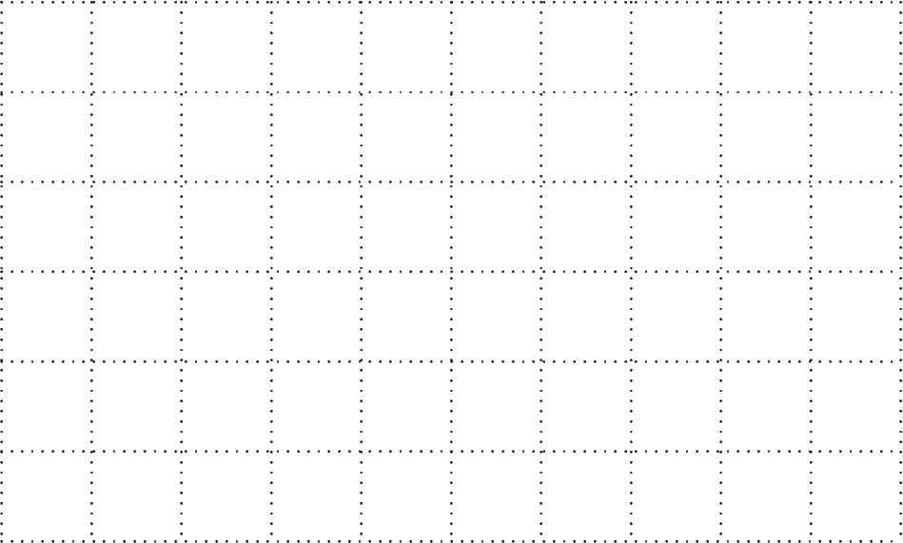
[1]

6 Use one of these symbols <, = or > to make each statement true.

(a) 0.7 ................... [1]

(b) 4² ................... 16 [1]

7 Sam makes 16 cakes.
Each cake needs a piece of ribbon 17 cm long for decoration.

Ribbon is only sold in rolls of 1.1 metres, which can then be cut into 17 cm pieces.
One roll of ribbon costs 84p.

Calculate the cost of the ribbon that Sam must buy to decorate the 16 cakes.
You must show your working.

£ ……..…………….………………. [4]

8 Eve changes £340 into euros.
£1 is worth 1.14 euros.

Eve says

340 ÷ 1.14 = 298.25
Therefore, £340 is worth 298.25 euros.

Is Eve correct or incorrect?
Give a reason for your decision.

Eve is .………………… because ………………………………………………………………..……

....………………………………………………………………………………...……………………… [1]

9 (a) Simplify.

(i) 4r – 8t – 2r + 3t

(a)(i) ……..…………….………………. [2]

(ii) a × a × a × a

(ii) ……..…………….………………. [1]

(iii) 8b⁴ b

(iii) ……..…………….………………. [1]

(b) Factorise.

3a − 15b

(b) ……..…………….………………. [1]

10 (a) One morning Jack records the first 50 vehicles to pass the school gate.
Jack’s results are shown in this table.

Type of vehicle | Number
Car | 27
Lorry | 7
Motorbike | 10
Van | 6

Use Jack’s results to estimate the probability that the next vehicle will not be a lorry.

(a) ……..…………….………………. [2]

(b) One afternoon Rowan records some vehicles that pass the school gate.
of the vehicles they record are cars.

For Rowan’s results, write down the ratio of cars to not cars.
Give your answer in its simplest form.

(b) ……..…………….… : ……..…………….… [1]

11 Write a number in each box to make each statement true.

(a) – 8 = -10 [1]

(b) ÷ 2 = [1]
7
16
7

(c) × = [1]
5
8
3
4

12 Here are the first four terms of a sequence.

9 15 21 27

(a) Write down the next term of the sequence.

(a) ……..…………….………………. [1]

(b) Explain how you worked out your answer.

………....……………………………………………………………….………………...……… [1]

(c) Explain why 80 is not a term in this sequence.

………....……………………………………………………………….………………...……… [1]

13 At the end of each day, a driver works out the mean distance they have driven so far that week.

At the end of 5 days, the mean distance they have driven is 177.5 miles per day.
At the end of 6 days, the mean distance they have driven is 180 miles per day.

Work out how many miles the driver drove on the sixth day of that week.

miles [4]

14 Box A contains 64 books.
Box B contains 65 books.

Alex has read of the books in box A.
Alex has also read the same number of books in box B.

Work out the fraction of the books in box B that Alex has read.
Give your answer as a fraction in its lowest form.

……..…………….………………. [3]

15 A researcher asked 58 customers leaving a fish and chip shop what they had bought.
The Venn diagram shows some of the results.

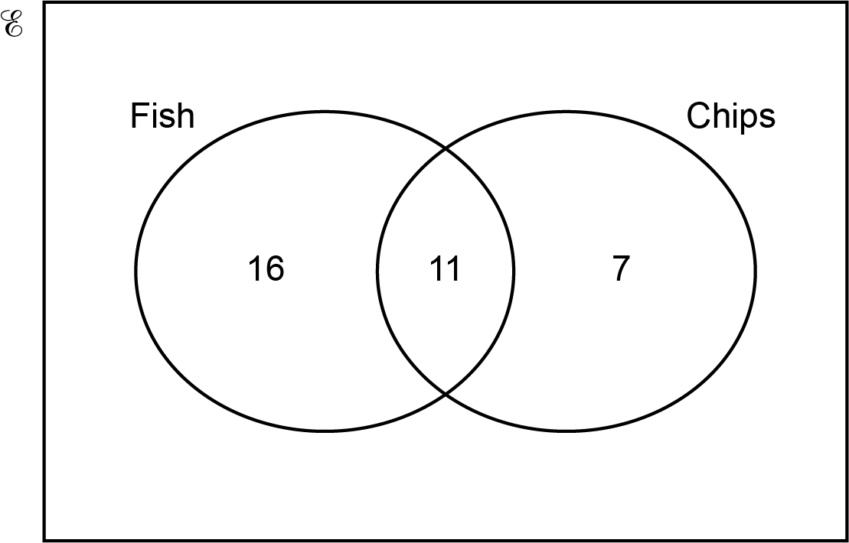

(a) How many customers bought fish but not chips?

(a) ……..…………….………………. [1]

(b) Complete the Venn diagram to show the number of customers who did not buy fish or chips.
[2]

(c) One of the 58 customers is chosen at random.

Write down the probability that this customer bought fish.

(c) ……..…………….………………. [2]

16 (a) Rearrange this formula to make d the subject.

f = 4d + 5

(a) ……..……………….………………. [2]

(b) Use the formula

v = u + at

to find the final velocity, when

- the initial velocity is 4 m/s
- the acceleration is 5.5 m/s²
- the time is 8 seconds.

(b) ……..…………….………………. m/s [2]

17 The density of gold is 19.3 g/cm³.
Ben has a gold nugget of volume 6.8 cm³.

Calculate the mass of the gold nugget.

……..…………….………………. g [2]

18 In 2022, comet A and comet B were both seen from Earth.
Comet A is seen from Earth every 70 years.
Comet B is seen from Earth every 126 years.

Find the next year when both comets will be seen from Earth.

……..…………….………………. [4]

19 Clara is counting the photos on her phone.
The ratio of the number of photos of her family to photos of her friends is 5 : 7.
She has 550 photos of her family.
60% of the photos of her friends include Dan.

Work out how many of the photos of her friends include Dan.

……..…………….………………. [4]

20 Ellis invests £3000 at a rate of 4.5% per year compound interest.

Calculate the value of Rowan’s investment after 6 years.
Give your answer correct to the nearest penny.

£ ……..…………….………………. [3]

21 The table below shows the approximate population of three countries in 2022.

Country | Population
China | 1.41 × 10⁹
Kiribati | 1.31 × 10⁵
Tuvalu | 1.13 × 10⁴

(a) Calculate the approximate total population of Kiribati and Tuvalu in 2022.
Give your answer in standard form, correct to 3 significant figures.

(a) ……..…………….………………. [4]

(b) Show that in 2022 the population of China was approximately 125 000 times the population of Tuvalu. [2]

22 A theatre has an adult price and a child price for their shows.

A group of 5 adults and 4 children paid a total of £137.
A group of 2 adults and 3 children paid a total of £73.

Work out the price for one adult and the price for one child.
You must show your working.

Price for one adult £ ……..…………….……………….

Price for one child £ ……..…………….………………. [5]

23 An examination has three papers.
Paper 1 is marked out of 50.
Paper 2 is marked out of 60.
Paper 3 is marked out of 90.
The three marks are added together to form the total mark out of 200.

A student scored 60% on Paper 1 and 65% on Paper 2.

Find the mark they need to get on Paper 3 to achieve 62% of the total marks.
You must show your working.

……..…………….………………. [5]

24 B is 12 km due east of A.
C is north-east of A and on a bearing of 315° from B.

Complete the diagram to show the positions of A, B and C.
Show clearly the values of all three angles in triangle ABC.

Scale: 1 cm represents 2 km

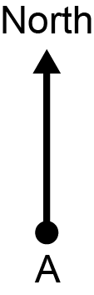

[4]

25 The diagram shows an isosceles triangle, ABC.

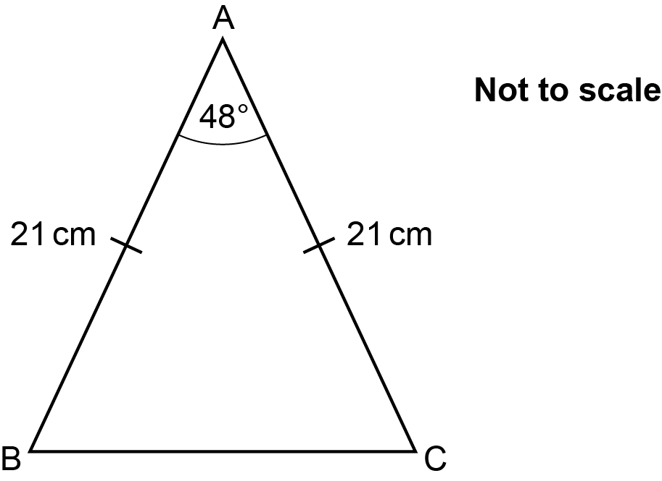

AB = AC = 21 cm.
Angle BAC = 48°.

Calculate the length of BC.
You must show your working.

……..…………….………………. cm [5]

26 (a) Construct the perpendicular from the point P to the line AB.

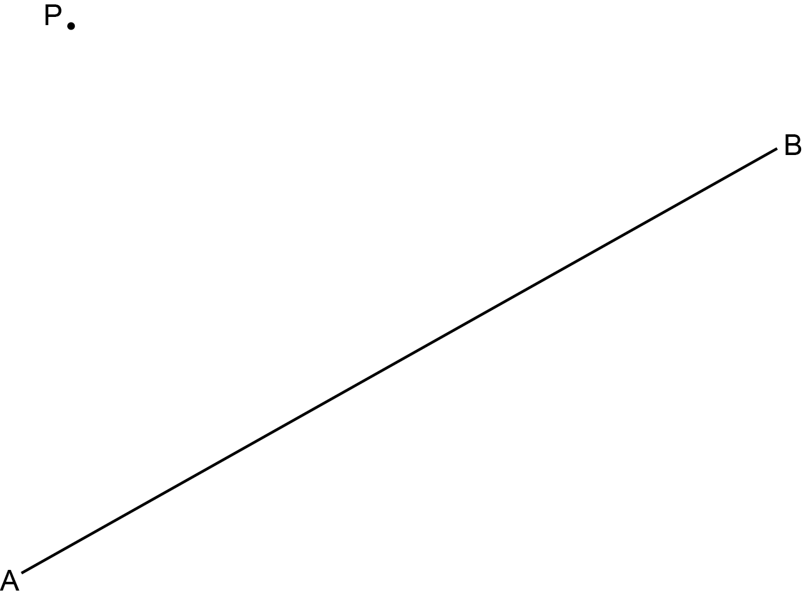

[2]

(b) The diagram shows a field LMN.

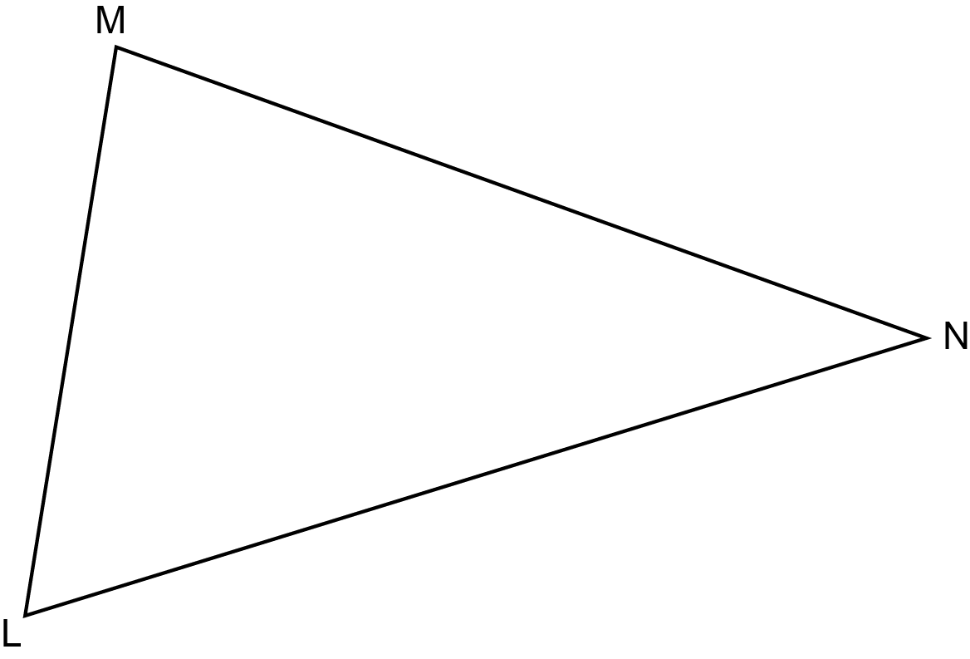

A tree is to be planted in the field so that it is

- the same distance from the fences LM and LN
and
- the same distance from corner L as from corner N.

Show, by construction, whether this can be done or cannot be done.

(b) This ……..…………….………………. be done. [5]

27 A bag contains 42 balls.
Each ball is either red or green.
The ratio of red balls to green balls is 4 : 3.

Work out the smallest number of balls of each colour that have to be added to the bag so that the ratio of red balls to green balls becomes 7 : 4.
You must show your working.

Number of red balls added to the bag = ……..…………….……………….

Number of green balls added to the bag = ……..…………….………………. [5]

END OF QUESTION PAPER

Please note – web links are correct at date of publication but other websites may change over time. If you have any problems with a link you may want to navigate to that organisation’s website for a direct search.

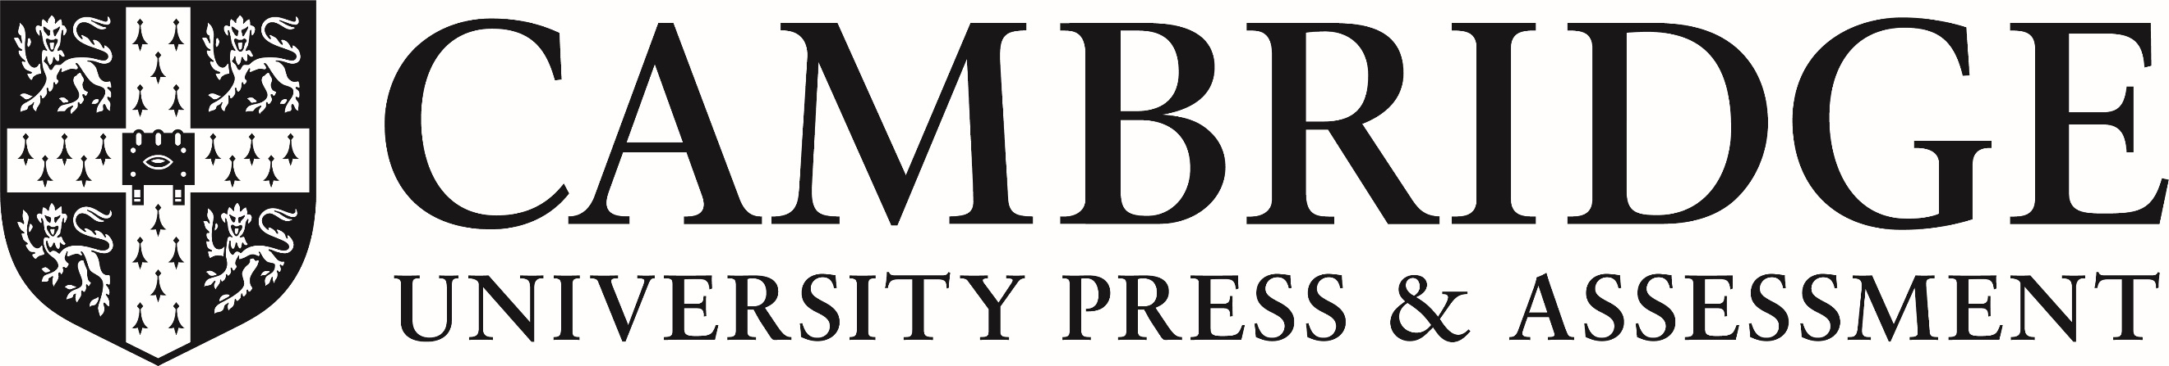

We’d like to know your view on the resources we produce. Click ‘Like’ or ‘Dislike’ to send us an auto generated email about this resource. Add comments if you want to. Let us know how we can improve this resource or what else you need. Your email will not be used or shared for any marketing purposes.
Looking for another resource? There is now a quick and easy search tool to help find free resources for your qualification.
OCR is part of Cambridge University Press & Assessment, which is itself a department of the University of Cambridge.
For staff training purposes and as part of our quality assurance programme your call may be recorded or monitored.
Oxford Cambridge and RSA Examinations is a Company Limited by Guarantee. Registered in England. Registered office
The Triangle Building, Shaftesbury Road, Cambridge, CB2 8EA. Registered company number 3484466. OCR is an exempt charity.
OCR operates academic and vocational qualifications regulated by Ofqual, Qualifications Wales and CCEA as listed
in their qualifications registers including A Levels, GCSEs, Cambridge Technicals and Cambridge Nationals.
OCR provides resources to help you deliver our qualifications. These resources do not represent any teaching method we expect you to use. We update our resources regularly and aim to make sure content is accurate but please check the OCR website so that you have the most up to date version. OCR cannot be held responsible for any errors or omissions in these resources.
Though we make every effort to check our resources, there may be contradictions between published support and the specification, so it is important that you always use information in the latest specification. We indicate any specification changes within the document itself, change the version number and provide a summary of the changes. If you do notice a discrepancy between the specification and a resource, please contact us.
© OCR 2023 - You can copy and distribute this resource freely if you keep the OCR logo and this small print intact and you acknowledge OCR as the originator of the resource.
OCR acknowledges the use of the following content: N/A
Whether you already offer OCR qualifications, are new to OCR or are thinking about switching, you can request more information using our Expression of Interest form.
Please get in touch if you want to discuss the accessibility of resources we offer to support you in delivering our qualifications.

