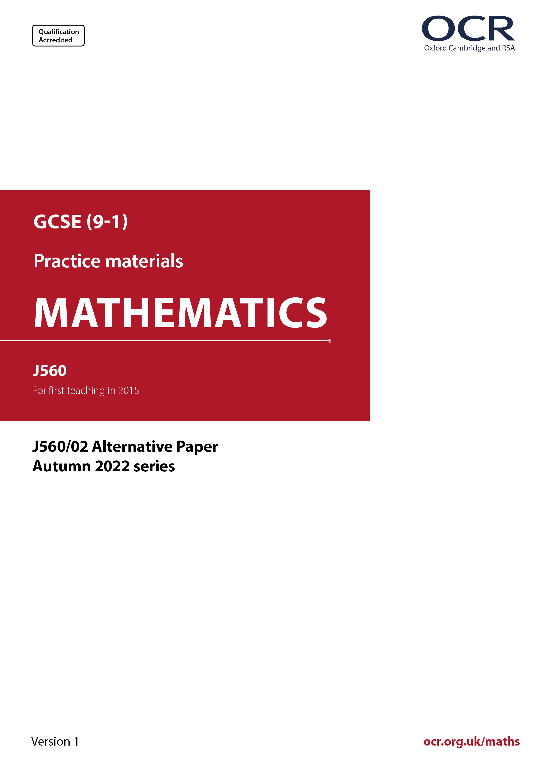
ocr.org.uk/maths

Introduction
OCR’s Alternative Papers for GCSE (9-1) Mathematics are each created by taking one of our past papers and amending the numbers/graphs/diagrams/tables/etc. in its questions.
This Alternative Paper is an amended version of one of the November 2022 series papers. The wording and topics assessed are essentially the same, but the responses students need to make will be different. Using both this paper and the corresponding November 2022 exam paper with your students at different points in the year will allow you to monitor how their learning has progressed in the time between the two papers.
Please note that when students originally sat this paper in 2022, they were given a formulae sheet. Foundation tier and Higher tier formulae sheets are published on Teach Cambridge alongside the Alternative Papers, for use with students as required.
Additional Alternative Papers and past papers are available to download from Teach Cambridge.



GCSE (9-1) Mathematics
J560/02 Paper 2 (Foundation Tier)
Alternative Paper (November 2022)

Time allowed: 1 hour 30 minutes

F
You must have:
- geometrical instruments
- tracing paper
Do not use:
- a calculator

Name

INSTRUCTIONS
- Use black ink. You can use an HB pencil, but only for graphs and diagrams.
- Write your answer to each question in the space provided. If you need extra space, use
the lined pages at the end of this booklet. The question numbers must be clearly shown.
- Answer all the questions.
- Where appropriate, your answer should be supported with working. Marks might be
given for using a correct method, even if your answer is wrong.

INFORMATION
- The total mark for this paper is 100.
- The marks for each question are shown in brackets [ ].
- This document has 20 pages.

ADVICE
- Read each question carefully before you start your answer.



Answer all the questions.

1 The pictogram shows the number of students who were late to school in a particular week.

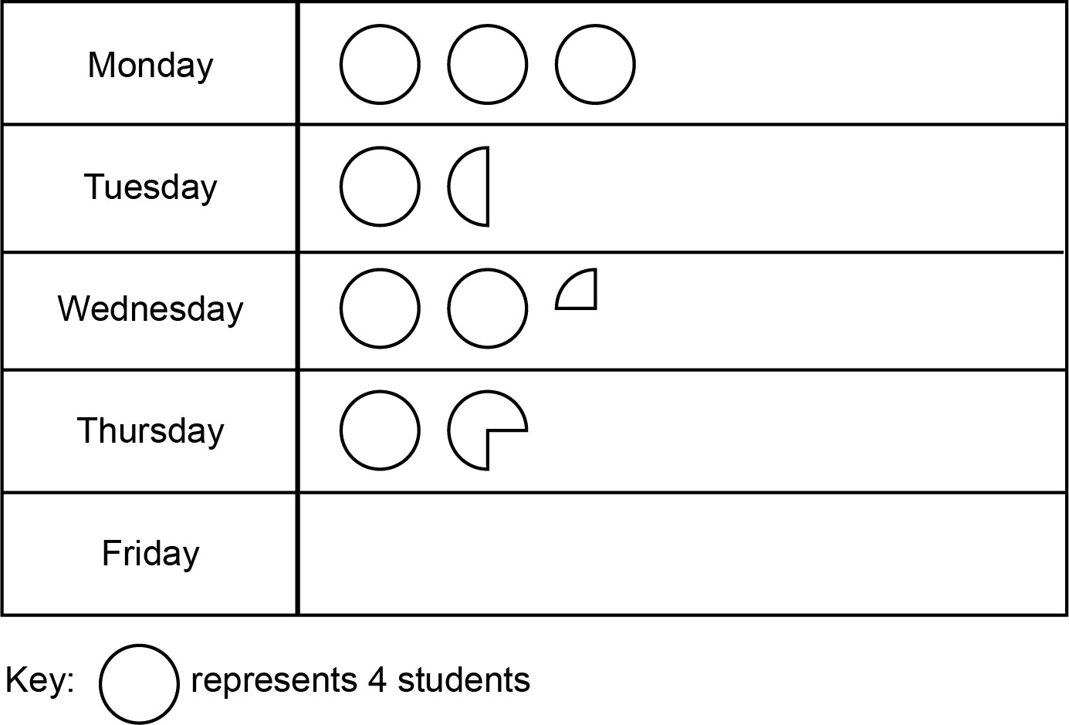

(a) Alex says

The pictogram shows 3 circles for Monday.
Therefore 3 students were late on Monday.

Explain what Alex has done wrong.
Write down the correct number of students who were late on Monday.

Alex has ..………………………………….……………………………………………………..

.....…………..…………………………………………….……………………………………….

Correct number ……..…………….………………. [2]

(b) 10 students were late on Friday.

Complete the pictogram above to show this information. [1]

2 (a) Complete each statement by writing the missing power in the box.

(i) 5 × 5 × 5 × 5 = 5 [1]

(ii) 8 = 2 [1]

(b) Work out.

${\text{3}}^{\text{2}} \text{×} \sqrt{\text{25}}$

(b) ……..…………….………………. [3]

3 Work out.

(a) 0.24 + 7.3

(a) ……..…………….………………. [1]

(b) 5.6 ÷ 7

(b) ……..…………….………………. [1]

4 (a) Write $\frac{\text{17}}{\text{3}}$ as a mixed number.

(a) ……..…………….………………. [1]

(b) Write $\text{1}\frac{\text{6}}{\text{7}}$ as an improper fraction.

(b) ……..…………….………………. [1]

(c) Kai says that $\frac{\text{5}}{\text{8}}$ written as a decimal is 0.58.

Is Kai correct?
Show how you decide.

.………………… because ………………………………………………………………………

....……………………………………………………………………………………………… [2]

5 Write 54 as a product of prime factors.

……..…………….………………. [2]

6 The diagram shows two intersecting straight lines.

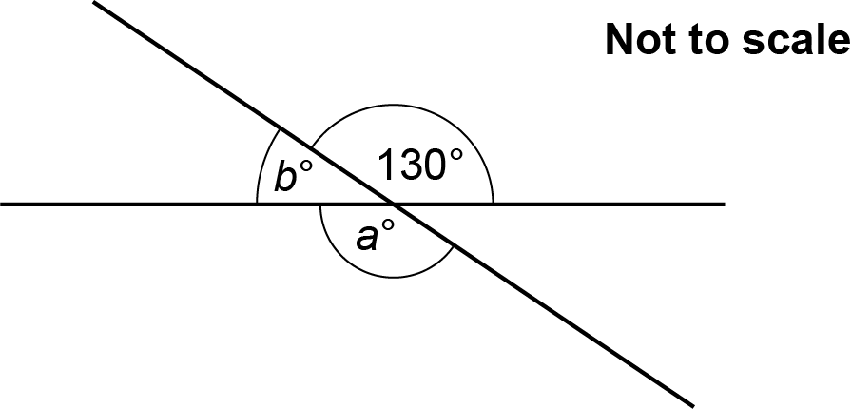

(a) Find the value of a.
Give a reason for your answer.

a = .………………… because ……………………………………………..……………………

..……....……….………………………………………………………………………..……… [2]

(b) Find the value of b.
Give a reason for your answer.

b = .………………… because ………..…………………………….……………………………

..……....……….…………………………………..………………….………………………… [2]

7 Find the value of 5x + 4y when x = 2 and y = -3.

……..…………….………………. [2]

8 (a) Write 55% as a fraction in its simplest form.

(a) ……..…………….………………. [2]

(b) 20 people ran a race.
3 of them won a medal.

Work out the percentage of people that won a medal.

(b) ……..…………….………………. % [2]

(c) Increase 150 by 30%.

(c) ……..…………….………………. [3]

9 (a) By writing each number correct to 1 significant figure, find an estimate for 57.8 × 4.2.

(a) ……..…………….………………. [2]

(b) Harper works out 57.8 × 4.2 on a calculator.
Harper’s answer is 2427.6.

Do you think Harper has used their calculator correctly?
Explain why.

.….….…………… because ………………………………………………………………………

....…..…………………………………………………………………………………………… [1]

10 Jamal has £8 to spend on vegetables.
The table shows the prices.

Cauliflower (each) | £1.30
Potatoes (for 1 kilogram) | 85p
Mushrooms (for a 400 g pack) | £1.20

Jamal buys 3 cauliflowers and 2 kilograms of potatoes.
Jamal spends the remaining money on mushrooms.

Work out the mass, in grams, of mushrooms that Jamal buys.
You must show your working.

……..…………….………………. g [6]

11 (a) Sketch the graph of x = -3.
Show clearly the value of any intercepts.

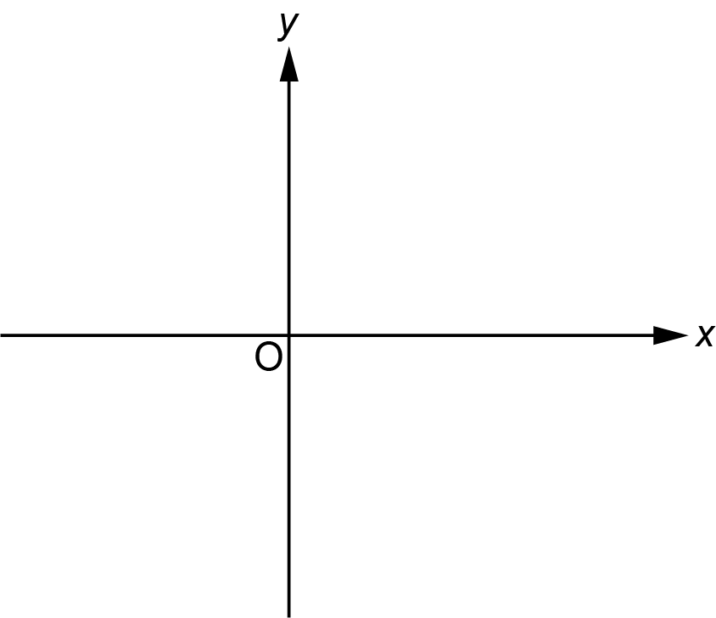
[2]

(b) Sketch the graph of y = x – 2.
Show clearly the value of any intercepts.

[3]

(c) Sketch the graph of y = x ³.

[1]

12 Multiply out.

(a) 5 (x + 2)

(a) ……..…………….………………. [1]

(b) 4b (b – 1)

(b) ……..…………….………………. [2]

13 Work out.

(a) $\frac{\text{4}}{\text{9}}\text{×} \text{2}$

(a) ……..…………….………………. [1]

(b) $\frac{\text{3}}{\text{4}}$ – $\frac{\text{1}}{\text{3}}$

(b) ……..…………….………………. [2]

14 Solve.

4x – 7 = 19 – 6x

x = ……..…………….………………. [3]

15 Azmi invests £400 at a simple interest rate of r % each year.
After 3 years, Azmi’s investment is worth £460.

Find the value of r.

r = ……..…………….………………. [4]

16 The diagram shows part of a regular 18-sided polygon.

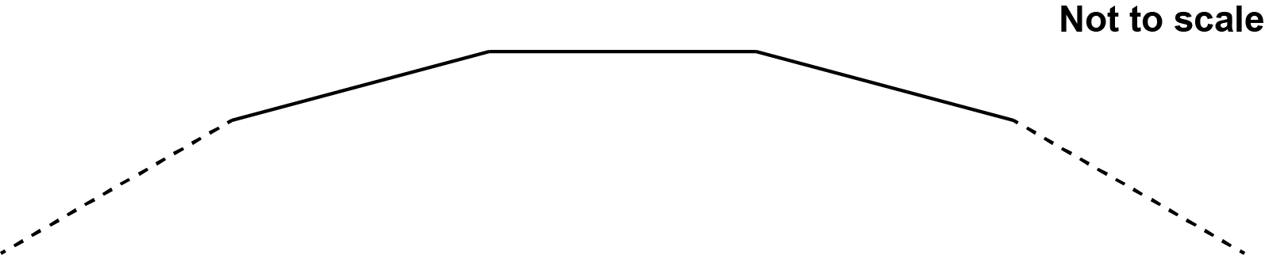

For this polygon, find the ratio of the size of one interior angle to the size of one exterior angle.
Give your answer in its simplest form.
You must show your working.

……..…………….… : ……..…………….… [5]

17 A straight line, L, is shown below.

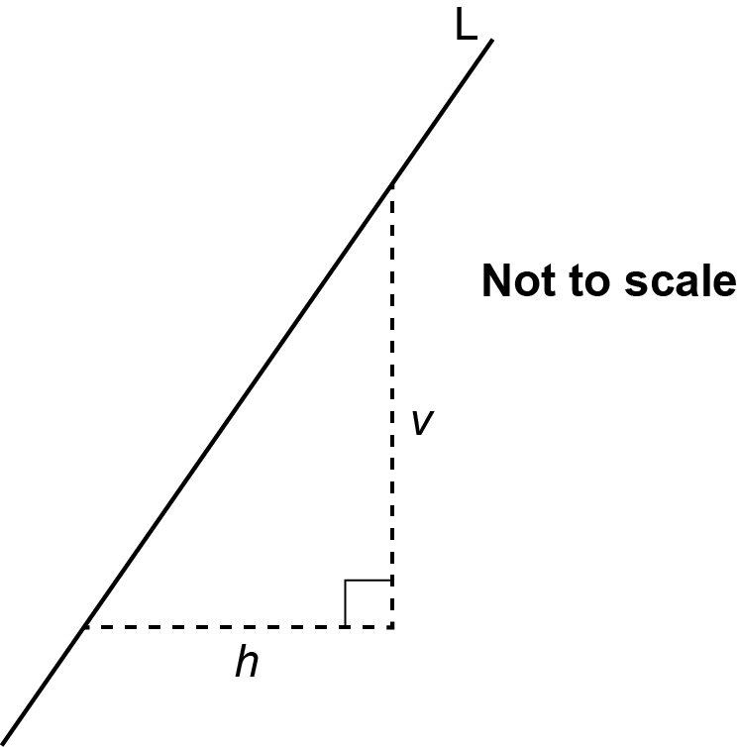

(a) Write down the ratio v : h when the gradient of line L is 5.

(a) ..…………….… : ..…………….… [1]

(b) Find the gradient of line L as a fraction in its simplest form when v : h = 8 : 14.

(b) ……..…………….………………. [2]

18 Find all the possible integer values that satisfy the inequality 6 < 3x ⩽ 15.

……..…………….………………. [3]

19 Layla has a fair spinner numbered 2, 3 and 5.

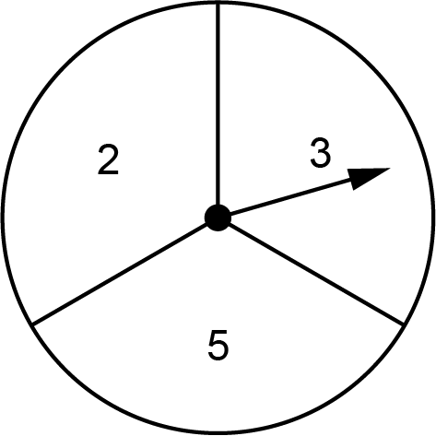

Layla spins the spinner twice and multiplies the two scores to get a result.

(a) Complete the table to show all of the possible results.

First spin
Result | 2 | 3 | 5
2 | 4 | 6
3 | 6 | 9
5 |  | 15 | 25

Second
spin

[1]

(b) Find the probability that the result is an odd number.

(b) ……..…………….………………. [2]

20 Rowan and Jamie open a packet of biscuits.
Rowan and Jamie share all of the biscuits in the ratio 1 : 3.

(a) Write down the fraction of the biscuits that Rowan receives.

(a) ……..…………….………………. [1]

(b) Rowan eats some of her biscuits.
She is then left with 15% of the biscuits that were in the packet.

Work out the percentage of her biscuits that Rowan has eaten.

(b) ……..…………….……………….% [4]

21 The graph shows information about the number of babies born in a hospital.
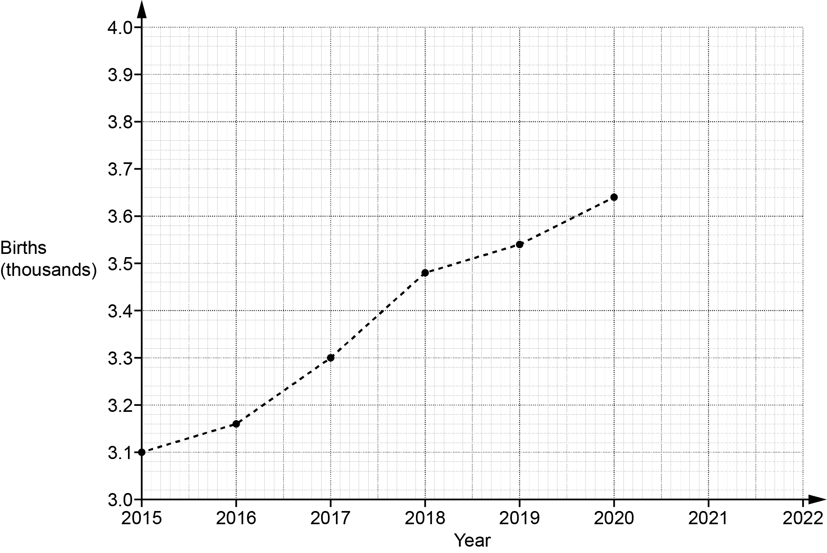

(a) The number of babies born in the hospital in 2021 was 3740.
Plot this point on the graph. [1]

(b) Work out the increase in the number of births in the hospital between 2016 and 2018.

(b) ……..…………….………………. [2]

(c) Sam says that there was a huge increase in the number of births in the hospital between 2015 and 2020.

Describe how Sam may have been misled by the graph.

.………..……….……………………………………………………………………………………

………....………..……………………………………………………………………………… [1]

(d) Ashley says that the number of births in the hospital will be greater than 3800 in 2022.

Write down an assumption Ashley has made.

.………..……….……………………………………………………………………………………

………....………..……………………………………………………………………………… [1]

22 The diagram shows a cylinder with radius 9 cm and height 15 cm.

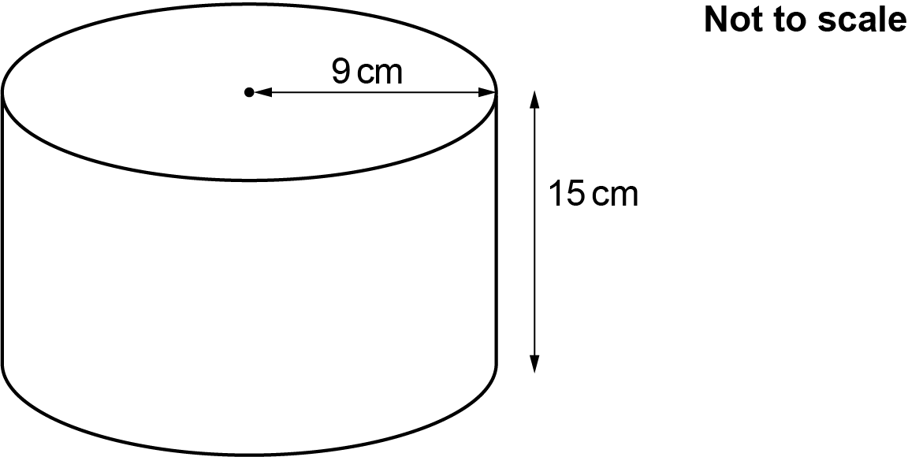

(a) On the grid below, draw the plan view of the cylinder.
Use the scale 1 cm represents 3 cm.

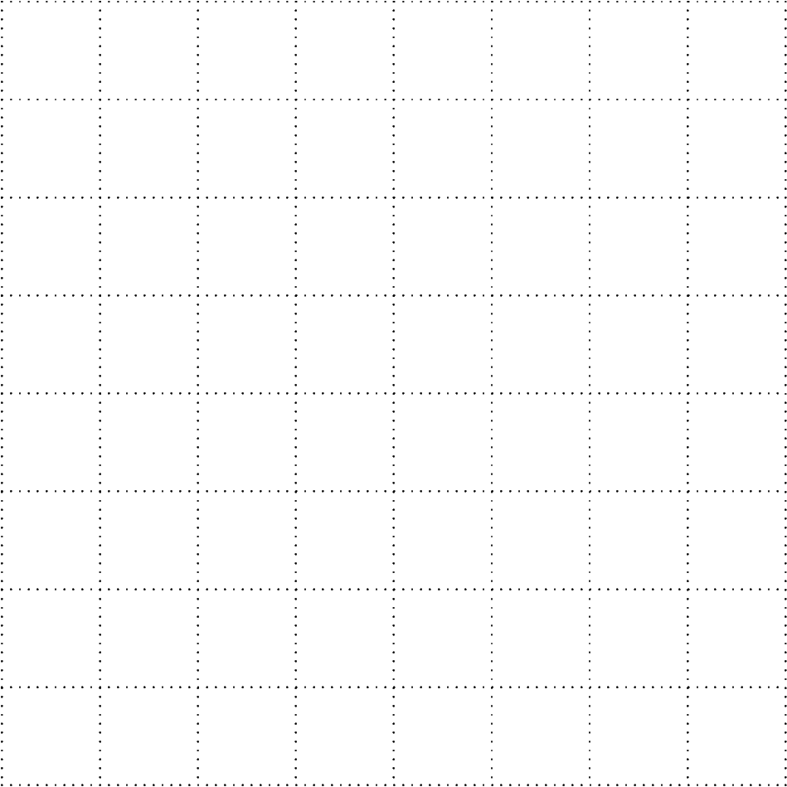
[2]

(b) On the grid below, draw the front elevation of the cylinder.
Use the scale 1 cm represents 3 cm.

[2]

23 A student says that they have placed the following values in order starting with the smallest.

${\left( \frac{\text{1}}{\text{5}} \right)}^{\text{2}}$ $\sqrt{\text{0.16}}$ 10⁻¹

Has the student done this correctly?
Show how you decide.

.………………… because ………………………………………………………………………

....……………………………………………………………………………………………… [4]

24 Blake has a bag containing 5 red counters and 2 yellow counters.
There are no other counters in the bag.

Blake takes a counter at random from the bag, puts it back, and then takes another counter.

Blake says

The probability that the two counters are the same colour is less than 50%.

Is Blake correct?
Show how you decide.
You may use this tree diagram if you wish.

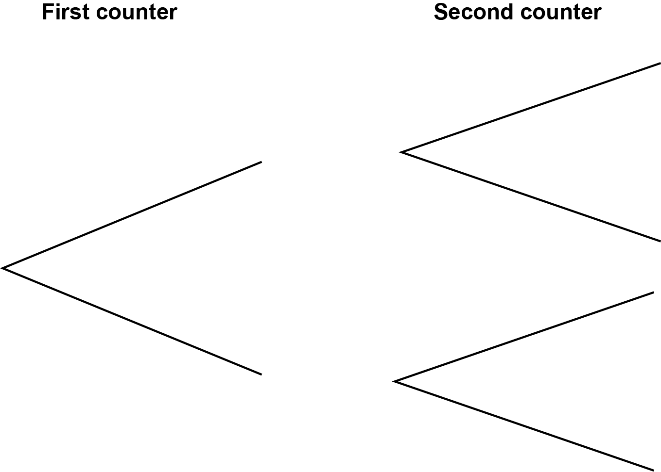

.………………… because ………………………………………………………………………………

....……………………………………………………………………………………………………… [5]

25 The diagram shows a right-angled triangle and a rectangle.

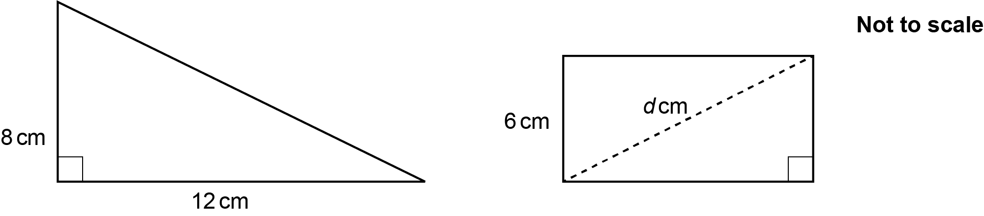

The triangle and rectangle have the same area.

Calculate the length, d cm, of the diagonal of the rectangle.
You must show your working.

d = ……..…………….………………. cm [6]

END OF QUESTION PAPER
ADDITIONAL ANSWER SPACE

If additional space is required, you should use the following lined page(s). The question number(s) must be clearly shown in the margin(s).

…………………………………………………………………………………………………………………..

…………………………………………………………………………………………………………………..

…………………………………………………………………………………………………………………..

…………………………………………………………………………………………………………………..

…………………………………………………………………………………………………………………..

…………………………………………………………………………………………………………………..

…………………………………………………………………………………………………………………..

…………………………………………………………………………………………………………………..

…………………………………………………………………………………………………………………..

…………………………………………………………………………………………………………………..

…………………………………………………………………………………………………………………..

…………………………………………………………………………………………………………………..

…………………………………………………………………………………………………………………..

…………………………………………………………………………………………………………………..

…………………………………………………………………………………………………………………..

…………………………………………………………………………………………………………………..

…………………………………………………………………………………………………………………..

…………………………………………………………………………………………………………………..

…………………………………………………………………………………………………………………..

…………………………………………………………………………………………………………………..

…………………………………………………………………………………………………………………..

…………………………………………………………………………………………………………………..

…………………………………………………………………………………………………………………..

Please note – web links are correct at date of publication but other websites may change over time. If you have any problems with a link you may want to navigate to that organisation’s website for a direct search.



We’d like to know your view on the resources we produce. Click ‘Like’ or ‘Dislike’ to send us an auto generated email about this resource. Add comments if you want to. Let us know how we can improve this resource or what else you need. Your email will not be used or shared for any marketing purposes.
Looking for another resource? There is now a quick and easy search tool to help find free resources for your qualification.
OCR is part of Cambridge University Press & Assessment, which is itself a department of the University of Cambridge.
For staff training purposes and as part of our quality assurance programme your call may be recorded or monitored.
Oxford Cambridge and RSA Examinations is a Company Limited by Guarantee. Registered in England. Registered office
The Triangle Building, Shaftesbury Road, Cambridge, CB2 8EA. Registered company number 3484466. OCR is an exempt charity.
OCR operates academic and vocational qualifications regulated by Ofqual, Qualifications Wales and CCEA as listed
in their qualifications registers including A Levels, GCSEs, Cambridge Technicals and Cambridge Nationals.
OCR provides resources to help you deliver our qualifications. These resources do not represent any teaching method we expect you to use. We update our resources regularly and aim to make sure content is accurate but please check the OCR website so that you have the most up to date version. OCR cannot be held responsible for any errors or omissions in these resources.
Though we make every effort to check our resources, there may be contradictions between published support and the specification, so it is important that you always use information in the latest specification. We indicate any specification changes within the document itself, change the version number and provide a summary of the changes. If you do notice a discrepancy between the specification and a resource, please contact us.
© OCR 2023 - You can copy and distribute this resource freely if you keep the OCR logo and this small print intact and you acknowledge OCR as the originator of the resource.
OCR acknowledges the use of the following content: N/A
Whether you already offer OCR qualifications, are new to OCR or are thinking about switching, you can request more information using our Expression of Interest form.
Please get in touch if you want to discuss the accessibility of resources we offer to support you in delivering our qualifications.

