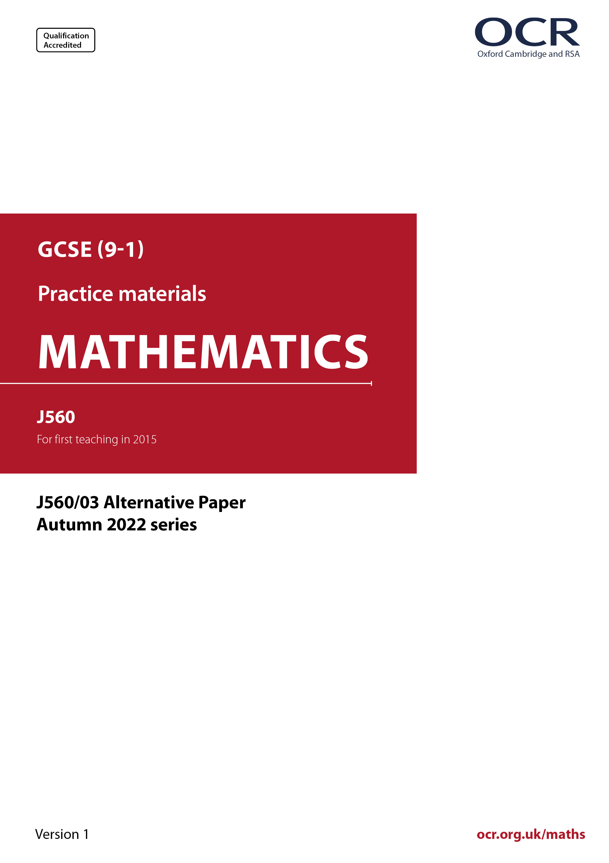
ocr.org.uk/maths

Introduction
OCR’s Alternative Papers for GCSE (9-1) Mathematics are each created by taking one of our past papers and amending the numbers/graphs/diagrams/tables/etc. in its questions.
This Alternative Paper is an amended version of one of the November 2022 series papers. The wording and topics assessed are essentially the same, but the responses students need to make will be different. Using both this paper and the corresponding November 2022 exam paper with your students at different points in the year will allow you to monitor how their learning has progressed in the time between the two papers.
Please note that when students originally sat this paper in 2022, they were given a formulae sheet. Foundation tier and Higher tier formulae sheets are published on Teach Cambridge alongside the Alternative Papers, for use with students as required.
Additional Alternative Papers and past papers are available to download from Teach Cambridge.



GCSE (9-1) Mathematics
J560/03 Paper 3 (Foundation Tier)
Alternative Paper (November 2022)

Time allowed: 1 hour 30 minutes

You can use:
- a scientific or graphical calculator
- geometrical instruments
- tracing paper

Name

INSTRUCTIONS
- Use black ink. You can use an HB pencil, but only for graphs and diagrams.
- Write your answer to each question in the space provided. If you need extra space, use
the lined pages at the end of this booklet. The question numbers must be clearly shown.
- Answer all the questions.
- Where appropriate, your answer should be supported with working. Marks might be
given for using a correct method, even if your answer is wrong.
- Use the π button on your calculator or take π to be 3.142 unless the question says
something different.

INFORMATION
- The total mark for this paper is 100.
- The marks for each question are shown in brackets [ ].
- This document has 22 pages.

ADVICE
- Read each question carefully before you start your answer.

Answer all the questions.

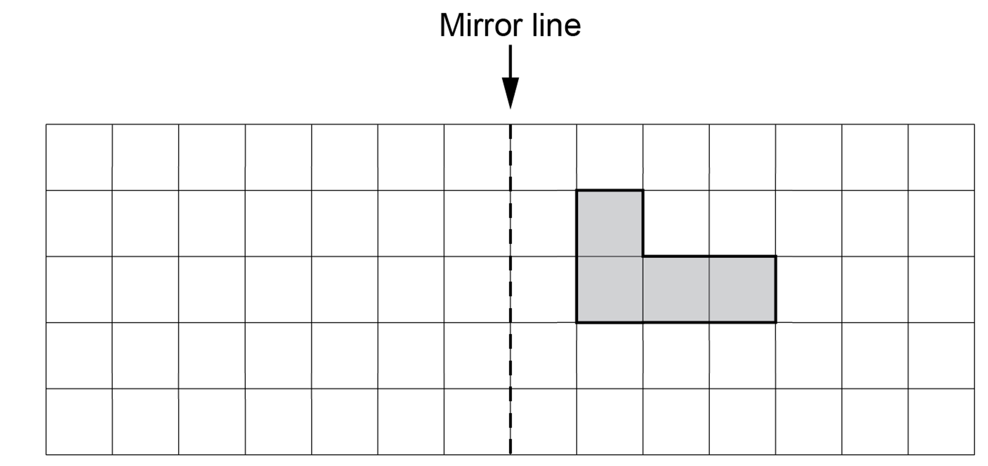
1 Reflect this shape in the mirror line.

[2]

2 (a) Write these numbers in order of size, starting with the smallest.

-10 20 0.315

(a) …..………..…… , …..………..…… , …..………..…… [1]
smallest

(b) Find the difference between the largest and the smallest of these numbers.

25 205 2.05 200.5

(b) ……..…………….………………. [2]

3 (a) Insert brackets to make this calculation correct.

3 × 3 ― 3 = 0 [1]

(b) Insert two of these symbols +, ―, × or ÷ to make this calculation correct.

24 …. 6(5 …. 1) = 0 [1]

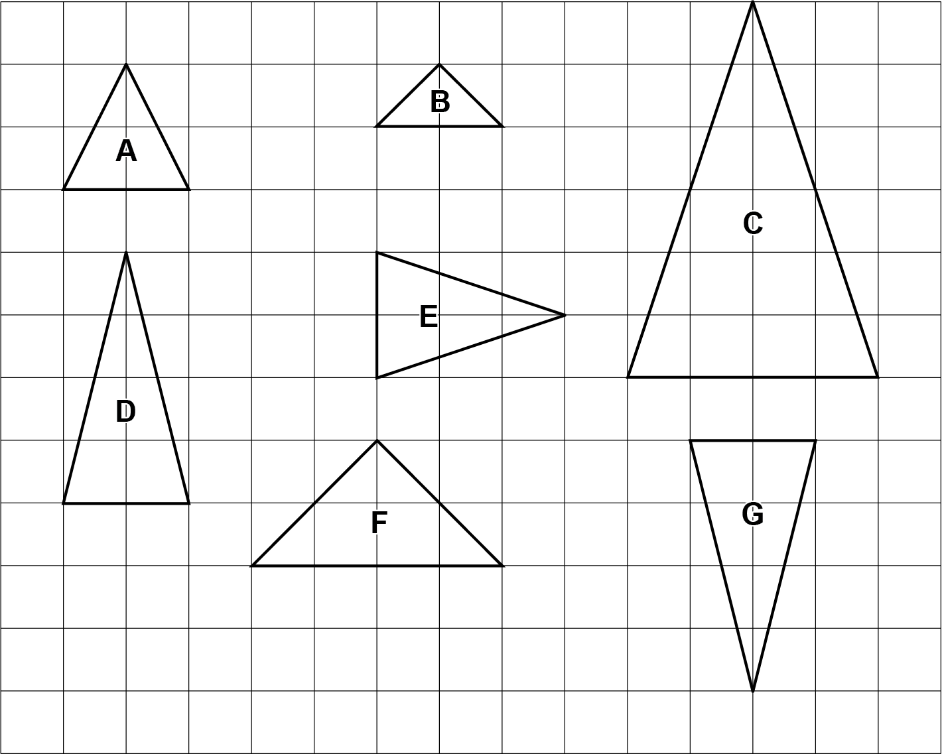
4 On the grid are seven triangles, labelled A to G.

Complete each statement by writing the letter of the correct triangle.

Triangle D is congruent to triangle ……….………………….

Triangle C is mathematically similar to triangle ………....…[2]

5 Solve.
(a)

(a) x = ……..…………….………………. [1]

(b) 9 – x = –3

(b) x = ……..…………….………………. [1]

6 (a) Write 32 : 80 as a ratio in its simplest form.

- .…………….… : ……..…………….… [2]

(b) A plan has a scale of 16 centimetres represents 1 metre.
The scale can be written as a ratio in the form 1 : n.

Find the value of n.

(b) n = ………………………….…………. [2]

7 It takes a librarian minutes to put a plastic cover on a book.

Work out how many books the librarian can cover in hour.

……..…………….………………. [3]

8 (a) Complete this statement by writing a positive whole number in each box to make two
different but equivalent fractions.
6
2
=

[2]

(b) Complete this statement by writing a possible positive whole number in the box.

1
3
12
1
6

< <

[2]

9 A breakfast menu consists of a drink, an egg dish and toast chosen from these lists.

Drink Egg dish Toast
Tea (T) Fried eggs (F) White (W)
Coffee (C) Scrambled eggs (S) Brown (B)
Poached eggs (P)

(a) Some of the possible meal deals are shown in this table.

Complete the table to show all the possible meal deals.
You may not need all the rows.

Drink | Egg dish | Toast
T | F | W
T | F | B
T | S | W
[2]

(b) Write down the fraction of the meal deals that include poached eggs (P).

(b) ……..…………….………………. [1]

10 Two supermarkets, A and B, have special offers on the same packet of biscuits.

Supermarket A

Normal price:
£1.60 for each packet

Special offer:
Buy two packets at the normal price and get a third packet for half price
Supermarket B

Normal price:
£1.70 for each packet

Special offer:
10% off the normal price

(a) Sam buys one packet of these biscuits.

Which supermarket is best value for Sam?
Show how you decide.

Supermarket ....……..……… because ………………………………………………………..…….

..……....…………………………………………………………………………………………..…. [3]

(b) Ling buys three packets of these biscuits.

Which supermarket is best value for Ling?
Show how you decide.

Supermarket ....……..……… because ………………………………………………………..…….

..……....…………………………………………………………………………………………..…. [3]

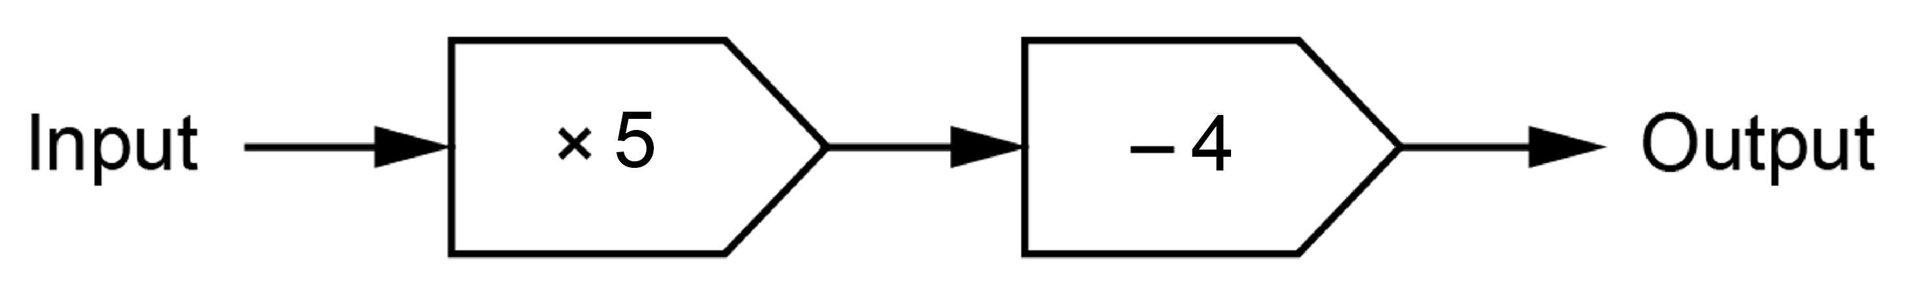
11 Here is a function machine.

(a) (i) Find the output when the input is 10.

(a) (i) ……..…………….………………. [1]

(ii) Find the input when the output is 21.

(ii) ……..…………….………………. [2]

(b) The input is x and the output is y.

Write an equation for y in terms of x.

(b) ……..…………….………………. [2]

12 Azmi has a bag of marbles that are red or blue or green or yellow.

Azmi takes a marble at random, records the colour and returns the marble to the bag.
Azmi does this 900 times.

The table shows some of the results.

Colour | Red | Blue | Green | Yellow
Frequency | 72 | 90 | 315
Relative frequency | 0.08 | 0.10 | 0.35 | 0.47

(a) Complete the table to show the number of times a yellow marble is taken. [2]

(b) (i) There are 50 marbles in the bag.

Work out how many blue marbles are likely to be in the bag.

(b) (i) ……..…………….………………. [2]

(ii) Is your answer to part (b)(i) likely to be the actual number of blue marbles in the bag?
Give a reason for your answer.

....……..……… because ………………………………………………………………………..…….

..……....…………………………………………………………………………………………..…. [1]

13 (a) All of the loaves in a baker’s shop cost the same price.
Darcy buys 4 loaves and pays £5.24.
Taylor buys 7 loaves.

Work out how much Taylor pays.

(a) £ ……..…………….………………. [3]

(b) Frankie and Dan travel the same distance to school.

Frankie walks to school in 18 minutes.
Dan runs to school at three times the speed that Frankie walks.

Find how many minutes it takes Dan to run to school.

(b) ……..…………….………………. min [2]

14 (a) An integer between 100 and 110 is written as the product of its prime factors as 2 × 3 × f.

Find the value of f and the integer.

(a) f = ……..…………….……………..

Integer = ……..…………….……………. [3]

(b) 147 and 245 are written as the product of their prime factors.

147 = 3 × 7 ² 245 = 5 × 7 ²

Work out the highest common factor (HCF) of 147 and 245.

(b) ……..…………….………………. [2]

15 (a) 10 ² is written in words as ‘one hundred’.

Write 10 ⁵ in words.

(a) ……..…………………………………………...………………. [2]

(b) Work out (2.7 × 10^{–1}) × 1000, giving your answer in standard form.

(b) ……..…………….………………. [2]

16 A ball of dough is left to rise before it is baked.
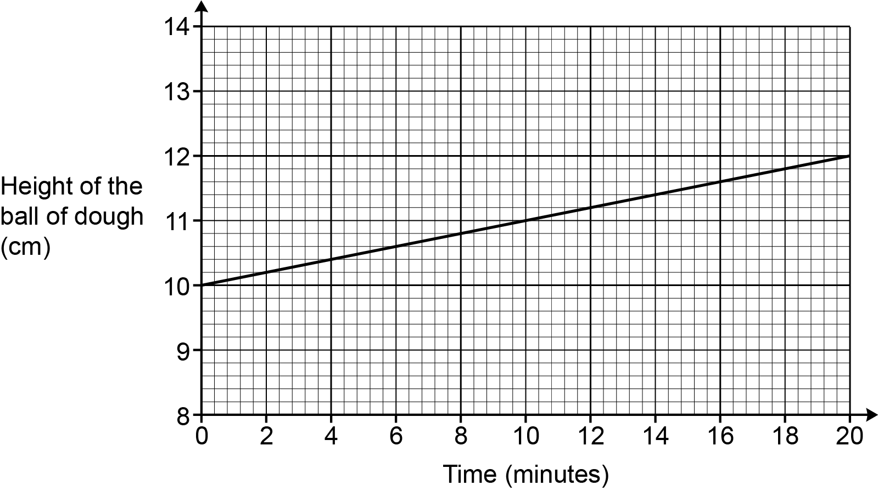
The graph shows the height of the ball of dough over the first 20 minutes.

(a) Work out the gradient of the line as a decimal, giving the units of your answer.
Show how you work out your answer.

(a) ……..…………….………………. [3]

(b) A baker works out the height of the ball of dough at the end of 30 minutes as 13 cm.

(i) Use your gradient to show that the baker could be correct. [2]

(ii) What assumption has the baker made?

…………………………………………………………………………………………………

..…………………………………………………………………………………………… [1]

17 Rowan draws a circle and works out its area, in cm², and circumference, in cm.
The answer for the area is three times the answer for the circumference.

Work out the diameter of the circle.
You must show your working.

……..…………….………………. cm [4]

18 The graph shows the solution to this pair of simultaneous equations.

2x + y = 11
x + 2y = 10

Use the solution to work out the value of x + 3y.
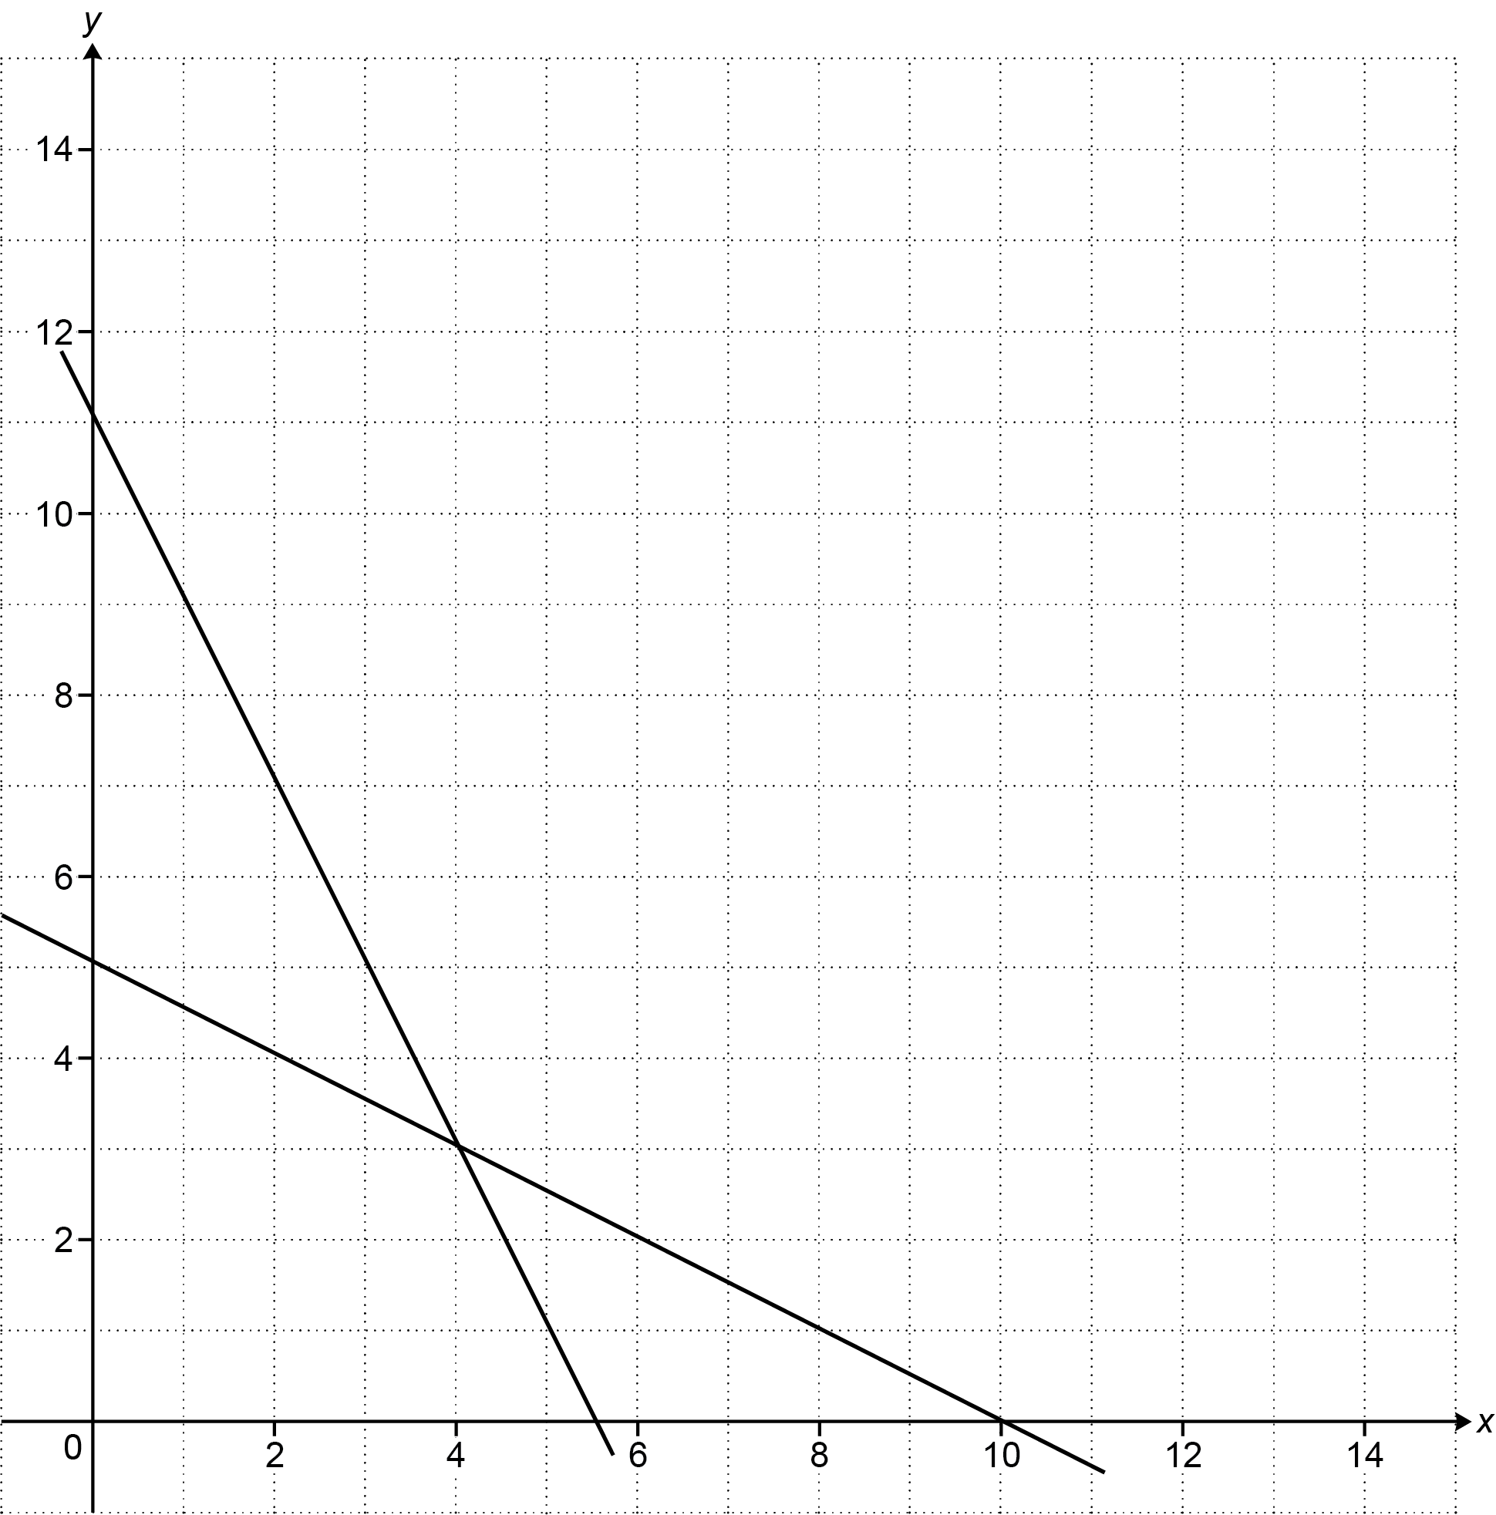
You must show how you work out your answer.

x + 3y = ……..…………….………………. [3]

19 Triangle A and triangle B are drawn on the coordinate grid.
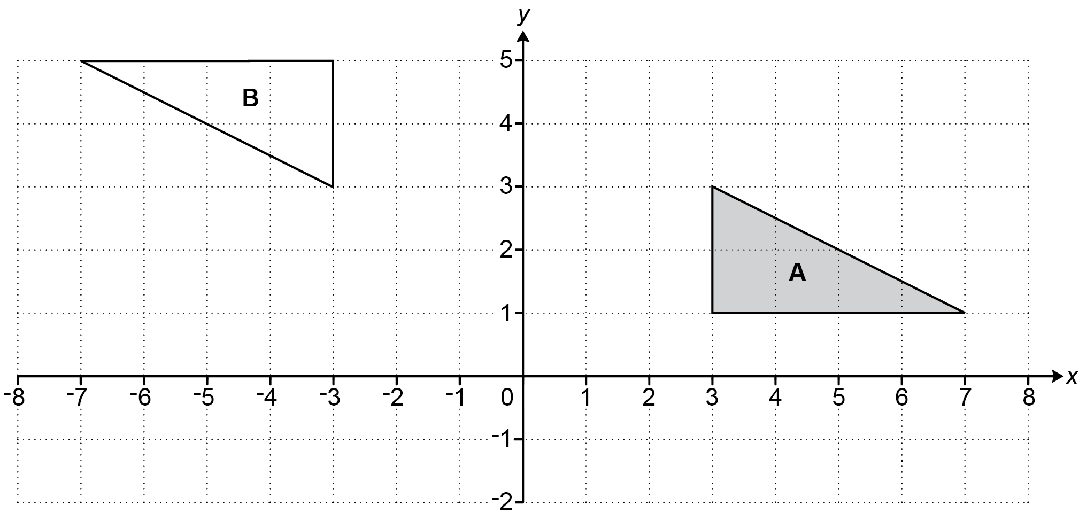

Describe fully the single transformation that maps triangle A onto triangle B.

..…………………………………………………………………………...…………………………………

....…………………………………………………………………………..…………………………… [3]

20 $\vec{\text{PQ}}$ = $\left(\begin{matrix}2 \\ 3\end{matrix}\right)$ and $\vec{\text{QR}}$ = $\left(\begin{matrix}5 \\ 2\end{matrix}\right)$.

Work out $\vec{\text{PR}}$.

[2]

21 Solve.

x² + 6x – 135 = 0

You must show your working.

x = ……..…………….… or x = ……..…………….… [3]

22 A recipe for a batch of jam needs 4 oranges, 7 lemons and 1.5 kg of sugar.
A cook uses the recipe to make lots of batches of jam.
They use 18 more lemons than oranges in total.

Find how much sugar the cook should use.

……..…………….………………. kg [3]

23 Alex and Kai are playing a game against a computer.
They can win, draw or lose the game.

Alex says

I think the probability of us winning the game is 0.25.

Kai says

I think the probability of us losing the game is 0.8.

(a) Explain why Alex and Kai cannot both be correct.

..………………………………………………………………………………………………………

....………………………………………………………………………………………………… [1]

(b) Alex is correct. The probability of them winning the game is 0.25.
Kai is not correct. The probability of them losing the game is actually 0.6.

Complete this partly drawn tree diagram to show all the possible outcomes of playing the game twice.

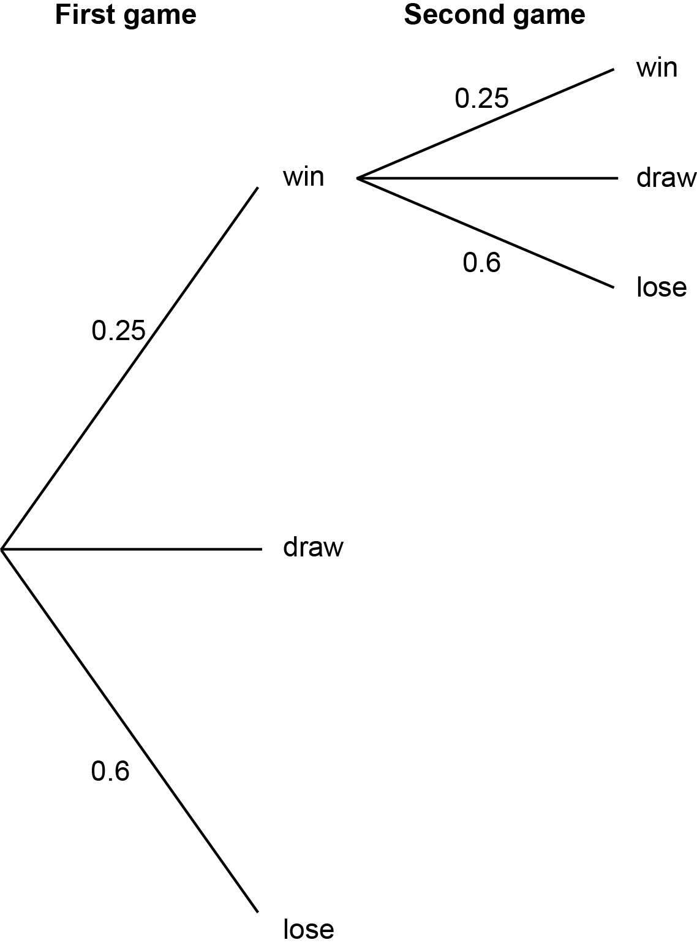
[3]

(c) Find the probability of them losing the first game and winning the second game.

(c) ……..…………….………………. [2]

24 The scatter diagram shows the number of visitors to a children’s playground and the maximum
temperature on fifteen Saturdays in summer.

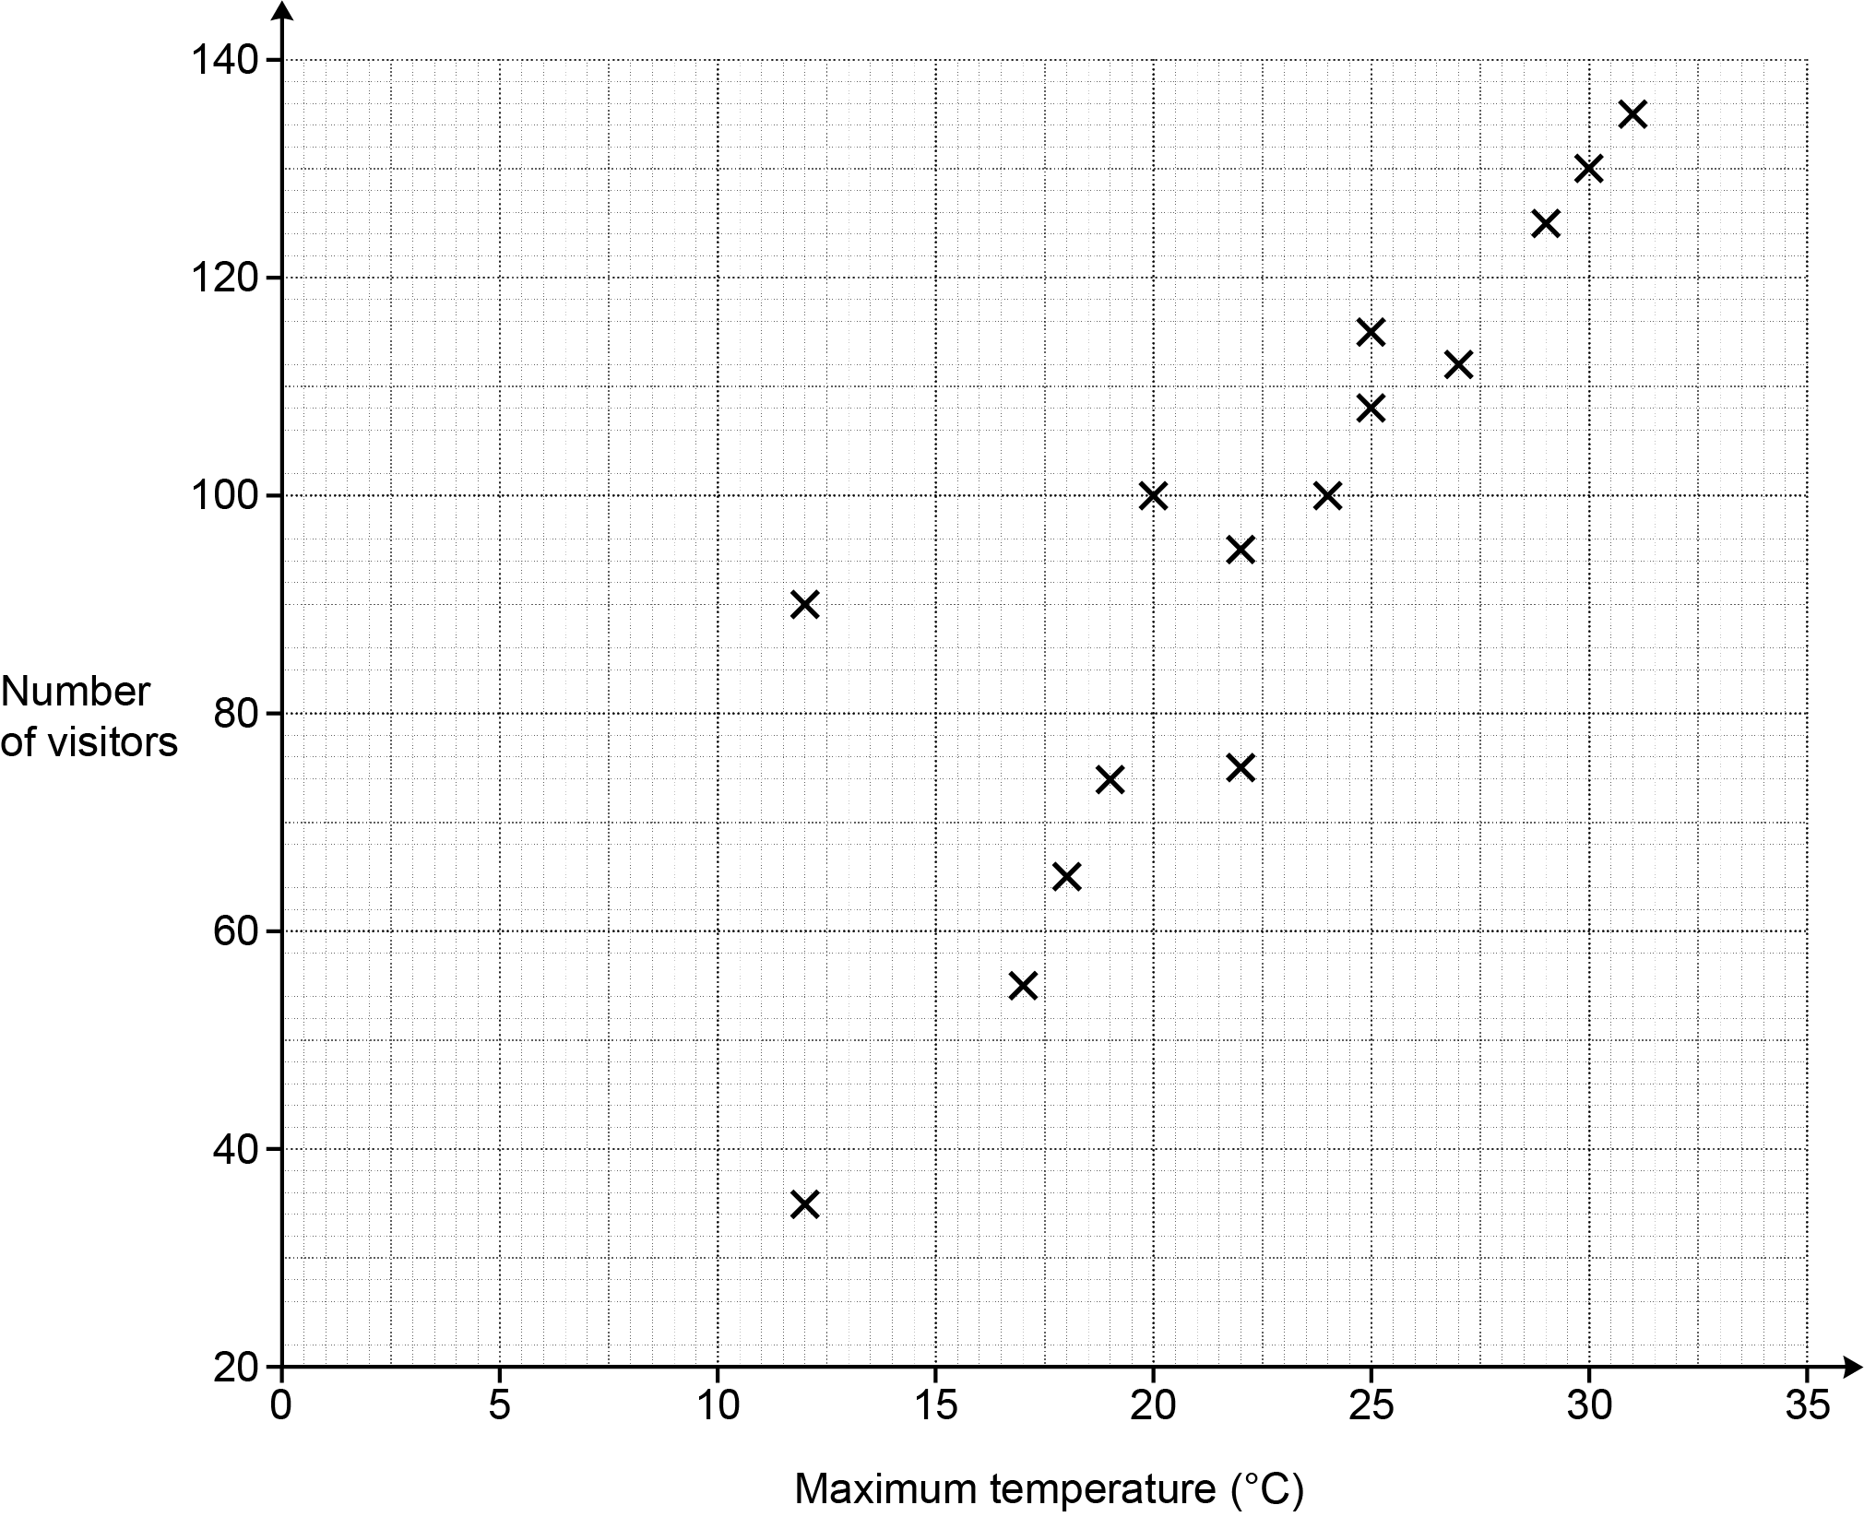

(a) Describe the type of correlation shown in the scatter diagram.

(a) ……..…………….………………. [1]

(b) One Saturday was a cool but sunny day.

(i) Circle the most likely point on the scatter diagram for this Saturday. [1]

(ii) Explain why you chose this point.

..………………………………………………………………………………………………

....…………………………………………………………………………… …………… [1]

(c) Use a line of best fit to predict the number of visitors on a Saturday that has a maximum
temperature of 21 °C.

(c) ……..…………….………………. visitors [2]

25 A child has four identical wooden cubes of side length 7 cm.

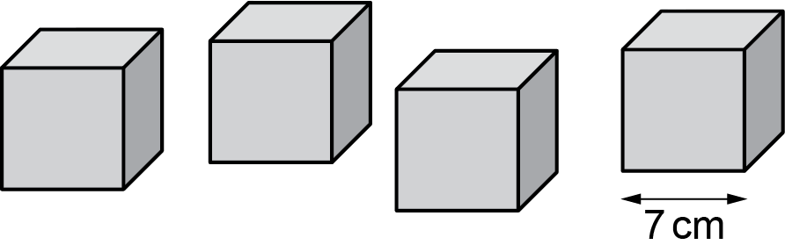

(a) They arrange the cubes in a 2 by 2 by 1 arrangement to form a cuboid.

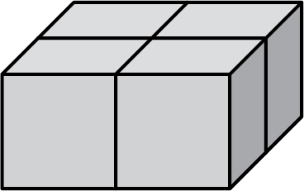

Show that the surface area of the cuboid is 784 cm². [2]

(b) The child rearranges the cubes in a 4 by 1 by 1 arrangement to form a different cuboid.

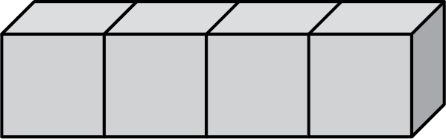

Calculate the percentage increase in surface area for this cuboid compared with the
2 by 2 by 1 cuboid.

(b) ……..…………….………………. % [4]

26 Triangles ABC and DEF are mathematically similar.
Angle ABC = Angle DEF.

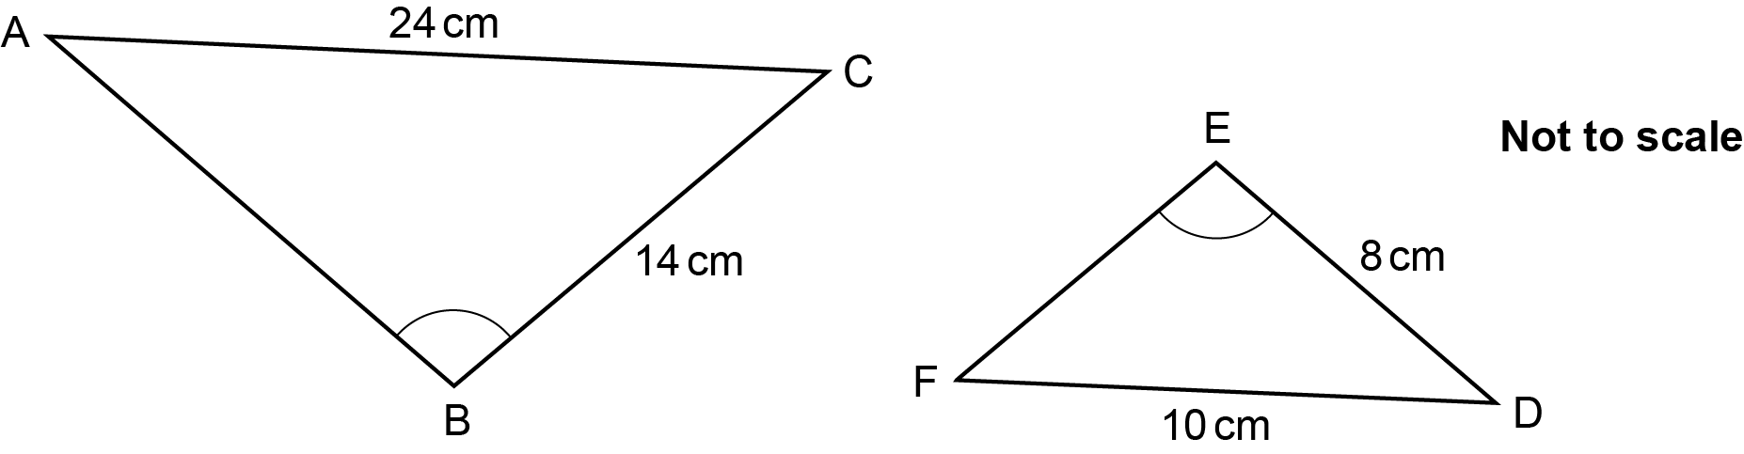

Calculate the perimeter of triangle ABC.

……..…………….………………. cm [4]

END OF QUESTION PAPER

Please note – web links are correct at date of publication but other websites may change over time. If you have any problems with a link you may want to navigate to that organisation’s website for a direct search.



We’d like to know your view on the resources we produce. Click ‘Like’ or ‘Dislike’ to send us an auto generated email about this resource. Add comments if you want to. Let us know how we can improve this resource or what else you need. Your email will not be used or shared for any marketing purposes.
Looking for another resource? There is now a quick and easy search tool to help find free resources for your qualification.
OCR is part of Cambridge University Press & Assessment, which is itself a department of the University of Cambridge.
For staff training purposes and as part of our quality assurance programme your call may be recorded or monitored.
Oxford Cambridge and RSA Examinations is a Company Limited by Guarantee. Registered in England. Registered office
The Triangle Building, Shaftesbury Road, Cambridge, CB2 8EA. Registered company number 3484466. OCR is an exempt charity.
OCR operates academic and vocational qualifications regulated by Ofqual, Qualifications Wales and CCEA as listed
in their qualifications registers including A Levels, GCSEs, Cambridge Technicals and Cambridge Nationals.
OCR provides resources to help you deliver our qualifications. These resources do not represent any teaching method we expect you to use. We update our resources regularly and aim to make sure content is accurate but please check the OCR website so that you have the most up to date version. OCR cannot be held responsible for any errors or omissions in these resources.
Though we make every effort to check our resources, there may be contradictions between published support and the specification, so it is important that you always use information in the latest specification. We indicate any specification changes within the document itself, change the version number and provide a summary of the changes. If you do notice a discrepancy between the specification and a resource, please contact us.
© OCR 2023 - You can copy and distribute this resource freely if you keep the OCR logo and this small print intact and you acknowledge OCR as the originator of the resource.
OCR acknowledges the use of the following content: N/A
Whether you already offer OCR qualifications, are new to OCR or are thinking about switching, you can request more information using our Expression of Interest form.
Please get in touch if you want to discuss the accessibility of resources we offer to support you in delivering our qualifications.

