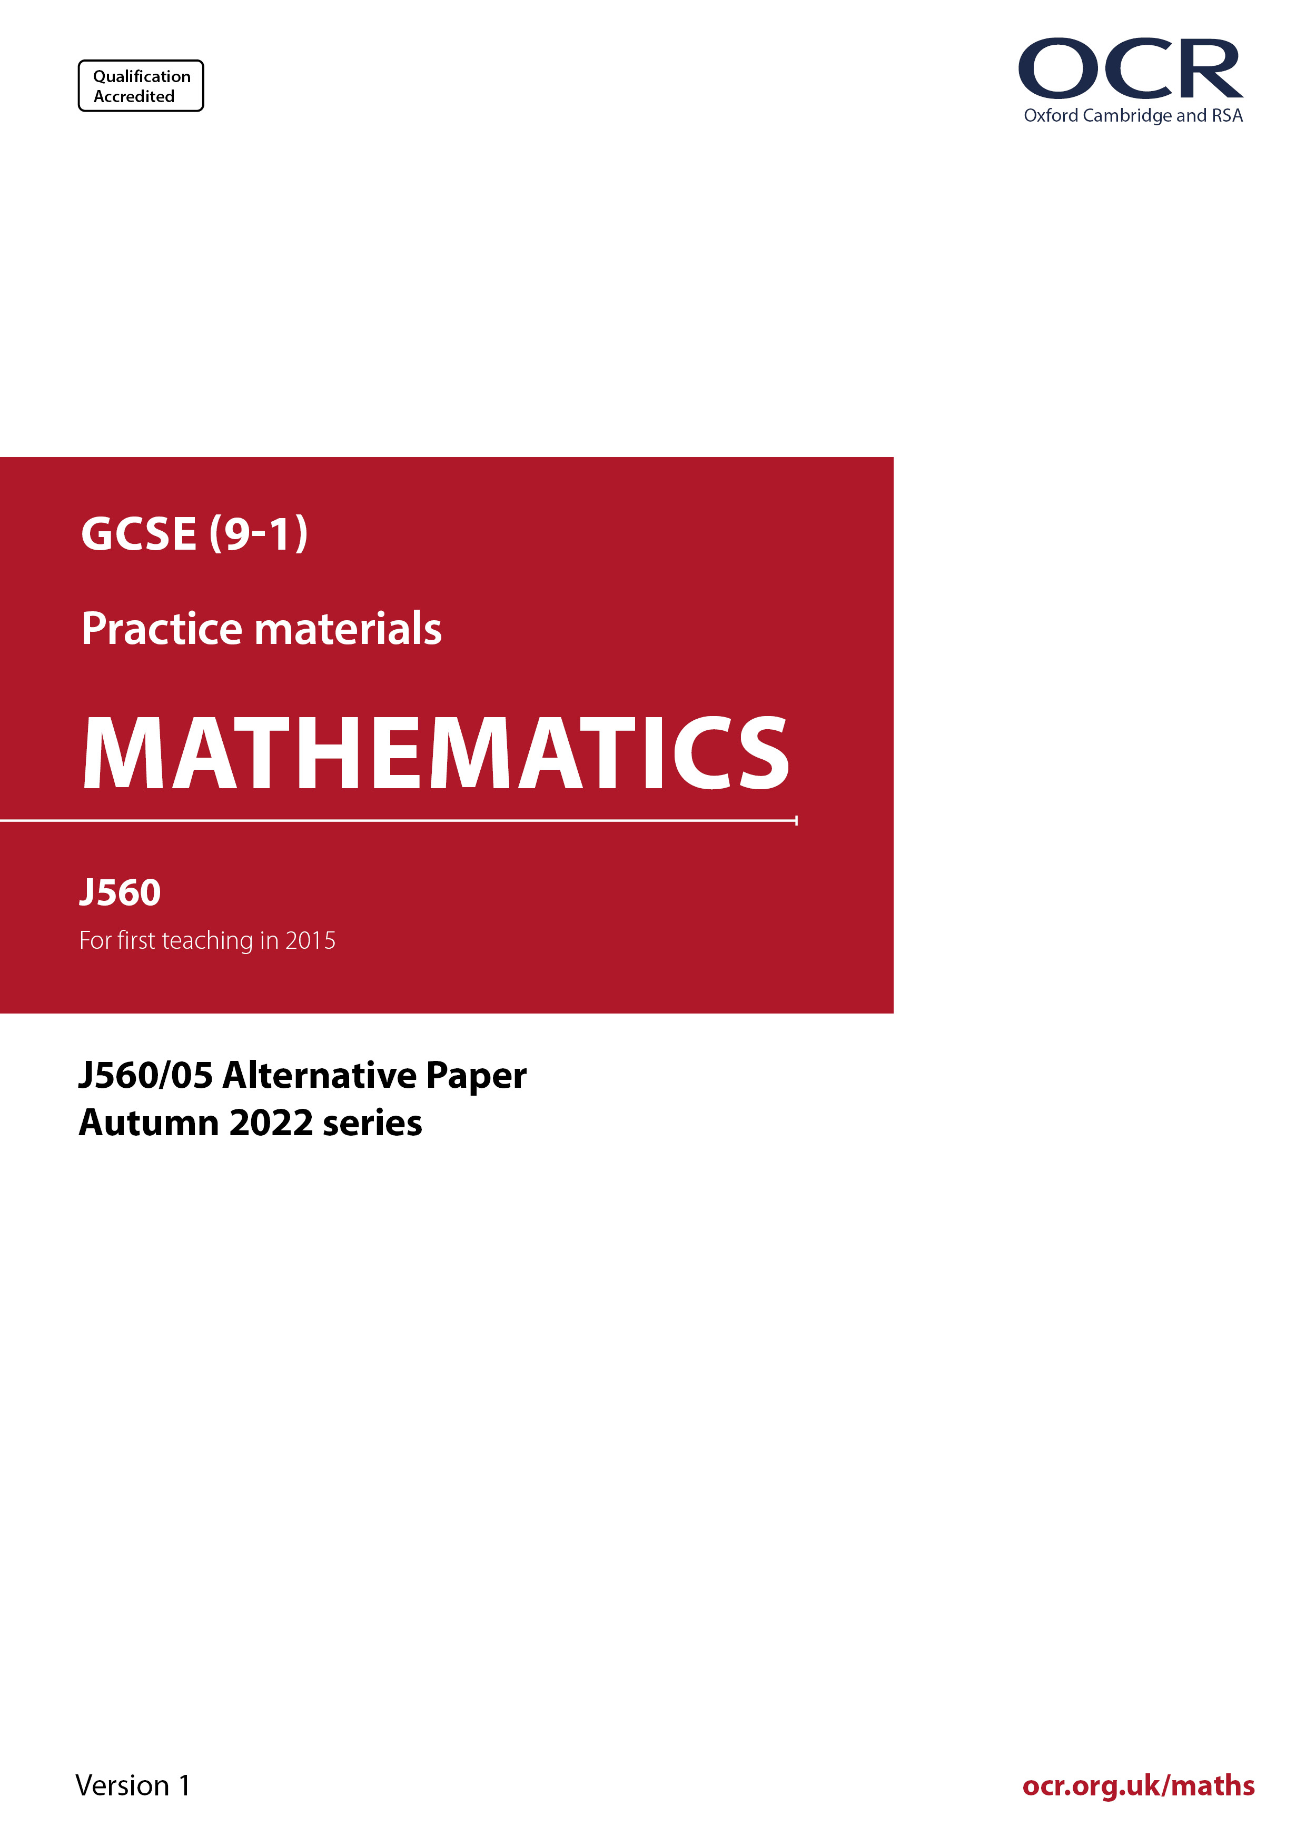
ocr.org.uk/maths

Introduction
OCR’s Alternative Papers for GCSE (9-1) Mathematics are each created by taking one of our past papers and amending the numbers/graphs/diagrams/tables/etc. in its questions.
This Alternative Paper is an amended version of one of the November 2022 series papers. The wording and topics assessed are essentially the same, but the responses students need to make will be different. Using both this paper and the corresponding November 2022 exam paper with your students at different points in the year will allow you to monitor how their learning has progressed in the time between the two papers.
Please note that when students originally sat this paper in 2022, they were given a formulae sheet. Foundation tier and Higher tier formulae sheets are published on Teach Cambridge alongside the Alternative Papers, for use with students as required.
Additional Alternative Papers and past papers are available to download from Teach Cambridge.



GCSE (9-1) Mathematics
J560/05 Paper 5 (Higher Tier)
Alternative Paper (November 2022)

Time allowed: 1 hour 30 minutes

H
You must have:
- geometrical instruments
- tracing paper
Do not use:
- a calculator

Name

INSTRUCTIONS
- Use black ink. You can use an HB pencil, but only for graphs and diagrams.
- Write your answer to each question in the space provided. If you need extra space, use
the lined pages at the end of this booklet. The question numbers must be clearly shown.
- Answer all the questions.
- Where appropriate, your answer should be supported with working. Marks might be
given for using a correct method, even if your answer is wrong.

INFORMATION
- The total mark for this paper is 100.

- The marks for each question are shown in brackets [ ].
- This document has 24 pages.

ADVICE
- Read each question carefully before you start your answer.

Answer all the questions.

1 Azmi was paid £12.00 per hour.
Azmi receives a pay increase of 30%.

Work out how much Azmi is now paid per hour.

£ ……..…………….………………. [3]

2 Find all the possible integer values that satisfy the inequality -1 < x + 2 ⩽ 4.

……..…………….………………. [3]

3 Layla has a fair spinner numbered 2, 3 and 5.

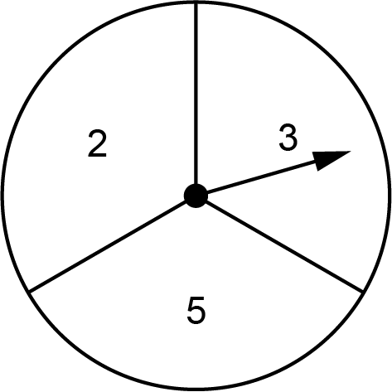

Layla spins the spinner twice and multiplies the two scores to get a result.

(a) Complete the table to show all of the possible results.

First spin
Result | 2 | 3 | 5
2 | 4 | 6
3 | 6 | 9
5 |  | 15 | 25

Second
spin

[1]

(b) Find the probability that the result is an odd number.

(b) ……..…………….………………. [2]

4 Rowan and Jamie open a packet of biscuits.
Rowan and Jamie share all of the biscuits in the ratio 1 : 3.

(a) Write down the fraction of the biscuits that Rowan receives.

(a) ……..…………….………………. [1]

(b) Rowan eats some of her biscuits.
She is then left with 15% of the biscuits that were in the packet.

Work out the percentage of her biscuits that Rowan has eaten.

(b) ……..…………….……………….% [4]

5 Blake goes on a journey.

She travels by taxi for $\frac{2}{9}$ of the journey.

She travels by train for $\frac{7}{10}$ of the journey.

She walks for the remaining 700 m of the journey.

Find the length of this journey in kilometres.
You must show your working.

……..…………….………………. km [6]

6 The graph shows information about the number of babies born in a hospital.
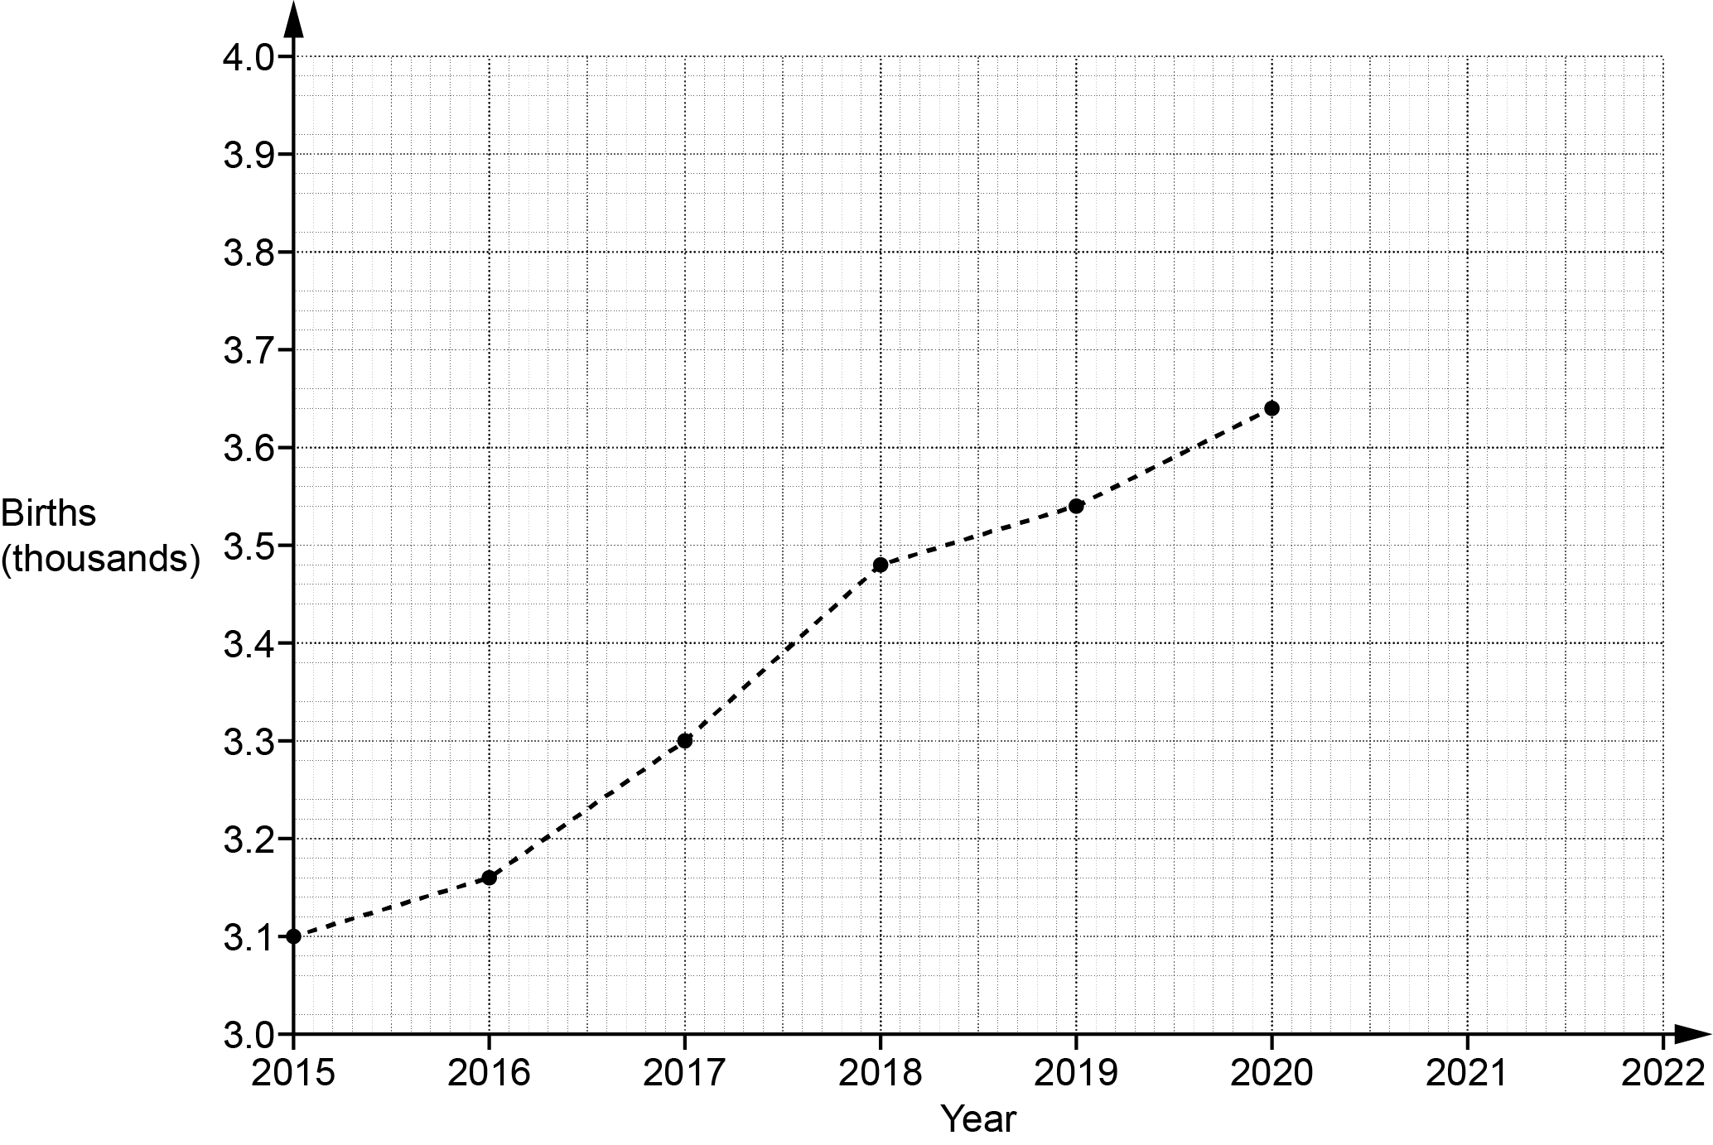

(a) The number of babies born in the hospital in 2021 was 3740.
Plot this point on the graph. [1]

(b) Work out the increase in the number of births in the hospital between 2016 and 2018.

(b) ……..…………….………………. [2]

(c) Sam says that there was a huge increase in the number of births in the hospital between 2015 and 2020.

Describe how Sam may have been misled by the graph.

.………...……..….……………………………………………………………………………………

…………...………..……………………………………………………………………………… [1]

(d) Ashley says that the number of births in the hospital will be greater than 3800 in 2022.

Write down an assumption Ashley has made.

….……..…..…….…………………………………………….………………………………………

………......………..……………………………………………………….…...………………… [1]

7 The diagram shows a straight line crossing a pair of parallel lines.

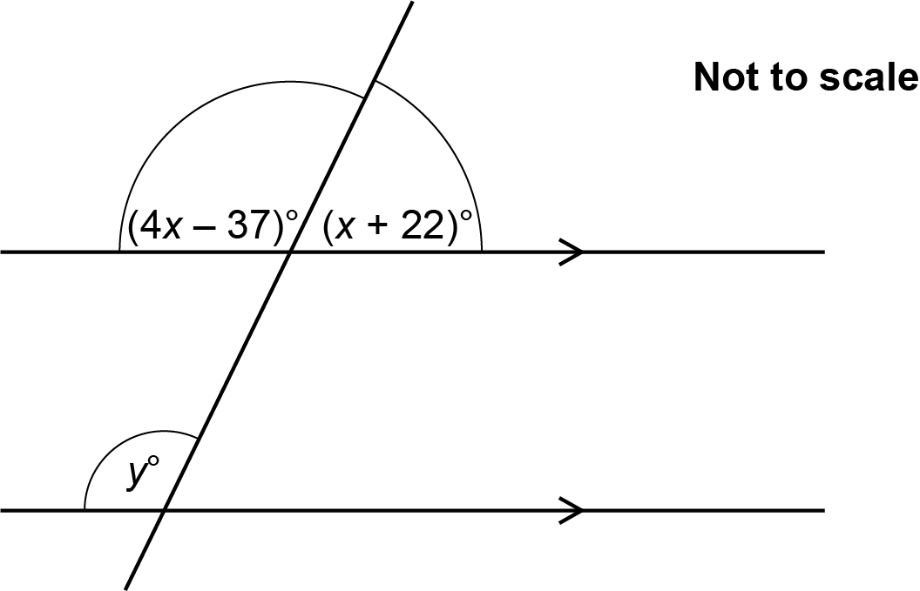

Find the value of y.
You must show your working.

y = ……..…………….………………. [5]

8 The diagram shows a cylinder with radius 9 cm and height 15 cm.

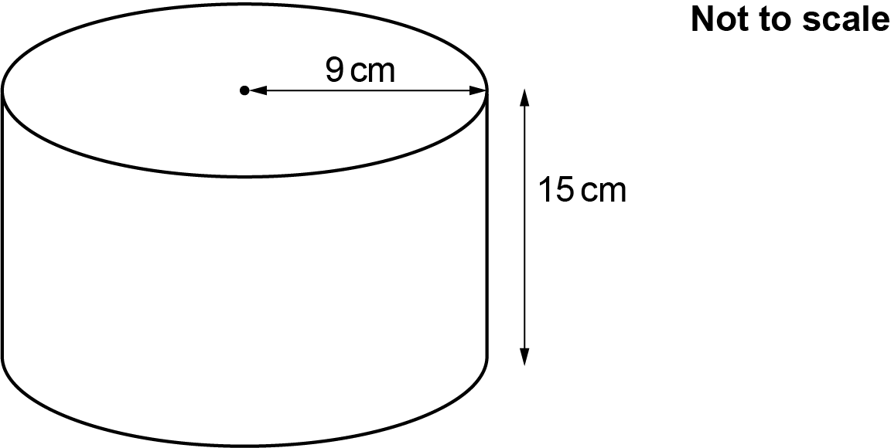

(a) On the grid below, draw the plan view of the cylinder.
Use the scale 1 cm represents 3 cm.

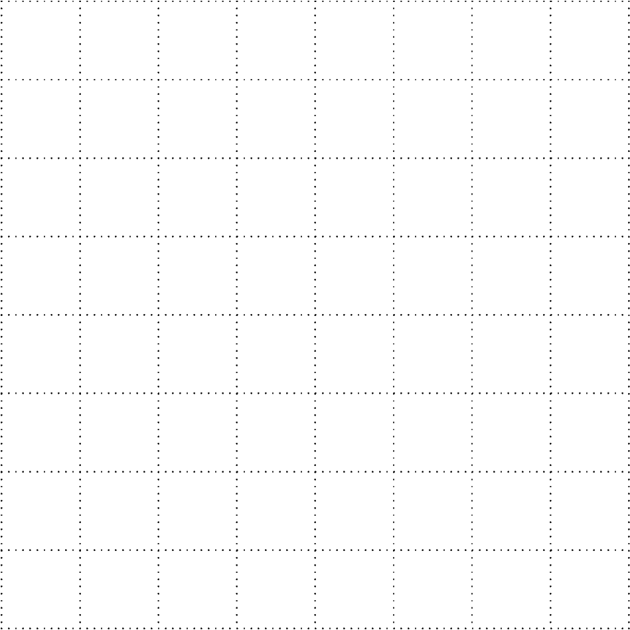
[2]

(b) On the grid below, draw the front elevation of the cylinder.
Use the scale 1 cm represents 3 cm.

[2]

9 A student says that they have placed the following values in order starting with the smallest.

${\left( \frac{\text{1}}{\text{5}} \right)}^{\text{2}}$ $\sqrt{\text{0.16}}$ 10⁻¹

Has the student done this correctly?
Show how you decide.

.………………… because ………………………………………………………………………...………

....………………………………………………………………………………...……………………… [4]

10 The parallelogram and the trapezium have the same area.

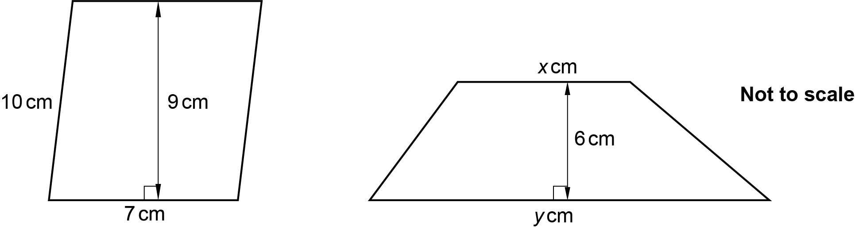

The ratio of x : y is 4 : 3.

Find the value of x and the value of y.
You must show your working.

x = ……..……………….………..…...

y = ……..…………….………………. [6]

11 Write $0. \dot{6}\dot{3}$ as a fraction in its simplest form.

……..…………….………………. [3]

12 The time, t minutes, taken by each of 70 students to complete a sponsored walk is recorded.

The table shows information about these times.

Time  (t minutes) | 40 < t ⩽ 50 | 50 < t ⩽ 60 | 60 < t ⩽ 70 | 70 < t ⩽ 80 | 80 < t ⩽ 90
Frequency | 18 | 32 | 15 | 0 | 5

(a) Two students are picked at random.
Jamal works out the probability that they both took 60 minutes or less to complete the sponsored walk .
Jamal’s working is shown below.

The number of students who took 60 minutes or less is 18 + 32 = 50

The probability that one student took 60 minutes or less is

The probability they both took 60 minutes or less is

Explain the error in their method and write the correct calculation that Jamal needs to do.
You do not need to work out the answer to the calculation.

The error is ....……..………………………………………………………………………………...

.…………....……………………..…………………………………………………………………...

The correct calculation is ....……..……………………………………………………………. [2]

(b) Two students are picked at random from those who took more than 60 minutes.

Find the probability that one of them took 70 minutes or less and the other took more than
80 minutes.
You must show your working.

(b) ……..…………….………………. [5]

13 Points A, B, C and D lie on the circumference of a circle.
Line AC intersects line BD at point E.

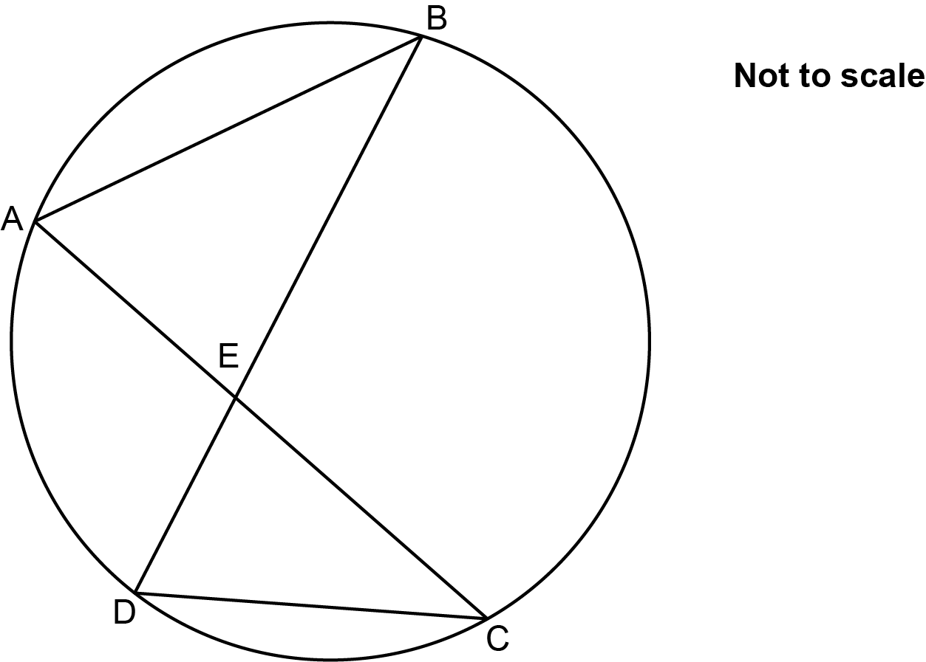

Prove that triangle AEB is similar to triangle DEC.

....……..…………………………………………………………………...…………………………………

.…………....…………………………………………………..…………………………………..…………

.....……..…………………………………………………………..…………………………………………

..……....…………………………………………………………….…………………………………... [3]

14 The number of ants, P, in a colony is given by the formula

P = b ^{x}a

where x is the number of months after the start of June.

At the start of June, there were 15 000 ants in the colony.
After one month, there were 13 800 ants in the colony.

Find the value of a and the value of b.
Give the value of b as a decimal.

a = ……..…………….………………..

b = ……..…………….….……………. [4]

15 (a) Simplify.

(a) ……..…………….………………. [2]

(b) Rationalise the denominator and simplify.

(b) ……..…………….………………. [3]

(c) Work out.

(c) ……..…………….………………. [2]

16 The graph shows the distance travelled by a particle over the first 40 seconds of its motion.

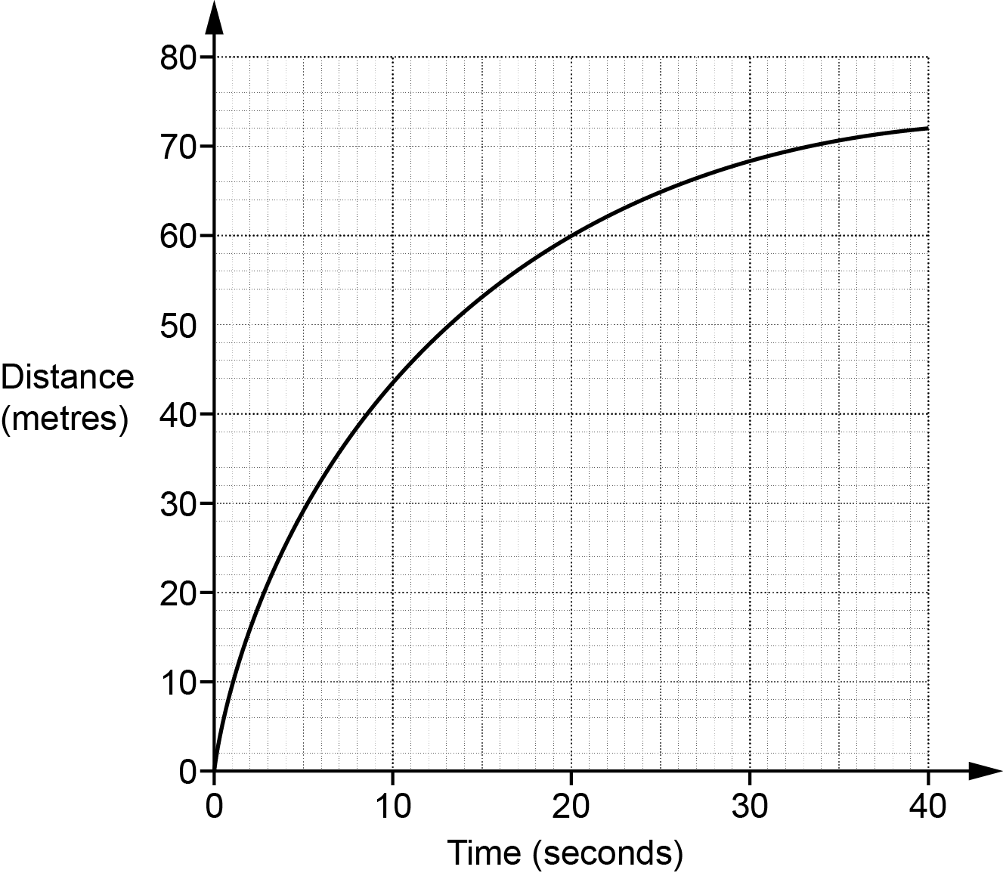

(a) Show that the average speed of the particle over the first 40 seconds of its motion is 1.8 m/s.
[1]

(b) Estimate the speed of the particle at 20 seconds.
You must show working to support your estimate.

(b) ……..…………….………………. m/s [3]

17 The diagram shows triangle ABC.

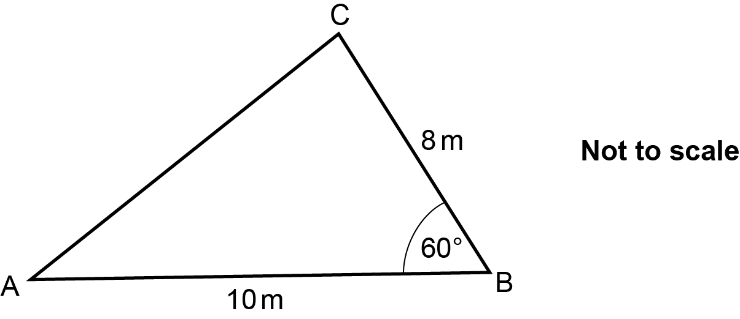

Find the area of the triangle.
Give your answer in the form where a and b are integers.

……..…………….………………. m² [3]

18 (a) By factorising, find the roots of y = x ² + 16x + 55.

(a) x = ................... and x = ................... [3]

(b) (i) Write y = x ² + 16x + 55 in the form y = (x + a) ² ― b.

(b)(i) y = ……..…………….………………. [3]

(ii) Write down the coordinates of the turning point of the graph of y = x ² + 16x + 55

(ii) (……...……….… , ……..………….…) [2]

19 (a) Sketch the graph of y = 3 ^{-x} indicating any values where the graph crosses the axes.

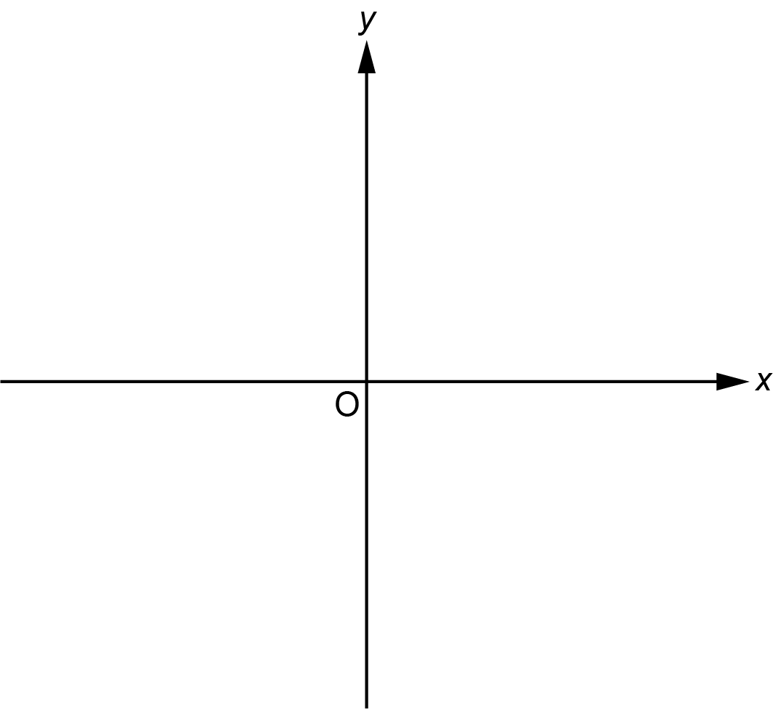
[2]

(b) Sketch the graph of y = sin x for 0°⩽ x ⩽ 360° indicating any values where the graph crosses the axes.

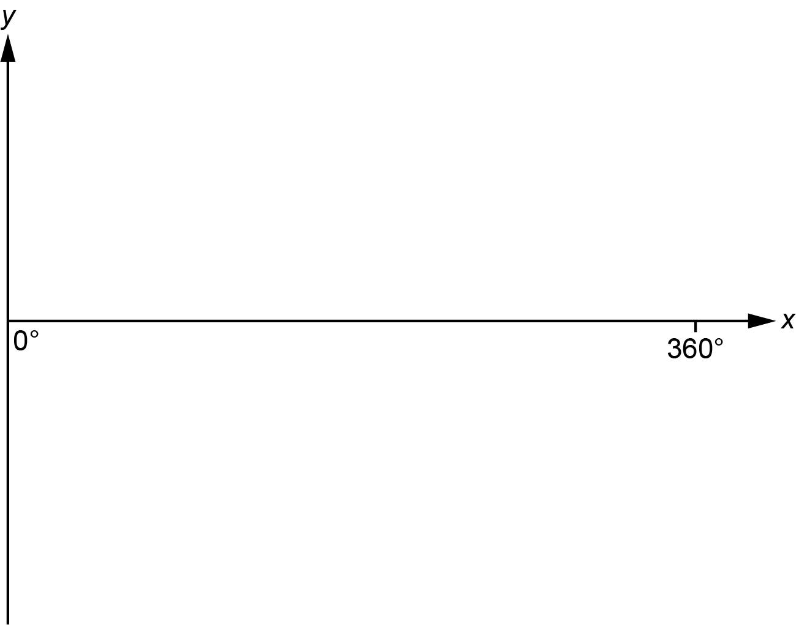
[2]

20 Reece has a box in the shape of a cuboid.
The internal dimensions of the box are 9 cm by 3 cm by 5 cm.

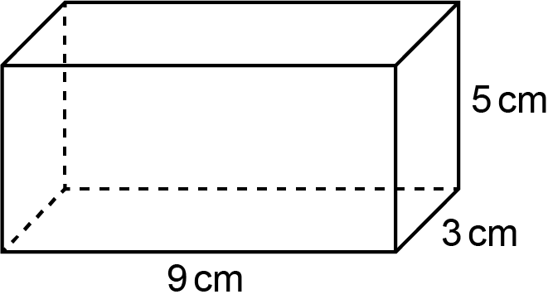

Reece is given a crayon of length 11 cm.

Show that the crayon does not fit completely inside the box. [4]

21 The graph of $y= \frac{1}{x+3}$ is drawn on the grid for -6 ⩽ x ⩽ 1.

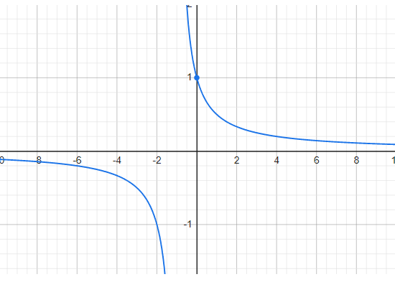

(a) There are no values of x for which $\frac{1}{x+3}=k$.

Find the value of k.

(a) k = ……..…………….………………. [1]

(b) (i) Use the graph to find approximate solutions to the equation
Give your answers to 1 decimal place.
Show your working on the graph.

(b)(i) x = ................... or x = ................... [4]

(ii) Show algebraically that has the same solutions as 2x² + 10x + 11 = 0.
[4]

END OF QUESTION PAPER

ADDITIONAL ANSWER SPACE

If additional space is required, you should use the following lined page(s). The question number(s) must be clearly shown in the margin(s).

…………………………………………………………………………………………………………………..

…………………………………………………………………………………………………………………..

…………………………………………………………………………………………………………………..

…………………………………………………………………………………………………………………..

…………………………………………………………………………………………………………………..

…………………………………………………………………………………………………………………..

…………………………………………………………………………………………………………………..

…………………………………………………………………………………………………………………..

…………………………………………………………………………………………………………………..

…………………………………………………………………………………………………………………..

…………………………………………………………………………………………………………………..

…………………………………………………………………………………………………………………..

…………………………………………………………………………………………………………………..

…………………………………………………………………………………………………………………..

…………………………………………………………………………………………………………………..

…………………………………………………………………………………………………………………..

…………………………………………………………………………………………………………………..

…………………………………………………………………………………………………………………..

…………………………………………………………………………………………………………………..

…………………………………………………………………………………………………………………..

…………………………………………………………………………………………………………………..

…………………………………………………………………………………………………………………..

…………………………………………………………………………………………………………………..

Please note – web links are correct at date of publication but other websites may change over time. If you have any problems with a link you may want to navigate to that organisation’s website for a direct search.



We’d like to know your view on the resources we produce. Click ‘Like’ or ‘Dislike’ to send us an auto generated email about this resource. Add comments if you want to. Let us know how we can improve this resource or what else you need. Your email will not be used or shared for any marketing purposes.
Looking for another resource? There is now a quick and easy search tool to help find free resources for your qualification.
OCR is part of Cambridge University Press & Assessment, which is itself a department of the University of Cambridge.
For staff training purposes and as part of our quality assurance programme your call may be recorded or monitored.
Oxford Cambridge and RSA Examinations is a Company Limited by Guarantee. Registered in England. Registered office
The Triangle Building, Shaftesbury Road, Cambridge, CB2 8EA. Registered company number 3484466. OCR is an exempt charity.
OCR operates academic and vocational qualifications regulated by Ofqual, Qualifications Wales and CCEA as listed
in their qualifications registers including A Levels, GCSEs, Cambridge Technicals and Cambridge Nationals.
OCR provides resources to help you deliver our qualifications. These resources do not represent any teaching method we expect you to use. We update our resources regularly and aim to make sure content is accurate but please check the OCR website so that you have the most up to date version. OCR cannot be held responsible for any errors or omissions in these resources.
Though we make every effort to check our resources, there may be contradictions between published support and the specification, so it is important that you always use information in the latest specification. We indicate any specification changes within the document itself, change the version number and provide a summary of the changes. If you do notice a discrepancy between the specification and a resource, please contact us.
© OCR 2023 - You can copy and distribute this resource freely if you keep the OCR logo and this small print intact and you acknowledge OCR as the originator of the resource.
OCR acknowledges the use of the following content: N/A
Whether you already offer OCR qualifications, are new to OCR or are thinking about switching, you can request more information using our Expression of Interest form.
Please get in touch if you want to discuss the accessibility of resources we offer to support you in delivering our qualifications.

