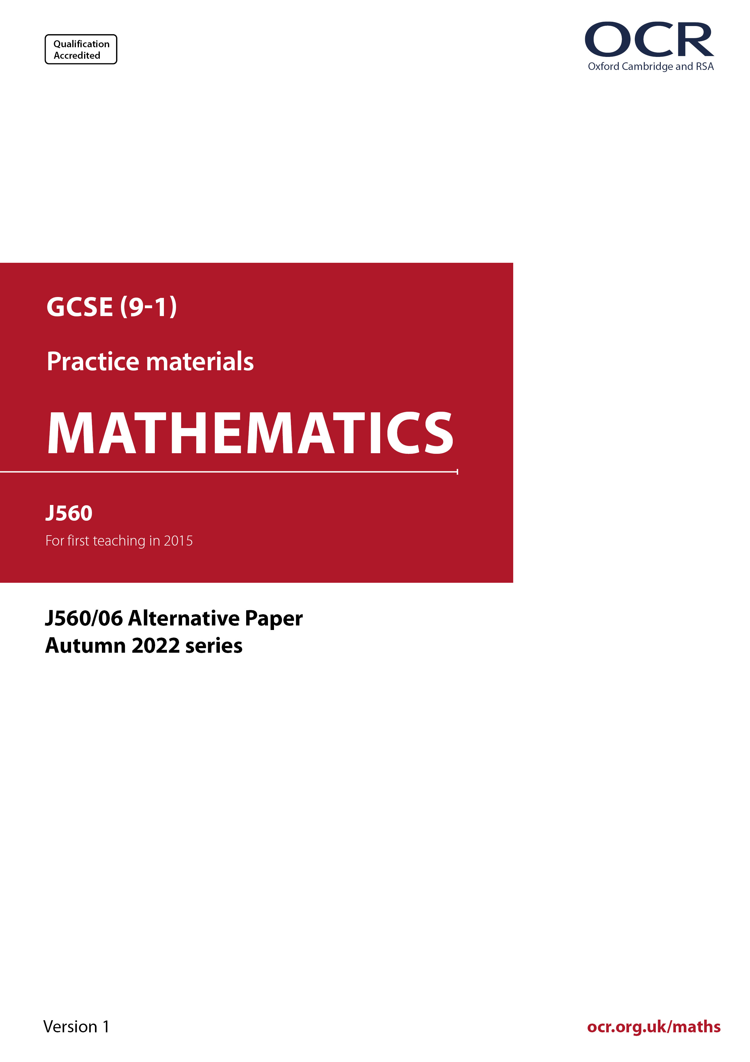
ocr.org.uk/maths

Introduction
OCR’s Alternative Papers for GCSE (9-1) Mathematics are each created by taking one of our past papers and amending the numbers/graphs/diagrams/tables/etc. in its questions.
This Alternative Paper is an amended version of one of the November 2022 series papers. The wording and topics assessed are essentially the same, but the responses students need to make will be different. Using both this paper and the corresponding November 2022 exam paper with your students at different points in the year will allow you to monitor how their learning has progressed in the time between the two papers.
Please note that when students originally sat this paper in 2022, they were given a formulae sheet. Foundation tier and Higher tier formulae sheets are published on Teach Cambridge alongside the Alternative Papers, for use with students as required.
Additional Alternative Papers and past papers are available to download from Teach Cambridge.



GCSE (9-1) Mathematics
J560/06 Paper 6 (Higher Tier)
Alternative Paper (November 2022)

Time allowed: 1 hour 30 minutes

You can use:
- a scientific or graphical calculator
- geometrical instruments
- tracing paper

Name

INSTRUCTIONS
- Use black ink. You can use an HB pencil, but only for graphs and diagrams.
- Write your answer to each question in the space provided. If you need extra space, use
the lined pages at the end of this booklet. The question numbers must be clearly shown.
- Answer all the questions.
- Where appropriate, your answer should be supported with working. Marks might be
given for using a correct method, even if your answer is wrong.
- Use the π button on your calculator or take π to be 3.142 unless the question says
something different.

INFORMATION
- The total mark for this paper is 100.
- The marks for each question are shown in brackets [ ].
- This document has 22 pages.

ADVICE
- Read each question carefully before you start your answer.

Answer all the questions.

1 Shape A and shape B are drawn on the coordinate grid.

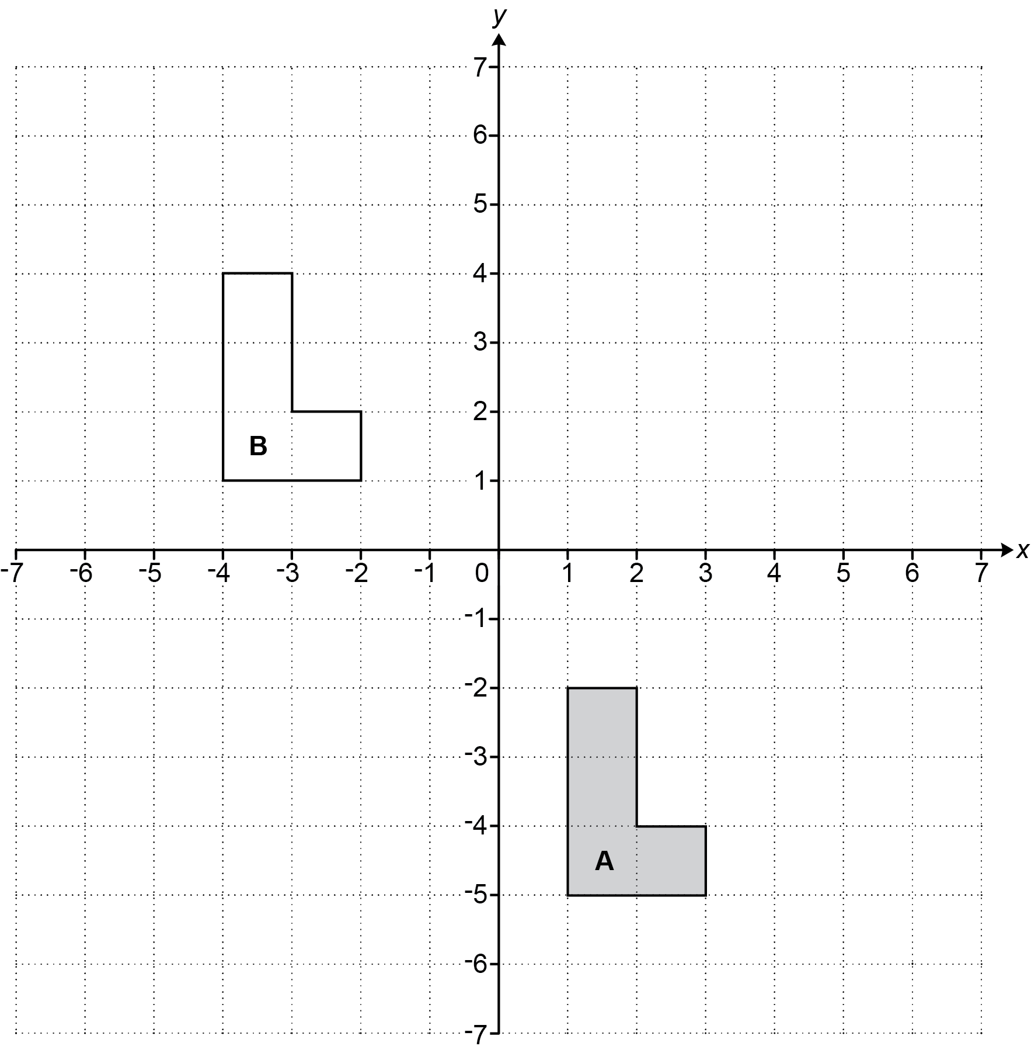

(a) Describe fully the single transformation that maps shape A onto shape B.

..…………..……………………………………………………………………………………………

....…………..……………………………………………………………………………………… [2]

(b) Reflect shape A in the line y = –1. [2]

2 A recipe for a batch of jam needs 4 oranges, 7 lemons and 1.5 kg of sugar.
A cook uses the recipe to make lots of batches of jam.
They use 18 more lemons than oranges in total.

Find how much sugar the cook should use.

……..…………….………………. kg [3]

3 In 1980, Layla’s flat was worth £25 000.
Today, Layla’s flat is worth 1100% of its value in 1980.

Calculate the value of Layla’s flat today.

£ ……..…………….………………. [2]

4 Alex and Kai are playing a game against a computer.
They can win, draw or lose the game.

Alex says

I think the probability of us winning the game is 0.25.

Kai says

I think the probability of us losing the game is 0.8.

(a) Explain why Alex and Kai cannot both be correct.

..………………………………………………………………………………………………………

....………………………………………………………………………………………………… [1]

(b) Alex is correct. The probability of them winning the game is 0.25.
Kai is not correct. The probability of them losing the game is actually 0.6.

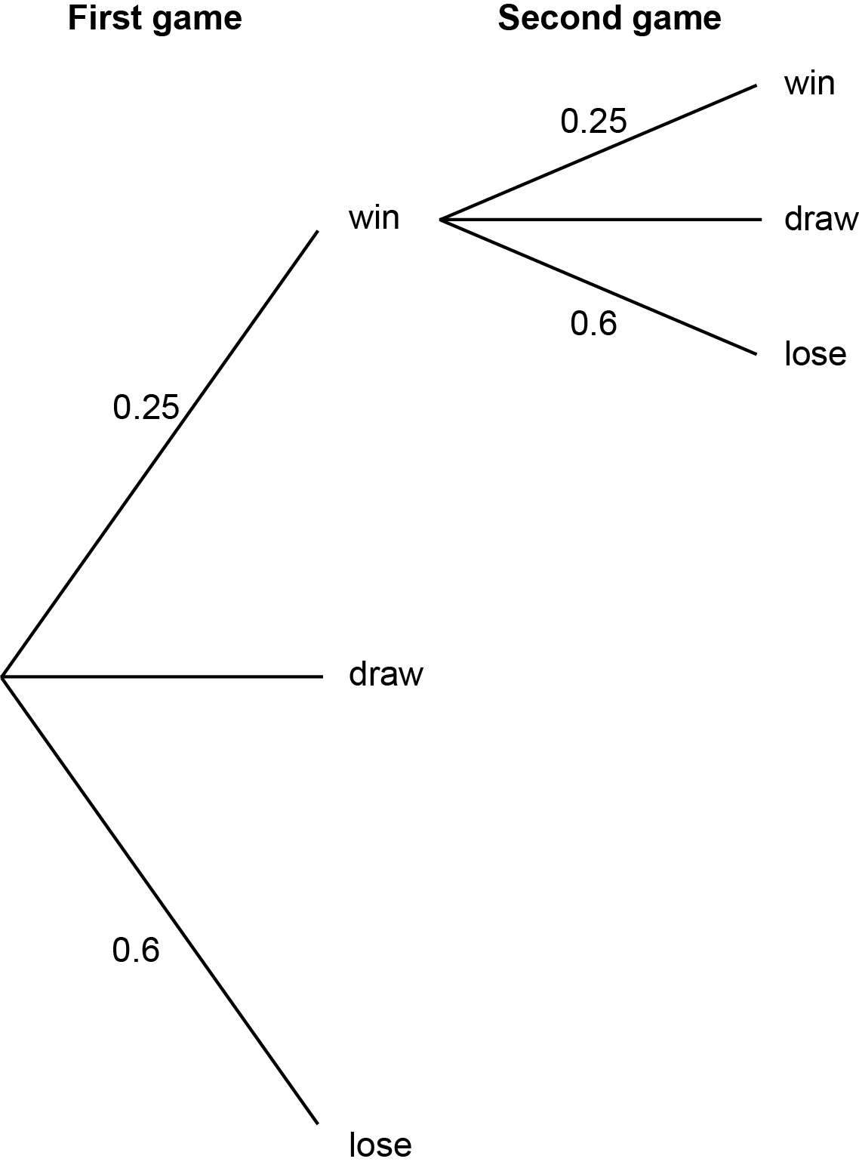
Complete this partly drawn tree diagram to show all the possible outcomes of playing the game twice.

[3]

(c) Find the probability of them losing the first game and winning the second game.

(c) ……..…………….………………. [2]

5 In space, distances can be measured in Astronomical Units.
In this question, use the conversion 1 Astronomical Unit = 1.5 × 10⁸ km.

(a) On a particular day the distance from Earth to Mars is 0.5222 Astronomical Units.

Calculate the distance from Earth to Mars in kilometres on that day.
Give your answer in standard form.

(a) ……..…………….………………. km [3]

(b) On a particular day the distance from Earth to Neptune is 4 364 000 000 km.

Calculate the distance from Earth to Neptune in Astronomical Units on that day.

(b) ……..…………………. Astronomical Units [2]

6 The scatter diagram shows the number of visitors to a children’s playground and the maximum
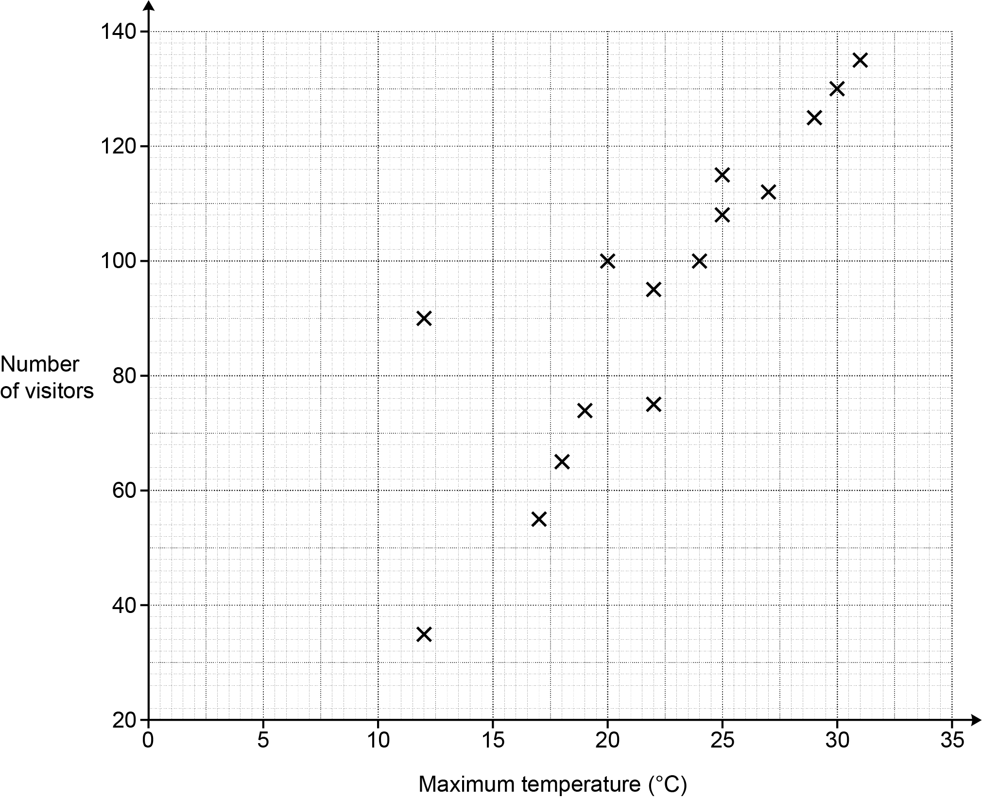
temperature on fifteen Saturdays in summer.

(a) Describe the type of correlation shown in the scatter diagram.

(a) ……..…………….………………. [1]

(b) One Saturday was a cool but sunny day.

(i) Circle the most likely point on the scatter diagram for this Saturday. [1]

(ii) Explain why you chose this point.

..………………………………………………………………………………………..………

....……………………………………………………………………………………..…… [1]

(c) Use a line of best fit to predict the number of visitors on a Saturday that has a maximum
temperature of 21 °C.

(c) ……..…………….………………. visitors [2]

7 A child has four identical wooden cubes of side length 7 cm.

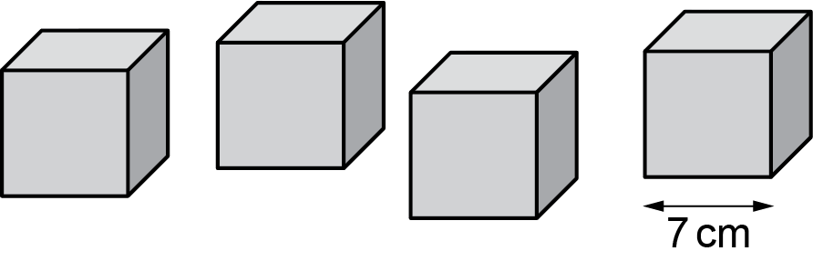

(a) They arrange the cubes in a 2 by 2 by 1 arrangement to form a cuboid.

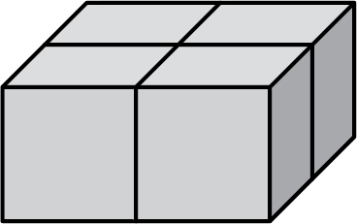

Show that the surface area of the cuboid is 784 cm². [2]

(b) The child rearranges the cubes in a 4 by 1 by 1 arrangement to form a different cuboid.

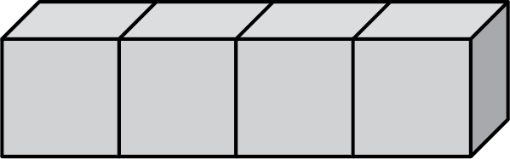

Calculate the percentage increase in surface area for this cuboid compared with the
2 by 2 by 1 cuboid.

(b) ……..…………….………………. % [4]

8 Triangles ABC and DEF are mathematically similar.
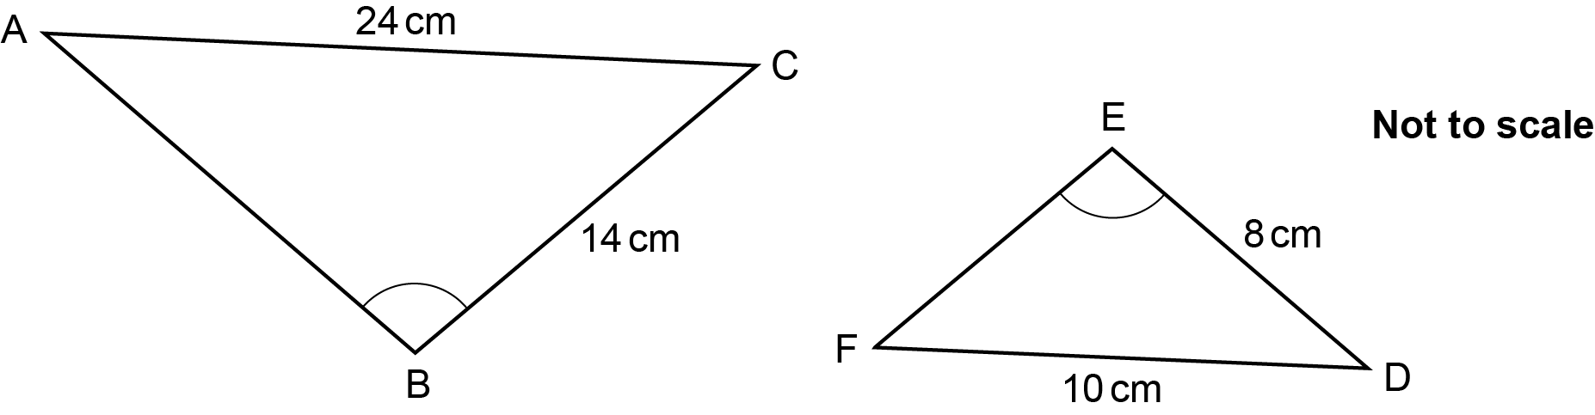
Angle ABC = Angle DEF.

Calculate the perimeter of triangle ABC.

……..…………….………………. cm [4]

9 Given that (2^{k})⁷ × 16 = 2⁴⁶, find the value of k.

k = ……..…………….………………. [3]

10 The highest common factor (HCF) of two numbers is 15.
The lowest common multiple (LCM) of the same two numbers is 210.
The two numbers are not 15 and 210.

Find the two numbers.

……..…………….… and ……..…………….… [3]

11 Factorise fully 30x ² + 2x – 12.

……..…………….………………. [3]

12 The graph shows the speed of a car during the first 40 seconds of a journey.
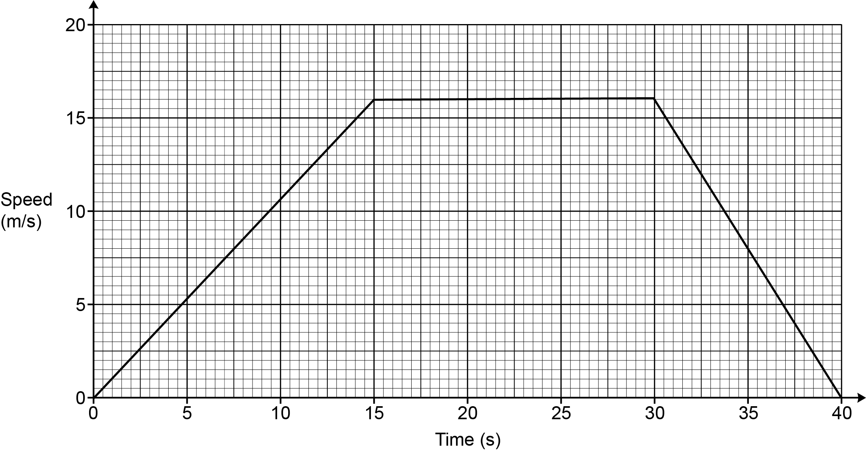

(a) Write down the acceleration of the car between 15 seconds and 30 seconds.

(a) ……..…………….……………….m/s² [1]

(b) Work out the average speed of the car, in m/s, during the 40 seconds.
You must show your working.

(b) ……..…………….………………. m/s [5]

13 (a) Here is a function.

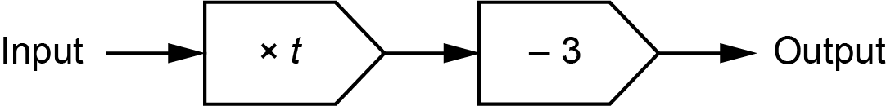

When the input is 6, the output is 19.

Find the value of t.

(a) t = ……..…………….………………. [3]

(b) Here is another function.
When the input is x, the output is y.

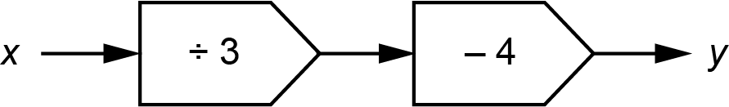

Write an algebraic expression for x in terms of y.

(b) ……..…………….………………. [2]

14 (a) The time taken to paint a wall is inversely proportional to the number of people painting.
It takes 50 minutes for 3 people to paint the wall if nobody stops painting.

Nina, Ling and Charlie start painting the wall.
After 20 minutes Nina stops painting.
She leaves Ling and Charlie to finish painting the wall.

Assume that Nina, Ling and Charlie paint at the same rate.

Work out the total time taken to paint the wall.

(a) ……..…………….………………. minutes [3]

(b) y is inversely proportional to x ².
y = 4 when x = 1.5.

Find the value of y when x = 6.

(b) ……..…………….………………. [3]

15 The region R is shown on this grid.
A is the point (0, 5) and B is the point (5, 7.5).

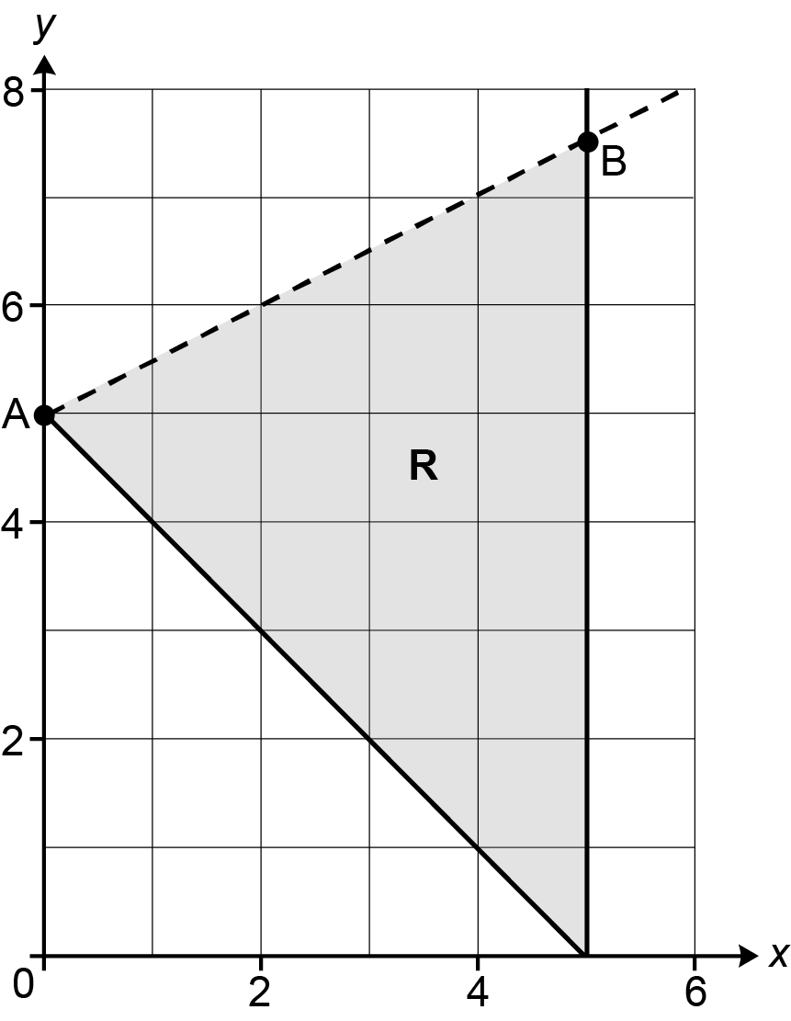

(a) Show that an equation of the straight line through A and B is 2y = x +10. [3]

(b) Write down the three inequalities that define region R.

(b) …………………….………………

…………………….………………

…………………….……………... [5]

16 A plane flies from London to Singapore.
The distance is 10 800 km, correct to the nearest 100 km.
The plane travels at an average speed of 830 km/h, correct to the nearest 10 km/h.

Calculate the shortest possible flight time of the plane.
Give your answer in hours and minutes, correct to the nearest minute.
You must show your working.

…….……….… hours …….……….… minutes [5]

17 Mia weighs many apples.

The weights of the apples are summarised below.

- heaviest apple = 70 g
- range = 40 g
- median = 50 g
- lower quartile = 45 g
- 50% of the apples weigh between 45 g and 60 g
- mean = 53 g

(a) (i) Write down the interquartile range for the weights of the apples.

(a) (i) ……..…………….………………. g [1]

(ii) Write down the percentage of the apples that weigh between 45 g and 50 g.

(ii) ……..…………….………………. % [1]

(b) Draw a box plot to show the distribution of the weights of the apples.

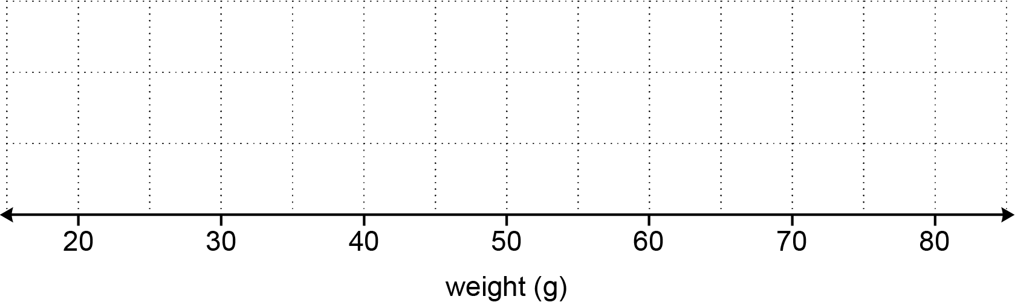
[3]

(c) Mia eats two of the apples.
The apples that they eat weigh 50 g and 58 g.

Mia says

The mean weight of all the apples was 53 g.
I ate one apple that weighed less than the mean and another apple that weighed
more than the mean.
Therefore, the mean of the remaining apples will still be 53 g.

Is Mia correct?
Explain your reasoning.

.…………....………….…….…………….………………………………………………..…………

.....……..…………….….……………….……………………………………………………………

..……....……………….….………….………………………………………………………..…. [2]

18 A circle has equation x² + y² = 100.
The sketch shows the circle and two points, A and B, which lie on the circumference of the circle.

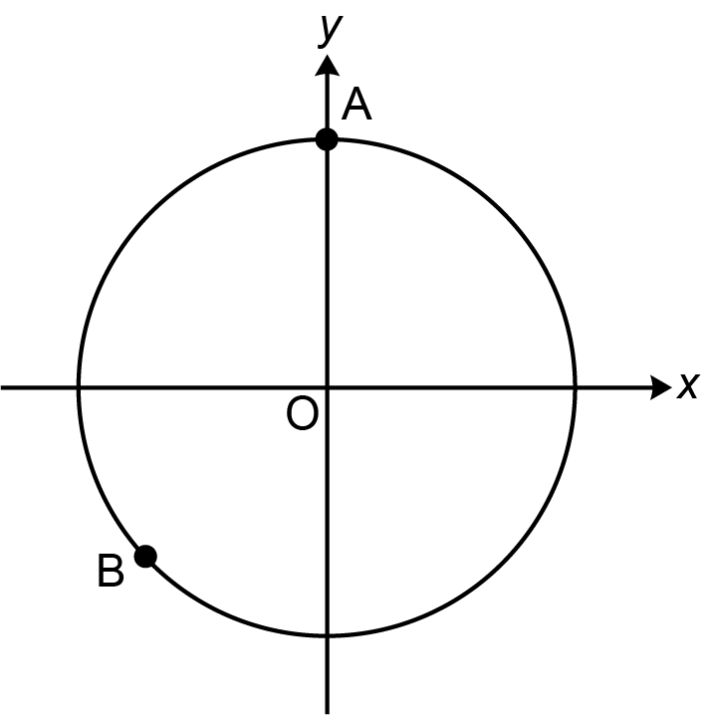

(a) Write down the coordinates of point A.

(a) (……..……….… , ……..……….…) [1]

(b) Point B has x-coordinate −7.

Find the exact value of the y-coordinate of point B.

(b) ……..…………………..………………. [3]

(c) Another point, C, lies on the circle and has an x-coordinate that is three times its
y-coordinate.

Find the two possible pairs of coordinates for point C.
Give your answers in exact form.
You must show your working.

(c) (……..….… , ……..….…) and (……..….… , ……..….…) [5]

19 PQS and QRS are triangles.

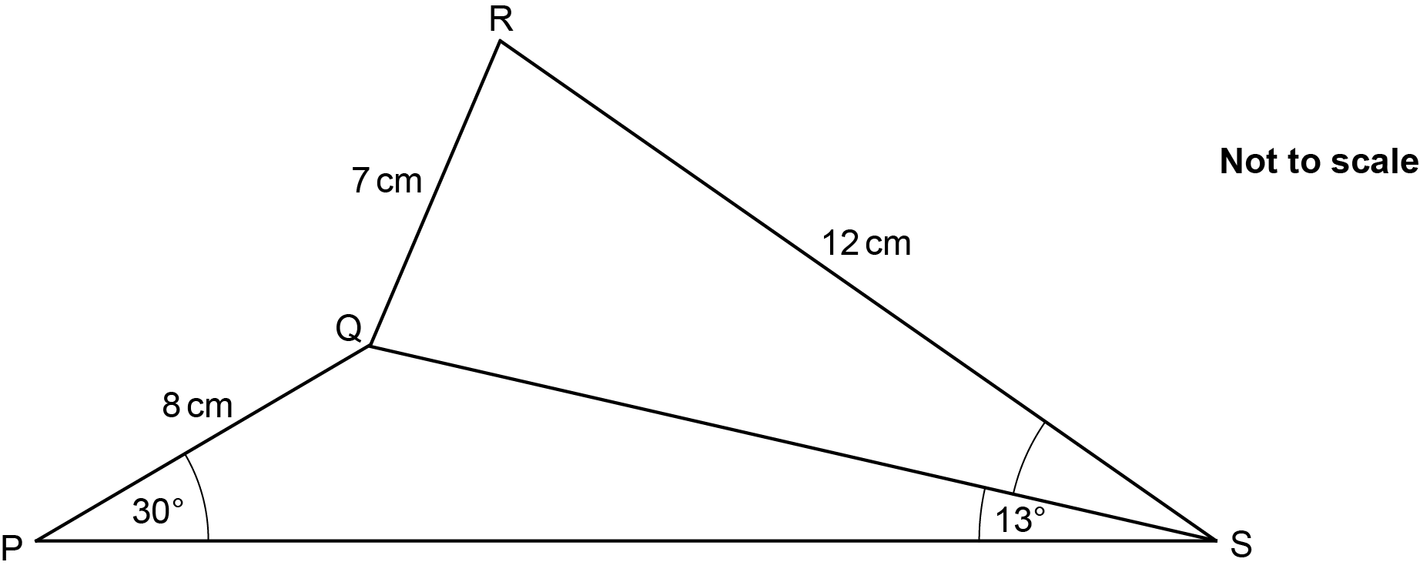

PQ = 8 cm, QR = 7 cm and RS = 12 cm.
Angle QPS = 30° and angle PSQ = 13°.

Calculate angle QSR.
Give your answer correct to 1 decimal place.
You must show your working.

……..…………….………………. ° [6]

20 Write as a single fraction in its simplest form.

……..…………….………………. [4]

END OF QUESTION PAPER

Please note – web links are correct at date of publication but other websites may change over time. If you have any problems with a link you may want to navigate to that organisation’s website for a direct search.



We’d like to know your view on the resources we produce. Click ‘Like’ or ‘Dislike’ to send us an auto generated email about this resource. Add comments if you want to. Let us know how we can improve this resource or what else you need. Your email will not be used or shared for any marketing purposes.
Looking for another resource? There is now a quick and easy search tool to help find free resources for your qualification.
OCR is part of Cambridge University Press & Assessment, which is itself a department of the University of Cambridge.
For staff training purposes and as part of our quality assurance programme your call may be recorded or monitored.
Oxford Cambridge and RSA Examinations is a Company Limited by Guarantee. Registered in England. Registered office
The Triangle Building, Shaftesbury Road, Cambridge, CB2 8EA. Registered company number 3484466. OCR is an exempt charity.
OCR operates academic and vocational qualifications regulated by Ofqual, Qualifications Wales and CCEA as listed
in their qualifications registers including A Levels, GCSEs, Cambridge Technicals and Cambridge Nationals.
OCR provides resources to help you deliver our qualifications. These resources do not represent any teaching method we expect you to use. We update our resources regularly and aim to make sure content is accurate but please check the OCR website so that you have the most up to date version. OCR cannot be held responsible for any errors or omissions in these resources.
Though we make every effort to check our resources, there may be contradictions between published support and the specification, so it is important that you always use information in the latest specification. We indicate any specification changes within the document itself, change the version number and provide a summary of the changes. If you do notice a discrepancy between the specification and a resource, please contact us.
© OCR 2023 - You can copy and distribute this resource freely if you keep the OCR logo and this small print intact and you acknowledge OCR as the originator of the resource.
OCR acknowledges the use of the following content: N/A
Whether you already offer OCR qualifications, are new to OCR or are thinking about switching, you can request more information using our Expression of Interest form.
Please get in touch if you want to discuss the accessibility of resources we offer to support you in delivering our qualifications.

