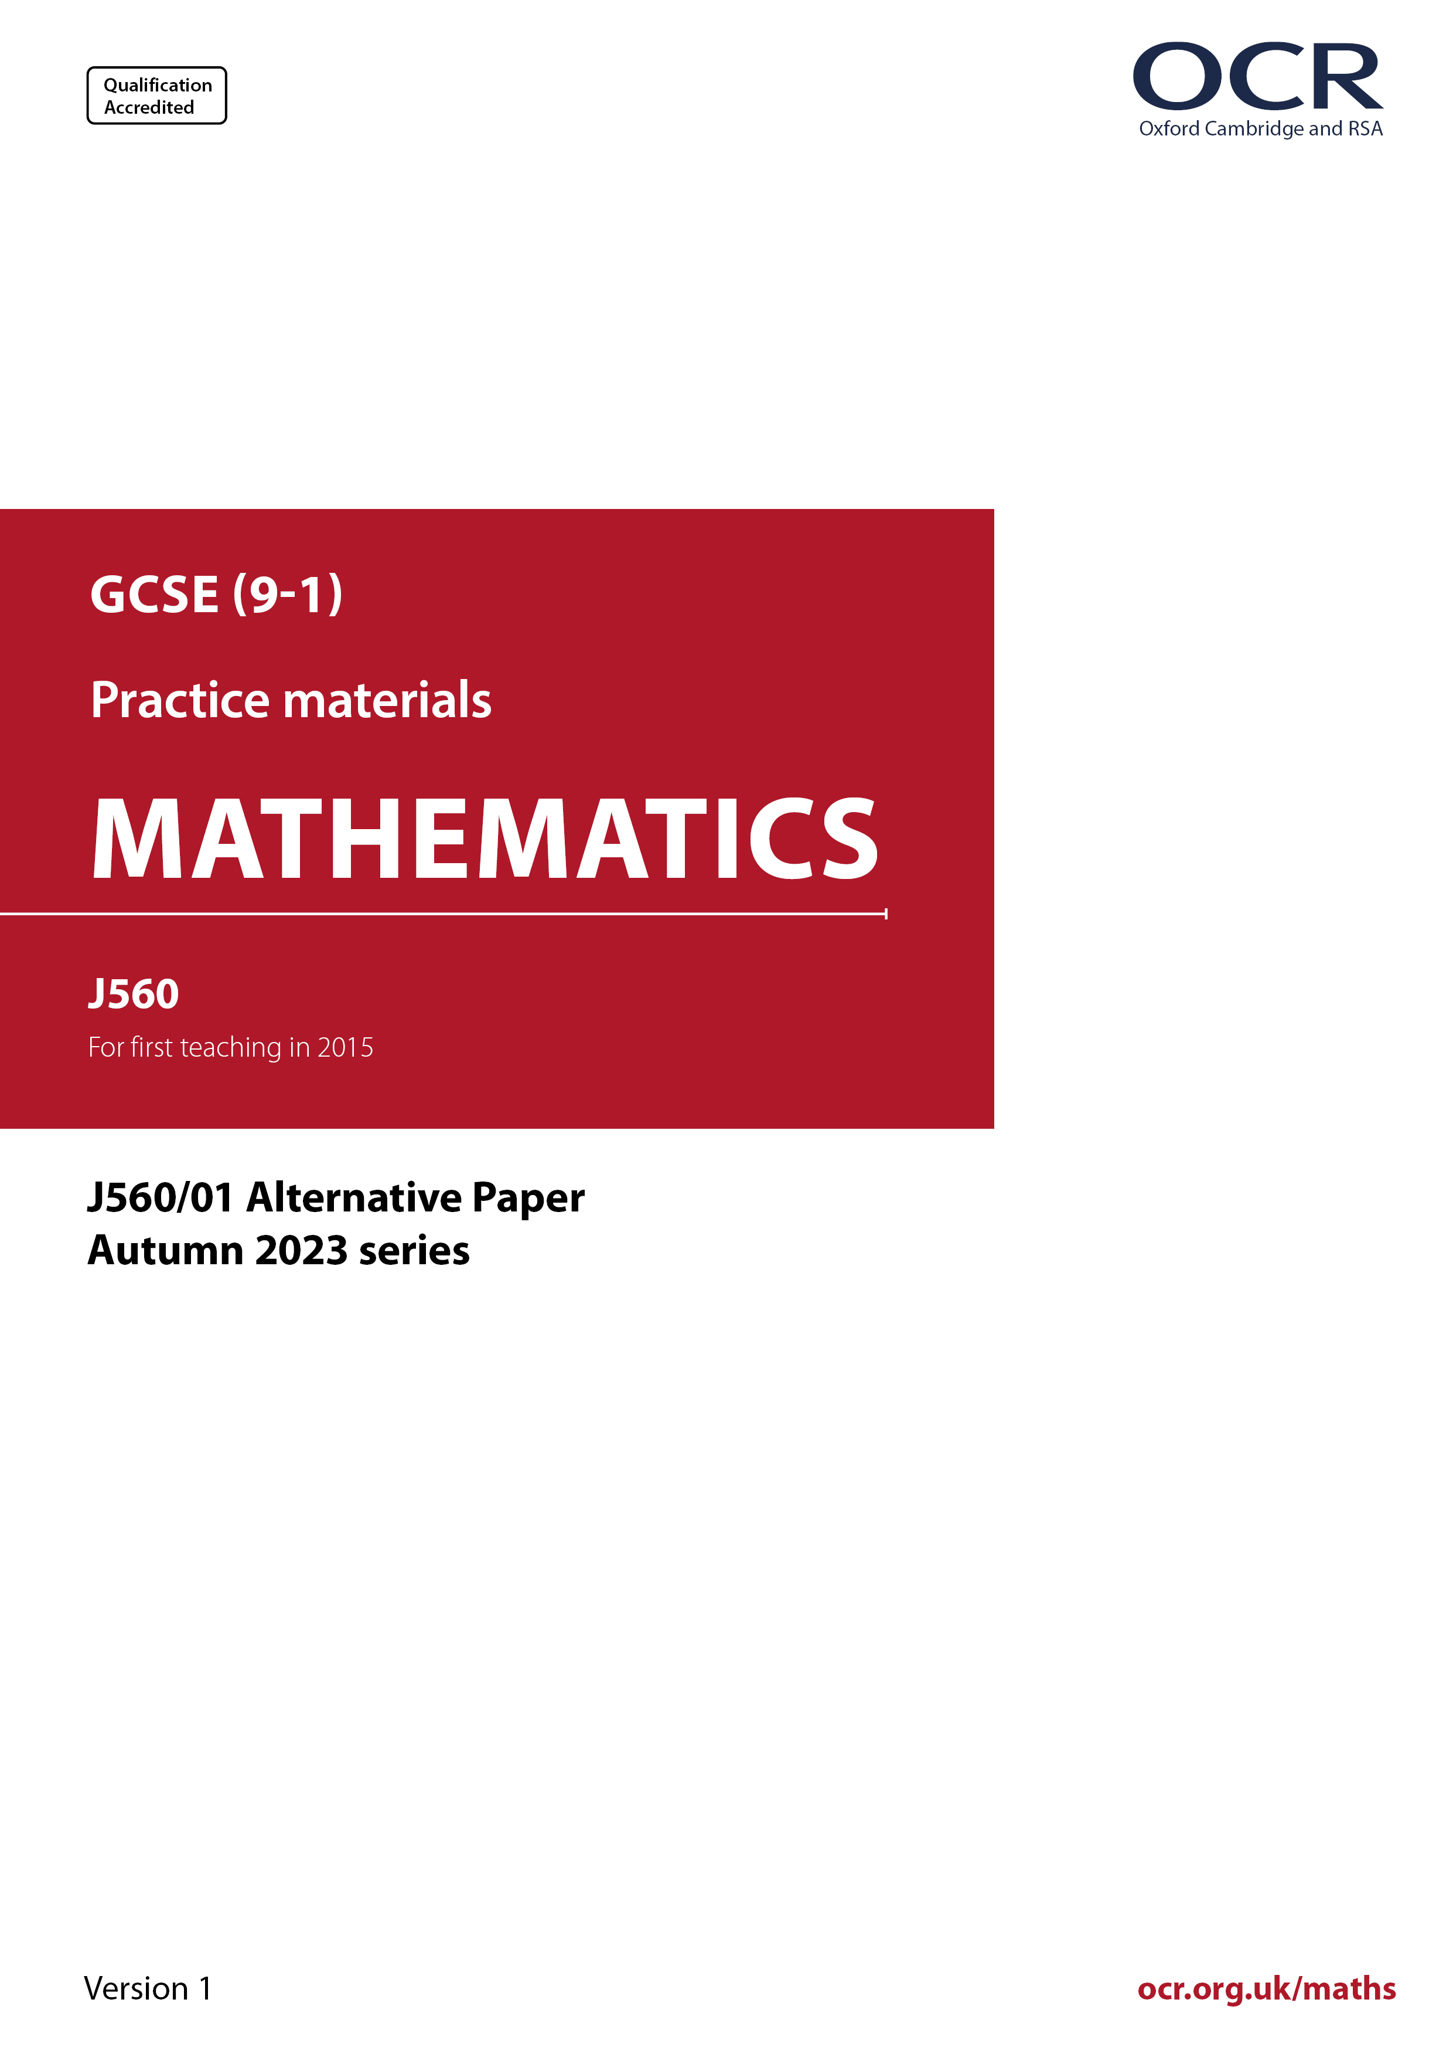
ocr.org.uk/maths
ocr.org.uk/maths
Introduction
OCR’s Alternative Papers for GCSE (9-1) Mathematics are each created by taking one of our past papers and amending the numbers/graphs/diagrams/tables/etc. in its questions.
This Alternative Paper is an amended version of one of the Autumn 2023 series papers. The wording and topics assessed are essentially the same, but the responses students need to make will be different. Using both this paper and the corresponding Autumn 2023 exam paper with your students at different points in the year will allow you to monitor how their learning has progressed in the time between the two papers.
Please note that when students originally sat this paper in 2023, they were given a formulae sheet. Foundation tier and Higher tier formulae sheets are published on Teach Cambridge alongside the Alternative Papers, for use with students as required.
Additional Alternative Papers and past papers are available to download from Teach Cambridge.



GCSE (9-1) Mathematics
J560/01 Paper 1 (Foundation Tier)
Alternative Paper (Autumn 2023)

Time allowed: 1 hour 30 minutes

F

You can use:
- a scientific or graphical calculator
- geometrical instruments
- tracing paper

Name

INSTRUCTIONS
- Use black ink. You can use an HB pencil, but only for graphs and diagrams.
- Write your answer to each question in the space provided. You can use extra paper if you need to, but you must clearly show your candidate number, the centre number and the question numbers
- Answer all the questions.
- Where appropriate, your answer should be supported with working. Marks might be
given for using a correct method, even if your answer is wrong.
- Use the π button on your calculator or take π to be 3.142 unless the question says
something different.

INFORMATION
- The total mark for this paper is 100.
- The marks for each question are shown in brackets [ ].
- This document has 22 pages.

ADVICE
- Read each question carefully before you start your answer.

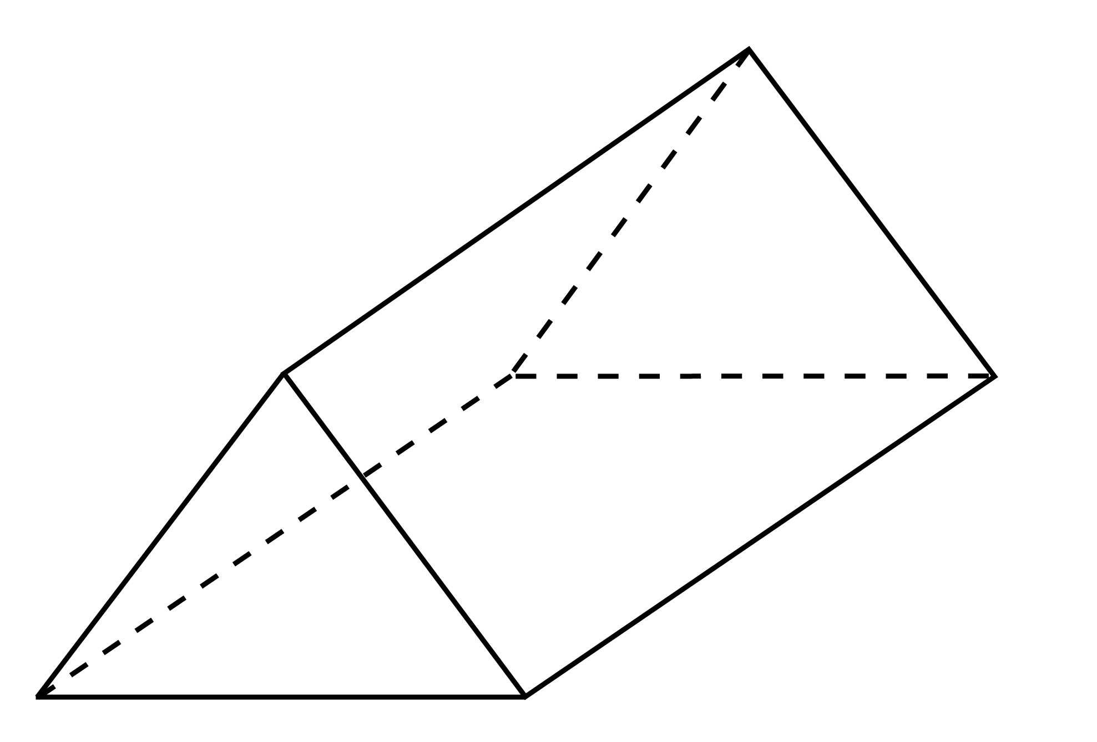
1 (a) Write down the mathematical name of this solid.
Choose from the list of names in the box.
cone cube cuboid cylinder

prism pyramid sphere
(a) ……..…………….………………. [1]

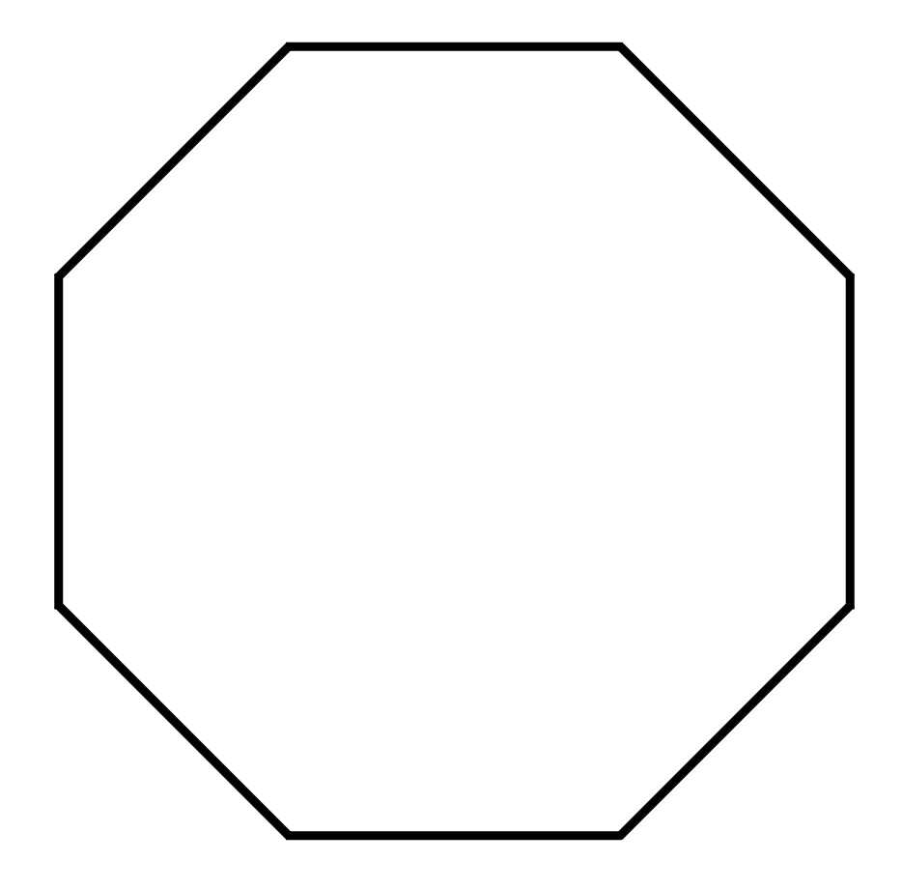
(b) Write down the mathematical name of this polygon.
(b) ……..…………….………………. [1]

(c) On the grid below, sketch a quadrilateral with these properties.

- All angles are equal
and
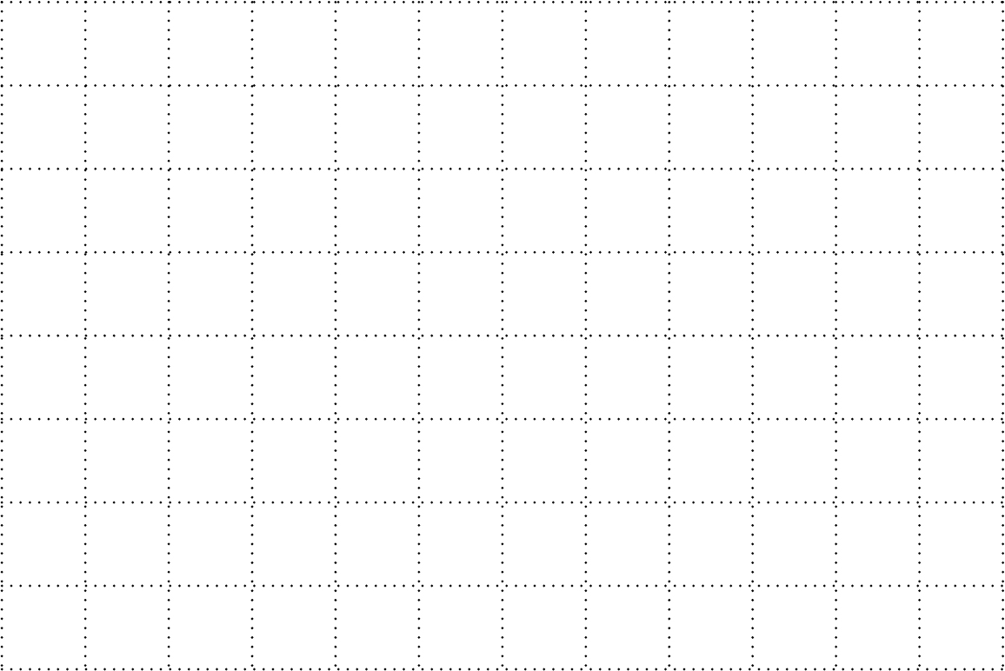
- the diagonals are at right angles to each other.

[1]

2 (a) Round 5749 to the nearest hundred.

(a) ……..…………….………………. [1]

(b) Round £5.4685 to the nearest penny.

(b) £……..…………….………………. [1]

3 (a) What fraction of this shape is shaded?


(a) ……..…………….………………. [1]

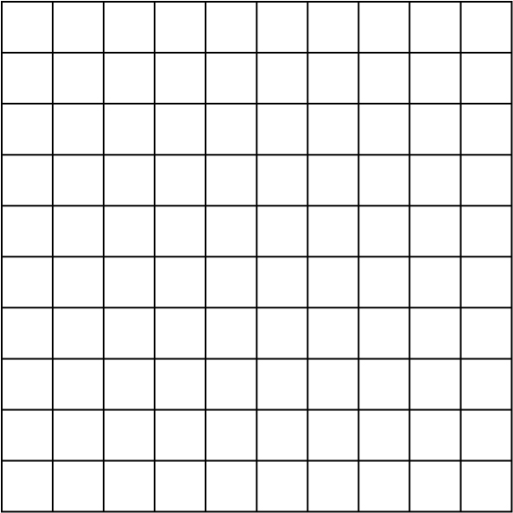
(b) The diagram below is made up of 100 small squares.

Shade 6% of the diagram.
[1]

4 (a) Write down the three factors of 49.

- ……..…….… , ……..…….… , and ……..…….… [2]

(b) Write down a square number between 50 and 90.

(b) ……..…………….………………. [1]

5 Find the number that is halfway between 6.4 and 8.

……..…………….………………. [2]

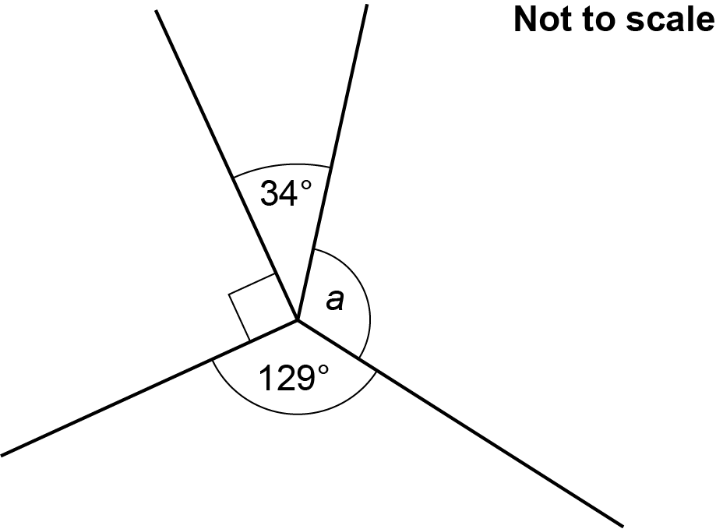
6 Four lines meet at a point.

Work out the size of angle a.

a = ……..…………….……………….° [2]

7 A painter mixes blue paint and red paint in the ratio 3 : 5.
They make a total of 1.6 litres of paint.

Work out how much blue paint they use.
Give your answer in millilitres.

……..…………….………………. ml [3]

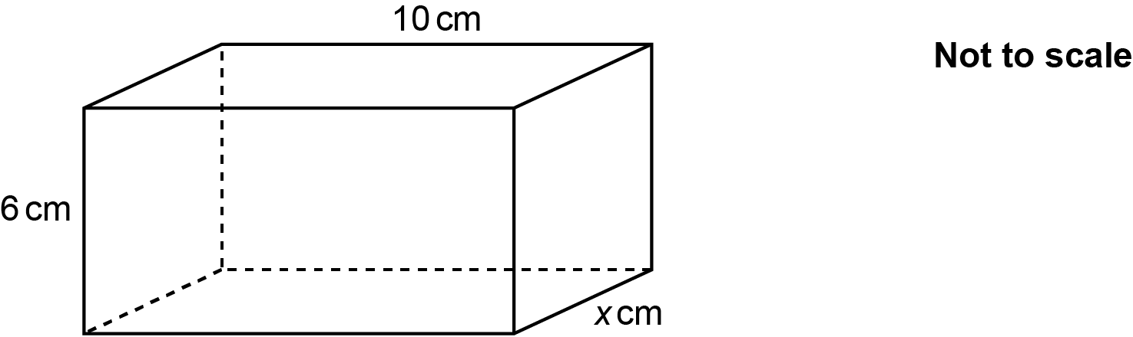
8 The diagram shows a cuboid with dimensions 10 cm, 6 cm and x cm.

The volume of the cuboid is 420 cm³.

Find the value of x.

x = ……..…………….………………. [3]

9 Alex and Emma compete in the same motorcycle race.
Alex completes the race in 5 hours.
Alex’s average speed was 40 miles per hour.
Emma’s average speed was 32 miles per hour.

Calculate how long it took Emma to complete the race.
Give your answer in hours and minutes.

……..…….… hours ……..…….… minutes [4]

10 Heidi and Yoshi use this recipe to make scones.
The recipe shows the ingredients needed to make 20 scones.
Ingredients to make
20 scones

500 g flour
60 g sugar
125 g butter
100 g sultanas
90 ml milk
2 eggs

(a) Heidi makes 30 scones.

She uses a tablespoon to measure the amount of milk she needs.
The size of a tablespoon is 15 ml.

How many tablespoons of milk should Heidi use to make 30 scones?

(a) ……..…………….………………. [3]

(b) Yoshi has 1.2 kg of flour and 250 g of sultanas.
He has lots of all of the other ingredients.

Work out the maximum number of scones that Yoshi can make.
You must show your working.

(b) ……..…………….………………. [4]

11 120 children are asked if they have a scooter (S) or a bicycle (B).

- 53 children only have a scooter.
- 28 children only have a bicycle.
- 23 children have both a scooter and a bicycle.

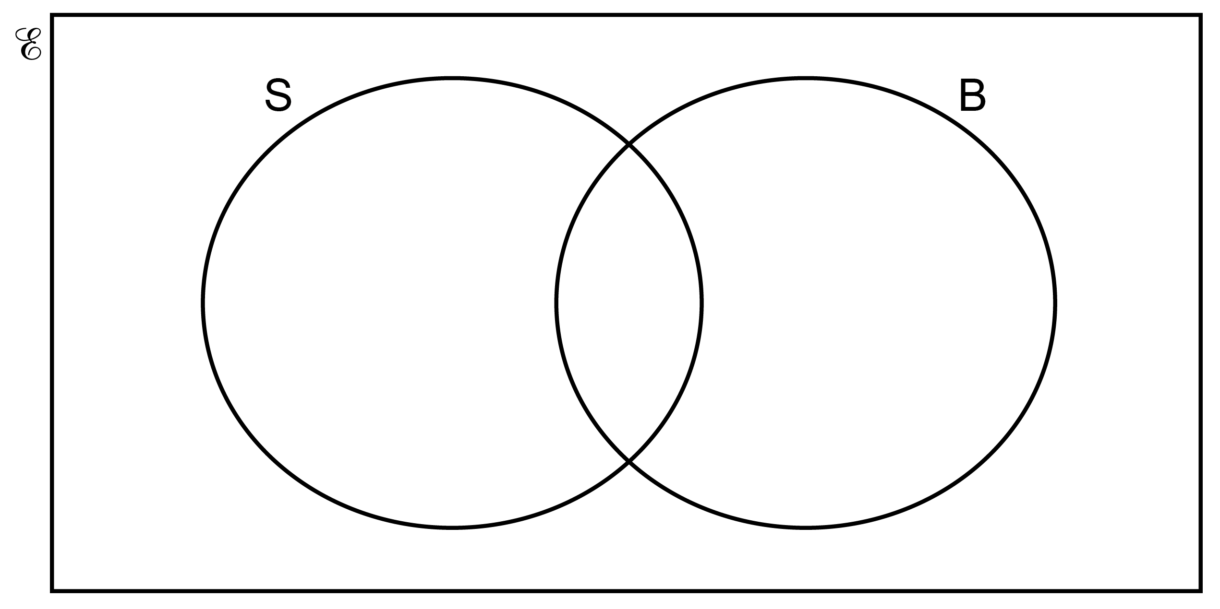
(a) Show this information on the Venn diagram.
[1]

(b) (i) How many children do not have a scooter or a bicycle?

(b) (i) ……..…………….………………. [1]

(ii) Write your answer in the correct place on the Venn diagram. [1]

(c) One of the 120 children is chosen at random.

Work out the probability they have a bicycle.

(c) ……..…………….………………. [2]

12 The costs to hire a campervan are shown below.
Campervan hire

First day £110
Each extra day £80
Each mile travelled 70p

Riley hired a campervan and travelled 480 miles.
The total cost of hiring the campervan was £766.

Calculate how many days Riley hired the campervan for.
You must show your working.

……..…………….………………. days [5]

13 A skater is in a competition.

Here are their scores after two events.
Event Score
1 16 out of 26 points
2 28 out of 40 points
3 out of 54 points

Event 3 is out of 54 points.

The skater’s overall score is found by adding the three scores together.

Find the score the skater needs in event 3 to achieve 65% of the total points.

……..…………….………………. [4]

14 For each graph below, select its possible equation from this list.

A B C

D E F

Write the letter of the equation beneath each graph.
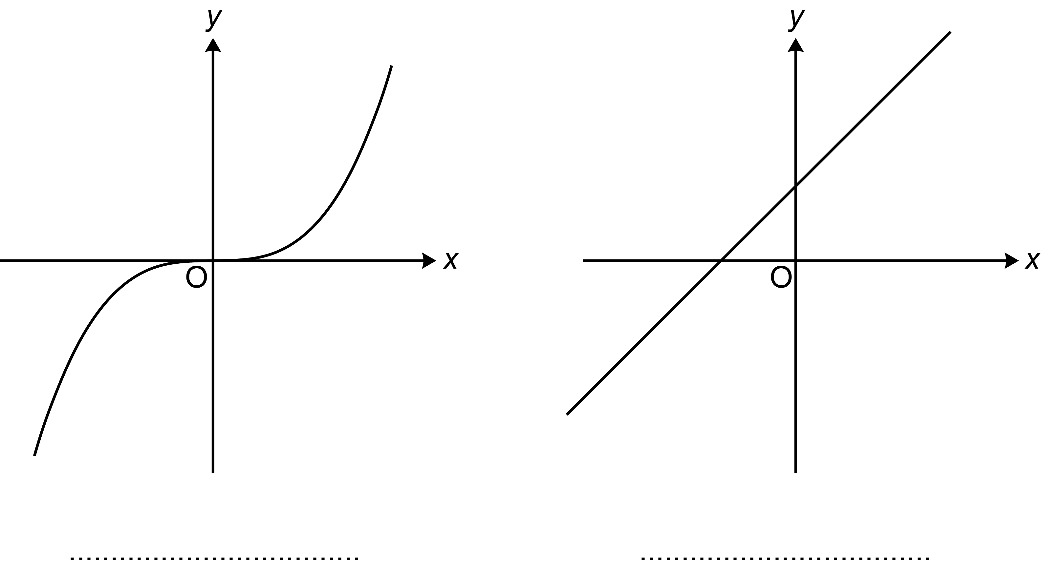

[2]

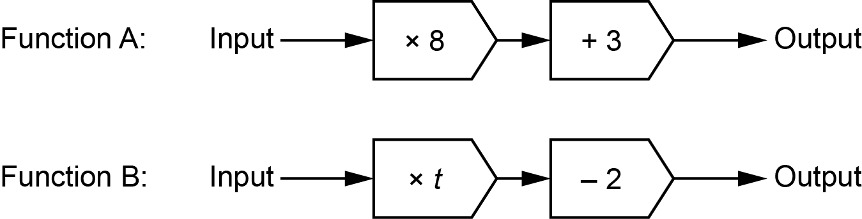
15 Here are two functions.

When the input of each function is 5, the output of Function A is equal to the output of Function B.

Work out the value of t in Function B.

t = ……..…………….………………. [4]

16 (a) Multiply out.

(a) [2]

(b) Solve.

(b) [2]

(c) Solve by factorising.

x² + 9x + 20 = 0

(c) x = ................... or x = [3]

17 A prime number is a whole number that has exactly two factors.

(a) Explain why 1 is not a prime number.

…..

…… [1]

(b) h and k are prime numbers.

Write down the 6 factors of

(b) ................ ................ ................ ................ ................ ................ [2]

18 (a) The table shows the results for a hockey club’s ‘A’ team.

Result | Frequency
Win | 28
Draw | 15
Lose | 17
Total | 60

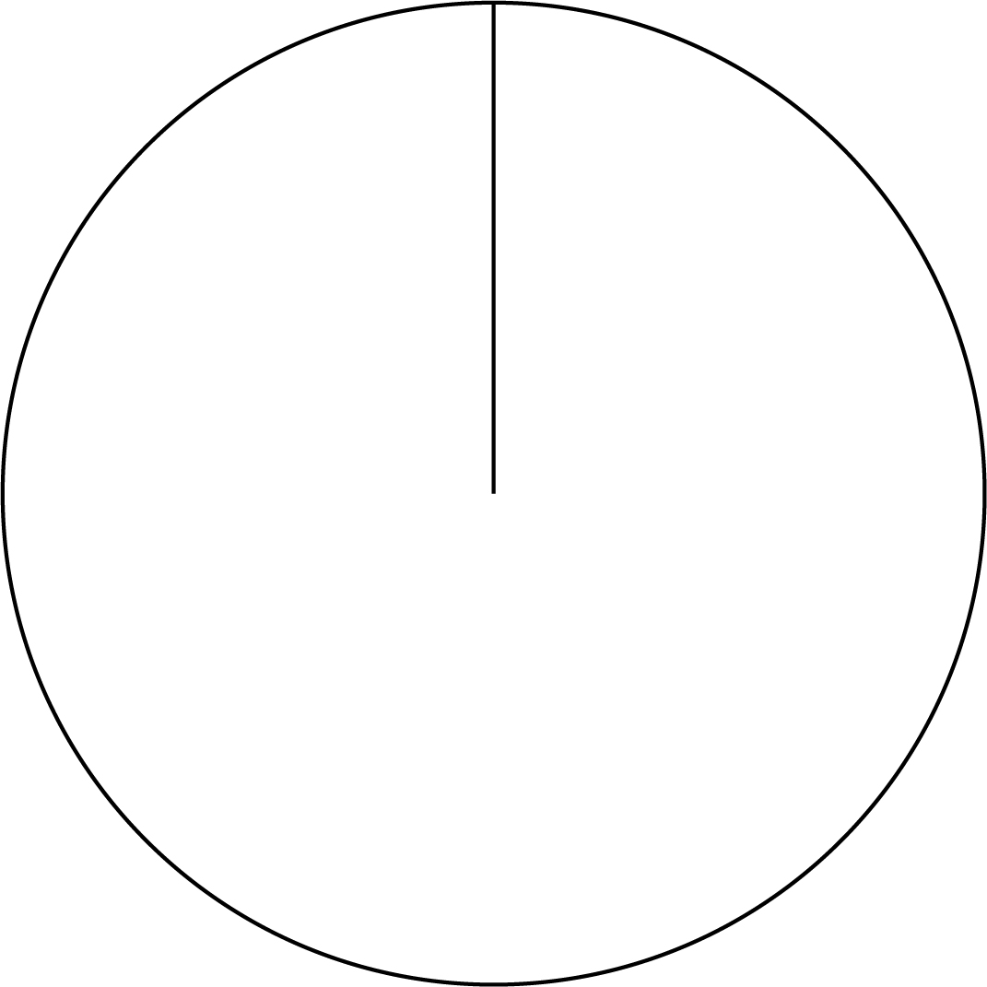
Complete a labelled pie chart to show these results.

[4]

(b) Here are the results for the hockey club’s ‘B’ team and ‘C’ team.
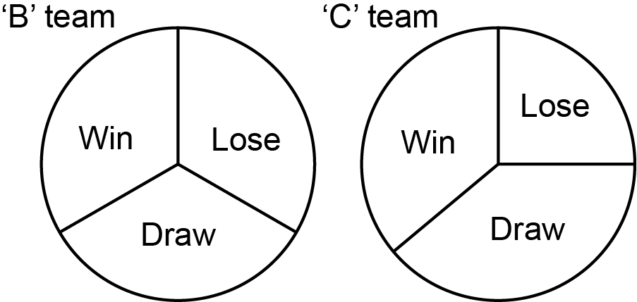

The ‘C’ team manager says

The pie charts show that the ‘C’ team lost less games than the ‘B’ team.

Referring to the pie charts, explain why the ‘C’ team manager may not be correct.

[1]

19 The graph shows Sam’s journey from home to a waterpark.
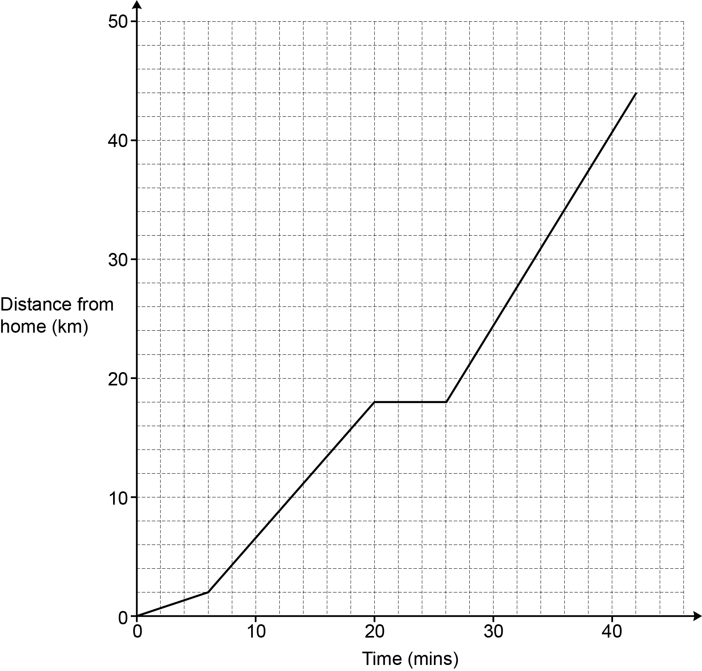
During the journey Sam stops for petrol.

(a) For how long did Sam stop for petrol?

(a) mins [1]

(b) Sam drives the same route back home from the waterpark at an average speed of
40 km/h.
Sam leaves the waterpark at 18:00.

Work out the time when Sam arrives home.

(b) [4]

20 (a) Write an expression for the weight, in kilograms, of an object weighing x grams.

(a) kg [1]

(b) Write an expression for the area, in cm², of a playground of area y m².

(b) cm² [1]

21 (a) A student is using trigonometry to work out an angle, B, in a right-angled triangle.
They tell the teacher that cos .

Explain why this student must be wrong.

[1]

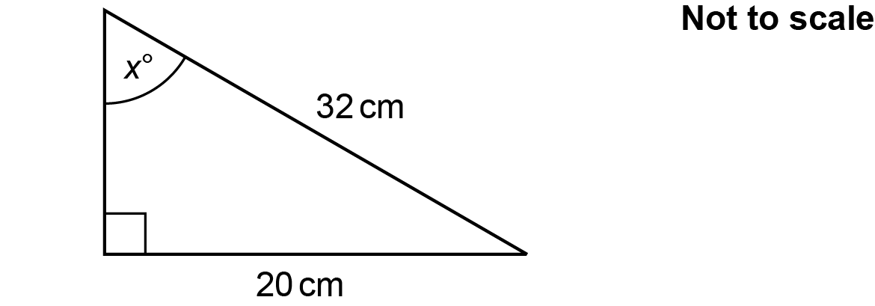
(b) Here is a right-angled triangle.

Work out the value of x.

x = [3]

22 On a bus route there is a set of traffic lights and a level crossing.
The probability that the bus stops at the traffic lights is 0.6.
The probability that the bus stops at the level crossing is 0.3.

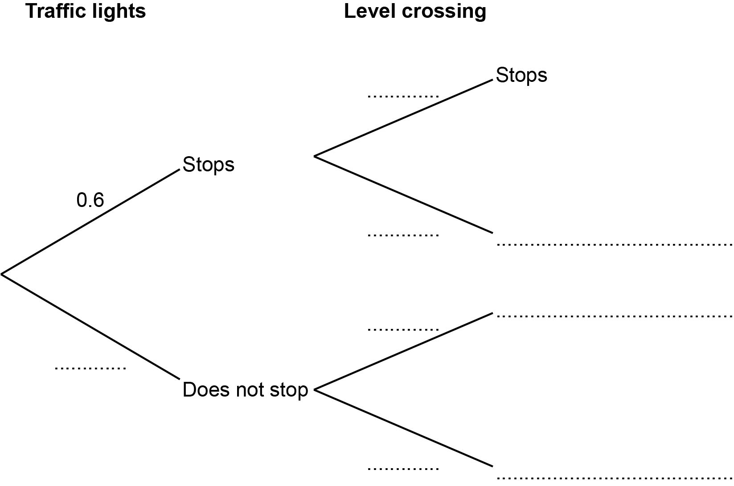
(a) Use the information to complete the tree diagram.

[3]

(b) Find the probability that the bus stops at either the traffic lights or at the level crossing but not both.

(b) [3]

23 (a) The measurements, in centimetres, of two triangles are shown in the table.

 | Side 1 | Side 2 | Side 3
Triangle 1 | 4 | 5.8 | 7.5
Triangle 2 | 8.8 | 12.76 | 16.5

Are the two triangles mathematically similar?
Show how you decide.

……………… because …………………………………………………………………………

…...…………………………………………………………………………………………… [3]

(b) Are these two triangles definitely congruent?
Give a reason.
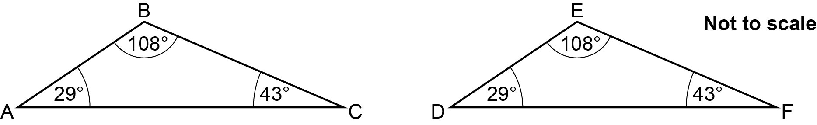

……………… because …………………………………………………………………………

…...…………………………………………………………………………………………… [1]

24 3 kg of apples and 4 kg of bananas cost £8.25.
2 kg of apples and 3 kg of bananas cost £5.78.

Find the cost of 1 kg of apples and the cost of 1 kg of bananas.
You must show your working.

1 kg of apples cost £ ......................

1 kg of bananas cost £ ......................
[5]

25 Finley and Taylor are conducting surveys.
They are both given the same list of 10 257 people from which to select their sample.

Finley selects every 28th person.
Taylor selects every 32nd person.
They both start counting from the first name in the list.

Work out how many people will be selected to be in both surveys.
You must show your working.

[5]

26 XOY is a sector of a circle, centre O.
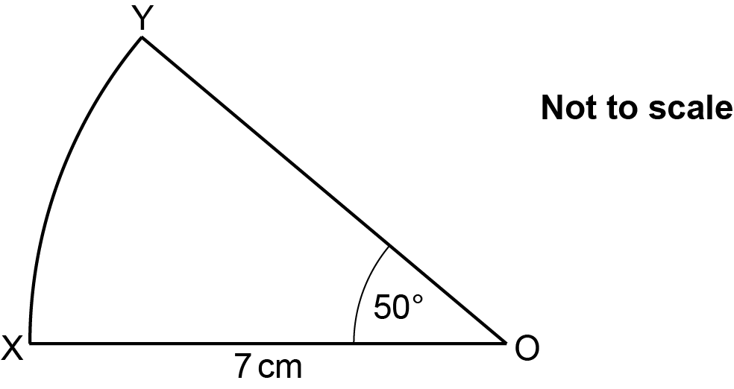

Show that the area of the sector is 21.4 cm², correct to 3 significant figures. [3]

END OF QUESTION PAPER

Please note – web links are correct at date of publication but other websites may change over time. If you have any problems with a link you may want to navigate to that organisation’s website for a direct search.



We’d like to know your view on the resources we produce. Click ‘Like’ or ‘Dislike’ to send us an auto generated email about this resource. Add comments if you want to. Let us know how we can improve this resource or what else you need. Your email will not be used or shared for any marketing purposes.
Looking for another resource? There is now a quick and easy search tool to help find free resources for your qualification.
OCR is part of Cambridge University Press & Assessment, which is itself a department of the University of Cambridge.
For staff training purposes and as part of our quality assurance programme your call may be recorded or monitored. © OCR 2024 Oxford Cambridge and RSA Examinations is a Company Limited by Guarantee. Registered in England. Registered office The Triangle Building, Shaftesbury Road, Cambridge, CB2 8EA. Registered company number 3484466. OCR is an exempt charity.
OCR operates academic and vocational qualifications regulated by Ofqual, Qualifications Wales and CCEA as listed in their qualifications registers including A Levels, GCSEs, Cambridge Technicals and Cambridge Nationals.
OCR provides resources to help you deliver our qualifications. These resources do not represent any teaching method we expect you to use. We update our resources regularly and aim to make sure content is accurate but please check the OCR website so that you have the most up to date version. OCR cannot be held responsible for any errors or omissions in these resources.
Though we make every effort to check our resources, there may be contradictions between published support and the specification, so it is important that you always use information in the latest specification. We indicate any specification changes within the document itself, change the version number and provide a summary of the changes. If you do notice a discrepancy between the specification and a resource, please contact us.
You can copy and distribute this resource in your centre, in line with any specific restrictions detailed in the resource. Resources intended for teacher use should not be shared with students. Resources should not be published on social media platforms or other websites.
OCR acknowledges the use of the following content: N/A
Whether you already offer OCR qualifications, are new to OCR or are thinking about switching, you can request more information using our Expression of Interest form.
Please get in touch if you want to discuss the accessibility of resources we offer to support you in delivering our qualifications.

