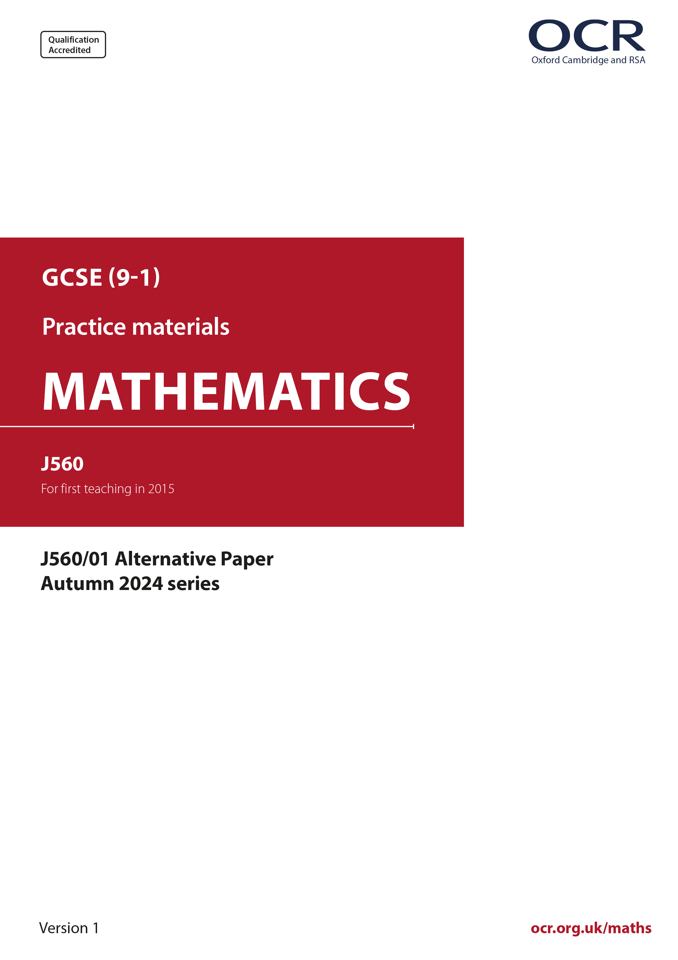
ocr.org.uk/maths

Introduction
OCR’s Alternative Papers for GCSE (9-1) Mathematics are each created by taking one of our past papers and amending the numbers/graphs/diagrams/tables/etc. in its questions.
This Alternative Paper is an amended version of one of the November 2024 series papers. The wording and topics assessed are essentially the same, but the responses students need to make will be different. Using both this paper and the corresponding November 2024 exam paper with your students at different points in the year will allow you to monitor how their learning has progressed in the time between the two papers.
Please note that when students originally sat this paper in 2024, they were given a formulae sheet. Foundation tier and Higher tier formulae sheets are published on Teach Cambridge alongside the Alternative Papers, for use with students as required.
Additional Alternative Papers and past papers are available to download from Teach Cambridge.



GCSE (9-1) Mathematics
J560/01 Paper 1 (Foundation Tier)
Alternative Paper (November 2024)

Time allowed: 1 hour 30 minutes

F
You must have:
- the Formulae Sheet for Foundation Tier (inside this document)

You can use:
- a scientific or graphical calculator
- geometrical instruments
- tracing paper

Name

INSTRUCTIONS
- Use black ink. You can use an HB pencil, but only for graphs and diagrams.
- Write your answer to each question in the space provided. You can use extra paper if you need to, but you must clearly show your candidate number, the centre number and the question numbers
- Answer all the questions.
- Where appropriate, your answer should be supported with working. Marks might be
given for using a correct method, even if your answer is wrong.
- Use the π button on your calculator or take π to be 3.142 unless the question says
something different.

INFORMATION
- The total mark for this paper is 100.
- The marks for each question are shown in brackets [ ].
- This document has 19 pages.

ADVICE
- Read each question carefully before you start your answer.

- 200 students at a school were asked how they travel to school.

The pictogram shows the results for four of the ways they travel to school.

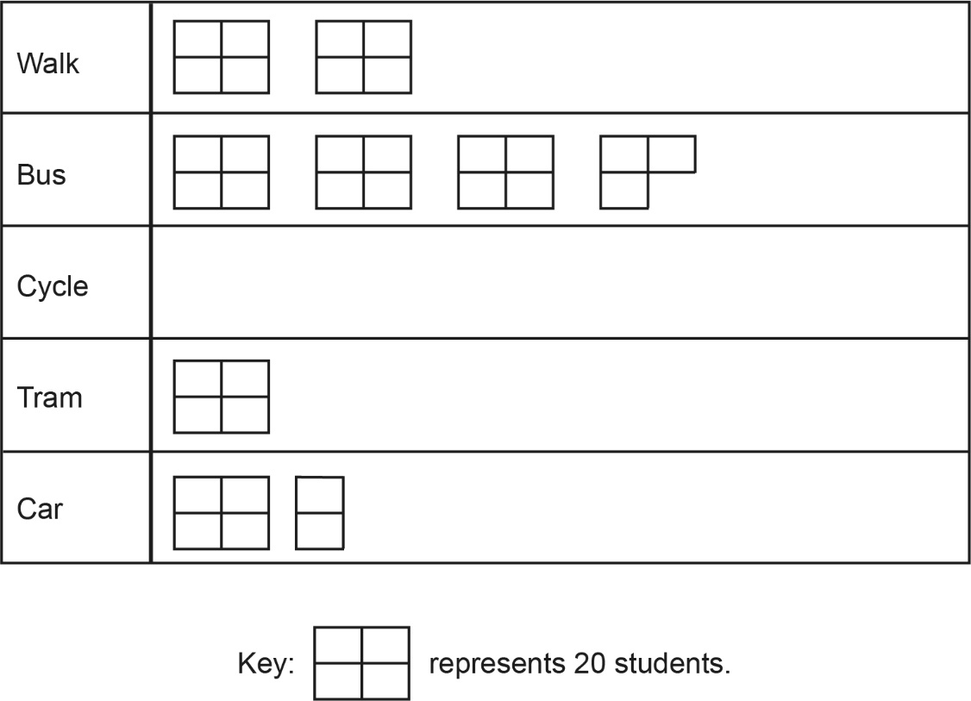

- How many students take the tram to school?
(a) .......................................................... [1]

- How many more students walk to school than travel by car to school?
(b) .......................................................... [2]

- The rest of the 200 students cycle to school.

Complete the pictogram to show the number of students who cycle to school. [3]
- The total number of students at the school is 1000.

What fraction of the students at the school were asked how they travel to school?
Give your answer in its simplest form.
(d) .......................................................... [2]

- (a) (i) Write down an even number.
(a)(i) .......................................................... [1]

- Write down a common multiple of 7 and 12.
(ii) .......................................................... [1]

- Write 12 : 30 as a ratio in its simplest form.
(b) .......................................................... [2]

- Complete this table of fractions, decimals and percentages.

Fraction |  | Decimal |  | Percentage
 | = | 0.4 | =
 | = | 0.06 | = | 6%
 | = | 1.35 | =
[3]

- Write the following numbers in order of size, smallest first.

0.728 0.74 0.7052 0.742
..................... , ..................... , ................... , ..................... [2]
smallest
- (a) The diagram shows a triangle, ABC.
The angle at A is 40°.

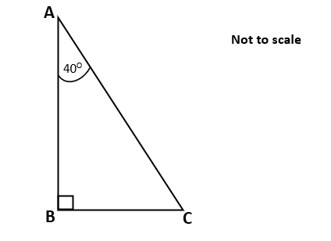

- What does the symbol at angle B mean?
Choose from this list.

An acute The biggest An obtuse A reflex A right
angle angle angle angle angle
(a)(i) .......................................................... [1]

- Work out the angle at C.
Give a geometrical reason for your answer.
The angle at C is ............................. ° because ......................................................

............................................................................................................................ [2]

- A student works out the size of angle x in this diagram.

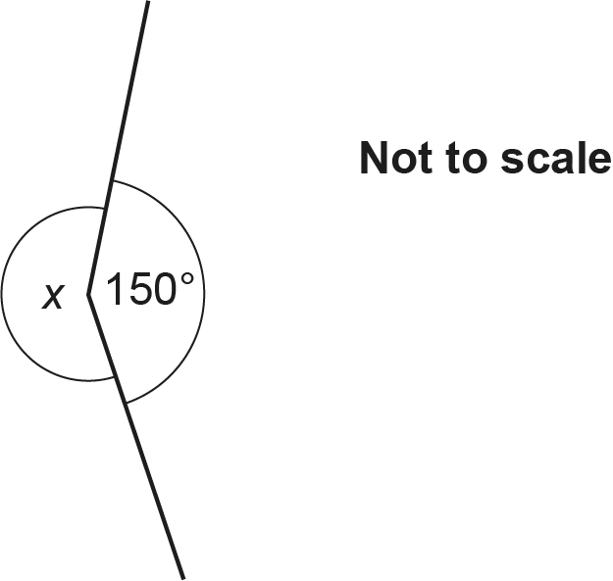
The student says the angle is 250°.

Explain why the student’s answer cannot be correct.

..................................................................................................................................... [1]

- The circumference of a circle is 21 cm.

Calculate the diameter of the circle.
Give your answer correct to 1 decimal place.
.......................................................... cm [3]

- Sketch the graph of x = 7 on the axes below.
Show clearly the value of any intercepts.

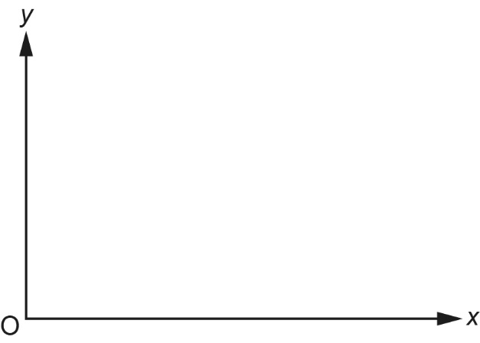
[2]

- (a) Insert two of these symbols +, −, $\text{×}$ or ÷ to make this calculation correct.

6.....(3.....1) = 12 [1]

- Calculate

Give your answer correct to 3 significant figures.
.......................................................... [3]

- Here is a list of five numbers.

10 3 28 44 11

- Find the range.
(a) .......................................................... [2]

- A sixth number is added to the list.
The mean of the six numbers is 17.5.

Work out the sixth number.
(b) .......................................................... [3]

- Simplify.

5j + 2k – 9j + 7k
.......................................................... [2]

- A recipe for cookies uses only butter, flour and sugar in the ratio 2 : 3 : 2.
Using this recipe, 180 g of sugar is needed to make 10 cookies.

Using this recipe, work out how much flour is needed to make 35 cookies.
.......................................................... g [3]

- The deposit for a holiday is of the total cost.

A customer pays a deposit of £548.

Calculate the total cost of the holiday.
£ .......................................................... [3]

- Amari drives from home to a shopping centre.
The graph shows information about the journey and the time spent at the shopping centre.

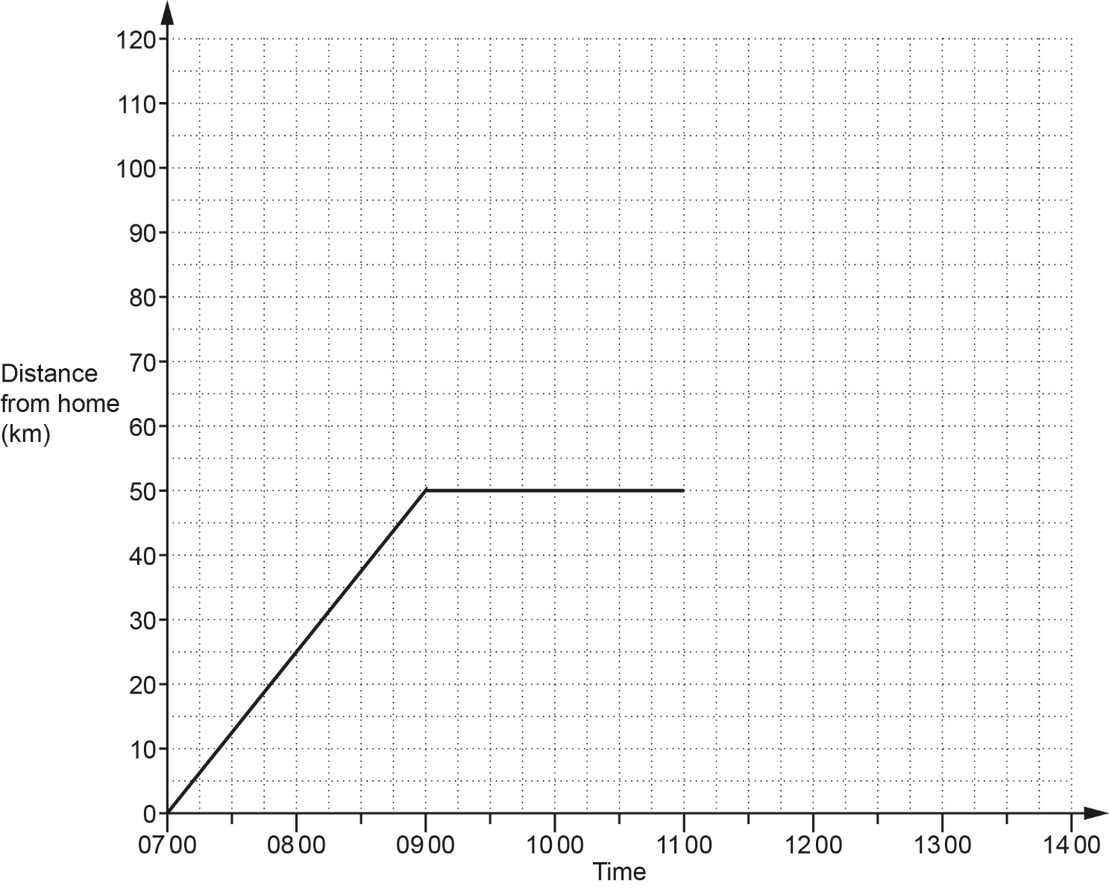

- State an assumption that has been made when the graph was drawn.

...........................................................................................................................................

..................................................................................................................................... [1]

- Write down the distance from Amari’s home to the shopping centre.
(b) .......................................................... km [1]

- Calculate Amari’s average speed, in km/h, from home to the shopping centre.
(c) .......................................................... km/h [2]

- Amari leaves the shopping centre at 11 00.
Amari drives home without stopping.
The journey home takes 1 hours.

Complete the graph to show this information. [2]

- Six adults and two children go to a theme park.
The cost of an adult ticket is £13 more than the cost of a child ticket.
The total cost of the eight tickets is £118.

Work out the cost of an adult ticket.
You must show your working.
£ .......................................................... [5]

- The cost of sending a child to nursery is £4.40 per hour on each weekday.
On Saturday the cost is 1 times the weekday hourly rate.

A child goes to nursery for:

- 8 hours on Wednesday
- 4 hours on Thursday
- 3 hours on Saturday.

The total cost for the three days is reduced by 10% as a special offer.

Work out the cost for the three days after the 10% reduction.
You must show your working.
£ .......................................................... [6]

- Hugo pays £38.88 for 27 litres of diesel.
Jane puts 80 litres of the same diesel into her car.
Jane has £115 with which to pay for her diesel.

Does Jane have enough money to pay for her diesel?
Show how you decide.
.............................. because ......................................................................................................

.............................................................................................................................................. [4]

- Factorise fully.

- 10x² + 15x
(a) .......................................................... [2]

- x² + 9x + 18
(b) .......................................................... [2]

- (a) N is a number such that:

- N = 2 × 3 × 5 × k, where k is a prime number
- N is greater than 200.

Find the smallest possible value of N.
(a) N = .......................................................... [3]

- a and b are different prime numbers.

Explain why a × b is not a prime number.

...........................................................................................................................................

..................................................................................................................................... [1]

- Each week the manager of a petrol station records the average daily sales, in litres, and the average price, in pounds, of a litre of petrol for that week.

The table shows their results for ten weeks.

Week | 1 | 2 | 3 | 4 | 5 | 6 | 7 | 8 | 9 | 10
Price per litre (£) | 1.42 | 1.45 | 1.47 | 1.50 | 1.54 | 1.60 | 1.57 | 1.52 | 1.61 | 1.49
Litres sold per day | 740 | 725 | 620 | 705 | 685 | 660 | 675 | 695 | 655 | 710

The results for the first nine weeks are plotted on the scatter diagram.

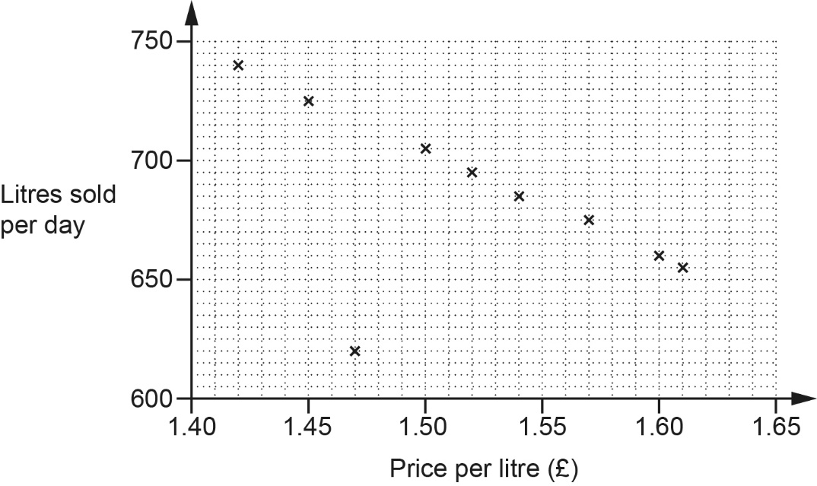

- Plot the result for week 10. [1]

- Describe the type of correlation shown in the scatter diagram.

(b) .......................................................... [1]

- In one week, there was a delay with petrol deliveries.

Circle the most likely point on the scatter diagram for that week. [1]

- (i) On the scatter diagram, draw a line of best fit. [1]

- Use the line of best fit to estimate the average daily sales when the price per litre of petrol is £1.56
(d)(ii) .......................................................... litres [1]

- The manager says,

As the sales go down, the total amount of money we take stays roughly the same.

Find evidence to support this statement.

...........................................................................................................................................

..................................................................................................................................... [3]

- The diagram shows an equilateral triangular prism.
Each side of the equilateral triangle is 4 cm and the length of the prism is 8 cm.

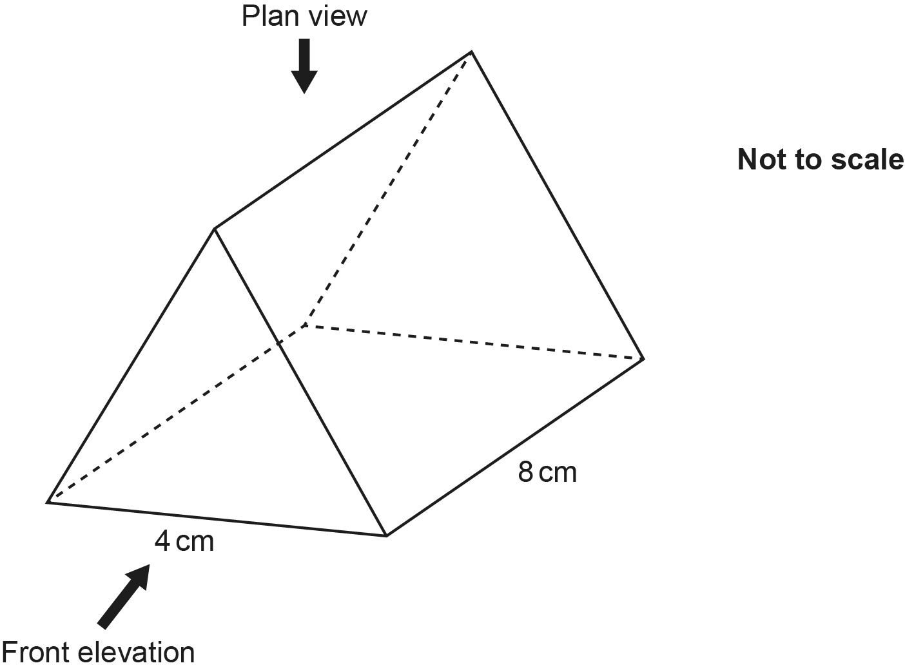
- Draw an accurate plan view of the prism on the one-centimetre square grid below.


[3]

- Draw an accurate front elevation of the prism on the one-centimetre isometric
grid below.


[2]

- At the start of 2020, the value of a particular house was £125 000.
The value of the house then decreased by 8% each year.

Calculate the total loss in value of the house at the end of 3 years.
£ .......................................................... [4]

- The width, w, of a car parking space is 3.2 metres, correct to 1 decimal place.

Complete the error interval for the width, w.
.......................... ⩽ w < .......................... [2]

- Force is measured in newtons (N).
A force of 180 N is applied to a surface of area 8 cm².

Work out the pressure, in N/cm², applied to this surface.
.......................................................... N/cm² [2]

- The diagram shows a rectangular garden ABCD.
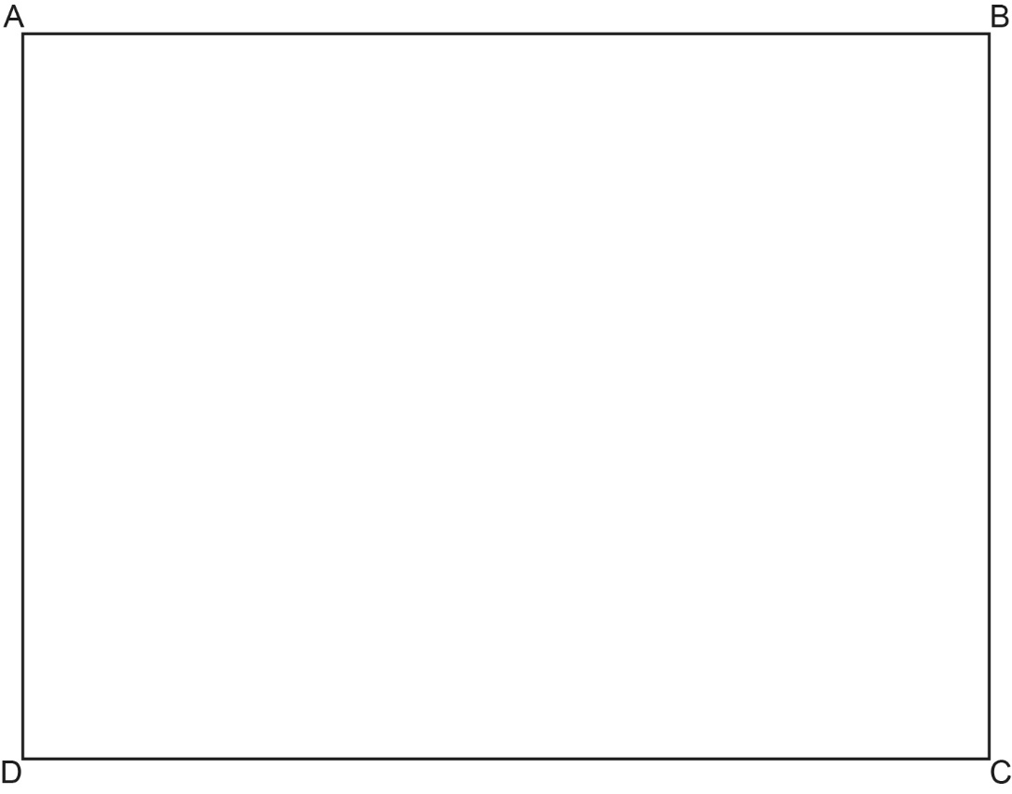
The region of the garden that is closer to BC than BA is to be made into a patio.

Construct and shade the region for the patio.
Show all your construction lines. [3]

- Triangles ABC and PQR are mathematically similar.
Angle ACB = Angle PRQ.
Angle ABC = Angle PQR.

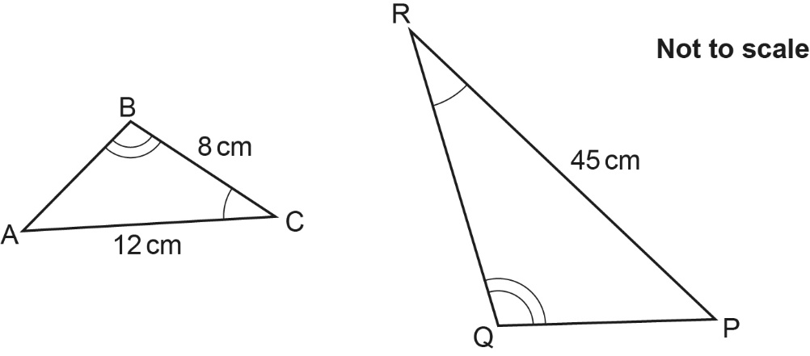

The perimeter of triangle PQR is 104 cm.

Find the length of PQ.
PQ = .......................................................... cm [4]
END OF QUESTION PAPER

Please note – web links are correct at date of publication but other websites may change over time. If you have any problems with a link you may want to navigate to that organisation’s website for a direct search.



We’d like to know your view on the resources we produce. Click ‘Like’ or ‘Dislike’ to send us an auto generated email about this resource. Add comments if you want to. Let us know how we can improve this resource or what else you need. Your email will not be used or shared for any marketing purposes.
Looking for another resource? There is now a quick and easy search tool to help find free resources for your qualification.
OCR is part of Cambridge University Press & Assessment, which is itself a department of the University of Cambridge.
For staff training purposes and as part of our quality assurance programme your call may be recorded or monitored. © OCR 2024 Oxford Cambridge and RSA Examinations is a Company Limited by Guarantee. Registered in England. Registered office The Triangle Building, Shaftesbury Road, Cambridge, CB2 8EA. Registered company number 3484466. OCR is an exempt charity.
OCR operates academic and vocational qualifications regulated by Ofqual, Qualifications Wales and CCEA as listed in their qualifications registers including A Levels, GCSEs, Cambridge Technicals and Cambridge Nationals.
OCR provides resources to help you deliver our qualifications. These resources do not represent any teaching method we expect you to use. We update our resources regularly and aim to make sure content is accurate but please check the OCR website so that you have the most up to date version. OCR cannot be held responsible for any errors or omissions in these resources.
Though we make every effort to check our resources, there may be contradictions between published support and the specification, so it is important that you always use information in the latest specification. We indicate any specification changes within the document itself, change the version number and provide a summary of the changes. If you do notice a discrepancy between the specification and a resource, please contact us.
You can copy and distribute this resource in your centre, in line with any specific restrictions detailed in the resource. Resources intended for teacher use should not be shared with students. Resources should not be published on social media platforms or other websites.
OCR acknowledges the use of the following content: N/A
Whether you already offer OCR qualifications, are new to OCR or are thinking about switching, you can request more information using our Expression of Interest form.
Please get in touch if you want to discuss the accessibility of resources we offer to support you in delivering our qualifications.

