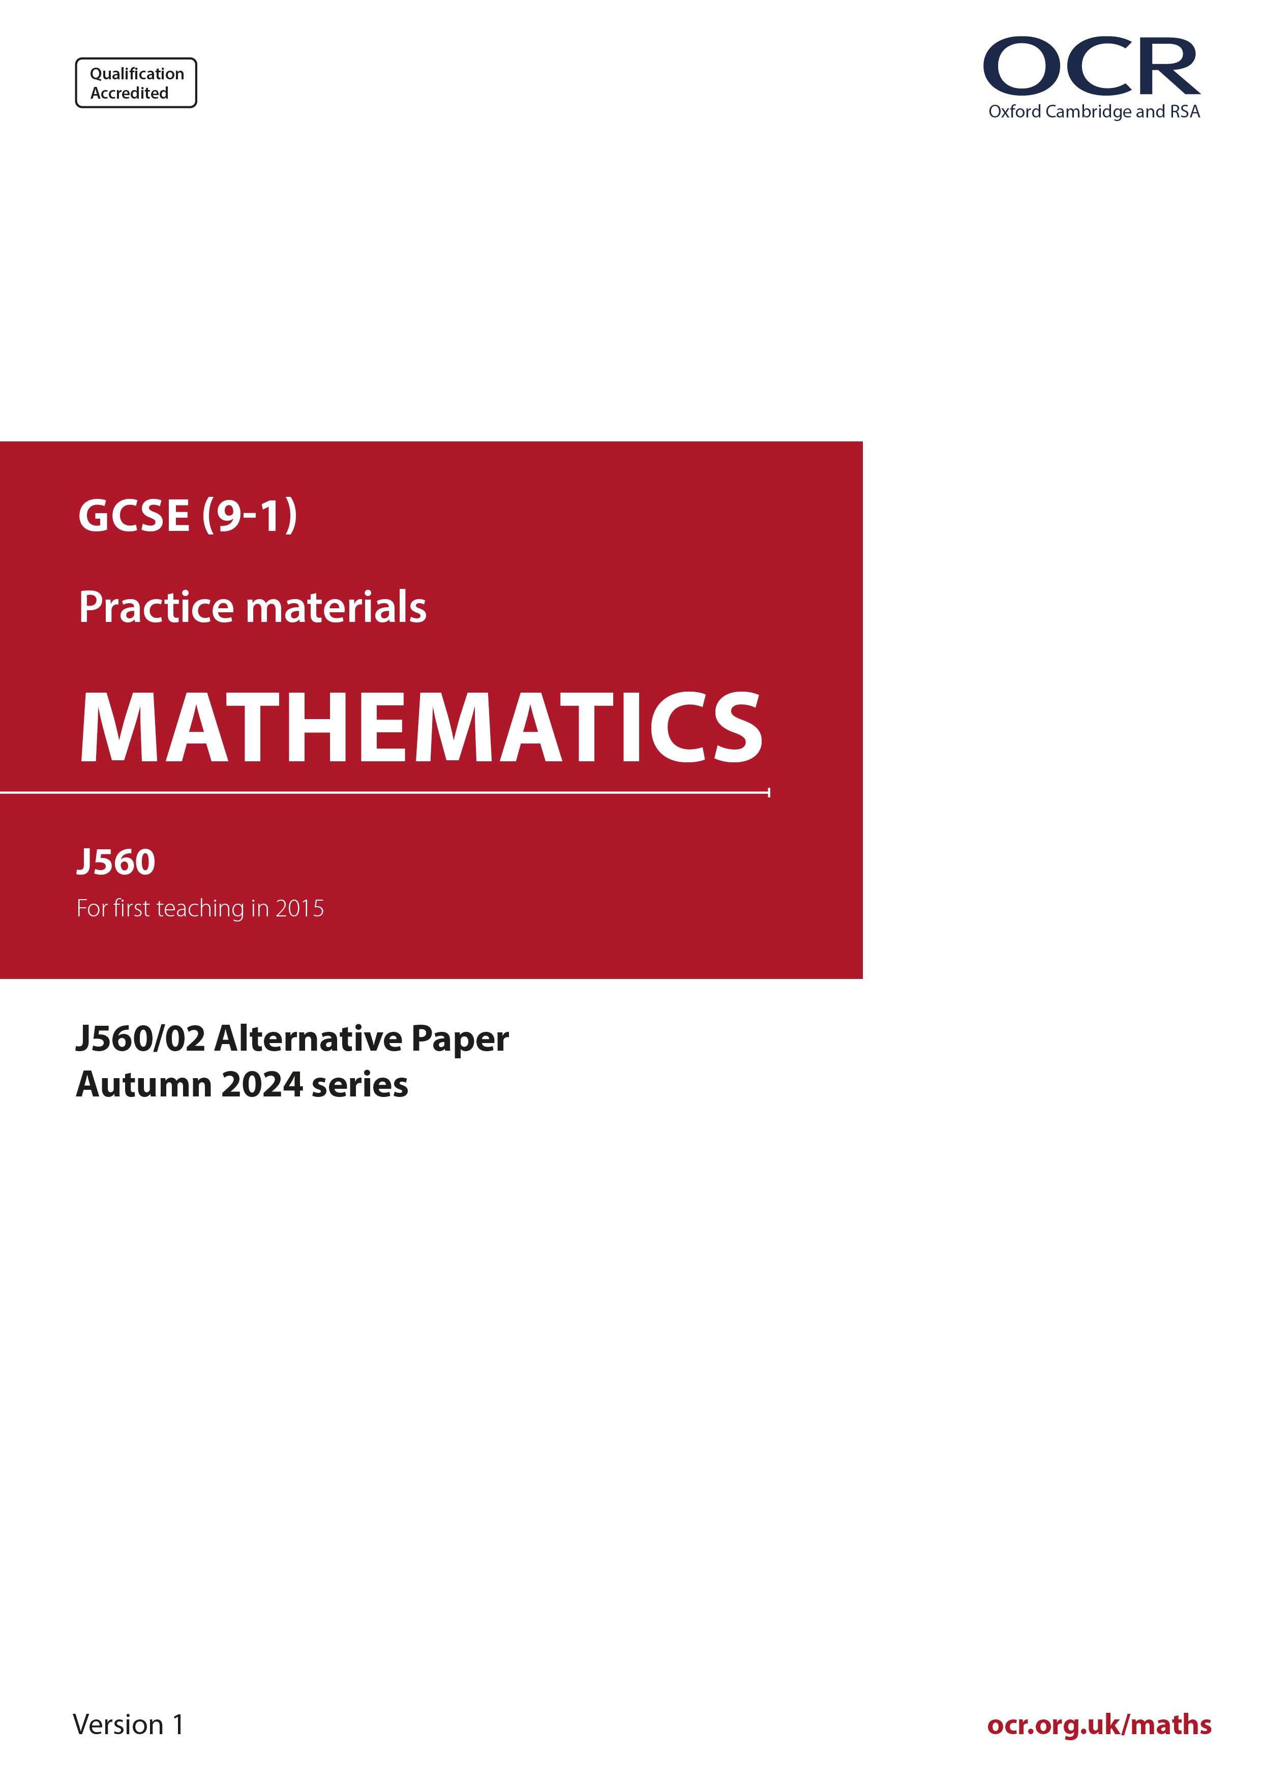
ocr.org.uk/maths

Introduction
OCR’s Alternative Papers for GCSE (9-1) Mathematics are each created by taking one of our past papers and amending the numbers/graphs/diagrams/tables/etc. in its questions.
This Alternative Paper is an amended version of one of the November 2024 series papers. The wording and topics assessed are essentially the same, but the responses students need to make will be different. Using both this paper and the corresponding November 2024 exam paper with your students at different points in the year will allow you to monitor how their learning has progressed in the time between the two papers.
Please note that when students originally sat this paper in 2024, they were given a formulae sheet. Foundation tier and Higher tier formulae sheets are published on Teach Cambridge alongside the Alternative Papers, for use with students as required.
Additional Alternative Papers and past papers are available to download from Teach Cambridge.



GCSE (9-1) Mathematics
J560/02 Paper 2 (Foundation Tier)
Alternative Paper (November 2024)

Time allowed: 1 hour 30 minutes

F
You must have:
- the Formulae Sheet for Foundation Tier (inside this document)

You can use:
- geometrical instruments
- tracing paper
- Do not use a calculator

Name

INSTRUCTIONS
- Use black ink. You can use an HB pencil, but only for graphs and diagrams.
- Write your answer to each question in the space provided. You can use extra paper if you need to, but you must clearly show your candidate number, the centre number and the question numbers
- Answer all the questions.
- Where appropriate, your answer should be supported with working. Marks might be
given for using a correct method, even if your answer is wrong.

INFORMATION
- The total mark for this paper is 100.

- The marks for each question are shown in brackets [ ].
- This document has 19 pages.

ADVICE
- Read each question carefully before you start your answer.

- (a) Write down a multiple of 7 between 30 and 40.
(a) .......................................................... [1]

- Write down a factor of 66 between 11 and 30.
(b) .......................................................... [1]

- Work out.

- 9 + -6
(a) .......................................................... [1]

- 51 × 4
(b) .......................................................... [1]

- 2849 ÷ 7
(c) .......................................................... [1]

- 6.46 + 3.6
(d) .......................................................... [1]

- The vertical line chart shows the rainfall, in millimetres (mm), in March and April.

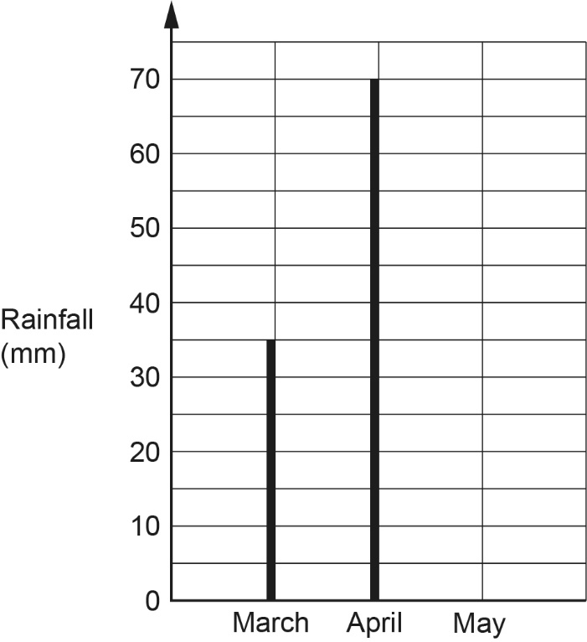

- Write down the rainfall in April.
(a) .......................................................... mm [1]

- In May there was 65 mm of rainfall.

Complete the vertical line chart for May. [1]

- Work out the total rainfall for March, April and May.
(c) .......................................................... mm [2]

- Here is a rectangle.

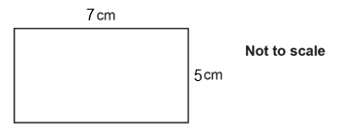

Work out the area of the rectangle.

.......................................................... cm² [2]

- (a) Complete each statement.

- 29 kilograms = .......................... grams. [1]

- 308 millilitres = .......................... litres. [1]

- 7 square centimetres = .......................... square millimetres. [1]

- A train travels 100 km at an average speed of 80 km/h.

Work out the time taken for this journey.
Give your answer in hours and minutes.
(b) ................................. hours ....................... minutes [3]
- There are 20 coins in a bag.

- Eight 5p coins.
- Five 10p coins.
- Four 20p coins
- Three 50p coins.

- The diagram shows a probability scale.

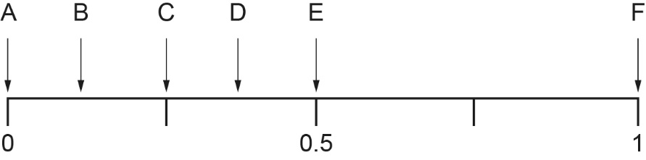

One coin is taken at random from the bag.

Which arrow shows the probability that the coin:

- is a £1 coin,
(a)(i) .......................................................... [1]

- is a 10p coin,
(ii) .......................................................... [1]

- has a value less than £1?
(iii) .......................................................... [1]

- More coins are added to the 20 coins already in the bag.
One coin is taken at random from the bag.

The probability of the coin being a 5p, a 10p, a 20p or a 50p coin are now all equal.

Find the minimum number of coins that must be in the bag.
(b) .......................................................... [2]

- (a) Work out.

(a) .......................................................... [2]

- Work out.

Give your answer in its simplest form.
(b) .......................................................... [2]

- (a) A sequence is generated using the rule:

- multiply the previous term by 3
- then subtract 1.

The 2nd term of the sequence is 26.

- Find the 3rd term of the sequence.

(a)(i) .......................................................... [1]

- Find the 1st term of the sequence.
(ii) .......................................................... [2]

- Here are the first four terms of a different sequence.

4 8 12 16

Find the nth term of the sequence.
(b) .......................................................... [1]

- 60 students each chose two activities, one from Option 1 and one from Option 2.

Option | Activity
1 | football or hockey
2 | athletics or multigym

This frequency tree shows the number of students choosing some of the activities.

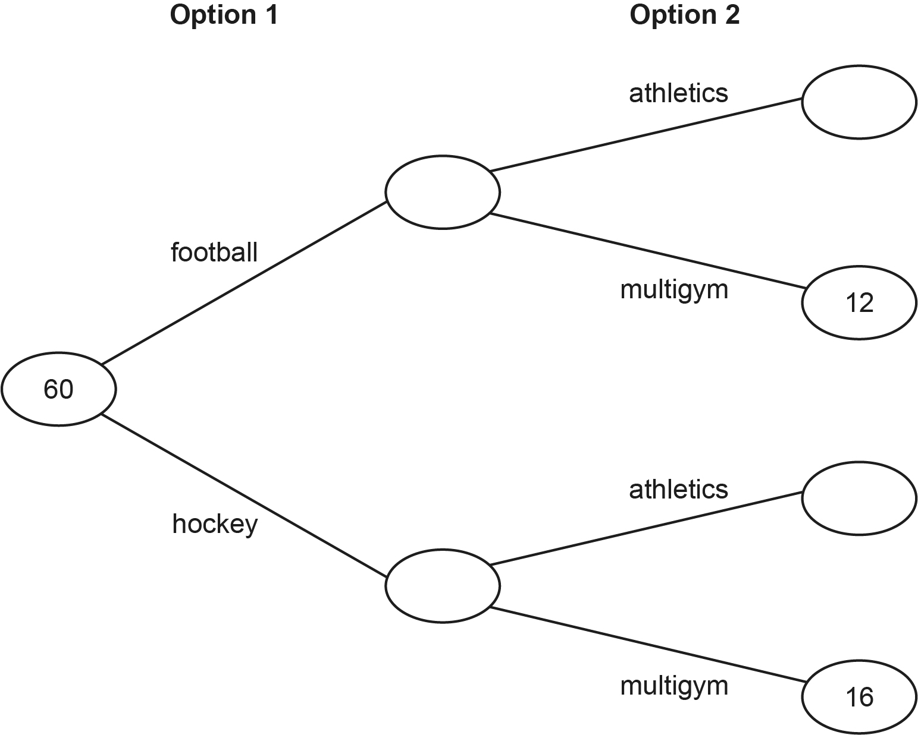

- How many more students chose hockey and multigym rather than football
and multigym?
(a) .......................................................... [1]

- Ten more students chose football rather than hockey.

Complete the frequency tree. [4]

- (a) The table shows charges made by a gas company to its customers.

Cost per day  PLUS  Cost per unit of gas used | 23p  7p

The owner of a flat receives a gas bill covering a period of 100 days.
They have used 7000 units of gas in this period.

Show that their bill is for £513. [4]
- The owner of a house is supplied gas by a different gas company.

- The cost per day is 35p.
- They use 10 000 units of gas in 100 days.
- Their bill covering the period of 100 days is £885.

Work out the cost per unit of gas used, giving your answer in pence.
(b) .......................................................... p [4]

- Triangle A is drawn on the grid below.

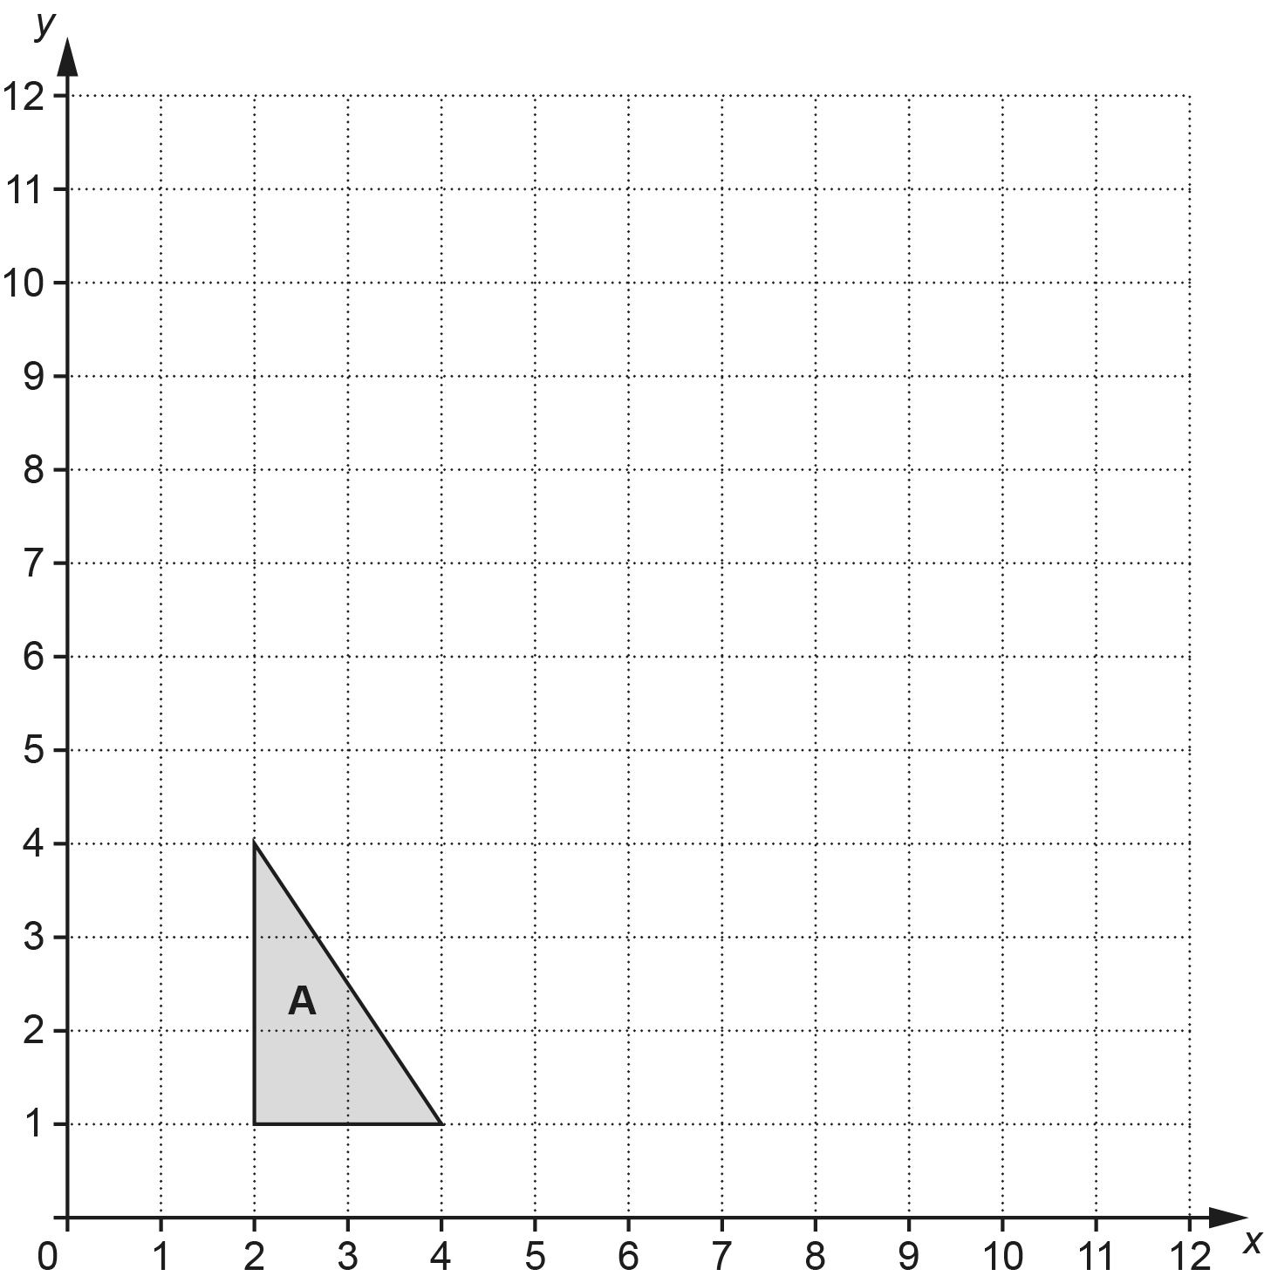

- Enlarge triangle A by scale factor 3 with centre of enlargement (1, 1).
Label the image B. [3]

- Complete the description of the single transformation that maps triangle B back to triangle A.

Enlargement by scale factor .................... with centre of enlargement ...................... [2]

- A spinner has five sides numbered 1 to 5.
If the spinner is fair, the probability that it lands on the number 1 is 0.2.

A student spins the spinner 400 times.

- Assuming the spinner is fair, use the information to work out how many times the spinner is expected to land on the number 1.
(a) .......................................................... [2]

- The spinner actually landed on the number 1 on 77 of the 400 spins.

Decide whether or not the result suggests this spinner is likely to be a fair spinner.
Give a reason for your answer.
............................... because ............................................................................................

..................................................................................................................................... [1]

- (a) Find the value of:

- 3⁴ ,
(a)(i) .......................................................... [2]

(ii) .......................................................... [1]

- Simplify.

y²⁰ ÷ y⁴
(b) .......................................................... [1]

- 2^{p} × 2 =

Find the value of p.
(c) p =..................................................... [2]

- Layla is thinking of a fraction.
The numerator is a cube number less than 100.
The denominator is a square number less than 100.
The fraction is equivalent to .

Find the fraction that Layla is thinking of.
.......................................................... [3]
- The graph shows the time, in minutes, taken by some pupils to travel to school on Tuesday.

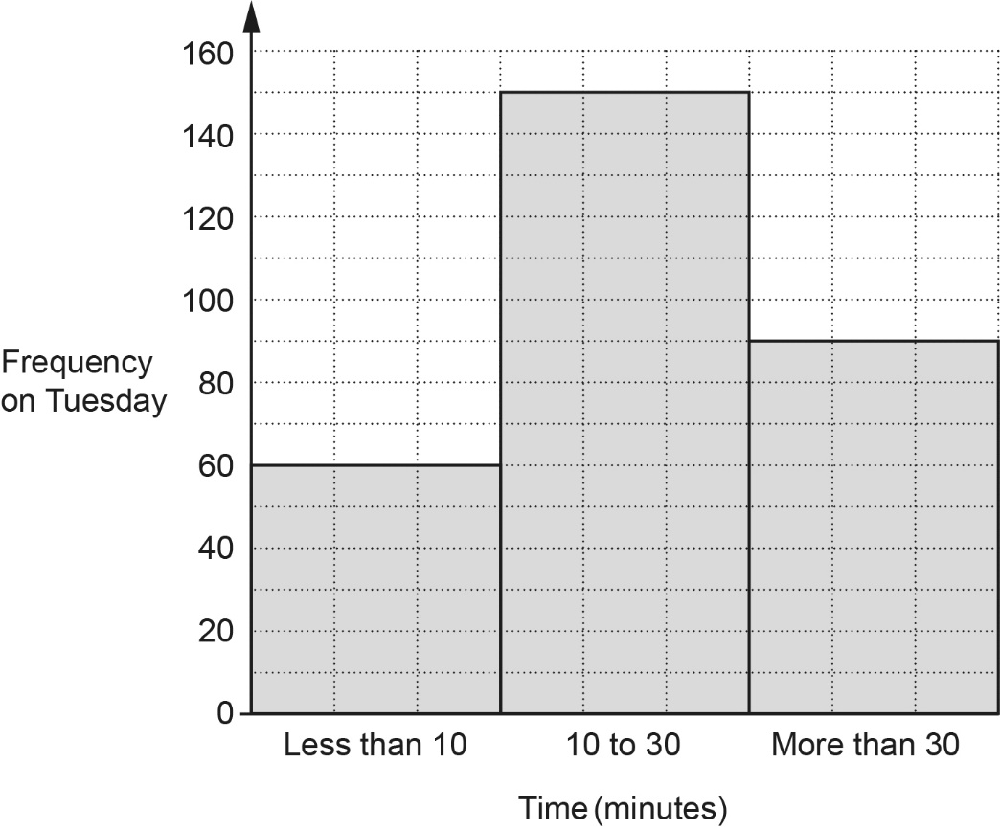

- Find the percentage of these pupils that took less than 10 minutes to travel to school.
(a) .......................................................... % [3]

- On Tuesday the number of pupils taking more than 30 minutes to travel to school was 40% less than on Monday.

Find the number of pupils taking more than 30 minutes to travel to school on Monday.
(b) .......................................................... [3]

- An electrician charges £40 per visit plus £19 per hour.

Write an expression for the cost, in £, charged by the electrician for one visit lasting t hours.

£ .......................................................... [2]

- Casey has a shelf 83.7 cm long.
She has many books, each of width 3.8 cm.
Casey puts two paperweights, each of width 5 cm, and the maximum possible number of books on the shelf.

Work out the amount of space on the shelf that is left over.
You must show your working.
.......................................................... cm [5]
- Ben has twenty cards numbered 11 to 30.
He picks a card at random.

Ben says,

In these twenty cards, there are three multiples of 7 and ten even numbers.
Therefore, the probability that I pick a card that is a multiple of 7 or an even
number is

Describe the error in Ben’s method and give the correct answer.

The error is ................................................................................................................................

....................................................................................................................................................

The correct answer is .......................................................... [2]

- Amos makes craft figures at a constant rate.
He can make 10 craft figures in 40 minutes.

- Find the number of craft figures Amos can make in 6 hours.
(a) .......................................................... [3]

- Beth makes craft figures 10% quicker than Amos.

Work out how long Beth takes to make 15 craft figures.
(b) .......................................................... minutes [3]

- Here is a question and an incorrect answer.

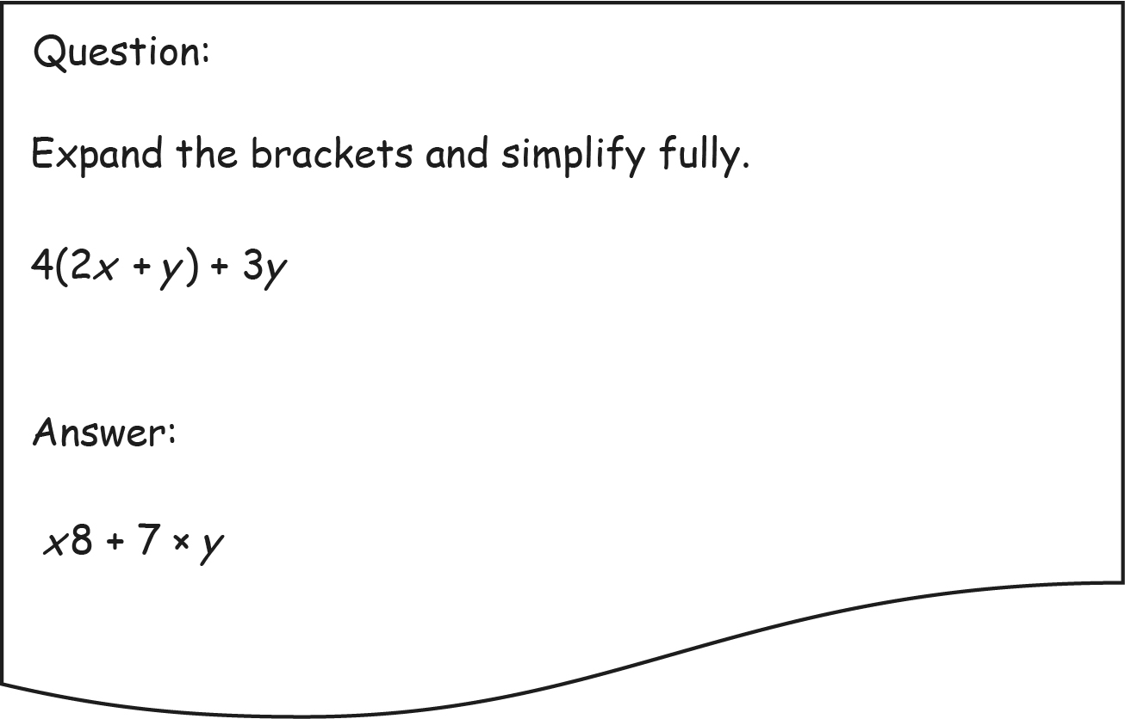

Explain why the answer is not correct.

....................................................................................................................................................

.............................................................................................................................................. [2]

- (a) Show that (x + 5)(x – 7) = x² – 2x – 35. [1]
- The diagram shows a sketch of the graph y = (x + 5)(x – 7).

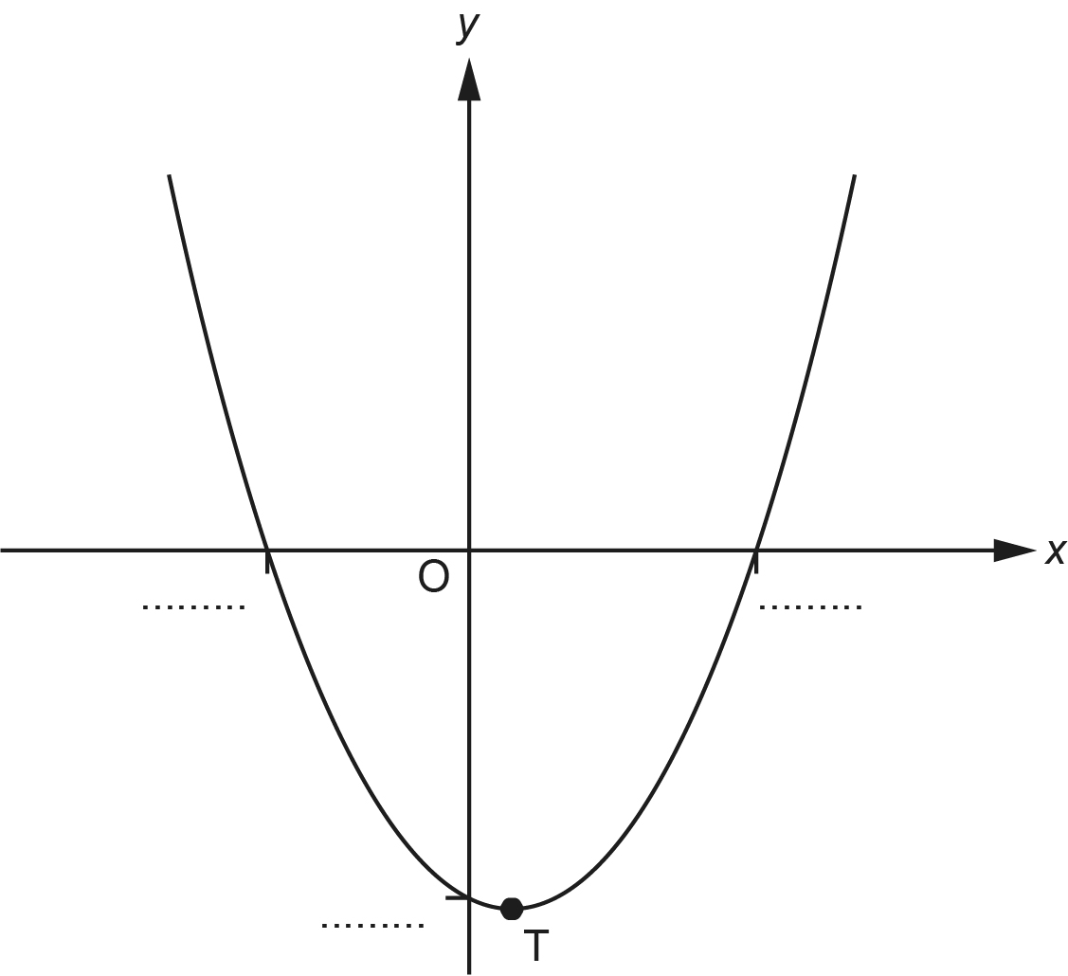

Complete the diagram by adding the values of the three intercepts with the axes. [2]

- The minimum point on the graph is marked T.

Write down the coordinates of the point T.
(c) (........... , ...........) [2]

- In this question, all lengths are in centimetres.

The diagram shows an isosceles triangle ABC.
AB = AC.

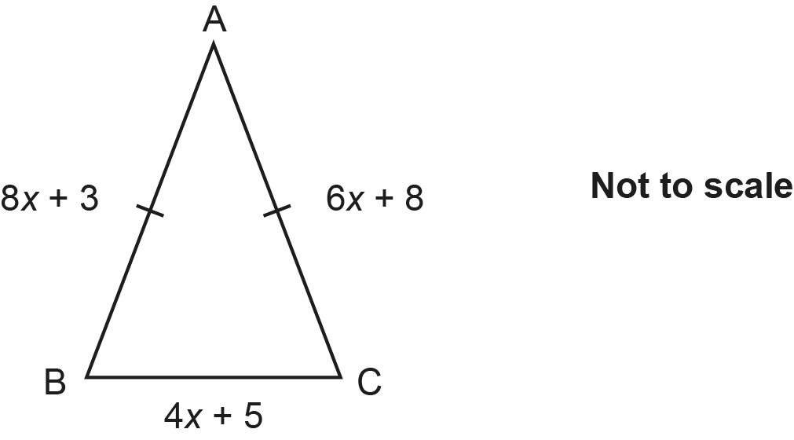

Find the perimeter of the triangle.
You must show your working.
.......................................................... cm [6]

- The diagram shows two right-angled triangles, ABC and BDC, joined at BC.

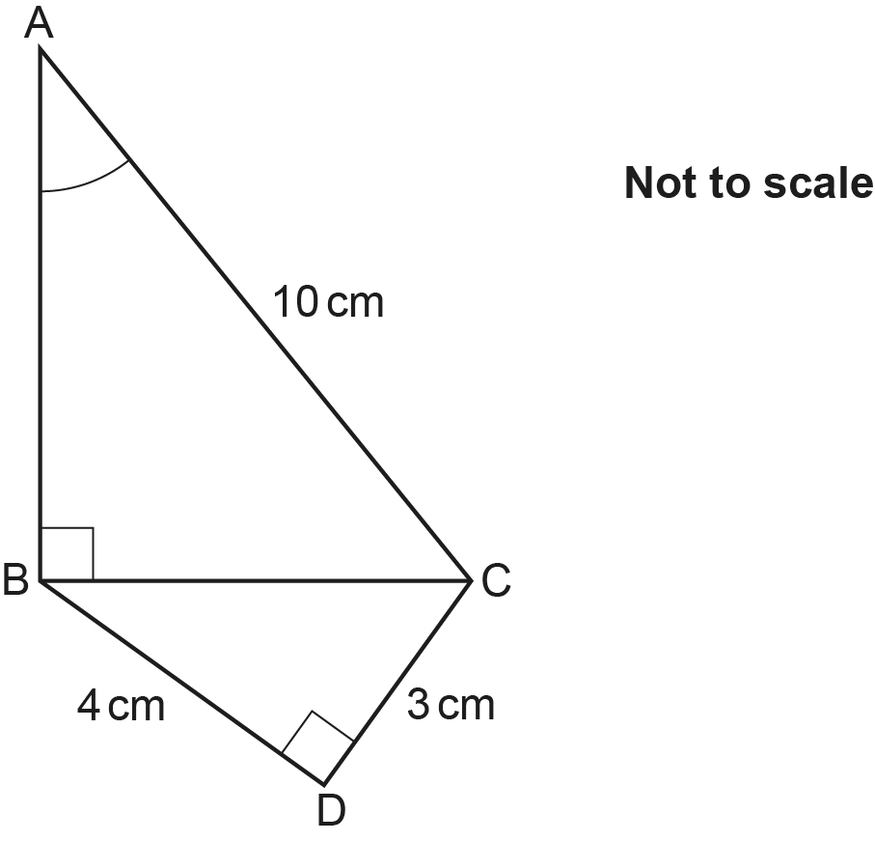

Work out angle BAC.
You must show your working.
..........................................................° [5]
END OF QUESTION PAPER

Please note – web links are correct at date of publication but other websites may change over time. If you have any problems with a link you may want to navigate to that organisation’s website for a direct search.



We’d like to know your view on the resources we produce. Click ‘Like’ or ‘Dislike’ to send us an auto generated email about this resource. Add comments if you want to. Let us know how we can improve this resource or what else you need. Your email will not be used or shared for any marketing purposes.
Looking for another resource? There is now a quick and easy search tool to help find free resources for your qualification.
OCR is part of Cambridge University Press & Assessment, which is itself a department of the University of Cambridge.
For staff training purposes and as part of our quality assurance programme your call may be recorded or monitored. © OCR 2024 Oxford Cambridge and RSA Examinations is a Company Limited by Guarantee. Registered in England. Registered office The Triangle Building, Shaftesbury Road, Cambridge, CB2 8EA. Registered company number 3484466. OCR is an exempt charity.
OCR operates academic and vocational qualifications regulated by Ofqual, Qualifications Wales and CCEA as listed in their qualifications registers including A Levels, GCSEs, Cambridge Technicals and Cambridge Nationals.
OCR provides resources to help you deliver our qualifications. These resources do not represent any teaching method we expect you to use. We update our resources regularly and aim to make sure content is accurate but please check the OCR website so that you have the most up to date version. OCR cannot be held responsible for any errors or omissions in these resources.
Though we make every effort to check our resources, there may be contradictions between published support and the specification, so it is important that you always use information in the latest specification. We indicate any specification changes within the document itself, change the version number and provide a summary of the changes. If you do notice a discrepancy between the specification and a resource, please contact us.
You can copy and distribute this resource in your centre, in line with any specific restrictions detailed in the resource. Resources intended for teacher use should not be shared with students. Resources should not be published on social media platforms or other websites.
OCR acknowledges the use of the following content: N/A
Whether you already offer OCR qualifications, are new to OCR or are thinking about switching, you can request more information using our Expression of Interest form.
Please get in touch if you want to discuss the accessibility of resources we offer to support you in delivering our qualifications.

