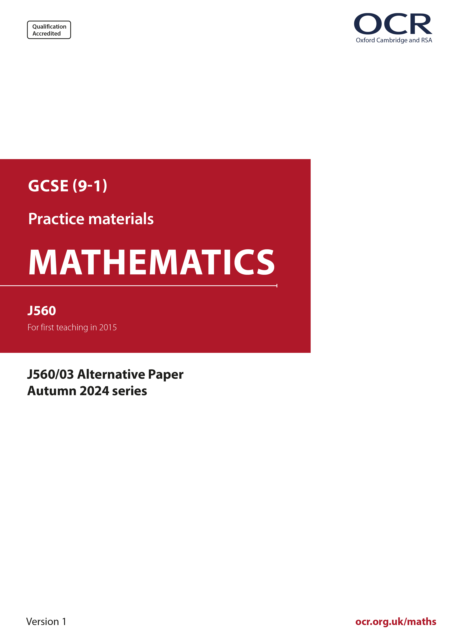
ocr.org.uk/maths

Introduction
OCR’s Alternative Papers for GCSE (9-1) Mathematics are each created by taking one of our past papers and amending the numbers/graphs/diagrams/tables/etc. in its questions.
This Alternative Paper is an amended version of one of the November 2024 series papers. The wording and topics assessed are essentially the same, but the responses students need to make will be different. Using both this paper and the corresponding November 2024 exam paper with your students at different points in the year will allow you to monitor how their learning has progressed in the time between the two papers.
Please note that when students originally sat this paper in 2024, they were given a formulae sheet. Foundation tier and Higher tier formulae sheets are published on Teach Cambridge alongside the Alternative Papers, for use with students as required.
Additional Alternative Papers and past papers are available to download from Teach Cambridge.



GCSE (9-1) Mathematics
J560/03 Paper 3 (Foundation Tier)
Alternative Paper (November 2024)

Time allowed: 1 hour 30 minutes

F
You must have:
- the Formulae Sheet for Foundation Tier (inside this document)

You can use:
- a scientific or graphical calculator
- geometrical instruments
- tracing paper

Name

INSTRUCTIONS
- Use black ink. You can use an HB pencil, but only for graphs and diagrams.
- Write your answer to each question in the space provided. You can use extra paper if you need to, but you must clearly show your candidate number, the centre number and the question numbers
- Answer all the questions.
- Where appropriate, your answer should be supported with working. Marks might be
given for using a correct method, even if your answer is wrong.
- Use the π button on your calculator or take π to be 3.142 unless the question says
something different.

INFORMATION
- The total mark for this paper is 100.
- The marks for each question are shown in brackets [ ].
- This document has 23 pages.

ADVICE
- Read each question carefully before you start your answer.

- The diagram shows a square drawn on a one-centimetre square grid.

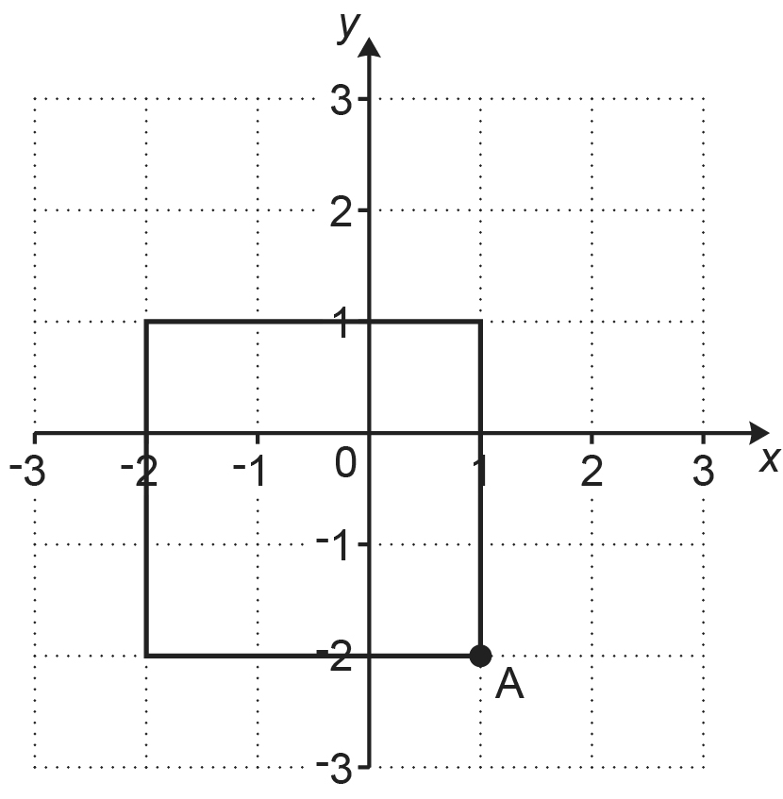

- Write down the coordinates of point A.
(a) (........... , ...........) [1]

- Find the area of the square.
(b) .................................................. cm² [1]

- (a) Write down all the factors of 21.
(a) .......................................................... [2]

- Find the largest number that will divide exactly into 21 and 84.
(b) .......................................................... [1]

- 60 people are asked if they have visited France (F) and if they have visited Greece (G).

The Venn diagram shows the results.

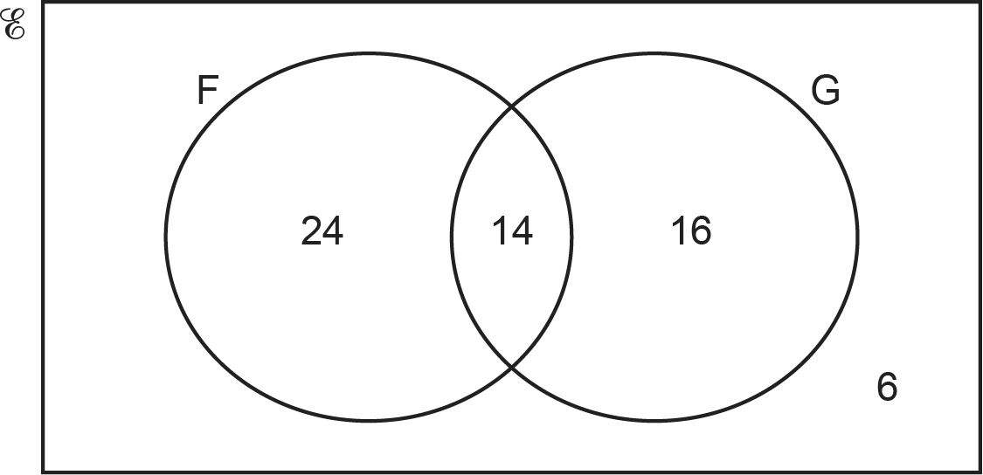

- How many of the 60 people have not visited either France or Greece?
(a) .......................................................... [1]

- How many of the 60 people have visited Greece?
(b) .......................................................... [1]

- Li thinks of a number.

Li says,

When I square root my number and divide the result by 10 the answer is 1.4.

Find Li’s number.
.......................................................... [2]

- These are the ingredients for making some scones.

Flour | 350 g
Butter | 80 g
Sugar | 55 g
Milk | 160 ml

10 ml of milk weighs 10.4 g.

Work out the total weight of all the ingredients.
.......................................................... g [3]

- (a) By rounding each value to one significant figure, estimate the cost of 5.8 kg of carrots at 82p per kg.
(a) £ .......................................................... [2]

- A student works out an estimate for this calculation.

Their method is to:
- round each number correct to the same number of significant figures and
- work out the approximation.

The student writes

.

What error has the student made in using their method?

...........................................................................................................................................

..................................................................................................................................... [1]

- (a) Rearrange this formula to make x the subject.

y = x – 4
(a) .......................................................... [1]

- Rearrange this formula to make w the subject.

p = 5w
(b) .......................................................... [1]
- For each statement, tick () whether the value of x is true or false.
The first one is done for you.

Statement | Value of x | True | False
x > -1 | 3
x ⩽ -2 | -2
= 0.5 | 50
x – 2 ≠ 1 | 3
-2 < x < -0.7 | 0
[3]

- This is a function machine.

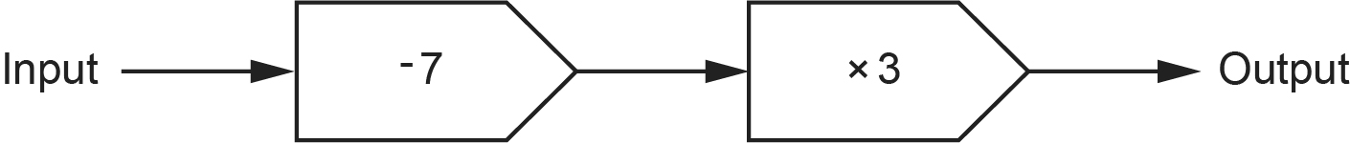

- (i) Find the output when the input is 9.
(a)(i) .......................................................... [1]

- Find the input when the output is 36.
(ii) .......................................................... [2]

- Complete this function machine to show the equation y = 6 + 4x.

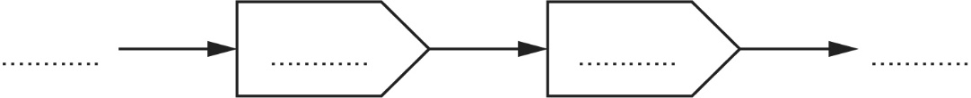
[2]

- 100 students vote in a school election.

1 vote is spoiled and is not counted.
The remaining votes are for Darcie or Ivan and are in the ratio 4 : 7.

How many more votes does Ivan have than Darcie?
.......................................................... [3]

- In a particular town last year:

- it rained on 11 of the 30 days in November
- it rained on 12 of the 31 days in December.

- Which month, November or December, had the highest proportion of rainy days?
Show how you decide.
..................................... because ......................................................................................

..................................................................................................................................... [3]

- Jamal says,

I think the probability it will rain on December 25th next year is .

What assumption has Jamal made?

[1]

- The table shows some numbers each written as a power of 9.

Number | ... as a power of 9 |  | ... as a power of 3
9 | 9 | 9¹ | 3 × 3 | 3²
81 | 9 × 9 | 9²
729 | 9 × 9 × 9 | 9³

- Complete the table to show 81 and 729 each written as a power of 3. [2]

- A number is written as 9¹⁵.

Use a pattern in the table to help you write this number as a power of 3.
(b) .......................................................... [1]

- (a) Write 0.01204 in standard form.
(a) .......................................................... [1]

- A weather blogger writes:

- 1.495 × 10¹¹ raindrops fall in a storm.
- the mass of each raindrop is 6 × 10⁻⁵ grams.

Calculate the total mass of all of the raindrops that fall in the storm.
Give your answer in standard form in kilograms.
(b) .......................................................... kilograms [4]

- (a) Machine A makes enough lollipops to fill 400 packs.

There are 8 lollipops in each pack.

Show that 3200 lollipops are made by machine A. [1]
- Machine B makes 4800 lollipops in the same time it took machine A to make
3200 lollipops.

Machine B makes lollipops one at a time and at a constant rate.

What fraction of the time needed to fill 400 packs is saved if machine B is used rather than machine A?
Give your answer in its simplest form.
(b) .......................................................... [3]

- Shop A and shop B have special offers on the same cupcakes.

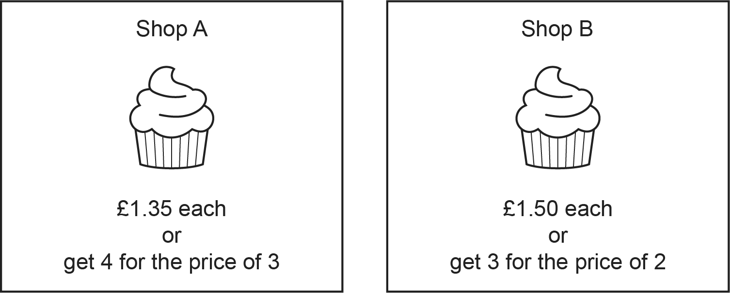

- Show that the special offer cost of 6 cupcakes from Shop A is £6.75. [1]
- Riley wants 25 cupcakes for a party.

Which shop will be cheapest and by how much?
Show how you decide.
(b) Shop ................. by .................p [5]

- Sasha has these two sets of number cards.

One card is taken at random from each set.
Sasha adds the numbers on the two cards to get a total.

- Complete the table to show all the possible totals.

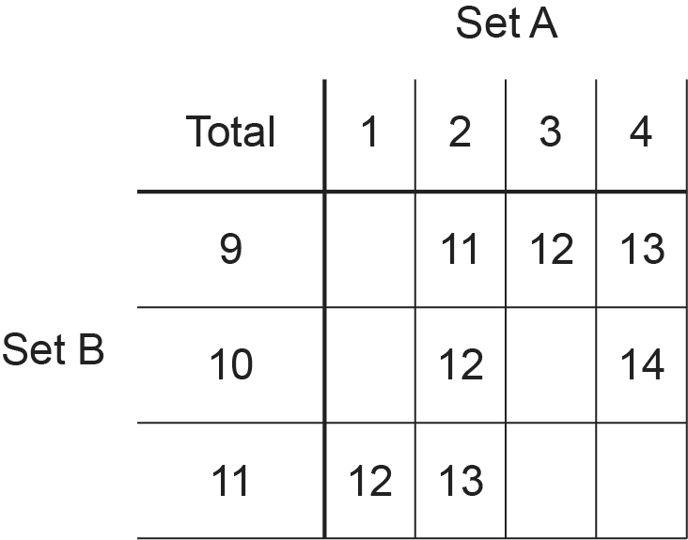
[2]

- Find the probability that the total is a prime number.
Give your answer as a fraction.
(b) .......................................................... [2]

- The price of a holiday increases from £320 to £350.

Work out the percentage increase in the price of the holiday.
.......................................................... % [3]

- Kobe invests £x at a rate of 1.5% per year simple interest for 6 years.
Shanti also invests £x but at a rate of 1.1% per year simple interest for 7 years.

Kobe earns £156 more interest than Shanti.

Work out the value of x.
You must show your working.
x = .......................................................... [6]

- Taylor spins a fair five-sided spinner.
The sectors of the spinner are numbered 1, 2, 3, 4 and 5.

Taylor also throws a fair six-sided dice.
Three of the dice faces are red, two are blue, and one is yellow.

- Complete this tree diagram.

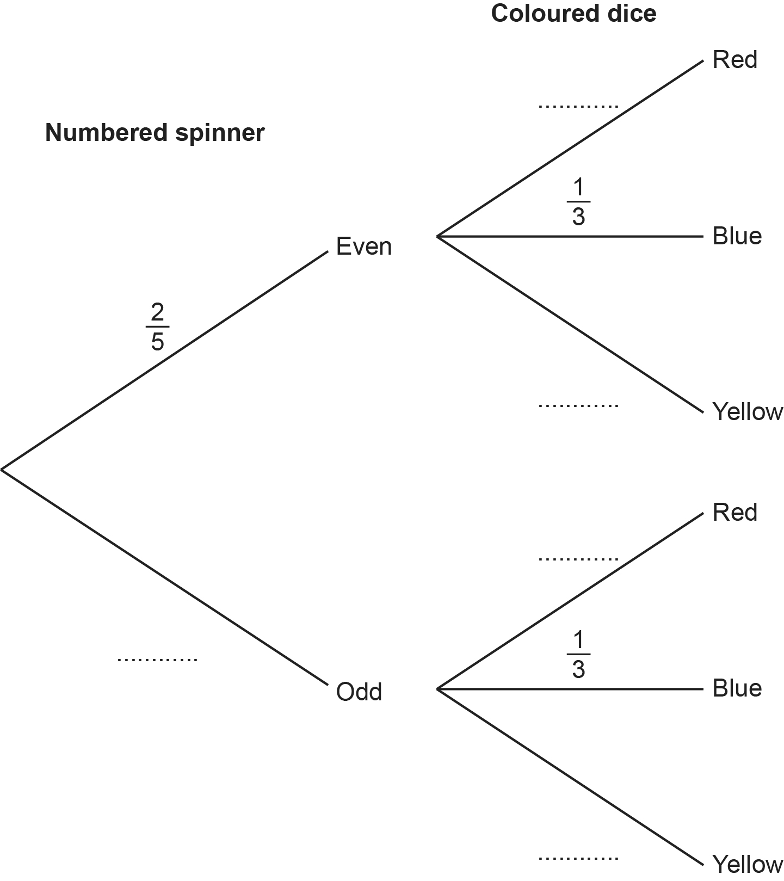
[3]

- Calculate the probability that Taylor gets an even number on the spinner and a blue face on the dice.
(b) .......................................................... [2]

- (a) The diagram shows the cross-section of a triangular prism.

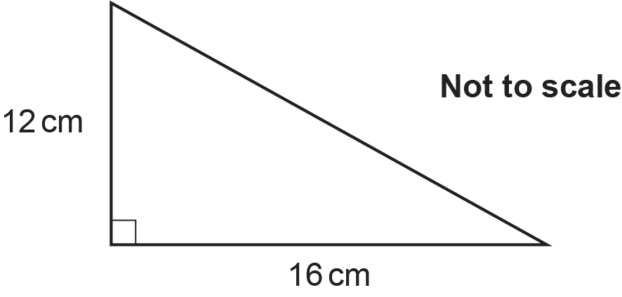

Work out the area of the cross-section.
(a) .......................................................... cm² [2]

- This diagram shows the triangular prism.

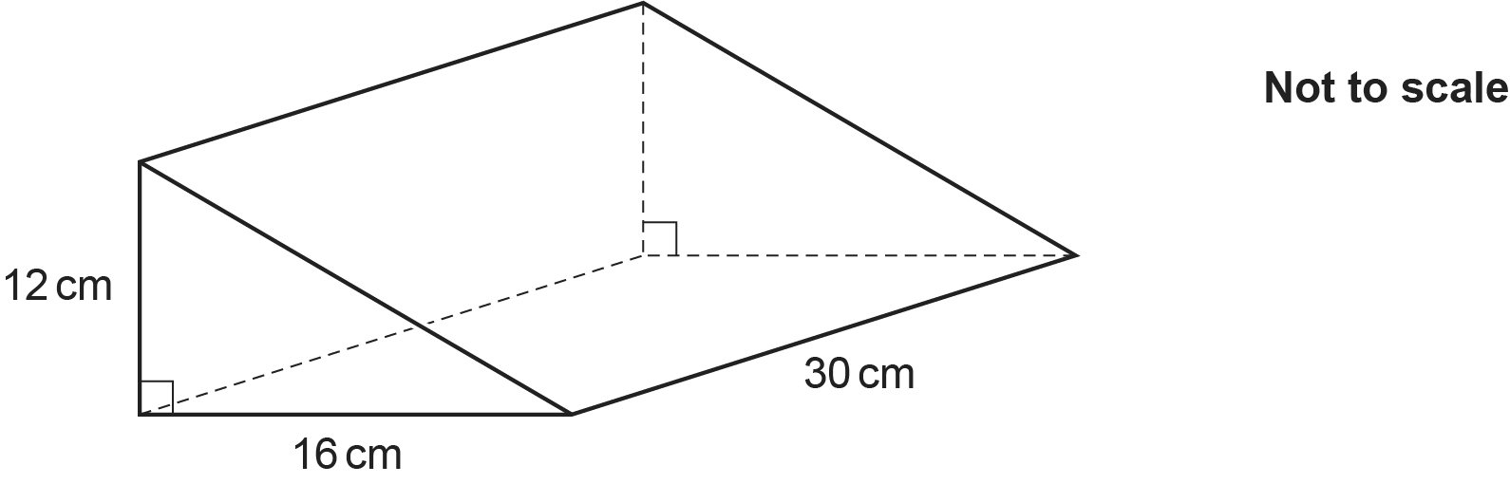

Work out the total surface area of the triangular prism.
You must show your working.
(b) .......................................................... cm² [5]

(c) Two of these triangular prisms are joined to make a new prism.
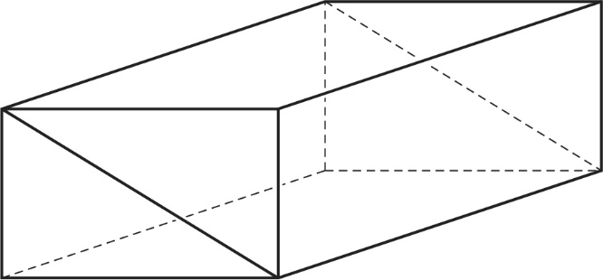
Give a reason why the total surface area of this prism is not two times your answer in part (b).

[1]

- Here are the first three tile patterns of a sequence.

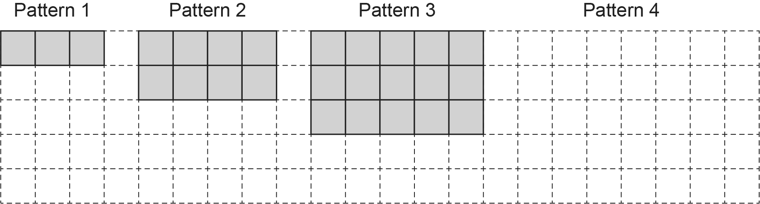

- Draw Pattern 4 in the space above. [1]

- Complete this table.

Pattern | Calculation | Number of tiles
1 | 1 × 3 | 3
2 | 2 × 4 | 8
3 | 3 × 5 | 15
4
5
10
n |  | n² + 2n
[4]

- Each pattern in the sequence can be split into a square of tiles and a double column
of tiles.

For example, Pattern 3:

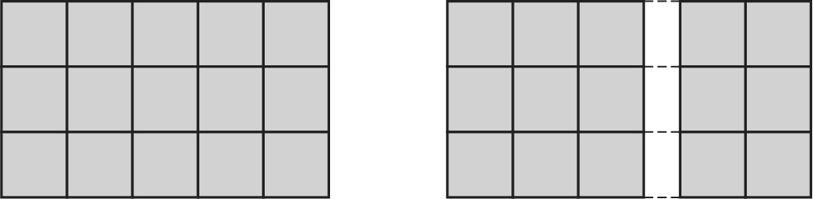

The square in Pattern n contains 4225 tiles.

Work out how many tiles are in Pattern n.
(c) .......................................................... [3]

- A bag contains only blue, green and red counters in the ratio 8 : 3 : 1.
There are 95 more blue counters than green counters in the bag.

Work out the total number of counters in the bag.
.......................................................... [4]

- A farmer has 60 apple trees.
The table shows the heights, h metres, of the apple trees.

Height (h metres) | Frequency
1 < h ⩽ 2 | 4
2 < h ⩽ 3 | 8
3 < h ⩽ 4 | 29
4 < h ⩽ 5 | 19

- Calculate an estimate of the mean height of the 60 apple trees.
(a) .......................................................... m [4]

- Explain why it is not possible to use the information from this table to calculate the exact value of the mean height.

...........................................................................................................................................

..................................................................................................................................... [1]

- .

- On the grid below, draw .

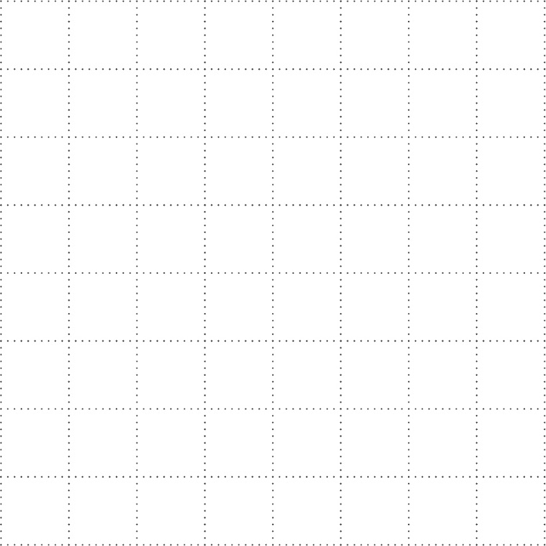
[2]

- Work out .

[2]

- Write down .

[1]

- The diagram represents a rectangular field.
A and B are two trees.

A straight path goes across the field.
The path is always the same distance from A and B.

Construct the route followed by the path.
Show all your construction lines.
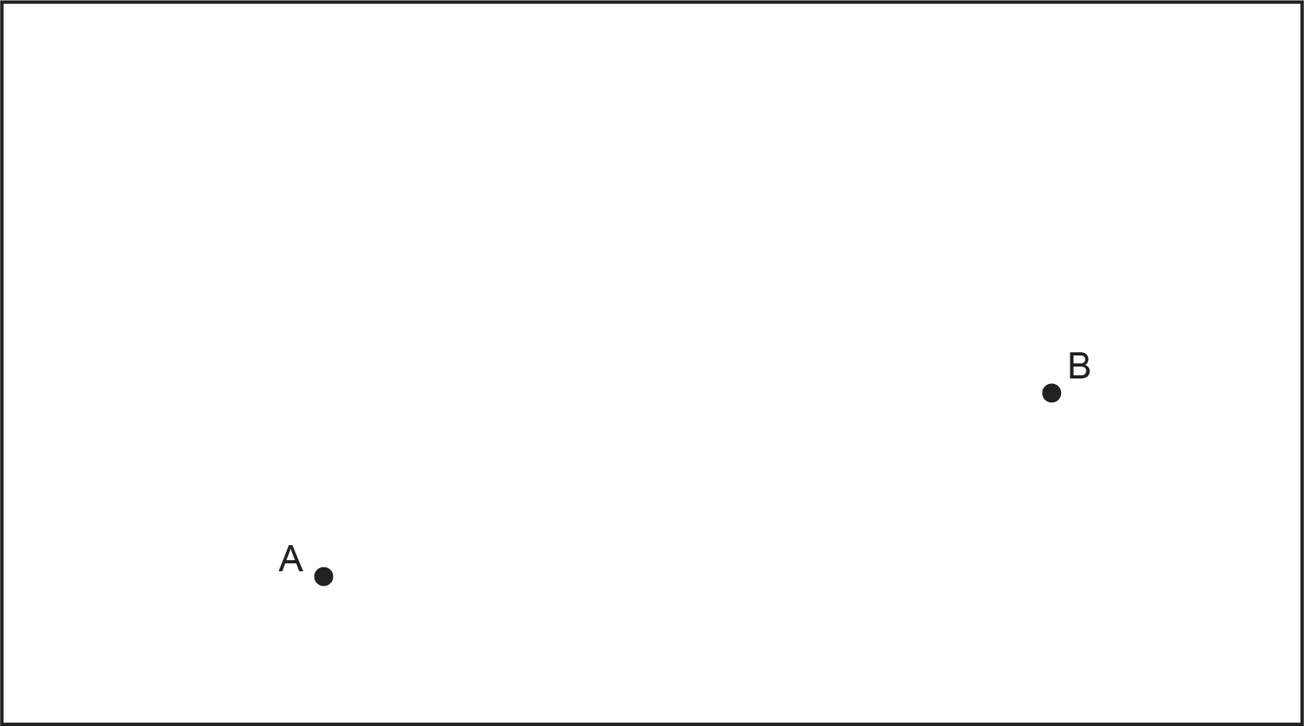
[2]
END OF QUESTION PAPER

Please note – web links are correct at date of publication but other websites may change over time. If you have any problems with a link you may want to navigate to that organisation’s website for a direct search.



We’d like to know your view on the resources we produce. Click ‘Like’ or ‘Dislike’ to send us an auto generated email about this resource. Add comments if you want to. Let us know how we can improve this resource or what else you need. Your email will not be used or shared for any marketing purposes.
Looking for another resource? There is now a quick and easy search tool to help find free resources for your qualification.
OCR is part of Cambridge University Press & Assessment, which is itself a department of the University of Cambridge.
For staff training purposes and as part of our quality assurance programme your call may be recorded or monitored. © OCR 2024 Oxford Cambridge and RSA Examinations is a Company Limited by Guarantee. Registered in England. Registered office The Triangle Building, Shaftesbury Road, Cambridge, CB2 8EA. Registered company number 3484466. OCR is an exempt charity.
OCR operates academic and vocational qualifications regulated by Ofqual, Qualifications Wales and CCEA as listed in their qualifications registers including A Levels, GCSEs, Cambridge Technicals and Cambridge Nationals.
OCR provides resources to help you deliver our qualifications. These resources do not represent any teaching method we expect you to use. We update our resources regularly and aim to make sure content is accurate but please check the OCR website so that you have the most up to date version. OCR cannot be held responsible for any errors or omissions in these resources.
Though we make every effort to check our resources, there may be contradictions between published support and the specification, so it is important that you always use information in the latest specification. We indicate any specification changes within the document itself, change the version number and provide a summary of the changes. If you do notice a discrepancy between the specification and a resource, please contact us.
You can copy and distribute this resource in your centre, in line with any specific restrictions detailed in the resource. Resources intended for teacher use should not be shared with students. Resources should not be published on social media platforms or other websites.
OCR acknowledges the use of the following content: N/A
Whether you already offer OCR qualifications, are new to OCR or are thinking about switching, you can request more information using our Expression of Interest form.
Please get in touch if you want to discuss the accessibility of resources we offer to support you in delivering our qualifications.

