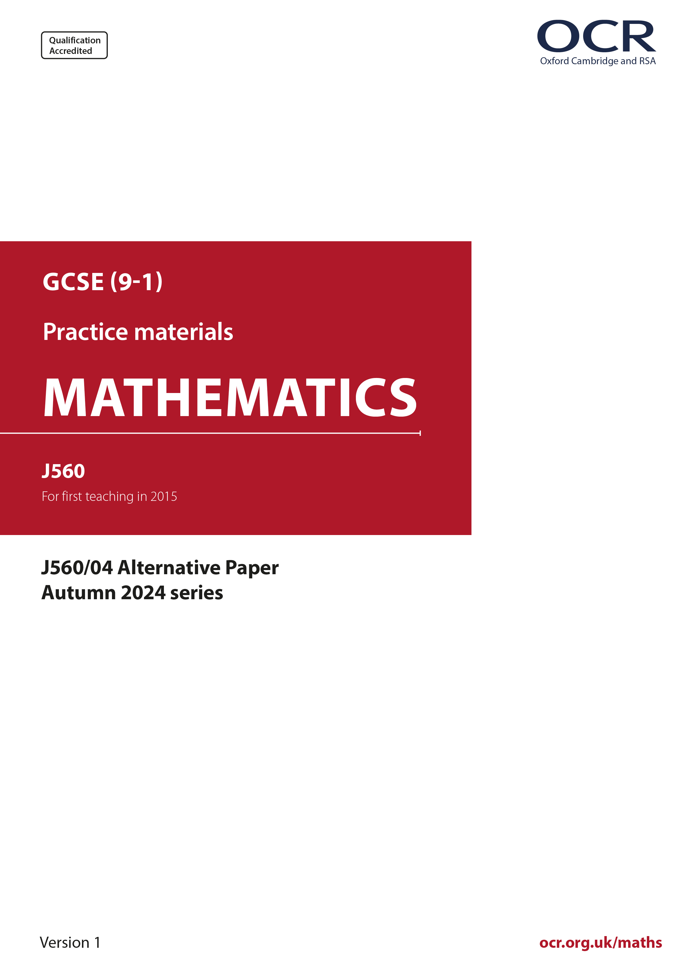
ocr.org.uk/maths

Introduction
OCR’s Alternative Papers for GCSE (9-1) Mathematics are each created by taking one of our past papers and amending the numbers/graphs/diagrams/tables/etc. in its questions.
This Alternative Paper is an amended version of one of the November 2024 series papers. The wording and topics assessed are essentially the same, but the responses students need to make will be different. Using both this paper and the corresponding November 2024 exam paper with your students at different points in the year will allow you to monitor how their learning has progressed in the time between the two papers.
Please note that when students originally sat this paper in 2024, they were given a formulae sheet. Foundation tier and Higher tier formulae sheets are published on Teach Cambridge alongside the Alternative Papers, for use with students as required.
Additional Alternative Papers and past papers are available to download from Teach Cambridge.



GCSE (9-1) Mathematics
J560/04 Paper 4 (Higher Tier)
Alternative Paper (November 2024)

Time allowed: 1 hour 30 minutes

H
You must have:
- the Formulae Sheet for Higher Tier (inside this document)

You can use:
- a scientific or graphical calculator
- geometrical instruments
- tracing paper

Name

INSTRUCTIONS
- Use black ink. You can use an HB pencil, but only for graphs and diagrams.
- Write your answer to each question in the space provided. You can use extra paper if you need to, but you must clearly show your candidate number, the centre number and the question numbers
- Answer all the questions.
- Where appropriate, your answer should be supported with working. Marks might be
given for using a correct method, even if your answer is wrong.
- Use the π button on your calculator or take π to be 3.142 unless the question says
something different.

INFORMATION
- The total mark for this paper is 100.
- The marks for each question are shown in brackets [ ].
- This document has 19 pages.

ADVICE
- Read each question carefully before you start your answer.

- Factorise fully.

- 10x² + 15x
(a) .......................................................... [2]

- x² + 9x + 18
(b) .......................................................... [2]

- You may use these kinematics formulae to answer these questions.

v = u + at

v² = u² + 2as

A moving particle accelerates at 3 m/s² for 9 seconds.
The particle’s final velocity after the 9 seconds is 32 m/s.

- Show that the velocity of the particle at the start of the 9 seconds is 5 m/s. [2]
- Work out the distance travelled by the particle during the 9 seconds.

(b) .......................................................... m [3]

- (a) N is a number such that:

- N = 2 × 3 × 5 × k, where k is a prime number
- N is greater than 200.

Find the smallest possible value of N.
(a) N = .......................................................... [3]

- a and b are different prime numbers.

Explain why a × b is not a prime number.

...........................................................................................................................................

..................................................................................................................................... [1]

- Each week the manager of a petrol station records the average daily sales, in litres, and the average price, in pounds, of a litre of petrol for that week.

The table shows their results for ten weeks.

Week | 1 | 2 | 3 | 4 | 5 | 6 | 7 | 8 | 9 | 10
Price per litre (£) | 1.42 | 1.45 | 1.47 | 1.50 | 1.54 | 1.60 | 1.57 | 1.52 | 1.61 | 1.49
Litres sold per day | 740 | 725 | 620 | 705 | 685 | 660 | 675 | 695 | 655 | 710

The results for the first nine weeks are plotted on the scatter diagram.

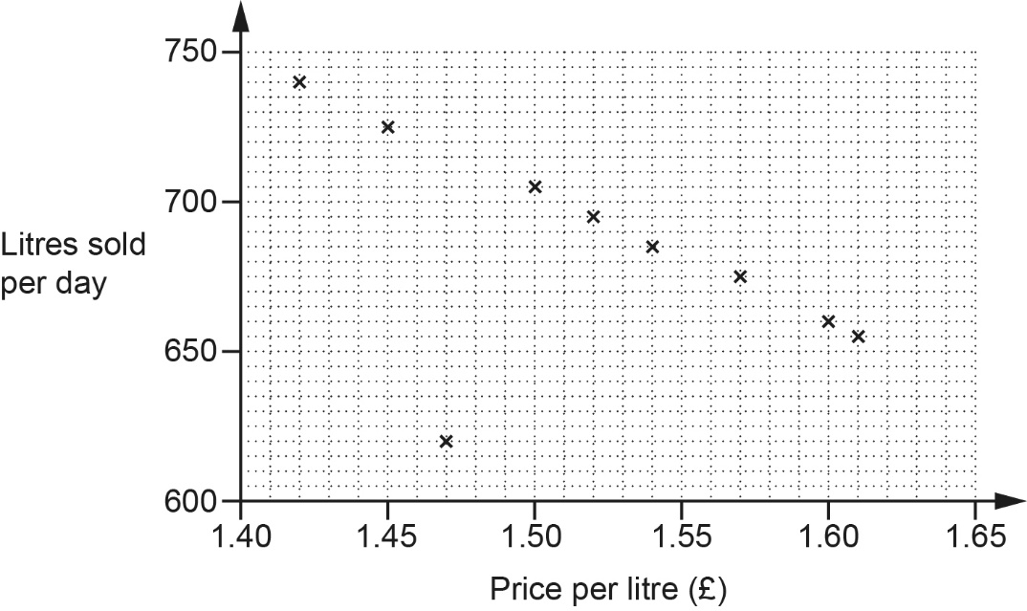

- Plot the result for week 10. [1]

- Describe the type of correlation shown in the scatter diagram.

(b) .......................................................... [1]

- In one week, there was a delay with petrol deliveries.

Circle the most likely point on the scatter diagram for that week. [1]

(i) On the scatter diagram, draw a line of best fit. [1]

- Use the line of best fit to estimate the average daily sales when the price per litre of petrol is £1.56.
(d)(ii) .......................................................... litres [1]

- The manager says,

As the sales go down, the total amount of money we take stays roughly the same.

Find evidence to support this statement.
...........................................................................................................................................

..................................................................................................................................... [3]

- A person invests £12 000 at a rate of 15% per year compound interest.

Calculate the total amount of interest earned after 3 years.
£ .......................................................... [3]

- The diagram shows an equilateral triangular prism.
Each side of the equilateral triangle is 4 cm and the length of the prism is 8 cm.

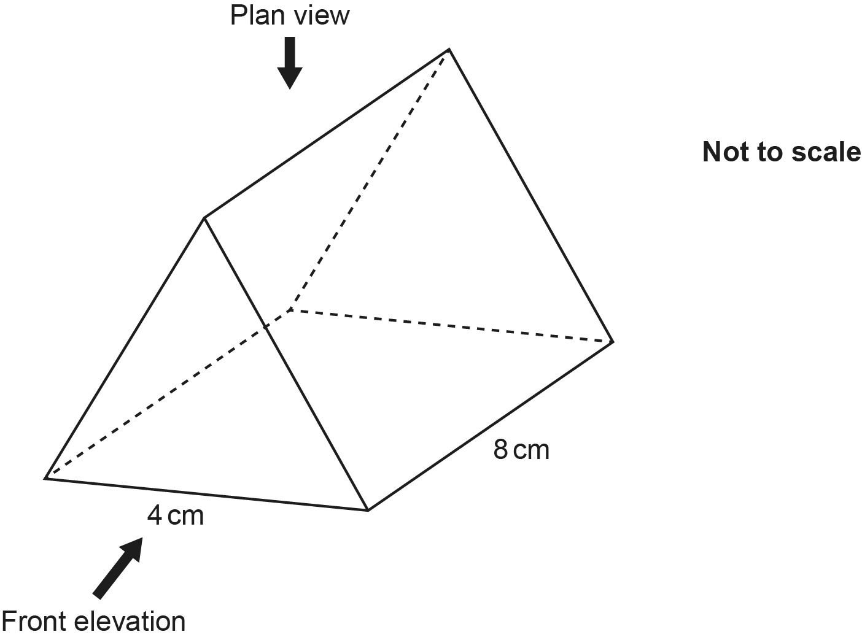

- Draw an accurate plan view of the prism on the one-centimetre square grid below.


[3]

- Draw an accurate front elevation of the prism on the one-centimetre isometric
grid below.


[2]

- A rock has a mass of 37 260 g and a volume of 13 800 cm³.

Work out the density of the rock.
Give the units of your answer.
.......................................................... ............... [3]

- There is a total of 328 balls in a bag.
There are white balls, red balls and green balls only.

The ratio of white balls to red balls is 2 : 3.
The ratio of red balls to green balls is 7 : 2.

Work out the number of white balls in the bag.
.......................................................... [4]

- A cylinder has a radius of 11.2 cm.
The ratio of the radius of the cylinder to the height of the cylinder is 4 : 9.

Find the volume of the cylinder.
.......................................................... cm³ [4]

- Here is a table of values for y = x² – x – 6.

x | -3 | -2 | -1 | 0 | 1 | 2 | 3
y | 6 | 0 | -4 | -6 | -6 | -4 | 0

- Draw the graph of y = x² – x – 6 for -3 ⩽ x ⩽ 3.

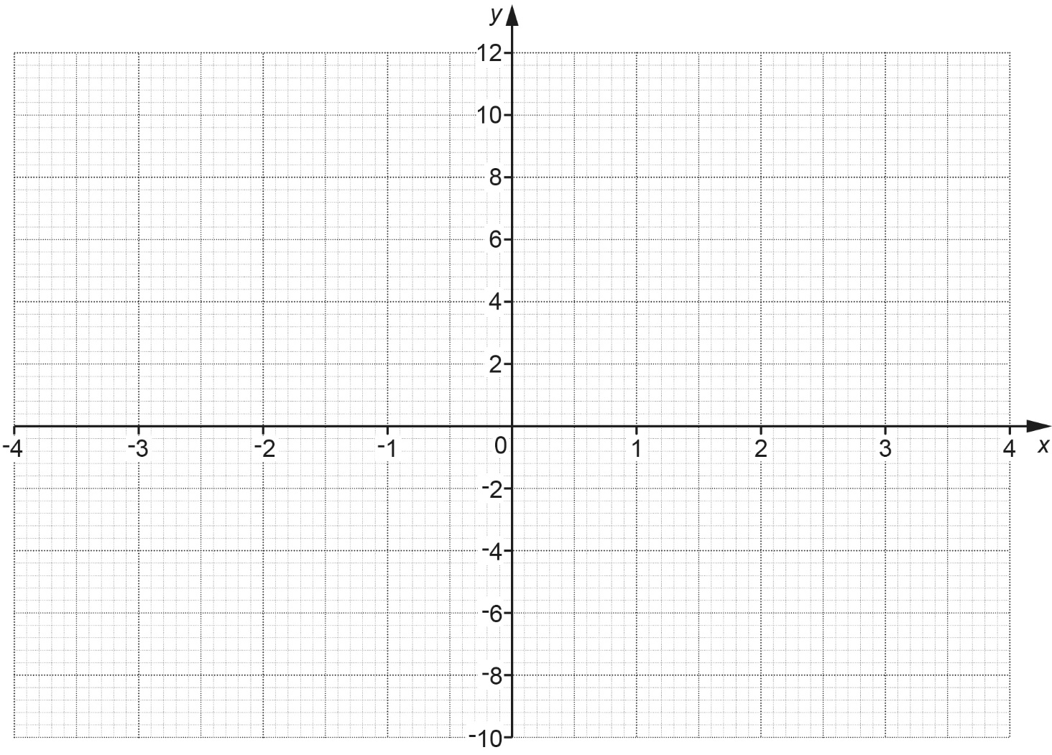
[3]

- Write down the equation of the line of symmetry of the graph.

(b) .......................................................... [1]

- Use the graph to solve the equation x² – x – 6 = 0.

(c) x = ........................... or x = ........................... [2]

- Triangles ABC and PQR are mathematically similar.
Angle ACB = Angle PRQ.
Angle ABC = Angle PQR.

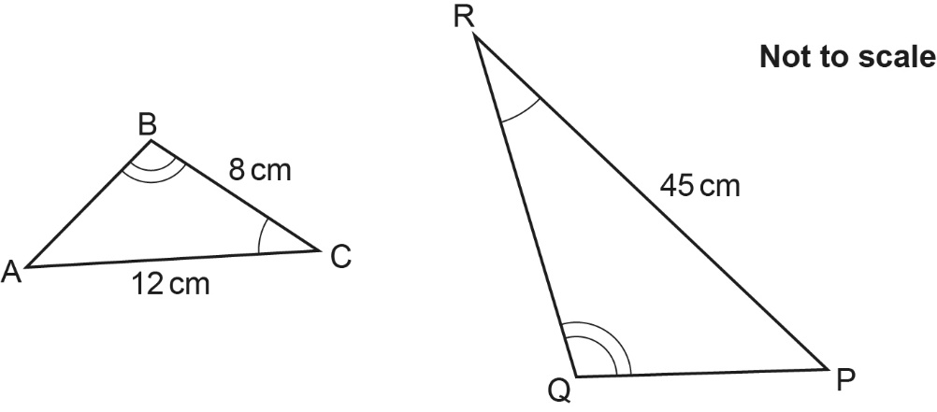

The perimeter of triangle PQR is 104 cm.

Find the length of PQ.
PQ = .......................................................... cm [4]

- y is directly proportional to the cube of t.
y = 14 when t = 2.

t is directly proportional to x.
t = 16 when x = 4.

Find a formula for y in terms of x.
Give your answer in its simplest form.
You must show your working.
y = .......................................................... [6]

- A water company is laying pipes to cover a distance of 102 metres, correct to the nearest metre.
Each pipe has a length of 2.4 metres, correct to 1 decimal place.
Assume the pipes are laid end to end with no gaps or overlaps.

Work out the minimum number of pipes the water company needs to be sure of covering
that distance.
You must show your working.
.......................................................... [4]

- The histogram summarises the heights, h cm, of some plants in a garden centre.

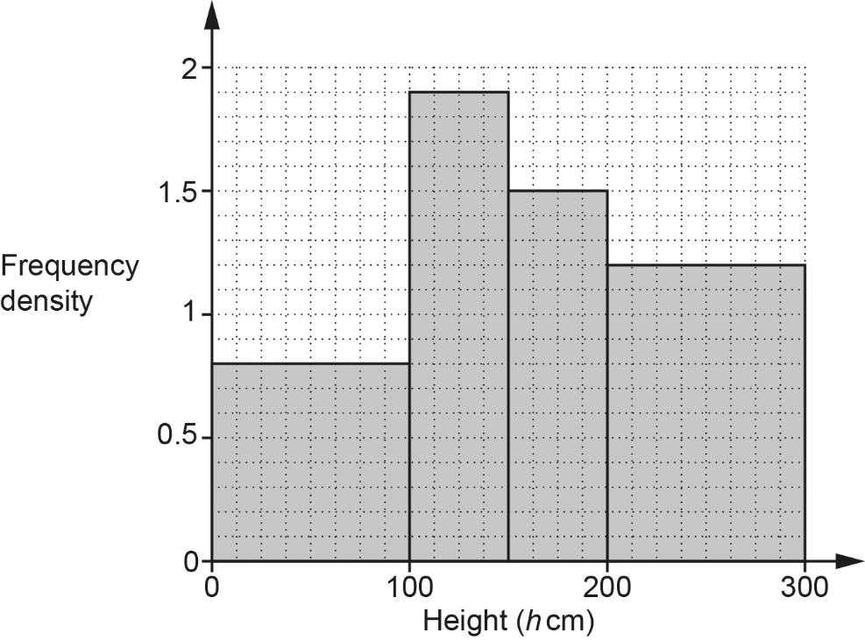

- Show that there are 120 plants with a height in the interval 200 < h ⩽ 300. [1]
- The value, in pounds, of each plant depends on the plant’s height.
The table below shows this information.

Height (h cm) | Value (£)
0 < h ⩽ 100 | 3.10
100 < h ⩽ 150 | 3.60
150 < h ⩽ 200 | 4.00
200 < h ⩽ 300 | 5.30

Use this information to find the total value of the plants represented in the histogram.
(b) £ .......................................................... [4]
- In a survey, some students were asked whether they had travelled to school by bus (B) or by car (C) in the last week.
The Venn diagram shows some of the results.

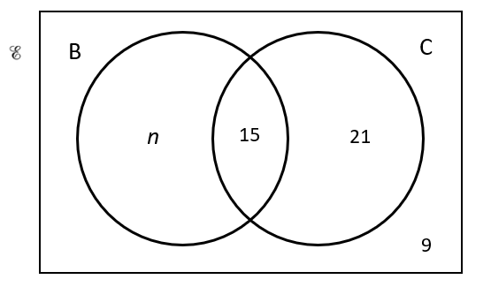

- One of the students is chosen at random.
The probability that, in the last week, this student had travelled to school by bus and by car is.

Find the value of n.
(a) n = .......................................................... [3]

- One of the students is chosen at random.

Find the probability that, in the last week, this student had travelled to school by car given that they had also travelled to school by bus.
(b) .......................................................... [2]

- AC is a diagonal of the quadrilateral ABCD.

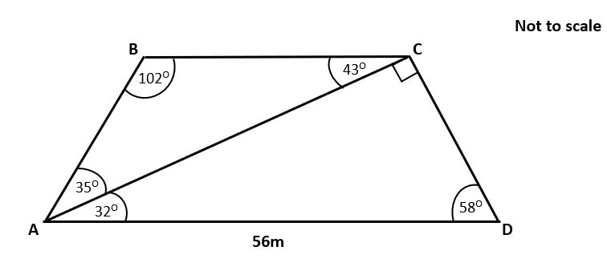

AD = 56 m.
Angle ABC = 102°, angle BCA = 43° and angle BAC = 35°.
Angle ACD = 90°, angle CDA = 58° and angle CAD = 32°.

Find the area of ABCD.
You must show your working.
.......................................................... m² [6]
- An app’s passcode consists of three digits. Each of the digits is a number from 1 to 5.
A digit can be used more than once.

Find the fraction of the possible passcodes that contain at least one 2.
.......................................................... [4]

- Some sequences are defined using this term-to-term rule.

un+1 = 3un − 10

- If u3 = 14, show that u4 = 32. [1]
- If u3 = 14, work out u2.
(b) .......................................................... [3]

- If u1 = 5, write down the value of u100.
Give a reason for your answer.
u100 = .................. because ...............................................................................................

..................................................................................................................................... [2]

- Two ornaments, A and B, are mathematically similar.
The table shows information about the two ornaments.

 | Ornament A | Ornament B
Height (m) | h | 14
Surface area (m²) | 216 | A
Volume (m³) | 80 | 3430

Find the value of h and the value of A.
You must show your working.

h = ..........................................................

A = .......................................................... [6]
- (a) Show that the equation x³ – 6x + 1 = 0 has a solution between x = 2 and x = 3. [3]
- Use x = 2.5 to find a smaller interval for the solution to x³ – 6x + 1 = 0.
You must show your working.
(b) .......................................................... [2]

- Find this solution correct to 1 decimal place.
You must show your working.

(c) x = .......................................................... [3]

END OF QUESTION PAPER

Please note – web links are correct at date of publication but other websites may change over time. If you have any problems with a link you may want to navigate to that organisation’s website for a direct search.



We’d like to know your view on the resources we produce. Click ‘Like’ or ‘Dislike’ to send us an auto generated email about this resource. Add comments if you want to. Let us know how we can improve this resource or what else you need. Your email will not be used or shared for any marketing purposes.
Looking for another resource? There is now a quick and easy search tool to help find free resources for your qualification.
OCR is part of Cambridge University Press & Assessment, which is itself a department of the University of Cambridge.
For staff training purposes and as part of our quality assurance programme your call may be recorded or monitored. © OCR 2024 Oxford Cambridge and RSA Examinations is a Company Limited by Guarantee. Registered in England. Registered office The Triangle Building, Shaftesbury Road, Cambridge, CB2 8EA. Registered company number 3484466. OCR is an exempt charity.
OCR operates academic and vocational qualifications regulated by Ofqual, Qualifications Wales and CCEA as listed in their qualifications registers including A Levels, GCSEs, Cambridge Technicals and Cambridge Nationals.
OCR provides resources to help you deliver our qualifications. These resources do not represent any teaching method we expect you to use. We update our resources regularly and aim to make sure content is accurate but please check the OCR website so that you have the most up to date version. OCR cannot be held responsible for any errors or omissions in these resources.
Though we make every effort to check our resources, there may be contradictions between published support and the specification, so it is important that you always use information in the latest specification. We indicate any specification changes within the document itself, change the version number and provide a summary of the changes. If you do notice a discrepancy between the specification and a resource, please contact us.
You can copy and distribute this resource in your centre, in line with any specific restrictions detailed in the resource. Resources intended for teacher use should not be shared with students. Resources should not be published on social media platforms or other websites.
OCR acknowledges the use of the following content: N/A
Whether you already offer OCR qualifications, are new to OCR or are thinking about switching, you can request more information using our Expression of Interest form.
Please get in touch if you want to discuss the accessibility of resources we offer to support you in delivering our qualifications.

