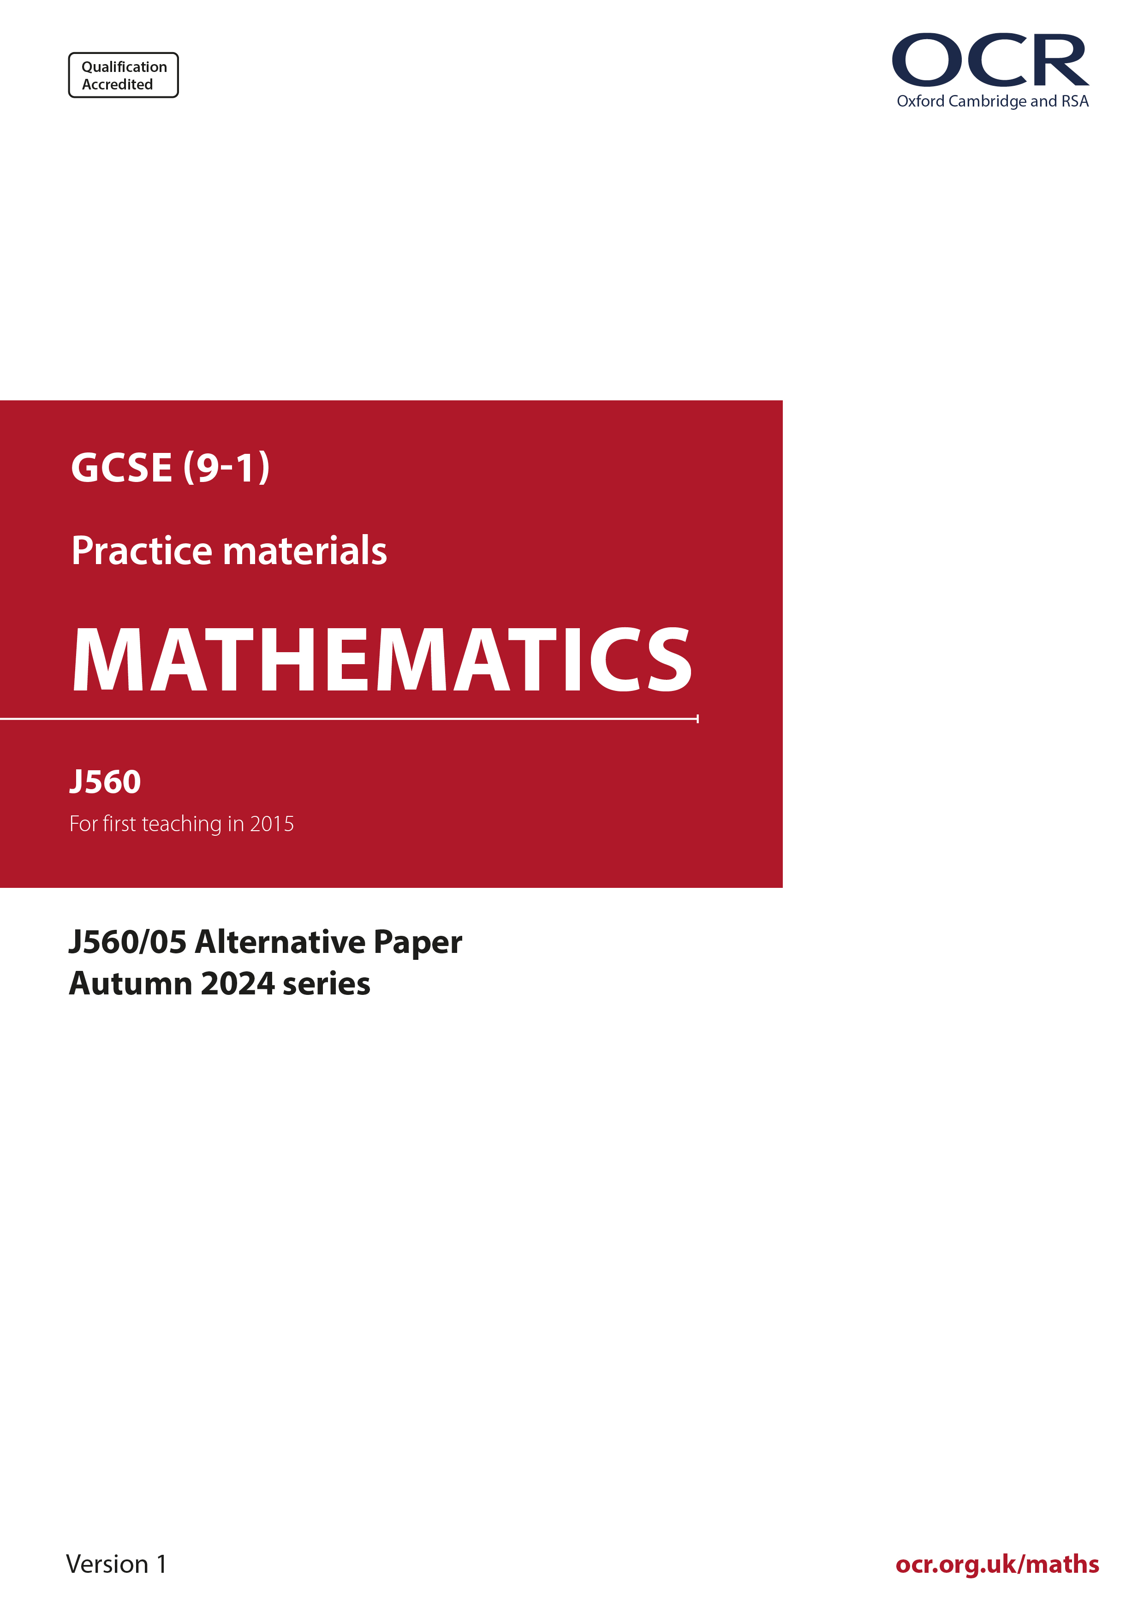
ocr.org.uk/maths

Introduction
OCR’s Alternative Papers for GCSE (9-1) Mathematics are each created by taking one of our past papers and amending the numbers/graphs/diagrams/tables/etc. in its questions.
This Alternative Paper is an amended version of one of the November 2024 series papers. The wording and topics assessed are essentially the same, but the responses students need to make will be different. Using both this paper and the corresponding November 2024 exam paper with your students at different points in the year will allow you to monitor how their learning has progressed in the time between the two papers.
Please note that when students originally sat this paper in 2024, they were given a formulae sheet. Foundation tier and Higher tier formulae sheets are published on Teach Cambridge alongside the Alternative Papers, for use with students as required.
Additional Alternative Papers and past papers are available to download from Teach Cambridge.



GCSE (9-1) Mathematics
J560/02 Paper 5 (Higher Tier)
Alternative Paper (November 2024)

Time allowed: 1 hour 30 minutes

H
You must have:
- the Formulae Sheet for Higher Tier (inside this document)

You can use:
- geometrical instruments
- tracing paper
- Do not use a calculator

Name

INSTRUCTIONS
- Use black ink. You can use an HB pencil, but only for graphs and diagrams.
- Write your answer to each question in the space provided. You can use extra paper if you need to, but you must clearly show your candidate number, the centre number and the question numbers
- Answer all the questions.
- Where appropriate, your answer should be supported with working. Marks might be
given for using a correct method, even if your answer is wrong.

INFORMATION
- The total mark for this paper is 100.
- The marks for each question are shown in brackets [ ].
- This document has 19 pages.

ADVICE
- Read each question carefully before you start your answer.

- Work out.

.......................................................... [4]

- (a) Work out the size of an exterior angle of a regular octagon.
(a) .......................................................... [2]

- Use your answer to part (a) to write down the size of an interior angle of a regular octagon.
(b) .......................................................... [1]

- The graph shows the time, in minutes, taken by some pupils to travel to school on Tuesday.

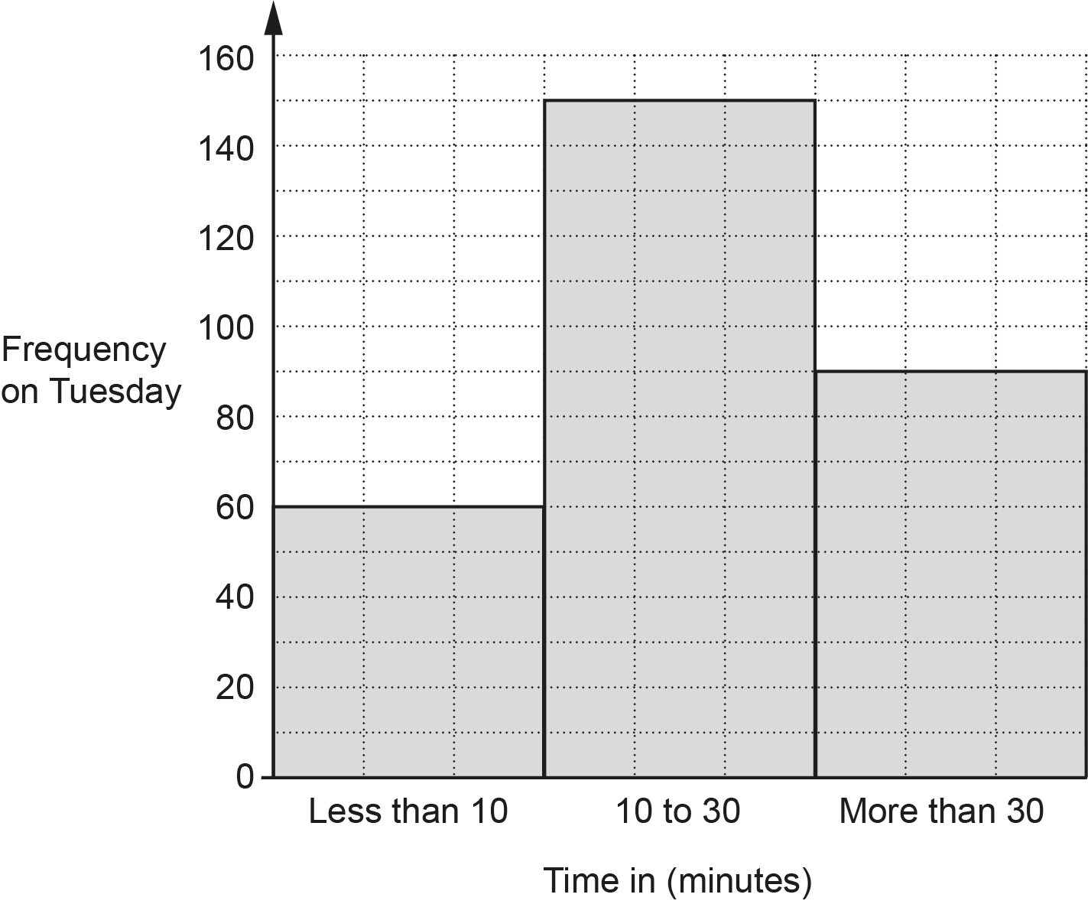

- Find the percentage of those pupils that took less than 10 minutes to travel to school.
(a) .......................................................... % [3]

- On Tuesday the number of pupils taking more than 30 minutes to travel to school was 40% less than on Monday.

Find the number of pupils taking more than 30 minutes to travel to school on Monday.
(b) .......................................................... [3]

- An electrician charges £40 per visit plus £19 per hour.

Write an expression for the cost, in £, charged by the electrician for one visit lasting t hours.
£ .......................................................... [2]

- Orla has a shelf 83.7 cm long.
She has many books, each of width 3.8 cm.
Orla puts two paperweights, each of width 5 cm, and the maximum possible number of books on the shelf.

Work out the amount of space on the shelf that is left over.
You must show your working.
.......................................................... cm [5]

- James has twenty cards numbered 11 to 30.
He picks a card at random.

James says,

In these twenty cards, there are three multiples of 7 and ten even numbers.
Therefore, the probability that I pick a card that is a multiple of 7 or an even
number is

Describe the error in James’ method and give the correct answer.

The error is ................................................................................................................................

....................................................................................................................................................

The correct answer is .......................................................... [2]

- Henry makes craft figures at a constant rate.
He can make 10 craft figures in 40 minutes.

- Find the number of craft figures Henry can make in 6 hours.
(a) .......................................................... [3]

- Amaya makes craft figures 10% quicker than Henry.

Work out how long Amaya takes to make 15 craft figures.
(b) .......................................................... minutes [3]

- Here is a question and an incorrect answer.

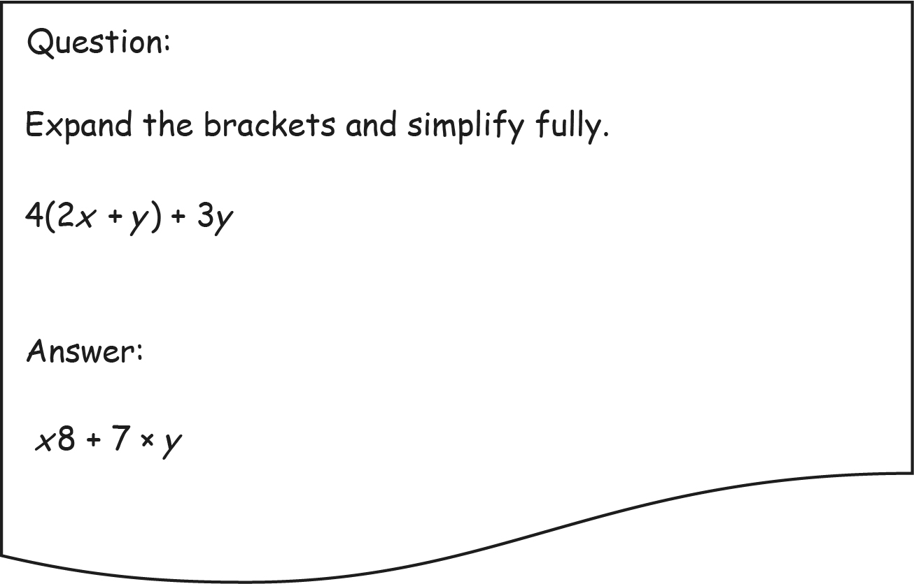

Explain why the answer is not correct.

....................................................................................................................................................

.............................................................................................................................................. [2]

- Solve.

4x + 17 = 13 – 6x
x = .......................................................... [3]

- A straight line has equation y = 5x + 11.

- Write down the gradient of the line.
(a) .......................................................... [1]

- Alex says the graph of y = 5x + 11 passes through the point (3, 23).

Is Alex correct?
Show how you decide.
............................... because ............................................................................................

..................................................................................................................................... [2]

- A bag only contains green, red, blue and yellow discs.

Mei carries out an experiment.
She picks one disc at a time from the bag, records its colour and then returns the disc to the bag.
When she has finished the experiment, Mei works out the relative frequency of each colour.
Some of her results are shown in the table.

Colour | Green | Red
Relative frequency | 0.25 | 0.15

The relative frequency of the yellow discs was five times the relative frequency of the blue discs.

In total, there are 3000 discs in the bag.

- Use this information to find an estimate for the total number of green and yellow discs that are in the bag.
You must show your working.
(a) .......................................................... [5]

- Explain why your estimate may not be reliable.

...........................................................................................................................................

..................................................................................................................................... [1]
- A housing estate is built on a triangular piece of land.

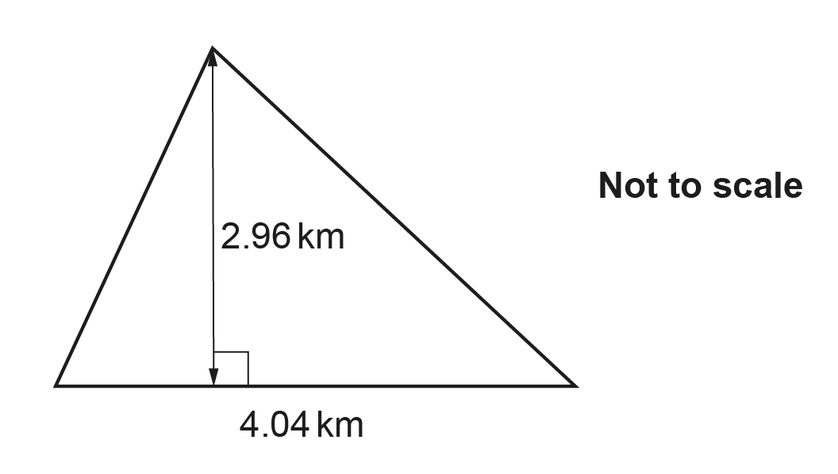

There are 8947 people living on the estate.

Work out an estimate of the population density of the estate in people per km².
.......................................................... people per km² [4]

- Write as a recurring decimal.
.......................................................... [2]
- The expected value of a painting, £P, is given by the formula

P = 3000 × 1.15^{n}

where n is the number of years after it was bought and 0 ⩽ n ⩽ 4.

- Write down the value of the painting when it was bought.
(a) £ .......................................................... [1]

- Write down the annual percentage increase in the expected value of the painting.
(b) .......................................................... % [1]

- The table shows the expected value of the painting n years after it was bought.

Years after the painting is bought (n) | 1 | 2 | 3 | 4
Expected value of the painting, rounded to the nearest £ | 3450 | 3968 | 4563 | 5247

On the next page, draw a suitable graph to show the expected value of the painting n years after it was bought, where 0 ⩽ n ⩽ 4.

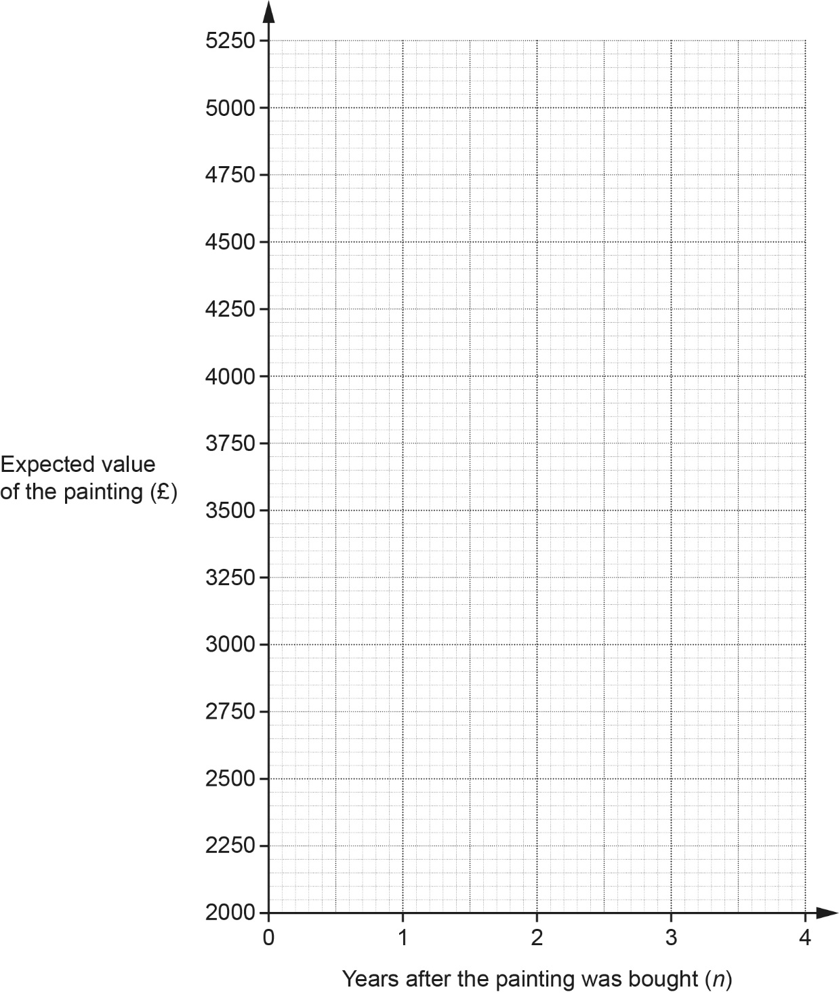
[3]

- An art collector correctly works out 3000 × 1.15¹⁰ as 12 137.

They say,

The expected value of the painting 10 years after it was bought is £12 137

What assumption has the art collector made?

...........................................................................................................................................

..................................................................................................................................... [1]

- (a) The diagram shows a rectangle, OPQR, and a circle, centre O, which passes through Q.
OR = 5 cm and RQ = 12 cm.

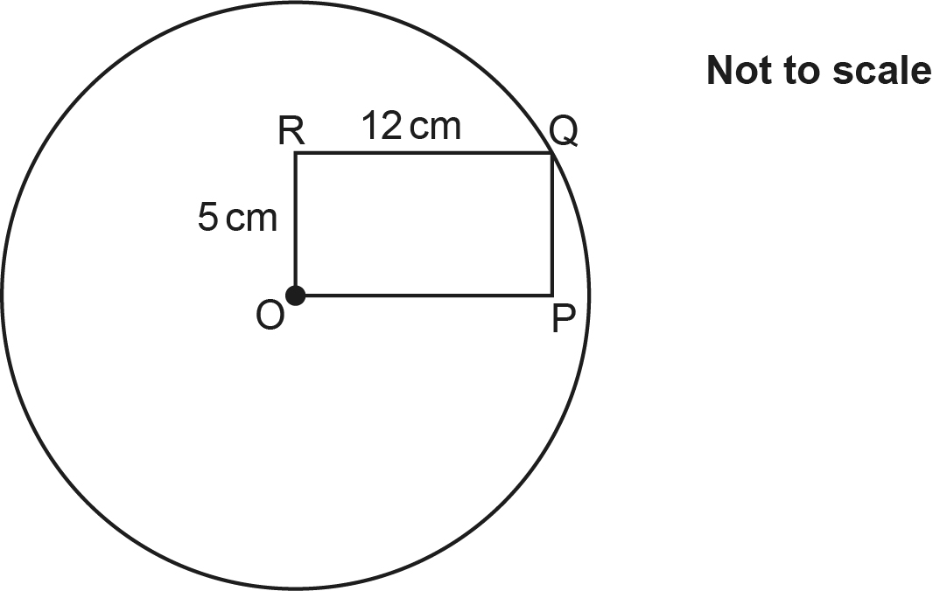

Find the circumference of the circle.
Give your answer in terms of $\text{π}$.
(a) .......................................................... cm [4]

- AOB is a sector of a circle, centre O and radius 12 cm.
Angle AOB = x°.
The arc, AB, has length 4π cm.

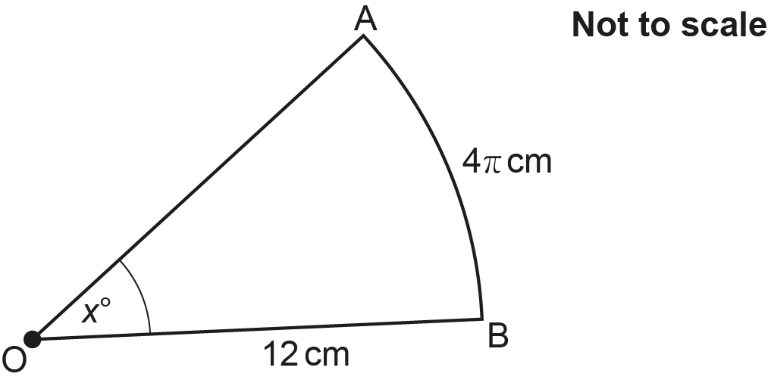

Find the area of the sector.
Give your answer in terms of π.
(b) .......................................................... cm² [4]

- In the diagram below, the shaded region is a parallelogram.
The parallelogram can be identified by four inequalities.
Two of the inequalities are y ⩾ 8 and y ⩾ x.

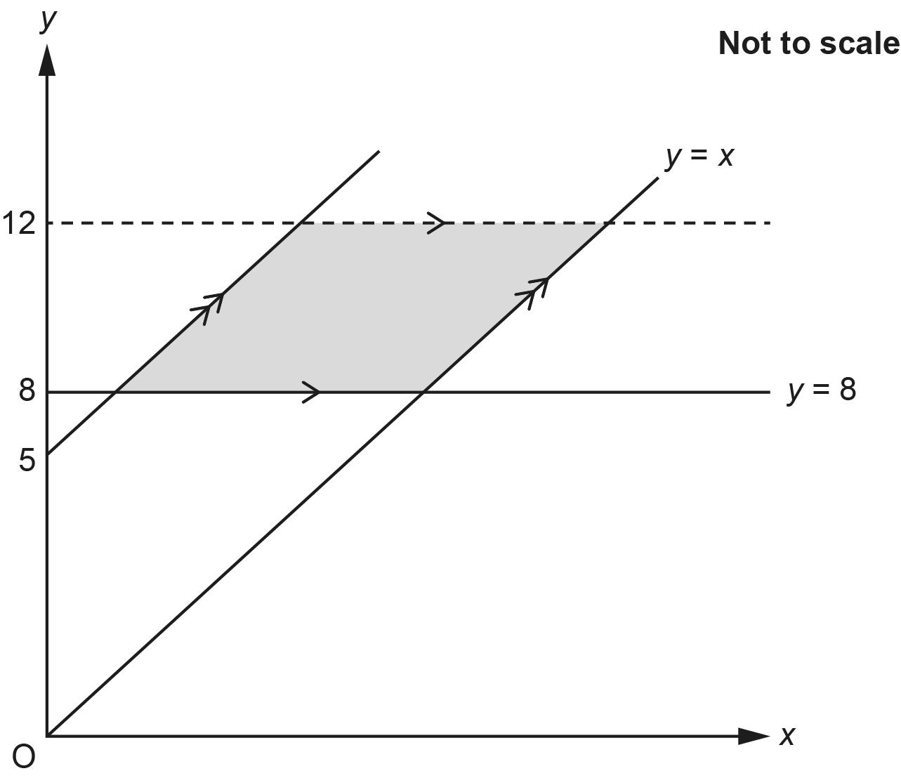

- Write down the other two inequalities that identify the parallelogram.

(a) ..........................................................

..........................................................
[3]

- Work out the area of the parallelogram.
You must show your working.
(b) .......................................................... square units [4]

- A farmer grows pumpkins.
The farmer records the masses, m kilograms, of 80 of their pumpkins.
The table shows the results.

Mass (m kg) | 0 < m ⩽ 5 | 5 < m ⩽ 10 | 10 < m ⩽ 15 | 15 < m ⩽ 20 | 20 < m ⩽ 25
Frequency | 8 | 12 | 32 | 18 | 10

- Complete the cumulative frequency table.

Mass (m kg) | m ⩽ 5 | m ⩽ 10 | m ⩽ 15 | m ⩽ 20 | m ⩽ 25
Cumulative frequency | 8 | 20
[1]

- Draw the cumulative frequency graph to represent these results.

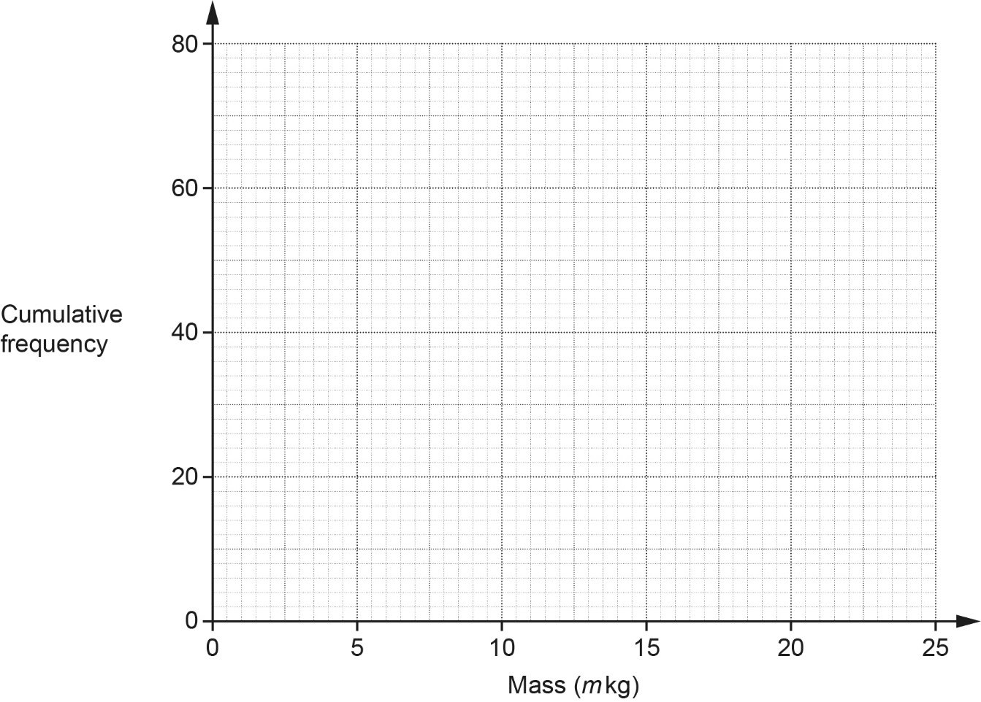
[3]

- Write down the lower quartile of the mass of the 80 pumpkins.
(c) .......................................................... kg [1]

- The farmer picks a pumpkin at random.

Find an estimate for the probability that the pumpkin has a mass greater than 17 kg.
(d) .......................................................... [2]

- Solve.

You must show your working.
x = ................................. or x = ................................ [6]

- A, B, C and D are points on the circumference of a circle, centre O.
BD is a diameter of the circle.
EBF is a tangent to the circle.

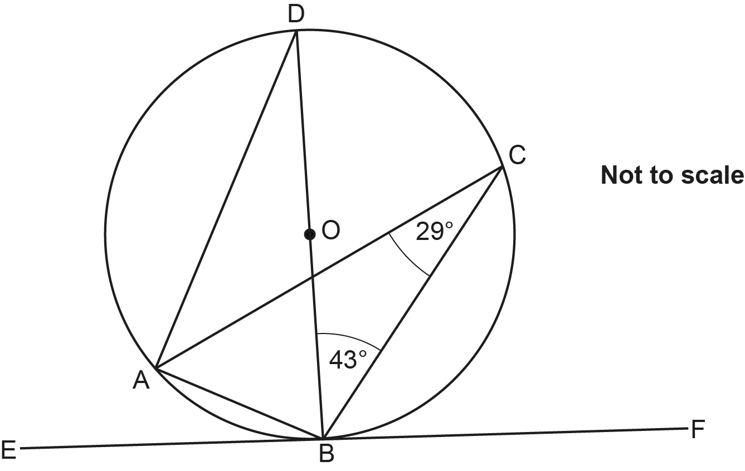

- Give a reason why angle BAD = 90°.

..................................................................................................................................... [1]

- Write down one other angle that is 90°.
Give a reason for your answer.

Angle ...................... because ...........................................................................................

..................................................................................................................................... [2]

- Write down the value of angle CAD.
(c) .......................................................... ° [1]

- Write down the value of angle EBA.
(d) .......................................................... ° [1]

- Simplify.

.......................................................... [2]

- (a) Work out.

(a) .......................................................... [1]

- 3x × 9y = 27

Show that y = . [4]

- A sequence has nth term 2n2 + 3.

Prove algebraically that the sum of any two consecutive terms in this sequence is always
a multiple of 4. [6]
END OF QUESTION PAPER

Please note – web links are correct at date of publication but other websites may change over time. If you have any problems with a link you may want to navigate to that organisation’s website for a direct search.



We’d like to know your view on the resources we produce. Click ‘Like’ or ‘Dislike’ to send us an auto generated email about this resource. Add comments if you want to. Let us know how we can improve this resource or what else you need. Your email will not be used or shared for any marketing purposes.
Looking for another resource? There is now a quick and easy search tool to help find free resources for your qualification.
OCR is part of Cambridge University Press & Assessment, which is itself a department of the University of Cambridge.
For staff training purposes and as part of our quality assurance programme your call may be recorded or monitored. © OCR 2024 Oxford Cambridge and RSA Examinations is a Company Limited by Guarantee. Registered in England. Registered office The Triangle Building, Shaftesbury Road, Cambridge, CB2 8EA. Registered company number 3484466. OCR is an exempt charity.
OCR operates academic and vocational qualifications regulated by Ofqual, Qualifications Wales and CCEA as listed in their qualifications registers including A Levels, GCSEs, Cambridge Technicals and Cambridge Nationals.
OCR provides resources to help you deliver our qualifications. These resources do not represent any teaching method we expect you to use. We update our resources regularly and aim to make sure content is accurate but please check the OCR website so that you have the most up to date version. OCR cannot be held responsible for any errors or omissions in these resources.
Though we make every effort to check our resources, there may be contradictions between published support and the specification, so it is important that you always use information in the latest specification. We indicate any specification changes within the document itself, change the version number and provide a summary of the changes. If you do notice a discrepancy between the specification and a resource, please contact us.
You can copy and distribute this resource in your centre, in line with any specific restrictions detailed in the resource. Resources intended for teacher use should not be shared with students. Resources should not be published on social media platforms or other websites.
OCR acknowledges the use of the following content: N/A
Whether you already offer OCR qualifications, are new to OCR or are thinking about switching, you can request more information using our Expression of Interest form.
Please get in touch if you want to discuss the accessibility of resources we offer to support you in delivering our qualifications.

